Report on influenza viruses received and tested by the Melbourne WHO Collaborating Centre for Reference and Research on Influenza in 2018

Olivia H Price, Natalie Spirason, Cleve Rynehart, Sook Kwan Brown, Angela Todd, Heidi Peck, Manisha Patel, Sally Soppe, Ian G Barr and Michelle K Chow

# Abstract

As part of its role in the World Health Organization’s (WHO) Global Influenza Surveillance and Response System (GISRS), the WHO Collaborating Centre for Reference and Research on Influenza in Melbourne received a total of 3993 human influenza-positive samples during 2018. Viruses were analysed for their antigenic, genetic and antiviral susceptibility properties. Selected viruses were propagated in qualified cells or hens’ eggs for use as potential seasonal influenza vaccine virus candidates. In 2018, influenza A(H1)pdm09 viruses predominated over influenza A(H3) and B viruses, accounting for a total of 53% of all viruses analysed. The majority of A(H1)pdm09, A(H3) and influenza B viruses analysed at the Centre were found to be antigenically similar to the respective WHO-recommended vaccine strains for the Southern Hemisphere in 2018. However, phylogenetic analysis indicated that a significant proportion of circulating A(H3) viruses had undergone genetic drift relative to the WHO-recommended vaccine strain for 2018. Of 2864 samples tested for susceptibility to the neuraminidase inhibitors oseltamivir and zanamivir, three A(H1)pdm09 viruses showed highly reduced inhibition by oseltamivir, while one B/Victoria virus showed highly reduced inhibition by both oseltamivir and zanamivir.

Keywords:GISRS, influenza, vaccines, surveillance, laboratory, annual report, WHO

# Introduction

The WHO Collaborating Centre for Reference and Research on Influenza in Melbourne (the Centre) is part of the World Health Organization’s Global Influenza Surveillance and Response System (WHO GISRS). GISRS is a worldwide network of laboratories that was established in 1952 to monitor changes in influenza viruses circulating in the human population, with the aim of reducing its impact through the use of vaccines and antiviral drugs.1,2 The Centre in Melbourne is one of five such Collaborating Centres (others are in Atlanta, Beijing, London and Tokyo) that monitor antigenic and genetic changes in circulating human influenza viruses, and make biannual recommendations on which influenza strains should be included in the influenza vaccine for the upcoming season in either the northern or southern hemisphere. This report summarises the results of virological surveillance activities undertaken at the Centre in Melbourne during 2018.

Two types of influenza virus cause significant disease in humans: types A and B. Influenza A viruses are further classified into subtypes, based on their haemagglutinin (HA) and neuraminidase (NA) surface proteins. Globally, there are currently two influenza A subtypes circulating in the human population: A(H1N1)pdm09 and A(H3N2). Influenza B viruses are not classified into subtypes; however, there are two distinct co-circulating lineages of influenza B viruses: B/Victoria/2/87 (B/Victoria lineage) and B/Yamagata/16/88 (B/Yamagata lineage). In addition, each year influenza C viruses are detected from humans, but these viruses do not cause severe disease and are not a major focus of influenza surveillance.

# Methods

## Virus isolation

All A(H1)pdm09 and influenza B viral isolates received at the Centre were re-passaged in cell culture (Madin-Darby Canine Kidney (MDCK) cells), whilst all A(H3) viral isolates were re-passaged in MDCK-SIAT-1 cells.3 Virus isolation in cell culture was also attempted from a selection of original clinical specimens received. A smaller subset of influenza-positive original clinical samples was directly inoculated into eggs and a qualified cell line to generate potential candidate vaccine viruses.

## Antigenic analysis

The antigenic properties of influenza viral isolates were analysed using the haemagglutination inhibition (HI) assay as previously described4 and by microneutralisation assay for a subset of A(H3N2) viruses. The majority of the HI assays were performed using the TECAN Freedom EVO200 robot platform which incorporates a camera (SciRobotics, Kfar Saba, Israel) and imaging software (FluHemaTM) for automated analysis. In HI assays, viruses were tested for their ability to agglutinate turkey (A(H1N1)pdm09 and B viruses) or guinea pig (A(H3N2) viruses) red blood cells (RBC) in the presence of ferret antisera previously raised against several reference viruses. Isolates were identified as antigenically similar to the reference strain if the test samples had a titre that was no more than fourfold higher than the titre of the homologous reference strain. During 2018, results were reported with reference to the A/Michigan/45/2009 (H1N1)pdm09-like, A/Singapore/INFIMH-16-0019/2016 (H3N2)-like, B/Brisbane/60/2008-like (Victoria lineage), and B/Phuket/3073/2013-like (Yamagata lineage) viruses that were recommended for inclusion in the southern hemisphere 2018 influenza vaccine. In recent years (including 2018), HI assays involving A(H3) viruses have been performed in the presence of oseltamivir carboxylate (OC) in order to reduce non-specific binding of the NA protein.5 The addition of OC reduces the number of influenza virus isolates that can be tested by HI, as around 20% of viruses lose the ability to bind RBC. To test a subset of these viruses, the Centre has employed the Focus Reduction Assay (FRA), a microneutralisation assay which is more specific and sensitive than the HI assay and does not require binding to RBC.6 The FRA utilised the same ferret antisera as used in the HI assay and was performed as previously described7 but with 1.2% Avicell RC591 (IMCD Mulgrave, Australia) replacing the carboxymethyl cellulose.

## Genetic analysis

For influenza-positive samples that failed to grow in MDCK cells, real-time reverse transcription polymerase chain reaction (RT-PCR) was performed to determine the influenza type/subtype/lineage using the CDC Influenza Virus Real-Time RT-PCR kit.[1]

A substantial subset of all influenza viruses analysed at the Centre underwent genetic analysis by sequencing of viral RNA genes – usually HA and NA genes as well as the matrix gene for influenza A viruses and the non-structural protein gene (NS) for influenza B viruses. The full genomes (all eight gene segments) of a smaller subset of viruses were also sequenced.

For sequencing, RNA was extracted from isolates or original clinical specimens using either a manual QIAGEN QIAamp Viral RNA kit or the automated QIAGEN QIAXtractor platform, followed by RT-PCR using the BIOLINE MyTaq one-step RT-PCR kit according to the manufacturer’s recommendations, with gene-specific primers (primer sequences available on request). Conventional Sanger sequencing was carried out on PCR products using an Applied Biosystems 3500XL Genetic Analyzer (Applied Biosystems, Foster City, CA, USA). Sequence assembly was performed using the Geneious Prime software version 9.0.4 (Biomatters Ltd, Auckland, New Zealand). Next generation sequencing (NGS) was also performed on a selection of viruses using an Applied Biosystems Ion TorrentTM Personal Genome MachineTM (PGM) System according to the manufacturer**’**s recommendations**.** These sequences were analysed using a proprietary pipeline, FluLINE.8 Phylogenetic analysis was performed using Geneious 9.0.4 and FigTree v1.3.1 software.

## Antiviral drug resistance testing

Circulating viruses were tested for their sensitivity to the currently-used neuraminidase inhibitors oseltamivir (Tamiflu) and zanamivir (Relenza). The neuraminidase inhibition (NAI) assay used was a functional fluorescence-based assay using the substrate 20-(4-methylumbelliferyl)-a-D-N-acetylneuraminic acid (MUNANA), in which the susceptibility of test viruses to the antiviral drugs was measured in terms of the drug concentration needed to reduce the influenza neuraminidase enzymatic activity by 50% (IC50), and compared to values obtained with sensitive reference viruses of the same subtype or lineage. NAI assays were performed as previously described9 with the incorporation of a robotic platform by TECAN EVO200 and Infinite 200Pro for liquid handling and plate reading (Tecan Australia). For the purposes of reporting, reduced inhibition of influenza A viruses has been defined by WHO as a 10- to 99-fold increase in IC50, while highly reduced inhibition was defined as a ≥ 100-fold increase in IC50 in an NAI assay. For influenza B viruses, these figures were 5- to 49-fold and ≥ 50-fold increases in IC50, respectively. However, it should be noted that the relationship between the IC50 value and the clinical effectiveness of a neuraminidase inhibitor is not well understood and a small or medium reduction in inhibition may not be clinically significant.

Viruses found to have highly reduced inhibition by either oseltamivir or zanamivir underwent genetic analysis using pyrosequencing, Sanger sequencing or NGS to determine the presence of amino acid substitutions in the NA protein that were associated with the reduction of inhibition by neuraminidase inhibitors. For example, a change from histidine to tyrosine at position 275 (H275Y) of the NA protein of A(H1N1)pdm09 viruses is known to reduce inhibition by oseltamivir, as does the H273Y NA mutation in B viruses.10 Pyrosequencing was also performed on original clinical specimens of selected viruses which may have contained a known mutation such as H275Y but for which no isolate was available for phenotypic testing. Pyrosequencing was performed as previously described11 using the MyTaq One-Step RT-PCR Kit (QIAGEN, Hilden, Germany) for virus amplification, with pyrosequencing reactions performed using the PyroMark instrument (QIAGEN, Hilden, Germany).

## Candidate vaccine strains

The viruses used to produce human influenza vaccines are required to be isolated and passaged in embryonated hens’ eggs or qualified cell lines.12–14 The Centre undertook primary isolation of selected viruses from clinical samples directly into eggs, using previously described methods,15 with the following modifications. First, the viruses were inoculated initially into the amniotic cavity of the embryonated eggs. Once growth was established there, the isolates were passaged in the allantoic cavity. Egg incubation conditions differed slightly, with A(H1)pdm09 and A(H3) viruses incubated at 35 oC for three days and influenza B viruses incubated at 33 oC for three days. In addition, selected clinical samples were inoculated into the qualified cell line MDCK 33016PF (Seqirus Limited, Holly Springs, NC, USA) and incubated at 35 oC for three days, with viral growth monitored by haemagglutination of turkey or guinea pig RBC. These isolates were then analysed by HI assay, real time RT-PCR and genetic sequencing using the methods described above.

# Results

During 2018, the Centre received 3993 clinical specimens and/or virus isolates from 40 laboratories in 17 countries (Figure 1). As in previous years, most samples were submitted by laboratories in the Asia-Pacific region, including Australian laboratories.16–19 However unlike previous years, most samples were received between August and December, which is toward the end of the year and after the typical Southern Hemisphere influenza season. Figure 2 shows the weekly temporal distribution of samples sent to the Centre by type and subtype/lineage. During 2018, influenza A(H1)pdm09 was the predominant circulating strain. A similar number of A(H3) and B viruses circulated. As in 2017, for samples received from Australia where lineage was confirmed, B/Yamagata viruses predominated extensively over B/Victoria viruses. Overall, isolation was attempted for 3757 (94%) of the samples received and yielded 2903 isolates (overall isolation rate of 77%). Of the viruses for which type and subtype could be confirmed, isolation rates by cell propagation were 85% (1546/1828) for A(H1)pdm09, 89% (745/833) for A(H3) and 88% (600/683) for influenza B. However, amongst these viruses, 18% (151/745 isolated) of A(H3) isolates did not reach sufficient titres for antigenic analysis. A total of 2680 viral isolates were successfully characterised by HI assay comparing them to the 2018 vaccine-like reference viruses (Table 1). In addition, 420 samples were characterised by real-time RT-PCR to determine their type/subtype or lineage. Sanger sequencing and NGS techniques were used to sequence the HA genes of 1273 viruses. The full genomes of 181 viruses were sequenced using either Sanger sequencing or NGS. Of the samples for which results could be obtained via antigenic or genetic analysis (n = 3038), influenza A(H1)pdm09 viruses predominated, comprising 53% (n = 1624) of viruses received and analysed. Of the remaining viruses, there were similar proportions of A(H3) (24%, n = 725) and B (23%, n = 704; comprising 17% (n = 506) B/Yamagata and 6% (n = 176) B/Victoria) viruses.

Figure 1. Geographic spread of influenza laboratories sending viruses to the Centre during 2018.

Figure 2. Number of samples received at the Centre by week of sample collection, 2018.

## A(H1)pdm09

Of the 1542 A(H1)pdm09 isolates analysed by HI assay using ferret antisera in 2018, the majority (99%) were antigenically similar to the vaccine reference strain A/Michigan/45/2015 (Table 1).

Sequencing and phylogenetic analysis of HA genes from 522 viruses showed that all A(H1)pdm09 viruses sent to the Centre during 2018 fell into the 6B.1 clade (Figure 3). The majority of viruses reacted in a similar manner to the reference and 2018 vaccine virus A/Michigan/45/2015 in HI assays using ferret antisera. In total, 21 A(H1)pdm09 viruses were inoculated into eggs for isolation of candidate vaccine strains. Of these, 19 (90%) were successfully isolated, all of which fell into subclade 6B.1. A total of 44 viruses were inoculated into the qualified cell line MDCK 33016PF, of which 36 (82%) grew successfully. All isolated viruses were from the subclade 6B.1.

Of 1537 A(H1)pdm09 viruses tested, three viruses exhibited highly reduced inhibition by oseltamivir. All of these viruses — two from Singapore and one from Malaysia —were confirmed to contain the H275Y substitution in their NA genes, a known mutation that is associated with highly reduced inhibition by oseltamivir.

Figure 3. Phylogenetic tree of haemagglutinin genes of A(H1)pdm09 viruses received by the Centre during 2018.

**Legend:**

***# 2018 SOUTHERN HEMISPHERE VACCINE STRAIN***

* REFERENCE VIRUS

e: egg isolate

Scale bar represents 0.3% nucleotide sequence difference between viruses

Amino acid changes relative to the outgroup sequence (A/CALIFORNIA/07/2009e) are shown

(+/-) indicates gain/loss of a potential glycosylation site

| Braces indicate clades

## A(H3)

Antigenic analysis of 566 A(H3) subtype isolates using the HI assay showed that only 2.1% were low reactors to the ferret antisera prepared against the cell-propagated reference strain A/Singapore/INFIMH-16-0019/2016 (Table 1). However, 50.6% of viruses were low reactors to the ferret antisera prepared against the egg-propagated strain A/Singapore/INFIMH-16-0019/2016 (data not shown). An additional 151 A(H3) viruses were inoculated and isolated by cell culture but did not reach sufficient titres for antigenic analysis, whilst a further 70 were successfully isolated but did not reach sufficient titres when tested by HI assay in the presence of oseltamivir carboxylate.

Table 1. Antigenic analysis of viruses received by the Centre in 2018, by geographic region of origin.

|  | A(H1N1)pdm09 reference strain: | | A(H3N2)a reference strain: | | B/Victoria reference strain: | | B/Yamagata reference strain: | |
| --- | --- | --- | --- | --- | --- | --- | --- | --- |
| A/Michigan/45/2015 (cell) | | A/Singapore/INFIMH-16-0019/2016 (cell) | | B/Brisbane/60/2008 (cell) | | B/Phuket/3073/2013 (cell) | |
| **Region** | **Like** | **Low reactor (%)** | **Like** | **Low reactor (%)** | **Like** | **Low reactor (%)** | **Like** | **Low reactor (%)** |
| Australasia | 1087 | 10 (0.9) | 283 | 7 (2.4) | 11 | 3 (21.4) | 267 | 2 (0.7) |
| South East Asia | 321 | 3 (0.9) | 222 | 2 (0.9) | 54 | 11 (16.9) | 125 | 0 |
| Pacific | 45 | 0 | 14 | 3 (17.6) | 28 | 0 | 51 | 1 (1.9) |
| Africa | 36 | 1 (2.7) | 2 | 0 | 0 | 0 | 2 | 0 |
| South Asia | 15 | 0 | 24 | 0 | 5 | 2 (28.6) | 7 | 0 |
| East Asia | 23 | 0 | 9 | 0 | 1 | 0 | 3 | 0 |
| **Total** | **1527** | **14 (0.9%)** | **554** | **12 (2.1%)** | **99** | **16 (13.9%)** | **455** | **3 (0.7%)** |

a Note that many A(H3) virus isolates that were obtained could not be analysed by HI assay due to low haemagglutination assay (HA) titre in the presence of oseltamivir

A total of 64 A(H3) viruses that could not be characterised by HI assay were analysed using the FRA assay. The FRA assay indicated that only 6.3% of these viruses showed greater than fourfold difference in titre compared to the cell-propagated reference strain A/Singapore/INFIMH-16-0019/2016, and a similar proportion had a greater than fourfold difference in titre compared to the egg-propagated strain (data not shown).

The HA genes of 398 A(H3) viruses were sequenced. Phylogenetic analysis indicated that the majority of circulating viruses fell into subclade 3C.2a1 based on their HA genes, which is the same as the 2018 vaccine strain A/Singapore/INFIMH-16-0019/2016 (Figure 4). There was also a significant number of 3C.2a2 viruses, while a smaller proportion of A(H3) viruses fell into the 3C.2a3, 3C.2a4 and 3C.3a clades.

Figure 4. Phylogenetic tree of haemagglutinin genes of A(H3) viruses received by the Centre during 2018.

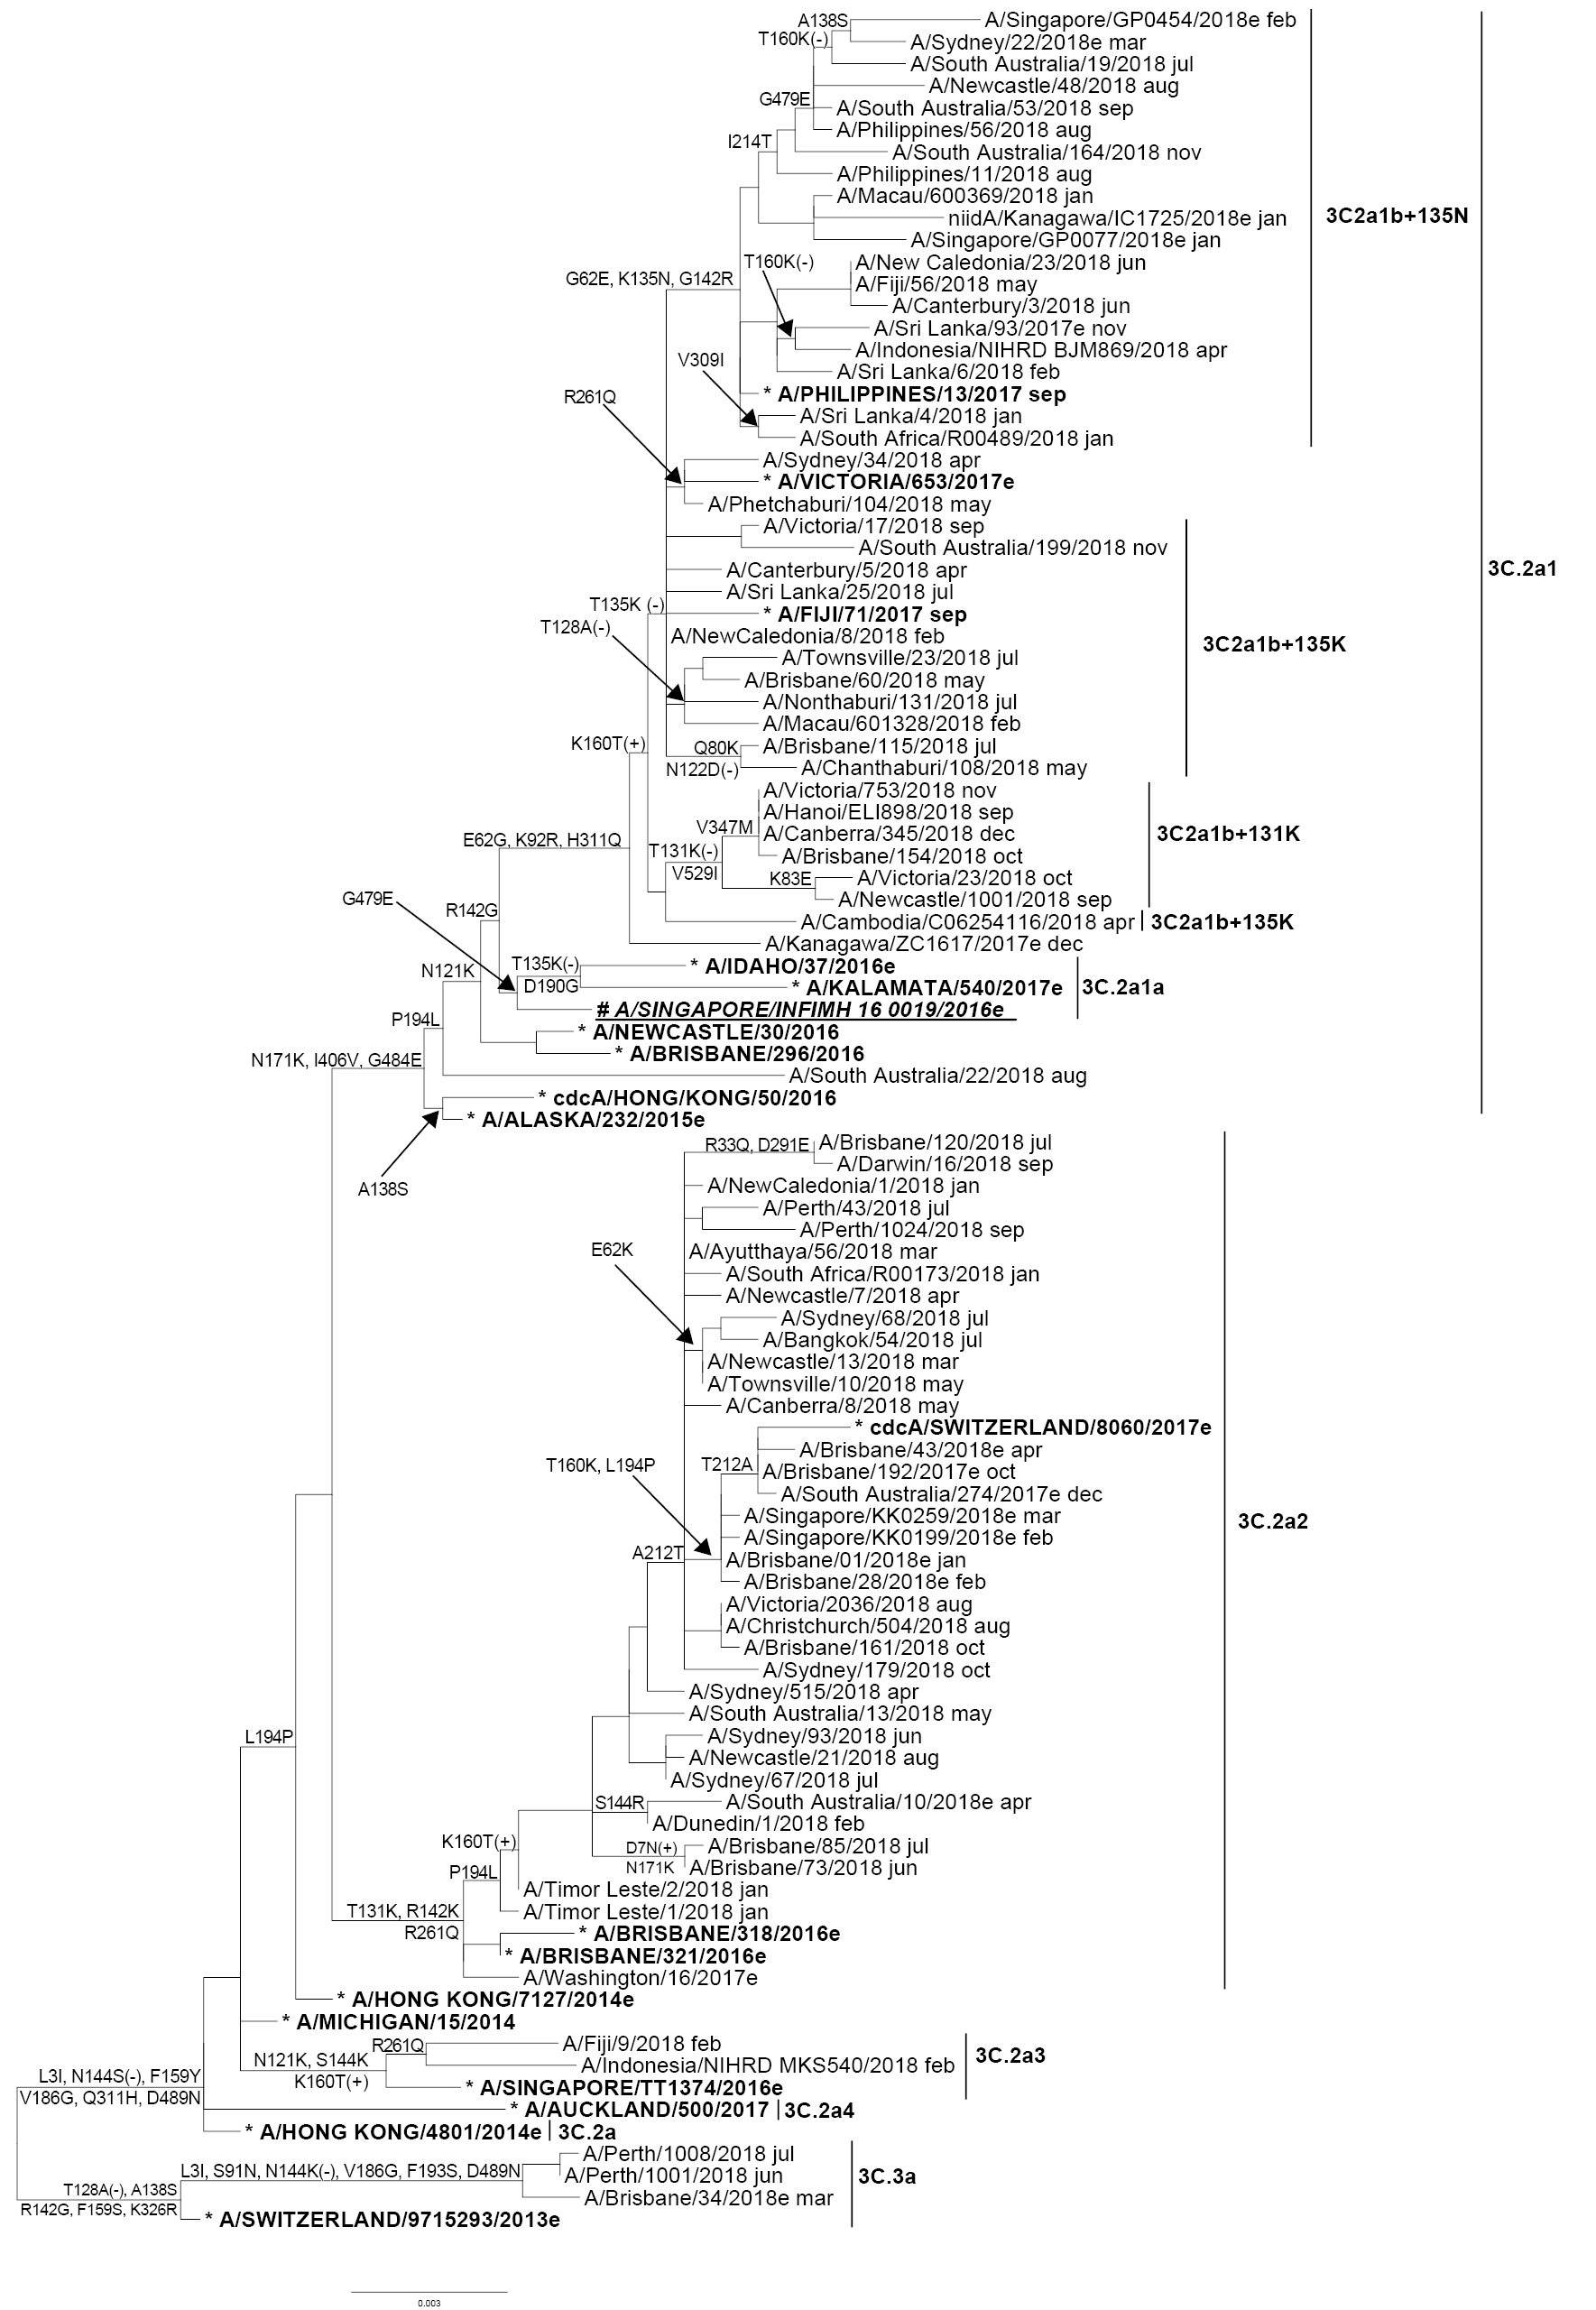

**Legend:**

***# 2018 SOUTHERN HEMISPHERE VACCINE STRAIN***

* REFERENCE VIRUS

e: egg isolate

Scale bar represents 0.3% nucleotide sequence difference between viruses

Amino acid changes relative to the outgroup sequence (A/SWITZERLAND/9715293/2013e) are shown

(+/-) indicates gain/loss of a potential glycosylation site

| Braces indicate clades

In total, 48 viruses were inoculated into eggs, of which 28 (58%) grew successfully. These consisted of 27 viruses from clade 3C.2a, which included 21 from subclade 3C.2a2 and six from 3C.2a1. Additionally, one virus was isolated from subclade 3C.3a. A total of 54 viruses was inoculated into the qualified cell line MDCK 33016PF, of which 45 (83%) grew successfully. These consisted primarily of viruses from the 3C.2a clade, which included 20 from subclade 3C.2a1b, 21 from subclade 3C.2a2 and three from subclade 3C.2a3. One virus was isolated from subclade 3C.3a.

None of the 723 A(H3) viruses tested by NAI assay showed highly reduced inhibition by oseltamivir or zanamivir.

## Influenza B

Amongst influenza B viruses received at the Centre during 2018, B/Yamagata lineage viruses were predominant over B/Victoria lineage viruses (Figure 2). A total of 573 influenza B viruses were characterised by HI assay. Almost all B/Yamagata lineage viruses were antigenically similar to the B/Phuket/3073/2013-like vaccine virus, while 86% of B/Victoria lineage viruses were antigenically similar to the B/Brisbane/60/2018 vaccine virus (Table 1).

Sequencing was performed on HA genes from 104 B viruses, with a similar number of B/Victoria and B/Yamagata viruses. Most of the viruses of B/Victoria lineage were genetically similar to the B/Brisbane/60/2008 reference virus (Figure 5).

Figure 5. Phylogenetic tree of haemagglutinin genes of B/Victoria viruses received by the Centre during 2018.

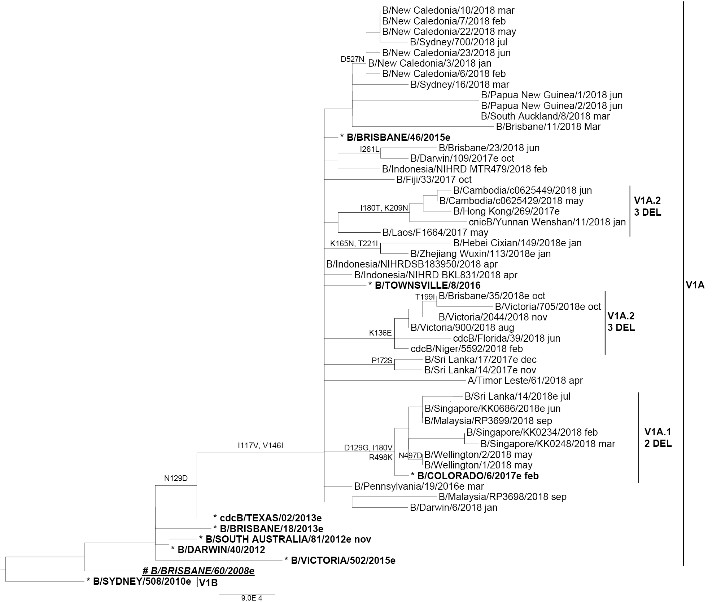

**Legend:**

***# 2018 SOUTHERN HEMISPHERE QUADRIVALENT VACCINE STRAIN***

* REFERENCE VIRUS

e: egg isolate

Scale bar represents 0.09% nucleotide sequence difference between viruses

Amino acid changes relative to the outgroup sequence (B/SYDNEY/508/2010e) are shown

2 DEL and 3 DEL indicate subclades containing 2- or 3- amino acid deletions at the positions 162-163 or 162-164 respectively

| Braces indicate clades

However, B/Victoria viruses bearing a two or three amino acid (double or triple) deletion in the HA protein at positions 162–163 or 162–164 respectively have been increasing in frequency in many countries.20 Of the 59 B/Victoria viruses received at the Centre during 2018 that were sequenced, we found 14 viruses bearing the double HA deletion and four viruses bearing the triple HA deletion. All B/Yamagata lineage viruses belonged to Clade 3, which is the same genetic clade as the 2018 vaccine virus B/Phuket/3073/2013 (Figure 6).

Figure 6. Phylogenetic tree of haemagglutinin genes of B/Yamagata viruses received by the Centre during 2018.

(+/-) indicates gain/loss of a potential glycosylation site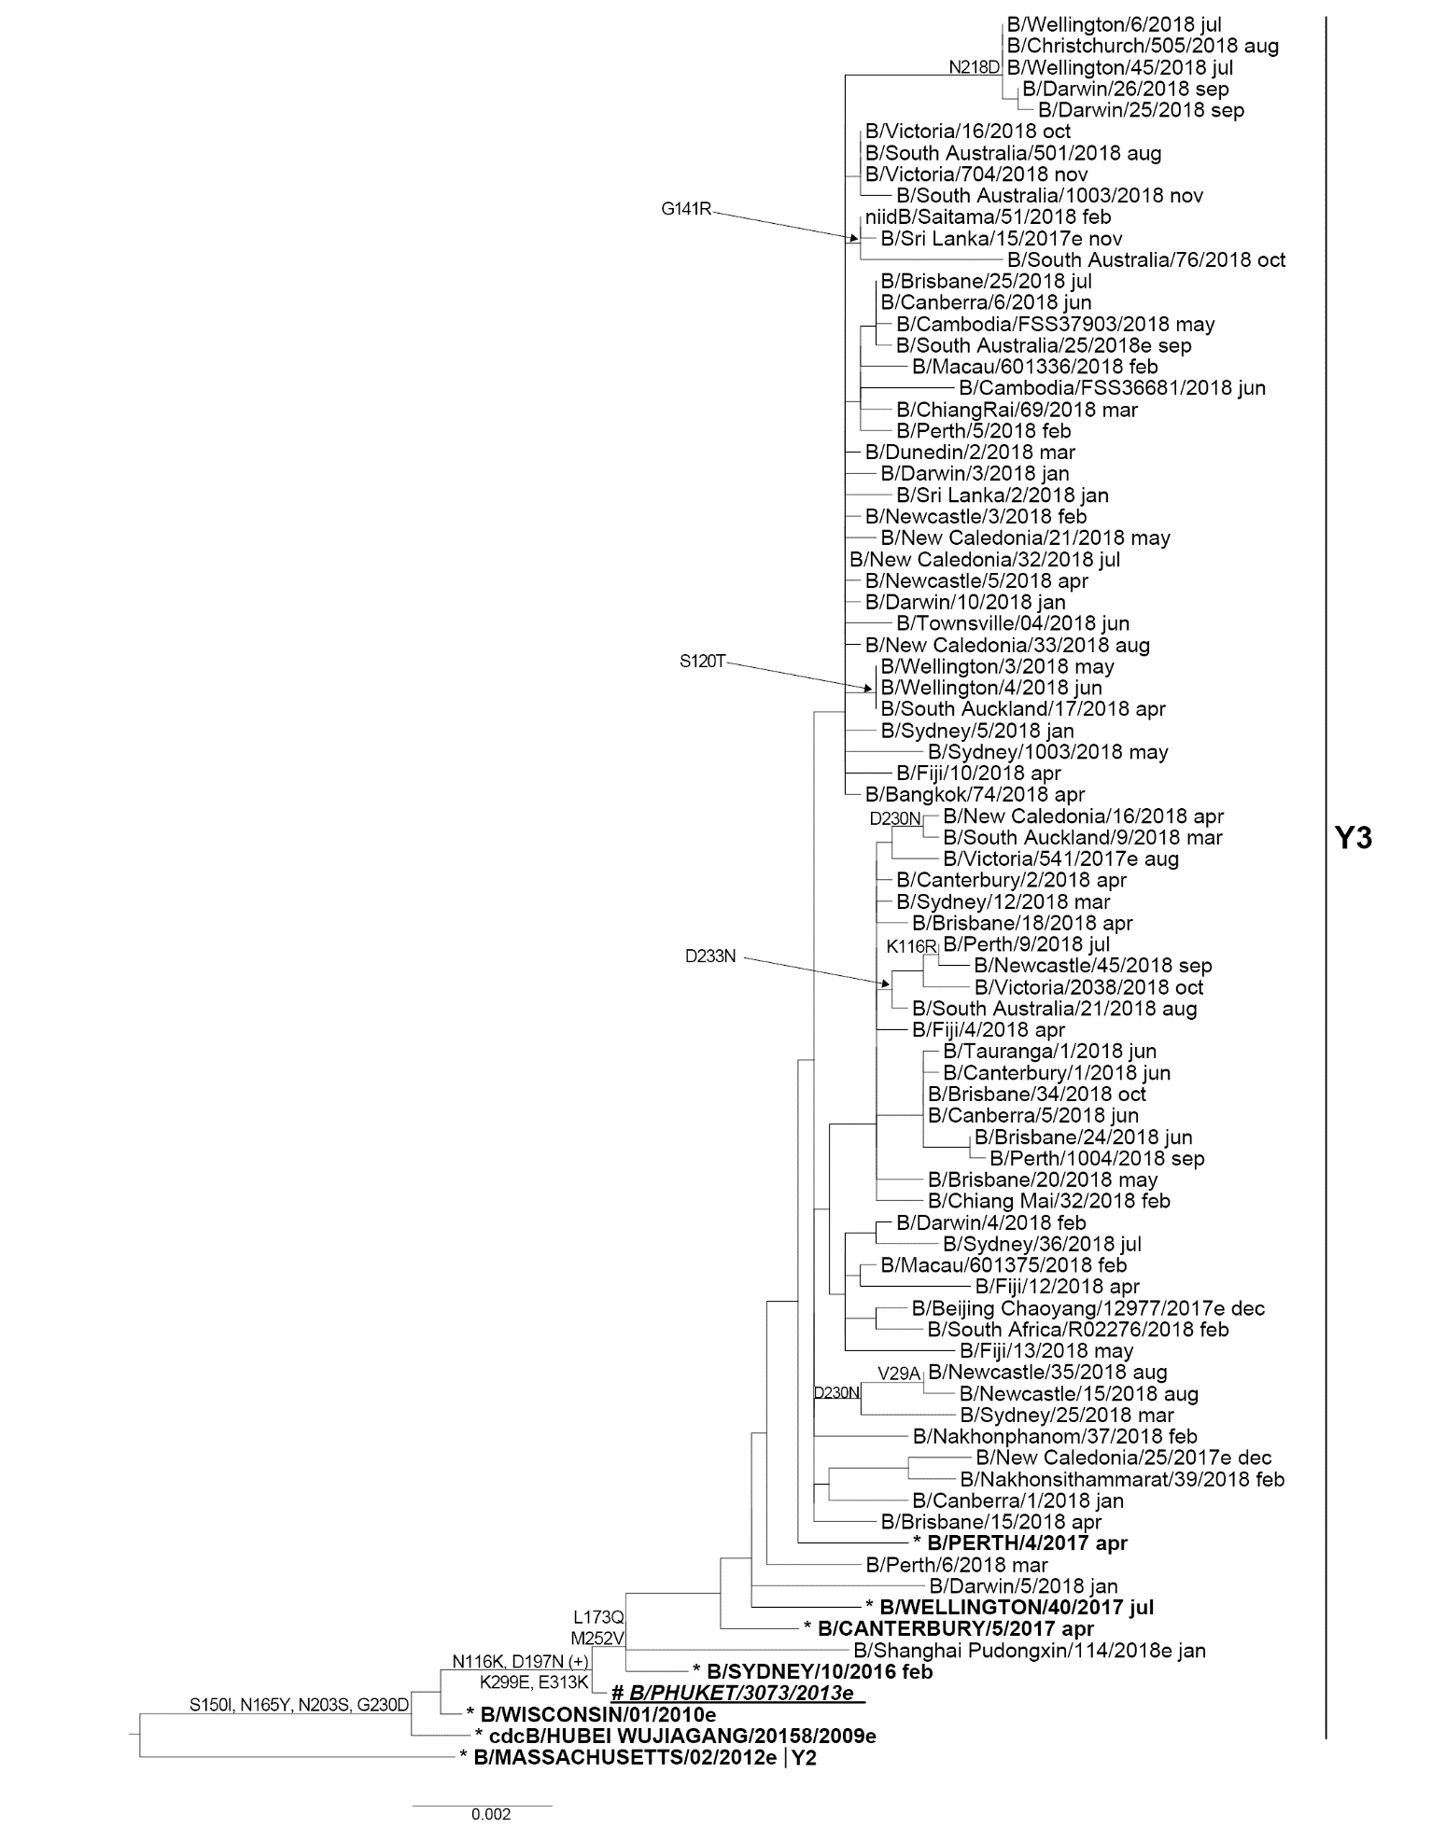

**Legend:**

***# 2018 SOUTHERN HEMISPHERE VACCINE STRAIN***

* REFERENCE VIRUS

e: egg isolate

Scale bar represents 0.2% nucleotide sequence difference

between viruses

Amino acid changes relative to the outgroup sequence (B/

MASSACHUSETTS/02/2012e) are shown

(+/-) indicates gain/loss of a potential glycosylation site

| Braces indicate clades

Egg isolation was attempted for ten B/Victoria and seven B/Yamagata viruses, resulting in the successful isolation of eight (80%) B/Victoria viruses and four (57%) B/Yamagata viruses. At least one representative from the major clades of both B lineages was amongst the successful egg isolates. No influenza B viruses were inoculated into the qualified cell line MDCK 33016PF in 2018.

Of 458 B/Yamagata viruses tested, none displayed highly reduced inhibition by oseltamivir or zanamivir. However, one of the 141 B/Victoria viruses tested showed highly reduced inhibition by both oseltamivir and zanamivir. This virus, which was from Malaysia, contained a G140R substitution in its NA gene, which has been shown to reduce susceptibility to neuraminidase inhibitor drugs.21

# Discussion

In 2018 the majority of samples received at the Centre were from Australia (59%), which was similar to previous years.16–19 During 2018, the Centre received the smallest annual number of samples since 2007. This correlated with the reduced number of notifications of laboratory-confirmed influenza during the 2018 Australian influenza season (48,000 cases), which was less than half of the five-year average.22 The geographical spread of influenza around the country in 2018 was relatively even, with all states except Western Australia experiencing lower levels of activity than in the 2017 season.23 The contrast between 2017 and 2018 seasons in Western Australia was less pronounced due to the lower influenza activity in 2017 compared to southern and eastern jurisdictions. As in previous years, the number of samples received at the Centre peaked in August.16–19 However, the pattern in the later part of 2018 deviated from previous years, with an increase in samples received in November and December 2018. This correlated with the increase in cases observed in the Northern Territory in late October which continued until the end of the year.23,24 Indeed, 43% of the Australian samples received at the Centre in November and December were from the Northern Territory. The activity was driven by A(H1)pdm09, which comprised 99% of Northern Territory samples received during this time. While A(H1)pdm09 viruses predominated across the country in 2018, no significant antigenic variation from the 2018 vaccine strain A/Michigan/45/2015 was observed by HI assay testing at the Centre. Influenza A(H3) and B viruses circulated at lower levels. This pattern of circulation was reflected in the relative proportions of samples received at the Centre during 2018.

During 2018, influenza notification rates in Australia were highest in children under 10 years of age;22 this correlated with observations during the 2018–2019 Canadian influenza season, in which A(H1)pdm09 viruses also predominated.25 This is postulated to be a result of lower population immunity levels to A(H1)pdm09 in children under 10 years of age as they had not yet been born during the 2009 pandemic. The majority of circulating A(H1)pdm09 viruses were antigenically and genetically similar to the cell-derived A/Michigan/45/2015reference strain used in the 2018 vaccine. Final vaccine effectiveness (VE) estimates for the 2018 season in Australia have not been published at the time of writing, but interim estimates suggest that vaccine protection in Australia for all age groups was the highest against A(H1)pdm09 viruses amongst both primary care; 78% (95% CI: 51, 92) and hospitalised patients; 83% (CI 95%: 58, 93).23,26

HI assays performed at the Centre showed that while the vast majority of A(H3) viruses tested were antigenically similar to the cell-grown reference strain A/Singapore/INFIMH-16-0019/2016, half of the viruses analysed were low reactors to egg-derived A/Singapore/INFIMH-16-0019/2016. Adaptive changes acquired by A(H3) candidate viruses in their HA gene during propagation in eggs may alter their antigenicity and consequently produce lower VE. While every effort is made to obtain A(H3) egg isolates which retain the antigenic characteristics of their cell-derived counterparts, the A(H3) component included in vaccines in recent years has been affected by such adaptations.27,28

In addition, there are ongoing difficulties in the antigenic characterisation of A(H3) viruses. Evolutionary changes in this subtype continue to pose challenges in detecting antigenic changes using the HI assay.5,29 A large number of A(H3) viruses isolated in MDCK-SIAT-1 cells cannot be assayed by HI in the presence of oseltamivir carboxylate. After taking into account viruses that had insufficient titre for antigenic analysis following cell culture, as well as viruses that had insufficient titres when tested by HI assay in the presence of oseltamivir carboxylate, overall only 70% of all A(H3) viruses received by the Centre during 2018 and isolated in cell culture were successfully analysed by the HI assay. The FRA allowed successful antigenic characterisation of a total of 305 A(H3) viruses, comprising viruses that were successfully analysed by HI assay and some that were not. Of the viruses analysed by FRA, 89% and 91% were antigenically similar to the cell- and egg-propagated reference strain (A/Singapore/INFIMH-16-0019/2016), respectively. At this time, however, the FRA remains time- and labour-intensive and complements rather than replaces the HI assay. Genetic analysis has therefore become an increasingly important tool for detecting both minor and major changes in circulating A(H3) viruses.

Genetic data from the Centre indicated that many circulating A(H3) viruses in 2018 belong to clade 3C.2a1, which also contains the 2018 vaccine strain, A/Singapore/INFIMH-16-0019/2016. A significant proportion of circulating viruses also fell into clade 3C.2a2, and the H3 component of the vaccine was changed to a 3C.2a2 virus (A/Switzerland/8060/2017) for the 2019 influenza season.30

Antigenic and genetic data generated at the Centre indicated that the majority of influenza B/Yamagata lineage viruses that circulated in 2018 were similar to the recommended vaccine strain, B/Phuket/3073/2013. However, in the case of circulating B/Victoria lineage viruses, the emergence of viruses containing a two- or three- amino deletion in the HA protein likely contributed to a greater proportion of low reactors against the vaccine strain B/Brisbane/06/2008 in 2018 compared to 2017 when these viruses did not circulate widely. While the Centre received only one virus containing the double deletion in 2017, almost half of the B/Victoria viruses received in 2018 that were sequenced had either the double or triple deletion. The increased circulation of the double deletion viruses in many countries led to the change of the B/Victoria vaccine component to B/Colorado/06/2017 (a HA double-deletion virus), which reacts well with ferret antisera raised to two-amino-acid HA deletion B/Victoria viruses, although B/Victoria viruses with no deletion or a three-amino-acid deletion were less well inhibited by these antisera.30 While the WHO recommended the 2019 Southern Hemisphere trivalent vaccine contain a B/Victoria-lineage strain, the Australian Influenza Vaccine Committee instead chose to include a B/Yamagata-lineage strain because the B/Yamagata lineage viruses had predominated extensively over B/Victoria lineage viruses in Australia in 2017 and 2018, and were predicted to do so again in 2019.

With the continual change and evolution in influenza viruses and the absence of an effective universal vaccine, there remains a need for ongoing influenza surveillance and considered decision-making around influenza vaccine updates. The work performed by the Centre in Melbourne is crucial to the efforts of the global surveillance community to ensure that viruses recommended for the influenza vaccine remain updated and as closely matched to the future circulating viruses as possible.

# Acknowledgements

The authors would like to thank all of the National Influenza Centres and other contributing laboratories who sent influenza-positive samples to the Centre during 2018. We thank Ms Leah Gillespie for technical advice and Prof Kanta Subbarao for her comments and input to this report. The FluLINE was developed by October Sessions and Uma Kamaraj from Duke-NUS Medical School, Singapore. The Melbourne WHO Collaborating Centre for Reference and Research on Influenza is supported by the Australian Government Department of Health.

# Author details

Ms Olivia H Price, Epidemiologist1

Mrs Natalie Spirason, Medical Scientist1

Mr Cleve Rynehart, Medical Scientist1

Mrs Sook Kwan Brown, Medical Scientist1

Mrs Angela Todd, Medical Scientist1

Ms Heidi Peck, Head – Serology1

Mrs Manisha Patel, Medical Scientist1

Mrs Sally Soppe, Medical Scientist1

Prof Ian G Barr, Deputy Director1

Dr Michelle K Chow, Communications Officer1

1. WHO Collaborating Centre for Reference and Research on Influenza

## Corresponding author

Prof Ian Barr

WHO Collaborating Centre for Reference and Research on Influenza

Peter Doherty Institute for Infection and Immunity

792 Elizabeth St Melbourne 3000

Email: ian.barr@influenzacentre.org

# References

1. Hay AJ, McCauley JW. The WHO global influenza surveillance and response system (GISRS)-A future perspective. Influenza Other Respir Viruses. 2018;12(5):551–7.
2. Monto AS. Reflections on the Global Influenza Surveillance and Response System (GISRS) at 65 years: an expanding framework for influenza detection, prevention and control. Influenza Other Respir Viruses. 2018;12(1):10–2.
3. Oh DY, Barr IG, Mosse JA, Laurie KL. MDCK-SIAT1 cells show improved isolation rates for recent human influenza viruses compared to conventional MDCK cells. J Clin Microbiol. 2008;46(7):2189–94.
4. Hobson D, Curry RL, Beare AS, Ward-Gardner A. The role of serum haemagglutination-inhibiting antibody in protection against challenge infection with influenza A2 and B viruses. J Hyg (Lond). 1972;70(4):767–77.
5. Lin YP, Gregory V, Collins P, Kloess J, Wharton S, Cattle N et al. Neuraminidase receptor binding variants of human influenza A(H3N2) viruses resulting from substitution of aspartic acid 151 in the catalytic site: a role in virus attachment? J Virol. 2010;84(13):6769–81.
6. Okuno Y, Tanaka K, Baba K, Maeda A, Kunita N, Ueda S. Rapid focus reduction neutralization test of influenza A and B viruses in microtiter system. J Clin Microbiol. 1990;28(6):1308–13.
7. Tilmanis D, van Baalen C, Oh DY, Rossignol JF, Hurt AC. The susceptibility of circulating human influenza viruses to tizoxanide, the active metabolite of nitazoxanide. Antiviral Res. 2017;147:142–8.
8. Zhou B, Deng YM, Barnes JR, Sessions OM, Chou TW, Wilson M et al. Multiplex reverse transcription-PCR for simultaneous surveillance of influenza A and B viruses. J Clin Microbiol. 2017;55(12):3492–501.
9. Hurt AC, Okomo-Adhiambo M, Gubareva LV. The fluorescence neuraminidase inhibition assay: a functional method for detection of influenza virus resistance to the neuraminidase inhibitors. Methods Mol Biol. 2012;865:115–25.
10. Hurt AC, Besselaar TG, Daniels RS, Ermetal B, Fry A, Gubareva L et al. Global update on the susceptibility of human influenza viruses to neuraminidase inhibitors, 2014–2015. Antiviral Res. 2016;132:178–85.
11. Deng YM, Caldwell N, Barr IG. Rapid detection and subtyping of human influenza A viruses and reassortants by pyrosequencing. PLoS One. 2011;6(8):e23400.
12. Gerdil C. The annual production cycle for influenza vaccine. Vaccine. 2003;21(16):1776–9.
13. Stöhr K, Bucher D, Colgate T, Wood J. Influenza virus surveillance, vaccine strain selection, and manufacture. Methods Mol Biol. 2012;865:147–62.
14. Weir JP, Gruber MF. An overview of the regulation of influenza vaccines in the United States. Influenza Other Respir Viruses. 2016;10(5):354–60.
15. WHO Global Influenza Surveillance Network. Manual for the laboratory diagnosis and virological surveillance of influenza. Geneva: World Health Organization; 2011.
16. Sullivan SG, Chow MK, Barr IG, Kelso A. Influenza viruses received and tested by the Melbourne WHO Collaborating Centre for Reference and Research on Influenza annual report, 2014. Commun Dis Intell Q Rep. 2015;39(4):E602–11.
17. Leung VK, Spirason N, Lau H, Buettner I, Leang SK, Chow MK. Influenza viruses received and tested by the Melbourne WHO Collaborating Centre for Reference and Research on Influenza annual report, 2015. Commun Dis Intell Q Rep. 2017;41(2):E150–60.
18. Roe M, Kaye M, Iannello P, Lau H, Buettner I, Tolosa MX et al. Report on influenza viruses received and tested by the Melbourne WHO Collaborating Centre for Reference and Research on Influenza in 2017. Commun Dis Intell (2018). 2019;43. https://doi.org/10.33321/cdi.2019.43.25.
19. Leung VK, Deng YM, Kaye M, Buettner I, Lau H, Leang SK et al. Annual report on influenza viruses received and tested by the Melbourne WHO Collaborating Centre for Reference and Research on Influenza in 2016. Commun Dis Intell (2018). 2019;43. https://doi.org/10.33321/cdi.2019.43.3.
20. World Health Organization. Recommended composition of influenza virus vaccines for use in the 2019 southern hemisphere influenza season. 27 September 2018. Available from: https://www.who.int/influenza/vaccines/virus/recommendations/201809_recommendation.pdf
21. Farrukee R, Leang SK, Butler J, Lee RT, Maurer-Stroh S, Tilmanis D et al. Influenza viruses with B/Yamagata- and B/Victoria-like neuraminidases are differentially affected by mutations that alter antiviral susceptibility. J Antimicrob Chemother. 2015;70(7):2004–12.
22. Australian Government Department of Health. National Notifiable Diseases Surveillance System. [Internet.] Canberra: Australian Government Department of Health; 2018. [Accessed 20 August 2018.] Available from: http://www9.health.gov.au/cda/source/cda-index.cfm
23. Australian Government Department of Health. Australian Influenza Surveillance Report – 2018 National Influenza Season Summary. [Internet.] Available from: https://www1.health.gov.au/internet/main/publishing.nsf/Content/ozflu-surveil-2018-final.htm
24. Barr IG, Deng YM, Grau ML, Han AX, Gilmour R, Irwin M et al. Intense interseasonal influenza outbreaks, Australia, 2018/19. Euro Surveill. 2019;24(33). https://doi.org/10.2807/1560-7917.ES.2019.24.33.1900421.
25. Skowronski DM, Leir S, De Serres G, Murti M, Dickinson JA, Winter AL et al. Children under 10 years of age were more affected by the 2018/19 influenza A(H1N1)pdm09 epidemic in Canada: possible cohort effect following the 2009 influenza pandemic. Euro Surveill. 2019;24(15). https://doi.org/10.2807/1560-7917.ES.2019.24.15.1900104.
26. Shakur S, Laurenson-Schafer H, Vette K, Hammond A, Besselaar T, Fitzner J et al. Review of the 2018 influenza season in the southern hemisphere. Wkly Epidemiol Rec. 2018;93(51/52):693–705.
27. Skowronski DM, Janjua NZ, De Serres G, Sabaiduc S, Eshaghi A, Dickinson JA et al. Low 2012–13 influenza vaccine effectiveness associated with mutation in the egg-adapted H3N2 vaccine strain not antigenic drift in circulating viruses. PLoS One. 2014;9(3):e92153.
28. Zost SJ, Parkhouse K, Gumina ME, Kim K, Diaz Perez S, Wilson PC et al. Contemporary H3N2 influenza viruses have a glycosylation site that alters binding of antibodies elicited by egg-adapted vaccine strains. Proc Natl Acad Sci U S A. 2017;114(47):12578–83.
29. Barr IG, Russell C, Besselaar TG, Cox NJ, Daniels RS, Donis R et al. WHO recommendations for the viruses used in the 2013-2014 Northern Hemisphere influenza vaccine: Epidemiology, antigenic and genetic characteristics of influenza A(H1N1)pdm09, A(H3N2) and B influenza viruses collected from October 2012 to January 2013. Vaccine. 2014;32(37):4713–25.
30. World Health Organization. Recommended composition of influenza virus vaccines for use in the 2019 southern hemisphere influenza season: September 2018. [Accessed 27 September 2018.] Available from: https://www.who.int/influenza/vaccines/virus/recommendations/201809_recommendation.pdf?ua=1

**Communicable Diseases Intelligence**

ISSN: 2209-6051 Online

**Communicable Diseases Intelligence (CDI) is a peer-reviewed scientific journal published by the Office of Health Protection, Department of Health. The journal aims to disseminate information on the epidemiology, surveillance, prevention and control of communicable diseases of relevance to Australia.**

**Editor:** Cindy Toms

**Deputy Editor:** Simon Petrie

**Design and Production:** Kasra Yousefi

**Editorial Advisory Board:** David Durrheim, Mark Ferson, John Kaldor, Martyn Kirk and Linda Selvey

**Website**: <http://www.health.gov.au/cdi>

**Contacts**Communicable Diseases Intelligence is produced by:   
Health Protection Policy Branch, Office of Health Protection, Australian Government Department of Health  
GPO Box 9848, (MDP 6) CANBERRA ACT 2601

**Email:** [cdi.editor@health.gov.au](mailto:cdi.editor@health.gov.au)

**Submit an Article**You are invited to submit your next communicable disease related article to the Communicable Diseases Intelligence (CDI) for consideration. More information regarding CDI can be found at: <http://health.gov.au/cdi>.

Further enquiries should be directed to: [cdi.editor@health.gov.au](mailto:cdi.editor@health.gov.au).

This journal is indexed by Index Medicus and Medline.

Creative Commons Licence - Attribution-NonCommercial-NoDerivatives CC BY-NC-ND

© 2019 Commonwealth of Australia as represented by the Department of Health

This publication is licensed under a Creative Commons Attribution-NonCommercial-NoDerivatives 4.0 International Licence from <https://creativecommons.org/licenses/by-nc-nd/4.0/legalcode> (Licence). You must read and understand the Licence before using any material from this publication.

**Restrictions**The Licence does not cover, and there is no permission given for, use of any of the following material found in this publication (if any):

* the Commonwealth Coat of Arms (by way of information, the terms under which the Coat of Arms may be used can be found at [www.itsanhonour.gov.au](http://www.itsanhonour.gov.au/));
* any logos (including the Department of Health’s logo) and trademarks;
* any photographs and images;
* any signatures; and
* any material belonging to third parties.

**Disclaimer**Opinions expressed in Communicable Diseases Intelligence are those of the authors and not necessarily those of the Australian Government Department of Health or the Communicable Diseases Network Australia. Data may be subject to revision.

**Enquiries**Enquiries regarding any other use of this publication should be addressed to the Communication Branch, Department of Health, GPO Box 9848, Canberra ACT 2601, or via e-mail to: [copyright@health.gov.au](mailto:copyright@health.gov.au)

**Communicable Diseases Network Australia**Communicable Diseases Intelligence contributes to the work of the Communicable Diseases Network Australia.  
<http://www.health.gov.au/cdna>

1. The CDC Influenza Virus Real-Time RT-PCR Influenza A/B Typing Panel (RUO) (Catalog No. FluRUO-01), FR-198, was obtained through the International Reagent Resource, Influenza Division, WHO Collaborating Center for Surveillance, Epidemiology and Control of Influenza, Centers for Disease Control and Prevention, Atlanta, GA, USA. https://www.internationalreagentresource.org/