Letter to the editor

Influenza vaccination uptake in our most vulnerable groups: how well are we protecting them in 2019?
Frank Beard, Alexandra Hendry, Kristine Macartney
Annual influenza vaccination is strongly recommended for children aged 6 months to < 5 years, adults aged ≥ 65 years, Indigenous people aged ≥ 6 months, and anyone aged ≥ 6 months with specified medical conditions.¹ We previously reported a fivefold increase in influenza vaccine uptake in children aged 6 months to < 5 years, from 5.0% in 2017 to 25.6% in 2018,² in the context of new state/territory-funded programs. We aimed to review whether uptake improved in 2019, and to report the first national influenza vaccine uptake estimates in older adults (≥ 65 years of age) from the ‘whole-of-life’ Australian Immunisation Register (AIR) established in late 2016. Previously published adult uptake data have been limited to sporadic surveys based on self-report.³
With Australian Government Health Department approval, we analysed de-identified AIR data as at 30 September 2019. Influenza vaccine uptake estimates were calculated weekly for 1 March to 31 August 2019, by age and Indigenous status (Figure 1).
Between March and August 2019, a total of 568,510 (39.7%) children aged 6 months to < 5 years had ≥ 1 dose of influenza vaccine recorded on the AIR, up from 25.6% in 2018.² Uptake varied by age subgroup, highest in the youngest (6 months to < 1 year; 56.7%) and lowest in the oldest (3 to < 5 years; 35.6%). Uptake was similar in Indigenous and non-Indigenous children (39.9% versus 39.7%).
Analysis of AIR adult vaccination data showed recorded influenza vaccine uptake was 58.0% for adults aged ≥ 65 years in 2019. As anticipated, this was lower than that reported in the most recent (2014) national survey (73%),³ and in test-negative controls from the Influenza Complications Alert Network (FluCAN) sentinel hospital-based surveillance program in 2018 (77%),⁴ but higher than initial years of the AIR where recorded uptake in this age group was 31.5% (2017) and 46.3% (2018),⁵ demonstrating improved completeness of reporting over time. However, true coverage is certainly higher, based on knowledge of vaccine doses distributed, emphasising the importance of continuing efforts to encourage reporting to the AIR.
In contrast, recorded uptake in Indigenous adults aged ≥ 65 years was 75.1%, very similar to the 74% reported in the most recent (2012/2013) National Aboriginal and Torres Strait Islander Health Survey.⁶ Recorded uptake in 2019 for Indigenous people in the 15 to < 50 and 50 to < 65 year age groups was lower (28.9% and 52.0%, respectively, data not shown), but also consistent with 2012/2013 survey findings.⁶
The different vaccination patterns observed are also noteworthy, commencing and peaking several weeks earlier in adults aged ≥ 65 years than in young children. This may be due to early rollout and prioritisation following the early onset of influenza activity in 2019. The steeper uptake from June to August in children aged 6 to < 12 months likely reflects children reaching 6 months of age throughout the season, and the routine scheduled visit for other vaccines at this milestone. These data can help inform program and immunisation provider service delivery.
In conclusion, uptake of influenza vaccine in young children continues to increase, driven by state/territory-funded universal influenza vaccination programs. Funding for this age group under the NIP, commencing 2020, should underpin further improvement. AIR data underestimate true adult influenza vaccine uptake, although data completeness has improved substantially. We advocate that:
- Clinicians and public health programs continue to enhance strategies to increase influenza vaccination for all at-risk individuals as recommended, and
- Immunisation providers, including those in primary care, vaccinating pharmacists and workplace and hospital-based providers, report all vaccinations, including influenza, to the AIR, so that individual and population-level data can inform both clinical management and public health policy and practice.

Author details
Dr Frank Beard, ^{1,2} Dr Alexandra Hendry,¹ Prof Kristine Macartney^{1,2}
- National Centre for Immunisation Research and Surveillance, Westmead, NSW, Australia
- The University of Sydney, NSW, Australia

Corresponding author
Dr Frank Beard
Associate Director, Coverage, Evaluation, Surveillance and Social Science National Centre for Immunisation Research and Surveillance Locked Bag 4001, Westmead NSW 2145
Phone (02) 9845 1406
Email: frank.beard@health.nsw.gov.au

References
- Australian Technical Advisory Group on Immunisation (ATAGI). Australian Immunisation Handbook. [Internet.] Canberra: Australian Government Department of Health; 2019. [Accessed 8 November 2019.] Available from: https://immunisationhandbook.health.gov.au.
- Beard FH, Hendry AJ, Macartney K. Early success with room for improvement: influenza vaccination of young Australian children. Med J Aust. 2019;210(11):484–6.
- Newspoll. Newspoll Omnibus Survey on adult flu vaccinations: summary report. 2014. [Accessed 8 April 2019.] Available from: https://beta.health.gov.au/resources/publications/newspoll-omnibus-survey-on-adult-flu-vaccinations-summary-report.
- Cheng AC, Holmes M, Dwyer DE, Senanayake S, Cooley L, Irving LB et al. Influenza epidemiology in patients admitted to sentinel Australian hospitals in 2018: the Influenza Complications Alert Network (FluCAN). Commun Dis Intell (2018). 2019;43. doi: https://doi.org/10.33321/cdi.2019.43.48.
- Hull B, Hendry A, Dey A, Macartney K, McIntyre P, Beard F. Exploratory analysis of the first 2 years of adult vaccination data recorded on AIR. Sydney: National Centre for Immunisation Research and Surveillance; 2019. [Accessed on 29 November 2019.] Available from: http://ncirs.org.au/sites/default/files/2019-11/Analysis%20of%20adult%20vaccination%20data%20on%20AIR_Nov%202019.pdf
- Webster F, Gidding H, Matthews V, Taylor R, Menzies R. What isn’t measured isn’t done – eight years with no progress in Aboriginal and Torres Strait Islander adult influenza and pneumococcal vaccination. Aust N Z J Public Health. 2019;43(6):558–62.

Figure 1. Cumulative influenza vaccine uptake (≥1 dose) by age group, all Australians (A) and Indigenous Australians (B), 1 March to 31 August 2019
A)
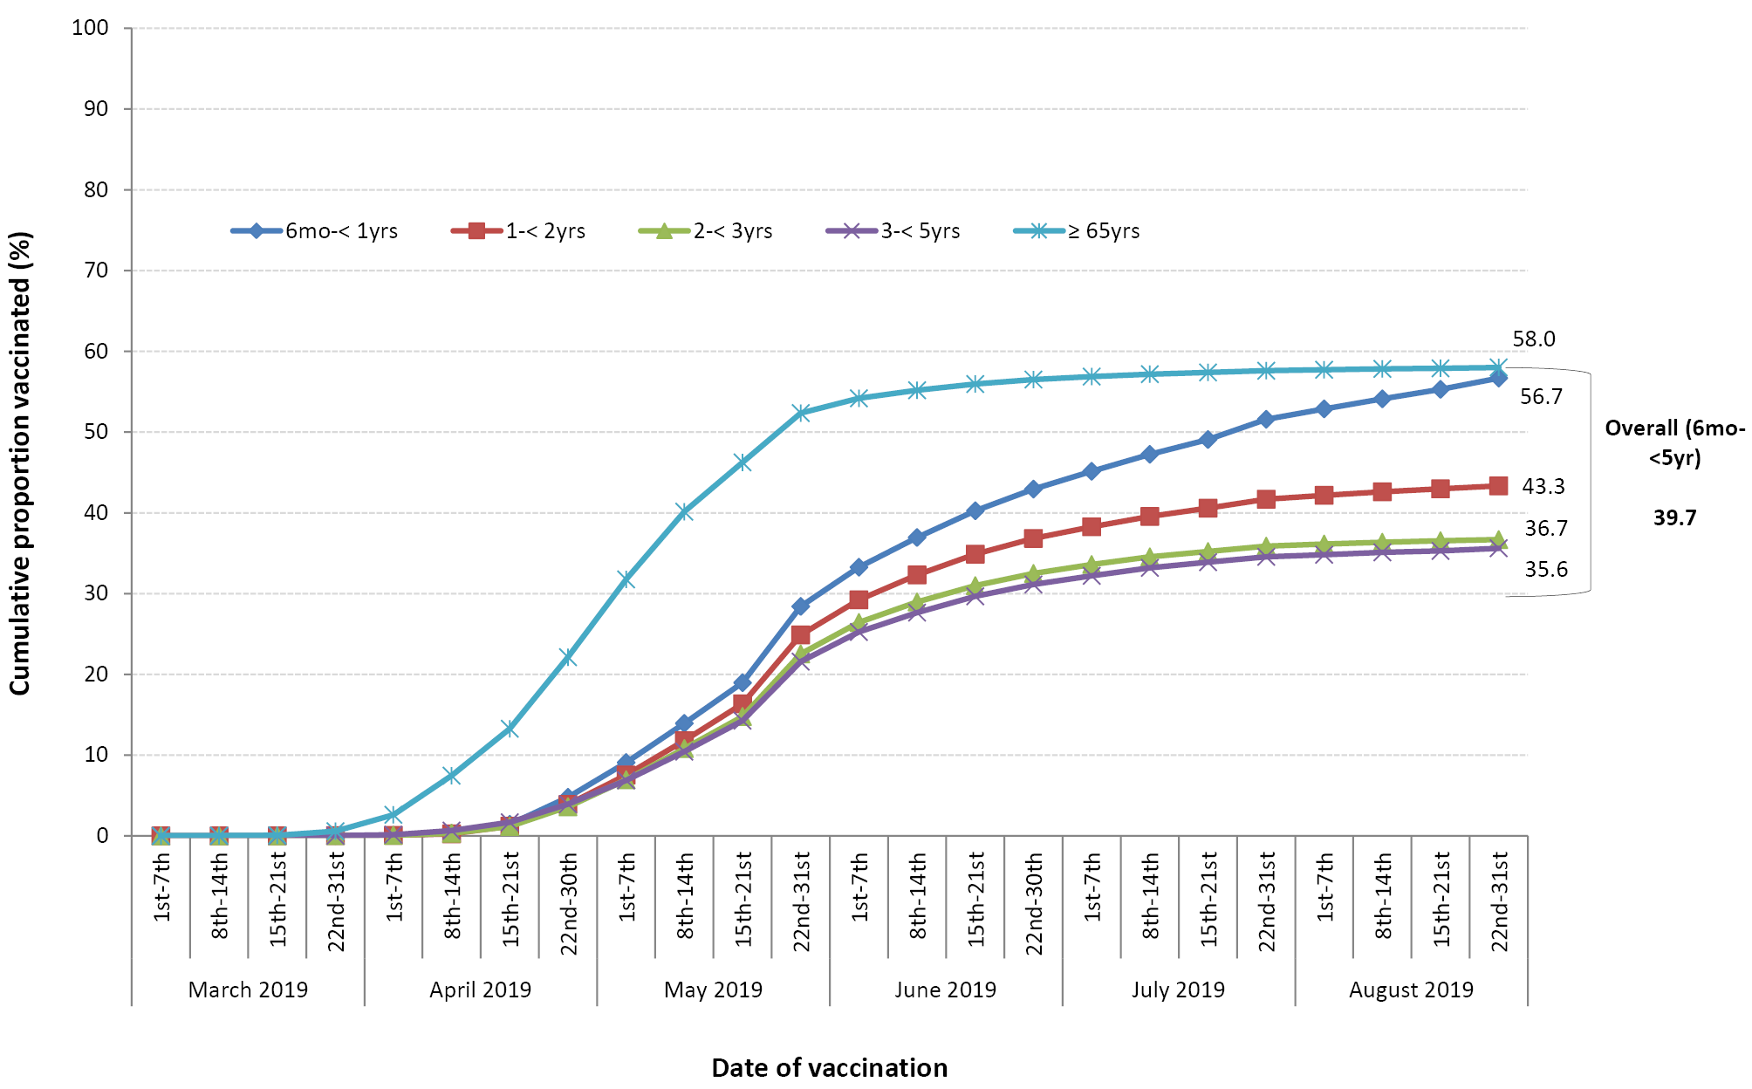
B)
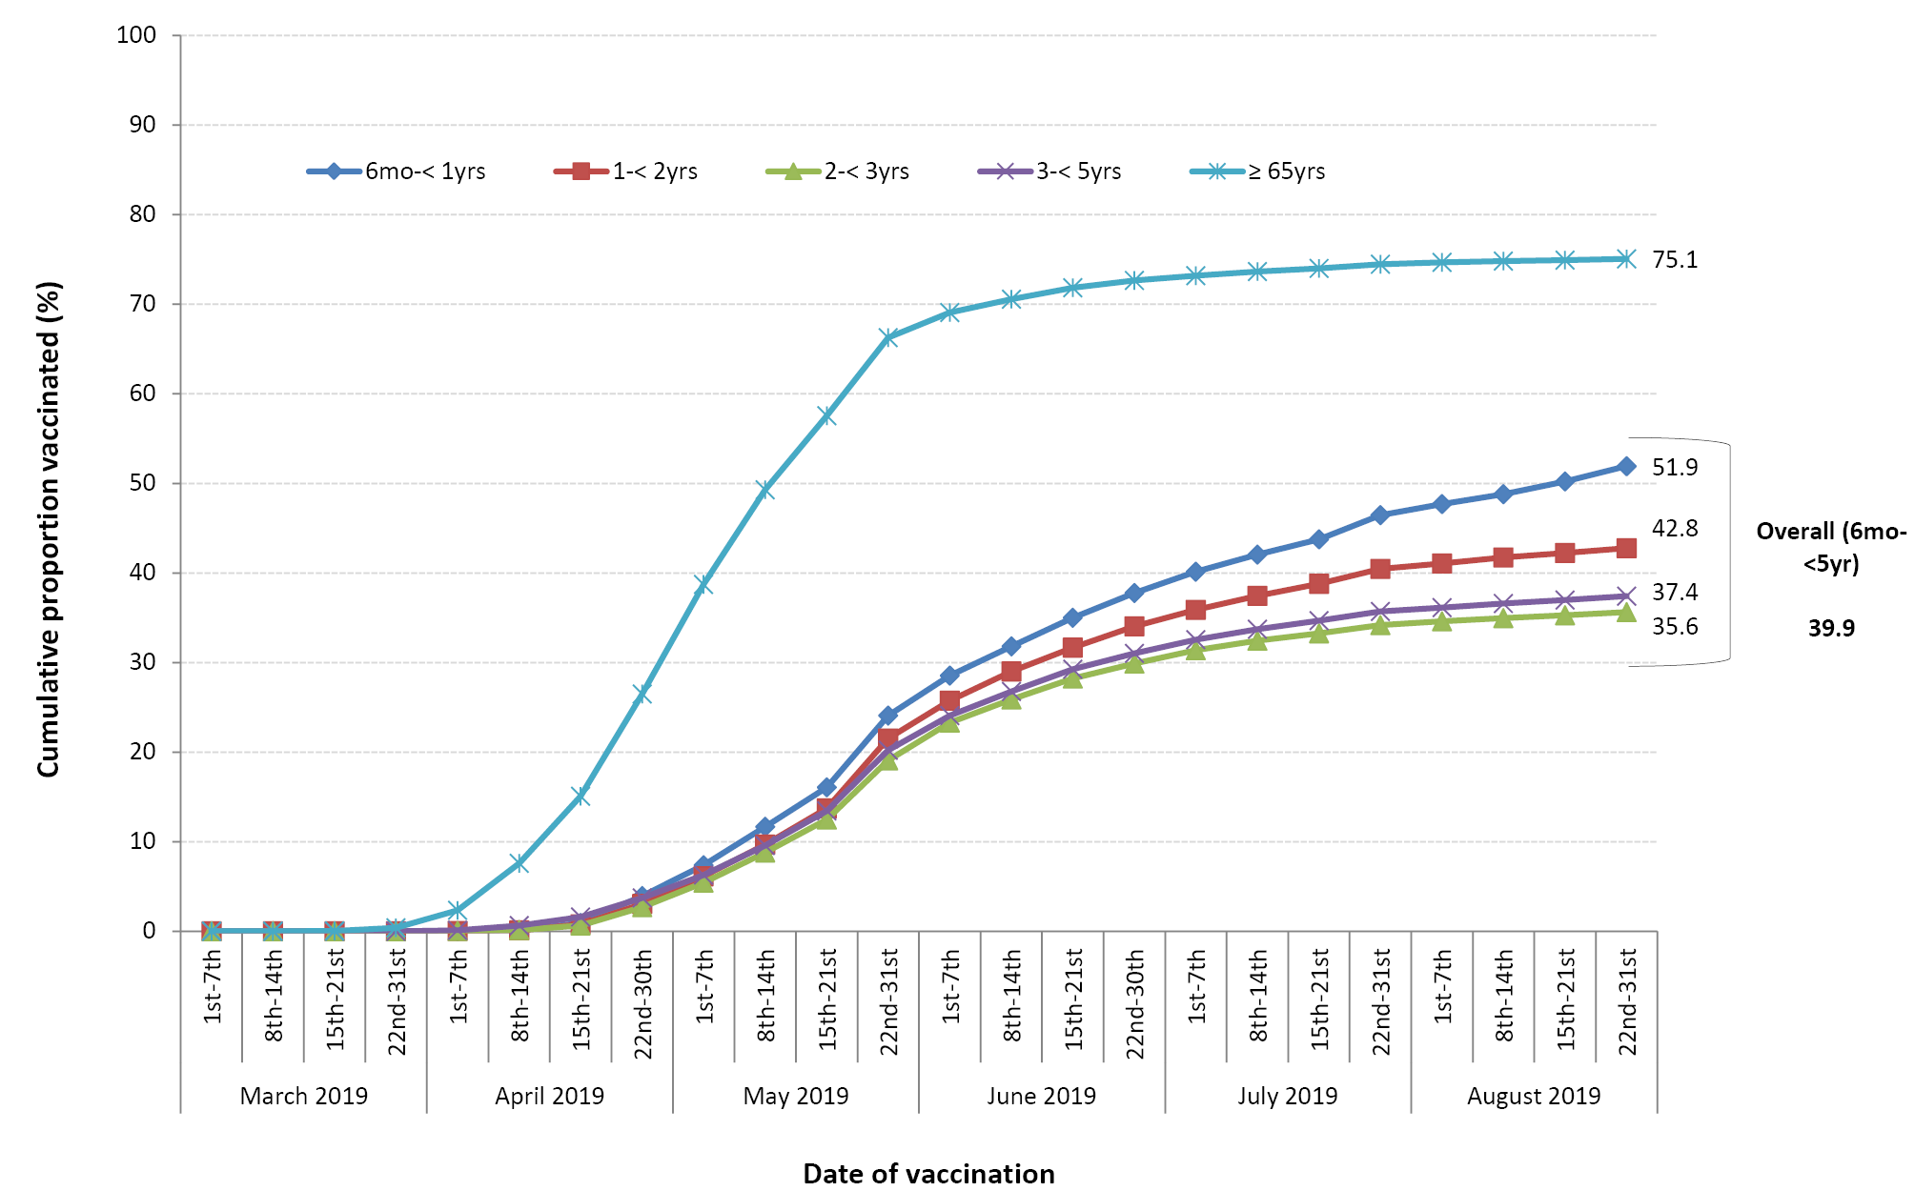

Communicable Diseases Intelligence
ISSN: 2209-6051 Online

Communicable Diseases Intelligence (CDI) is a peer-reviewed scientific journal published by the Office of Health Protection, Department of Health. The journal aims to disseminate information on the epidemiology, surveillance, prevention and control of communicable diseases of relevance to Australia.

Editor: Tanja Farmer
Deputy Editor: Simon Petrie
Design and Production: Kasra Yousefi
Editorial Advisory Board: David Durrheim, Mark Ferson, John Kaldor, Martyn Kirk and Linda Selvey

Website: http://www.health.gov.au/cdi

Contacts
Communicable Diseases Intelligence is produced by:
Health Protection Policy Branch, Office of Health Protection, Australian Government Department of Health
GPO Box 9848, (MDP 6) CANBERRA ACT 2601

Email: cdi.editor@health.gov.au

Submit an Article
You are invited to submit your next communicable disease related article to the Communicable Diseases Intelligence (CDI) for consideration. More information regarding CDI can be found at: http://health.gov.au/cdi.
Further enquiries should be directed to: cdi.editor@health.gov.au.

This journal is indexed by Index Medicus and Medline.

Creative Commons Licence - Attribution-NonCommercial-NoDerivatives CC BY-NC-ND
© 2020 Commonwealth of Australia as represented by the Department of Health
This publication is licensed under a Creative Commons Attribution-NonCommercial-NoDerivatives 4.0 International Licence from https://creativecommons.org/licenses/by-nc-nd/4.0/legalcode (Licence). You must read and understand the Licence before using any material from this publication.

Restrictions
The Licence does not cover, and there is no permission given for, use of any of the following material found in this publication (if any):
- the Commonwealth Coat of Arms (by way of information, the terms under which the Coat of Arms may be used can be found at www.itsanhonour.gov.au);
- any logos (including the Department of Health’s logo) and trademarks;
- any photographs and images;
- any signatures; and
- any material belonging to third parties.

Disclaimer
Opinions expressed in Communicable Diseases Intelligence are those of the authors and not necessarily those of the Australian Government Department of Health or the Communicable Diseases Network Australia. Data may be subject to revision.

Enquiries
Enquiries regarding any other use of this publication should be addressed to the Communication Branch, Department of Health, GPO Box 9848, Canberra ACT 2601, or via e-mail to: copyright@health.gov.au

Communicable Diseases Network Australia
Communicable Diseases Intelligence contributes to the work of the Communicable Diseases Network Australia.
http://www.health.gov.au/cdna

