Creutzfeldt-Jakob disease surveillance in Australia: update to 31 December 2019
Christiane Stehmann, Matteo Senesi, Shannon Sarros, Amelia McGlade, Marion Simpson, Genevieve Klug, Catriona McLean, Colin L Masters and Steven Collins

Abstract
Nationwide surveillance of Creutzfeldt-Jakob disease and other human prion diseases is performed by the Australian National Creutzfeldt-Jakob Disease Registry (ANCJDR). National surveillance encompasses the period since 1 January 1970, with prospective surveillance occurring from 1 October 1993. Over this prospective surveillance period, considerable developments have occurred in pre-mortem diagnostics; in the delineation of new disease subtypes; and in a heightened awareness of prion diseases in healthcare settings. Surveillance practices of the ANCJDR have evolved and adapted accordingly. This report summarises the activities of the ANCJDR during 2019.
Since the ANCJDR began offering diagnostic cerebrospinal fluid (CSF) 14-3-3 protein testing in Australia in September 1997, the annual number of referrals has steadily increased. In 2019, 513 domestic CSF specimens were referred for 14-3-3 protein testing and 85 persons with suspected human prion disease were formally added to the national register. As of 31 December 2019, just under half (42 cases) of the 85 suspect case notifications remain classified as ‘incomplete’; 16 cases were excluded through either detailed clinical follow-up (3 cases) or neuropathological examination (13 cases); 20 cases were classified as ‘definite’ and seven as ‘probable’ prion disease. For 2019, sixty-three percent of all suspected human prion disease related deaths in Australia underwent neuropathological examination. No cases of variant or iatrogenic CJD were identified. Two possibly causal novel prion protein gene (PRNP) sequence variations were identified.
Keywords: Creutzfeldt-Jakob disease, prion disease, transmissible spongiform encephalopathy, disease surveillance

Introduction
Of human prion diseases (also known as transmissible spongiform encephalopathies), the most common is Creutzfeldt-Jakob disease (CJD). The Australian National Creutzfeldt-Jakob Disease Registry (ANCJDR) was established in 1993 as part of the response to four people dying from CJD related to fertility treatment utilising cadaveric pituitary hormones. As described previously,¹ human prion disease mostly arises sporadically but can occur through person-to-person transmission or from a genetic aetiology. In 1993, the Allars inquiry² released its findings into the use of cadaver-derived pituitary hormones under the Australian Human Pituitary Hormone Program and the association with four medically-acquired (iatrogenic) CJD (iCJD) deaths, recommending a broadening of the responsibilities of the nascent ANCJDR. In addition to monitoring for further cases of iCJD in Australia, related to cadaveric pituitary hormone treatment for infertility or short stature and contaminated dura mater grafts, the ANCJDR’s activities have evolved to encompass the surveillance of all types of CJD, including sporadic, genetic and variant CJD (vCJD, the zoonosis related to bovine spongiform encephalopathy: BSE), as well as other prion diseases such as Gerstmann-Sträussler-Scheinker syndrome and fatal sporadic or familial insomnia.
Human prion disease became a notifiable disease in all states and territories of Australia in June 2006. Most initial case awareness at the ANCJDR arises through diagnostic testing requests made to the ANCJDR; this occurs prior to Health Department notification. After a preliminary review of referred cases, those deemed to be genuine suspected human prion disease undergo further detailed evaluation and addition to the national surveillance register, to determine whether a case can be excluded from suspicion or can be classified as a ‘definite’, ‘probable’ or ‘possible’ prion disease case according to diagnostic criteria endorsed by the Creutzfeld-Jakob Disease International Surveillance Network (colloquially EUROCJD) and to determine the aetiology of the illness.³
The incidence of sporadic CJD (sCJD) is commonly reported to be approximately one case per million per year; however, in most countries with longstanding surveillance systems in place, annual incidence rates have been consistently reported above this quoted figure.^{4,5} Multi-national collaborative studies show that intensity of surveillance correlates with reported incidence rates.⁶ Temporally, human prion disease incidence rates have increased in most countries, including Australia, as surveillance mechanisms have been optimised and diagnostic testing capabilities improved, in parallel with a generally greater awareness of this rare disease in the healthcare setting.
In this report, updated national surveillance figures to 31 December 2019 are provided for all retrospective (to 1970) and prospective (from 1993) cases ascertained, including a discussion on case notifications, classifications and overall incidence, as well as a brief overview of CJD occurrence in Indigenous Australians. In 2019, the annual mortality rate of prion disease in Australia was essentially stable; 85 persons with suspected human prion disease were added to the national register (an additional nine cases were known in 2018 and therefore contribute to the 2018 notification numbers), with 63% of all suspected prion disease case deaths undergoing neuropathological examination.
Since the ANCJDR began offering cerebrospinal fluid (CSF) 14-3-3 protein testing in Australia in September 1997, the annual number of referrals has steadily increased. In 2019, the ANCJDR received 513 domestic specimens for 14-3-3 protein diagnostic testing; a significant increase in CSF diagnostic referrals has been experienced since 2017, coinciding with the introduction of additional CSF biomarker (total-tau protein) testing.

Surveillance Methods
Patients with suspected human prion disease have been prospectively notified to the ANCJDR since October 1993. From 1997 onwards, suspected cases have been increasingly notified through referral for CSF 14-3-3 protein western blot testing, which has over time become the predominant source of initial awareness of suspected CJD cases. Other ascertainment mechanisms include, or have included, personal communications from clinicians, families, hospitals and CJD-related groups, as well as health record searches through hospitals and health departments.
Once referred to the ANCJDR, referrals undergo a prima facie assessment and, if the suspicion of prion disease is supported, the case is notified to the appropriate health department and added to the ANCJDR register as a formal ‘suspected case’ for continued surveillance and evaluation with the aim of exclusion or classification according to EUROCJD-endorsed diagnostic criteria. Investigation of registered cases can be prolonged, as the ANCJDR requires next-of-kin consent to access and compile the appropriate clinical information from various health information sources to facilitate a comprehensive review. Response times can vary, as the information can be extensive or sources numerous. Medico-demographic questionnaires are offered and forwarded to families if they are willing to contribute, providing valuable information for analysis and evaluation.
Classification of registered cases remains as ‘incomplete’ until all known available information is gathered and reviewed, or until a definitive result from neuropathological assessment is obtained. Cases may be excluded from the register based on neuropathological examination or after thorough clinical evaluation. A ‘definite’ classification requires brain neuropathological examination, including immunochemical analysis; ‘probable’ and ‘possible’ cases are reliant on a specific clinical profile and diagnostic test outcomes being met as previously described.³ As of 1 January 2017, the diagnostic criteria were amended to include a positive result in the real-time quaking-induced conversion (RT-QuIC) assay using CSF or other tissues in a person with a progressive neurological syndrome. The updated EUROCJD diagnostic criteria for surveillance of sporadic CJD are listed in Appendix 1. In keeping with previous reports, the total number of confirmed prion disease cases for 2019, including for statistical analyses, are those that have been classified as ‘definite’ or ‘probable’ cases during 2019.
In support of its surveillance responsibilities, the ANCJDR provides diagnostic platforms for ante- and post-mortem testing for human prion diseases. The testing of CSF for the presence of a family of low molecular weight proteins (14-3-3) has been performed weekly by the ANCJDR since 1997. This test has been readily utilised by clinicians. As described previously, the CSF 14-3-3 protein test provides an increasing proportion of initial awareness of cases of suspected human prion disease to the ANCJDR each year. In 2017, the ANCJDR formally added detection of CSF total-tau protein concentrations, which is also National Association of Testing Authorities/International Laboratory Accreditation Cooperation (NATA/ILAC) accredited, for the diagnosis of human prion disease, while continuing to develop and transition to the powerful real time quaking-induced conversion (RT-QuIC) assay to detect the presence of misfolded prion protein in CSF. The total-tau enzyme-linked immunosorbent assay (ELISA) test is performed at the National Dementia Diagnostic Laboratory on a fortnightly basis. The RT-QuIC assay is currently performed at the ANCJDR for research purposes only in consultation with managing clinicians. The ANCJDR also undertakes western blot analysis for misfolded, protease-resistant prion protein in brain and tonsil tissue from biopsies or autopsies to supplement immunohistochemical assessment, as required. Prion protein gene (PRNP) testing for sequence variations in the open reading frame, particularly for proven disease-causing mutations, is performed by an external, independent provider as appropriate. The ANCJDR actively promotes all diagnostic tests to clinicians and families to achieve the most accurate diagnosis and classification of persons suspected to suffer from prion disease.
Annual human prion disease incidence rates are calculated using direct age-standardisation, based on the 1970–2019 Australian Bureau of Statistics estimated resident population data for Australia and for each state and territory.⁷ Health information is collected through a combination of public health and surveillance responsibilities, based on the national notification of communicable diseases in observance of the National Health Security Act 2007 and Privacy Act 1988 (Cth) 16B. ANCJDR surveillance activities for 2019 were approved by The University of Melbourne Human Research Ethics Committee.

Results
In 2019, the ANCJDR received 513 domestic CSF specimens for 14-3-3 protein testing. This number reflects a continuing positive trend in annual CSF referral numbers and represents an increased awareness and perceived utility of 14-3-3 protein diagnostic testing by clinicians (Figure 1). In 2019, non-domestic CSF referrals made up 7% of the total CSF specimens received by the ANCJDR; the total number of non-domestic CSF test referrals has also steadily increased over time.

Figure 1: Annual number of CSF specimens referred to the ANCJDR for 14-3-3 protein diagnostic testing, from 1997 to 2019
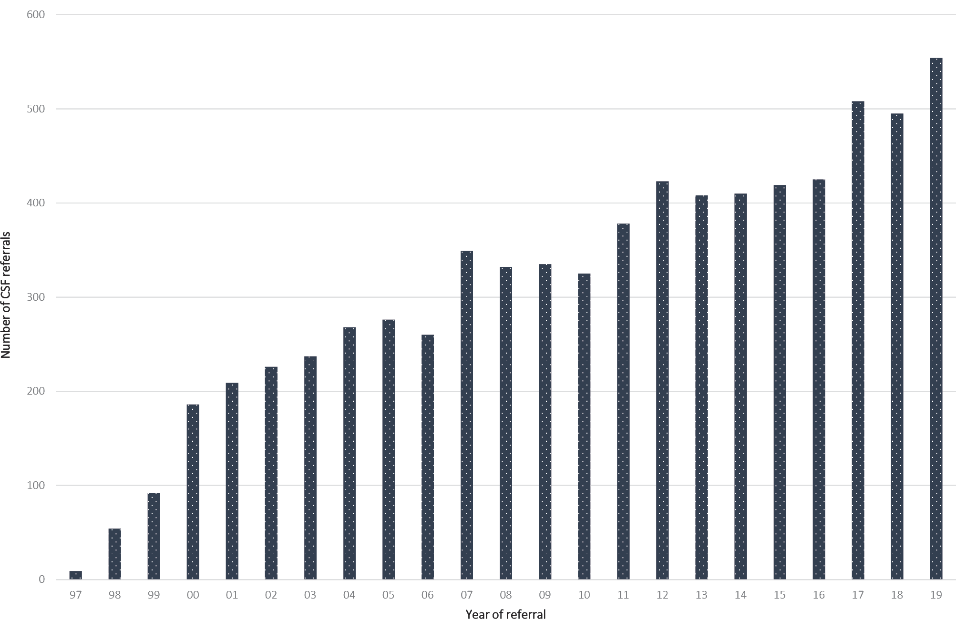
The majority of domestic CSF referrals come from the most populous states, in which there has been a noticeable steady increase in test referrals, while CSF referrals from the ACT, NT and Tasmania have remained relatively unchanged.
As summarised in Table 1, of the 513 domestic CSF specimens referred to the ANCJDR for testing, 90 specimens tested ‘positive’ and 19 tested ‘atypical positive’ (with the presence of additional non-specific protein bands) in the 14-3-3 protein western blot assay. Of the 444 specimens tested for total-tau protein, 56 specimens returned sufficiently elevated concentrations of total-tau protein (> 1072 pg/ml) to support the likelihood of human prion disease. Of the 33 CSF specimens tested using the RT-QuIC assay, 20 returned positive test results. As reported by other national CJD surveillance registries, CSF biomarker results support the complementary utility of the total-tau ELISA and RT-QuIC technologies to the 14-3-3 protein western blot assay to aid in the pre-mortem diagnosis of CJD or other human prion diseases. CSF diagnostic testing resulted in 67 formal suspect case notifications.

Table 1: Summary of diagnostic test results of CSF specimens tested, 1 January to 31 December 2019
14-3-3 results | Subtotal | Total-tau ELISA results  (positive/tested) | RT-QuIC  Results  (positive/tested) | Suspect case notifications
14-3-3  Positive | 90 | 46/85 | 16/23 | 52
14-3-3  atypical positive | 19 | 2/18 | 0/3 | 3
14-3-3  Equivocal | 3 | 0/2 | 0 | 0
14-3-3  Negative | 352 | 4/322 | 2/5 | 12
Unsuitable specimen  Not tested  Outstanding results | 49 | 4/17 | 2/2 | 8
Overseas referrals | 41 | - | - | -
Total | 554 | 56/444 | 20/33 | 75 (67)ª
a 8 duplicate CSF specimens submitted for diagnostic testing; CSF testing resulted in a total of 67 formal suspect case notifications; 18 formal suspect case referrals did not have a CSF referred for diagnostic testing.
During 2019, 94 persons with suspected human prion disease were added to the national CJD surveillance register following prima facie review. Of these, nine cases were known to the ANCJDR prior to 2019 through CSF referrals. At the time of their initial notification in 2018, these cases were not added to the register due to a low level of suspicion for prion disease after initial case review. Further information ascertained in 2019 increased the likelihood of prion disease resulting in formal notification and addition of the cases to the register. These nine cases therefore contribute to the total number of suspect case notifications arising in 2018.
The 85 suspected cases for 2019 were initially notified via: request for CSF 14-3-3 protein testing (48 cases) and personal communications from neuropathology services (12 cases), clinicians or hospitals (16 cases), families and the CJD Support Group Network (9 cases). In 18 suspected cases, no CSF specimen was received by the ANCJDR for diagnostic testing; these cases were notified by neuropathologists (11 cases), the treating doctor or hospital (2 cases) or the patient’s family via the CJD Support Group Network (5 cases). While there is still a predominance of initial case awareness through referrals for CSF diagnostic testing, there has been a noticeable increase, in recent years, in case notifications through treating clinicians, neuropathologists, health departments and families seeking expert advice and guidance from the ANCJDR. Some previous pro-active ANCJDR surveillance mechanisms (e.g. mortality database searches and reply-paid mailouts to clinicians) have been discontinued over time due to human resource constraints.
The number of suspected cases added to the ANCJDR register in 2019 follows the trend of increasing rates. The average annual number of suspected prion disease cases notified to the ANCJDR for the period 1997–2019 (i.e., since the introduction of diagnostic testing of CSF) is 72.
States and territories exhibited modest fluctuations in the annual number of suspect case notifications for 2019 compared to both the previous year and the longer-term average.
Of the 85 formal suspect case notifications received in 2019, 20 cases were confirmed as ‘definite’ by neuropathological examination and seven cases were classified as ‘probable’ following detailed review of clinical information. Thirteen cases were confirmed as non-prion disease following neuropathological assessment and three following detailed clinical case review, while 18 cases were still alive and considered ‘incomplete’ at the end of the 2019; neuropathology reports were pending for 14 deceased suspected cases. It is routine for several months to elapse between performance of a post-mortem and completion of the neuropathology report. Another ten cases have died without autopsy and remain ‘incomplete’ pending detailed case investigation.
Since 1993, there has been a positive trend in the annual number of suspected cases of human prion disease undergoing post-mortem brain examination, or less commonly brain biopsies, albeit with relative plateauing over the last 15 years, beginning with twelve such cases in 1993 to around 30–40 per year for the period from 2005 to 2019 (Figure 2). In 2019, of the 71 suspected CJD case deaths, 45 were referred for a brain post-mortem examination with four additional patients undergoing pre-mortem brain biopsy.

Figure 2: Number of brain-only post-mortem (PM) examinations and brain biopsies (BBx) completed relative to suspect case deaths from 1993 to 2019, by year
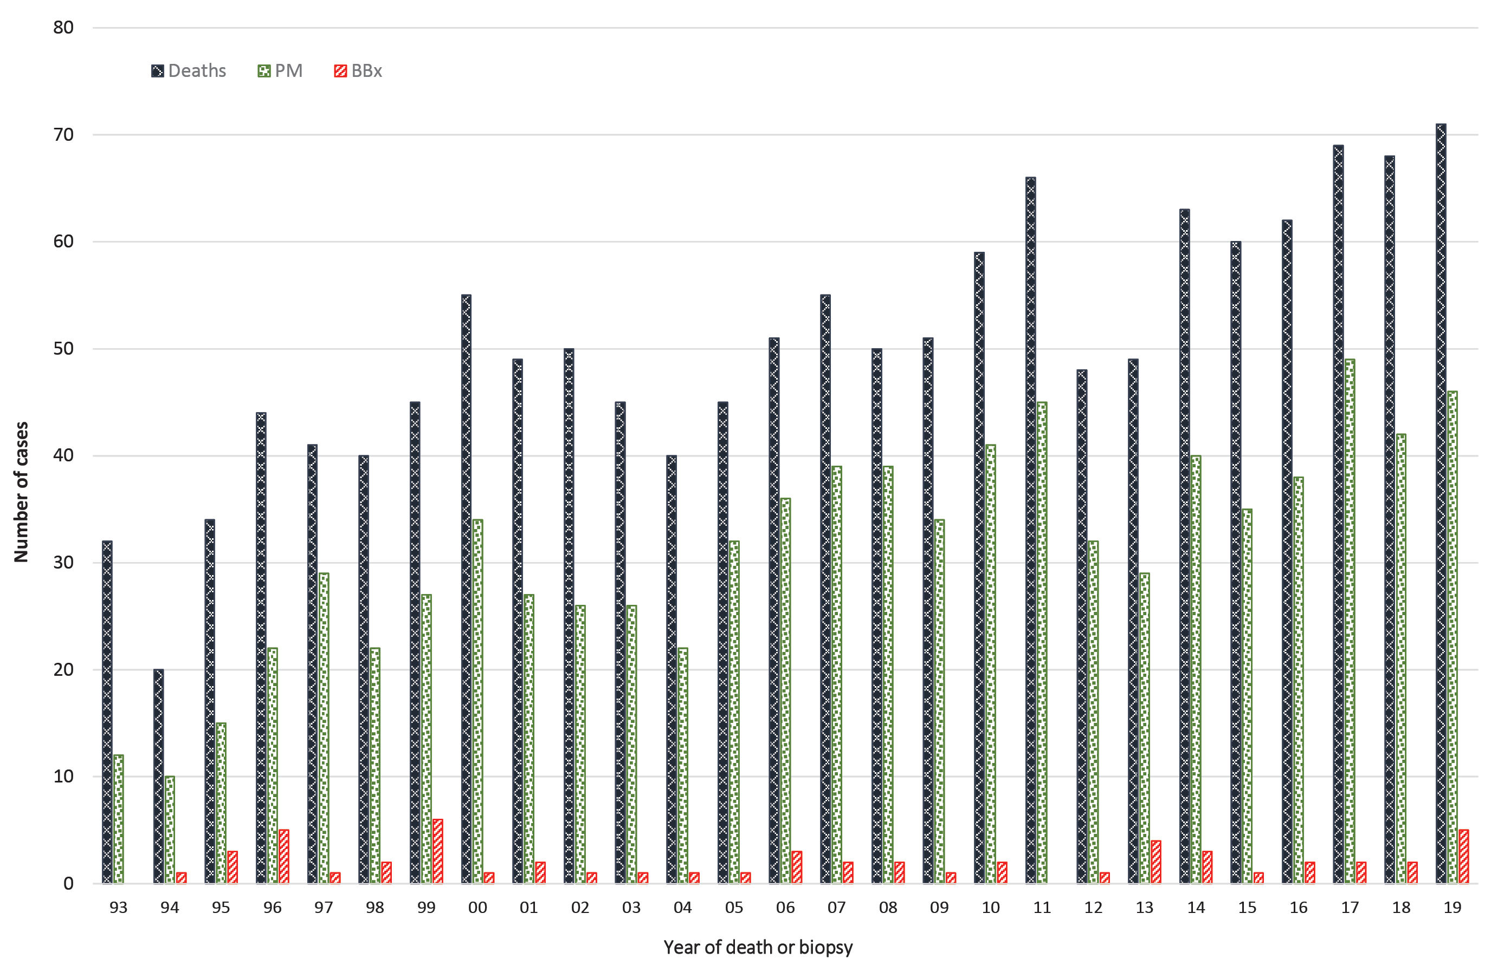

The average annual proportion of suspected prion disease cases on the register between 1993 and 2018 undergoing post-mortem brain examination is 63% (range 38–78%); the provisional proportion for 2019 is 63%. Annual suspected prion disease brain autopsy referrals by state and territory over the period 1993–2019 display considerable fluctuation in each region. In the more populous states, there has generally been an overall temporal increase in brain autopsy referrals. In regions with smaller populations this positive trend is also present but less robust due to the relative impact of variation in the annual brain autopsy referrals caused by small population sizes and case numbers. In Queensland, the influence of the diminished access to a facile suspected prion disease brain autopsy service during 2012–2013 is reflected by the sharp decline in the annual neuropathological examination rates (Figure 3) for those years. From 2014 onwards, Queensland has had a significant increase in brain autopsy neuropathological referrals to the highest number (16) since prion disease surveillance began in 1993 and the highest number of all states and territories in 2018. This increase aligns with the increase in suspected case notifications.
Figure 3: Annual brain-only autopsy referrals for suspected prion disease during 1993 to 2019, by year and selected state
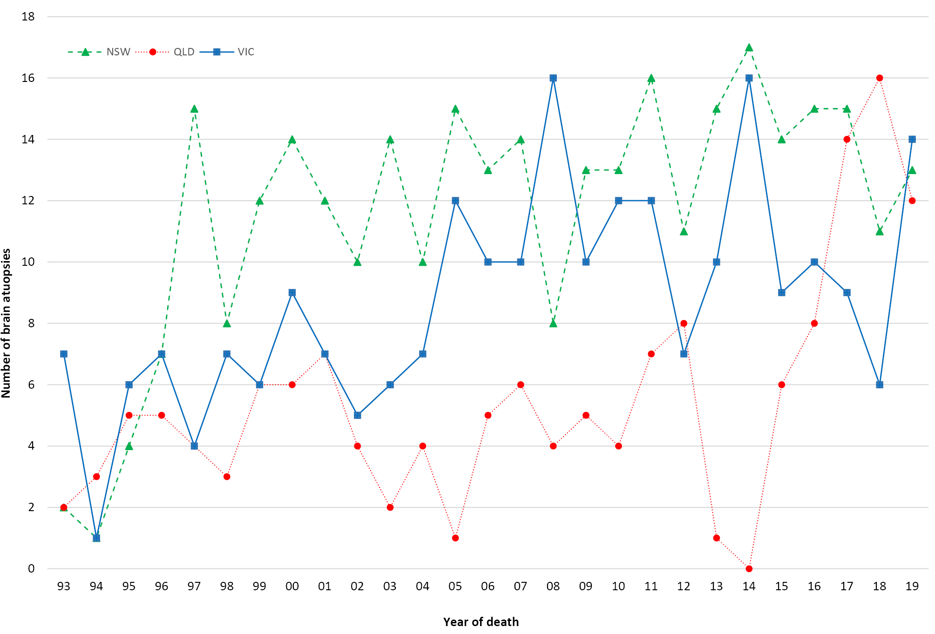
As of 31 December 2019, there were 1,321 cases on the ANCJDR register with 1,033 of these being classified as ‘probable’ or ‘definite’ prion disease cases. An additional ‘definite’ iatrogenic case who was treated in Australia but died in the UK is included in Table 2; this case is not classified as an Australian case due to their location at death and is thereby excluded from the overall statistical analysis of Australian prion disease cases. Since the start of prospective surveillance in 1993, 770 suspected prion disease cases have been excluded from the register after detailed follow-up.
Table 2: Overall summary of Australian human prion disease, 1 January 1970 to 31 December 2019
Classification | Sporadic | Familial | Iatrogenic | Variant CJD | Incomplete | Total
Definite | 619 | 59 | 5ª | 0 | 0 | 683
Probable | 324 | 22 | 4 | 0 | 0 | 350
Possible | 14 | 0 | 1 | 0 | 0 | 15
Incomplete |  | 6 | 0 | 0 | 267 | 273
Total | 957 | 87 | 10 | 0 | 267 | 1321
a Includes one definite iatrogenic case who received pituitary hormone treatment in Australia but disease onset and death occurred while a resident of the United Kingdom. This case is not included in statistical analysis since morbidity and mortality did not occur within Australia.
In 2019, 38 cases were re-classified from ‘incomplete’ to ‘definite’ prion disease and 28 cases to ‘probable’ prion disease; no further cases of ‘possible’ prion disease were classified. The total number of ‘possible’ cases remains at 15, 14 of which were sporadic and one iCJD (Table 2). In 2019, the total number of ‘incomplete’ cases under evaluation was slightly lower than in 2018.
The age-standardised mortality rate (ASR) for prion disease for 2019 is 1.08 per million. This figure is provisional and almost certainly an underestimate, as 33 neuropathology reports are pending and 15 cases who died in 2019 remain under investigation. Annual ASR values for human prion disease in Australia during the period of 1970 to 2019 have generally increased. The mean annual ASR during the period from 1970 to 2019 is one death per million (range 0.1–1.8). For the prospective surveillance period of 1993 to 2018, the annual mean ASR is 1.33 deaths per million (range 0.7–1.8). By state and territory, most regions in Australia have an annual mean ASR equivalent to or above one case per million per year between 1993 and 2019 (Table 3). Tasmania and the Northern Territory have recorded 0.81 and 0.7 deaths per million per year, respectively, during this period. Given the small population numbers in these two jurisdictions, the Tasmanian and Northern Territory ASR values are unlikely to represent a significant difference to other states and territories.
Table 3: ‘Definite’ and ‘probable’ cases of human prion disease from 1993 to 2019, by year and state or territory
 | ACT | NSW | NT | Qld | SA | Tas | Vic | WA | Australia
2019 (provisional data) | 1 | 8 | 0 | 4 | 3 | 1 | 10 | 7 | 34
Total cases 1993-2019 | 14 | 257 | 5 | 125 | 67 | 13 | 235 | 104 | 820
Long-term annual average case numbers 1993-2019 | 0.5 | 9.5 | 0.2 | 4.6 | 2.5 | 0.5 | 8.7 | 3.9 | 30
Average ASR | 1.48 | 1.28 | 0.70 | 1.06 | 1.41 | 0.81 | 1.56 | 1.69 | 1.33

A breakdown of annual case numbers and mortality rates is shown in Figure 4 and Table 3. The highest annual number of ‘probable’ and ‘definite’ prion disease cases reported, since surveillance commenced in 1993, was 51 in 2017, resulting in an annual ASR of 1.71 deaths per million. Although this rate is higher than the long-term average of 1.3 deaths per million, similar mortality rates were reported in 1996, 2000, 2006, 2011 and 2016.
The proportions of human prion disease aetiologies on the ANCJDR register for 2019 remained similar to previous years (Figure 5); the vast majority of the 1,033 statistical cases of human prion disease are ‘sporadic’ (91%) while genetic and iatrogenic cases represent 8% and < 1%, respectively, of all ‘definite’ and ‘probable’ cases.
There are currently 943 ‘definite’ and ‘probable’ sporadic prion disease cases on the ANCJDR register. The distribution is almost equal between males (47%) and females (53%), with the slight predominance in females reflecting their longer life expectancy. The average age at death is 66.9 years, with a median of 68 years, ranging in age from 19 to 91 years. The average duration of illness is 6.3 months, with a median of 3.7 months, ranging from 0.9 to 60 months. A recent study by the ANCJDR confirmed that sporadic CJD occurs in Indigenous Australians across Australia with the phenotype and incidence rate similar to non-Indigenous Australians; five of the eight identified Indigenous Australian cases were confirmed by brain autopsy examination.⁸
Genetic prion disease has been confirmed in 81 individuals, with 55% females. The average age at death for genetic prion disease is 58.5 years, with the average duration of disease 13.7 months. The average age at death in females is 60 years, with a median of 62 years, ranging in age from 18 to 82 years. The average age at death in males is 57.1 years, with a median of 59 years, ranging in age from 20 to 83 years. The average duration of illness is 12.6 months, with a median of 4.1 months, ranging from 1.3 to 108 months.
There are currently 51 families affected by genetic prion disease on the ANCJDR register, comprising 81 individuals (59 ‘definite’ and 22 ‘probable’ cases); three prion protein gene (PRNP) mutation carriers were removed from the register after brain autopsies excluded evidence of prion disease. Six cases on the register remain under investigation without a neuropathological or case classification outcome; however, there is a documented concern for genetic prion disease. Three families are of unspecified PRNP status although there is a recorded family history of prion disease. The range of PRNP mutations in Australian genetic prion disease cases is shown in Table 4. In 2019, two novel PRNP sequence variations with unknown pathogenicity were identified.

Figure 4: Human prion disease in Australia from 1993 to 2019; number of cases and age-standardised mortality rates, by year
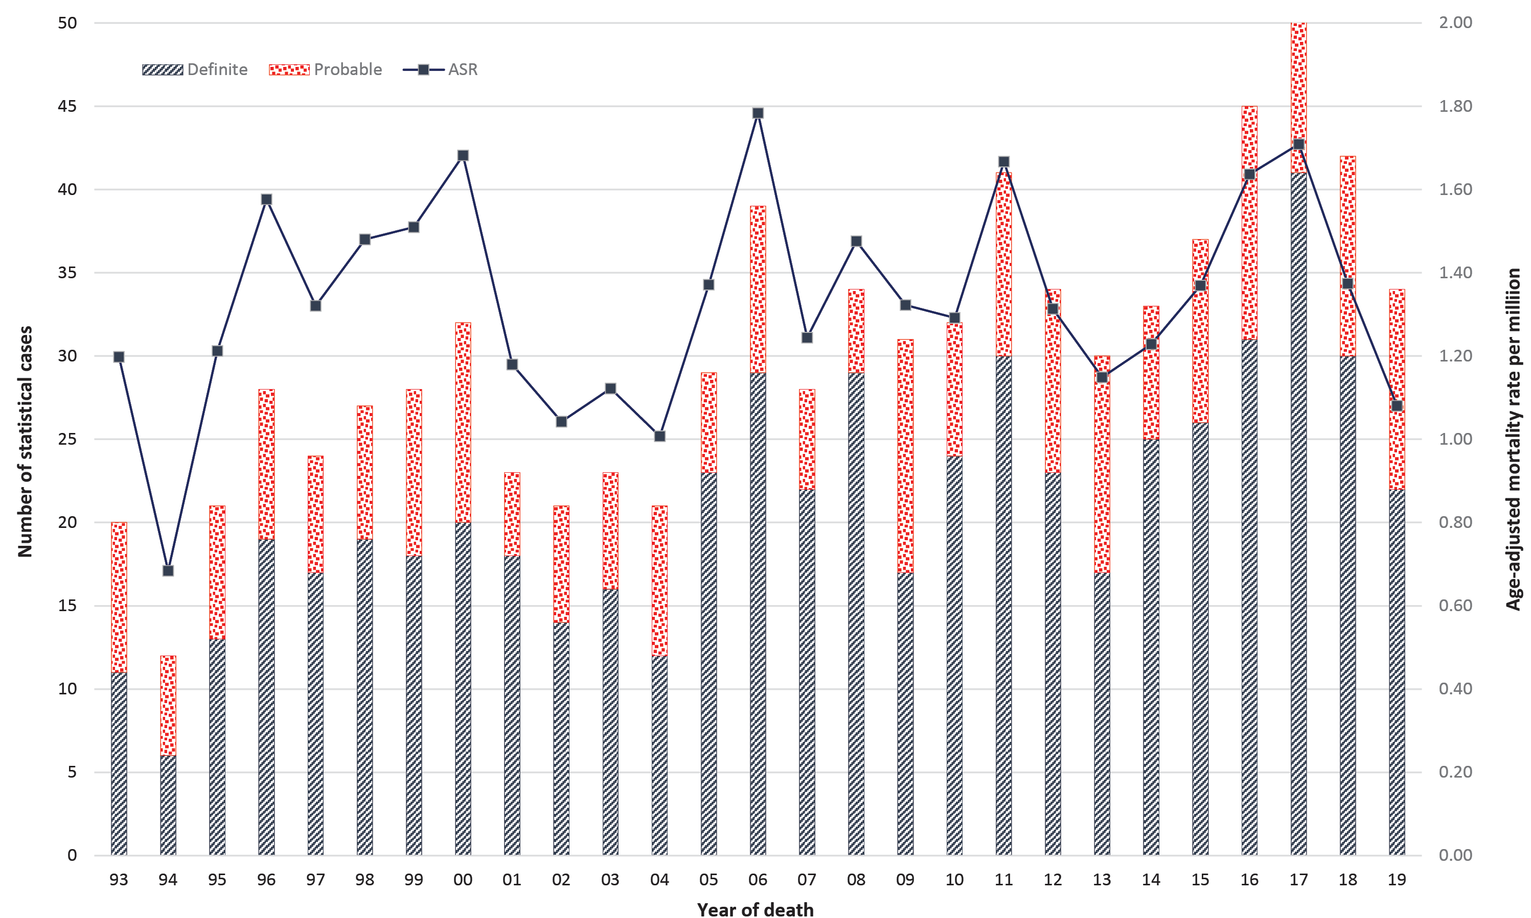
Figure 5: ‘Definite’ and ‘probable’ human prion disease cases 1970 to 2019,ª by year and aetiology
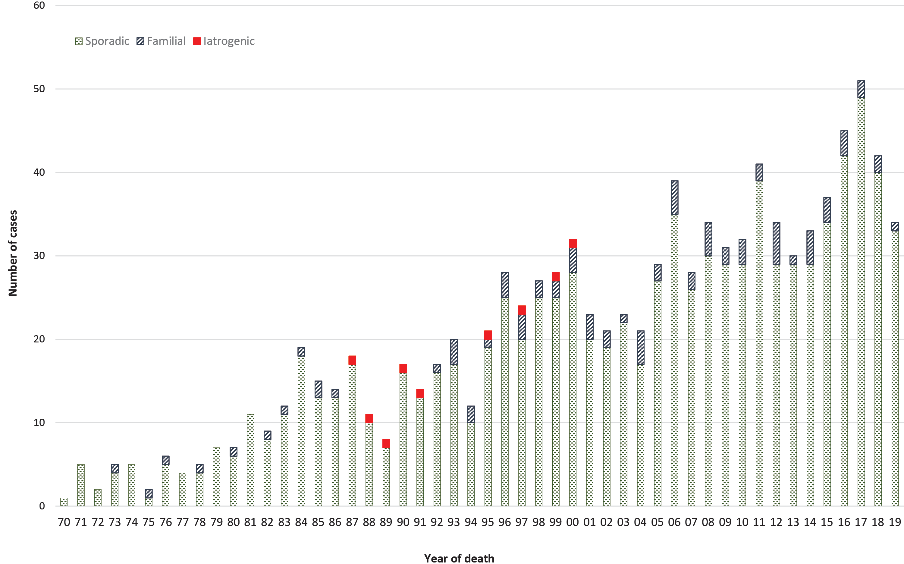
a Includes one definite iatrogenic case who received pituitary hormone treatment in Australia but disease onset and death occurred while a resident of the United Kingdom. This case is not included in statistical analysis since morbidity and mortality did not occur within Australia.

Table 4: Prion protein gene (PRNP) sequence variations/mutations identified in Australian casesª
Mutation/polymorphism | Definite/probable  cases | Cases  PM proven  not CJD
E200K | 39 | 3
D178N | 12 | 0
V210I | 8 | 0
P105T | 9 | 0
P102L | 4 | 0
Insert unspecified | 1 | 0
7OPRI^{b} | 1 | 0
4OPRI^{b} | 1 | 0
2OPRI^{b} | 1 | 0
G131V | 1 | 0
T188A | 1 | 0
V180I | 1 | 0
A133V | 1 | 0
V176G | 1 | 0
E200D | 1 | 0
V189I | 1 | 0
Not determined | 7 | 0
a 9 cases are family members who died before 1970
b OPRI - abbreviation for octapeptide repeat insertion

No vCJD or further iCJD cases were confirmed in Australia during 2019. The most recent human cadaveric pituitary gonadotrophin-related CJD death occurred in 1991, while the most recent Lyodura-related CJD death occurred in 2000. Globally, the most recent iCJD cases were reported to have died in 2018 in the USA (human growth hormone), Canada and Austria (dura mater).
Since vCJD was first reported in 1996, a total of 232 patients, from 12 countries, have been identified with this disease. The most recent vCJD case died in France in 2019. A recent vCJD case (death occurred in 2016) from the UK was the first to be reported as methionine-valine heterozygous at codon 129 of the PRNP gene;⁹ all cases previously had been methionine homozygous. The patient was 36 years old when he presented with psychiatric symptoms prior to onset of neurological features that included cognitive decline, ataxia and myoclonus, dying after an illness of 20 months. CSF 14-3-3 and RT-QuIC were negative. Brain magnetic resonance imaging (MRI) revealed features more typical of sporadic CJD (bilateral high signal in basal ganglia) without any posterior thalamic high signal (‘pulvinar sign’). The patient did not meet the epidemiologic diagnostic surveillance criteria for ‘probable’ or ‘possible’ vCJD, although fulfilled criteria for ‘probable’ sporadic CJD; neuropathology, including western blot glycotyping were typical of vCJD. It remains uncertain whether this case marks the start of a second wave of vCJD affecting those heterozygous for methionine-valine at codon 129. This case also underscores the importance of performing suspect CJD brain autopsy examinations and the benefits of maintaining high level surveillance within Australia.

Discussion
In 2019, the number of suspected prion disease referrals and confirmed cases broadly matched the long-term average (1997–2018). Australia continued to be free of vCJD and no further cases of iCJD were detected. By state and territory, generally only modest fluctuations in the number of suspected case referrals compared to the previous year were observed during 2019 which are within previously observed ranges. In 2017 and 2018 however, the highest recorded number of ‘definite’ and ‘probable’ prion disease cases in Queensland was observed contributing to an annual age-standardised mortality rate of 1.98 and 1.93 deaths per million in 2017 and 2018, respectively, for this state. Occasional high mortality rates have been reported previously in Queensland in 1999 and 2000. During 2012 and 2013, the reduced number of cases in Queensland was attributed to several possible factors including the temporary interruption of a facile suspected prion disease autopsy service, changes to the approach of recording suspected cases on the national case register for investigation by the ANCJDR, and natural fluctuations. Since the restoration of the routine suspected prion disease autopsy service through the Royal Brisbane Hospital towards the end of 2014, expected rates of prion disease-related post-mortems have been observed; a corresponding increase in statistical (‘definite’ or ‘probable’) cases has been observed. These findings illustrate the importance of brain autopsies to the accurate surveillance of prion disease in Australia.
Fluctuations in annual suspect case referrals and prion disease mortality rates are not surprising given the small absolute case numbers involved and the potential impact of extraneous factors. For example, higher referral rates were experienced in 1998 and 1999 when the 14-3-3 protein test was first introduced and in 2006 when notifiable disease legislation was completed in all states and territories; however, the higher number of case referrals in 2017 continued in 2018 and 2019 and, although likely to be an underestimate of final case classifications (until all post-mortem reports and case reviews are finalised), the currently observed rates are comparable to previous years and contribute to a period of stable case ascertainment. Increased case classifications since 2015 have also contributed to stabilising the number of ‘incomplete’ cases currently under investigation. Prior to 2015, the addition of new suspect cases considerably exceeded fully evaluated cases with an outcome.
Long-term national surveillance units report differing annual prion disease mortality rates, ranging from 0.24 to 4.56 per million population.^{4,5,10} Higher rates of human prion disease over short time frames have also been recognised and investigated in various global settings with inconclusive outcomes.¹⁰ The underlying basis for fluctuations and differences in national mortality rates is uncertain, although variation in case ascertainment is one potentially contributing factor.⁵
Spatio-temporal clustering of CJD has previously been recognised in NSW and Victoria.^{10,11} Detailed epidemiological assessment by the ANCJDR did not disclose any likely horizontal transmission event but instead uncovered a heightened intensity of surveillance.¹¹ This more intense level of surveillance was reflected by the significantly higher rates of referrals of suspect prion disease cases for evaluation and diagnostic testing to the ANCJDR, as well as higher neuropathological examination rates in suspected patients.^{6,11,12} Monitoring of the geographical distribution of suspected case referrals and confirmed cases remains an important facet of ANCJDR national surveillance.
Notably, an upwards trajectory of incidence rates of prion disease has been reported from many countries with effective surveillance methods. This overall increase in sporadic CJD cases has also been observed in Australia and is most likely due to a combination of an ageing population, improved case ascertainment and diagnostic methodologies, and greater awareness of prion disease in the healthcare sector.¹³
Ascertainment mechanisms in 2019 were unchanged compared to recent years, with the majority of initial referrals coming through requests for diagnostic CSF 14-3-3 protein testing. Some proactive ascertainment mechanisms, such as state health department and tertiary hospital mortality data base searches, have ceased while other case detection methods have increased. In 2019, in addition to CSF 14-3-3 diagnostic testing requests, 18% of suspect case referrals to the ANCJDR were initially through direct communications from treating clinicians and hospitals, 14% through neuropathology referrals and 10% through communications with families or the CJD Support Group Network. The number of CSF referrals to the ANCJDR for diagnostic (14-3-3 protein) testing remained high for 2019. A 20% increase in diagnostic test referrals coincided with the introduction of CSF total-tau protein estimation in 2017. Estimation of total-tau protein in CSF is NATA/ILAC accredited and complementary to 14-3-3 protein testing to support a pre-mortem diagnosis of sporadic CJD. The identification of misfolded prion protein in CSF by RT-QuIC continues to be developed by the ANCJDR as a diagnostic test and is currently selectively performed for cases after discussion with clinicians. The addition of CSF total-tau protein estimation to 14-3-3 protein detection as a biomarker for the pre-mortem evaluation of suspected sCJD offers modestly enhanced diagnostic capacity while the ANCJDR completes imminent transition to clearly superior protein amplification techniques such as RT-QuIC.
The proportion of post-mortems being performed in suspect prion disease cases remains high and aligns with the long-term mean brain autopsy percentage of approximately 60% (of suspected case deaths) between 1993 and 2017. This contrasts with the findings of an Australian healthcare setting survey where the national hospital post-mortem rate was 12% in 2002–2003;¹⁴ more recently, a major Australian tertiary centre audit of hospital autopsy data has described an autopsy rate of 6.6% in 2011–2013.¹⁵ The high suspected prion disease-related post-mortem rate underpins the high and consistent number of confirmed Australian human prion disease cases recorded over the more recent prospective surveillance time period, and provides confident understanding of the cause of death in suspected cases ultimately determined as non-prion disease.
In 2019, two novel PRNP sequence variants of unknown pathogenicity were identified due to increased rates of referrals for PRNP gene sequencing in persons with suspected CJD, with such broader genetic screening informing the understanding of the true prevalence of genetic prion disease in Australia.
A recent study by the ANCJDR of prion disease in Indigenous Australians⁸ has confirmed that sporadic CJD occurs in Indigenous Australians throughout Australia with a phenotype and incidence rate equivalent to non-Indigenous Australians, supporting the adequacy of national human prion disease surveillance.

Acknowledgements
The ANCJDR wishes to thank families, as well as medical practitioners and associated staff, for their generous support of Australian CJD surveillance. The ANCJDR also thanks Associate Professor Handan Wand, Professor Matthew Law and Professor John Kaldor (The Kirby Centre; formerly the National Centre in HIV Epidemiology and Clinical Research at the University of New South Wales) for their expert ad hoc epidemiological and statistical support, as well as the CJD Support Group Network for their assistance in surveillance activities.

Author details
Dr Christiane Stehmann – Coordinator, Australian National Creutzfeldt-Jakob Disease Registry (ANCJDR)¹
Dr Matteo Senesi – Research Fellow, ANCJDR¹
Ms Shannon Sarros – Research Assistant, ANCJDR²
Ms Amelia McGlade – Research Assistant, ANCJDR²
Dr Marion Simpson – Neurologist, ANCJDR²
Ms Genevieve Klug – Research Assistant, ANCJDR²
Professor Catriona A McLean – Neuropathologist, ANCJDR^{1,3}
Professor Colin L Masters – Director, ANCJDR¹
Professor Steven J Collins – Director, ANCJDR²

- The Florey Institute, The University of Melbourne, Victoria, 3010, Australia
- Department of Medicine, The University of Melbourne, Victoria, 3010, Australia
- The Alfred Hospital, Department of Anatomical Pathology, 55 Commercial Rd, Melbourne Vic 3004 Australia

Corresponding author
Prof Steven Collins, Australian National Creutzfeldt-Jakob Disease Registry, Department of Medicine, The University of Melbourne, Victoria, 3010, Australia.
Telephone: +61 8344 1949.
Facsimile: +61 9349 5105.
Email: s.collins@unimelb.edu.au

References
- Klug GM, Boyd A, Zhao T, Stehmann C, Simpson M, McLean CA et al. Surveillance for Creutzfeldt-Jakob disease in Australia: update to December 2012. Commun Dis Intell Q Rep. 2013;37(2):E115–20.
- Allars M. Report of the inquiry into the use of pituitary derived hormones in Australia and Creutzfeldt-Jakob disease. Canberra: AGPS, 1994.
- Zerr I, Kallenberg K, Summers DM, Romero C, Taratuto A, Heinemann U et al. Updated clinical diagnostic criteria for sporadic Creutzfeldt-Jakob disease. Brain. 2009;132(10):2659–68.
- Creutzfeldt-Jakob Disease International Surveillance Network: Surveillance Data. [Internet]. Available from: http://www.eurocjd.ed.ac.uk/surveillance%20data%201.html
- Uttley L, Carroll C, Wong R, Hilton DA, Stevenson M. Creutzfeldt-Jakob disease: a systematic review of global incidence, prevalence, infectivity, and incubation. Lancet Infect Dis. 2020;20(1):e2–10.
- Klug GM, Wand H, Simpson M, Boyd A, Law M, Masters CL et al. Intensity of human prion disease surveillance predicts observed disease incidence. J Neurol Neurosurg Psychiatry. 2013;84(2):1372–7.
- Australian Bureau of Statistics. 3101.0 Australian Demographic Statistics – June 2018. Tables 51 to 59. Accessed on January 2020. Available from: http://www.abs.gov.au/AUSSTATS/abs@.nsf/DetailsPage/3101.0Sep%202017?OpenDocument
- Panegyres PK, Stehmann C, Klug GM, Masters CL, Collins S. Prion disease in Indigenous Australians. Intern Med J. 2020. doi: https://doi.org10.1111/imj.14835.
- Mok T, Jaunmuktane Z, Joiner S, Campbell T, Morgan C, Wakerley B et al. Variant Creutzfeldt–Jakob disease in a patient with heterozygosity at PRNP codon 129. N Engl J Med. 2017;376(3):292–4.
- Glatzel M, Rogivue C, Ghani A, Streffer JR, Amsler L, Aguzzi A. Incidence of Creutzfeldt-Jakob disease in Switzerland. Lancet 2002;360(9327):139–41.
- Klug GM, Wand H, Boyd A, Law M, Whyte S, Kaldor J et al. Enhanced geographically restricted surveillance simulates sporadic Creutzfeldt-Jakob disease cluster. Brain. 2009:132(2);493–501.
- Collins S, Boyd A, Fletcher A, Kaldor J, Hill A, Farish S et al. Creutzfeldt-Jakob disease cluster in an Australian rural city. Ann Neurol. 2002;52(1):115–8.
- Stevenson M, Uttley L, Oakley JE, Carroll C, Chick SE and Wong,R. Interventions to reduce the risk of surgically transmitted Creutzfeldt-Jakob disease: a cost-effective modelling review. Health Technol Assess. 2020;24(11):1–150.
- The Royal College of Pathologists of Australasia Autopsy Working Party. The decline of the hospital autopsy: a safety and quality issue for healthcare in Australia. Med J Aust. 2004;180(6):281–5.
- Jackett L, McLean C. Hospital autopsy audit: discordant primary clinical diagnoses are found in 20% of cases in a reducing autopsy case load. Selection bias or significant findings? Pathology. 2015;47(6):499–502.

Appendix 1
EUROCJD diagnostic criteria for surveillance of sporadic CJD from 1 January 2017
Definite:
Progressive neurological syndrome AND Neuropathologically or immunohistochemically or biochemically confirmed
Probable:
I + two of II and typical EEGª
OR
1.2.2 I + two of II and typical MRI brain scan^{b}
OR
1.2.3 I + two of II and positive CSF 14-3-3
OR
1.2.4 Progressive neurological syndrome and positive RT-QuIC in CSF or other tissues
Possible:
I + two of II + duration < 2 years
I Rapid progressive cognitive impairment
II A Myoclonus
B Visual or cerebellar problems
C Pyramidal or extrapyramidal features
D Akinetic mutism

a Generalised periodic complexes
b High signal in caudate/putamen and MRI brain scan or at least two cortical regions (temporal, parietal, occipital) either on DWI or FLAIR
Communicable Diseases Intelligence
ISSN: 2209-6051 Online

Communicable Diseases Intelligence (CDI) is a peer-reviewed scientific journal published by the Office of Health Protection, Department of Health. The journal aims to disseminate information on the epidemiology, surveillance, prevention and control of communicable diseases of relevance to Australia.

Editor: Tanja Farmer
Deputy Editor: Simon Petrie
Design and Production: Kasra Yousefi
Editorial Advisory Board: David Durrheim, Mark Ferson, John Kaldor, Martyn Kirk and Linda Selvey

Website: http://www.health.gov.au/cdi

Contacts
Communicable Diseases Intelligence is produced by:
Health Protection Policy Branch, Office of Health Protection, Australian Government Department of Health
GPO Box 9848, (MDP 6) CANBERRA ACT 2601

Email: cdi.editor@health.gov.au

Submit an Article
You are invited to submit your next communicable disease related article to the Communicable Diseases Intelligence (CDI) for consideration. More information regarding CDI can be found at: http://health.gov.au/cdi.
Further enquiries should be directed to: cdi.editor@health.gov.au.

This journal is indexed by Index Medicus and Medline.

Creative Commons Licence - Attribution-NonCommercial-NoDerivatives CC BY-NC-ND
© 2020 Commonwealth of Australia as represented by the Department of Health
This publication is licensed under a Creative Commons Attribution-NonCommercial-NoDerivatives 4.0 International Licence from https://creativecommons.org/licenses/by-nc-nd/4.0/legalcode (Licence). You must read and understand the Licence before using any material from this publication.

Restrictions
The Licence does not cover, and there is no permission given for, use of any of the following material found in this publication (if any):
- the Commonwealth Coat of Arms (by way of information, the terms under which the Coat of Arms may be used can be found at www.itsanhonour.gov.au);
- any logos (including the Department of Health’s logo) and trademarks;
- any photographs and images;
- any signatures; and
- any material belonging to third parties.

Disclaimer
Opinions expressed in Communicable Diseases Intelligence are those of the authors and not necessarily those of the Australian Government Department of Health or the Communicable Diseases Network Australia. Data may be subject to revision.

Enquiries
Enquiries regarding any other use of this publication should be addressed to the Communication Branch, Department of Health, GPO Box 9848, Canberra ACT 2601, or via e-mail to: copyright@health.gov.au

Communicable Diseases Network Australia
Communicable Diseases Intelligence contributes to the work of the Communicable Diseases Network Australia.
http://www.health.gov.au/cdna

