Australian National Enterovirus Reference Laboratory annual report, 2019
Linda K Hobday, Aishah Ibrahim, Matthew E Kaye, Leesa Bruggink, Presa Chanthalavanh, Arnau Garcia-Clapes, Jason A Roberts, Bruce R Thorley

Abstract
Australia monitors its polio-free status by conducting surveillance for cases of acute flaccid paralysis (AFP) in children less than 15 years of age, as recommended by the World Health Organization. Cases of AFP in children are notified to the Australian Paediatric Surveillance Unit or the Paediatric Active Enhanced Disease Surveillance System and faecal specimens are referred for virological investigation to the National Enterovirus Reference Laboratory. In 2019, no cases of poliomyelitis were reported from clinical surveillance and Australia reported 1.34 non-polio AFP cases per 100,000 children, meeting the World Health Organization’s performance criterion for a sensitive surveillance system. The non-polio enteroviruses coxsackievirus A2, coxsackievirus A16, echovirus 9, and enterovirus A71 were identified from clinical specimens collected from AFP cases. Australia also performs enterovirus and environmental surveillance to complement the clinical system focussed on children. In 2019, 175 cases of wild polio were reported, with three countries remaining endemic: Afghanistan, Nigeria and Pakistan.
Keywords: poliovirus, acute flaccid paralysis, surveillance, enterovirus, poliomyelitis, eradication, vaccination, vaccine preventable disease

Introduction
Australia has established clinical and virological surveillance schemes to monitor its polio-free status. The clinical surveillance follows the World Health Organization (WHO) recommendation of investigating cases of acute flaccid paralysis (AFP) in children less than 15 years of age due to a higher risk of poliovirus infection. AFP cases are ascertained either by clinicians, notifying the Australian Paediatric Surveillance Unit (APSU) via a monthly report card, or through the Paediatric Active Enhanced Disease Surveillance System (PAEDS) at seven sentinel tertiary paediatric hospitals.^{1,2} WHO recommends that two faecal specimens be collected for virological investigation at least 24 hours apart, and within 14 days of the onset of paralysis, from cases of AFP so as to exclude poliovirus as the causative agent. It is a requirement of the WHO polio eradication program that the specimens are tested in a WHO-accredited laboratory, which for Australia is the National Enterovirus Reference Laboratory (NERL) at the Victorian Infectious Diseases Reference Laboratory (VIDRL), at the Peter Doherty Institute for Infection and Immunity. The clinical and laboratory data from AFP cases in children are reviewed by the Polio Expert Panel (PEP) and reported to WHO as evidence of Australia’s continued polio-free status.
Enterovirus and environmental surveillance programs were established as virological surveillance for poliovirus, to complement the clinical surveillance program focussed on AFP cases in children. Non-polio enteroviruses such as enterovirus A71 and enterovirus D68 have been associated with AFP, with an increased interest in the latter after reports of a possible association with acute flaccid myelitis since 2010.^{3,4} Non-paralytic poliovirus infection may manifest clinically from a mild febrile illness to meningitis or meningoencephalitis. The Enterovirus Reference Laboratory Network of Australia (ERLNA) involves public diagnostic virology laboratories, reporting enterovirus typing results from clinical specimens to exclude poliovirus involvement and establish the epidemiology of non-polio enteroviruses (NPEVs) in Australia. Most poliovirus infections are asymptomatic, with the virus shed for weeks in the faeces of infected persons. WHO supports the testing of environmental samples, such as raw sewage and river water, as a means of detecting the presence of wild poliovirus in polio-free countries.
The number of wild polio cases worldwide increased from 33 in 2018 to 175 in 2019, with only wild poliovirus serotype 1 detected in Afghanistan and Pakistan, reporting 29 and 146 cases respectively.⁵ Nigeria has not reported wild polio cases since August 2016; increased surveillance in previously silent areas, along with progress in immunisation activities and additional surveillance sensitivity assessments, could potentially lead to the country and the African region being certified polio-free in 2020.⁶ The global eradication of wild poliovirus type 3 was declared in 2019, after it was last reported in Nigeria in November 2012.⁷ The global eradication of wild poliovirus type 2 was certified in September 2015, with the last detection reported in India in 1999.⁸
In 2019, reports of circulating vaccine-derived poliovirus (cVDPV) type 2 occurred in 19 countries: Angola, Benin, Burkina Faso, Cameroon, Central African Republic, Chad, China, Côte d’Ivoire, Democratic Republic of Congo, Ethiopia, Ghana, Malaysia, Niger, Nigeria, Pakistan, the Philippines, Somalia, Togo and Zambia.^{9,10} The cVDPV1 outbreak in Papua New Guinea was considered to be over in 2019, after 12 months of enhanced surveillance since the last detection from an environmental sample collected in November 2018. WHO first declared the international spread of wild poliovirus and circulating vaccine-derived poliovirus to be a Public Health Emergency of International Concern in May 2014. The situation has been assessed every three months since then and the declaration has remained in place, with countries known to be exporting wild poliovirus and circulating vaccine-derived poliovirus required to ensure all residents and long-term visitors are vaccinated between four weeks and 12 months prior to international travel.¹¹
This report summarises the polio surveillance program in Australia for 2019 encompassing clinical surveillance for AFP cases in children and virological surveillance for poliovirus.

Methods

Acute flaccid paralysis surveillance
Paediatricians reviewing a patient less than 15 years of age presenting with AFP, or clinicians reviewing a patient of any age with suspected poliomyelitis, are requested to notify the NERL. Poliovirus infection, including suspected poliomyelitis, is notifiable under the Nationally Notifiable Disease Surveillance System.¹² Paediatricians notify AFP cases to the APSU and are then requested to complete a clinical questionnaire by the AFP National Surveillance Co-ordinator based within the NERL. Alternatively, AFP cases are ascertained by PAEDS nursing staff from medical records.
According to the WHO surveillance criterion, two faecal specimens must be collected more than 24 hours apart due to intermittent virus shedding, and within 14 days of the onset of paralysis, while the virus titre remains high, to be classified as adequate.¹³ The faecal specimens are tested by the NERL with funding from the Australian Government Department of Health.
The PEP, a subcommittee of the Communicable Disease Network of Australia, reviews the clinical and laboratory data for all notified cases of AFP, irrespective of whether they are an eligible or ineligible case. An eligible case is an Australian child less than 15 years of age with AFP (including Guillain-Barré syndrome and transverse myelitis) or an Australian of any age with suspected polio.
The PEP classifies cases of AFP as:
- Poliomyelitis due to wild poliovirus, vaccine-derived poliovirus (VDPV) or vaccine-associated paralytic poliomyelitis (VAPP);
- Polio-compatible if there is insufficient evidence to exclude poliomyelitis;
- Non-polio AFP; or
- Non-AFP.
The clinician is contacted if the PEP requires more information regarding the AFP case before a final classification can be made. After each PEP meeting, the Australian AFP case classifications are forwarded to WHO for inclusion in the global AFP surveillance data published in the Weekly Epidemiological Record. Ineligible cases are not reported to WHO.
The WHO AFP surveillance performance indicator for a polio non-endemic country is one case of non-polio AFP per 100,000 children aged less than 15 years.¹³ For Australia in 2019, this equated to 47 cases, based on the Australian Bureau of Statistics estimate of Australia’s population at 30 June 2018. The WHO surveillance performance indicator for laboratory testing is that at least 80% of notified AFP cases have adequate faecal specimens collected and tested in a WHO-accredited laboratory. An AFP surveillance scheme that meets the WHO surveillance performance indicators is deemed sufficiently sensitive to detect wild poliovirus or cVDPV cases if poliovirus is circulating.

Virus culture
Upon receipt at the NERL, faecal specimens are treated with minimum essential medium containing Earle’s salts and extracted with chloroform, which enteroviruses are resistant to, for removal of bacteria and fungi. The suspension is clarified via centrifugation and the supernatant inoculated onto the two mammalian cell lines recommended by WHO for the isolation of poliovirus: L20B (a transgenic mouse epithelial cell line expressing the human poliovirus receptor, CD155) and RD-A (human rhabdomyosarcoma).^{14,15}
Two WHO real-time reverse transcription polymerase chain reaction (RT-PCR) tests are used to determine whether a poliovirus is a wild strain, an oral poliomyelitis vaccine (OPV) strain (Sabin-like) or a VDPV, in a process known as intratypic differentiation (ITD).¹⁶ The NERL sequences the complete poliovirus viral protein 1 (VP1) genomic region, which contains a major neutralising antibody binding site. The VP1 genomic sequence provides valuable biological information, including the number of mutations within a significant region of OPV virus strains; it also enables phylogenetic analysis of wild poliovirus to rapidly determine the likely source of the virus, as utilised in the 2007 wild poliovirus importation.¹⁷

Environmental surveillance
Environmental samples are processed by the NERL according to the two-phase separation procedure published by WHO.¹⁸ In brief, 800 ml of sewage is collected as a grab sample prior to any biological or chemical treatment. At the laboratory 500 ml of the sample is vigorously shaken at 4 ºC with dextran, polyethylene glycol and sodium chloride. The mixture is incubated overnight at 4 ºC in a separating funnel and the lower organic phase collected the next day and clarified using chloroform treatment and centrifugation. The sample extract is inoculated onto the L20B and RD-A cell lines and observed microscopically for cytopathic effect as for faecal specimens. All enterovirus isolates from cell culture are typed by nucleic acid sequencing as described in the Methods section for enterovirus surveillance.

Enterovirus surveillance
The ERLNA was established primarily as a means of detecting imported poliovirus amongst untyped enteroviruses from clinical specimens. The network consists of nine public sector diagnostic virology laboratories in the Australian Capital Territory (Canberra Hospital), New South Wales (Royal Prince Alfred Hospital and the Institute of Clinical Pathology and Medical Research), Queensland (Queensland Health and Scientific Services), South Australia (SA Pathology), Tasmania (Royal Hobart Hospital), Victoria (Royal Children’s Hospital and VIDRL) and Western Australia (Queen Elizabeth II Medical Centre).
The NERL encourages members of the ERLNA to perform their own enterovirus typing. It has advised members of the ERLNA on enterovirus detection, has supplied laboratory and computer analysis protocols, and has performed tests in parallel with other laboratories for quality assurance purposes. The NERL receives untyped enteroviruses from four laboratories for typing on a regular basis. The other laboratories perform their own enterovirus typing and report the results to the NERL for inclusion in the national enterovirus database.
Clinical specimens are screened for enterovirus using a real-time RT-PCR directed to highly conserved sequence in the 5’ untranslated region (UTR).¹⁹ Enterovirus typing is primarily performed using an in-house nested RT-PCR assay: the first round of the assay amplifies the entire capsid-encoding region of the virus and the second round targets a fragment of the VP3/VP1 genomic region. If the typing assay does not amplify a suitable fragment for sequencing and serotype determination, a second semi-nested RT-PCR assay that amplifies a fragment of the 5’UTR is employed to determine the enterovirus species and may exclude poliovirus. PCR products are sequenced using Illumina MiSeq next-generation sequencing when full genome or complete capsid sequences are required or if virus mixtures were detected by Sanger sequencing methodology.

Results

Classification of AFP cases
A total of 83 notifications of AFP cases were received in 2019 (Table 1). The PEP classified 63 cases as non-polio AFP, a rate of 1.34 cases per 100,000 children less than 15 years of age, which exceeds the WHO AFP surveillance performance criterion for a polio-free country of one case of non-polio AFP per 100,000 children (Table 2, Figure 1). Guillain-Barré syndrome and transverse myelitis were the most common cause of non-polio AFP in 2019, with the PEP classifying 18 and 13 cases, respectively, with these two conditions.

Table 1: Notification of acute flaccid paralysis cases, 2019 by state and territory
State or territory | Estimated population aged < 15 yearsª | Expected number of AFP cases in 2018 | Total number of notifications | Ineligible notifications | Duplicate notifications | Eligible cases with final classification by PEP | Non-polio AFP rate per 100,000 children
ACT | 80,243 | 0.5 | 0 | 0 | 0 | 0 | 0.00
NSW | 1,493,346 | 15.0 | 37 | 4 | 5 | 28 | 1.87
NT | 53,503 | 0.5 | 2 | 0 | 0 | 2 | 4.00
Qld | 980,422 | 10.0 | 17 | 1 | 7 | 9 | 0.9
SA | 306,952 | 3.0 | 2 | 0 | 0 | 2 | 0.67
Tas | 93,707 | 1.0 | 2 | 0 | 0 | 2 | 2.00
Vic | 1,186,020 | 12.0 | 19 | 1 | 2 | 16 | 1.33
WA | 507,265 | 5.0 | 4 | 0 | 0 | 4 | 0.8
Australia | 4,631,219 | 47.0 | 83 | 6 | 14 | 63 | 1.34
a Australian Bureau of Statistics, estimated population at 30 June 2018. Available at www.abs.gov.au.
Fourteen cases were notified by more than one source, whether by two or more clinicians through the APSU or a clinician and the PAEDS system. Six notifications were deemed to be ineligible due to the patient’s age being greater than 14 years or the clinical presentation was subsequently determined not to be AFP.

Notification of AFP cases by state and territory
In 2019, AFP cases were notified from all jurisdictions in Australia except the Australian Capital Territory (Table 1). The non-polio AFP rates for eligible cases exceeded the WHO AFP surveillance performance indicator of one case per 100,000 children less than 15 years of age in half the states and territories with the Australian Capital Territory, Queensland, South Australia and Western Australia not reaching the target.

Faecal collection from AFP cases
A total of 94 faecal specimens from 49 of the 63 eligible cases were tested at the NERL in 2019. Specimens collected from 31 of the AFP cases classified as non-polio AFP were considered adequate according to the WHO criterion of two faecal specimens collected within 14 days of the onset of paralysis, representing 49% of the classified cases compared to the WHO criterion of 80% (Figure 2, Table 2).

Figure 1: Non-polio acute flaccid paralysis rate, Australia 1995 to 2019ª
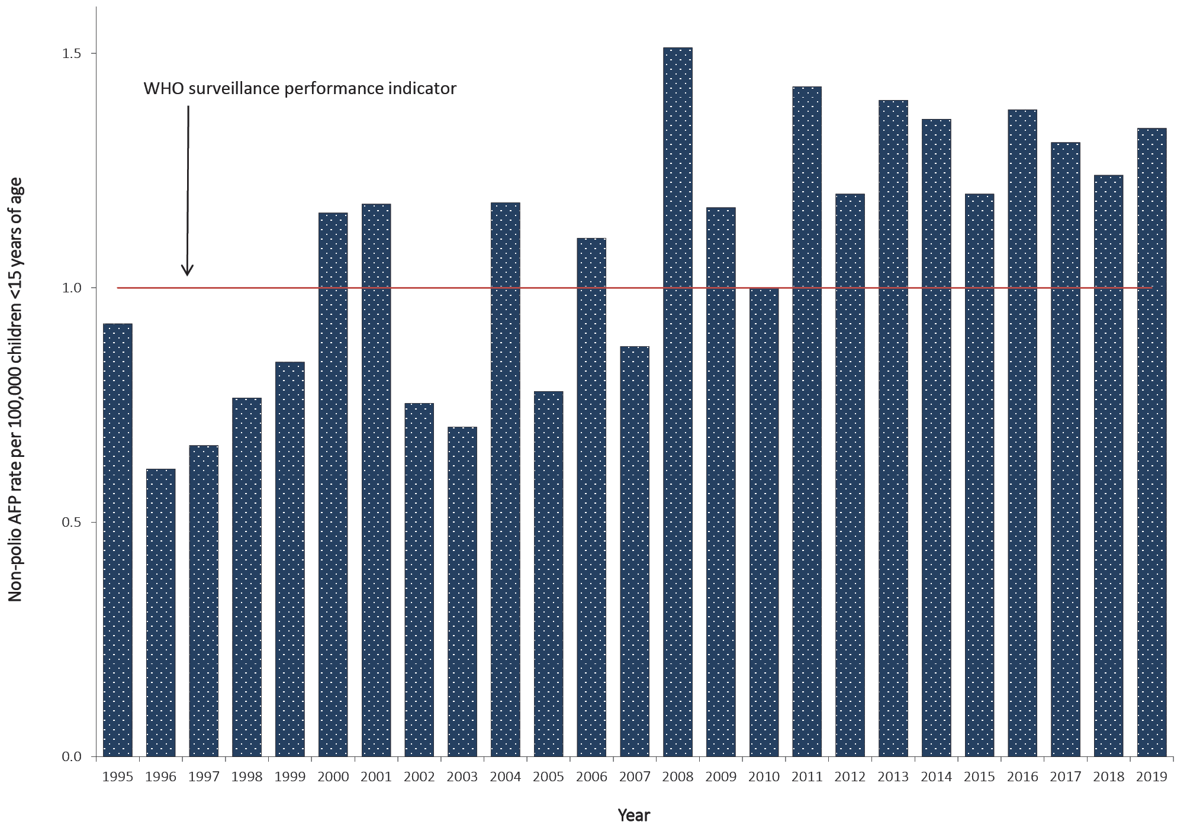
a The WHO AFP surveillance performance indicator for a polio non-endemic country is one case per 100,000 children <15 years of age, which is highlighted by the red line.
Table 2: Australia’s surveillance for cases of acute flaccid paralysis, 2019, compared with the main World Health Organization performance indicators
WHO surveillance performance indicator for AFP cases in children < 15 years | Performance of Australia’s AFP surveillance
≥ 1.0 non-polio AFP case / 100,000 children (47 cases for Australia in 2018) | 63 cases classified as non-polio AFP | 1.34 (63 / 47) non-polio AFP cases / 100,000 children < 15 years
≥ 80% of classified AFP cases with adequate specimens (2 faecal specimens collected at least 24 hours apart and within 14 days of onset of paralysis | 31 AFP cases with adequate specimens collected | 49% (31 / 63) classified non-polio AFP cases with adequate specimens

While the optimal period to collect stool specimens is within 14 days of the onset of paralysis, poliovirus can still be detected after 60 days and 78% of cases had at least one specimen collected within this extended time frame.¹³ No poliovirus was detected in any of the specimens. The following non-polio enteroviruses were identified from stool specimens collected from eight non-polio AFP cases with the jurisdiction specified in brackets: coxsackievirus A2 (Queensland), coxsackievirus A16 (Western Australia), echovirus 9 (New South Wales), and enterovirus A71 (Victoria).
Figure 2: Adequate faecal specimen collection rate, Australia 1995 to 2019ª
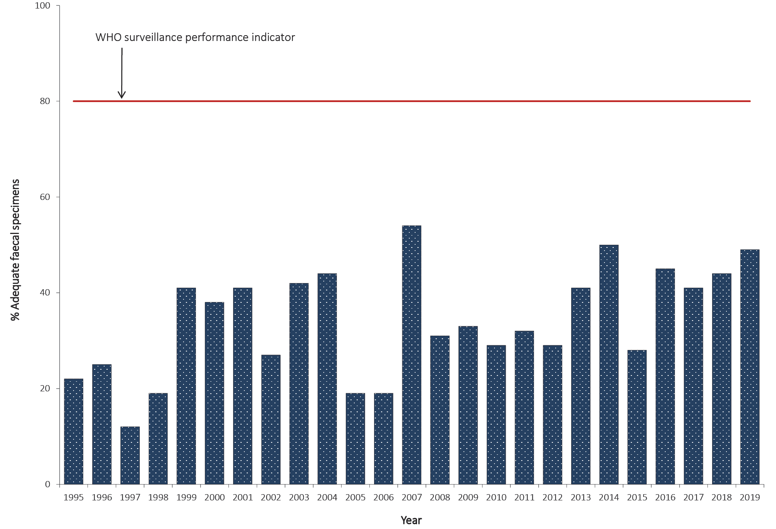
a The WHO criterion for adequate specimen collection is two faecal specimens collected more than 24 hours apart and within 14 days of the onset of paralysis from 80% of the cases classified as non-polio AFP, which is highlighted by the red line.

Environmental surveillance
Environmental surveillance was established at a wastewater treatment plant in Melbourne from October 2017 (Table 3). Nine collections were tested in 2019 and Sabin-like poliovirus type 3 was isolated from one sample. The VP1 region was sequenced and determined to have 99.78% identity to prototype Sabin 3 sequence, which suggests the source of the virus was from a recent vaccination event and would have been shed by an international visitor or returned traveller from a country that still uses OPV. Enterovirus infections are ubiquitous and the isolation of NPEVs from the eight other sewage samples served as an indicator of the quality of the collection and test procedures.

Table 3: Laboratory results reported by the NERL, 2019
Result | Specimens from AFP cases involving children < 15 years of age | Specimens from AFP cases involving patients ≥ 15 years of age | Environmental surveillance | Enterovirus surveillance | Total
Sabin poliovirus type 3 | 0 | 0 | 1 | 0 | 1
Rhinovirus | 1 | 0 | 0 | 1 | 2
Non-polio enterovirus | 12 | 2 | 8 | 30 | 52
No enterovirus identified | 83 | 5 | 0 | 9 | 97
Total | 96 | 7 | 9 | 40 | 152

Enterovirus surveillance
A total of 52 NPEVs were typed by the NERL and an additional 97 by members of the Enterovirus Reference Laboratory Network of Australia from clinical specimens (Tables 3 and 4). No polioviruses were reported amongst the enterovirus typings. The most common types of NPEV identified by the laboratory network, in order of decreasing frequency, were coxsackievirus A9, coxsackievirus A6, and echovirus 18.

Polio regional reference laboratory activities
As part of its role as a Polio Regional Reference Laboratory, in 2019, the NERL received four stool specimens from AFP cases in Brunei Darussalam and 53 from Pacific Island countries (Fiji, Kiribati, Solomon Islands and Tonga) with no poliovirus isolated from the specimens. In May 2018, the NERL reported a VDPV type 1 from Papua New Guinea, which was subsequently identified as a circulating strain or cVDPV1. As a result of the ensuing international public health response, a total of 651 stool specimens were tested by the NERL from Papua New Guinea in 2019, including 480 from AFP cases involving children less than 15 years of age, 51 from AFP cases greater than 14 years of age and 120 from contacts of AFP cases. The last detection of cVDPV1 was in October 2018 and the outbreak was considered over after 12 months without a further detection.

Quality assurance programs
In 2019, the NERL was accredited as a WHO Polio Regional Reference Laboratory and participated in quality assurance panels issued by WHO for poliovirus sequencing, the Royal College of Pathologists of Australasia for enterovirus detection by RT-PCR, and Quality Control for Molecular Diagnostics (QCMD) for enterovirus typing.

Discussion
In 2019, Australia met the WHO non-polio AFP surveillance target for the twelfth year in a row, reporting 1.34 cases per 100,000 children less than 15 years of age. The notification of AFP cases via the APSU and the PAEDS systems has routinely met the international standard that assesses whether an imported case of polio in children less than 15 years of age would be detected, although gaps in AFP surveillance were noted at the sub-national level in the Australian Capital Territory, Queensland, South Australia and Western Australia based on the WHO surveillance target. PAEDS routinely perform retrospective audits at the hospitals where it operates to identify any missed cases of AFP as a check of the system’s performance and none were identified in Queensland, South Australia and Western Australia.²⁰ Australia has never met the strict WHO surveillance target for adequate stool collection from 80% of the non-polio AFP cases; however, 78% of the cases had at least one specimen collected within 60 days of the onset of paralysis. The APSU, PAEDS and members of the Polio Expert Panel and the National Certification Commission for Polio Eradication in Australia have endeavoured to improve the rate of adequate faecal specimen collection from AFP cases through provision of information to clinicians, presentations at tertiary paediatric hospitals and reviewing data to identify areas for improvement.
Enterovirus and environmental surveillance supplement the AFP surveillance program providing additional means of monitoring Australia’s polio-free status. Poliovirus was not identified through enterovirus surveillance in 2019, but a Sabin-like poliovirus type 3 isolate was reported from a sewage sample. Genetic sequencing determined the Sabin poliovirus to be closely related to the prototype vaccine strain, indicating the source to have been a visitor or returned traveller from a country that still uses oral polio vaccine, since Australia replaced the live attenuated vaccine with inactivated polio vaccine in 2005.
On World Polio Day, 24 October 2019, WHO announced the global eradication of wild poliovirus type 3, which was last detected in Nigeria in November 2012. This historic announcement means that of the three indigenous strains of wild poliovirus, only wild poliovirus type 1 remains endemic after the global eradication of wild poliovirus type 2 was announced in September 2015. Unfortunately the number of wild poliovirus type 1 cases in Pakistan increased dramatically from 12 in 2018 to 146 in 2019 and the geographic distribution of positive environmental samples expanded beyond the recognised core reservoirs, indicating more widespread transmission than determined by AFP surveillance.²¹ In April–May 2019, three environmental samples collected in the Sistan-Baluchistan province of Iran, which borders southern Pakistan, were positive for wild poliovirus type 1, with the closest genetic linkage to the lineage circulating in Karachi, the capital of Sindh province, located in southern Pakistan.²² This was the first report of a wild poliovirus importation in a polio-free country since 2014, indicating the overall success of the recommendations implemented after WHO declared the international spread of wild poliovirus and circulating vaccine-derived poliovirus to be a Public Health Emergency of International Concern in May 2014.
VDPV2 was reported in 19 countries in 2019 compared to seven countries in 2018.^{9,10} It had been expected that the removal of poliovirus type 2 from OPV in 2015, alongside the introduction of at least one dose of trivalent inactivated polio vaccine in the routine immunisation schedule to maintain immunity to poliovirus type 2, would reduce the number of cVDPV2 outbreaks.²³ While the genetic sequence of some of these cVDPV2 outbreaks indicated a source preceding the switch to bivalent OPV in 2015, other instances were new emergences in countries adjoining those that had used monovalent OPV2 in response to their own more recent cVDPV2 outbreak. Sabin type 2 vaccine strains that are genetically more stable due to codon deoptimization, with a lower risk of reversion compared to the current strain, are undergoing clinical trials and may hold the solution to this ongoing and serious problem.²⁴
With the eradication of two of the three wild poliovirus strains certified, the global polio eradication program has entered the endgame phase. In 2015, WHO member states committed to only retaining polioviruses in poliovirus-essential facilities that are certified to stringent containment conditions to mitigate the risk of poliovirus being reintroduced to the community through a containment breach.²⁵ In addition, it is recognised that poliovirus potentially infectious materials may be stored by laboratories that worked with enteric and respiratory disease agents and facilities that were engaged in nutrition research or environmental studies when wild poliovirus or VDPV was circulating or OPV was in usage. In 2018, WHO published Guidance to Minimize Risks for Facilities Collecting, Handling or Storing Materials Potentially Infectious for Polioviruses to assist facilities that may have retained such material.²⁶

Table 4: Enterovirus test results from samples originating in Australia, 1995 to 2019
Year | Poliovirus |  | Non-polio enterovirus | No enterovirus detected | EVID results referredª | Total samples reviewed
 | Sabin-like | Non-Sabin-like
1995 | 190 | 0 | 200 | 13 | 0 | 403
1996 | 224 | 0 | 198 | 9 | 0 | 431
1997 | 124 | 0 | 76 | 0 | 0 | 200
1998 | 52 | 0 | 15 | 4 | 0 | 71
1999^{b} | 60 | 1 | 9 | 9 | 0 | 79
2000 | 45 | 0 | 44 | 47 | 0 | 136
2001^{b} | 46 | 5 | 33 | 75 | 0 | 159
2002 | 36 | 0 | 21 | 49 | 0 | 106
2003 | 9 | 0 | 15 | 47 | 0 | 71
2004 | 6 | 0 | 26 | 61 | 0 | 93
2005 | 18 | 0 | 10 | 39 | 0 | 67
2006 | 2 | 0 | 6 | 71 | 29 | 108
2007^{c} | 0 | 2 | 32 | 115 | 107 | 256
2008 | 0 | 0 | 20 | 92 | 77 | 189
2009^{d} | 1 | 0 | 63 | 78 | 113 | 255
2010 | 0 | 0 | 170 | 39 | 108 | 317
2011 | 0 | 0 | 174 | 61 | 205 | 440
2012 | 0 | 0 | 155 | 97 | 123 | 375
2013e | 1 | 0 | 242 | 198 | 230 | 671
2014 | 0 | 0 | 68 | 128 | 506 | 702
2015^{f} | 12 | 0 | 185 | 96 | 168 | 461
2016 | 0 | 0 | 242 | 143 | 227 | 612
2017^{g} | 1 | 1 | 204 | 92 | 173 | 471
2018^{h} | 2 | 0 | 231 | 89 | 198 | 520
2019^{i} | 1 | 0 | 52 | 97 | 97 | 247
a Enterovirus identification (EVID) results include retrospective data made available via the ERNLA.
b Untyped enterovirus or uncharacterised poliovirus isolates were referred for further testing after completion of a laboratory inventory. The six isolates (one in 1999 and five in 2001) tested as non-Sabin-like and were subsequently identified as wild type poliovirus prototype strains and were destroyed.
c Wild poliovirus type 1 was imported from Pakistan.
d A Sabin-like poliovirus type 1 was identified from an unimmunised infant.
e A Sabin-like poliovirus type 2 was identified from an infant who was immunised overseas with oral polio vaccine and hospitalised with diarrhoea upon return to Australia.
f Ten archived Sabin-like poliovirus type 1 samples were identified during a laboratory clean-up. Single isolations of Sabin-like poliovirus type 2 and type 3 were identified from sewage.
g A Sabin-like poliovirus type 3 and a VDPV2 (non-Sabin-like) were isolated from sewage.
h Two separate isolations of Sabin-like poliovirus type 1 were identified from sewage.
i Sabin-like poliovirus type 3 was identified from sewage.

Acknowledgements
The authors thank the clinicians and healthcare workers who participated in the AFP surveillance program in 2019 as well as the teams at APSU and PAEDS. The active involvement of the laboratory members of the ERLNA is gratefully acknowledged. We thank Hope Smith, Jean Moselen and Megan Triantifilou for their valuable laboratory support in 2018-2019. The poliovirus surveillance program co-ordinated by the NERL is funded by the Australian Government Department of Health, the Victorian Government Department of Health and VIDRL.

Author details
Ms Linda Hobday¹
Mrs Aishah Ibrahim¹
Dr Matthew Kaye¹
Dr Leesa Bruggink¹
Presa Chanthalavanh¹
Arnau Garcia-Clapes¹
Dr Jason Roberts²
Dr Bruce Thorley¹
- National Enterovirus Reference Laboratory, Victorian Infectious Diseases Reference Laboratory, Doherty Institute, 792 Elizabeth St, Melbourne 3000, Victoria, Australia
- Electron Microscopy Laboratory, Victorian Infectious Diseases Reference Laboratory, Doherty Institute, 792 Elizabeth St, Melbourne 3000, Victoria, Australia

Corresponding author
Dr Bruce Thorley
National Enterovirus Reference Laboratory, Victorian Infectious Diseases Reference Laboratory, Locked Bag 815, CARLTON SOUTH Vic 3053.
Telephone: +61 3 9342 9607.
Facsimile: +61 3 9342 9665.
Email: bruce.thorley@vidrl.org.au

References
- Australian Paediatric Surveillance Unit (APSU). Study Protocol, Acute Flaccid Paralysis. [Internet.] APSU, 2014. [Accessed on 23 March 2020.] Available from: http://www.apsu.org.au/assets/current-studies/AFP-Study-Protocol-June-2014.pdf.
- Paediatric Active Enhanced Disease Surveillance (PAEDS). Surveillance and research: acute flaccid paralysis. [Internet.] Sydney: National Centre for Immunisation Research and Surveillance, PAEDS; 2020. [Accessed on 23 March 2020.] Available from: http://www.paeds.org.au/our-work/surveillance-and-research.
- Huang SW, Cheng D, Wang JR. Enterovirus A71: virulence, antigenicity, and genetic evolution over the years. J Biomed Sci. 2019;26(1):81. doi: https://doi.org/10.1186/s12929-019-0574-1.
- Bao J, Thorley B, Elliott EJ, McIntyre P, Britton PN. Acute flaccid myelitis – has it gone unrecognised in Australian children? Commun Dis Intell (2018). 2020;44. doi: https://doi.org/10.33321/cdi.2020.43.22.
- World Health Organization (WHO). Global wild poliovirus 2015–2020. Geneva: WHO; 10 March 2020. [Accessed on 23 March 2020.] Available from: http://polioeradication.org/wp-content/uploads/2020/03/Weekly-GPEI-Polio-Analyses-20200311.pdf
- Adamu US, Archer WR, Braka F, Damisa E, Siddique A, Baig S, et al. Progress toward poliomyelitis eradication — Nigeria, January 2018 – May 2019. MMWR Morb Mortal Wkly Rep. 2019;68(29):642–6.
- WHO. Two out of three wild poliovirus strains eradicated: global eradication of wild poliovirus type 3 declared on World Polio Day. [Internet.] Geneva: WHO; 24 October 2019. [Accessed on 23 March 2020.] Available from: https://www.who.int/news-room/feature-stories/detail/two-out-of-three-wild-poliovirus-strains-eradicated.
- Global Polio Eradication Initiative. Global eradication of wild poliovirus type 2 declared. [Internet.] Geneva: WHO, Global Polio Eradication Initiative; 20 September 2015. [Accessed on 23 March 2020.] Available from: http://www.polioeradication.org/mediaroom/newsstories/Global-eradication-of-wild-poliovirus-type-2-declared/tabid/526/news/1289/Default.aspx.
- Jorba J, Diop OM, Iber J, Henderson E, Zhao K, Quddus A et al. Update on vaccine-derived poliovirus outbreaks — worldwide, January 2018 – June 2019. MMWR Morb Mortal Wkly Rep. 2019;68(45):1024–8.
- Global Polio Eradication Initiative. Circulating vaccine-derived poliovirus. [Internet.] Geneva: WHO, Global Polio Eradication Initiative. [Accessed 23 March 2020.] Available from: http://polioeradication.org/polio-today/polio-now/this-week/circulating-vaccine-derived-poliovirus/
- WHO. Statement of the Twenty-third IHR Emergency Committee regarding the international spread of poliovirus. [Internet.] Geneva: WHO; 7 January 2020. [Accessed on 23 March 2020.] Available from: https://www.who.int/news-room/detail/07-01-2020-statement-o-the-twenty-third-ihr-emergency-committee-regarding-the-international-spread-of-poliovirus.
- Australian Government Department of Health. Poliovirus infection. [Internet.] Canberra: Australian Government Department of Health; 1 January 2015. [Accessed on 23 March 2020.] Available from: https://www1.health.gov.au/internet/main/publishing.nsf/Content/cda-surveil-nndss-casedefs-cd_polio.htm.
- WHO. Poliomyelitis. Last updated September 5, 2018. Geneva: WHO; 5 September 2018. [Accessed 23 March 2020.] Available from: https://www.who.int/immunization/monitoring_surveillance/burden/vpd/WHO_SurveillanceVaccinePreventable_18_Polio_R2.pdf.
- Wood DJ, Hull B. L20B cells simplify culture of polioviruses from clinical samples. J Med Virol. 1999;58(2);188–92.
- WHO. Polio Laboratory Manual, 4th edition. (WHO/IVB/04.10) Geneva: WHO, Department of Immunization, Vaccines and Biologicals; 2004.
- Kilpatrick DR, Yang CF, Ching K, Vincent A, Iber J, Campagnoli R et al. Rapid group-, serotype-, and vaccine strain-specific identification of poliovirus isolates by real-time reverse transcription PCR using degenerate primers and probes containing deoxyinosine residues. J Clin Microbiol. 2009;47(6):1939–41.
- Stewardson AJ, Roberts JA, Beckett CL, Prime HT, Loh PS, Thorley BR et al. Imported case of poliomyelitis in Melbourne, Australia. Emerg Infect Dis. 2009;15(1):63–5.
- WHO. Guidelines for environmental surveillance of poliovirus circulation. (WHO/V&B/03.03) Geneva: WHO, Department of Vaccines and Biologicals; 2003.
- Roberts JA. Thesis. “Chapter 2: Development of a Novel Enterovirus Detection and Super-Speciation Assay”, An integrated bioinformatics and computational biophysics approach to enterovirus surveillance and research. RMIT University, 2014: 62-109. [Accessed: 27 March 2018.] Available from: https://researchbank.rmit.edu.au/view/rmit:162129.
- McRae JE, Quinn HE, Saravanos GL, McMinn A, Britton PN, Wood N et al. Paediatric Active Enhanced Disease Surveillance (PAEDS) annual report 2016: prospective hospital-based surveillance for serious paediatric conditions. Comm Dis Intell (2018). 2019;43. doi: https://doi.org/10.33321/cdi.2019.43.5.
- Hsu CH, Kader M, Mahamud A, Bullard K, Jorba J, Agbor J et al. Progress toward poliomyelitis eradication – Pakistan, January 2018 – September 2019. MMWR Morb Mortal Wkly Rep. 2019 15;68(45):1029–33.
- WHO. Emergencies preparedness, response. Wild poliovirus type 1 – Islamic Republic of Iran. [Internet.] Geneva: WHO; 24 May 2019. [Accessed on 23 March 2020.] Available from: https://www.who.int/csr/don/24-may-2019-wild-polio-virus-islamic-republic-of-iran/en/.
- Blake IM, Pons-Salort M, Molodecky NA, Diop OM, Chenoweth P, Bandyopadhyay AS et al. Type 2 poliovirus detection after global withdrawal of trivalent oral vaccine. N Engl J Med. 2018;379:834–45.
- Konopka-Anstadt JL, Campagnoli R, Vincent A, Shaw J, Wei L, Wynn NT et al. Development of a new oral poliovirus vaccine for the eradication end game using codon deoptimization. NPJ Vaccines. 2020;5:26. doi: https://doi.org/10.1038/s41541-020-0176-7.
- WHO. WHO global action plan to minimize poliovirus facility-associated risk after type-specific eradication of wild polioviruses and sequential cessation of OPV use: GAPIII. Geneva: WHO, 2015; Available from: https://apps.who.int/iris/handle/10665/208872.
- WHO. Poliovirus containment: guidance to minimize risks for facilities collecting, handling or storing materials potentially infectious for polioviruses. Geneva: WHO; 2018. Available from: https://apps.who.int/iris/handle/10665/276199.

Communicable Diseases Intelligence
ISSN: 2209-6051 Online

Communicable Diseases Intelligence (CDI) is a peer-reviewed scientific journal published by the Office of Health Protection, Department of Health. The journal aims to disseminate information on the epidemiology, surveillance, prevention and control of communicable diseases of relevance to Australia.

Editor: Tanja Farmer
Deputy Editor: Simon Petrie
Design and Production: Kasra Yousefi
Editorial Advisory Board: David Durrheim, Mark Ferson, John Kaldor, Martyn Kirk and Linda Selvey

Website: http://www.health.gov.au/cdi

Contacts
Communicable Diseases Intelligence is produced by:
Health Protection Policy Branch, Office of Health Protection, Australian Government Department of Health
GPO Box 9848, (MDP 6) CANBERRA ACT 2601

Email: cdi.editor@health.gov.au

Submit an Article
You are invited to submit your next communicable disease related article to the Communicable Diseases Intelligence (CDI) for consideration. More information regarding CDI can be found at: http://health.gov.au/cdi.
Further enquiries should be directed to: cdi.editor@health.gov.au.

This journal is indexed by Index Medicus and Medline.

Creative Commons Licence - Attribution-NonCommercial-NoDerivatives CC BY-NC-ND
© 2020 Commonwealth of Australia as represented by the Department of Health
This publication is licensed under a Creative Commons Attribution-NonCommercial-NoDerivatives 4.0 International Licence from https://creativecommons.org/licenses/by-nc-nd/4.0/legalcode (Licence). You must read and understand the Licence before using any material from this publication.

Restrictions
The Licence does not cover, and there is no permission given for, use of any of the following material found in this publication (if any):
- the Commonwealth Coat of Arms (by way of information, the terms under which the Coat of Arms may be used can be found at www.itsanhonour.gov.au);
- any logos (including the Department of Health’s logo) and trademarks;
- any photographs and images;
- any signatures; and
- any material belonging to third parties.

Disclaimer
Opinions expressed in Communicable Diseases Intelligence are those of the authors and not necessarily those of the Australian Government Department of Health or the Communicable Diseases Network Australia. Data may be subject to revision.

Enquiries
Enquiries regarding any other use of this publication should be addressed to the Communication Branch, Department of Health, GPO Box 9848, Canberra ACT 2601, or via e-mail to: copyright@health.gov.au

Communicable Diseases Network Australia
Communicable Diseases Intelligence contributes to the work of the Communicable Diseases Network Australia.
http://www.health.gov.au/cdna

Telephone: (03) 9342 9607; email: enterovirus@vidrl.org.au.
http://www.apsu.org.au/.
Available at http://www.who.int/wer/en/.

