Australia’s national zoster vaccination program: Knowledge, attitudes and behaviour of general practitioners
Harunor Rashid, Aditi Dey, Ramesh Manocha, Mohamed Tashani, Kristine Macartney, Frank Beard

Abstract

Objectives
To assess knowledge, attitudes and behaviour of Australian general practitioners (GPs) regarding herpes zoster vaccination under the National Immunisation Program (NIP) from 2016 for adults aged 70–79 years.

Design, setting, participants
National cross-sectional online survey of GPs, October–November 2017.

Outcome measures
Knowledge, attitudes and behaviour regarding zoster vaccination, including challenges experienced and recommendations for improvement.

Results
Of the 1026 GPs who responded (response rate 7.9%), 98.5% were aware that zoster vaccine is NIP-funded for adults aged 70–79 years and 85.4% that it is recommended for age 60–69 years; however, 51.3% incorrectly thought it is routinely recommended for age 50–59 years. A minority (4.6%) incorrectly believed that being immunocompromised is not a contraindication to zoster vaccination and 16.0% that it cannot be co-administered with influenza or pneumococcal vaccine. Almost half (48.9%) rarely or never reported zoster vaccination data to the Australian Immunisation Register (AIR). Challenges perceived included lack of adequate information on vaccine contraindications; efficacy and safety concerns; and difficulty applying age criteria for NIP eligibility in general practice. Respondents indicated a desire for program expansion to include younger and older adult age groups.

Conclusion
This Australian GP survey, conducted one year after the introduction of the national zoster vaccination program, identified some knowledge gaps. A repeat survey of GPs is warranted to determine whether these issues persist, particularly regarding contraindication to vaccination for immunocompromised individuals. We encourage all GPs to offer zoster vaccination in line with current Australian evidence-based guidelines, particularly for the NIP-funded 70–79 years cohort; ensuring compliance with relevant contraindications; and reporting to AIR.
Keywords: general practitioner; herpes zoster; immunocompromise; national zoster vaccination program; post-herpetic neuralgia; zoster vaccine.

Introduction
Herpes zoster, or shingles, results from reactivation of latent varicella–zoster virus infection and typically presents as a painful vesicular rash in a dermatomal distribution, most commonly in older adults and immunocompromised individuals. It is often complicated by persistent chronic debilitating pain known as post-herpetic neuralgia (PHN), defined as pain persisting for ≥ 3 months. PHN can severely affect physical and psychological wellbeing and is often treatment-resistant.¹ The annual incidence in Australian adults aged ≥ 70 years is 13.1–13.8 per 1000 for herpes zoster and 2.4–3.2 per 1000 for PHN.²
A live attenuated zoster vaccine (Zostavax®, Seqirus) is registered in Australia for people aged ≥ 50 years and was included in the National Immunisation Program (NIP) from 1 November 2016 for individuals aged 70 years, with a five-year catch-up program for people aged 71–79 years.^{3,4} Vaccination is recommended in Australia for adults aged ≥ 60 years in the Australian Immunisation Handbook (the Handbook) but is only funded under the NIP for those aged 71–79 years, for whom vaccination is particularly recommended. The Handbook notes that vaccination is less efficacious in people aged ≥ 80 years, although it may still provide some clinical benefit, and is not routinely recommended for use in those aged 50–59 years, but is permissible based on registered indication recommended.⁵
Clinical trial data suggest vaccination with Zostavax® reduces the incidence of herpes zoster by 61% and the incidence of PHN by 67% among adults aged ≥ 60 years out to around 3 years post-vaccination,⁶ although vaccine efficacy then declines over time.⁷ The safety profile of the vaccine has been generally favourable, although it is contraindicated in immunocompromised individuals due to the risk of disseminated infection with the vaccine strain.^{8,9} While a new non-live recombinant subunit zoster vaccine (Shingrix®) has shown promising effectiveness of over 90% against zoster and PHN in clinical trials,¹⁰ and is not contraindicated in immunocompromised individuals, this vaccine is not yet available in Australia.
The current program represented the first time that a live attenuated vaccine was funded for older adults. As there were no published data on Australian GPs’ knowledge, attitudes and practices in relation to the national zoster vaccination program, we undertook a survey to assess these factors. This survey was conducted as part of a more comprehensive program evaluation which also sought to assess program implementation and vaccine safety.¹¹

Methods
We conducted a web-based survey (using SurveyMonkey®) of Australian GPs, via the Healthed network, from 16 October to 3 November 2017. Healthed is a private continuing professional development and education provider for GPs that has approximately 13,000 GPs’ contact details on its national electronic database. Healthed provided an incentive for respondents who participated in the survey of entry into a draw for five shopping vouchers worth AU$500 each.
The format of the survey questionnaire was based on our previous evaluations,¹² and the content was developed in consultation with experts in the field. The questionnaire comprised 21 questions, a mix of open-ended, closed-ended, Likert scale, matrix and multiple choice. The survey included questions on individual GPs’ demographics; location and nature of practice; knowledge, beliefs and attitudes about the national zoster immunisation program; recording of zoster vaccination data in the Australian Immunisation Register (AIR); challenges experienced with the program; and recommendations for improvement.
The study was approved by the Sydney Children’s Hospitals Network Human Research Ethics Committee (Ref: LNR/17/SCHN/250).

Results
A total of 1026 GPs completed the survey (response rate 7.9%), of whom 75.2% were female and 80.7% were aged 35–64 years. Most respondents (81.4%) were from three states: New South Wales, Victoria and Queensland (Table 1). Nearly all respondents (98.5%) were aware that zoster vaccine is funded for adults aged 70 to 79 years, and most (85.4%) that it is recommended for adults aged 60–69 years (Figure 1). However, over half (51.3%) incorrectly thought the vaccine is recommended for 50 to 59 year olds and only 42.7% correctly reported that it is recommended for adults aged ≥ 80 years (Figure 1). Most respondents (95.5%) were aware that it is not funded for younger adults and 89.0% were aware that it is not funded for those aged ≥ 80 years (Figure 2).
Figure 1: GPs’ knowledge about zoster vaccine recommendations by age group
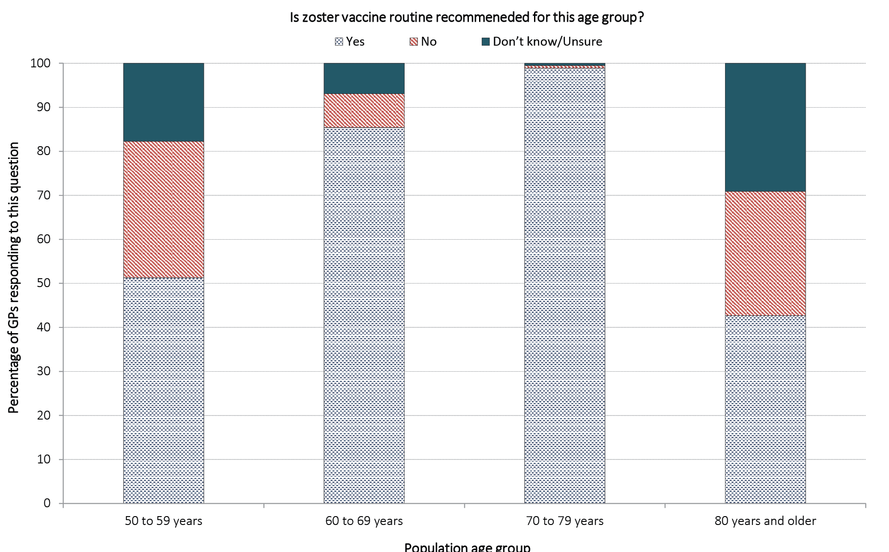
Figure 2: GPs’ knowledge about National Immunisation Program funding for zoster vaccination by age group
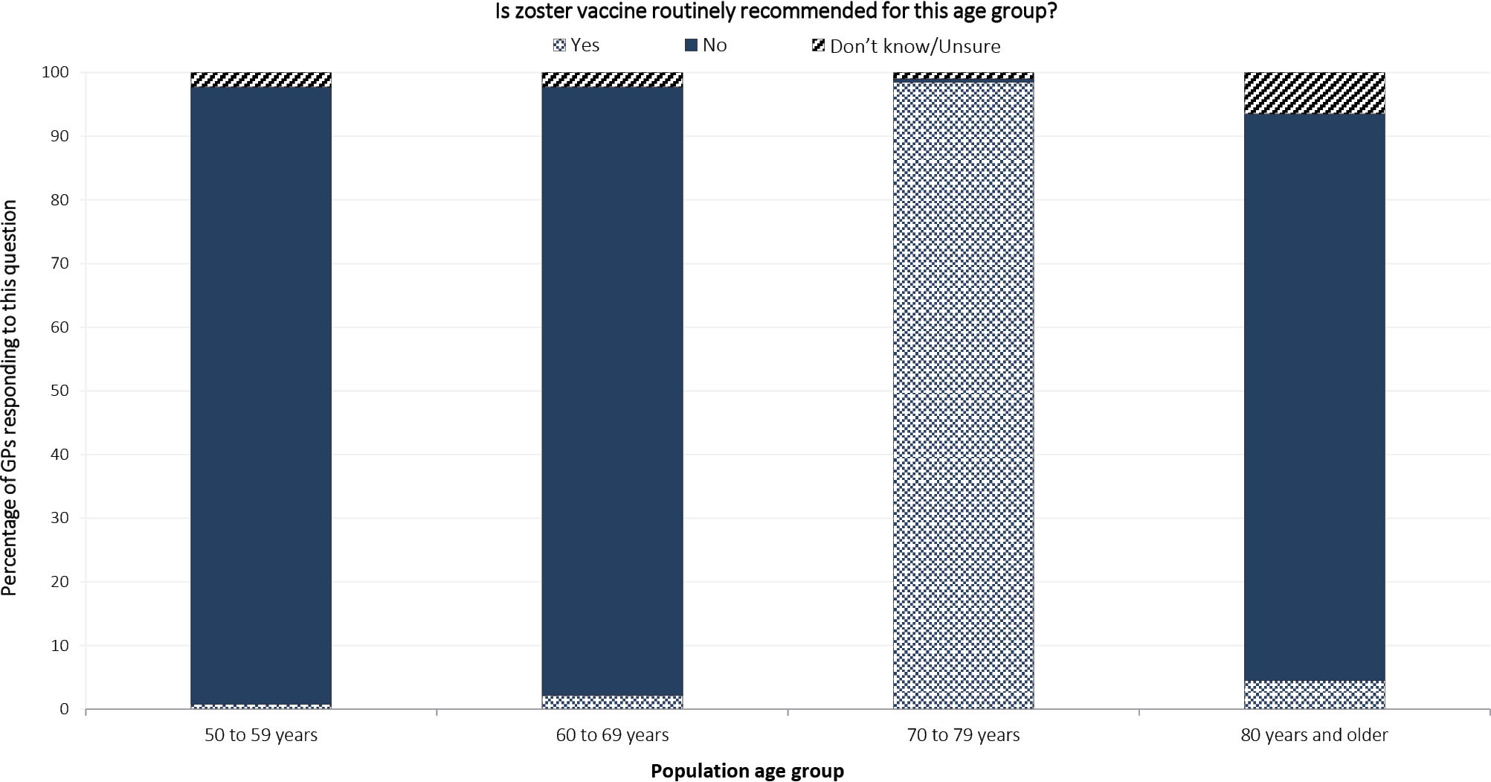
Table 1: Demographic characteristics of the surveyed GPs (n = 1,026)
Characteristics | n (%)
Male | 254 (24.8)
Female | 772 (75.2)
Age bands
25–34 years | 73 (7.1)
35–44 years | 236 (23.0)
45–54 years | 256 (25.0)
55–64 years | 336 (32.7)
≥ 65 years | 126 (12.2)
Location of practices
New South Wales | 357 (34.8)
Victoria | 289 (28.2)
Queensland | 189 (18.4)
Western Australia | 80 (7.8)
South Australia | 76 (7.4)
Tasmania | 18 (1.8)
Australian Capital Territory | 13 (1.3)
Northern Territory | 4 (0.4)
Types of practices
Private, independent, 5–9 GPs | 427 (41.6)
Private, independent, 2–4 GPs | 239 (23.3)
Private, independent, ≥ 10 GPs | 238 (23.2)
Private, independent, solo practice | 61 (5.9)
Aboriginal Medical Service | 12 (1.2)
Hospital-based clinic | 10 (1.0)
Other | 39 (3.8)
A minority of respondents had incorrect knowledge about the contraindications to zoster vaccination. Close to 1 in 20 (4.6%) disagreed with the Handbook’s recommendation that immunocompromised people should not receive zoster vaccine and 1 in 6 (16.0%) thought incorrectly that zoster vaccine could not be administered with influenza or pneumococcal vaccine. The majority of respondents reported providing advice regarding funded zoster vaccination to adults in the NIP target age group on at least a weekly basis (84.0% in relation to adults aged 70 years and 79.9% for those aged 71–79 years; Figure 3). However, 32.9% rarely and 2.6% never administered zoster vaccine to people aged 70–79 years, and 23.1% rarely, and 25.8% never reported zoster vaccination data to the AIR. A total of 187 respondents reported challenges experienced in the first year of the program. These challenges included: lack of timely availability of succinct information including advice on dangers of vaccination in immunocompromised individuals (37 respondents); supply issues including temporary shortages and supply irregularities (37); difficulty in applying and/or adhering to rigid age criteria in general practice (26); provider uncertainty about contraindications and risk of adverse events (18); public not being aware of the vaccine (10); cost barrier for individuals not covered under the NIP (10); patient concerns about safety (6); and provider concerns about efficacy (4).

Figure 3: GPs’ practices regarding the use of zoster vaccine
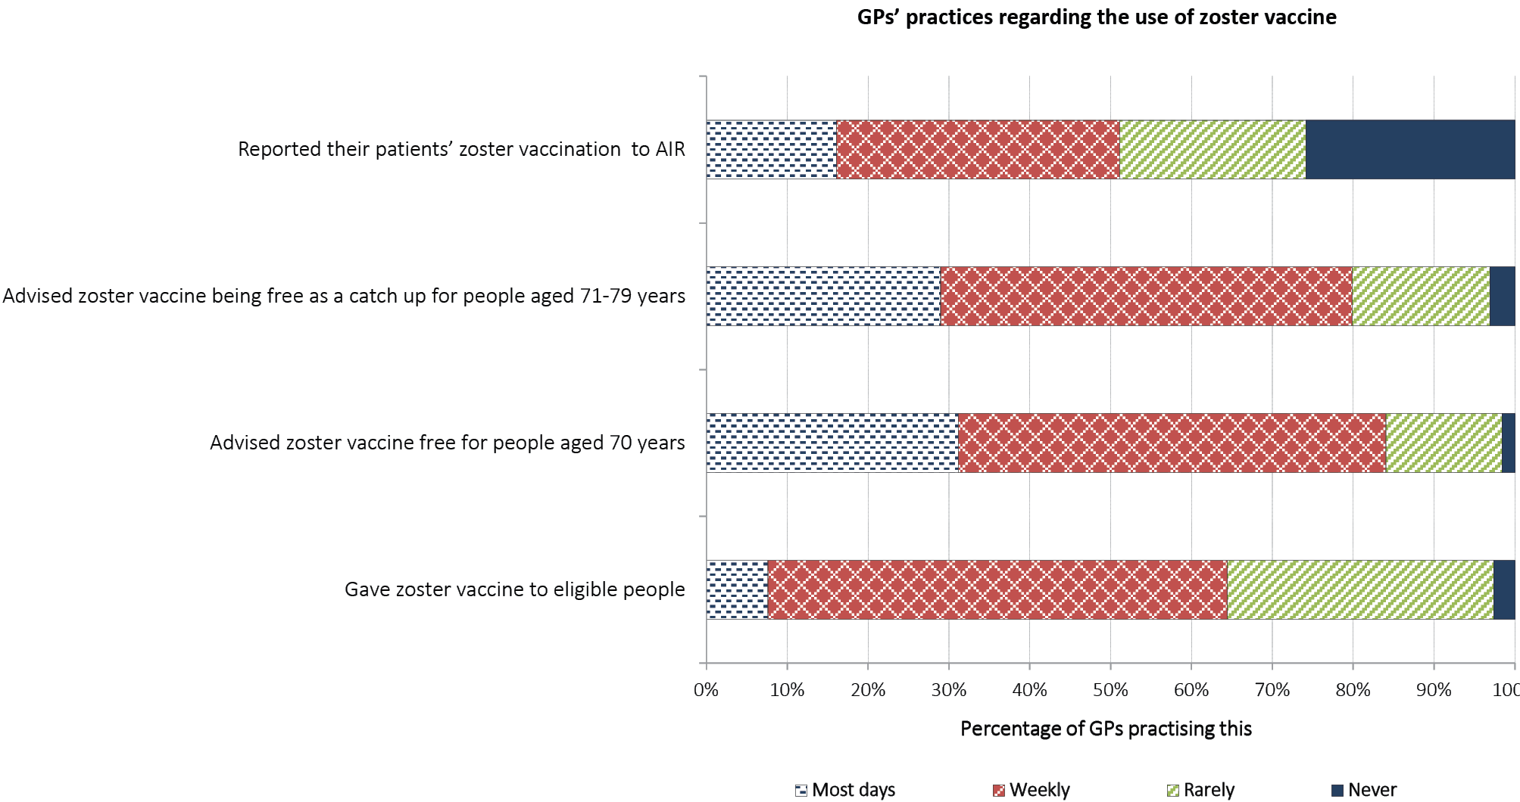
A total of 151 respondents provided recommendations for improvement of the program: these mainly focused on expansion of age eligibility (to both younger and older adults) and extension of the time period (currently planned to be 5 years) for NIP-funded catch-up vaccination of adults aged 71–79 years.

Discussion
Our study, conducted one year after the introduction of the national zoster vaccination program, found that most GPs surveyed were aware of the eligibility criteria for funded vaccinations under the NIP. However, there was more uncertainty around recommendations for vaccination, with just over half incorrectly stating that the vaccine is recommended and funded for 50 to 59 year olds and less than half of respondents aware that it is recommended for those aged ≥ 80 years. Uncertainty regarding the latter age group may be contributed to by Handbook wording that zoster vaccine is less efficacious in this age group, although they ‘may still receive some clinical benefit’.⁵ It may be appropriate to strengthen the wording of this recommendation given recent evidence suggesting that vaccine effectiveness against PHN is similar in the ≥ 80 years age group to that in younger age groups.¹³
We identified some other important knowledge gaps that are relevant to clinical practice, including that 16.0% of GP respondents were unaware that zoster vaccine can be administered with influenza or pneumococcal vaccine. More concerningly, about 1 in 20 of the GPs surveyed thought this live attenuated vaccine could be given to immunocompromised people, when it is clearly contraindicated in both the product information and the Handbook. These responses were obtained after the death in January 2017 of a 71-year-old Australian man with chronic lymphocytic leukaemia who developed disseminated varicella-zoster virus infection from the vaccine strain,^{14,15} resulting in numerous subsequent safety alerts and communications to immunisation providers.¹⁶
Over a third of GPs surveyed reported never or rarely administering zoster vaccine, and approximately 1 in 5 never or rarely advised that the vaccine is free to age-eligible patients. Further research to explore how much this reflects lack of penetration of recommendations versus differences in practice demographic profile would be of benefit. Almost half of respondents never or rarely reported zoster vaccinations to AIR. This is consistent with the considerable underreporting previously documented, with 1,427,234 doses of vaccine distributed from 1 October 2016 to 30 September 2018 but only 693,454 (48.6%) recorded in the AIR.¹⁷ Similar findings of likely underreporting of zoster vaccination to AIR have been reported from a national primary care dataset.¹⁸ Further research and engagement with immunisation providers is required so as to facilitate more complete reporting of zoster vaccinations to AIR.
In our study, the GPs surveyed considered application of the rigid age eligibility criteria under the NIP to be a key challenge of the program, and suggested that age eligibility be expanded to both younger and older adults. While this reflects the difficulty for GPs and other immunisation providers whenever there are age groups for which a vaccine is recommended but not funded under the NIP, expansion of eligibility beyond the 70–79 year age group would require reassessment of cost-effectiveness in these age groups.^{19,20} An in-depth study (preferably mixed methods) involving GPs who predominantly work with geriatric populations or residents of aged care facilities may help to contribute to understanding of current issues around age eligibility and other related challenges for giving this live attenuated vaccine to older Australians.
Our study is the first to report on the knowledge, attitudes and behaviour of Australian GPs in regards to zoster vaccination. Given this was a significant new national program and the first time a live vaccine has been recommended in older adults, this was important to assess, although a repeat survey would also be useful to assess any changes since 2017. While we surveyed GPs from all states and territories, and the age distribution of respondents was similar to that of Australian GPs overall,²¹ the sample might not be fully representative given the low response rate (7.9%), underrepresentation from some states/territories, and preponderance of female respondents (75%, though only 45% of GPs in Australia are female).²² Twelve respondents (1.2%) reported working in Aboriginal Medical Services. It is unclear given these limitations whether our findings might over-or underestimate knowledge of Australian GPs overall. Future research specifically targeting GPs working in Aboriginal and Torres Strait Islander health would be of benefit due to the higher risk of severe herpes zoster at a younger age in this population.²³
We encourage all GPs to recommend zoster vaccination to eligible patients without contraindications, in line with current Australian evidence-based guidelines,⁵ particularly for the NIP-funded 70–79 years cohort, and to report all vaccinations to the AIR to optimise monitoring of this preventive health intervention at both an individual and population level.

Acknowledgements
This survey formed part of a larger evaluation that was undertaken under the existing funding agreement between the National Centre for Immunisation Research and Surveillance (NCIRS) and the Australian Government Department of Health. The authors would like to thank Jennifer O’Dea for her help with study design and data collection.

Author details
Dr Harunor Rashid^{1,2} Dr Aditi Dey^{1,2} Dr Ramesh Manocha^{2,3} Dr Mohamed Tashani^{1,2} Prof Kristine Macartney^{1,2} Dr Frank Beard^{1,2}
- National Centre for Immunisation Research and Surveillance (NCIRS), Kids Research, The Children’s Hospital at Westmead, Sydney, New South Wales, Australia.
- Faculty of Medicine and Health, The University of Sydney, New South Wales, Australia.
- Healthed, PO Box 500, Burwood, New South Wales, Australia.

Corresponding author
Dr Harunor Rashid National Centre for Immunisation Research and Surveillance (NCIRS), Kids Research, The Children’s Hospital at Westmead, Locked Bag 4001, Westmead NSW, 2145, Australia. Email: harunor.rashid@health.nsw.gov.au Phone: +61 29845 1489.

References
- Cohen JI. Clinical practice: herpes zoster. N Engl J Med. 2013;369(3):255–63.
- Stein AN, Britt H, Harrison C, Conway EL, Cunningham A, Macintyre CR. Herpes zoster burden of illness and health care resource utilisation in the Australian population aged 50 years and older. Vaccine. 2009;27(4):520–9.
- National Centre for Immunisation Research and Surveillance (NCIRS). Significant events in zoster vaccination practice in Australia. Sydney: NCIRS; 2018. [Accessed on 7 May 2020.] Available from: http://www.ncirs.org.au/sites/default/files/2018-12/Zoster-history-Dec-2018.pdf.
- Jayasinghe S, Sheridan S, Macartney K. Herpes zoster vaccination in Australia: what’s available and who benefits? Aust Prescr. 2020;43(1):2–6.
- Australian Technical Advisory Group on Immunisation (ATAGI). The Australian Immunisation Handbook, 10th ed: Zoster (herpes zoster). [Internet.] Canberra: Australian Government Department of Health; 2018. [Accessed on 7 May 2020.] Available from: https://immunisationhandbook.health.gov.au/vaccine-preventable-diseases/zoster-herpes-zoster.
- Oxman MN, Levin MJ, Johnson GR, Schmader KE, Straus SE, Gelb LD et al. A vaccine to prevent herpes zoster and postherpetic neuralgia in older adults. N Engl J Med. 2005;352(22):2271–84.
- Morrison VA, Johnson GR, Schmader KE, Levin MJ, Zhang JH, Looney DJ et al. Long-term persistence of zoster vaccine efficacy. Clin Infect Dis. 2015;60(6):900–9.
- Dooling K, Guo A, Leung J, Belongia E, Harpaz R. Performance of zoster vaccine live (Zostavax): a systematic review of 12 years of experimental and observational evidence. Open Forum Infect Dis. 2017;4(Suppl 1):S412–3.
- Willis ED, Woodward M, Brown E, Popmihajlov Z, Saddier P, Annunziato PW et al. Herpes zoster vaccine live: a 10 year review of post-marketing safety experience. Vaccine. 2017;35(52):7231–9.
- Strezova A, Godeaux O, Aggarwal N, Leroux-Roels G, Lopez-Fauqued M, Van Damme P et al. A randomized lot-to-lot immunogenicity consistency study of the candidate zoster vaccine HZ/su. Vaccine 2017;35(48 Pt B):6700–6.
- NCIRS. Evaluation of the national shingles vaccination program process and early impact evaluation. Sydney: NCIRS; 2019. [Accessed on 7 May 2020.] Available from: http://ncirs.org.au/sites/default/files/2019-03/ZOS_201903_EvaluationNationalShinglesVaccinationReportFINAL.pdf.
- NCIRS. Program evaluation. [Internet.] Sydney: NCIRS. [Accessed on 14 May 2020.] Available from: http://ncirs.org.au/our-work/program-evaluation.
- Klein NP, Bartlett J, Fireman B, Marks MA, Hansen J, Lewis E et al. Long-term effectiveness of zoster vaccine live for postherpetic neuralgia prevention. Vaccine. 2019;37(36):5422–7.
- Alexander KE, Tong PL, Macartney K, Beresford R, Sheppeard V, Gupta M. Live zoster vaccination in an immunocompromised patient leading to death secondary to disseminated varicella zoster virus infection. Vaccine. 2018;36(27):3890–93.
- Dey A, Wang H, Quinn H, Hiam R, Wood N, Beard F, et al. Surveillance of adverse events following immunisation in Australia annual report, 2017. Commun Dis Intell (2018). 2019;43. doi: https://doi.org/10.33321/cdi.2019.43.29.
- Therapeutic Goods Administration (TGA). Zostavax vaccine. Safety advisory – not to be used in patients with compromised immune function. [Internet.] Canberra: Australian Government Department of Health, TGA; 2017. [Accessed on 16 February 2020.] Available from: https://www.tga.gov.au/alert/zostavax-vaccine.
- NCIRS. Exploratory analysis of the first 2 years of adult vaccination data recorded on AIR. Sydney: NCIRS; 2019. [Accessed on 14 May 2020.] Available from: http://www.ncirs.org.au/sites/default/files/2019-12/Analysis%20of%20adult%20vaccination%20data%20on%20AIR_Nov%202019.pdf.
- Lin J, Wood JG, Bernardo C, Stocks NP, Liu B. Herpes zoster vaccine coverage in Australia before and after introduction of a national vaccination program. Vaccine. 2020;38(20):3646–52.
- Nolan TM. The Australian model of immunization advice and vaccine funding. Vaccine. 2010;28(Suppl 1):A76–83.
- Pharmaceutical Benefits Advisory Committee (PBAC). Public Summary Document – November 2014 PBAC Meeting: 7.9 Zoster Virus Vaccine Live. Canberra: Australian Government Department of Health, Pharmaceutical Benefits Scheme, PBAC; 2014. [Accessed on 16 February 2020.] Available from: http://www.pbs.gov.au/industry/listing/elements/pbac-meetings/psd/2014-11/files/zoster-vaccine-psd-11-2014.pdf.
- Australian Government Department of Health. General practice: 2016 Factsheet. Canberra: Australian Government Department of Health; 2017. [Accessed on 14 May 2020.] Available from: https://hwd.health.gov.au/webapi/customer/documents/factsheets/2016/General%20practice.pdf
- Royal Australian College of General Practitioners (RACGP). General Practice: Health of the Nation 2017. Melbourne: RACGP; 2017. [Accessed on 14 May 2020.] Available from: https://www.racgp.org.au/FSDEDEV/media/documents/Special%20events/Health-of-the-Nation-2017-report.pdf.

Communicable Diseases Intelligence
ISSN: 2209-6051 Online

Communicable Diseases Intelligence (CDI) is a peer-reviewed scientific journal published by the Office of Health Protection, Department of Health. The journal aims to disseminate information on the epidemiology, surveillance, prevention and control of communicable diseases of relevance to Australia.

Editor: Tanja Farmer
Deputy Editor: Simon Petrie
Design and Production: Kasra Yousefi
Editorial Advisory Board: David Durrheim, Mark Ferson, John Kaldor, Martyn Kirk and Linda Selvey

Website: http://www.health.gov.au/cdi

Contacts
Communicable Diseases Intelligence is produced by:
Health Protection Policy Branch, Office of Health Protection, Australian Government Department of Health
GPO Box 9848, (MDP 6) CANBERRA ACT 2601

Email: cdi.editor@health.gov.au

Submit an Article
You are invited to submit your next communicable disease related article to the Communicable Diseases Intelligence (CDI) for consideration. More information regarding CDI can be found at: http://health.gov.au/cdi.
Further enquiries should be directed to: cdi.editor@health.gov.au.

This journal is indexed by Index Medicus and Medline.

Creative Commons Licence - Attribution-NonCommercial-NoDerivatives CC BY-NC-ND
© 2020 Commonwealth of Australia as represented by the Department of Health
This publication is licensed under a Creative Commons Attribution-NonCommercial-NoDerivatives 4.0 International Licence from https://creativecommons.org/licenses/by-nc-nd/4.0/legalcode (Licence). You must read and understand the Licence before using any material from this publication.

Restrictions
The Licence does not cover, and there is no permission given for, use of any of the following material found in this publication (if any):
- the Commonwealth Coat of Arms (by way of information, the terms under which the Coat of Arms may be used can be found at www.itsanhonour.gov.au);
- any logos (including the Department of Health’s logo) and trademarks;
- any photographs and images;
- any signatures; and
- any material belonging to third parties.

Disclaimer
Opinions expressed in Communicable Diseases Intelligence are those of the authors and not necessarily those of the Australian Government Department of Health or the Communicable Diseases Network Australia. Data may be subject to revision.

Enquiries
Enquiries regarding any other use of this publication should be addressed to the Communication Branch, Department of Health, GPO Box 9848, Canberra ACT 2601, or via e-mail to: copyright@health.gov.au

Communicable Diseases Network Australia
Communicable Diseases Intelligence contributes to the work of the Communicable Diseases Network Australia.
http://www.health.gov.au/cdna

