Surveillance system enhancements for Q fever in NSW, 2005-2015
Henry C. M. Clutterbuck, Keith Eastwood, Peter D. Massey, Kirsty Hope and Siobhan M. Mor

Abstract

Introduction
Q fever remains an important notifiable, zoonotic disease in Australia. Previous epidemiological reviews have noted increased importance of non-abattoir contact with livestock and native/feral animals. Changes to surveillance in New South Wales (NSW) have provided enhanced surveillance data with which to examine exposure pathways.

Methods
Descriptive analysis of NSW Q fever notification data for the period 2005-2015, with detailed analysis of exposures for the period 2011-2015 (after introduction of improvements to surveillance).

Results
Between 2005 and 2015, 1,653 confirmed cases of Q fever were notified in NSW residents who acquired the disease in this state. For the period 2011-2015, a high-risk occupation was reported in 345/660 (52.3%) of notifications with a known occupation. Of 641 cases with a known animal exposure, 345 (53.8%) had direct contact with livestock, while 62 (9.7%) had indirect contact with livestock (e.g. proximity to livestock, livestock holding areas or trucks). Direct or indirect contact with native/feral animals was reported in 111/641 (17.3%) cases. Mowing and close proximity to kangaroos/wallabies were commonly reported indirect exposure pathways, particularly in urban areas.

Conclusion
Enhancements to the state based surveillance database in NSW introduced in 2010 have resulted in improved collection of surveillance data for Q fever. Further refinement of Q fever surveillance can be achieved through continuing to improve data quality, standardising data collection and better elucidating exposure pathways of cases.
Keywords: Q fever; Coxiella burnetii; exposure; surveillance; Q fever vaccin

Summary
Q fever remains an important notifiable condition in NSW, especially in rural/regional areas but is also being reported in urban settings. Enhanced surveillance initiatives require collection of data that correlate to risk and information related to prevention strategies.

Introduction
Q fever is a zoonotic disease caused by the Gram-negative, intracellular bacterium, Coxiella burnetii.¹ It has a low infectious dose requiring as few as one bacterium to cause infection.² Approximately 40% of those infected will show clinical symptoms but presentation can vary from a mild influenza-like disease to severe illness requiring hospitalisation.³ The main route of transmission for C. burnetii to humans is inhalation of contaminated aerosols or dust from infected animals, their tissues or products.³ Aerosols can spread over wide areas under certain conditions.⁴ Domestic ruminants, such as cattle, sheep and goats, are considered to be the main source for human infections;⁵ however, C. burnetii has been identified in a diverse range of vertebrates including pigs, cats (domestic and feral), dogs, rabbits, foxes, rodents, deer birds and native Australian animals including kangaroos and wallabies.^{6,7}
In Australia, vaccination of people at risk of Q fever is the principal disease prevention strategy available. Abattoir and other meat industry workers were the main focus of the National Q Fever Management Program conducted in this country between 2001 and 2004. Whilst the program was running, the overall trend of reported Q fever cases decreased nationally.⁸ However, since 2009 the number of human notifications in Australia has been increasing for reasons which remain unclear.⁹ Most cases originate in Queensland and New South Wales (NSW).¹⁰
Q fever is a notifiable condition in all Australian states and territories. In NSW, Q fever surveillance data are collected by public health units (PHU) through telephone interview of the treating doctor and case. Currently there is not a standard surveillance form for this purpose. As the actual time and place of exposure is not usually known, the most obvious exposure is recorded by the PHU as being the presumed source of infection. Previous epidemiological reviews of NSW surveillance data captured prior to 2010, have noted increased importance of non-abattoir contact with livestock, wildlife or feral animals.^{11, 12} However, this work was limited by incomplete collection of surveillance data such as occupation and vaccination.
Following revisions to the NSW Public Health Act in 2010, an enhanced surveillance data system (Notifiable Conditions Information Management System, NCIMS) was introduced. These changes enabled detailed exposure data to be recorded and routine data quality checks to be incorporated. These factors together led to a greater concentration on the surveillance of exposure factors for many diseases, including Q fever. In this paper, we interrogated NCIMS data with a view to informing a regional and national approach to Q fever surveillance that is built on collection of an expanded minimum data set.

Methods
For this study, case records were extracted from NCIMS for all confirmed cases with onsets 1 January 2005 – 31 December 2015 and anonymised. Confirmed cases were defined as those that met the national case definition, which encompasses: (1) laboratory definitive evidence (detection of C. burnetii by nucleic acid testing, OR seroconversion or significant increase in antibody level to Phase II antigen in paired sera tested in parallel in the absence of recent Q fever vaccination, OR detection of C. burnetii by culture); OR (2) laboratory suggestive evidence (detection of specific IgM in the absence of recent Q fever vaccination) AND clinical evidence (a clinically compatible disease).¹³ Cases that did not meet this case definition and those who were exposed outside of NSW were excluded from the study.
Data extracted from NCIMS included: age, gender, Aboriginal and Torres Strait Islander status, hospitalisation, symptoms, vaccination status, occupation, high risk occupation, local government area (LGA) of residence, putative exposures (e.g. type of animal and nature of contact) and free text notes that include additional surveillance information, such as hospitalisation and other exposures, noted by the patient’s clinician.
Data were extracted and cleaned using Microsoft® Excel 2011 (Microsoft, Washington, USA). The free text notes for each case were manually examined and used to inform or enhance data entered into other fields. Data captured in the “occupation” field, “high risk occupation” field and the free text notes were aggregated to form one combined “occupation” field. This was then re-categorised using a standardised definition into “high risk” or “other” occupations. High risk occupation was one which involved direct contact with farmed livestock (cattle, sheep, goats, farmed deer) or their products (see Supplementary Table 1). We further interrogated the nature of the exposures in cases where contact with animals was noted. Data captured in “animal exposure setting”, “animal contact” and the free text notes were combined into one “nature of animal contact” field. The animal type (livestock, native/feral animal, companion animal, other) and nature of the contact (direct or indirect) was then identified based on a standardised definition developed by this study (see Supplementary Table 1). Where more than one putative exposure was noted, these were recorded as “multiple” in the new “nature of animal contact” field.
Table 1: Q fever notifications in New South Wales residents, by local government area classification, 2005-2015.
Local Government Area Classification | Number (%) of notifications | Notifications per 100,000  persons per year | Relative Risk (95% CI) | p-value
Urban
Metropolitan Developed | 41 (2.5) | 0.12 | Ref | NA
Regional Town/City | 806 (48.8) | 3.56 | 29.9 (21.8, 40.9) | <0.001
Fringe | 49 (3.0) | 0.31 | 2.6 (1.7, 4.0) | <0.001
Rural
Agricultural | 738 (44.6) | 13.0 | 108.8 (79.5, 149.0) | <0.001
Remote | 19 (1.2) | 21.3 | 178.5 (103.6, 307.6) | <0.001
Total | 1,653 | 2.11
Only those cases that were acquired in NSW were included in the analysis ( n =1,653).
Analysis was performed in Excel 2011 and R version 3.3.2 (R Foundation for Statistical Computing, Vienna, Austria). Data were separated into 2 groups, 1 January 2005 - 31 December 2010 and 1 January 2011 - 31 December 2015. The latter period followed the introduction of improved data collection methods, which allowed more detailed evaluation of putative exposures. Data were summarised using counts and proportions. Notification rates were calculated using Australian Bureau of Statistics data for each year as the denominator.¹⁴
To analyse the spatial distribution, cases were aggregated by LGA. Categorisation and sub-categorisation of LGAs was made according to Comparative Information on NSW Local Government Councils 2010/2011 available from the NSW state government.¹⁵ Urban LGAs were sub-categorised as: metropolitan developed, regional town/city and fringe; whilst rural LGAs were sub-categorised as: agricultural and remote. Cumulative incidence of Q fever was mapped by LGA using ArcGIS® software (ESRI, California, USA). Relative risk (RR) comparing cumulative incidence in each sub-category to metropolitan developed were calculated using 2x2 tables, with 95% confidence intervals (95% CI) and p-values generated in R.
Data utilised in this study were collected under the NSW Public Health Act 2010. Ethics approval for this study was granted by the University of Sydney Human Research Ethics Committee (Project No: 2015/929).

Results
Between 2005 and 2015, 1,653 confirmed cases of Q fever were notified in NSW residents who acquired the disease in this state. This corresponds to annual notification rates ranging from 1.41 to 2.81 per 100,000 population across the study period, with a sustained increase seen from 2013 (Figure 1). Males comprised 75.4% of all notifications, and the highest numbers of notifications were in the 45-49, 50-54 and 55-59 year age groups (Figure 2).

Figure 1: Q fever notifications and rates in New South Wales residents, by year, 2005-2015.
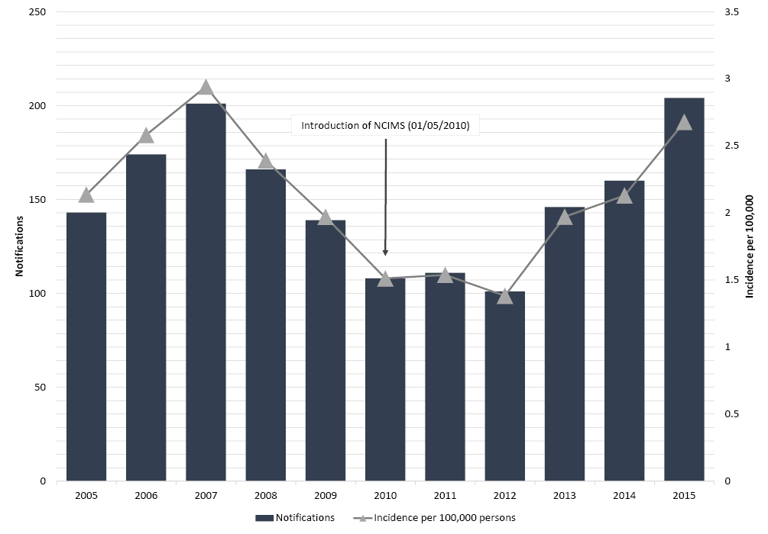
Only those cases that were acquired in NSW were included in the analysis ( n =1,653).
NCIMS – Notifiable Conditions Information Management System

Figure 2: Q fever notifications in New South Wales residents, by age and gender, 2005-2015.
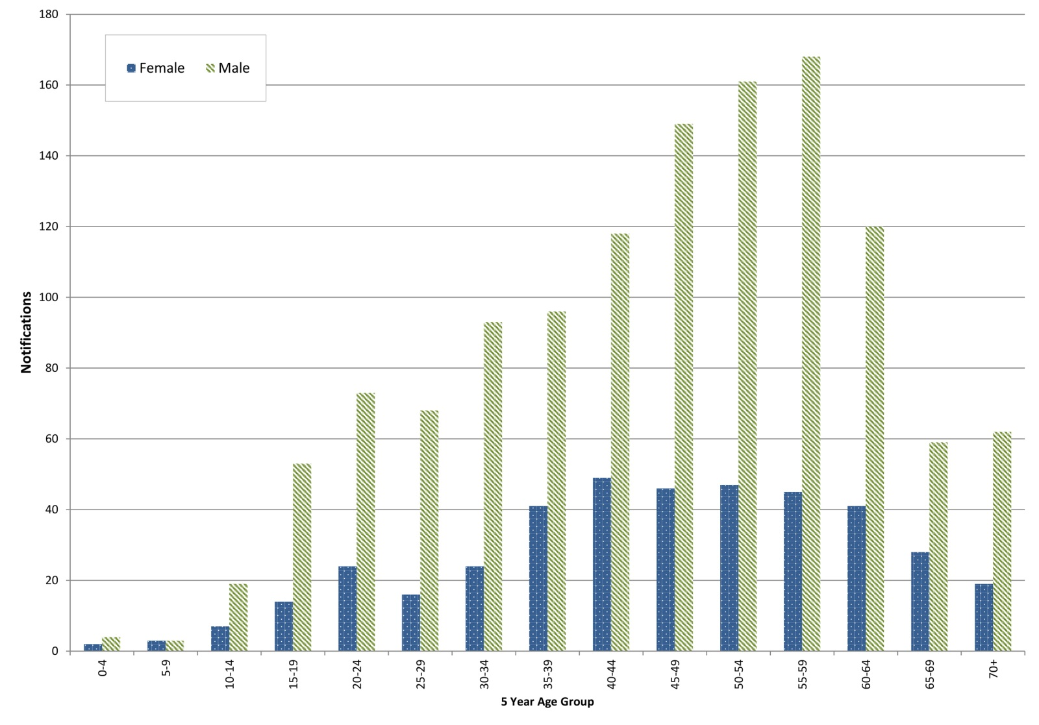
Only those cases that were acquired in NSW and which had a known gender were included in the analysis ( n =1,652*).
*One case had no gender reported.
Cumulative Q fever notification rates for the full 11 year study period (2005-2015) have been collated in Figure 3 to show geographical trends, with higher rates in the west and north-west of NSW. In rural LGAs, the notification rate was 1.19 per 100,000 population per year which was significantly higher than in urban LGAs (0.20 per 100,000 per year; RR 11.39; 95% CI 9.97, 13.01, p < 0.001). Within urban LGAs there was substantial variation in incidence (Table 1). The actual exposure location was unable to be determined using the current surveillance data.

Figure 3: Cumulative incidence of Q fever notifications per 100,000 residents in New South Wales.
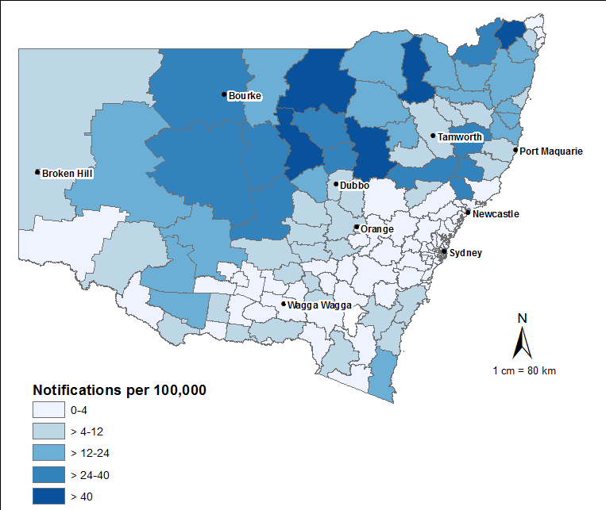
Only those cases that were acquired in NSW were included in the analysis (n=1,653).
For the period 2011-2015, 722 Q fever cases were reported as being acquired in NSW. Aboriginal and/or Torres Strait Islander Australians accounted for 25 of these notifications (3.5%, the same as the population percentage). Of the 722 reported cases, 336 (46.5%) were hospitalised. Symptoms reported included: fever (n=638; 88.4%); headache (517; 71.6%); malaise (487; 67.5%); chills (537; 74.4%); and lethargy (559; 77.4%). Abnormal liver function tests were reported in 447 cases (61.9%). Q fever vaccination status was reported in 670/722 cases (92.8%), of whom 10 (1.5%) were recorded as being vaccinated.
Putative sources of exposure are shown in Table 2 and Figure 4. Prior to the introduction of NCIMS (2005-2010) the proportion of cases with an unknown exposure source ranged from 64.9% in 2006 to 32.4% in 2010, with an average of 49.1%. After the introduction of NCIMS (2011-2015) the proportion of cases with an unknown exposure source ranged from 17.1% in 2011 to 7.8% in 2015, with an average of 11.9% (Figure 4). Between 2011-2015, a high-risk occupation was reported in only 345/660 (52.3%) of notifications with a known occupation (Table 2). Of 641 with a known animal exposure, 345 (53.8%) had direct contact with livestock (Table 2). Examples of transmission following indirect contact with livestock – reported in 62 cases – included being in proximity to livestock, livestock holding areas or trucks (23 cases) and laundering clothing contaminated by livestock waste (8 cases). Direct or indirect contact with native/feral animals was reported in 111/641 (17.3%) cases with a known exposure to animals (Table 2). Changes to NCIMS (2011-2015) appeared to enhance capture of data on indirect exposure to native/feral animals, particularly in urban areas (Figure 4). Of the 59 cases that had indirect contact with native/wild animals, mowing areas contaminated by faeces of native animals (26 cases) and close proximity to kangaroos/wallabies or their faeces (21 cases) were the most common exposures noted. Fifteen (2.3%) cases had direct contact with companion animals, while a further 86 cases had multiple putative exposures (e.g. livestock and native animals) (Table 2).
Table 2: Q fever notifications by occupation, animal exposure and local government area (LGA) classification in New South Wales, 2011-2015 (n=722).
LGA Classification | Urban |  |  | Rural |  | Total
LGA Sub-Classification | Metropolitan Developed | Regional Town/City | Fringe | Agricultural | Remote
Total | 18 | 366 | 18 | 315 | 5 | 722
Occupation
High risk occupation | 5 | 131 | 9 | 198 | 2 | 345
Other occupation | 11 | 199 | 9 | 95 | 1 | 315
Unknown * | 2 | 36 | 0 | 22 | 2 | 62
Animal exposure
Yes | 18 | 315 | 17 | 287 | 4 | 641
No | 0 | 28 | 0 | 12 | 0 | 40
Unknown * | 0 | 23 | 1 | 16 | 1 | 41
Nature of animal exposure
Livestock - direct | 7 | 136 | 8 | 193 | 1 | 345
Livestock - indirect | 1 | 30 | 4 | 27 | 0 | 62
Livestock - contact not specified | 0 | 8 | 1 | 7 | 0 | 16
Native/feral animal - direct | 1 | 11 | 0 | 2 | 0 | 14
Native/feral animal - indirect | 4 | 46 | 3 | 6 | 0 | 59
Native/feral animal - contact not specified | 2 | 30 | 0 | 5 | 1 | 38
Companion animal, including horses | 0 | 10 | 1 | 4 | 0 | 15
Other | 0 | 3 | 0 | 3 | 0 | 6
Multiple | 3 | 41 | 0 | 40 | 2 | 86
The nature of animal exposure is also detailed for 641 cases that reportedly had contact with animals.
*Includes cases where data were missing or stated as unknown.
See Supplementary table for detailed explanation of classifications

Figure 4: Q fever proportions by type of animal exposure and local government area (LGA; A: Rural, B: Urban) classification in New South Wales, 2005-2015.
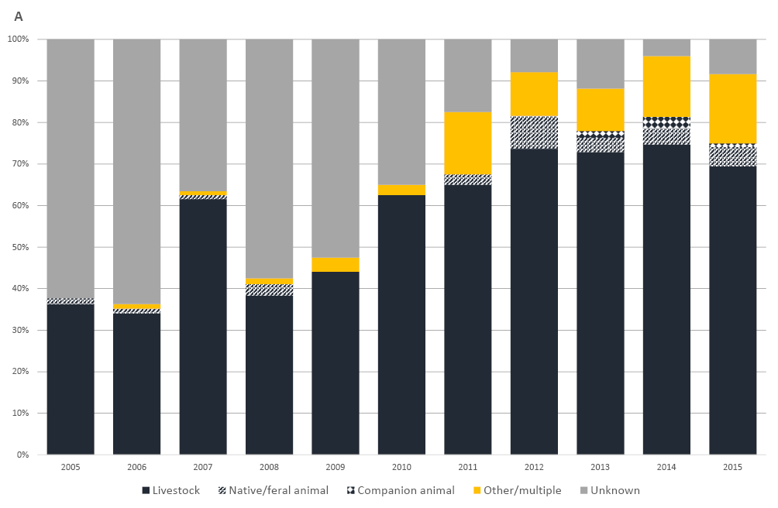
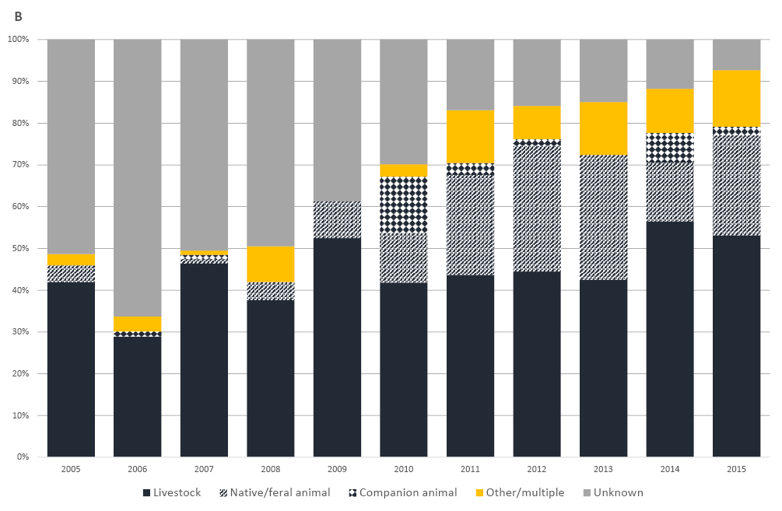

Discussion
Q fever remains an important notifiable condition in NSW, in particular in rural and regional areas of NSW. In this study, we interrogated the enhanced NCIMS system to investigate exposure risks in detail. While exposure risks largely confirm findings reported previously,^{12, 16} the study indicates that changes introduced to NCIMS in 2010 have led to improvements in collection of surveillance data for Q fever in NSW. Further, construction of the high risk occupation/exposure categories as done in this study could be used as the basis for development of a standardised tool to support collection of a national minimum data set for Q fever.
Enhanced data collection since 2010, has allowed for improved capture of vaccination status. This was identified as an issue in previous reviews conducted in NSW prior to 2010, where vaccination status was recorded for only 34% of cases.¹² Only 10 cases of Q fever were reported in vaccinated people during the period 2011-2015. It is not possible to determine whether the 10 cases reporting vaccination were true vaccine failures. Q-Vax has been reported to have 100% protection for at least 5 years due to its ability to stimulate long lasting T lymphocyte memory.¹⁷ It is possible that the cases were not vaccinated as public health units are not required to verify vaccination with the GP or the Q fever registry. Some of the cases reported being vaccinated more than 20 years prior to symptoms developing. There has been some suggestion that periodic exposure is needed to maintain immunity.¹⁸ As the questionnaire does not collect information on exposures outside of the incubation period, information around frequency of exposure to risk settings, and thus potential lack of “natural boosting” was not able to be explored.
Data relating to occupation were improved from previous studies through the analysis of free text notes and “occupation” fields. This resulted in 91.4% of cases in the period 2011-2015 having a known occupation compared to almost half being missing in previous studies.¹²
Nonetheless, reporting of no “high risk occupation” in 47.7% of cases supports the view that occupation is a poor proxy for exposure.¹⁶ It suggests that a change in the exposure profile of cases, or surveillance system enhancements have led to improvements in capture of non-livestock exposures.
Residence in a rural agricultural/remote LGA or regional town/city LGA was identified again as a risk factor for contracting Q fever. This has previously been described¹⁹ and is consistent with the increased (occupational or incidental) contact with livestock, and potentially wildlife. Most notifications in rural LGAs were employed in high-risk occupations or had direct exposure to livestock during the exposure period. This suggests access to skilled clinicians who can conduct testing and administer the vaccine is important in these areas. In those cases where proximity to livestock, livestock facilities (e.g. farms and abattoirs) or trucks was reported, it is possible that contaminated dust or aerosols, blown by wind from high risk sources, was the exposure pathway, as has been reported previously.⁴
Native animals have previously been implicated as a source of C. burnetii in NSW.²⁰⁻²² In this report, native animals were identified as the likely exposure for many cases, particularly in urban LGAs. Specifically, mowing was identified as the possible exposure activity in many cases and should be considered for inclusion in routine surveillance data collection activities. Additionally, ongoing refinement of surveillance questions should aim to tease out the specifics of urban exposures, particularly around wild animal contact to better understand potential threats in apparent low risk settings.
Whilst there is still incomplete data, reduction in incomplete and unknown cases demonstrates that the introduction of NCIMS has allowed not only a more detailed but also more complete data collection tool. This has allowed for a much improved overview of the epidemiology of Q fever in NSW. Nonetheless, many cases are still reported that have no clear exposure risk, suggesting that other, currently unknown pathways may exist. This study has some limitations. We divided cases into those which were notified in the 6 years prior to (2005-2010) and 5 years after (2011-2015) the introduction of the enhanced NCIMS system. As these changes were introduced in mid-2010, there was a brief period of enhanced data capture that marginally impacts 2010 findings. This may explain some of the decrease in terms of cases with unknown exposure in that year. In addition, cases are classified by address of residence and not exposure site as this is often unknown. It is also possible that the perceived exposure risk may not have been the actual source of infection. As with other surveillance systems not all cases will have been reported, and this is particularly true for a disease like Q fever where a high proportion of cases go undiagnosed.
In conclusion, this study has shown that enhancements to NCIMS introduced in 2010 have resulted in improved collection of surveillance data for Q fever. This is useful to inform public health prevention strategies. Whilst a large proportion of notifications were in people undertaking high risk occupations or directly contacting livestock, a significant number of cases, especially in urban settings, did not report this exposure. Further refinement of Q fever surveillance can be achieved through continuing to improve data quality, standardising data collection and elucidating exposure pathways in cases.

Acknowledgements
The authors thank Kelly Simpson for creating the spatial distribution map.

Authors details
Henry C. M. Clutterbuck^{1, 2}, Keith Eastwood^{3, 4}, Peter D. Massey^{3, 5}, Kirsty Hope⁶ and Siobhan M. Mor^{1,2}
- School of Veterinary Science, Faculty of Science, The University of Sydney, NSW, Australia
- Marie Bashir Institute for Infectious Diseases and Biosecurity, The University of Sydney, NSW, Australia
- Hunter New England Population Health, NSW, Australia
- University of Newcastle, NSW, Australia
- School of Health, University of New England, NSW, Australia
- Health Protection NSW, New South Wales Ministry of Health, Australia

Corresponding author
Keith Eastwood
keith.eastwood@hnehealth.nsw.gov.au
Phone: 0249246564

References
- Woldehiwet Z. Q fever (coxiellosis): epidemiology and pathogenesis. Res Vet Sci. 2004; 77(2):93-100.
- Brooke RJ, Kretzschmar ME, Mutters NT, Teunis PF. Human dose response relation for airborne exposure to Coxiella burnetii. BMC Infect Dis. 2013; 13:488.
- Angelakis E, Raoult D. Q fever. Vet Microbiol. 2010; 140(3):297-309.
- O’Connor BA, Tribe IG, Givney R. A windy day in a sheep saleyard: an outbreak of Q fever in rural South Australia. Epidemiol Infect. 2015; 143(2):391-398.
- Raoult D, Tissot-Dupont H, Foucault C, Gouvernet J, Fournier PE, Bernit E, et al. Q Fever 1985-1998: Clinical and Epidemiologic Features of 1,383 Infections. Medicine. 2000;79(2):109-123.
- Bøtner A, Broom D, Doherr MG, Domingo M, Hartung Jr, Keeling L, et al. Scientific Opinion on Q fever. EFSA Journal. 2010;8(5):1595-1709.
- Cooper A, Goullet M, Mitchell J, Ketheesan N, Govan B. Serological evidence of Coxiella burnetii exposure in native marsupials and introduced animals in Queensland, Australia. Epidemiol Infect. 2012; 140(7):1304-1308.
- Gidding HF, Wallace C, Lawrence GL, McIntyre PB. Australia’s national Q fever vaccination program. Vaccine. 2009; 27(14):2037-2041.
- National Notifiable Disease Surveillane System. Number of notifications for all diseases by year, Australia, 1991 to 2015 and year-to-date notifications for 2016. 2016.
- Sloan-Gardner TS, Massey P, Knope K. Understanding Q fever in Australia 1991 to 2013. Communicable Disease and Control Conference 2015; Brisbane2015.
- Lin M, Delpech V, McAnulty J, Campbell-Lloyd S. EpiReview: Notifications of Q Fever in New South Wales, 1991–2000. NSW Public Health Bull. 2001; 12(6):172-175.
- Lowbridge CP, Tobin S, Seale H, Ferson MJ. Notifications of Q fever in NSW, 2001–2010. NSW Public Health Bull. 2012; 23(1-2):31-35.
- The Department of Health. Q fever case definition summary 2016 [Available from:
http://www.health.gov.au/internet/main/publishing.nsf/content/cda-surveil-nndss-casedefs-cd_qfev.htm
- Australian Bureau of Statistics. Australian Demographic Statistics. 2005-2015;cat. no. 3101.0.
- Division of Local Government. Comparative Information on NSW Local Governement Councils 2010/11. Department of the Premier and Cabinet; 2012.
- Sloan-Gardner TS, Massey PD, Hutchinson P, Knope K, Fearnley E. Trends and risk factors for human Q fever in Australia, 1991-2014. Epidemiology and infection. 2016; 145:787-795.
- Marmion BP, Ormsbee RA, Kyrkou M, Wright J, Worswick DA, Izzo AA, et al. Vaccine prophylaxis of abattoir-associated Q fever: eight years’ experience in Australian abattoirs. Epidemiol Infect. 1990; 104(2):275-287.
- Ackland JR, Worswick DA, Marmion BP. Vaccine prophylaxis of Q fever. A follow-up study of the efficacy of Q-Vax (CSL) 1985-1990. Med J Aust. 1994; 160(11):704-708.
- Karki S, Gidding HF, Newall AT, McIntyre PB, Liu BC. Risk factors and burden of acute Q fever in older adults in New South Wales: a prospective cohort study. Med J Aust. 2015; 203(11):438.
- Graves SR, Islam A. Endemic Q Fever in New South Wales, Australia: A Case Series (2005-2013). Am J Trop Med Hyg. 2016; 95(1):55-59.
- Stevenson S, Gowardman J, Tozer S, Woods M. Life-threatening Q fever infection following exposure to kangaroos and wallabies. BMJ Case Rep. 2015.
- Flint J, Dalton CB, Merritt TD, Graves S, Ferguson JK, Osbourn M, et al. Q fever and contact with kangaroos in New South Wales. Commun Dis Intell Q Rep. 2016; 40(2): E202-203.
Supplementary table 1: NCIMS field aggregation and definitions used for classification of content
New field | NCIMS fields included | Classification | Definition used in this study
Occupation | High risk occupation Occupation Free text Notes | High risk occupation | Occupation involving direct contact with farmed livestock or their products (cattle, sheep, goats, farmed deer), including: abattoir worker, farmer/grazier, livestock carrier/handler/transporter/breeder, rouseabout/shearer/wool classer, farm manager, stockyard worker, tannery worker, veterinarian/veterinary student/veterinary nurse, contractors attending livestock facilities
 |  | Other occupation | All other noted occupations
Nature of animal contact | Animal exposure setting Animal contact Animal contact_calving Animal contact description Animal Contact_notes Free text notes | Livestock - direct | Direct contact with cattle, sheep, goats and farmed deer or their birthing products or vaginal fluids, skins or fleeces, meat or products (e.g. slaughtering, assisting with calving)
 |  | Livestock - indirect | Indirect contact with cattle, sheep, goats and farmed deer (e.g. proximity to livestock or livestock facilities, launders clothes contaminated by livestock faeces)
 |  | Livestock - contact not specified | No contact situation noted
 |  | Native/feral animal - direct | Direct contact with tissues or blood of native/feral animals e.g. hunting, butchering
 |  | Native/feral animal - indirect | Indirect contact with native/feral animals e.g. hiking, mowing areas contaminated by faeces
 |  | Native/feral animal - contact not specified | No contact situation noted
 |  | Companion animal | Direct or in direct contact with dogs, cats, horses,
 |  | Other | Other animal exposure not otherwise classified (e.g. ticks)
 |  | Multiple | More than one of the above categories

© Commonwealth of Australia 2018 - ISSN: 2209-6051 (Online)
This work is copyright. You may download, display, print and reproduce the whole or part of this work in unaltered form for your own personal use or, if you are part of an organisation, for internal use within your organisation, but only if you or your organisation do not use the reproduction for any commercial purpose and retain this copyright notice and all disclaimer notices as part of that reproduction. Apart from rights to use as permitted by the Copyright Act 1968 or allowed by this copyright notice, all other rights are reserved and you are not allowed to reproduce the whole or any part of this work in any way (electronic or otherwise) without first being given the specific written permission from the Commonwealth to do so. Requests and inquiries concerning reproduction and rights are to be sent to the Online, Services and External Relations Branch, Department of Health, GPO Box 9848, Canberra ACT 2601, or by email to copyright@health.gov.au
Communicable Diseases Intelligence aims to disseminate information on the epidemiology and control of communicable diseases in Australia. Communicable Diseases Intelligence invites contributions dealing with any aspect of communicable disease epidemiology, surveillance or prevention and control in Australia. Submissions can be in the form of original articles, short reports, surveillance summaries, reviews or correspondence. Instructions for authors can be found in Commun Dis Intell 2016;40(1):E189–E193.
Communicable Diseases Intelligence contributes to the work of the Communicable Diseases Network Australia
http://www.health.gov.au/cdna

This journal is indexed by Index Medicus and Medline
Disclaimer: Opinions expressed in Communicable Diseases Intelligence are those of the authors and not necessarily those of the Australian Government Department of Health or the Communicable Diseases Network Australia. Data may be subject to revision.

Editor: Cindy Toms
Deputy Editor: Phil Wright
Editorial and Production Staff: Leroy Trapani, Kasra Yousefi
Editorial Advisory Board: Peter McIntyre (Chair), David Durrheim, Mark Ferson, John Kaldor, Martyn Kirk
Website: http://www.health.gov.au/cdi
Communicable Diseases Intelligence is produced by Health Protection Policy Branch, Office of Health Protection, Australian Government, Department of Health, GPO Box 9848, (MDP 6) CANBERRA ACT 2601;
Email: cdi.editor@health.gov.au

