Evaluation of Australia’s Enhanced Invasive Pneumococcal Disease (IPD) Surveillance Program
Alexandra M Marmor, David Harley

Abstract
Australia’s Enhanced Invasive Pneumococcal Disease Surveillance Program is part of the National Notifiable Diseases Surveillance System, and is coordinated by the Enhanced Invasive Pneumococcal Disease Surveillance Working Group (EIPDSWG). This first evaluation of the surveillance program aimed to evaluate its performance against a number of attributes, identify ways in which surveillance may be improved, and make recommendations to the EIPDSWG. We conducted literature and document reviews; key informant interviews; an online stakeholder survey; and descriptive analyses of a subset of surveillance data. The program is complex, but has proved useful for detecting serotype replacement in response to the national infant vaccination program—informing a change to the recommended vaccine in 2011. The program is less useful for monitoring targeted programs in other high-risk groups, because complete data for cases aged between five and 50 years are not routinely collected in the largest jurisdictions and data collection is hampered by the absence of accessible electronic health records. Lack of support for reference laboratories for antimicrobial susceptibility testing, and data entry and transmission problems in some jurisdictions, have reduced the utility of the program for surveillance of antimicrobial resistance (AMR). Priority recommendations to the EIPDSWG focus on collecting complete data for all cases, to allow matching of serotypes to vaccines and surveillance of vaccine failures, while ensuring stakeholders can easily access useful surveillance data at the level of detail they require. Efforts should also be made to improve AMR data completeness, and to explore the feasibility of whole-genome sequencing methods for monitoring resistance.
Keywords: Invasive Pneumococcal Disease, evaluation, disease surveillance

Introduction
Invasive pneumococcal disease (IPD) is caused when the respiratory pathogen Streptococcus pneumoniae invades a normally sterile site.¹ This gram-positive bacterium is transmitted person-to-person via respiratory droplets and colonises the nasopharynx of many children within the first year of life.² Determinants of colonisation include overcrowding, childcare attendance, and exposure to tobacco smoke.³ The pathogen can cause non-invasive infections such as otitis media, sinusitis and non-bacteraemic pneumonia⁴, but in susceptible people may migrate to the bloodstream and other sterile sites, leading to invasive disease.⁵ The most common types of IPD are bacteraemic pneumonia, bacteraemia without focus, and meningitis.⁶ Over 90 serotypes of S. pneumoniae have been identified, although not all serotypes cause disease, and some are more likely than others to be associated with IPD and poorer outcomes following infection.⁷ IPD cases tend to be sporadic and epidemics—occurring mainly in institutions⁸ and disadvantaged populations, including in Aboriginal and Torres Strait Islander communities^{9,10}—are rare since the advent of antibiotics.⁸
Invasive pneumococcal disease remains a disease of public health importance in Australia. It is relatively uncommon, with an incidence rate of 6.9 per 100,000 in 2016 and similar incidence in the previous four years.¹¹ However, disease can be severe. The case fatality rate for invasive pneumococcal pneumonia is just under 20%^{12,13}; for pneumococcal meningitis up to 37%¹⁴,and serious disabilities in meningitis survivors are common.^{5,15} Despite the positive impact of targeted vaccination programs, significant disparities in the incidence of IPD persist, with relatively higher rates among those aged under five and over 65 years, and among Aboriginal and Torres Strait Islander people.¹¹ Invasive disease is a relatively small proportion of pneumococcal illness; there are three cases of non-bacteraemic pneumonia for each case of invasive pneumonia notified.¹⁹
Costs of pneumococcal vaccination and disease treatment are substantial.¹⁵⁻¹⁸ For example, the estimated cost of treating pneumococcal pneumonia and invasive bacteraemia and meningitis in people aged 65 years and over was $56.9 million in 2012.¹⁶
Treatment costs for otitis media, the most common non-invasive pneumococcal disease in children¹⁹, were estimated to be between $100 million and $400 million in 2008.²⁰ Therefore, it is vital that enhanced surveillance of IPD continues in order to detect changes in serotype and resistance profiles, and to monitor and inform vaccination and treatment strategies.
Invasive pneumococcal disease has been a notifiable condition nationally since 2001, and enhanced passive surveillance is conducted in all jurisdictions.²¹ This surveillance is a part of the National Notifiable Diseases Surveillance System (NNDSS) and is coordinated by the Enhanced Invasive Pneumococcal Disease Surveillance Working Group (EIPDSWG), a subcommittee of the Communicable Diseases Network Australia (CDNA).Although the NNDSS as a whole was evaluated in 2004,²² an evaluation focused on the IPD Surveillance Program has not been conducted. The purpose of this evaluation is to:
- assess the performance of the program;
- identify ways in which surveillance may be improved; and
- make recommendations to the EIPDSWG.

Methods
We followed the framework outlined in the Centers for Disease Control and Prevention (CDC) Updated Guidelines for Evaluating Public Health Surveillance Systems.²³ We described the program’s operation and collected evidence regarding usefulness and performance against a number of attributes (Box 1). We used literature and document reviews, key informant interviews, and descriptive analyses of surveillance data for cases notified between 1 July 2013 and 30 June 2016. We emailed a link to an anonymous online survey to individuals and groups identified as surveillance stakeholders (Table 1). Stakeholders were asked to assess the usefulness and performance of the program, to rate and describe their experience of notifying cases or using surveillance data (if applicable), and to make suggestions for improvement. Respondents indicated their informed consent in the online survey. The stakeholder survey and surveillance data analysis were reviewed and approved by the Australian National University Human Research Ethics Committee. An interim summary of the findings and recommendations was presented to the EIPDSWG for correction and comment.

Box 1 Surveillance system attributes defined in the CDC guidelines.²³
- Usefulness: contribution to prevention and control of IPD
- Simplicity: simplicity of structure and ease of operation
- Data Completeness & Quality: the completeness and validity of the data collected
- Flexibility: ability to adapt to changing information needs or operating conditions
- Acceptability: willingness of persons and organisations to participate in the surveillance system
- Sensitivity: proportion of incident cases detected and the ability of the system to detect outbreaks
- Positive Predictive Value: proportion of notified cases that truly have IPD
- Representativeness: ability to accurately describe the occurrence of IPD over time and its distribution in the population by place and person
- Timeliness: time between steps in the system, production of useful data and timeliness for public health intervention
- Stability: ability to collect, manage and provide data properly without failure; and the ability to be operational when it is needed
Table 1 Stakeholder groups and their interest in the IPD surveillance program.
Stakeholder Group | Interest in the IPD Surveillance Program
Australian Technical Advisory Group on Immunisation (ATAGI) | Advises the Minister for Health on vaccines and advises the Pharmaceutical Benefits Advisory Committee on the strength of evidence for existing, new and emerging vaccines²⁴
Pneumococcal vaccine manufacturers (Pfizer, Seqirus, GlaxoSmithKline) | Use serotype data to monitor vaccine failure and develop new multivalent vaccines for the Australian market
Antimicrobial Resistance (AMR) Coordination Unit, Australian Commission on Safety and Quality in Health Care | Undertaking the Antimicrobial Use and Resistance in Australia (AURA) Project (development of an antimicrobial resistance surveillance system)²⁵
Infectious Diseases Physicians, Paediatricians and other medical officers | Make diagnoses of IPD and may notify; may use antimicrobial resistance data to guide treatment decisions
Commonwealth, state and territory health departments | Conduct surveillance and responsible for vaccination policy and programs
Public and private laboratories | Notify IPD cases
Researchers and academics active in field of pneumococcal disease | Use data to explore changes in pneumococcal disease epidemiology and vaccine effectiveness

Results
Twenty interviews were conducted with EIPDSWG members and data managers from the Australian Government Department of Health. All jurisdictions and reference laboratories were represented. On average, members had over seven years of experience on the Working Group, and six were founder members. There were 28 responses to the stakeholder survey. Most respondents were academic researchers, or from diagnostic laboratories or vaccine companies (Table 2). None of the respondents indicated an affiliation with the Australian Technical Advisory Group on Immunisation (ATAGI) or the Antimicrobial Resistance (AMR) Coordination Unit.
Table 2 Affiliation of stakeholder survey respondents.
Group | Number of respondents
Diagnostic laboratory (public or private) | 7
Researcher / academic | 6
Vaccine manufacturer | 4
State/territory policy and programs | 3
Infectious Disease Physician | 2
Researcher / academic and National Centre for Immunisation Research and surveillance (NCIRS) | 2
NCIRS | 1
Researcher / academic and Public Health Practitioner | 1
Researcher / academic and paediatrician | 1
Researcher / academic and policy and programs | 1
Total | 28

Program Operation
The program is complex, with variation in notification processes, follow-up, data entry and transmission from the jurisdictions to the NNDSS. The case definition for IPD involves laboratory confirmation (Box 2), requiring the participation of a large number of public and private diagnostic laboratories, as well as four public health reference laboratories and the communicable disease branches in each jurisdiction (Figure 1).

Figure 1 Simple representation of the operation of Australia’s Enhanced Invasive Pneumococcal Disease Surveillance Program, 2017.
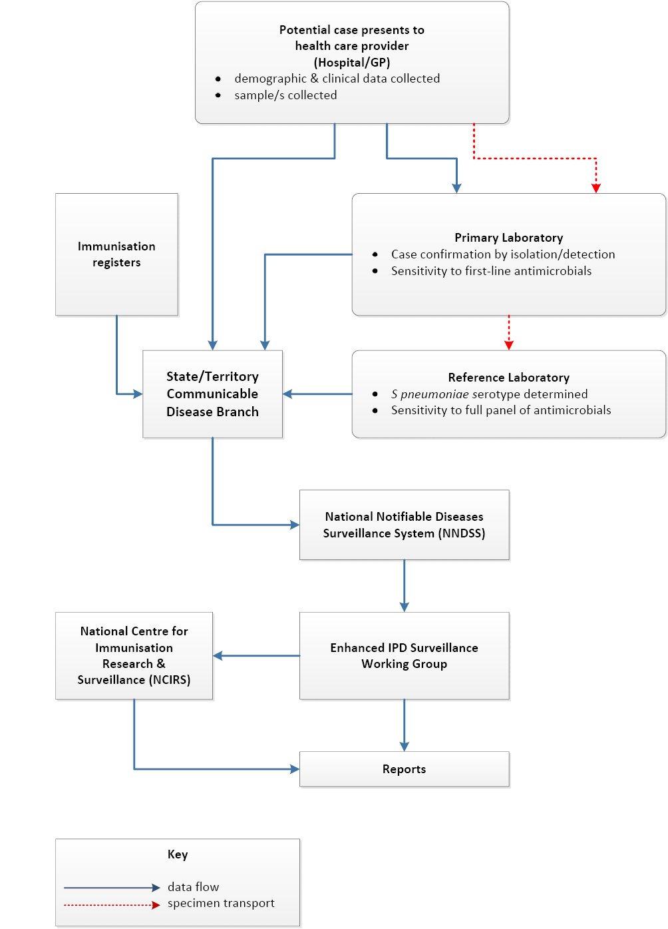

Box 2 The case definition for a confirmed case of invasive pneumococcal disease (IPD), Australia, 2017.Only confirmed cases are notified.
- Isolation of S. pneumoniae from a normally sterile site by culture
OR
- Detection of S. pneumoniae from a normally sterile site by nucleic acid testing
While data are collected for all notified cases, the largest jurisdictions do not routinely collect data on Indigenous status, vaccination history or enhanced data (including risk factors) for cases aged between five and 50 years. Data collection in some jurisdictions is hampered by the absence of accessible electronic health records. Summaries of surveillance data are published in regular IPD reports and NNDSS Annual Reports, and selected variables of the IPD dataset from 2009 to 2015 are publically available on the Australian Government Department of Health website.²⁶
Nearly 200 jurisdictional and reference laboratory staff are involved in IPD surveillance data collection nationally, but all have other duties. Testing, data entry and reporting of a case by reference laboratories takes an average 30, but up to 60, minutes. Data collection in jurisdictions with electronic access to clinical records takes 90 minutes or less per case, but three to 10 hours per case in jurisdictions without electronic access.
There are five objectives for the surveillance program published on the Department of Health’s website (Table 3).²⁷
These have not been endorsed by the EIPDSWG. Overall, EIPDSWG members thought that the objectives were appropriate, although not all were currently being met.

Table 3 EIPDSWG members’ assessment of the stated objectives of the surveillance program, 2016.
Objective ²⁷ | Proportion of EIPDSWG members who thought this objective was… |  | Key issues identified by members
 | …relevant | …being met
To record every case of IPD occurring in Australia | 100% | 80% | Milder disease not captured
To collect detailed information on each case of IPD as set out in the NNDSS Invasive Pneumococcal Infection Enhanced Surveillance Form | 90% | 40% | - Largest jurisdictions do not routinely collect detailed information on cases aged over 5 years  - Antimicrobial resistance (AMR) and serotype data incomplete
To collate nationally this information in the NNDSS dataset for enhanced IPD surveillance | 95% | 80% | Missing data as for Objective 2
To measure the impact of conjugate pneumococcal vaccination on the rates and types of pneumococcal disease, the prevalence of circulating pneumococcal serotypes and levels of antibiotic resistance | 100% | 40% | - Should include polysaccharide vaccination  - Vaccination and AMR data incomplete  - Declining completeness of serotype data due to use of molecular diagnostics
To assess whether cases or deaths in children under 5 years and adults over 65 years are due to IPD vaccine failure or antibiotic resistance | 85% | 40% | - Cannot infer causality, only association  - Difficulty in determining deaths  - Should include other high-risk groups targeted for vaccination  - Vaccination, serotype and AMR data incomplete

Usefulness
Over 90% of respondents in EIPDSWG interviews and the stakeholder survey indicated that the program was very or extremely useful. Surveillance data provided evidence of serotype replacement following the introduction of the national universal infant pneumococcal vaccination program in 2005 and informed a change in the recommended vaccine for infants in 2011.²⁸ However, the program is less useful for monitoring the response to vaccination programs targeted to other high-risk groups, due to lower completeness in vaccination and risk factor data fields for cases aged over five years. There are inconsistencies between risk factor categories in jurisdictional data collection forms, the national dataset, and The Australian Immunisation Handbook 10th Edition.¹⁹ Antimicrobial resistance (AMR) data collected during IPD surveillance has been requested by the Antimicrobial Use and Resistance in Australia (AURA) project for monitoring S. pneumoniae resistance. Currently, the surveillance data have only moderate utility for this purpose, because reference laboratories are not funded to test susceptibility to the full panel of antimicrobials, and because problems with data entry and transmission in some jurisdictions have led to missing data on sensitivity to first-line antimicrobials. Other stakeholders indicated that the public IPD dataset would be more useful if it included more detailed data from 2001 onwards. The EIPDSWG has proved a useful forum for rapid communication between jurisdictions, with members indicating that it assisted in the detection of a cross-border pneumococcal outbreak in 2011 and 2012.

Simplicity
Although stakeholders indicated that the notification process was easy, the surveillance program is not a simple system. This is largely due to the collection of enhanced data. The flow of data is complicated, and this is compounded by the fact that data collection systems are not harmonised across jurisdictions.

Data completeness and quality
The quality and completeness of the surveillance data is excellent overall (Figure 2), but some issues were identified (Table 3).

Figure 2 Completeness of data for IPD cases notified between 1 July 2013 and 30 June 2016, Australia.
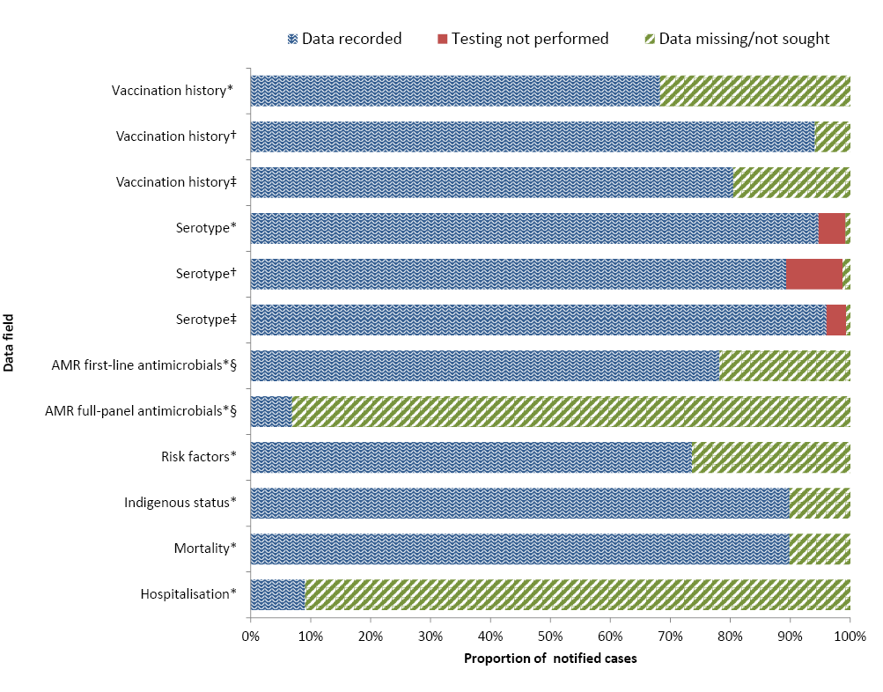
*All cases;
†cases aged <5 years only;
‡cases aged >50 years only;
§the proportion of cases for which testing is performed is unknown.

Flexibility
Over 15 years, the program has been flexible enough to accommodate changes in IPD epidemiology and available vaccines. Examination of the core and enhanced data fields revision history indicates multiple changes to both datasets since 2001, including changes to reflect the introduction of the 13vPCV and the identification of new serotypes. However, the program needs to accommodate trends in laboratory methods. In particular, the increase in the proportion of cases confirmed by polymerase chain reaction (PCR) only will reduce the program’s ability to attain high completeness for serotype and AMR data fields. The move towards whole-genome sequencing (WGS) for diagnosis and surveillance will lead to profound advances in the understanding of communicable disease epidemiology.²⁹ A study using Canadian pneumococcal surveillance isolates demonstrated 95% sensitivity and 100% specificity of genomic prediction of susceptibility to erythromycin, clindamycin, chloramphenicol and tetracycline; and a 98% success rate for determining sequence type.³⁰ Researchers who conducted a similar study in the United States concluded that their WGS-based methodology could accurately and reliably detect and measure resistance phenotypes, and determine other critical pneumococcal strain features.³¹ The EIPDSWG could consider initiating or auspicing pilot implementation studies of WGS using Australian IPD surveillance data. The speed of change in next-generation sequencing indicates that WGS may soon be comparable to conventional laboratory methods in terms of time and cost.^{29, 32} Now is the time for the EIPDSWG to initiate work with relevant parties to plan for such a change in Australia, ensuring that standards and formats allow data to be shared and synthesised internationally.

Acceptability
Overall, the program is acceptable to diagnostic laboratories, largely as a result of engagement with laboratory networks during the planning and early implementation phases in 2000 and 2001. However, work is required to ensure the ongoing commitment of laboratories to forward isolates to the reference laboratories for serotyping and AMR testing. Also, the burden of following up every case is unacceptable to some jurisdictions. These jurisdictions could consider collecting data on a random sample of cases aged five to 50 years. The expansion of the national My Health Record and transition to an opt-out system³³ may also improve acceptability, data completeness and quality.

Sensitivity
A capture-recapture study using linked hospitalisation data estimated the sensitivity of the surveillance program in Victoria to be 78%.³⁴ However, this study used data from the first two years of surveillance (2001-2003), when laboratory staff and doctors may have been unaccustomed to notifying cases of IPD. The current sensitivity of the national program for detecting cases of IPD is unknown, but EIPDSWG members and stakeholders felt that it was acceptable. The factors affecting the ability of the system to capture every case (shown in Figure 3) are beyond the control of the EIPDSWG. The availability of PCR, the results of which are unaffected by antimicrobial treatment, improves diagnostic and surveillance sensitivity, although serotyping from PCR is less sensitive than from culture-based methods.³⁵

Figure 3 Factors affecting sensitivity of the IPD surveillance Program.
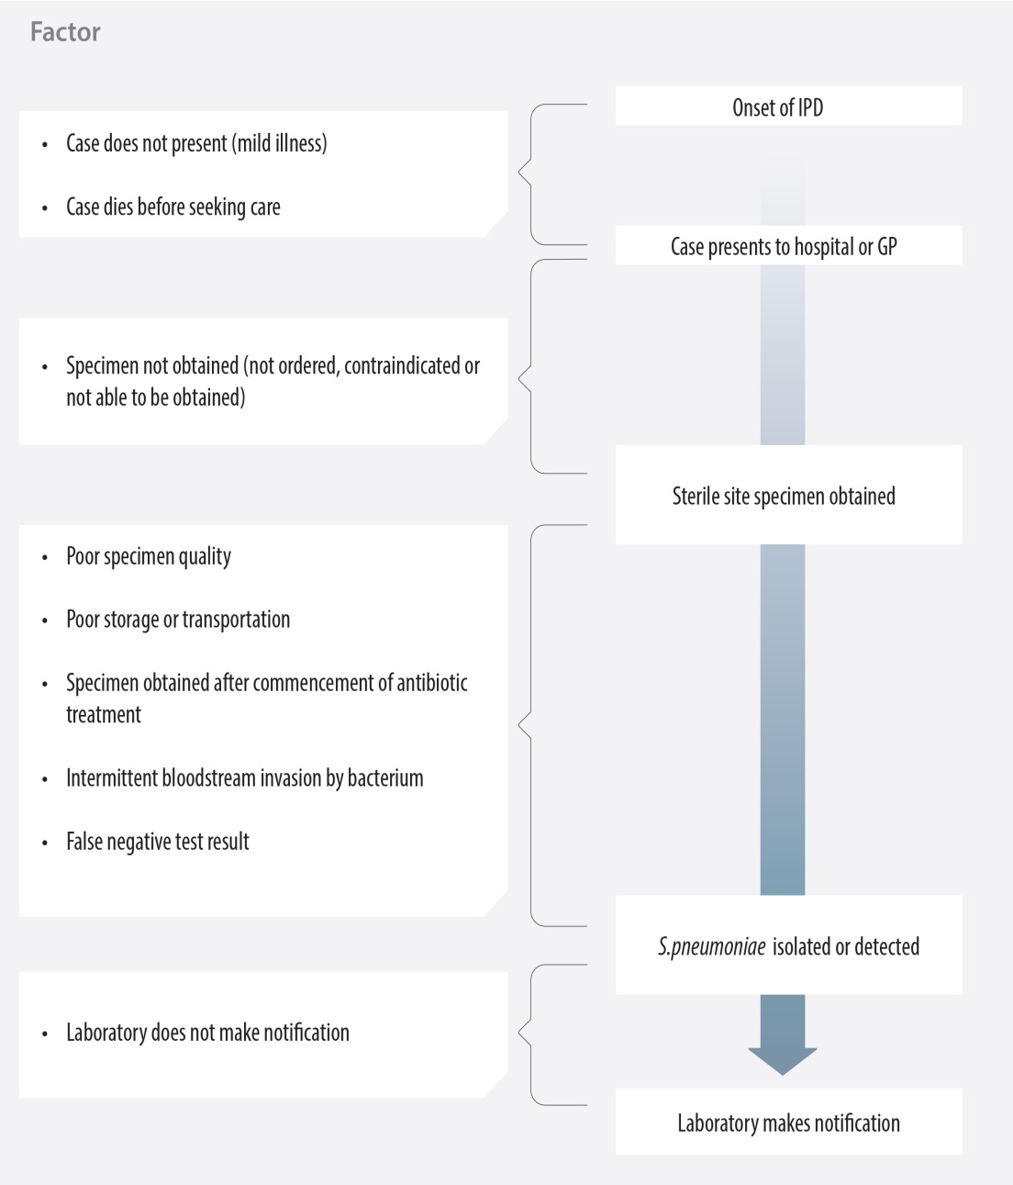

Positive Predictive Value
As only laboratory-confirmed (not suspected) cases are notified, it is rare for non-IPD cases to be notified, and so it is likely that the positive predictive value is high. Notified cases that are not IPD are mainly due to notification of isolates from a non-sterile site (e.g. sputum, bronchial washings, ear swabs), or urinary antigen testing. Rarely, the reference laboratory identifies the isolate as a bacterium other than S. pneumoniae, despite a positive culture in the diagnostic laboratory.

Representativeness
As the true sensitivity of the program is unknown, it is difficult to determine if there is any pattern to missed cases. It is clear that, for cases aged between five and 50 years, there is relatively lower completeness of vaccination history, Indigenous status, and enhanced data fields (including risk factors), compared with other cases.

Timeliness
The median time between onset of disease and receipt of notification by the jurisdictions (six days, Figure 3), and between notification and publication of data summaries in Quarterly Reports (three months), was acceptable. However, there is significant delay of up to 10 months in transmission of enhanced data from the NNDSS to the National Centre for Immunisation Research and Surveillance (NCIRS) due to data quality checks. This therefore delays the annual IPD report from NCIRS to ATAGI.

Stability
Forty percent of EIPDSWG interviewees rated the stability of the program as ‘excellent’, and half rated it as ‘good’. None indicated that there had been any significant periods during which the program could not function. The exception was one reference laboratory which became overwhelmed during the 2009 H1N1 influenza pandemic, and was unable to type about 20% of IPD isolates. These favourable responses reflect the fact that the program has operated for over 15 years without major problems, and confirm that the NNDSS is a stable system. Steps must be taken to ensure the succession of EIPDSWG members who, through their passion for IPD prevention, have achieved the stability and longevity of the program so far.
Table 4 Issues affecting quality and completeness of data in Australia’s Enhanced Invasive Pneumococcal Disease Surveillance Program, 2017.
Issue | Data fields affected | Proportion of relevant data fields affected nationally 30 June 2013 – 1 July 2016 | Number of jurisdictions affected
Cases aged 5-50 years not routinely followed up | Vaccination history* | 18% | 3
 | Risk factors | 21% | 3
 | Clinical category | 19% | 3
Difficulty accessing medical records | Vaccination history * | ‡ | 3
 | Mortality | ‡ | 3
 | Risk factors | ‡ | 3
 | Clinical category | ‡ | 2
Testing not performed | Sensitivity to full panel of antimicrobials | 92% | 8
 | Serotype (non-culture specimens only) | 12% | 1
Data entry/transmission | Sensitivity to first-line antimicrobials | 12% | 1
Data field missing from national data collection form † | Hospitalisation | 91% | 8
Missing data | Date fields | 11% | 6
Data entry errors/ | Date fields | 2% | 8
Illogical data | Serotype/ laboratory method | 2% | 4
* For cases aged over seven years prior to October 2016 only. The whole-of-life Australian Immunisation Register was introduced in 2016 to record all vaccinations administered under the NIP and most privately-funded vaccines.
† Hospitalisation was ratified as a NNDSS core data field in March 2016 and to the data collection form in April 2016, therefore it was not routinely collected for the years 2013-2016.
‡ Not determined

Discussion
This evaluation confirms that the enhanced IPD surveillance program is a useful, flexible and stable disease surveillance system. Nonetheless, the program is not performing to its full potential, particularly in terms of data collection for cases aged between five and 50 years to inform targeted vaccination programs, AMR monitoring, and providing easily accessible and useful surveillance data. The declining number of cases, the increasing availability of vaccination data for all ages on the whole-of-life Australian Immunisation Register³⁶ and the continued move towards electronic medical records should put complete data collection for all cases within the reach of all jurisdictions. Ongoing work is required of the EIPDSWG to ensure complete AMR testing; to harmonise notification, data entry and transmission processes; and to plan for the shift to whole-genome sequencing. Specific recommendations to the EIPDSWG are listed in Box 3.
Box 3 Recommendations to the EIPDSWG for improving Australia’s enhanced IPD surveillance program, 2017.
Priority Recommendations
- Collect complete surveillance data for all cases in all jurisdictions. If resource constraints preclude this in some jurisdictions, consider prospectively following up a random sample of cases aged five to 50 years.
- Ensure researchers and vaccine developers can access the data at the level of detail they require in the public dataset, while maintaining the privacy of cases. This includes
  - finer stratification of age-groups for cases aged less than five years
  - data from 2001 onwards;
  - all available serotype data; and
  - data on vaccine failures.
- Improve the completeness and quality of antimicrobial resistance (AMR) data by
  - addressing issues with data transmission in some jurisdictions;
  - agreeing on the standards for reference laboratory AMR testing; and
  - advocating for funding for reference laboratories to undertake this testing for every case.
Other Recommendations
- Review the program objectives to ensure they reflect the EIPDSWG’s aspirations for the program.
- Harmonise notification processes, data collection forms and data transmission from the jurisdictions to the NNDSS. This should include standardising risk factor data domains to ensure they reflect groups at high risk of IPD, as identified in the Australian Immunisation Handbook 10th Edition.
- Advocate for all jurisdictions to implement exclusively electronic laboratory notification systems, ensuring that these collect data consistent with the NNDSS data fields.
- Support jurisdictions to modify their databases to prevent entering non-logical data, and to conduct post-entry logic checks, where these are not already in place.
- Working with relevant partners, plan for the shift to whole-genome sequencing by overseeing the development of quality standards for IPD sequencing and bioinformatics, and by auspicing pilot implementation studies.
- Work with the Public Health Laboratory Network to enhance engagement and communication with diagnostic laboratories to ensure their full participation. This should include a review and promotion of the guidelines for forwarding samples to reference laboratories.
- Implement succession planning interventions to ensure there is depth of capacity within the EIPDSWG, reference laboratories and jurisdictions to maintain the program at the current high standard.
This evaluation was limited by the low number of responses to the stakeholder survey. Most notifications are made by diagnostic laboratories, but with only seven responses from laboratory staff it is unlikely that we obtained a representative sample, and we received no feedback on some issues including failure to forward PCR samples to reference laboratories. Conversely, the three companies manufacturing vaccines for the Australian market were overrepresented. We only assessed data quality using logic checks of notification data. It may be useful to conduct a quality audit of a random sample of notified cases using the original data sources. We did not estimate the sensitivity of the national program, but this could be approached using a capture-recapture analysis of linked surveillance and hospitalisation data.
Figure 4 Median intervals between elements of case notification (1 July 2013 to 30 June 2016) and reporting (2001 – 2016) in Australia’s enhanced IPD surveillance program.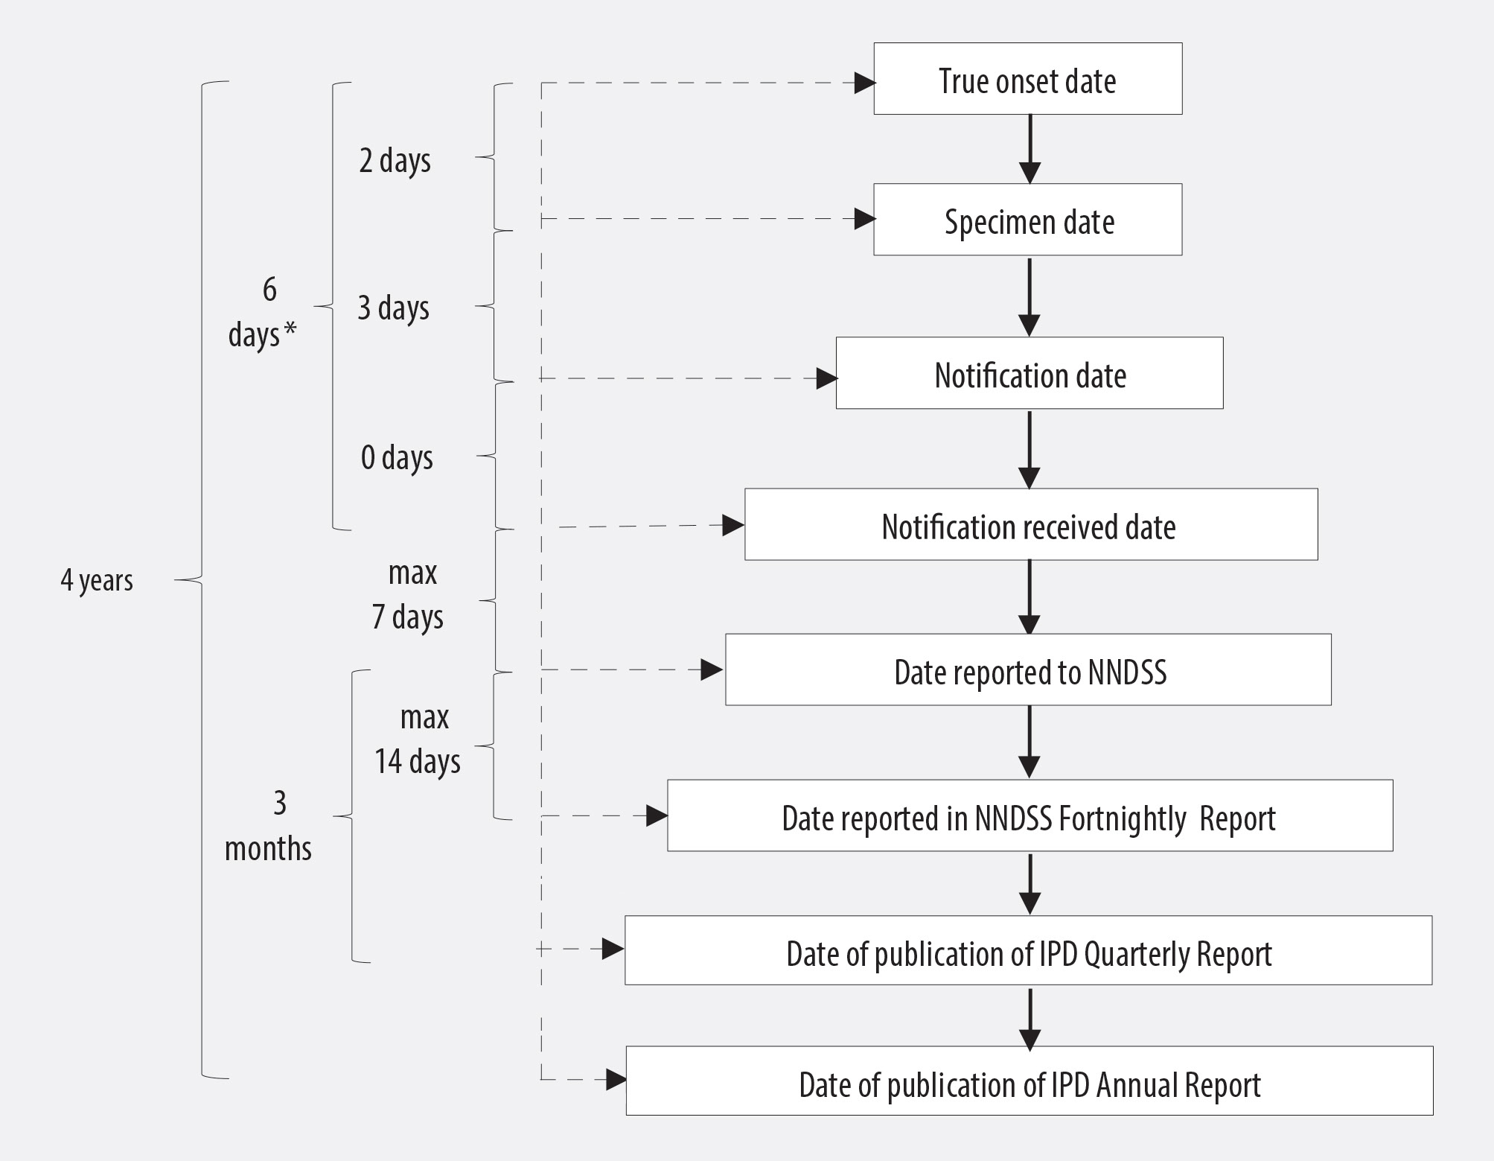
*This interval does not equal the sum of the sub-intervals, due to missing data in date fields

Acknowledgements
We thank the members of the EIPDSWG who participated in interviews and provided comments on the draft evaluation report; Mark Trungove, Data Manager with the Australian Government Department of Health’s Office of Health Protection, for his advice and support; stakeholders who responded to the evaluation survey; and Nick Pascual, who provided comments on the evaluation report and this article.
AM completed this work while she was a Master of Philosophy (Applied Epidemiology) scholar, on placement at the Australian Government Department of Health, and supported by an Australian Government Research Training Scholarship.

Author details and affiliations
Ms Alexandra M Marmor Master of Philosophy (Applied Epidemiology)Scholar, National Centre for Epidemiology and Population Health, Australian National University and Indigenous Health Division, Australian Government Department of Health
Associate Professor David Harley Deputy Director, Queensland Centre for Intellectual and Developmental Disability MRI-UQ, The University of Queensland Mater Hospitals Brisbane and Visiting Fellow - National Centre for Epidemiology and Population Health, Australian National University
Corresponding author: Alexandra Marmor
2 Huon Place LYONS ACT 2606 Phone 0405 683 029 alex_sticpewich@hotmail.com

References
- Australian Government Department of Health. Australian national notifiable diseases and case definitions 2017 [Available from: www.health.gov.au/casedefinitions.
- Bogaert D, de Groot R, Hermans PWM. Streptococcus pneumoniae colonisation: the key to pneumococcal disease. The Lancet Infectious Diseases. 2004;4(3):144-54.
- Rodrigo C, Lim WS. The relevance of pneumococcal serotypes. Curr Infect Dis Rep. 2014;16(4):403.
- Obaro S, Adegbola R. The pneumococcus: carriage, disease and conjugate vaccines. J Med Microbiol. 2002;51(2):98-104.
- Randle E, Ninis N, Inwald D. Invasive pneumococcal disease. Arch Dis Child Educ Prac Ed 2011;96(5):183-90.
- Chiu C, McIntyre P. Pneumococcal vaccines: past, present and future. Australian Prescriber. 2013;36(3):88–93.
- Feldman C, Anderson R. Recent advances in our understanding of Streptococcus pneumoniae infection. F1000Prime Reports. 2014;6:82.
- Tyrrell GJ, Lovgren M, Ibrahim Q, Garg S, Chui L, Boone TJ, et al. Epidemic of invasive pneumococcal disease, western Canada, 2005–2009. Emerg Infect Dis. 2012;18(5):733.
- Hanna JN, Humphreys JL, Murphy DM. Invasive pneumococcal disease in Indigenous people in north Queensland, 1999-2004. Med J Aust. 2006;184(3):118-21.
- Lai J, Cook H, Yip T-W, Berthelsen J, Gourley S, Krause V, et al. Surveillance of pneumococcal serotype 1 carriage during an outbreak of serotype 1 invasive pneumococcal disease in central Australia 2010-2012. BMC Infect Dis. 2013;13(1):409.
- Pennington K, and the Enhanced Invasive Pneumococcal Disease Surveillance Working Group ftCDNA. Invasive Pneumococcal Disease Surveillance, 1 October to 31 December 2016. Commun Dis Intell. 2017;41(1):E114-E9.
- Lin SH, Lai CC, Tan CK, Liao WH, Hsueh PR. Outcomes of hospitalized patients with bacteraemic and non-bacteraemic community-acquired pneumonia caused by Streptococcus pneumoniae. Epidemiol Infect. 2011;139(9):1307-16.
- Wagenvoort GH, Sanders EA, de Melker HE, van der Ende A, Vlaminckx BJ, Knol MJ. Long-term mortality after IPD and bacteremic versus non-bacteremic pneumococcal pneumonia. Vaccine. 2017;35(14):1749-57.
- Mook-Kanamori BB, Geldhoff M, van der Poll T, van de Beek D. Pathogenesis and pathophysiology of pneumococcal meningitis. Clin Microbiol Rev. 2011;24(3):557-91.
- Newall AT, Creighton P, Philp DJ, Wood JG, MacIntyre CR. The potential cost-effectiveness of infant pneumococcal vaccines in Australia. Vaccine. 2011;29(45):8077-85.
- Earle K, Williams S. Burden of pneumococcal disease in adults aged 65 years and older: an Australian perspective. Pneumonia. 2016;8(1):9.
- Pharmaceutical Benefits Scheme. Pneumococcal polysaccaride conjugute vaccine, 13-valent adsorbed, injection, 0.5 mL, pre-filled syringe, Prevenar-13®. 2010.
- Pharmaceutical Benefits Scheme. Australian statistics on medicines 2015. 2016.
- Australian Technical Advisory Group on Immunisation. The Australian Immunisation Handbook. 10th ed. Canberra: Commonwealth of Australia; 2013.
- Taylor PS, Faeth I, Marks MK, Del Mar CB, Skull SA, Pezzullo ML, et al. Cost of treating otitis media in Australia. Expert Rev Pharmacoecon Outcomes Res. 2009;9(2):133-41.
- Toms C, de Kluyver R, Enhanced Invasive Pneumococcal Disease Surveillance Working Group. Invasive Pneumococcal Disease in Australia, 2011 and 2012. Commun Dis Intell. 2016;40(2).
- Miller M, Roche P, Spencer J, Deeble M. Evaluation of Australia’s National Notifiable Disease Surveillance System. Commun Dis Intell. 2004;28(3).
- Centers for Disease Control and Prevention. Updated guidelines for evaluating public health surveillance systems: recommendations from the guidelines working group. MMWR. 2001;50(No. RR-13).
- AusGovBoards. Australian Technical Advisory Group on Immunisation (ATAGI): Australian Government; 2015 [Available from: www.ausgovboards.gov.au/boards/australian-technical-advisory-group-immunisation-atagi.
- Australian Commission on Safety and Quality in Health Care. Antimicrobial Use and Resistance in Australia Project 2015 [Available from: www.safetyandquality.gov.au/national-priorities/amr-and-au-surveillance-project/roleofcommission.
- Australian Government Department of Health. Invasive Pneumococcal Disease surveillance 2017 [Available from: www.health.gov.au/internet/main/publishing.nsf/Content/cda-surveil-nndss-ipd-reports.htm.
- Australian Government Department of Health. Surveillance systems reported in Communicable Diseases Intelligence, 2016. 2016 [Available from: www.health.gov.au/internet/main/publishing.nsf/Content/cda-surveil-surv_sys.htm#ipd]
- National Centre for Immunisation Research and Surveillance. Significant events in pneumococcal vaccination practice in Australia. 2015 [Available from: www.ncirs.edu.au/assets/provider_resources/history/Pneumococcal-history-November-2015.pdf]
- Sintchenko V, Holmes N. Early warning systems augmented by bacterial genomics. Microbiology Australia. 2014;March:44-8.
- Deng X, Memari N, Teatero S, Athey T, Isabel M, Mazzulli T, et al. Whole-genome Sequencing for Surveillance of Invasive Pneumococcal Diseases in Ontario, Canada: Rapid Prediction of Genotype, Antibiotic Resistance and Characterization of Emerging Serotype 22F. Frontiers in microbiology. 2016;7:2099.
- Metcalf BJ, Chochua S, Gertz R, Li Z, Walker H, Tran T, et al. Using whole genome sequencing to identify resistance determinants and predict antimicrobial resistance phenotypes for year 2015 invasive pneumococcal disease isolates recovered in the United States. Clin Microbiol Infect. 2016;22(12):1002. e1-. e8.
- European Centre for Disease Prevention and Control. Expert opinion on whole genome sequencing for public health surveillance. Stockholm: ECDC; 2016.
- Australian Government Department of Health. My Health Record - continuation and expansion 2017 [Available from: www.health.gov.au/internet/budget/publishing.nsf/Content/budget2017-factsheet47.htm.
- Clothier H, Vu T, Sundararajan V, Andrews R, Counahan M, Tallis G, et al. Invasive pneumococcal disease in Victoria: a better measurement of the true incidence. Epidemiol Infect. 2008;136(2):225-31.
- Avni T, Mansur N, Leibovici L, Paul M. PCR using blood for diagnosis of invasive pneumococcal disease: systematic review and meta-analysis. J Clin Microbiol. 2010;48(2):489-96.
- Australian Government Department of Health. Australian Immunisation Register (AIR): Australian Government; 2017 [Available from: www.immunise.health.gov.au/internet/immunise/publishing.nsf/Content/ohp-acir.htm

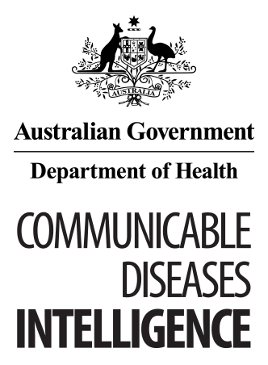
© Commonwealth of Australia 2018 - ISSN: 2209-6051 (Online)
This work is copyright. You may download, display, print and reproduce the whole or part of this work in unaltered form for your own personal use or, if you are part of an organisation, for internal use within your organisation, but only if you or your organisation do not use the reproduction for any commercial purpose and retain this copyright notice and all disclaimer notices as part of that reproduction. Apart from rights to use as permitted by the Copyright Act 1968 or allowed by this copyright notice, all other rights are reserved and you are not allowed to reproduce the whole or any part of this work in any way (electronic or otherwise) without first being given the specific written permission from the Commonwealth to do so. Requests and inquiries concerning reproduction and rights are to be sent to the Online, Services and External Relations Branch, Department of Health, GPO Box 9848, Canberra ACT 2601, or by email to copyright@health.gov.au
Communicable Diseases Intelligence aims to disseminate information on the epidemiology and control of communicable diseases in Australia. Communicable Diseases Intelligence invites contributions dealing with any aspect of communicable disease epidemiology, surveillance or prevention and control in Australia. Submissions can be in the form of original articles, short reports, surveillance summaries, reviews or correspondence. Instructions for authors can be found in Commun Dis Intell 2016;40(1):E189–E193.
Communicable Diseases Intelligence contributes to the work of the Communicable Diseases Network Australia.
http://www.health.gov.au/cdna

This journal is indexed by Index Medicus and Medline.
Disclaimer: Opinions expressed in Communicable Diseases Intelligence are those of the authors and not necessarily those of the Australian Government Department of Health or the Communicable Diseases Network Australia. Data may be subject to revision.

Editor: Cindy Toms
Deputy Editor: Phil Wright
Editorial and Production Staff: Leroy Trapani, Kasra Yousefi
Editorial Advisory Board: Peter McIntyre (Chair), David Durrheim, Mark Ferson, John Kaldor, Martyn Kirk
Website: http://www.health.gov.au/cdi
Communicable Diseases Intelligence is produced by Health Protection Policy Branch, Office of Health Protection, Australian Government, Department of Health, GPO Box 9848, (MDP 6) CANBERRA ACT 2601;
Email: cdi.editor@health.gov.au

