Monitoring the incidence and causes of diseases potentially transmitted by food in Australia: Annual report of the OzFoodNet network, 2012
The OzFoodNet Working Group

Abstract
This report summarises the incidence of diseases potentially transmitted by food in Australia and details outbreaks associated with food in 2012. OzFoodNet sites reported 27,976 notifications of diseases or conditions that may be transmitted by food. The most commonly notified infections were Campylobacter (15,668 notifications), followed by Salmonella (11,249 notifications). OzFoodNet sites also reported 2,180 outbreaks of gastrointestinal illness affecting 40,547 people and resulting in 955 people being hospitalised and 131 associated deaths. The majority of outbreaks (83%, 1,819/2,180) were due to person-to-person transmission, 10% (208) were due to an unknown mode of transmission and 7% (144) were suspected or confirmed to be foodborne. Less than 0.5% of these outbreaks were due to waterborne or suspected waterborne transmission (7 outbreaks) and animal-to-human transmission (2 outbreaks). Foodborne and suspected foodborne outbreaks affected 2,117 persons and included 183 hospitalisations and 9 associated deaths. Salmonella was the most common aetiological agent identified in foodborne outbreaks, and restaurants were the most frequently reported food preparation setting. A single food vehicle was identified for 60 outbreaks. There were an additional 30 outbreaks attributed to multiple food vehicles. Of those outbreaks attributed to a single food vehicle 28 (47%) were associated with the consumption of dishes containing raw or minimally cooked eggs and 27 of these outbreaks were due to S. Typhimurium with the other due to S. subsp I ser 4,5,12 :i:-(commonly known as monophasic S. Typhimurium). These data assist agencies to document sources of foodborne disease, develop food safety policies, and prevent foodborne illness.

Introduction
In Australia, an estimated 4.1 million domestically acquired cases of foodborne gastroenteritis occur each year, costing an estimated $1.2 billion per year.¹⁻³ The associated losses in productivity and impacts on lifestyle, in addition to direct medical expenses, can result in a substantial burden for Australians. Many of these illnesses are preventable by appropriate interventions. Foodborne disease surveillance can be used to gather evidence to help inform appropriate control measures.⁴ Health departments conduct surveillance for foodborne diseases, and diseases potentially transmitted by food, to monitor trends in illness, detect outbreaks, inform preventative measures and to evaluate the efficacy of interventions.^{5,6}
Most foodborne diseases manifest as mild self-limiting gastroenteritis, with approximately 28% of affected individuals seeking medical attention.¹ Consequently, surveillance data collected by health departments underestimate the true burden of disease. In Australia, for every case of salmonellosis notified to a health department there are an estimated 7 infections that occur in the community, while there are approximately 8 cases in the community for every notified case of Shiga toxin-producing Escherichia coli (STEC) and 10 cases in the community for every notified case of campylobacteriosis.⁷⁻¹⁰
Public health authorities use surveillance data to detect outbreaks and clusters of disease. Trends in surveillance data also contribute to the assessment of the efficacy of public health interventions.¹¹ In Australia, state and territory health departments conduct surveillance for between 10 and 15 different diseases that may be transmitted through food. Most of these diseases are also transmitted by the faecal–oral route and as such may be transmitted by contact with infected animals, environments or people, and may be acquired domestically or overseas. They may also be transmitted by contaminated food preparation equipment or surfaces, or through the consumption of contaminated water. Health departments additionally collect summary data on notified outbreaks of foodborne diseases, providing robust information on contaminated foods causing illness in Australia.
The Australian Government established OzFoodNet (Australia’s enhanced foodborne disease surveillance system) in 2000 to improve national surveillance and conduct applied research into the causes of foodborne illness.¹² OzFoodNet aggregates and analyses national-level information on the incidence of diseases caused by pathogens commonly transmitted by food, and investigates foodborne disease outbreaks. The OzFoodNet network in 2012 included foodborne disease epidemiologists from each state and territory Health department, and collaborators from the Department of Agriculture and Water Resources (Agriculture), Food Standards Australia New Zealand (FSANZ), the Public Health Laboratory Network (PHLN) and the National Centre for Epidemiology and Population Health (NCEPH) at the Australian National University. OzFoodNet is a member of the Communicable Diseases Network Australia (CDNA), which is Australia’s peak body for communicable disease control.¹³ This is the 12th annual report for the OzFoodNet network and summarises the 2012 surveillance and outbreak data, including a comparison with data from previous years.

Methods

Population under surveillance
In 2012, the OzFoodNet network covered all Australian states and territories, with the estimated population being 22,680,439 persons as at 30 June 2012.¹⁴

Data sources

Notified infections
All Australian states and territories have public health legislation requiring doctors and pathology laboratories to notify cases of infectious diseases that are important to public health. State and territory health departments record details of notified cases on surveillance databases. These surveillance datasets are aggregated into a national database—the National Notifiable Diseases Surveillance System (NNDSS)¹⁵—under the auspices of the National Health Security Act 2007. This 2012 report provides analysis of aggregated data from NNDSS and enhanced surveillance data from OzFoodNet sites on the following 9 diseases or conditions: botulism, campylobacteriosis, salmonellosis, listeriosis, Salmonella Typhi (typhoid fever) infection, hepatitis A virus infections, shigellosis, STEC infection and haemolytic uraemic syndrome (HUS).
There may be differences when comparing OzFoodNet enhanced data and NNDSS derived notifications. This is due to continual adjustments to NNDSS data made by states and territories after the date of data extraction. Also, some jurisdictions report on notification date rather than onset date. Data for this report were extracted from NNDSS in August 2015 and were analysed by the date of diagnosis within the reporting period 1 January to 31 December 2012. Date of diagnosis was derived for each case from the earliest date supplied by the jurisdiction, which could be the date of onset of the case’s illness, the date a specimen was collected or the date that a health department received the notification. Estimated resident populations for each state or territory as at June 2012 were used to calculate rates of notified infections.¹⁴

Enhanced surveillance for listeriosis
Commencing in 2010, OzFoodNet collected enhanced surveillance data on all notified cases of listeriosis in Australia via the National Enhanced Listeriosis Surveillance System (NELSS). This enhanced surveillance system adds to the routinely collected data within NNDSS. NELSS includes a centralised national database that contains information regarding the characterisation of Listeria monocytogenesisolates by molecular subtyping methods, food histories and exposure data on all notified listeriosis cases in Australia. The overall aim of this enhanced surveillance is to enable timely detection of clusters and to initiate a public health response. Local public health unit staff interview all cases with a standard national listeriosis questionnaire. Interviews are conducted at the time individual cases are reported to improve accurate recall of foods consumed during the incubation period. Data are collated nationally via an online open-source database using NetEpi Case Manager. This is a secure web-based reporting system used by OzFoodNet epidemiologists for the enhanced surveillance of listeriosis and multi-jurisdictional outbreaks in Australia. NetEpi allows data to be entered from multiple sites and promotes nationally consistent data collection and analysis by OzFoodNet epidemiologists.¹⁶⁻¹⁸

Supplementary surveillance
OzFoodNet sites also collected supplementary data on infections which may be transmitted by food. Information on travel status was collected for cases of SalmonellaEnteritidis infection, hepatitis A infection, Shigella infection and typhoid fever. Locally-acquired infection includes people acquiring their infection in Australia from overseas-acquired cases, from unknown sources of infection, and from possible false-positive testing results where no or inconsistent clinical illness was reported.
Due to extensive changes in testing methodology, including the increased use of multi-locus variable number tandem repeat analysis (MLVA) and the decreased use of traditional phage typing (PT), the completeness of subtyping for salmonellosis notifications was not able to be effectively assessed in this report. A breakdown of completeness of Salmonella serotyping was included.

Outbreaks of gastrointestinal disease including foodborne disease outbreaks
OzFoodNet sites collected summary information on gastrointestinal disease outbreaks that occurred in Australia during 2012, including those transmitted via the ingestion of contaminated food (foodborne outbreaks). A foodborne outbreak was defined as an incident where 2 or more persons experienced a similar illness after consuming a common food or meal and analytical epidemiological and/or microbiological evidence implicated the food or meal as the source of illness. A suspected foodborne outbreak was defined as an incident where 2 or more persons experienced illness after consuming a common meal or food and descriptive epidemiological evidence implicated the food or meal as the suspected source of illness. Outbreaks where food-to-person-to-food transmission occurred were included in this definition. A cluster was defined as an increase in infections that were epidemiologically related in time, place or person where there is no common setting and investigators were unable to implicate a vehicle or determine a mode of transmission.
Summary information for foodborne and suspected foodborne outbreaks has been combined for analysis. Information collected on each outbreak included the setting where the outbreak occurred, where the food was prepared, the month the outbreak investigation commenced, the aetiological agent, the number of persons affected, the type of investigation conducted, the level of evidence obtained, and the food vehicle responsible for the outbreak. To summarise the data, outbreaks were categorised by aetiological agent, food vehicle and the setting where the implicated food was prepared. Data on outbreaks due to recreational waterborne transmission and from clusters investigated by jurisdictional health departments were also summarised. The number of outbreaks and documented causes reported here may vary from summaries previously published by individual states and territories as these can take time to finalise.

Data analysis
All analyses were conducted using Microsoft Excel.

Results

Rates of the most commonly notified foodborne enteric infections
In 2012, OzFoodNet sites reported 27,976 notifications of 9 diseases or conditions that may be transmitted by food (Table 1), which represents a 9% decrease compared with a mean of 30,747 notifications per year for the previous 5 years (2007–2011).

Table 1: Number of notified cases, crude rate and 5-year mean (2007–2011) rate per 100,000 population of diseases or infections commonly transmitted by food, Australia, 2012, by disease and state or territory
Disease/infection |  | State or territory
 |  | ACT | NSW | NT | Qld | SA | Tas. | Vic. | WA | Aust.
Botulism | Notified cases, 2012 | 0 | 0 | 0 | 0 | 0 | 0 | 0 | 0 | 0
Campylobacteriosis* | Notified cases, 2012 | 477 | ^{NN} | 175 | 4,182 | 2,161 | 882 | 5,885 | 1,906 | 15,668
 | Crude rate, 2012 | 127.3 | ^{NN} | 74.5 | 91.7 | 130.6 | 172.3 | 104.7 | 78.4 | 101.8
 | Mean rate, 2007-2011 | 130.9 | ^{NN} | 96.6 | 109.4 | 128.7 | 137.1 | 116.6 | 98.5 | 113.8
Haemolytic uraemic syndrome (HUS) | Notified cases, 2012 | 0 | 10 | 0 | 4 | 0 | 1 | 5 | 0 | 20
 | Crude rate, 2012 | 0.0 | 0.1 | 0.0 | 0.1 | 0.0 | 0.2 | 0.1 | 0.0 | 0.1
 | Mean rate, 2007-2011 | 0.1 | 0.1 | 0.2 | 0.1 | 0.1 | 0.0 | 0.1 | 0.0 | 0.1
Hepatitis A | Notified cases, 2012 | 1 | 42 | 3 | 34 | 7 | 2 | 63 | 14 | 166
 | Crude rate, 2012 | 0.3 | 0.6 | 1.3 | 0.7 | 0.4 | 0.4 | 1.1 | 0.6 | 0.7
 | Mean rate, 2007-2011 | 1.2 | 1.1 | 1.3 | 1.0 | 1.2 | 0.7 | 2.1 | 1.1 | 1.3
Listeriosis | Notified cases, 2012 | 0 | 39 | 0 | 5 | 4 | 3 | 34 | 8 | 93
 | Crude rate, 2012 | 0.0 | 0.5 | 0.0 | 0.1 | 0.2 | 0.6 | 0.6 | 0.3 | 0.4
 | Mean rate, 2007-2011 | 0.4 | 0.4 | 0.1 | 0.2 | 0.2 | 0.4 | 0.4 | 0.3 | 0.3
Salmonellosis | Notified cases, 2012 | 240 | 2,947 | 407 | 2,811 | 849 | 278 | 2,549 | 1,168 | 11,249
 | Crude rate, 2012 | 64.1 | 40.4 | 173.3 | 61.6 | 51.3 | 54.3 | 45.3 | 48.1 | 49.6
 | Mean rate, 2007-2011 | 46.9 | 41.1 | 221.1 | 58.1 | 48.7 | 40.8 | 37.4 | 49.3 | 46.9
Shiga toxin-producing Escherichia coli (STEC) infection | Notified cases, 2012 | 6 | 13 | 2 | 27 | 45 | 7 | 11 | 1 | 112
 | Crude rate, 2012 | 1.6 | 0.2 | 0.9 | 0.6 | 2.7 | 1.4 | 0.2 | 0.0 | 0.5
 | Mean rate, 2007-2011 | 0.3 | 0.2 | 0.4 | 0.5 | 2.8 | 0.1 | 0.2 | 0.2 | 0.5
Shigellosis | Notified cases, 2012 | 6 | 124 | 107 | 81 | 48 | 7 | 120 | 53 | 546
 | Crude rate, 2012 | 1.6 | 1.7 | 45.6 | 1.8 | 2.9 | 1.4 | 2.1 | 2.2 | 2.4
 | Mean rate, 2007-2011 | 1.5 | 1.6 | 52.8 | 2.1 | 4.2 | 0.6 | 1.9 | 5.3 | 2.8
Typhoid Fever | Notified cases, 2012 | 1 | 43 | 4 | 15 | 3 | 1 | 37 | 18 | 122
 | Crude rate, 2012 | 0.3 | 0.6 | 1.7 | 0.3 | 0.2 | 0.2 | 0.7 | 0.7 | 0.5
 | Mean rate, 2007-2011 | 0.3 | 0.6 | 0.8 | 0.4 | 0.3 | 0.3 | 0.6 | 0.5 | 0.5
* Campylobacteriosis is notifiable in all jurisdictions except New South Wales.
^{NN} Not notifiable

Campylobacteriosis
In 2012, OzFoodNet sites (excluding New South Wales where campylobacteriosis was not notifiable) reported 15,668 notifications of Campylobacter infection. This equates to a rate of 101.8 notifications per 100,000 population and is an 11% decrease compared with the 5-year historic mean of 113.8 per 100,000 (Table 1, Figure 1). Queensland reported a rate of 91.7 notifications per 100,000 population, a 16% decrease below the 5-year historic mean and Tasmania reported a rate of 172.3 notifications per 100,000 population, a 26% increase above the 5-year historic mean (Table 1).
Figure 1: Notification rate for campylobacteriosis, Australia, by year of diagnosis
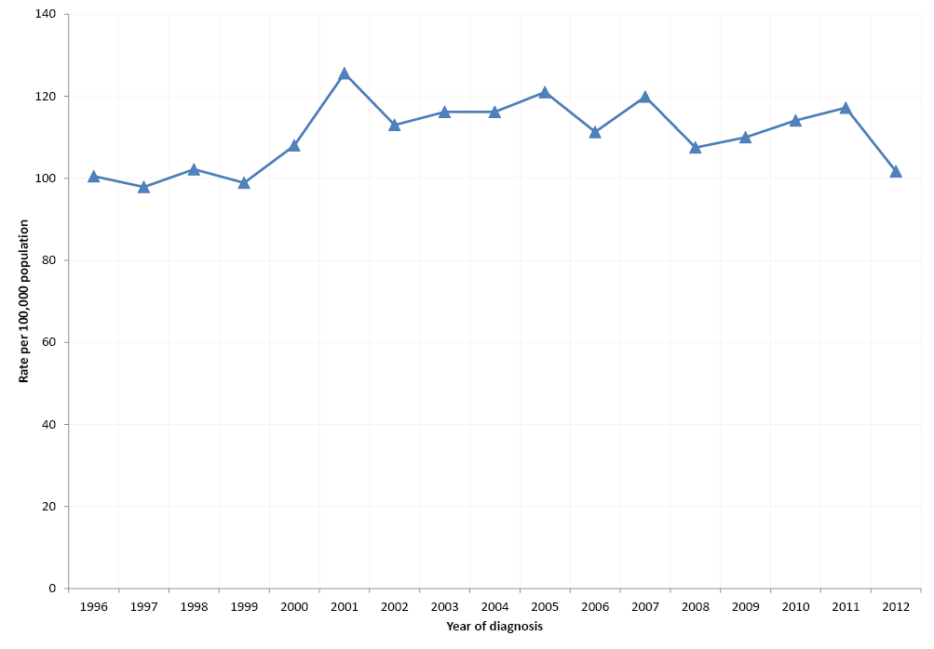
Overall, 54% of notified cases were males. Notification rates were highest in children 0–4 years of age for both males and females (198.4 and 135.9 notifications per 100,000, respectively) with additional peaks in the 20–29 years age group and in the >60 year age group. Of particular note is the higher rates for males compared to females in the >80 years age groups (Figure 2).
Figure 2: Notification rate for campylobacteriosis, Australia*, 2012, by age group and sex 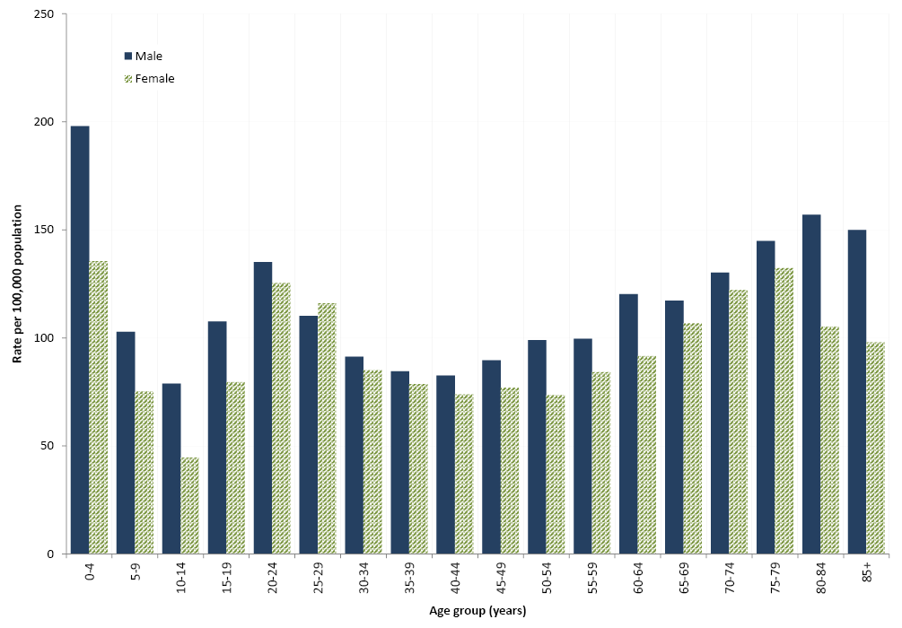

Salmonellosis
In 2012, Australian jurisdictions reported 11,249 notifications of salmonellosis, at a rate of 49.6 notifications per 100,000 population. This is a 6% increase compared with the mean for the previous 5 years (46.9 notifications per 100,000 population). Compared to the 5-year historic mean, rates in 2012 were reasonably stable in New South Wales and Western Australia, while the Northern Territory had the largest decrease (22%) (Table 1). The remaining jurisdictions had higher rates compared with the 5-year historic mean, with the Australian Capital Territory having the largest percentage increase (37%), followed by Tasmania (33%). Notification rates ranged from 40.4 notifications per 100,000 population in New South Wales, to 173.3 notifications per 100,000 population in the Northern Territory which often has the highest rate of salmonellosis (Table 1). The majority of cases of salmonellosis in the Northern Territory are thought to be due to infection from environmental sources.¹⁹
In 2012, the ratio of male to female cases was equal (1:1). The median age for all salmonellosis notifications was 25 years, similar to 2011 (24 years). The highest notification rates were in children 0–4 years of age for both males and females (190 and 181 notifications per 100,000 population respectively) followed by the 5-9 year age group for males (57.2 notifications per 100,000 population) and the 20-24 year age group for females (56.7 notifications per 100,000 population) (Figure 4).

Figure 3: Notification rate for salmonellosis, Australia, by year of diagnosis
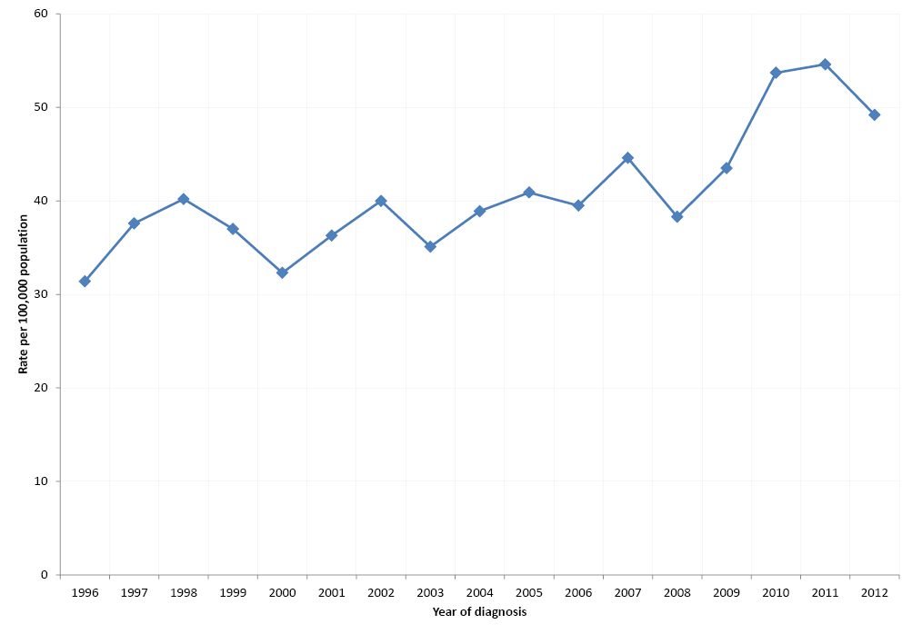
Figure 4: Notification rate for salmonellosis, Australia, 2012, by age group and sex 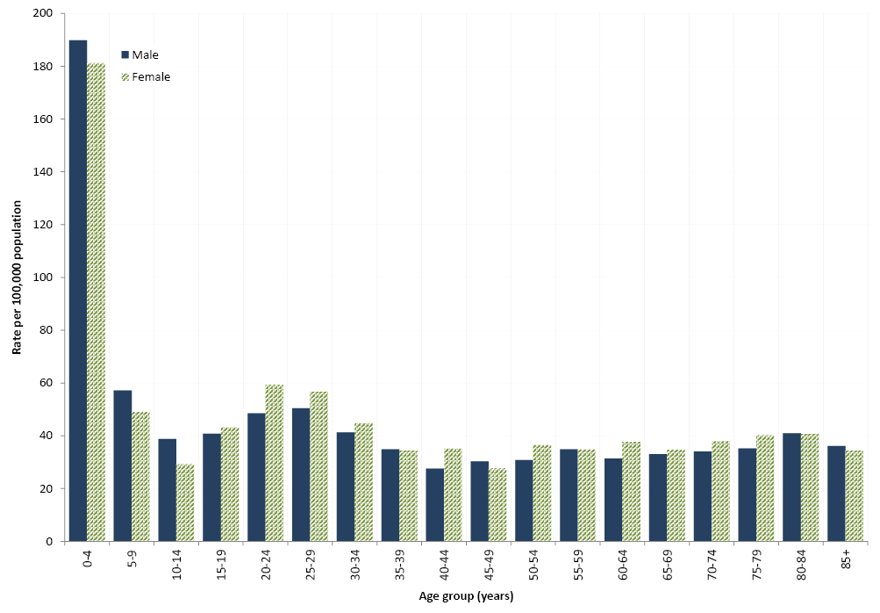
Of the 11,249 salmonellosis notifications in 2012, 98% (10,996) were further typed at an enteric reference laboratory, into 157 unique serovars accounting for 10,484 notifications. The remaining 512 isolates were unable to be assigned a serovar and were grouped into 74 unique incomplete antigenic structures. S. Typhimurium was the most commonly notified serovar in 2012, responsible for 4,985 notifications (Table 2).
Table 2: Five most common Salmonella serotypes, Australia, 2012, by state or territory compared with the 5-year mean
State or territory |  | S. Typhimurium | S. Enteritidis | S. Virchow | S. Saintpaul | S. Paratyphi B Bv Java
ACT | Notified cases, 2012 | 159 | 11 | 5 | 4 | 5
 | Mean (2007-2011) | 112 | 9 | 3 | 1 | 3
 | % change | 42% | 22% | 67% | 300% | 67%
NSW | Notified cases, 2012 | 1597 | 156 | 90 | 35 | 85
 | Mean (2007-2011) | 1616 | 125 | 95 | 43 | 66
 | % change | -1% | 25% | -5% | -19% | 29%
NT | Notified cases, 2012 | 46 | 22 | 50 | 41 | 4
 | Mean (2007-2011) | 48 | 10 | 41 | 48 | 11
 | % change | -4% | 120% | 22% | -15% | -64%
Qld | Notified cases, 2012 | 989 | 131 | 251 | 193 | 30
 | Mean (2007-2011) | 682 | 107 | 262 | 204 | 37
 | % change | 45% | 22% | -4% | -5% | -19%
SA | Notified cases, 2012 | 436 | 69 | 12 | 15 | 16
 | Mean (2007-2011) | 450 | 43 | 17 | 11 | 13
 | % change | -3% | 60% | -29% | 36% | 23%
Tas | Notified cases, 2012 | 96 | 14 | 0 | 4 | 7
 | Mean (2007-2011) | 66 | 7 | 6 | 2 | 2
 | % change | 45% | 100% | -100% | 100% | 250%
Vic | Notified cases, 2012 | 1,367 | 180 | 40 | 34 | 64
 | Mean (2007-2011) | 1,183 | 116 | 47 | 27 | 41
 | % change | 16% | 55% | -15% | 26% | 56%
WA | Notified cases, 2012 | 295 | 244 | 17 | 46 | 62
 | Mean (2007-2011) | 365 | 211 | 18 | 43 | 40
 | % change | -19% | 16% | -6% | 7% | 56%
Australia | Notified cases, 2012 | 4,985 | 827 | 465 | 372 | 273
 | Mean (2007-2011) | 4,521 | 629 | 490 | 380 | 212
 | % change | 10% | 31% | -5% | -2% | 29%

Salmonella Enteritidis
S. Enteritidis is a globally important Salmonella serotype that can infect the internal contents of eggs, but is not endemic in Australian egg layer flocks.^{20,21} The majority of cases in Australia are associated with overseas travel. To monitor incidence of this serotype in Australia, OzFoodNet conducts enhanced surveillance of locally-acquired infections of S. Enteritidis in humans.
During 2012, OzFoodNet sites reported 827 cases of S. Enteritidis infection (Table 3) compared with 812 notifications in 2011 and 835 notifications in 2010. Travel histories were obtained for 94% (779/827) of cases in 2012, which is similar to the 95% (769/812) obtained for cases in 2011. Of those cases in 2012 with travel history, 91% (709/779) had travelled overseas and 9% (70) were locally-acquired. Western Australia reported the highest number (29%, 244/827) of notified cases, while Queensland, where S. Enteritidis PT 26 is endemic, reported the largest number of locally-acquired cases (Table 3).
Table 3: Number of Salmonella Enteritidis infections, Australia, 2012, by travel history and state or territory
State or territory | Overseas-acquired | Locally-acquired | Unknown | Total
ACT | 10 | 1 | 0 | 11
NSW | 125 | 8 | 23 | 156
NT | 20 | 0 | 2 | 22
Qld | 76 | 41 | 14 | 131
SA | 67 | 2 | 0 | 69
Tas | 11 | 0 | 3 | 14
Vic | 174 | 2 | 4 | 180
WA | 226 | 16 | 2 | 244
Total | 709 | 70 | 48 | 827

In 2012, South-East Asia (92%, 650/709) was the most common region of overseas acquisition for S. Enteritidis. Similar to previous years, the most common overseas country of acquisition was Indonesia (63%, 449/709). This was followed by Thailand (8%, 55/709) and Malaysia (6%, 45/709).
Phage typing was performed on 69% (536/779) of the S. Enteritidis cases with travel history and the most common phage types among overseas-acquired cases were PT 1 (26%), 6a (10%), 13 (8%), and 21 (8%) (Table 4). Locally-acquired cases were sporadic with no clusters detected by person, place, or time. Similar to previous years, the most common phage types among locally-acquired isolates were PT 26 (24%), and PT 1 (13%) (Table 4).
Table 4. Five most common phage types of locally and overseas-acquired Salmonella Enteritidis infections, Australia, 2012
Overseas-acquired cases |  |  | Locally-acquired cases
Phage type | n | % of total typed (n=468) | Phage type | n | % of total typed (n=68)
1 | 123 | 26% | 26 | 16 | 24%
6a | 49 | 10% | 1 | 9 | 13%
13 | 39 | 8% | RDNC | 7 | 10%
21 | 39 | 8% | 13 | 5 | 7%
RDNC | 37 | 5% | 14c | 4 | 6%
^{RDNC} Reactions Do Not Conform

Salmonella Paratyphi (paratyphoid)
Salmonella serovars Paratyphi A, B and C (not including S. Paratyphi B biovar Java) are notified and reported under salmonellosis, however they cause an enteric fever similar to S. Typhi but typically milder which is commonly referred to as paratyphoid. In 2012, there were 78 notifications of paratyphoid, compared to 68 in 2011 and a 5-year historic mean of 67. S. Paratyphi A infection was the aetiology for 82% (64/78) of paratyphoid notifications, with the remainder (14/78) being due to S. Paratyphi B infection. The majority of paratyphoid infections (83%, 65/78) were contracted overseas: most commonly in India (n=29) and Indonesia (n=11). The country of acquisition was unknown for 10 notifications and 3 infections were reported to be acquired in Australia.

Listeriosis
There were 93 notifications of L. monocytogenes infection reported in 2012 (0.4 notifications per 100,000 population), higher than the 5-year historical mean (0.3 notifications per 100,000 population) (Table 1). State and territory rates ranged from 0.0 to 0.6 notifications per 100,000 population. Of the 93 notifications, 32% (30) were in people 60 years of age or over and females accounted for 61% (57). Eleven cases in 2012 were pregnant women with 3 associated neonatal infections.
The most commonly reported L. monocytogenes types were serotype 4b, 4d, 4e and binary type (BT) 255 (26%, 24/93) followed by serotype 4b, 4d, 4e and BT 254 (24%, 22) (Table 5).
Table 5: Five most common Listeria monocytogenes strains, Australia, 2012, by molecular serotype and binary type
Serotype | Binary type | Number of cases
4b, 4d, 4e | 255 | 24
4b, 4d, 4e | 254 | 22
1/2c, 3c | 82 | 8
4b, 4d, 4e | 190 | 5
1/2b,3b,7 | 158 | 4
Source: OzFoodNet National Enhanced Listeriosis Surveillance System
One multi-jurisdictional outbreak (this investigation continued into 2013 and will be reported in the 2013 annual report) and 2 multi-jurisdictional clusters were investigated in 2012.

Shigellosis
There were 546 notifications of Shigella infection in Australia in 2012, a rate of 2.4 notifications per 100,000 population compared with the 5-year historical mean of 2.8 per 100,000 (Figure 5, Table 1). It has been estimated that around 12% of shigellosis cases are acquired via foodborne transmission.2 Compared with the 5-year historical mean, there has been an increase in cases in Tasmania (+133%), Victoria (+11%), New South Wales (+6%) and the Australian Capital Territory (+7%) and a decline in cases in Western Australia (-59%), South Australia (-31%), the Northern Territory and Queensland (-14% each). As in previous years, the highest notification rate occurred in the Northern Territory, with 45.6 per 100,000 population. The lowest rate was in Tasmania with 1.4 per 100,000. In 2012, notification rates for shigellosis were highest in males and females 0–4 years of age, with 6.1 and 7.2 notifications per 100,000 population respectively (Figure 6). The overall rate for males was 2.4 per 100,000 in 2012 compared with the female rate of 2.3 per 100,000. Indigenous status was recorded for 88% (480/546) of shigellosis cases. Of these, 31% (147/480) identified as being Aboriginal or Torres Strait Islander. Data on male-to-male sexual exposure was reported for notifications in the Australian Capital Territory, New South Wales, Queensland, Tasmania and Victoria (62%, 338/546). Of these, 16% (55/338) reported male-to-male sexual contact during their period of acquisition.
Figure 5: Notification rate for shigellosis, Australia, by year of diagnosis
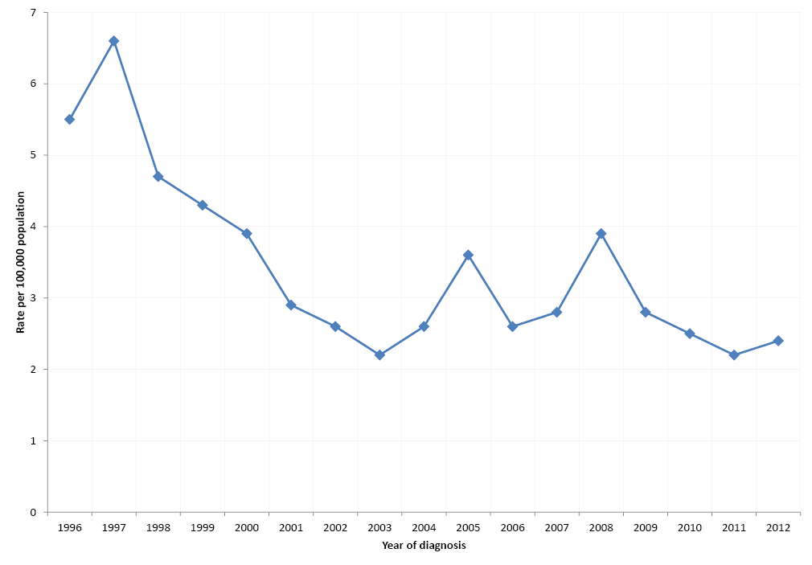

Figure 6: Notification rate for shigellosis, Australia, 2012, by age and sex
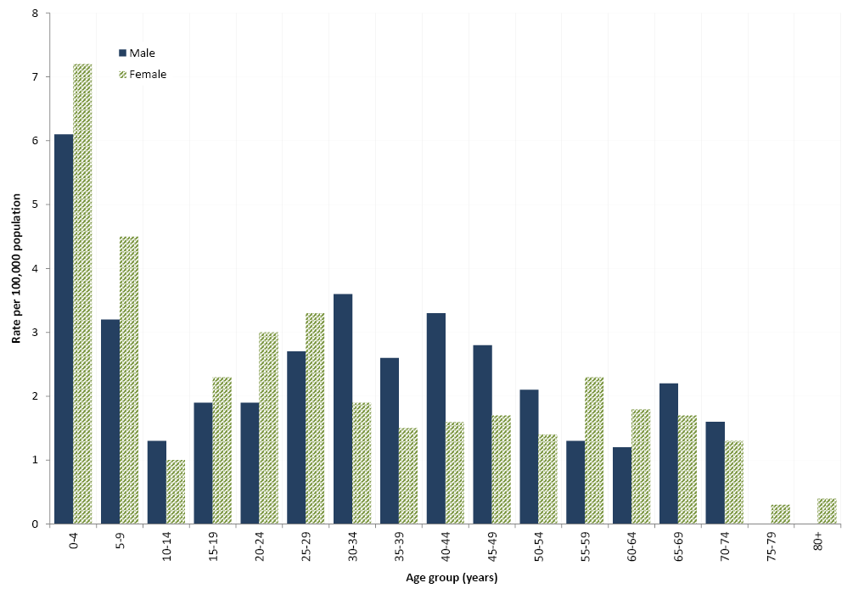
Travel history information was available for 68% (371/546) of shigellosis notifications in 2012 and of these, 54% (201/371) acquired their illness overseas. The most common overseas countries of acquisition were Indonesia (12%, 45/371) and India (11%, 39/371). Nearly all Shigella isolates were typed (97%, 530/546) with Shigellasonnei being the most frequent species notified (70%, 371/530), followed by Shigellaflexneri (27%, 145/530). There were also 9 notifications of Shigellaboydii and 5 notifications of Shigelladysenteriae. Shigellasonnei biotype a was the most frequently notified infection (34%, 187/546) (Table 6).
Table 6: Number, percentage and ratio of the top 10 Shigella infections, Australia, 2011 and 2012, by biotype
Biotype | 2011 |  | 2012 |  | Ratio‡
 | n | %* | n | %†
Shigella sonnei biotype a | 164 | 33% | 187 | 34% | 1.1
Shigella sonnei biotype g | 139 | 28% | 141 | 26% | 1.0
Shigella sonnei untyped | 34 | 7% | 35 | 6% | 1.0
Shigella flexneri 2a | 27 | 6% | 32 | 6% | 1.2
Shigella flexneri 4a | 18 | 4% | 5 | 1% | 0.3
Shigella flexneri 4 | 18 | 4% | 15 | 3% | 0.8
Shigella flexneri 3a | 15 | 3% | 12 | 2% | 0.8
Shigella flexneri 2b | 12 | 2% | 12 | 2% | 1.0
Shigella untyped | 12 | 2% | 17 | 3% | 1.4
Shigella flexneri untyped | 10 | 2% | 15 | 3% | 1.5
* Proportion of total shigellosis notified in 2011.
† Proportion of total shigellosis notified in 2012.
‡ Ratio of the number of cases in 2012 compared with the number in 2011.

Typhoid Fever
In 2012, there were 122 notifications of Salmonella Typhi infection (typhoid fever) in Australia, a rate of 0.5 notifications per 100,000 population. This was the same as the 5-year historical mean (2007-2011) of 0.5 per 100,000 population (Table 1). Most notifications were in New South Wales (43/122) and Victoria (37/122). In 2012, 60% (73/122) of cases were male. Travel history was known for 97% (116/122) of cases, with 97% (115/118) of these likely to have acquired the infection overseas.
Most of the overseas-acquired cases of typhoid fever notified in 2012 had travelled to India (57%, 65/115), Bangladesh (11%, 13//115) or Indonesia (10%, 12/115). The most commonly notified phage type was PT E1 and these infections were mostly associated with travel to India. Two of the 6 cases with no known history of overseas travel were also PT E1 (Table 7).
Table 7: Notifications of Salmonella Typhi infection, Australia, 2012, by phage type and country of acquisition
Phage type | Australia | Bangladesh | India | Indonesia | Other countries | Unknown | Total
E1 | 0 | 0 | 22 | 0 | 10 | 2 | 34
E9 | 1 | 3 | 8 | 0 | 5 | 1 | 18
A | 0 | 1 | 1 | 1 | 4 | 0 | 7
D2 | 0 | 0 | 0 | 4 | 1 | 0 | 5
Other types | 1 | 3 | 10 | 1 | 0 | 2 | 17
Unable to be typed | 1 | 1 | 10 | 2 | 1 | 1 | 16
Unknown | 0 | 5 | 14 | 4 | 2 | 0 | 25
Total | 3 | 13 | 65 | 12 | 23 | 6 | 122

Hepatitis A
In 2012, there were 166 hepatitis A notifications with a rate of 0.7 notifications per 100,000 population. This was slightly higher than the rate (0.6 per 100,000 population) reported in 2011¹⁵ and 44% lower than the 5-year historical mean (1.3 notifications per 100,000) (Table 1). There was a large decrease in hepatitis A notifications between 1997 and 2001 and then a more gradual decrease from 2002 to 2012 (Figure 7). Indigenous status was known for 95% (157/166) of hepatitis A cases in 2012. No cases of hepatitis A were identified as being in Aboriginal or Torres Strait Islander peoples. This is consistent with the small percentage of cases reported between 2007 and 2011, and a shift from the 2004 and 2006 period when 10%–15% (28–49 cases) of cases per year identified as being Aboriginal or Torres Strait Islander.²²⁻ ²⁴
Figure 7: Notification rate for hepatitis A infections, Australia, by year of diagnosis 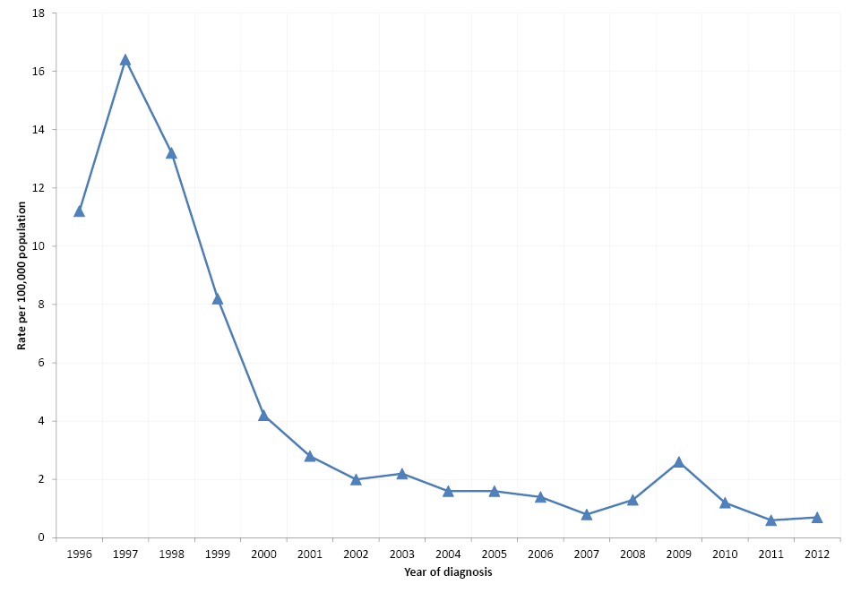
In 2009, the majority of cases notified were part of a large multi-jurisdictional outbreak associated with the consumption of semi-dried tomatoes.^{22,25} The median age of cases in 2012 was 27 years (range 1 - 92 years) and 51% were female (85/166).
In 2012, 77% (127/166) of hepatitis A infections were acquired overseas. Counties of acquisition included India (20%, 25/127), Lebanon (13%, 16/127) and Indonesia (10%, 13/127). In the same year, 23% (39/166) of hepatitis A cases were locally-acquired (Figure 8), the lowest number and proportion since recording of country of acquisition began in 2006.
Figure 8: Place of acquisition for hepatitis A cases, Australia, by year of diagnosis (n=1,862) 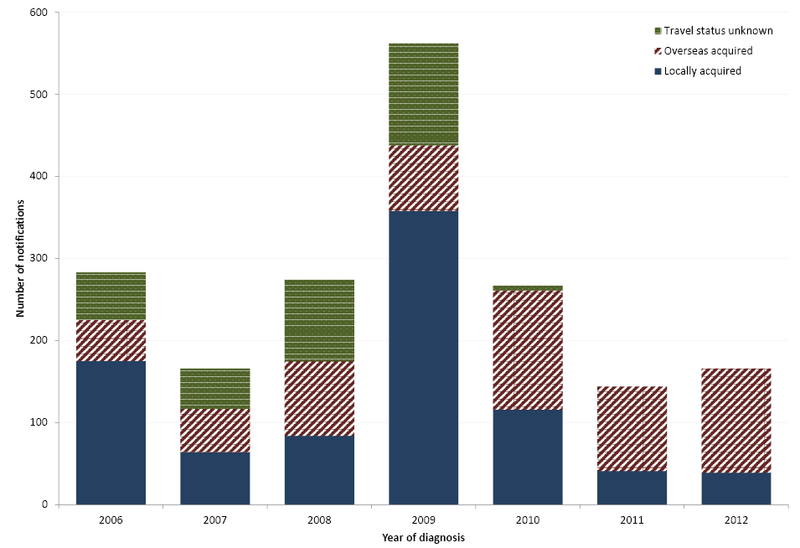

Shiga toxin-producing Escherichia coli (STEC) infection
In 2012, there were 112 notifications of STEC infection in Australia, a rate of 0.5 notifications per 100,000 population, equivalent to the 5-year historical mean (Table 1, Figure 9). Twenty of these cases were also diagnosed with HUS. Per the NNDSS surveillance case definitions (available online from: http://www.health.gov.au/casedefinitions), these conditions are notified separately. In 2012, 53% (59/112) of cases were male. The median age of cases was 46 years (range 1–95 years).
Figure 9: Notification rate for Shiga toxin-producing Escherichia coli infections, Australia, by year of diagnosis* 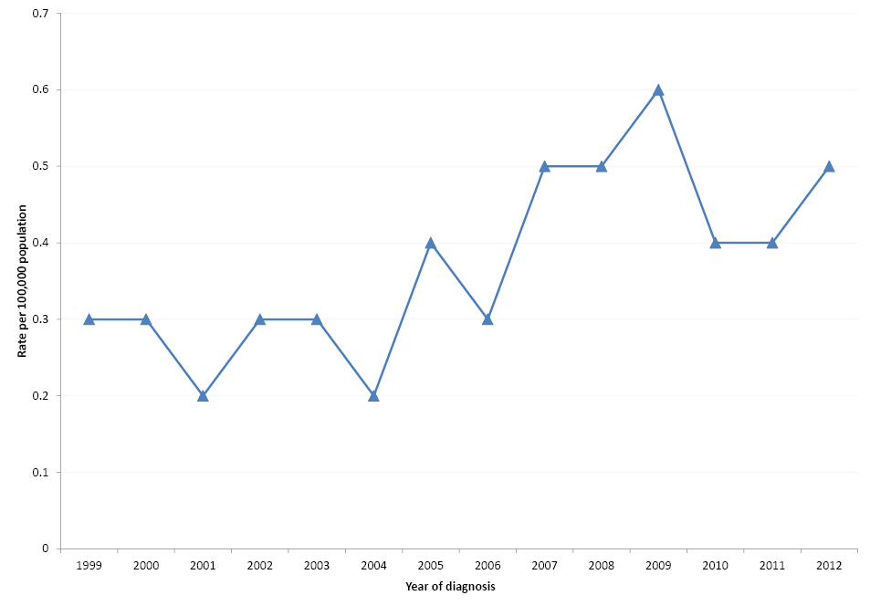
*STEC became notifiable in Australia in 1999.
Notified cases of STEC infection are strongly influenced by state and territory practices regarding the screening of stool specimens.²⁶ In particular, South Australian public health laboratories routinely test all bloody stools with a polymerase chain reaction (PCR) assay specific for genes coding for Shiga toxins, making rates for this state typically the highest in the country. In 2012, South Australia had the highest rate of notifications with 2.7 notifications per 100,000 population (45/112) followed by the Australian Capital Territory with 1.6 notifications per 100,000 population (6/112). The increase in the notification rate for the Australian Capital Territory relates to the continuation of an STEC screening study which commenced in October 2011 based in a local laboratory.
In 2012, serogroup information was available for 56% of STEC cases (63/112). The most common serogroups identified were: O157 (48%, 30/63); O26 (13%, 8/63); O113 (8%, 5/63) and O111 (5%, 3/63). Serogroup information was obtained by serotyping cultured isolates or by PCR targeting serogroup-specific genes. The remaining 49 isolates were either not able to be serotyped or were Shiga- toxin positive by PCR only with no isolates obtained. In 2011 by comparison, O157 accounted for 38% (22/58) and O111 17% (10/58) of serotyped specimens.²⁴

Haemolytic Uraemic Syndrome (HUS)
In 2012, OzFoodNet sites reported 20 cases of HUS with a rate of 0.1 notifications per 100,000 population, which is equivalent to the 5-year historical mean (Table 1). There were 14 male and 6 female cases and the median age was 13 years (range 1 to 87 years). Similar to previous years, the majority of cases were in children, with 8 cases in children 0-9 years of age, 4 cases in children 10-15 years of age and only 8 cases in persons over 18 years of age.
Not all diagnoses of HUS are related to enteric pathogens (including those potentially transmitted by food). In 2012, all cases of HUS were also positive for STEC and 45% of HUS cases (9/20) had a serogroup identified including serotypes O157 (4/20), O169:H (1), O26 (1), O103 (1), O111:H (1) and O not typed:H11 (1). The remaining 11 cases were Shiga toxin positive but the isolates were unable to be serotyped.

Botulism
Four forms of naturally occurring botulism are recognised; foodborne, infant intestinal, wound, and “other” where cases are older than one year of age and no plausible exposure is known. Some of these cases are suspected to be due to intestinal colonisation.²⁷ Infant intestinal botulism mostly affects infants less than one year of age and occurs when Clostridium botulinum spores are ingested, germinate in the infant’s intestine and the organism produces botulinum toxin. It does not include cases where the preformed toxin is ingested; these are considered foodborne. There were no cases of any type of botulism reported in 2012. There were a total of 2 notifications of infant intestinal botulism reported in 2011, and none reported in 2010.^{23,24}

Outbreaks of gastrointestinal illness
In 2012, OzFoodNet sites reported 2,180 outbreaks of gastrointestinal illness (including foodborne disease), affecting 40,547 people, of whom 955 were hospitalised (Table 8). There were 131 deaths reported during these outbreaks. This is comparable with the 5-year historic mean (2007-2011) of 1,721 outbreaks. Outbreaks were most commonly due to norovirus (33%, 711/2,179), rotavirus (3%, 62/ 1,721) or other suspected viral agents (13%, 285/ 1,721), with 745 of unknown aetiology (34%).
Table 8: Outbreaks of gastrointestinal illness reported to state and territory health departments, Australia, 2012
Transmission mode | Number of outbreaks | Number ill | Number hospitalised | Number of deaths reported
Foodborne and suspected foodborne | 144 | 2,117 | 183 | 9
Person-to-person | 1,819 | 35,999 | 680 | 121
Animal-to-person | 2 | 16 | 1 | 0
Waterborne or suspected waterborne | 7 | 77 | 2 | 0
Unknown mode | 208 | 2,338 | 89 | 1
Total | 2,180 | 40,547 | 955 | 131

Outbreaks spread person-to-person
In 2012, 83% of all reported gastrointestinal outbreaks were transmitted from person to person (1,819/2,180). These outbreaks affected 35,999 people, of whom 680 were hospitalised. There were 121 deaths reported during these outbreaks (Table 8). Aged care facilities (49%, 894/1,819) were the most frequently reported setting of exposure for person-to-person outbreaks, followed by childcare centres (27%, 492/1,819).

Outbreaks spread animal-to-person
Two outbreaks in two separate months (April and June) were reported to have been transmitted from animal to person within the same aged care facility (Table 8). The aetiological agent for both outbreaks was identified as Campylobacterjejuni. These outbreaks affected a total of 16 people, with one case requiring hospitalisation. A number of cases had C. jejuni isolated from stool samples, along with a puppy that lived on-site at the aged care facility.²⁸

Waterborne outbreaks
There were 7 outbreaks reported to be waterborne or suspected to be waterborne. These outbreaks affected 77 people, with 2 people requiring hospitalisation (Table 7). Five outbreaks were attributed to Cryptosporidium, one outbreak was suspected viral gastroenteritis and for one outbreak the aetiology was unknown. The source of infection was confirmed for 6 of these outbreaks, with 5 related to exposure at public aquatic facilities and one outbreak was associated with a school camp.

Outbreaks with unknown mode of transmission
There were 208 outbreaks in which cases were clustered in time, place or person, where investigators were unable to develop an adequate hypothesis for the mode of transmission. These outbreaks affected 2,338 people, 89 of whom were hospitalised. There was one death reported during these outbreaks. Aged care facilities were the most frequently reported setting (36%, 74/208), followed by restaurants (10%, 21/208) and child care facilities (10%, 20/208). In 82% (170/208), both the aetiological agent and transmission mode remained unknown. In 8% (16/208) of these outbreaks, the aetiological agent was identified as Salmonella spp. and in 6% (12/208) the agent was norovirus.

Foodborne and suspected foodborne outbreaks
In 2012, OzFoodNet sites reported 144 outbreaks of foodborne and suspected foodborne illness. These outbreaks affected 2,117 people, with 183 hospitalised. Nine deaths were reported during these outbreaks (Table 8). This compares with a 5-year historic mean (2007-2011) of 144 outbreaks annually. The overall rate of foodborne disease outbreaks in 2012 was 6.3 per million population (Table 9). The highest rates were in the Australian Capital Territory (26.7 outbreaks per million population) and the Northern Territory (21.3 outbreaks per million population), although these jurisdictions reported only 10 and 5 outbreaks respectively. The largest number of outbreaks (47) was reported by New South Wales.
Table 9: Outbreaks of foodborne and suspected foodborne disease, Australia, 2012, by OzFoodNet site
State or territory | Number of outbreaks | Number ill | Mean size (persons) per outbreak | Number hospitalised | Outbreak rate per million population
ACT | 10 | 113 | 11.3 | 13 | 26.7
NSW | 47 | 457 | 9.7 | 26 | 6.4
NT | 5 | 45 | 9.0 | 1 | 21.3
Qld | 25 | 205 | 8.2 | 20 | 5.5
SA | 9 | 150 | 16.7 | 13 | 5.4
Tas. | 5 | 103 | 20.6 | 8 | 9.8
Vic. | 27 | 348 | 12.9 | 22 | 4.8
WA | 12 | 225 | 18.8 | 36 | 4.9
NSW/Vic | 1 | 3 | 3.0 | 3 | N/A
Multi-jurisdictional | 3 | 468 | 156.0 | 41 | N/A
Total | 144 | 2,117 | 14.7 | 183 | 6.3

Aetiologies
One out of every 5 foodborne and suspected foodborne outbreaks (58/144) were due to S. Typhimurium (Table 10). Other frequently reported pathogens were norovirus (10%, 15/144), other Salmonella serovars (6%, 8/144), scombrotoxin (4%, 6), Campylobacter species. (3%, 4/144) and Clostridium perfringens (2%, 3/144). There were 39 outbreaks of unknown aetiology (27%), which is similar to the figure reported in 2011 (31%, 47/151).

Table 10: Outbreaks of foodborne disease breaks and number affected, Australia, 2012, by aetiology and food category
Agent category | Total |  | Attributed to a single food category |  | Attributed to >1 food category |  | Not attributed to a food category
 | Number of outbreaks | Number ill | Number of outbreaks | Number ill | Number of outbreaks | Number ill | Number of outbreaks | Number ill
Salmonella Typhimurium* | 58 | 1,196 | 31 | 885 | 9 | 144 | 18 | 167
Salmonella spp. other | 8 | 88 | 3 | 56 | 3 | 22 | 2 | 10
Campylobacter spp. | 4 | 34 | 3 | 26 | 0 | 0 | 1 | 8
Staphylococcus aureus | 1 | 22 | 1 | 22 | 0 | 0 | 0 | 0
STEC | 1 | 5 | 1 | 5 | 0 | 0 | 0 | 0
Clostridium perfringens | 3 | 25 | 3 | 25 | 0 | 0 | 0 | 0
Listeria monocytogenes | 2 | 37 | 1 | 34 | 0 | 0 | 1 | 3
Amatoxin | 1 | 3 | 1 | 3 | 0 | 0 | 0 | 0
Ciguatoxin | 2 | 4 | 2 | 4 | 0 | 0 | 0 | 0
Scombrotoxin | 6 | 21 | 6 | 21 | 0 | 0 | 0 | 0
Norovirus | 15 | 267 | 3 | 18 | 10 | 171 | 2 | 78
Suspected viral | 2 | 44 | 0 | 0 | 1 | 19 | 1 | 25
Suspected bacterial toxin | 2 | 23 | 1 | 3 | 1 | 20 | 0 | 0
Unknown | 39 | 348 | 4 | 40 | 5 | 51 | 30 | 257
Total | 144 | 2,117 | 60 | 1,142 | 30 | 430 | 54 | 545
* Including S. subsp I ser 4, 5, 12:i:-

Food vehicles
Outbreaks were categorised as being attributable to one of 19 food commodities (i.e. 17 as described by Painter et al²⁹ with additional categories for lamb and kangaroo) if a single contaminated ingredient was identified or if all ingredients belonged to that food category. Outbreaks that could not be assigned to one of the 19 categories, or for which the report contained insufficient information for food category assignment were not attributed to any food category.³⁰
In 60 foodborne and suspected foodborne outbreaks (42%, 60/144), investigators attributed the outbreak to a single food commodity. In another 30 outbreaks (21%), the implicated dish contained a mix of ingredients, and no single ingredient was implicated. Thirty eight per cent of outbreaks (54/144) could not be definitively attributed to a particular food or foods due to a lack of evidence.
Of the outbreaks attributed to a single food (60/144), the foods most frequently implicated were eggs (47%, 28/60), fish (22%, 13/60) and poultry (10%, 6/60). During these outbreaks 882 people became ill, 75 people were hospitalised and 2 people were reported to have died (Table 11). Poultry implicated outbreaks affected the largest number of people (48%, 553/1,142). The majority of those affected (71%, 391/553) were part of a single outbreak of novel SalmonellaTyphimurium MLVA 03-16/17-09-12-523. This outbreak was the subject of an OzFoodNet multi-jurisdictional outbreak investigation and is discussed in more detail later in this report.
Table 11: Foodborne disease outbreaks attributed to a single food vehicle, Australia, 2012
Food Commodities  (based on Painter et al 2009) | Number of outbreaks | Number affected | Number hospitalised | Number of fatalities
Eggs | 28 | 320 | 37 | 0
Fish | 13 | 51 | 0 | 0
Poultry | 6 | 553 | 35 | 0
Lamb | 2 | 23 | 1 | 0
Pork | 2 | 25 | 1 | 0
Leafy greens | 2 | 40 | 3 | 0
Fungi | 2 | 13 | 3 | 2
Fruit-nuts | 1 | 43 | 7 | 0
Dairy | 1 | 34 | 34 | 6
Grains-beans | 1 | 22 | 6 | 0
Beef | 1 | 13 | 0 | 0
Kangaroo | 1 | 5 | 1 | 0
Total | 60 | 1,142 | 128 | 9

Egg associated outbreaks
There were 90 outbreaks with a known food vehicle or vehicles and, of these, almost a third (31%, 28/90) were suspected or confirmed to have been associated with the consumption of eggs and egg-based dishes (Table 12). These egg-associated outbreaks comprised 19% (28/144) of all foodborne outbreaks, just under half (42%, 28/66) of all foodborne Salmonella outbreaks, and half (51%, 23/45) of the outbreaks that were attributed to a single commodity. In these egg-associated outbreaks, eggs were served in desserts (11 outbreaks), in sauces and dressings such as mayonnaise, tartare or aioli (7 outbreaks), as a raw egg white emulsion (1 outbreak) and other egg containing vehicles (9 outbreaks).

Table 12: Foodborne disease outbreaks associated with eggs and egg-based dishes, Australia, 2012
State | Setting prepared | Agent responsible | Number affected | Evidence | Responsible vehicles
ACT | Restaurant | S. Typhimurium PT 170/108*, MLVA 03-10-07-12-523† | 10 | D | Mayonnaise, unspecified
ACT | Restaurant | S. Typhimurium PT 135a, MLVA 03-10-07-12-523 | 7 | D | Eggs, other
ACT | Restaurant | S. Typhimurium PT 170/108, MLVA 03-09-08-14-523 | 23 | A | Raw egg white emulsion
ACT | Restaurant | S. Typhimurium PT 135a, MLVA 03-13/12-11-10/09-523 | 20 | AM | Eggs benedict, hollandaise sauce
NSW | Restaurant | S. Typhimurium PT 170/108, MLVA 03-09-09-12-523 | 12 | M | Deep fried ice cream
NSW | Restaurant | S. Typhimurium PT 170/108, MLVA 03-09-07-12-523 | 3 | D | Ice-cream cake containing raw eggs
NSW | Restaurant | S. Typhimurium PT 170/108, MLVA 03-09-07-12-523 | 14 | D | Deep fried ice cream
NSW | Restaurant | S. Typhimurium PT 170/108, MLVA 03-09-07-13-523 | 20 | M | Mayonnaise containing raw eggs
NSW | Restaurant | S. Typhimurium PT 170/108, MLVA 03-09-09-12-523 | 5 | M | Deep fried ice cream
NSW | Restaurant | S. Typhimurium PT 170/108, MLVA 03-09-07-13-523 | 5 | D | Eggs and omelettes
NSW | Restaurant | S. Typhimurium PT 170/108, MLVA 03-09-09-12-523 | 9 | D | Deep fried ice cream
NSW | Take-away | S. Typhimurium PT 170/108, MLVA 03-10-07-13-523 | 14 | D | Vietnamese bakery goods
NSW | Commercial caterer | S. Typhimurium PT 170/108, MLVA 03-09-08-14-523 | 14 | D | Mayonnaise containing raw eggs
NSW | Restaurant | S. Typhimurium PT 170/108, MLVA 03-09-09-12-523 | 17 | D | Bombe Alaska
NSW | Restaurant | S. Typhimurium PT 135a, MLVA 03-13-09-11-550 | 4 | M | Bacon and egg burger
NSW | Bakery | S. Typhimurium PT 170/108, MLVA 03-09-09-12-523 | 27 | M | Numerous bakery goods
NSW | Take-away | S. Typhimurium PT 44, MLVA 03-10-08-09-523 | 11 | D | Vietnamese rolls
Qld | Private residence | S. Typhimurium MLVA 3-13-10-10-524 | 4 | D | Chocolate cake with raw egg meringue
Qld | Restaurant | S. Typhimurium PT 135a, MLVA 3-12-15/16-09-524 | 2 | D | French Toast
Qld | Restaurant | S. Typhimurium PT 16, MLVA 03-13-11-11-524 | 3 | D | Chicken Caesar salad with raw egg dressing
SA | Restaurant | S. Typhimurium PT 9, MLVA 03-15-07-11-550 | 11 | M | Deep fried ice cream
Tas. | Restaurant | S. Typhimurium PT 141 | 8 | D | Egg-based sauce
Tas. | Other | S. Typhimurium PT 135 | 44 | D | Probable raw egg mayonnaise and/or tartare sauce
Vic. | Private residence | S. subsp I ser 4,5,12 :i:- PT 193 | 14 | M | Raw egg ice cream cake
Vic. | Private residence | S. Typhimurium PT 4 | 4 | D | Raw egg smoothies
Vic. | Private residence | S. Typhimurium PT 135a | 7 | D | Suspected chocolate mousse containing raw eggs
Vic. | Private residence | S. Typhimurium PT 170/108 | 3 | D | Raw egg drink
Vic. | Private residence | S. Typhimurium PT 135a | 5 | D | Probable chocolate mousse with raw eggs
Evidence key:
D Descriptive evidence implicating the vehicle
^{A} Analytical epidemiological association between illness and vehicle
^{M} Microbiological confirmation of aetiology in vehicle and cases
^{AM} Analytical association and microbiological confirmation of aetiology
* Classification of this Salmonella Typhimurium phage type differs between laboratories, with the Microbiological Diagnostic Unit using PT 170 and SA Pathology using PT 108. This is due to a difference of interpretation of 1 phenotypic characteristic.
† Multiple-locus variable number tandem repeat analysis (MLVA) profiles are reported using the Australian coding convention agreed at a MLVA typing harmonisation meeting in Sydney in November 2011.

Settings
In 2012, foods implicated in foodborne and suspected foodborne outbreaks were most commonly prepared in restaurants (49%, 71/144), in private residences (13%, 18/144), or by a commercial caterer (9%, 13/144) (Table 13). This represents an increase in restaurants from 2011 (33%, 50/151). In the same period, outbreaks associated with aged care facilities decreased (from 15% (22/151) in 2011 to 5% (7/144) in 2012.
Table 13: Foodborne disease outbreaks, Australia, 2012, by implicated food preparation setting
Setting | Number of outbreaks | Per cent of outbreaks | Number affected
Restaurant | 71 | 49% | 779
Private residence | 18 | 13% | 125
Commercial caterer | 13 | 9% | 233
Aged care | 7 | 5% | 80
Take-away | 7 | 5% | 48
Other | 4 | 3% | 98
Bakery | 4 | 3% | 42
Commercially manufactured | 2 | 1% | 37
Primary produce | 2 | 1% | 45
Camp | 2 | 1% | 15
National franchised fast food | 2 | 1% | 8
Community | 1 | 1% | 131
Fair/festival/mobile service | 1 | 1% | 10
Hospital | 1 | 1% | 6
School | 1 | 1% | 4
Institution | 1 | 1% | 3
Unknown | 7 | 5% | 453
Total | 144 | 100%* | 2,117
*may not add up to 100 due to rounding

Investigative methods and levels of evidence
To investigate foodborne outbreaks, epidemiologists in the states and territories conducted 22 point source cohort studies and 8 case-control studies. Descriptive case series investigations were conducted for 90 outbreaks. In 24 outbreaks, no formal study was conducted (Appendix A).
There was an analytical association between illness and the implicated food as well as microbiological evidence of the aetiological agent in the epidemiologically implicated food for 4 outbreaks. Investigators relied on analytical evidence alone for 15 outbreaks and microbiological (or toxicological for non-microbial outbreaks) evidence alone for 19 outbreaks. These confirmed foodborne outbreaks comprised 26% (38/144) of all foodborne outbreaks (Appendix A).

Contributing factors
Investigators collect information about factors that are likely to have contributed to a foodborne outbreak occurring. This information may be based on measured evidence, inspections, interview data, observations or an investigator’s suspicion. Contamination factors are those that may have led to the food becoming contaminated or to contaminated products being consumed. The most commonly reported contributing factor for the 38 confirmed foodborne outbreaks was ingestion of contaminated raw products which occurred in 10 outbreaks (26%,). Contamination factors varied by the aetiology of outbreaks as described in Table 14.
Table 14: Factors reported as leading to the contamination of food vehicles in confirmed foodborne disease outbreaks, Australia, 2012, by aetiology
Agent | Contamination factor | Number of outbreaks | Number affected
Campylobacter | Cross contamination from raw ingredients | 1 | 15
Clostridium perfringens | Cross contamination/ inadequate cooking time/ temperature | 1 | 7
 | Inadequate cooking time/ temperature | 1 | 5
Histamine Fish Poisoning | Toxic substance or part of tissue | 2 | 7
Listeria monocytogenes | Unknown | 2 | 37
Norovirus | Cross contamination with sewage identified during harvest | 1 | 8
 | Food handler contamination | 1 | 22
 | Person to food to person | 2 | 23
Salmonella Typhimurium | Ingestion of contaminated raw products | 7 | 140
 | Cross contamination from raw ingredients | 2 | 61
 | Ingestion of contaminated raw products and inadequate cleaning of equipment | 1 | 27
 | Potential for cross contamination during production and processing | 1 | 391
 | Ingestion of contaminated raw products and cross contamination from raw ingredients | 1 | 131
 | Unknown | 4 | 55
Other Salmonella spp. | Cross contamination from raw ingredients | 2 | 16
 | Ingestion of contaminated raw products and inadequate cleaning of equipment | 1 | 4
Total |  | 38 | 1,075

Significant foodborne and suspected foodborne outbreaks
In 2012, OzFoodNet sites responded to 144 foodborne or suspected foodborne outbreaks including 3 multi-jurisdictional outbreak investigations conducted under the Guidelines for the epidemiological investigation of multi-jurisdictional outbreaks that are potentially foodborne (current endorsed version available from: http://health.gov.au/internet/main/publishing.nsf/Content/cdna-ozfoodnet.htm) and 2 other outbreaks with cases in 2 jurisdictions each. The median number of people affected in foodborne and suspected foodborne outbreaks was 9 people per outbreak (range 2-391). There were 6 outbreaks that each affected more than 40 people. Five of these outbreaks were due to S. Typhimurium and one was due to norovirus. These outbreaks affected at least 702 people of whom 38 people were reported to be hospitalised.
There were 9 deaths reported during foodborne or suspected foodborne outbreak investigations during 2012, 2 caused by amatoxin poisoning due to consumption of “death cap” mushrooms (Amanita phalloides), one associated with a listeriosis outbreak in New South Wales and Victoria and 6 associated with a multi-jurisdictional listeriosis outbreak investigation which commenced in 2012 and continued into 2013.
Summaries of significant single jurisdictional outbreaks are included in OzFoodNet quarterly reports.

Multi-jurisdictional outbreak investigations
During August 2012, New South Wales initiated an epidemiological investigation due to the emergence of 2 closely related but novel S. Typhimurium strains, MLVA 03-17-09-12-523 and 03-16-09-12-523. These patterns are equivalent to S. Typhimurium PT 135. Nationally, 391 cases were identified between May and December 2012, with the majority of cases being from New South Wales and Queensland. The New South Wales Food Authority identified a chicken supplier with S. Typhimurium PT 135 during July and August 2012. Supplier samples underwent MLVA testing and were found to have the same MLVA profiles. Industry control measures included destruction of affected flocks, vaccination, increased monitoring of chlorine levels, late processing of contaminated flocks and additional drag swabbing. A joint case control study between New South Wales and Queensland did not identify a significant association with the consumption of chicken.
A multi-jurisdictional outbreak investigation commenced on 3 October 2012 into cases of S. Typhimurium PT3 in 3 jurisdictions. Initial interviews indicated consumption of raw almonds from a single supermarket chain was a common exposure. There were 40 confirmed cases and 3 suspected cases reported from 6 Australian states with a median age of 33 years (range was 1 to 78 years). There were approximately equal numbers of males and females affected. Seven cases were hospitalised and there were no deaths reported. Onsets of illness ranged from 2 July 2012 to 26 November 2012. Interviews were conducted with 39 of the cases; 37 cases (95%) reported consuming almonds, either as a single food or part of a mixed nut product. The majority of cases who reported consuming almonds (32 cases or 86%) remembered purchasing them from a retailer known to have been supplied with almonds from the implicated company. There were 2 national food recalls of raw almonds and multiple media releases in relation to this outbreak. The investigation closed on 29 November 2012.
A multi-jurisdictional outbreak investigation of L. monocytogenes serotype (ST) 4b, 4d, 4e, binary type (BT) 254/255 and with a pulsed-field gel electrophoresis (PFGE) profile of 119A:44A:1 associated with the consumption of brie and/or camembert cheese commenced on 10 December 2012 and continued on to mid 2013. In total there were 34 confirmed cases of infection from 6 jurisdictions with and had illness onsets between 18 August 2012 and 19 April 2013. There were 6 deaths and one miscarriage reported during the outbreak. Brie and camembert cheeses produced by a Victorian manufacturer were implicated, and 2 recalls of a range of soft cheese products from this manufacturer were conducted in December 2012 and January 2013. The outbreak strain of L. monocytogeneswas detected in brie and camembert produced by the implicated manufacturer, and from product sampled from retailers in Victoria, New South Wales, Queensland and South Australia. Dairy Food Safety Victoria worked closely with the cheese manufacturer to improve processes, and more stringent routine test and hold protocols were implemented, as well as an extensive environmental testing protocol. The investigation closed on 22 August 2013.
There were 2 further investigations in 2012 with cases in 2 jurisdictions each which were not formally investigated as multi-jurisdictional outbreak investigations. Through its National Enhanced Listeriosis Surveillance System (NELSS), OzFoodNet identified an outbreak of suspected foodborne illness involving 3 cases of L. monocytogenesST 1/2a,3a, BT 58, PFGE 18A:17A:10. Cases occurred in January (New South Wales), late May (Victoria) and early June (Victoria). One case died. A case–case analysis was peformed using data from NELSS involving the 3 cases and 56 controls. In univariate analysis, smoked salmon had a statistically significant association between consumption and illness; however, as all 3 cases consumed smoked salmon in the 28 days prior to illness onset, an odds ratio (OR) could not be calculated (OR undefined; 95% CI 2.2 to undefined; P=0.02). All 3 cases consumed the same brand of smoked salmon but 2 of the cases also consumed other brands of smoked salmon. Health authorities met with the company of interest and concluded that it had an extensive program for Listeria identification and control in place. The company’s test and hold criteria for fish products exceeded the current microbiological requirements of the Australia New Zealand Food Standards Code.³¹ Twenty samples of ready-to-eat cold smoked salmon of varying brands, batches and date coding sampled from retail sites were all negative for Listeria.
Investigators detected an outbreak of S. Typhimurium PT 135, MLVA 03-14-13-13-524 associated with a catered sporting event in South Australia, with cases from South Australia and Tasmania. A cohort study was conducted, and 36 of 41 players and associated staff were interviewed, with 18 meeting the case definition (diarrhoea and/or stool sample positive for S. Typhimurium PT 135). Eleven cases (2 hospitalised) had faecal samples positive for S. Typhimurium PT 135 and/or S. Typhimurium MLVA 03-14-13-13-524. The illness was suspected to be associated with the consumption of food provided by a private caterer at the sporting venue; however, analytical evidence did not identify a single food item associated with illness. An environmental inspection was conducted where the food was prepared. No pathogens were detected from environmental swabs or food samples. As the oubreak was point source and occurred in South Australia it is included in Appendix A under South Australia.

Cluster investigation outcomes
In August 2011, in response to a national increase in S. Typhimurium PT 193 notifications, monophasic S. Typhimurium (S. subsp I ser 4, 5, 12:i:-) PT 193, and S. Typhimurium notifications with an MLVA pattern traditionally associated with PT 193 MLVA 04-15-10/11/12-00-489/490/493, OzFoodNet commenced a national cluster investigation. The aim of this investigation was to form a hypothesis as to the source of the increase in cases. Cases were interviewed using a hypothesis generating questionnaire which included a trawling section on foods containing pork and beef, contact with cows and pigs, contact with dogs and cats and food eaten by cats/dogs including pet treats. These exposures were targeted due to an association with these products and human salmonellosis internationally. However, no clear hypothesis generated at the national or jurisdictional level could identify common food vehicles or the source of infection. Outcome recommendations from this cluster investigation were that OzFoodNet continue to investigate clusters of S. Typhimurium PT 193, identify additional information on non-human sources of S. Typhimurium PT 193, and increase opportunistic microbiological sampling of meat, poultry, eggs and pet food products.

Discussion
This report documents the incidence of gastrointestinal diseases that may be transmitted by food in Australia during 2012. The OzFoodNet surveillance network concentrates its efforts on the surveillance of foodborne diseases and outbreak investigation. This is based on partnerships with a range of stakeholders, including the Australian Government and individual state and territory health departments, food safety regulators, public health laboratories, and government departments of primary industries. These partnerships and the analysis of data on notified cases and outbreaks contribute to public health action, the prevention of disease and the assessment of food safety policies and campaigns. A national program of surveillance for foodborne diseases and outbreak investigation such as OzFoodNet has many benefits including the identification of foods that cause human illness both locally and nationally through multi-jurisdictional outbreak investigations. Continuing to strengthen the quality of these data will ensure their use by agencies to develop food safety policy that contributes to preventing foodborne illness. This aims to reduce the cost of foodborne illness to the community, such as healthcare costs and lost productivity, and the costs to industry, such as product recalls and loss of reputation.
Campylobacter continues to be the most frequently notified enteric pathogen under surveillance by OzFoodNet despite not being notifiable in New South Wales. In 2011, the highest number of notifications for campylobacteriosis occurred since the commencement of the NNDSS in 1991 (17,733 notifications). There was a slight decrease in notification of campylobacteriosis in 2012 (15,668 notifications). Campylobacter was implicated in 3% (4/144) of foodborne or suspected foodborne outbreaks in 2012, fewer than that reported in 2011 (7%) and 2010 (6%). Subtyping of Campylobacter species is not routinely performed in Australia, hampering outbreak detection, but previous OzFoodNet outbreak investigations have identified consumption of undercooked poultry livers as a particular risk for outbreaks of campylobacteriosis. In 2012, 3 of the 4 foodborne or suspected foodborne Campylobacter outbreaks had strong associations with the consumption of poultry livers. It is important that poultry livers are handled in such a way as to avoid cross-contamination and are cooked thoroughly before eating.³² This is also an association that has been recognised internationally.³³ As a result of the increasing notifications of campylobacteriosis in Australia, OzFoodNet provided information on this issue to the Food Safety Information Council (http://www.foodsafety.asn.au/) – a non-government organisation that produces and disseminates community food safety information. The Food Safety Information Council then made campylobacteriosis prevention a major focus for their Australian Food Safety Week 2012 campaign. FSANZ also published a fact sheet on how to cook poultry liver safely (http://www.foodstandards.gov.au/consumer/safety/poultryliver/pages/default.aspx).
In 2011, both total salmonellosis notifications (12,271) and the national notification rate of 54.3 notifications per 100,000 population were at the highest levels since the commencement of the NNDSS in 1991. There was a slight decrease in 2012 in the number of notifications (11,249) and rate (49.6 notifications per 100,000 population). SalmonellaTyphimurium remains the most frequently isolated serovar in humans in Australia.
OzFoodNet sites reported a total of 144 foodborne or suspected foodborne outbreaks in 2012, including 3 multi-jurisdictional outbreak investigations. Foodborne outbreak data can be useful to help estimate the proportion of illness attributable to different commodities and/or foods.³⁴ Salmonella continued to be the leading cause of reported outbreaks of foodborne illness in Australia, with 46% of outbreaks (66/144) due to Salmonella. Of these, 88% (58/66) were due to S. Typhimurium (including 2 outbreaks of S. subsp I ser 4, 5, 12:i:-). Of the 58 S. Typhimurium outbreaks, 48% (28) were associated with egg-based dishes. OzFoodNet has monitored and reported on a national increase in Salmonella outbreaks associated with the consumption of raw or minimally cooked eggs (2001-2011).³⁵ Food vehicles that were identified during egg associated outbreak investigations included mayonnaise, dressings and desserts containing raw egg.
The Primary Production and Processing Standard for Eggs and Egg Products was gazetted in May 2011 and in-force from 26 November 2012.³⁹ This Standard places legal obligations on egg producers and processors to introduce measures to reduce food safety hazards. It also includes traceability of individual eggs for sale or used to produce egg pulp. Further information on the implementation of the egg standard at the state and territory level is available from: http://www.health.gov.au/internet/main/publishing.nsf/Content/foodsecretariat-isc-model.htm.
In 2012, the first outbreak of Salmonella in Australia associated with almonds was detected. Internationally, raw or unprocessed almonds have been associated with Salmonella contamination in Canada (2000/2001)⁴⁰ and the US (2003/2004).⁴¹ Other low moisture tree nuts, peanuts, and sesame seeds have also been associated with Salmonella contamination.⁴²
There were no cases of hepatitis A identified in Indigenous Australians in 2012; compared with 2 in 2011 and one in 2010. This is further evidence of the success of the staged introduction of hepatitis A vaccination programs targeted to young Aboriginal children from 1999 onwards in Queensland, the Northern Territory, South Australia and Western Australia.^{36,37}
Rates of STEC infection remained stable between the years 2000 and 2010³⁸ and have remained so over 2011 and 2012.

Limitations
OzFoodNet recognises some of the limitations of the data used in this report. Where there are small numbers of notifications, caution must be used in comparisons between states and territories, and over time. Some of the most common enteric pathogens such as norovirus and Clostridium perfringens are not notifiable in any state or territory, and Campylobacter is not notifiable in New South Wales, which is why investigation of outbreaks is important. A further limitation relates to the outbreak data provided by OzFoodNet sites for this report and the potential for variation in categorising features of outbreaks depending on investigator interpretation and circumstances. State and territory representatives are involved in a continuous program aimed at harmonising the collection and recording of the outbreak data via the Outbreak Register Working Group.

Acknowledgements
We thank the many epidemiologists, Masters of Applied Epidemiology scholars, project officers, interviewers and research assistants at each of the OzFoodNet sites who contributed to this report. We acknowledge the work of various public health professionals and laboratory staff around Australia who interviewed patients, tested specimens, typed isolates and investigated outbreaks. We would particularly like to thank jurisdictional laboratories, the Australian Salmonella Reference Centre at SA Pathology, the Institute of Clinical Pathology and Medical Research, Queensland Health Forensic and Scientific Services, the Microbiological Diagnostic Unit Public Health Laboratory, the National Enteric Pathogen Surveillance Scheme and PathWest for their help with foodborne disease surveillance in 2012. The quality of their work was the foundation of this report. OzFoodNet is an initiative of the Australian Government.

Author details
The OzFoodNet Working Group and additional contributors were (in alphabetical order): Brett Archer, (Health), Kate Astridge (Health), Robert Bell (Qld), Barry Combs (WA), Rachael Corvisy (Health), Anthony Draper (NT), Emily Fearnley (SA), Tove Fitzgerald (NSW), Gerard Fitzsimmons (Health), Neil Franklin (NSW), Catriona Furlong (NSW), Robyn Gibbs (WA), Debra Gradie (Health), Joy Gregory (Vic.), Michelle Harlock (NT and Tas), Karin Lalor (Vic.), Robyn Leader (Health), Megge Miller (SA), Cameron Moffatt (ACT), Sally Munnoch (Hunter New England), Jennie Musto (NSW), Amy Parry (SA), Ben Polkinghorne (NSW and Health), Nevada Pingault (WA), Timothy Sloan-Gardner (Health), Russell Stafford (Qld), Mark Veitch (Tas.) and Kate Ward (NSW).Correspondence: Dr Ben Polkinghorne, Coordinating Epidemiologist, OzFoodNet, Office of Health Protection, Australian Government Department of Health, GPO Box 9848, MDP 14, CANBERRA ACT 2601. Telephone: +61 2 6289 1831. Facsimile: +61 2 6289 2700. Email: ozfoodnet@health.gov.au

References
- Kirk MD, Glass K, Ford L, Brown K, Hall G. Foodborne illness in Australia: Annual incidence circa 2010. Canberra, ACT: National Centre for Epidemiology and Population Health, Australian National University; 2014.
- Kirk MD, Ford L, Glass K, Hall G. Foodborne illness, australia, circa 2000 and circa 2010.Emerg Infect Dis 2014;20(11):1857-1864.
- Abelson P, Potter Forbes M, Hall G. The annual cost of foodborne illness in Australia. Canberra: Australian Government Department of Health and Ageing; 2006.
- Centers for Disease Control and Prevention. Preliminary FoodNet Data on the incidence of infection with pathogens transmitted commonly through food--10 States, 2008.MMWR Morbidity and mortality weekly report 2009;58(13):333-337.
- Allos BM, Moore MR, Griffin PM, Tauxe RV. Surveillance for sporadic foodborne disease in the 21st century: the FoodNet perspective.Clin Infect Dis 2004;38(Suppl 3):S115-120.
- Hocking AD, editor.Foodborne microorganisms of public health significance. 6th edn: Australian Institute of Food Science and Technology Inc.; 2003.
- Majowicz SE, Edge VL, Fazil A, McNab WB, Dore KA, Sockett PN, et al. Estimating the under-reporting rate for infectious gastrointestinal illness in Ontario.Canadian journal of public health 2005;96(3):178-181.
- Hall G, Raupach J, Yohannes K, Halliday L, Unicomb L, Kirk MD. An estimate of the under-reporting of foodborne notifiable diseases:Salmonella,Campylobacter, Shiga-toxin producingEscherichia coli (STEC). Canberra: National Centre for Epidemiology and Population Health, Australian National University; 2006.
- Hall G, Yohannes K, Raupach J, Becker N, Kirk MD. Estimating community incidence ofSalmonella,Campylobacter, and Shiga toxin-producingEscherichia coli infections, Australia.Emerg Infect Dis 2008;14(10):1601-1609.
- Kirk M, Glass K, Ford L, Brown K, Hall G. Foodborne illness in Australia: Annual incidence circa 2010. Canberra, ACT: National Centre for Epidemiology and Population Health, Australian National University; 2014.
- Rothman KJ, Lash TJ, Greenland S.Modern Epidemiology. 3rd edn. Philadelphia: Lippincott Williams and Wilkins; 2008.
- Kirk MD, McKay I, Hall GV, Dalton CB, Stafford R, Unicomb L, et al. Food Safety: Foodborne Disease in Australia: The OzFoodNet Experience.Clin Infect Dis 2008;47(3):392-400.
- Lindenmayer P. Networking for health protection: the Communicable Diseases Network Australia.Communicable diseases intelligence quarterly report 2001;25(4):266-269.
- Australian Bureau of Statistics. Australian Demographic Statistics. Canberra: Australian Bureau of Statistics; 2011. Report No.: 3101.0.
- Miller M, Roche P, Spencer J, Deeble M. Evaluation of Australia’s National Notifiable Disease Surveillance System.Communicable diseases intelligence quarterly report 2004;28(3):311-323.
- Churches T, Conaty SJ, Gilmour RE, Muscatello DJ. Reflections on public health surveillance of pandemic (H1N1) 2009 influenza in NSW.N S W Public Health Bull 2010;21(1-2):19-25.
- Munnoch SA, Ward K, Sheridan S, Fitzsimmons GJ, Shadbolt CT, Piispanen JP, et al. A multi-state outbreak ofSalmonella Saintpaul in Australia associated with cantaloupe consumption.Epidemiol Infect 2009;137(3):367-374.
- Popovic I, Heron B, Covacin C. Listeria: an Australian perspective (2001-2010).Foodborne Pathog Dis 2014;11(6):425-432.
- Williams S. What is environmentalSalmonella?The Northern Territory Disease Control Bulletin 2005;12(4):3.
- Egg Scientific Advisory Panel. Proposal P301: Primary Production and Processing Standard for Eggs & Egg Products - Risk Assessment of Eggs and Egg Products. In. Barton: Food Standards Australia New Zealand (FSANZ); 2009.
- Animal Health Australia.Salmonella enteritidis infection in Poultry. 2011. Accessed on November. Available from: http://nahis.animalhealthaustralia.com.au/pmwiki/pmwiki.php?n=Factsheet.154-2?skin=factsheet
- OzFoodNet Working Group. Monitoring the incidence and causes of diseases potentially transmitted by food in Australia: annual report of the OzFoodNet Network, 2009.Communicable diseases intelligence quarterly report 2010;34(4).
- OzFoodNet Working Group. Monitoring the incidence and causes of diseases potentially transmitted by food in Australia: annual report of the OzFoodNet network, 2010.Communicable diseases intelligence quarterly report 2012;36(3):E213-241.
- OzFoodNet Working Group. Monitoring the incidence and causes of diseases potentially transmitted by food in Australia: Annual report of the OzFoodNet network, 2011.Communicable diseases intelligence quarterly report 2015;39(2):E236.
- Donnan EJ, Fielding JE, Gregory JE, Lalor K, Rowe S, Goldsmith P, et al. A multistate outbreak of hepatitis A associated with semidried tomatoes in Australia, 2009.Clin Infect Dis 2012;54(6):775-781.
- Combs BG, Raupach JC, Kirk MD. Surveillance of Shiga toxigenicEscherichia coli in Australia.Communicable diseases intelligence quarterly report 2005;29(4):366-369.
- Heymann DL.Control of Communicable Diseases Manual. 20th edn: American Public Health Association; 2015.
- Moffatt C, Appuhamy R, Andrew W, Wynn S, Roberts J, Kennedy K. An assessment of risk posed by aCampylobacter-positive puppy living in an Australian residential aged-care facility.Western Pacific Surveillance and Response 2014;5(3).
- Painter JA, Ayers T, Woodruff R, Blanton E, Perez N, Hoekstra RM, et al. Recipes for Foodborne Outbreaks: A Scheme for Categorizing and Grouping Implicated Foods.Foodborne pathogens and disease 2009;6(10):1259-1264.
- Centers for Disease Control and Prevention. Surveillance for foodborne disease outbreaks--United States, 2009-2010.MMWR Morbidity and mortality weekly report 2013;62(3):41-47.
- Australian New Zealand Food Standards Code – Standard 1.6.1 – Microbiological limits for Food. Accessed on 27 June 2013. Available from: http://www.legislation.gov.au/Details/F2012C00862.
- Merritt T, Combs B, Pingault N.Campylobacter outbreaks associated with poultry liver dishes.Communicable diseases intelligence quarterly report 2011;35(4):299-300.
- Jones AK, Rigby D, Burton M, Millman C, Williams NJ, Jones TR, et al. Restaurant cooking trends and increased risk forCampylobacter infection.Emerg Infect Dis 2016;22(7):1208.
- Ebel ED, Williams MS, Cole D, Travis CC, Klontz KC, Golden NJ, et al. Comparing Characteristics of Sporadic and Outbreak-Associated Foodborne Illnesses, United States, 2004–2011.Emerg Infect Dis 2016;22(7):1193.
- Moffatt CR, Appuhamy R, Kaye A, Carswell A, Denehy D. An outbreak ofSalmonellaTyphimurium phage type 135a gastroenteritis linked to eggs served at an Australian Capital Territory café.Communicable diseases intelligence quarterly report 2012;36(3):E281.
- Hanna JN, Hills SL, Humphreys JL. Impact of hepatitis A vaccination of Indigenous children on notifications of hepatitis A in north Queensland.Med J Aust 2004;181(9):482-485.
- Australian Technical Advisory Group on Immunisation. The Australian Immunisation Handbook. 10th ed. (2017 update). In Canberra: Australian Government Department of Health; 2017.
- Vally H, Hall G, Dyda A, Raupach J, Knope K, Combs B, et al. Epidemiology of Shiga toxin producingEscherichia coli in Australia, 2000-2010.BMC public health 2012;12(1):63.
- Food Standards Australia New Zealand. Australia New Zealand Food Standards Code - Standard 4.2.5 - Primary Production and Processing Standard for Eggs and Egg Product. In. Canberra: Food Standards Australia New Zealand (FSANZ); 2011.
- Chan E, Aramini J, Ciebin B, Middleton D, Ahmed R, Howes M, et al. Natural or raw almonds and an outbreak of a rare phage type ofSalmonella enteritidis infection.Canada communicable disease report 2002;28(12):97.
- Centers for Disease and Control Prevention. Outbreak ofSalmonella serotype Enteritidis infections associated with raw almonds--United States and Canada, 2003-2004.MMWR Morbidity and mortality weekly report 2004;53(22):484.
- Harris L, Palumbo M, Beuchat L, Danyluk M. Outbreaks of foodborne illness associated with the consumption of tree nuts, peanuts and sesame seeds [table and references]. 2017. Accessed on 16 May. Available from: http://ucfoodsafety.ucdavis.edu/files/169530.pdf

Appendix A: Foodborne and suspected foodborne outbreak summary for OzFoodNet sites, Australia, 2012
State or territory | Month | Setting prepared | Agent responsible | Number Ill | Hospitalised | Fatalities | Evidence | Epidemiological study | Responsible vehicles | Commodity | Contamination factor
MJOI | Aug | Unknown | Salmonella Typhimurium PT 135, MLVA 03-16/17-09-12-523 | 391 | Unknown | 0 | M | Case control study | fresh pre-cut chicken pieces | Poultry | Potential for cross contamination during production and processing
MJOI | Oct | Primary produce | Salmonella Typhimurium PT 3, PFGE 0434 | 43 | 7 | 0 | M | Case series | Raw Almonds | Fruit-nuts | Ingestion of contaminated raw products
MJOI | Dec | Commercially manufactured | Listeria monocytogenes PFGE type 119A:44A:1 | 34 | 34 | 6 | AM | Case series | Brie and/or camembert cheese | Dairy | Unknown
ACT | Jan | Restaurant | Amanita phalloides | 3 | 3 | 2 | D | No formal study | Wild mushrooms | Fungi | Toxic substance or part of tissue
ACT | Feb | Restaurant | Suspected viral gastroenteritis | 25 | 0 | 0 | D | Point source cohort | Unknown | Not attributed | Unknown
ACT | Feb | Fair/festival/mobile service | Salmonella Typhimurium PT 9, MLVA 03-12-16-13-526 | 10 | 3 | 0 | D | Case series | Chicken Doner kebab | Not attributed | Unknown
ACT | Feb | Restaurant | Unknown | 5 | 0 | 0 | D | No formal study | Oysters | Fish | Unknown
ACT | Feb | Restaurant | Salmonella Typhimurium PT 170/108*, MLVA 03-10-07-12-523 | 10 | 1 | 0 | D | Case series | Mayonnaise, unspecified | Eggs | Ingestion of contaminated raw products
ACT | Feb | Restaurant | Salmonella Typhimurium PT 135a, MLVA 03-10-07-12-523 | 7 | 3 | 0 | D | Case series | Eggs, other | Eggs | Ingestion of contaminated raw products
ACT | Mar | Restaurant | Salmonella Typhimurium PT 170/108, MLVA 03-09-08-14-523 | 23 | 1 | 0 | A | Point source cohort | Cold emulsion (raw egg white containing) | Eggs | Ingestion of contaminated raw products
ACT | Apr | Restaurant | Salmonella Typhimurium PT 135a, MLVA 03-13/12-11-10/09-523 | 20 | 2 | 0 | AM | Case control study34 (Moffatt et al., 2012) | Eggs benedict, hollandaise sauce | Eggs | Ingestion of contaminated raw products
ACT | May | Private residence | Campylobacter | 7 | 0 | 0 | D | Case series | Chicken liver pate | Poultry | Ingestion of contaminated raw products
ACT | Nov | Take-away | Suspected bacterial toxin | 3 | 0 | 0 | D | No formal study | Sashimi | Fish | Unknown
NSW | Jan | Restaurant | Unknown | 12 | 0 | 0 | D | No formal study | Unknown | Not attributed | Unknown
NSW | Jan | Private residence | Salmonella Give | 10 | 1 | 0 | D | Case series | Suspected cold pasta salad | Not attributed | Unknown
NSW | Jan | Restaurant | Salmonella Typhimurium MLVA 03-09-09-12-523 | 10 | 3 | 0 | M | Point source cohort | Profiteroles | Not attributed | Unknown
NSW | Jan | Restaurant | Salmonella Typhimurium PT 170/108, MLVA 03-09-07-13-523 | 5 | 0 | 0 | D | Case series | Eggs and omelettes | Eggs | Inadequate cooking and cooling time/ temperature
NSW | Feb | Other | Salmonella Muenchen | 16 | 1 | 0 | D | No formal study | Leg of Ham | Pork | Inadequate cleaning of equipment
NSW | Feb | Restaurant | Salmonella Typhimurium PT 170/108, MLVA 03-09-09-12-523 | 9 | 0 | 0 | D | Case series | Deep fried ice-cream containing raw eggs | Eggs | Inadequate cooking time/ temperature
NSW | Feb | Restaurant | Unknown | 4 | 1 | 0 | D | No formal study | Unknown | Not attributed | Unknown
NSW | Mar | Restaurant | Salmonella Typhimurium PT 170/108, MLVA 03-09-09-12-523 | 17 | 1 | 0 | M | Point source cohort | Bombe Alaska | Eggs | Ingestion of contaminated raw products
NSW | Mar | Restaurant | Salmonella Typhimurium PT 170/108, MLVA 03-10-07-15-523 | 15 | 0 | 0 | D | Case series | Unknown | Not attributed | Cross contamination of equipment and environment
NSW | Mar | Take-away | Salmonella Typhimurium PT 44, MLVA 03-10-08-09-523 | 11 | 0 | 0 | D | Case series | Vietnamese rolls | Eggs | Unknown
NSW | Mar | Restaurant | Unknown | 10 | 0 | 0 | D | No formal study | Unknown | Not attributed | Unknown
NSW | Mar | Commercial caterer | Salmonella Typhimurium MLVA 03-15/16-11-10/11-523 | 8 | Unknown | 0 | D | Point source cohort | Unknown | Not attributed | Unknown
NSW | Mar | Restaurant | Salmonella Typhimurium PT 135a, MLVA 03-13-09-11-550 | 4 | 2 | 0 | M | Case series | Bacon and egg burger | Eggs | Unknown
NSW | Feb | Restaurant | Salmonella Typhimurium PT 170/108, MLVA 03-09-07-13-523 | 20 | 3 | 0 | M | Case series | Mayonnaise containing raw eggs | Eggs | Ingestion of contaminated raw products
NSW | Apr | Private residence | Suspected viral gastroenteritis | 19 | 0 | 0 | A | Point source cohort | Home-made cakes | Not attributed | Suspected person-to-food-person
NSW | Apr | Commercial caterer | Unknown | 16 | 1 | 0 | A | Point source cohort | Lamb salad | Lamb | Unknown
NSW | Jan | Restaurant | Salmonella Typhimurium PT 170/108, MLVA 03-09-07-12-523 | 14 | 2 | 0 | D | Case series | Deep fried ice-cream containing raw eggs | Eggs | Unknown
NSW | Apr | Take-away | Salmonella Typhimurium PT 170/108, MLVA 03-10-07-13-523 | 14 | 0 | 0 | D | Case series | Vietnamese bakery goods | Eggs | Inadequate cooling time/ temperature
NSW | Apr | Restaurant | Salmonella Typhimurium PT 170/108, MLVA 03-09-09-12-523 | 5 | 1 | 0 | M | Case series | Deep fried ice-cream containing raw eggs | Eggs | Ingestion of contaminated raw products
NSW | Apr | Restaurant | Unknown | 3 | 0 | 0 | D | No formal study | Unknown | Not attributed | Unknown
NSW | Mar | Take-away | Salmonella Typhimurium PT 170/108, MLVA 03-09-08-13-523 | 3 | 0 | 0 | D | Case series | Unknown | Not attributed | Unknown
NSW | Apr | Other | Salmonella Wangata | 3 | 0 | 0 | D | No formal study | Unknown | Not attributed | Inadequate cleaning of equipment
NSW | Apr | Restaurant | Unknown | 3 | 0 | 0 | D | No formal study | Unknown | Not attributed | Unknown
NSW | May | Bakery | Salmonella Typhimurium PT 170/108, MLVA 03-09-09-12-523 | 27 | Unknown | 0 | M | Case series | Numerous bakery goods | Eggs | Ingestion of contaminated raw products and inadequate cleaning of equipment
NSW | May | Restaurant | Salmonella Typhimurium PT 170/108, MLVA 03-09-09-12-523 | 12 | 0 | 0 | M | No formal study | Deep fried ice-cream containing raw eggs | Eggs | Ingestion of contaminated raw products
NSW | May | Private residence | Histamine Fish Poisoning | 3 | 0 | 0 | D | Case series | Tuna | Fish | Toxic substance or part of tissue
NSW | Jun | Commercial caterer | Staphylococcus aureus | 22 | 6 | 0 | AM | Point source cohort | Fried rice | Grains-beans | Unknown
NSW | Jun | Restaurant | Salmonella Typhimurium PT 170/108, MLVA 03-09-07-12-523 | 3 | 0 | 0 | D | Case series | Ice-cream cake containing raw eggs | Eggs | Ingestion of contaminated raw products
NSW | Jun | Institution | Salmonella Typhimurium MLVA 03-14-09-14-523 | 3 | 0 | 0 | D | No formal study | Unknown | Not attributed | Unknown
NSW | Aug | Restaurant | Unknown | 3 | 0 | 0 | D | Case series | Unknown | Not attributed | Unknown
NSW | Sep | Commercial caterer | Salmonella Typhimurium PT 170/108, MLVA 03-09-08-14-523 | 14 | 0 | 0 | D | Case series | Mayonnaise containing raw eggs | Eggs | Ingestion of contaminated raw products
NSW | Sep | Restaurant | Unknown | 10 | 0 | 0 | D | Case series | Mushroom sauce | Fungi | Unknown
NSW | Sep | Unknown | Salmonella Typhimurium MLVA 03-27-08-21-496 | 9 | Unknown | 0 | D | Case series | Unknown | Not attributed | Unknown
NSW | Oct | Restaurant | Unknown | 20 | 0 | 0 | D | No formal study | Unknown | Not attributed | Unknown
NSW | Oct | Restaurant | Norovirus genotype II.4 2009 (New Orleans) | 8 | 0 | 0 | M | Case series | Oysters | Fish | Cross contamination of sewerage identified during harvest
NSW | Oct | Restaurant | Clostridium perfringens | 5 | 0 | 0 | M | Case series | Chicken burrito | Poultry | Inadequate cooking time/ temperature
NSW | Sep | Restaurant | Unknown | 10 | 0 | 0 | D | Case series | Unknown | Not attributed | Inadequate cooking time/ temperature
NSW | Nov | Restaurant | Salmonella Singapore | 7 | 3 | 0 | D | Case series | Unknown | Not attributed | Cross contamination/ inadequate cooking time/ temperature
NSW | Sep | Restaurant | Unknown | 5 | 0 | 0 | D | Case series | Unknown | Not attributed | Unknown
NSW | Nov | Restaurant | Salmonella Typhimurium PT 170/108, MLVA 03-09-08-13-523 | 3 | 1 | 0 | D | No formal study | Unknown | Not attributed | Unknown
NSW | Aug | Restaurant | Salmonella Typhimurium PT 135, MLVA 03-17-09-12-523 | 2 | 0 | 0 | D | Case series | Unknown | Not attributed | Unknown
NSW | Dec | Restaurant | Unknown | 16 | 0 | 0 | D | No formal study | Unknown | Not attributed | Unknown
NSW | Dec | Restaurant | Clostridium perfringens | 13 | 0 | 0 | D | Case series | Roast beef | Beef | Unknown
NSW | Dec | Restaurant | Unknown | 12 | 0 | 0 | D | Case series | Unknown | Not attributed | Unknown
NSW | Dec | Restaurant | Unknown | 8 | 0 | 0 | D | No formal study | Unknown | Not attributed | Unknown
NSW | Dec | Restaurant | Unknown | 7 | 0 | 0 | D | No formal study | Unknown | Not attributed | Unknown
NSW | Dec | Restaurant | Salmonella Typhimurium PT 170/108, MLVA 03-09-08-13-523 | 4 | 0 | 0 | D | Case series | Unknown | Not attributed | Unknown
NT | Jan | Private residence | Norovirus | 6 | 0 | 0 | D | No formal study | Salad sandwiches suspected | Not attributed | Person to food to person
NT | Jan | Private residence | Unknown | 8 | 0 | 0 | D | No formal study | Unknown | Not attributed | Unknown
NT | Jan | Restaurant | Norovirus | 22 | 0 | 0 | A | Point source cohort | Suspected egg or chicken sandwiches | Not attributed | Food handler contamination
NT | Mar | Take-away | Unknown | 4 | 0 | 0 | D | No formal study | Unknown | Not attributed | Unknown
NT | Oct | Camp | STEC | 5 | 1 | 0 | D | Point source cohort | Kangaroo Meat | Kangaroo | Ingestion of contaminated raw products, foods eaten undercooked
Qld | Jan | Private residence | Salmonella Typhimurium MLVA 03-13-10-10-524 | 4 | 0 | 0 | D | Case series | Chocolate cake with raw egg meringue | Eggs | Ingestion of contaminated raw products
Qld | Jan | Restaurant | Salmonella Infantis | 2 | 2 | 0 | M | Case series | Prawn Salad Rolls | Not attributed | Cross contamination from raw ingredients
Qld | Feb | Unknown | Salmonella Typhimurium MLVA 03-14-09-13-524 | 30 | Unknown | 0 | D | Case control study | Unknown | Not attributed | Unknown
Qld | Feb | National franchised fast food | Unknown | 4 | 0 | 0 | D | Case series | Potato & Gravy | Not attributed | Unknown
Qld | Feb | Restaurant | Salmonella Typhimurium MLVA 03-09-07-13-524 | 6 | 1 | 0 | D | Case series | Unknown | Not attributed | Unknown
Qld | Mar | Restaurant | Salmonella Typhimurium PT 135a, MLVA 03-12-13-09-524 | 5 | 1 | 0 | D | Case series | Suspected deep fried icecream | Not attributed | Unknown
Qld | Mar | Other | Unknown | 35 | 0 | 0 | D | Case series | Unknown | Not attributed | Unknown
Qld | Apr | Restaurant | Salmonella Typhimurium PT 193, MLVA 03-13-14-10-524 | 3 | 0 | 0 | D | Case series | Unknown | Not attributed | Unknown
Qld | May | Private residence | Histamine Fish Poisoning | 4 | 0 | 0 | D | Case series | Seafood - unknown | Fish | Toxic substance or part of tissue
Qld | May | Unknown | Salmonella subsp I MLVA 03-14-00-00-490 | 10 | 3 | 0 | D | Case series | Unknown | Not attributed | Unknown
Qld | Jun | Restaurant | Salmonella Typhimurium PT 135a, MLVA 03-12-15/16-09-524 | 2 | 2 | 0 | D | Case series | French Toast | Eggs | Unknown
Qld | Jul | Restaurant | Clostridium perfringens | 7 | 0 | 0 | A | Point source cohort | Lamb Curry | Lamb | Cross contamination/ inadequate cooking time/ temperature
Qld | Jul | Private residence | Histamine Fish Poisoning | 4 | 0 | 0 | M | Case series | Fresh Mullet Fillets | Fish | Toxic substance or part of tissue
Qld | Jul | Restaurant | Unknown | 5 | 0 | 0 | D | Case series | Unknown | Not attributed | Unknown
Qld | Jul | Restaurant | Norovirus | 6 | 0 | 0 | D | Case series | Oysters | Fish | Ingestion of contaminated raw products
Qld | Aug | Private residence | Ciguatera Fish Poisoning | 2 | 0 | 0 | D | Case series | Coral Trout | Fish | Toxic substance or part of tissue
Qld | Aug | Restaurant | Salmonella Typhimurium PT 16, MLVA 03-13-11-11-524 | 3 | 3 | 0 | D | Case series | Chicken Caesar Salad with raw egg dressing | Eggs | Unknown
Qld | Sep | Primary produce | Ciguatera Fish Poisoning | 2 | 0 | 0 | D | Case series | Coral Trout | Fish | Toxic substance or part of tissue
Qld | Sep | Aged care | Salmonella Typhimurium PT 16, MLVA 03-13-10-11-524 | 14 | 0 | 0 | D | Case series | Unknown | Not attributed | Unknown
Qld | Oct | Restaurant | Unknown | 12 | 0 | 0 | D | Case series | Unknown | Not attributed | Unknown
Qld | Nov | Restaurant | Norovirus genotype II.4 2009 (New Orleans) | 4 | 0 | 0 | D | Case series | Raw Oysters | Fish | Ingestion of contaminated raw products
Qld | Nov | Private residence | Histamine Fish Poisoning | 3 | 0 | 0 | M | Case series | Mahi Mahi | Fish | Toxic substance or part of tissue
Qld | Dec | Hospital | Salmonella Typhimurium PT 170/108, MLVA 03-09-07-12-524 | 6 | 3 | 0 | D | Case series | Unknown | Not attributed | Cross contamination from raw ingredients and inadequate cleaning of equipment
Qld | Dec | Restaurant | Salmonella Typhimurium PT 170/108, MLVA 03-09-07-15-524 | 29 | 5 | 0 | M | Case series | Sushi (unspecified) | Not attributed | Unknown
Qld | Dec | Restaurant | Histamine Fish Poisoning | 3 | 0 | 0 | D | Case series | Mahi Mahi | Fish | Toxic substance or part of tissue
SA | Feb | Commercial caterer | Salmonella Typhimurium PT 9, MLVA 03-15-07-11-550 | 25 | 4 | 0 | D | Point source cohort | Unknown | Not attributed | Unknown
SA | Mar | Commercial caterer | Salmonella Typhimurium PT 135, MLVA 03-14-13-13-524 | 18 | 2 | 0 | D | Point source cohort | Unknown | Not attributed | Unknown
SA | May | Restaurant | Unknown | 3 | 0 | 0 | D | No formal study | Unknown | Not attributed | Unknown
SA | May | National franchised fast food | Unknown | 4 | 0 | 0 | D | No formal study | Unknown | Not attributed | Unknown
SA | May | Commercial caterer | Salmonella Typhimurium PT 44, MLVA 03-10-09-09-523 | 50 | 2 | 0 | AM | Point source cohort | Multiple foods | Not attributed | Cross contamination from raw ingredients
SA | Jul | Bakery | Salmonella Typhimurium PT 9, MLVA 03-15-07-11-550 | 4 | 3 | 0 | D | Case series | Unknown | Not attributed | Unknown
SA | Jul | Restaurant | Campylobacter | 15 | 1 | 0 | A | Point source cohort | Chicken liver pâté | Poultry | Cross contamination from raw ingredients
SA | Sep | Restaurant | Salmonella Typhimurium PT 9, MLVA 03-15-07-11-550 | 11 | 1 | 0 | M | Case series | Deep fried ice-cream containing raw eggs | Eggs | Cross contamination from raw ingredients
SA | Oct | Aged care | Suspected bacterial toxin | 20 | 0 | 0 | A | Point source cohort | Vitamised foods | Not attributed | Unknown
Tas. | Feb | Restaurant | Salmonella Typhimurium PT 141 | 8 | 3 | 0 | D | Case series | Egg-based sauce | Eggs | Unknown
Tas. | Apr | Other | Salmonella Typhimurium PT 135 | 44 | 2 | 0 | D | No formal study | Suspected raw egg mayonnaise and/or tartare sauce | Eggs | Ingestion of contaminated raw products
Tas. | Jul | Commercial caterer | Unknown | 10 | 0 | 0 | D | Case series | Unknown | Not attributed | Unknown
Tas. | Jul | Commercial caterer | Unknown | 5 | 0 | 0 | D | Case series | Unknown | Not attributed | Unknown
Tas. | Dec | Restaurant | Salmonella Mississippi | 36 | 3 | 0 | D | Point source cohort | Suspected salad | Leafy greens | Unknown
Vic. | Jan | Take-away | Unknown | 9 | 1 | 0 | D | Case series | Fish and Chips | Not attributed | Unknown
Vic. | Jan | Commercial caterer | Unknown | 8 | 0 | 0 | D | Case series | Unknown | Not attributed | Unknown
Vic. | Feb | Commercial caterer | Norovirus | 27 | 0 | 0 | D | Case series | Suspected sandwiches | Not attributed | Person to food to person
Vic. | Feb | Aged care | Unknown | 10 | 0 | 0 | A | Point source cohort | Vitamised food | Not attributed | Unknown
Vic. | Feb | Aged care | Unknown | 5 | 0 | 0 | D | Case series | Unknown | Not attributed | Unknown
Vic. | Mar | Restaurant | Salmonella Typhimurium PT170/108 | 13 | 3 | 0 | D | Case series | Multiple foods | Not attributed | Unknown
Vic. | Mar | Unknown | Campylobacter | 8 | 2 | 0 | D | Case series | Unknown | Not attributed | Unknown
Vic. | Apr | Aged care | Salmonella Typhimurium PT 170/108 | 12 | 1 | 0 | A | Point source cohort | Vitamised meals | Not attributed | Unknown
Vic. | Apr | Private residence | Salmonella subsp I ser 4,5,12 :i:- PT193 | 14 | 2 | 0 | M | Case series | Raw egg ice-cream cake | Eggs | Cross contamination from raw ingredients
Vic. | Apr | Private residence | Salmonella Typhimurium PT 4 | 4 | 4 | 0 | D | Case series | Raw egg smoothies | Eggs | Ingestion of contaminated raw products
Vic. | Apr | Restaurant | Norovirus | 27 | 0 | 0 | D | Case series | Multiple foods | Not attributed | Food handler contamination
Vic. | May | School | Histamine Fish Poisoning | 4 | 0 | 0 | D | Case series | Tuna | Fish | Toxic substance or part of tissue
Vic. | Jun | Restaurant | Salmonella Newport | 10 | 0 | 0 | D | Case series | Kebabs | Not attributed | Unknown
Vic. | Jul | Private Residence | Salmonella Typhimurium PT135a | 7 | 0 | 0 | D | Case series | Chocolate Mousse containing raw eggs | Eggs | Ingestion of contaminated raw products
Vic. | Aug | Restaurant | Unknown | 5 | 0 | 0 | D | Case series | Unknown | Not attributed | Unknown
Vic. | Aug | Unknown | Unknown | 2 | 1 | 0 | D | Case series | Unknown | Not attributed | Unknown
Vic. | Sep | Restaurant | Norovirus | 43 | 0 | 0 | D | Point source cohort | Unknown | Not attributed | Unknown
Vic. | Oct | Restaurant | Norovirus | 17 | 1 | 0 | D | Case series | Salads prepared by an ill food handler | Not attributed | Person to food to person
Vic. | Oct | Private Residence | Salmonella Typhimurium PT 12a | 12 | 1 | 0 | D | Case series | Noodles with chicken and egg | Not attributed | Unknown
Vic. | Nov | Private Residence | Norovirus | 10 | 0 | 0 | A | Case control study | Cake | Not attributed | Person to food to person
Vic. | Nov | Private Residence | Salmonella Typhimurium PT 135a | 5 | 1 | 0 | D | Case series | Suspected chocolate mousse with raw eggs | Eggs | Ingestion of contaminated raw products
Vic. | Nov | Restaurant | Norovirus | 13 | 0 | 0 | D | Case series | Multiple foods contaminated by infectious food handler/s | Not attributed | Person to food to person
Vic. | Dec | Restaurant | Norovirus | 32 | 1 | 0 | D | Case series | Suspected salad | Not attributed | Unknown
Vic. | Dec | Restaurant | Norovirus | 35 | 0 | 0 | D | Case control study | Unknown | Not attributed | Unknown
Vic. | Dec | Unknown | Salmonella Typhimurium PT 170/108 | 3 | 1 | 0 | D | Case series | Scrambled eggs or chicken Teriyaki | Not attributed | Unknown
Vic. | Dec | Private Residence | Salmonella Typhimurium PT 170/108 | 3 | 3 | 0 | D | Case series | Raw egg drink | Eggs | Ingestion of contaminated raw products
Vic. | Dec | Aged care | Unknown | 10 | 0 | 0 | D | Case series | Unknown | Not attributed | Unknown
WA | Jan | Community | Salmonella Typhimurium PT 135a, PFGE 039 | 131 | 34 | 0 | M | Case series | Chicken meat | Poultry | Ingestion of contaminated raw products and cross contamination from raw ingredients
WA | Feb | Commercial caterer | Unknown | 21 | 0 | 0 | A | Case control study | Grapes and caramel slice | Not attributed | Person to food to person
WA | Feb | Take-away | Salmonella Anatum | 4 | 0 | 0 | M | Case series | Multiple salads | Leafy greens | Ingestion of contaminated raw products and inadequate cleaning of equipment
WA | Mar | Aged care | Unknown | 9 | 0 | 0 | D | Case series | Unknown | Not attributed | Unknown
WA | Apr | Restaurant | Salmonella Typhimurium PT 135a, PFGE 0436 | 4 | 1 | 0 | D | Case series | Unknown | Not attributed | Unknown
WA | May | Restaurant | Campylobacter | 4 | 0 | 0 | D | No formal study | Suspected chicken liver pate | Poultry | Ingestion of contaminated raw products
WA | Sep | Bakery | Norovirus | 4 | 1 | 0 | D | Case series | Multiple foods | Not attributed | Unknown
WA | Sep | Camp | Unknown | 10 | 0 | 0 | D | Case series | Unknown | Not attributed | Unknown
WA | Oct | Restaurant | Unknown | 9 | 0 | 0 | A | Point source cohort | Pork belly main meal | Pork | Unknown
WA | Nov | Restaurant | Norovirus | 13 | 0 | 0 | A | Point source cohort | Pickled octopus, prawns, asparagus | Not attributed | Person to food to person
WA | Dec | Commercial caterer | Unknown | 9 | 0 | 0 | A | Case control study | Unknown | Not attributed | Unknown
WA | Dec | Bakery | Unknown | 7 | 0 | 0 | D | Case series | Assorted sandwiches/rolls | Not attributed | Unknown
NSW/Vic. | Jul | Commercially manufactured | Listeria monocytogenes ST 1/2a,3a, BT 58, PFGE 18A:17A:10 | 3 | 3 | 1 | A | Case control study | Suspected smoked salmon | Not attributed | Unknown
Key
* Note this MJOI continues into 2013 (numbers reported are up to end of Dec 2012)
^{PT} Phage Type
^{PFGE} Pulse field gel electrophoresis
^{MLVA} Multi-locus variable number tandem repeat analysis
Evidence
^{D} Descriptive evidence implicating the vehicle
^{A} Analytical epidemiological association between illness and vehicle
^{M} Microbiological confirmation of aetiology in vehicle and cases
^{AM} Analytical association and microbiological confirmation of aetiology
© Commonwealth of Australia 2018 - ISSN: 2209-6051 (Online)
This work is copyright. You may download, display, print and reproduce the whole or part of this work in unaltered form for your own personal use or, if you are part of an organisation, for internal use within your organisation, but only if you or your organisation do not use the reproduction for any commercial purpose and retain this copyright notice and all disclaimer notices as part of that reproduction. Apart from rights to use as permitted by the Copyright Act 1968 or allowed by this copyright notice, all other rights are reserved and you are not allowed to reproduce the whole or any part of this work in any way (electronic or otherwise) without first being given the specific written permission from the Commonwealth to do so. Requests and inquiries concerning reproduction and rights are to be sent to the Online, Services and External Relations Branch, Department of Health, GPO Box 9848, Canberra ACT 2601, or by email to copyright@health.gov.au
Communicable Diseases Intelligence aims to disseminate information on the epidemiology and control of communicable diseases in Australia. Communicable Diseases Intelligence invites contributions dealing with any aspect of communicable disease epidemiology, surveillance or prevention and control in Australia. Submissions can be in the form of original articles, short reports, surveillance summaries, reviews or correspondence. Instructions for authors can be found in Commun Dis Intell 2016;40(1):E189–E193.
Communicable Diseases Intelligence contributes to the work of the Communicable Diseases Network Australia
http://www.health.gov.au/cdna

This journal is indexed by Index Medicus and Medline
Disclaimer: Opinions expressed in Communicable Diseases Intelligence are those of the authors and not necessarily those of the Australian Government Department of Health or the Communicable Diseases Network Australia. Data may be subject to revision.

Editor: Cindy Toms
Deputy Editor: Phil Wright
Editorial and Production Staff: Leroy Trapani, Kasra Yousefi
Editorial Advisory Board: Peter McIntyre (Chair), David Durrheim, Mark Ferson, John Kaldor, Martyn Kirk
Website: http://www.health.gov.au/cdi
Communicable Diseases Intelligence is produced by Health Protection Policy Branch, Office of Health Protection, Australian Government, Department of Health, GPO Box 9848, (MDP 6) CANBERRA ACT 2601;
Email: cdi.editor@health.gov.au

