The use of normal human immunoglobulin (NHIG) for public health purposes in Queensland 2004-2014 and Australia 2014-2016
Megan K Young, Allan W Cripps and Graeme R Nimmo

Abstract

Objective
To describe the use of normal human immunoglobulin (NHIG) recommended for public health purposes in Queensland and Australia.

Methods
Queensland public health unit (PHU) data on notified cases of measles, rubella and hepatitis A from 2004 to 2014 were examined; particularly regarding the number of contacts offered NHIG and the volume recommended per contact.
The National Blood Authority (NBA) provided unidentified data from NHIG order form inception (June 2014) through December 2016. Queensland orders were compared to PHU data where the data timeframes overlapped.

Results
NHIG usage varied by condition. For hepatitis A, usage declined after the introduction of vaccination for contacts in 2010. Usage fluctuated across the study period for measles and was not recommended for rubella. Average volumes per contact for hepatitis A and measles were 1.6mL and 11.9mL respectively based on PHU data.
PHU data approximated NBA data on NHIG usage for hepatitis A and rubella contacts. Calculated volumes of NHIG per measles contact were also similar, but PHU data underestimated the number of measles contacts for whom NHIG was ordered.

Discussion
This study is the first to document the use of NHIG for public health purposes in Australia. Results will be valuable for national blood sufficiency planning and cost effectiveness studies in the event of alterations to NHIG dosage recommendations.
Keywords: communicable diseases, normal human immunoglobulin, passive immunisation, measles, rubella, hepatitis A

Introduction
Australian blood donations are used to manufacture a number of different blood products including intravenous, subcutaneous and intramuscular preparations of polyvalent immunoglobulins.¹ These immunoglobulin products are costly to produce and in high demand in Australia.² The National Blood Authority regulates the usage of these products under the National Blood Arrangements, with the aim of ensuring an efficient, effective and ethically distributed national supply.³ To ensure this aim is met, clinical guidelines for immunoglobulin use should be evidence-based with respect to both effectiveness and efficiency.
While intravenous and subcutaneous immunoglobulin products are typically used for treatment of immunodeficiency, intramuscular immunoglobulin (also known as normal human immunoglobulin (NHIG)) is recommended to certain contacts of measles, rubella and hepatitis A cases as part of the public health response to these diseases.⁴⁻⁶ The definition of what constitutes contact with each of these diseases differs and is set out in national and state guidelines.⁴⁻⁶ Public health staff use these guidelines to counsel contacts about post-exposure prophylaxis, including the requirement, if any, for exclusion or restriction should prophylaxis be refused.
Recent systematic reviews have confirmed the effectiveness of passive immunisation for preventing measles, rubella and hepatitis A among contacts.⁷⁻⁹ The reviews did not identify any safety concerns associated with administration of immunoglobulin post-exposure, with no serious intervention-related adverse events reported in included studies. Notably, the reviews were unable to determine the doses of disease-specific antibodies required to effect the recorded preventive results.⁷⁻⁹ There is evidence that the effectiveness of passive immunisation is related to disease-specific antibody dose.^{7,8}
The recommended doses of NHIG for contacts of these diseases in Australia have remained unchanged for many years. For measles, the recommended dose is 0.2mL/kg to a maximum of 15mLs for immunocompetent individuals. For rubella, the recommended dose is 20mL. For hepatitis A, the recommended dose is 0.5mL for those less than 25kg, 1mL for those 25-50kg, and 2mL for those over 50kg.
Other countries have increased the recommended dose of NHIG for post-exposure passive immunisation against measles within the last decade in response to concerns about declining antibody levels in their blood products.¹⁰⁻¹²
NHIG in Australia is produced according to the requirements of the European pharmacopeia (personal communication Darryl Maher, CSL Behring, Australia). Thus, hepatitis A antibody concentration in NHIG is standardised to ≥100IU/mL, but measles and rubella antibody concentrations do not require standardisation and are not routinely measured. These latter disease-specific antibody concentrations depend on the respective concentrations of these antibodies in the pooled donated blood used to manufacture NHIG. This may change over time. Measles and rubella antibody levels in Australian NHIG have only recently been published.^{13,14}
If, in light of this new information, Australia were to alter the recommended post-exposure doses of NHIG, current usage data would enable an understanding of the potential budgetary impact of this policy change. Such usage data would also be valuable for informing the management of the national blood supply. This study aimed to describe the use of NHIG recommended for public health purposes in Queensland and Australia over the last decade and thus estimate the average number of contacts per case of disease who were recommended NHIG over time, and the average volume of NHIG recommended for these contacts.

Methods
Ethical approval was granted by Griffith University Human Research Ethics Committee (MED/64/14/HREC) and The Prince Charles Hospital Human Research Ethics Committee (HREC/15/QPCH/71) upon approval of data access under the Public Health Act 2005.

Queensland Public Health Unit Data
Paper and electronic public health records held in public health units on notified cases of measles, rubella and hepatitis A in Queensland were interrogated. Unidentified data were collected into a purpose built database. Fields collected for each notified case included: public health unit name, case notification date, disease notified (hepatitis A, measles, rubella), number of contacts, number of susceptible contacts, and number of contacts recommended NHIG. Susceptible contacts were those who were offered post-exposure prophylaxis (either vaccine or NHIG) and/or who were noted to be susceptible on the public health unit record. Public health unit staff use susceptibility definitions of contacts as per national and state guidelines.⁴⁻⁶ Fields collected for each contact recommended NHIG included: age at case notification date, weight, immunocompromised (yes/no), and volume of NHIG recommended.
Analyses were undertaken separately for measles, rubella and hepatitis A. The median number (and range) of contacts, susceptible contacts and contacts offered NHIG per case for the entirety of the available data period was calculated. Descriptive analysis examined the proportion of contacts recommended NHIG according to age group. The average volume (and range) in millilitres of NHIG recommended per contact was calculated. Where possible, missing data were then imputed and calculations of average volume (and range) of NHIG recommended per contact were repeated. The total number of contacts recommended NHIG and the average number of contacts recommended NHIG per case was graphed against time.

National Blood Authority Data
Unidentified data collected on NHIG order forms was supplied by CSL Behring, Australia under approval from the National Blood Authority. The current system of ordering NHIG for post-exposure prophylaxis purposes was implemented in June 2014. The following fields from the current order form were requested for the time period June 2014 through December 2016 inclusive: state/territory, date ordered, total volume NHIG required (mL), and number of patients being treated.
Analyses were undertaken separately for measles, rubella and hepatitis A. The total volume of NHIG ordered over the time period was calculated and examined by state/territory and over time. The volume of NHIG for each order was divided by the number of patients being treated by that order to calculate the average volume per contact for the order. The range of the average volumes per contact across orders was recorded. Where the number of patients was not recorded, the maximum volume recommended for the condition according to national guidelines was used to impute the number of contacts for the order. The average volume of NHIG ordered per contact overall was calculated. The total volume of NHIG ordered in Queensland from June to December 2014 was compared to the data collected from public health unit records for the same time period.

Results

Queensland Public Health Unit Data

Hepatitis A
Four hundred and sixty one cases were notified over the study period, the majority (51%) in the Brisbane area. The total number of contacts identified was 3,951. Fifty-two cases did not have any identified contacts within Australia. The largest number of contacts recorded for a case was 766. There were several other cases over the study period where large numbers of contacts were identified. Child care attendance and food handling were the most common situations resulting in large numbers of contacts. The median number of contacts per notified case of hepatitis A was 3.
Of 3,951 contacts, 3,001 (76%) were identified as being susceptible to hepatitis A. The median number of susceptible contacts per case was 3 (range 0-765). The median number of contacts per case recommended NHIG was zero (range 0-31). A total of 878 contacts were recommended NHIG over the study period, with 94% of these being contacts of cases notified between 2004 and 2009 inclusive (Figure 1). The average number of contacts recommended NHIG per notified case of hepatitis A noticeably declined after 2008 from 4 in that year to less than one from 2011 to 2014 (Figure 1).
Figure 1. Number of contacts of hepatitis A cases and average number of contacts per case of hepatitis A recommended normal human immunoglobulin post-exposure prophylaxis by year in Queensland, Australia
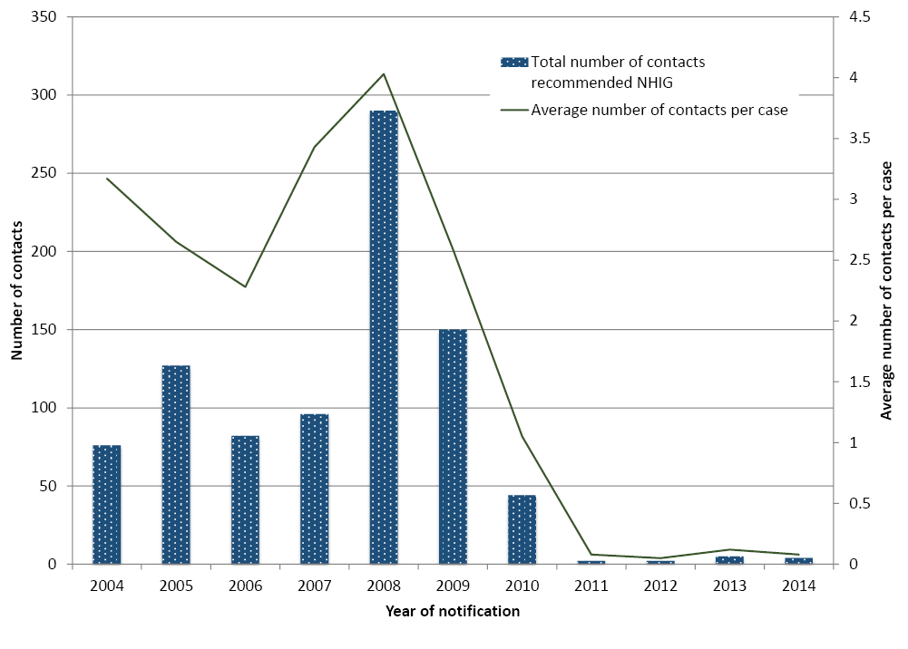
Twelve contacts recommended NHIG refused, leaving 866 for whom NHIG was ordered. The volume of NHIG recommended for individual contacts was frequently not recorded. Of the 866 for whom NHIG was ordered, the volume recommended was recorded for 60 contacts. The average volume for these 60 contacts was 1.3mL (range 0.15-2.2mL).
As current recommendations for the volume of NHIG are based on weight categories⁵, the amount ordered was subsequently assumed to be consistent with these recommendations where the individual’s weight was available. Where weight was also not recorded, adults were assumed to weigh more than 50kg and hence receive 2mL of NHIG, and children were assumed to be of average weight for their age¹⁵ and receive the volume recommended for that weight. Hence, boys aged 7 to 12 years and girls aged 8 to 14 years were assumed to be ordered 1mL.
On this basis, it was estimated that 19% of contacts (n=164) ordered NHIG were less than 25kg, 10% (n=84) were 25-50kg, and 67% (n=583) were more than 50kg. Contacts for whom age and weight details were not recorded (n=35) were omitted from calculations of the average volume of NHIG per contact. The average volume of NHIG recommended for 831 contacts was 1.6mL (range 0.15-2.2mL).
Twenty-five of 866 contacts for whom NHIG was ordered did not have any age details recorded, 25 were identified as children but numerical age was not recorded, and 224 were identified as adults but numerical age was not recorded. Of the remainder (n=592), the majority (54%) were aged less than 20 years (Table 1).
Seven of 866 contacts ordered NHIG were identified as being immunocompromised.

Table 1. Age group of contacts of Hepatitis A cases who received normal human immunoglobulin post-exposure prophylaxis in Queensland, 2004-2014
Age group | Number | Proportion of Total Contacts (%)
<10 years | 192 | 22
10-19 | 126 | 15
20-29 | 99 | 11
30-39 | 71 | 8
40-49 | 44 | 5
50-59 | 31 | 4
60-69 | 20 | 2
70+ | 9 | 1
Child – no numerical age given | 25 | 3
Adult – no numerical age given | 224 | 26
Age data missing | 25 | 3
Total | 866 | 100

Measles
Two hundred and eighteen cases were notified over the study period. Forty percent of cases were notified in the Brisbane area, a further 20% on the Sunshine Coast and a further 12% on the Gold Coast. The number of recorded contacts totalled 15,767 and ranged from none to 1,363, with a median of 18 contacts per case. Removing the influence of a single institutional outbreak where contacts of subsequent cases were the same as for the initial cases and thus not recounted, resulted in a median of 24 contacts per case.
Of 15,767 contacts, 2,359 (15%) were identified as being susceptible to measles. The median number of susceptible contacts per case was 3 (range 0-322). This was unaltered by removing the cases from the institutional outbreak. The median number of contacts per case recommended NHIG was zero (range 0-45). Again, this was unaltered by removing cases from the institutional outbreak. A total of 579 contacts were recommended NHIG over the study period, with 85% of these being contacts of cases notified between 2010 and 2014 inclusive. The average number of contacts recommended NHIG per case fluctuated, with no apparent trend over time (Figure 2).

Figure 2. Number of contacts of measles cases and average number of contacts per case of measles recommended normal human immunoglobulin post-exposure prophylaxis by year in Queensland, Australia
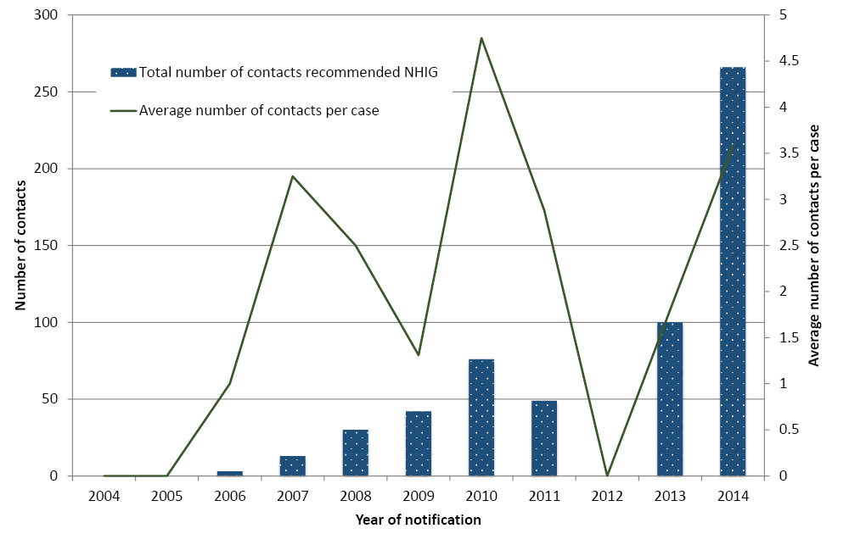
Thirty-six contacts recommended NHIG refused, leaving 543 for whom NHIG was ordered. The volume of NHIG recommended for individual contacts was recorded for only 55 contacts. The average volume recommended for these contacts was 11.0mL (range 1-15mL). Twenty-one contacts without recommended volume of NHIG recorded had details of weight recorded, which enabled calculation of the recommended volume according to national guidelines (0.2mL/kg if not immunocompromised or 0.5mL/kg if immunocompromised to a maximum of 15mL). The average volume for 76 contacts with either volume or weight details was 11.8mL (range 1-15mL). Imputing weight, based on weight distribution according to age group for adults¹⁶ and average weight for age for children¹⁵, for contacts where age was recorded, the average volume of NHIG recommended for 476 contacts was 11.5mL (range 0.7-15mL). Further imputing that those contacts identified as adults but without age details were recommended 15mL, resulted in an average of 11.9mL (range 0.7-15mL) recommended for 525 contacts.
Sixteen of 543 contacts for whom NHIG was ordered did not have any age details recorded, 54 were identified as adults but numerical age was not recorded, and 2 were identified as children but numerical age was not recorded. Of the remainder, the majority (63%) were aged between 20 and 49 (Table 2).
Eighteen of 543 contacts ordered NHIG were identified as being immunocompromised. All were adults. Thirty-four of 543 contacts ordered NHIG were identified as being pregnant.

Table 2. Age group of contacts of measles cases who received normal human immunoglobulin post-exposure prophylaxis in Queensland, 2004-2014
Age group | Number | Proportion of Total Contacts (%)
<10 years | 87 | 16
10-19 | 31 | 6
20-29 | 84 | 15
30-39 | 158 | 29
40-49 | 101 | 19
50-59 | 6 | 1
60-69 | 4 | 1
Child – no numerical age given | 2 | 0
Adult – no numerical age given | 54 | 10
Age data missing | 16 | 3
Total | 543 | 100

Rubella
Seventy-two cases were notified over the study period, the majority (64%) in the Brisbane area. The total number of contacts recorded was 2,088, however, 1,900 of these were recorded against one case as the estimated number of contacts for that case, and these contacts were not identified individually. The records for 14 of 72 cases did not have details about the number of contacts. For the remaining 57 cases, the median number of contacts per case was one.
Sufficient detail about the susceptibility of identified contacts was available for 40 of 57 cases. Among the 168 contacts of these 40 cases, 34 (20%) were recorded as susceptible to rubella. Three of these contacts were pregnant at the time of exposure. One was 37 weeks pregnant and advised to receive vaccination after delivery, one of unknown gestation was also advised to receive vaccination after delivery, and the third was 11 weeks pregnant without record of vaccination and was advised to undergo serology testing. The remaining susceptible contacts were also recommended vaccination. There was no record of NHIG being recommended for any contact of a rubella case.

National Blood Authority Data

Hepatitis A
Thirty-one orders for NHIG were identified as being for the purpose of hepatitis A prophylaxis over the period June 2014 through December 2016 inclusive. A total of 119.25mL was requested. The state of Victoria ordered the most NHIG during this time period at 95.25mL, followed by New South Wales at 10mL, Queensland at 8mL, South Australia at 4mL, and Western Australia at 2mL. Tasmania, the Australian Capital Territory, and the Northern Territory did not order any NHIG for contacts of hepatitis A during this time.
The volume ordered nationally each 6 months over the period of available data is shown in Figure 3. The average volume of NHIG ordered per contact during the available data period was 1.78mL (range 0.25 – 5mL).
From June to December 2014, Queensland placed 2 orders for NHIG for hepatitis A post-exposure prophylaxis totalling 1.5mL to treat 3 contacts. Public health unit data for the same time period included 3 contacts who were recommended NHIG totalling 2mL.

Measles
One hundred and twenty-six orders for NHIG were identified as being for the purpose of measles prophylaxis over the period June 2014 through December 2016 inclusive. A total of 6,679.1mL was requested. The state of Victoria ordered the most NHIG during this time period at 3,009.8mL, followed by Queensland at 2,802.7mL, Western Australia at 410mL, New South Wales at 369.6mL, Northern Territory at 50mL, South Australia at 32mL and Tasmania at 5mL. The Australian Capital Territory did not order any NHIG for contacts of measles during this time.
The volume ordered nationally each 6 months over the time period of available data is shown in Figure 3. The average volume of NHIG ordered per contact was 11.6mL (range 1.8 – 27mL).
Figure 3. Volumes of normal human immunoglobulin ordered nationwide in Australia for measles and hepatitis A post-exposure prophylaxis over time
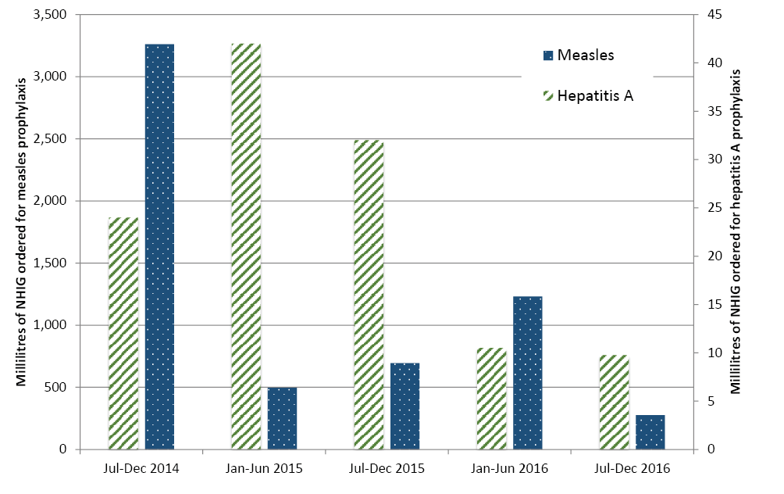
From June to December 2014, Queensland placed 23 orders for NHIG for measles post-exposure prophylaxis totalling 2,470.2mL to treat 170 contacts. Public health unit data for the same time period included 84 contacts recommended NHIG totalling 960.4mL.

Rubella
No orders for NHIG were identified as being for the purpose of rubella prophylaxis during the time period of available data.

Discussion
The use of NHIG recommended for public health purposes in Queensland and Australia over the last decade varied by notifiable condition. NHIG usage declined substantially as a prevention measure for hepatitis A in Queensland after 2010, corresponding to a change in the national guideline to recommend vaccination for post-exposure prophylaxis for most contacts. The average number of contacts recommended NHIG per case of hepatitis A between 2011 and 2014 was less than one. Contacts were on average recommended a volume of 1.6mL. NHIG usage for measles post-exposure prophylaxis fluctuated across the study period. The average number of contacts recommended NHIG per case of measles varied between zero and 4.75. The factor most likely to contribute to this is the number of notified cases each year. For example, 2014 stands out as the peak year for NHIG consumption for measles contacts in this study and corresponds to an annual number of notifications in Queensland that was 3 times the preceding 5 year average.¹⁷ On average, measles contacts were recommended a volume of 11.9mL of NHIG. There was no evidence that NHIG has been recommended for the post-exposure prophylaxis of rubella in Queensland (or Australia) during the study period.
The volumes of NHIG ordered for post-exposure prophylaxis of measles and hepatitis A between 2014 and 2016 varied across the country. Again, the factor most likely to influence usage according to condition by state is the number of notified cases, although population differences in the proportion of contacts who are susceptible may also impact. Overall the average volume of NHIG ordered per contact was 1.78mL for hepatitis A and 11.6mL for measles.
Across the period of study, a considerable proportion of identified contacts of Queensland cases of measles were deemed susceptible (15%), though this figure is consistent with the latest national serosurvey results that indicated 19.2% of the Australian population aged between one and 49 years are either seronegative or have an equivocal result for measles immunity.¹⁸ Within this group, susceptibility would have been assumed for some contacts in accordance with national guidelines⁴ due to a lack of documented measles vaccination or immunity, while others would have identified that they were unimmunised and or been seronegative to measles. The proportion of contacts in each of these categories is unknown, but it is likely that a lack of documentation of immunisation resulted in some contacts who were already immune to measles receiving post-exposure prophylaxis. The recent implementation of a national whole of life immunisation register should reduce this occurrence in the future.
Queensland public health unit data approximated National Blood Authority data on NHIG usage for the post-exposure prophylaxis of hepatitis A and rubella. Calculated volumes of NHIG per measles contact were also similar across these data sources, but the number of Queensland measles contacts who were ordered NHIG between June and December 2014 was double that recorded in Queensland public health unit records. This is likely to be due to limitations of public health unit data management capacity during measles outbreaks and that contacts resulting from hospital or primary health care exposures were likely to have been followed up directly by the relevant clinical facility.
This discrepancy in the number of measles contacts offered NHIG highlights a limitation of the public health unit data. Because only contacts identified to public health are recorded, the calculated numbers of contacts per case, susceptible contacts per case and contacts per case recommended NHIG are likely to be underestimates. However, it is reassuring that during a measles outbreak year (2014) the number of contacts per case recommended NHIG according to National Blood Authority data (4.59) was within the range estimated by public health unit data across the study period (Figure 2: 0-4.75).
A further limitation of this study was the amount of missing data, mostly regarding recommended volumes of NHIG. To redress this issue, missing data was imputed where possible. It is reassuring that the volumes of NHIG per contact calculated after imputing data were very similar to those using only complete data.
To our knowledge, this is the first study documenting the use of NHIG for the public health management of communicable diseases in Australia or elsewhere. It provides detailed baseline information to allow future comparisons within Australia and internationally.
The results are therefore beneficial to national blood sufficiency planning. Prior to the introduction of the national NHIG order form, public health unit data were the only collated records of the public health indications for NHIG used in Australia. By demonstrating approximation between the recommendations of public health professionals for the requirement for prophylaxis with NHIG and the orders placed for this blood product, this study provides a valid historical comparison for future analyses of NHIG usage utilising the national NHIG order form.
The results will also be valuable for future cost effectiveness studies. Cost effectiveness studies require information on utilisation of an intervention to allow cost comparison to an alternative. In the event alterations to the nationally recommended NHIG dosages, or other policy change concerning passive immunisation for the prevention of hepatitis A, measles or rubella are considered, this study will facilitate more reliable budgetary impact estimates.

Acknowledgements
We gratefully acknowledge the support provided by the following public health units in the conduct of this research:
Tropical Public Health Service (Cairns) Townsville Mackay Central Queensland Wide Bay Sunshine Coast Metro North Metro South Darling Downs West Moreton Gold Coast
We wish to thank CSL Behring (Australia) Pty Ltd, and particularly Laetitia Orlandini, for supply of the unidentified national NHIG order data.

Authors
Dr Megan K Young^{1,2}
Corresponding author: School of Medicine, Griffith University, Gold Coast Campus, 58 Parklands Dr, Southport QLD 4215 email: megan.young@griffith.edu.au ph 07 5678 0624
Prof Allan W Cripps¹ email: allan.cripps@griffith.edu.au
Prof Graeme R Nimmo^{1,3} email: graeme.nimmo@health.qld.gov.au
- School of Medicine and Menzies Health Institute Queensland, Griffith University
- Metro North Public Health Unit, Metro North Hospital and Health Service
- Pathology Queensland, Queensland Health

References
- CSL Behring. Plasma Fractionation for Australia 2017 [cited 2017 December 8]. Available from: http://www.cslbehring.com.au/s1/cs/auau/1255930481887/page/1199978997135/BusinessUnit.htm.
- Farrugia A, Cassar J. Plasma-derived medicines: access and usage issues. Blood Transfus. 2012;10:273-8.
- National Blood Authority Australia. National Immunoglobulin Governance Program [cited 2017 December 8]. Available from: https://www.blood.gov.au/Ig-program.
- Communicable Diseases Network Australia. Measles: National guidelines for public health units. Canberra: Commonwealth Department of Health; 2015.
- Communicable Diseases Network Australia. Hepatitis A: National guidelines for public health units. Canberra: Commonwealth Department of Health; 2009.
- Queensland Health. Rubella: Queensland Health Guidelines for public health units. Brisbane: Queensland Government; 2015.
- Young M, Cripps A, Nimmo G, van Driel M. Post-exposure passive immunisation for preventing rubella and congenital rubella syndrome. Cochrane Database of Systematic Reviews. 2015;Issue 9. Art. No.: CD010586. DOI: 10.1002/14651858.CD010586.pub2.
- Young M, Nimmo G, Cripps A, Jones M. Post-exposure passive immunisation for preventing measles. Cochrane Database of Systematic Reviews. 2014; Issue 4. Art. No: CD010056. DOI: 10.1002/14651858.CD010056.pub2.
- Liu J, Nikolova D, Fei Y. Immunoglobulins for preventing hepatitis A. Cochrane Database of Systematic Reviews. 2009; Issue 2, Art. No.: CD004181. DOI: 10.1002/14651858.CD004181.pub2.
- Ramsay M, Manikkavasagan G, Brown K, Craig L. Post exposure prophylaxis for measles: revised guidance May 2009. UK: Health Protection Agency; 2009.
- Starship Children’s Health Clinical Guideline, Best, Voss, Roberts, Freeman. Measles - Infection Control Definitions & Guidelines Auckland, New Zealand: Auckland District Health Board; October 2011 [Available from: http://www.adhb.govt.nz/starshipclinicalguidelines/_Documents/Measles.pdf.]
- Sinden J. Post exposure prophylaxis for measles New Zealand: NZBlood; 2012 Jan 4 [Available from: http://www.nzblood.co.nz/assets/Transfusion-Medicine/PDFs/POST-EXPOSURE-PROPHYLAXIS-FOR-MEASLES-111G001.pdf.
- Young M, Bertolini J, Kotharu P, Maher D, Cripps A. Do Australian immunoglobulin products meet international measles antibody titre standards? Human Vaccines and Immunotherapeutics. 2016; 13 (3): 607-612. DOI: 10.1080/21645515.2016.1234554
- Young M, Bertolini J, Kotharu P, Maher D, Cripps A. Rubella antibodies in Australian immunoglobulin products. Human Vaccines and Immunotherapeutics. 2017;Issue 8, published online 12 June, DOI: 10.1080/21645515.2017.1327110.
- Victorian State Government. Growth charts Victoria, Australia: State Government of Victoria; 2017 July 7 [cited 9 September 2017]. Available from: http://www.education.vic.gov.au/childhood/parents/mch/Pages/charts.aspx.
- Australian Bureau of Statistics. 4841.0 Facts at your Fingertips: Health, 2011 - Measuring Australians Canberra, Australia: Commonwealth of Australia; 2012 July 24 [cited 2017 Sept 15]. Available from: http://www.abs.gov.au/AUSSTATS/abs@.nsf/DetailsPage/4841.02011?OpenDocument
- Australian Government Department of Health. National Notifiable Diseases Surveillance System: number of notifications of measles received from State and Territory health authorities in the period of 1991 to 2016 and year-to-date notifications for 2017 2017 [cited 2017 December 15]. Available from: http://www9.health.gov.au/cda/source/rpt_4.cfm.
- Gidding H, Quinn H, Hueston L, Dwyer DE, McIntyre P. Declining measles antibodies in the era of elimination: Australia’s experience. Vaccine. 2018; 36:507-13.
Communicable Diseases Intelligence
ISSN: 2209-6051 Online

Communicable Diseases Intelligence (CDI) is a peer-reviewed scientific journal published by the Office of Health Protection, Department of Health. The journal aims to disseminate information on the epidemiology, surveillance, prevention and control of communicable diseases of relevance to Australia.

Editor: Cindy Toms
Deputy Editor: Phil Wright
Editorial and Production Staff: Leroy Trapani and Kasra Yousefi
Editorial Advisory Board: David Durrheim, Mark Ferson, John Kaldor, Martyn Kirk and Linda Selvey

Website: http://www.health.gov.au/cdi

Contacts
Communicable Diseases Intelligence is produced by:
Health Protection Policy Branch, Office of Health Protection, Australian Government Department of Health
GPO Box 9848, (MDP 6) CANBERRA ACT 2601

Email: cdi.editor@health.gov.au

Submit an Article
You are invited to submit your next communicable disease related article to the Communicable Diseases Intelligence (CDI) for consideration. More information regarding CDI can be found at: http://health.gov.au/cdi.
Further enquiries should be directed to: cdi.editor@health.gov.au.

This journal is indexed by Index Medicus and Medline.

Creative Commons Licence - Attribution-NonCommercial-NoDerivatives CC BY-NC-ND
© 2019 Commonwealth of Australia as represented by the Department of Health
This publication is licensed under a Creative Commons Attribution-NonCommercial-NoDerivatives 4.0 International Licence from https://creativecommons.org/licenses/by-nc-nd/4.0/legalcode (Licence). You must read and understand the Licence before using any material from this publication.

Restrictions
The Licence does not cover, and there is no permission given for, use of any of the following material found in this publication (if any):
- the Commonwealth Coat of Arms (by way of information, the terms under which the Coat of Arms may be used can be found at www.itsanhonour.gov.au);
- any logos (including the Department of Health’s logo) and trademarks;
- any photographs and images;
- any signatures; and
- any material belonging to third parties.

Disclaimer
Opinions expressed in Communicable Diseases Intelligence are those of the authors and not necessarily those of the Australian Government Department of Health or the Communicable Diseases Network Australia. Data may be subject to revision.

Enquiries
Enquiries regarding any other use of this publication should be addressed to the Communication Branch, Department of Health, GPO Box 9848, Canberra ACT 2601, or via e-mail to: copyright@health.gov.au

Communicable Diseases Network Australia
Communicable Diseases Intelligence contributes to the work of the Communicable Diseases Network Australia.
http://www.health.gov.au/cdna

