Summary of national surveillance data on vaccine preventable diseases in Australia, 2012–2015
Aditi Dey, Han Wang, Frank Beard, Kristine Macartney, Peter McIntyre

Acknowledgements
Hospitalisation data were provided by the Australian Institute of Health and Welfare.
Notification data from the National Notifiable Diseases Surveillance System were provided by the Office of Health Protection, Australian Government Department of Health.
We thank the Communicable Disease Epidemiology and Surveillance Section, Office of Health Protection, Australian Government Department of Health for providing comments on the draft report.
We thank the Australian Coordinating Registry, state and territory registries of births, deaths and marriages, state and territory coroners, and the National Coronial Information System, for providing access to cause of death data.
We also thank Deepika Jindal from NCIRS for editing of this report.
The National Centre for Immunisation Research and Surveillance of Vaccine Preventable Diseases is supported by the Australian Government Department of Health, the NSW Ministry of Health and The Children’s Hospital at Westmead. The opinions expressed in this report are those of the authors, and do not necessarily represent the views of these agencies.

Overview
This summary report on vaccine preventable diseases (VPDs) in Australia brings together the three most important national sources of routinely collected data on VPDs (notifications, hospitalisations and deaths) for all age groups for the four-year period January 2012 to December 2015. Detailed results are available in 16 individual chapters using a standard structure. For more information, readers are referred to Australian epidemiological studies of several individual VPDs which include data for some or all of this four year period: pertussis,¹ mumps,² rubella,³ hepatitis A,⁴ influenza,⁵ invasive pneumococcal disease⁶ and varicella-zoster.⁷
During the current reporting period 2012 to 2015, there were several changes in the National Immunisation Program (NIP). These changes included: 1) 2012 as the first full year when 13-valent pneumococcal conjugate vaccine (PCV13) replaced 7-valent pneumococcal conjugate vaccine (PCV7) for infant doses and a fourth dose of PCV13 replaced the 23-valent polysaccharide pneumococcal vaccine (23PPV) booster dose for Aboriginal and Torres Strait Islander children aged 12–18 months residing in Queensland, South Australia, Western Australia and the Northern Territory; 2) 2013 as the year when the second dose of measles-mumps-rubella (MMR) vaccine, previously given at 4 years, was brought forward to 18 months of age and delivered as combination measles-mumps-rubella-varicella (MMRV) vaccine, and when the combined Haemophilus influenzae type b (Hib) and meningococcal serogroup C (MenC) vaccine, Menitorix®, replaced separate Men C and Hib vaccines at 12 months of age; and 3) 2015 as the year when seasonal influenza vaccine first became funded for all Aboriginal and Torres Strait Islander children aged 6 months to less than 5 years.
Notifications, hospitalisations and deaths in successive four-year periods (2008–2011 and 2012–2015) are summarised in Table 1. Influenza, pertussis and invasive pneumococcal disease were the most commonly notified conditions, whereas cases of influenza, zoster and pneumococcal disease were the most common causes of hospitalisation in this reporting period. There was an ongoing absence of disease due to polio and a continuing low incidence of tetanus.
Table 1: Notifications, hospitalisations and deaths for selected vaccine preventable diseases, Australia, in two successive four year periods (2008 to 2011 and 2012 to 2015)ª
Disease | Notifications |  | Hospitalisations  Principal diagnosis |  | Deaths  Underlying cause
 | Average annual rate^{b}  2008–2011 | Average annual rate^{b}  2012–2015 | Average annual rate^{b}  2008–2011 | Average annual rate^{b}  2012–2015 | Number  (Average annual rate^{b})  2008–2011 | Number  (Average annual rate^{b})  2012–2015
Diphtheria | <0.01 | <0.01 | <0.01 | 0.01 | 1–3 (<0.01) | 1–3 (<0.01)
Haemophilus influenzae type b | 0.09 | 0.08 | 0.10 | 0.12 | 1–3 (<0.01) | 1–3 (<0.01)
Hepatitis A | 1.43 | 0.83 | 0.66 | 0.43 | 7 (0.01) | 5 (0.01)
Hepatitis B | 1.07 | 0.73 | 0.63 | 0.49 | 21 (0.02) | 80 (0.09)
Influenza^{c} | 124.69 | 259.06 | 18.45 | 34.68 | 289 (0.33) | 778 (0.84)
Measles | 0.50 | 0.83 | 0.19 | 0.31 | 1–3 (<0.01) | 1–3 (<0.01)
Meningococcal disease | 1.16 | 0.77 | 1.56 | 1.00 | 43 (0.05) | 36 (0.04)
Mumps | 0.80 | 1.34 | 0.33 | 0.31 | 0 (–) | 1–3 (<0.01)
Pertussis | 135.24 | 76.12 | 4.45 | 2.15 | 12 (0.01) | 12 (0.01)
Pneumococcal disease^{d} | 7.68 | 6.91 | 1.70 | 1.74 | 122 (0.14) | 88 (0.09)
Rotavirus | na^{e} | na^{e} | 4.83 | 3.83 | 1–3 (<0.01) | 1–3 (<0.01)
Q fever | 1.59 | 2.08 | 0.60 | 0.66 | 1–3 (<0.01) | 5 (0.01)
Rubella | 0.19 | 0.10 | 0.02 | 0.01 | 1–3 (<0.01) | 1–3 (<0.01)
Tetanus | 0.01 | 0.02 | 0.06 | 0.05 | 1–3 (<0.01) | 1–3 (<0.01)
Varicella | na^{e} | na^{e} | 2.30 | 1.15 | 16 (0.02) | 23 (0.02)
Zoster | na^{e} | na^{e} | 11.05 | 11.21 | 107 (0.12) | 110 (0.12)
a Data from the former period (2008–2011) have been reported in the previous report.⁸ Data from the later period (2012–2015) are reported in this current report. Deaths include those coded as the underlying cause.
b Rate per 100,000 population.
c These data represent minimum estimates due to limitations of notification systems and coding for influenza hospitalisations and deaths, which grossly underestimate influenza-related cases.
d Pneumococcal hospitalisations and deaths include septicaemia and meningitis only.
e na = not available.

Important changes in VPDs observed in this reporting period
Influenza was the most commonly reported VPD in Australia, with the incidence of notifications and hospitalisations during this reporting period approximately twice that in the previous period. It is likely that increased laboratory testing for influenza, with positive tests routinely reported by laboratories, was a major driver of this increase. Similarly, differences between jurisdictions may be influenced by varying testing and coding practices. The highest numbers and rates of influenza related deaths were reported in those aged ≥65 years.
Pertussis, the most commonly notified VPD in Australia during 2008–2011,⁸ was the second most commonly notified VPD for this reporting period, following declines in both notification and hospitalisation rates. Notification rates were highest in the 5–14 year age group, while infants accounted for 37% of coded hospitalisations.
There were seven notifications of diphtheria in Australia in the four years 2012–2015, after none in the nine years 2002–2010. The reasons for this increase in notifications should be explored further, including consideration of any changes in laboratory reporting and case definition.
Acute hepatitis B notifications progressively declined; a trend evident from 2007,⁹ which further accelerated during 2012 to 2015. Similarly, there was a continuing decline in the incidence of hepatitis A.⁴
Meningococcal disease notifications and hospitalisations declined overall in this reporting period. However, this varied by serogroup. Serogroups B and C declined but notifications of serogroup W and Y increased; this increase has accelerated in subsequent years.^{10–15}
There were small overall reductions in hospitalisations in Haemophilus influenzae type b disease, pneumococcal disease and rotavirus gastroenteritis in this reporting period, following on from larger earlier reductions, but this varied across age groups.
The varicella (chickenpox) hospitalisation rate declined by half in this reporting period compared to the previous four years, whereas the zoster hospitalisation rate increased slightly.
There were a number of measles outbreaks during this reporting period. Large measles outbreaks, mostly linked to imported cases in travellers from high endemicity regions, occurred in 2012¹⁶ and 2014,¹⁷ with notifications in 2014 the highest seen since 1998. However, the available evidence continues to support endemic measles having been eliminated in Australia since 2005,¹⁸ with verification by the World Health Organization in 2014.^{19,20}
Localised outbreaks of mumps (commencing in 2015) were seen towards the end of the reporting period in Aboriginal communities among two-dose-vaccinated adolescents and young adults, a phenomenon previously seen in Australia only in a 2007–2008 outbreak in the Kimberley,²¹ but well described elsewhere.^{2,22} The majority of previous mumps outbreaks in adolescents and young adults in Australia have primarily been in those who had received only one vaccine dose or were unvaccinated, as reported elsewhere.^{2,21–24}
Rubella notifications and hospitalisations continued to decline in this reporting period and have remained consistently low since 2004, following marked declines in the late 1990s and early 2000s. Current evidence supports Australia being able to verify elimination of rubella according to WHO criteria in the near future.^{3,25}
Q fever notifications increased during 2012 to 2015 compared to the previous four-year period. Multiple factors are likely to have contributed, including environmental conditions (drought, dust storms),²⁶ testing practices and increasing diagnostic awareness.²⁷

Limitations
The data sources used in this report have a number of limitations, discussed in detail in the body of the report. Comparison between the notification, hospitalisation and death data should be made with caution since these datasets differ in their purpose for data collection, reporting mechanisms and accuracy. Our analysis showed that the number of deaths in data derived from the National Notifiable Diseases Surveillance System (NNDSS) differ, for some diseases substantially, from those reported in cause of death data and the AIHW National Hospital Morbidity Database. Data on vaccination status (assessed using data on vaccine type and vaccination date) in the NNDSS had low levels of completeness for age groups not targeted for surveillance and vaccination programs. In addition, interpretation of hospitalisation data for codes occurring in any diagnosis field (versus principal diagnosis) and of death data including all coded associated causes of deaths (versus underlying cause only) is likely to lack specificity and should be interpreted with caution. Finally, the influence of changing patterns of diagnostic testing, particularly for influenza and pertussis, and of any changes in case definitions, are important considerations when interpreting the significance of notification rates of disease over time.

1. Introduction
The National Centre for Immunisation Research and Surveillance of Vaccine Preventable Diseases has published five comprehensive reports on vaccine preventable diseases (VPDs) and vaccination coverage in Australia, appearing every 2–3 years, since 2000. These reports (‘the VPD reports’) have been published as supplement issues of Communicable Diseases Intelligence. They serve as a national resource to support surveillance and control of VPDs in Australia, particularly those for which there is a national vaccination program, with several unique features that value-add to other national reports of communicable disease surveillance data.
In addition to the summary VPD report, which uses a standard structure across all VPDs, a rolling series of epidemiologic reviews provides more detailed data in age groups and time frames, which can be tailored specifically to current or proposed vaccination programs targeting specific VPDs. Recent reviews relevant to this report include studies on pertussis,¹ mumps,² rubella,³ hepatitis A,⁴ influenza,⁵ pneumococcal disease⁶ and varicella zoster.⁷

2. Methods
In keeping with established practice, three main sources of routinely collected data on VPDs in Australia were used for this report. Disease notification data were obtained from the Office of Health Protection’s National Notifiable Diseases Surveillance System (NNDSS), supplied by states and territories; data on coded hospitalisations were sourced from the Australian Institute of Health and Welfare (AIHW) National Hospital Morbidity Database; and causes of death unit record file data were obtained from the Australian Coordinating Registry.
A comprehensive listing of significant events in vaccination practice in Australia is available from the National Centre for Immunisation Research and Surveillance of Vaccine Preventable Diseases vaccination history tables.

Notifications
The NNDSS was established in its current form in 1991 and includes de-identified information on cases of notifiable disease reported by state and territory authorities in Australia. Each of the 8 state and territory health departments collects data on notifiable diseases under their respective public health legislation. Data quality of the NNDSS is continually monitored by the Office of Health Protection within the Australian Government Department of Health, and by the National Surveillance Committee, a committee which includes jurisdictional surveillance and data managers. There is a continual process of reviewing the national consistency of communicable disease surveillance on a daily, fortnightly and quarterly basis. Historically, state and territory notification criteria were based on the 1994 National Health and Medical Research Council surveillance case definitions.²⁸ In September 2003, a new set of national case definitions for notifiable diseases reported to the NNDSS was endorsed by the Communicable Diseases Network Australia,²⁹ with nearly all jurisdictions implementing the new definitions in January 2004 (New South Wales commenced in August 2004).
Information on case definitions currently in use for vaccine preventable diseases is available on the Australian Government Department of Health web site. The data collected by the NNDSS are frequently updated by jurisdictions. For this report, data extracted from the NNDSS (April 2017) were examined. Data were checked and cleaned. Disease notification data for cases with a date of diagnosis between 1 January 2012 and 31 December 2015 are included in this report. It should be noted that historical notification data included in this report have been updated from previous reports and the updated data used for trend analysis.
In this four-year report (2012 to 2015) and the previous four-year report (2008 to 2011),⁸ notification data are presented by the ‘date of diagnosis’. Reports on data prior to 2008 analysed notification data by date of onset (if the date of onset from the clinical history was collected and available), or the specimen collection date for laboratory-confirmed cases. For each notification record, a date of diagnosis is derived from the date of onset, or, where not supplied, the earliest date recorded among the three fields of date of specimen, date of notification, or date notification received (the only mandatory date field). The variables extracted for each VPD in this report were: date of diagnosis, age at onset, sex, Indigenous status and state or territory of residence.
Indigenous status in the notification data provided by the Department of Health to NCIRS includes five categories: ‘Aboriginal but not Torres Strait Islander origin’, ‘Torres Strait Islander but not Aboriginal origin’, ‘Aboriginal and Torres Strait Islander origin’, ‘not Aboriginal or Torres Strait Islander origin’ and ‘not stated’. For the purposes of calculating rates, we used two categories: ‘Indigenous’ (individuals identified as Aboriginal and/or Torres Strait Islander) and ‘other’ (individuals recorded as not Aboriginal or Torres Strait Islander and where not stated).
Completeness of Indigenous status was assessed for each disease by calculating the proportions of notifications where Indigenous status was not stated and/or where the data field was left blank.
Vaccination status was assessed using the new vaccine type and vaccination date data fields. In jurisdictions where new vaccination data fields were not used for the specified years, we used the old vaccination data fields. The following categories were used to further categorise data where the vaccination data fields were incomplete:
- information on vaccine type not available (code 8888 where cases were followed up but no information was available)
- missing vaccine type (code 9999 where cases were not followed up)
- no data recorded where the vaccine data field was left blank
We also used a cut-off of 14 days between vaccination date and disease onset date for estimating validity of vaccine doses. Vaccine doses given ≤14 days prior to disease onset date were considered invalid. We provide details of only valid vaccine doses in this report.

Hospitalisations
Hospitalisation data from the AIHW National Hospital Morbidity Database were analysed by calendar year of hospital admission for the four years 2012 to 2015. For trend analysis, the report uses selected historical data from previous reports.^{30–34} Hospitalisations where the date of admission fell within the reporting period were included, with analyses by variables such as age and sex grouped by the calendar year of hospital admission. Data for each VPD were extracted based on the International Statistical Classification of Diseases and Related Health Problems, 10th Revision, Australian Modification (ICD-10-AM). Records of hospitalisations included in analysis were those with the code(s) of interest listed as the principal diagnosis (the diagnosis recorded as chiefly responsible for the hospitalisation) or as any other diagnosis for that episode of hospitalisation. The proportion of hospitalisations where the disease of interest was coded as the principal diagnosis is reported for each disease. For hepatitis B, only hospitalisations with acute hepatitis B coded as the principal diagnosis are included, consistent with the approach taken in previous reports.
The variables extracted for analysis included: month of admission, age on admission, sex, Indigenous status, state or territory of residence, length of stay, and diagnosis (principal and other diagnoses) coded using the relevant edition of ICD-10-AM for the collection period.
Indigenous status in the hospitalisation data provided by AIHW to NCIRS includes the two categories ‘Indigenous Australians’ and ‘Other Australians’.

Deaths
Death data were obtained from the Cause of Death Unit Record File (COD URF) data from the Australian Coordinating Registry (ACR). The Queensland Registry of Births, Deaths and Marriages (RBDM) is the ACR for COD URF data. The ACR coordinates the approval and release of COD URF files on behalf of the data custodians – Australian Registrars of Births, Deaths and Marriages (RBDM), State/Chief Coroners and the National Coronial Information System (NCIS).
Since 1997, ICD-10 has been used to identify the cause of death. Deaths analysed in this report included those recorded as occurring in the calendar years 2012 to 2015. The variables included were cause of death, age, year of death, sex, and state or territory in which the death was recorded. Both underlying and associated causes of death were analysed for this reporting period. Deaths recorded in the NNDSS are also reported for relevant disease chapters.

Calculations
All rates were calculated using the mid-year estimated resident populations released by the ABS as the population denominator and hospital admissions as the numerator. Rates are presented as annual rates or average annual rates per 100,000 total population, or population in age, sex or geographical subgroups, as appropriate. The reported rate estimates for the populations were not stratified by age groups (i.e. all ages together) and are crude rates that have not been age-standardised.
For notification, hospitalisation and death data, the mid-year population estimates for the corresponding calendar year were used as the denominator population. Averages were calculated for rates of notifications and hospitalisations and for bed-days of hospitalisation episodes per year. The median (rather than average) and range were used to describe the distribution of notifications and hospitalisations per month, and the length of stay per hospitalisation episode, as these data are not normally distributed.
Current case definitions³⁵ and significant events in vaccination practice³⁶ in Australia were taken into consideration for this report. Previous changes in case definitions are no longer available on the current website³⁵ or in the public domain to be considered in this report.

Notes on interpreting data
Comparison between the notification, hospitalisation and death data should be made with caution since these datasets differ in their purpose for data collection, reporting mechanisms and accuracy. The rates presented in this report are crude rates, not adjusted for differences in population structure between jurisdictions.

Notification data
A major limitation of notification data is that they represent only a proportion of all the cases occurring in the community, due to under-reporting and/or testing practices. This proportion may vary between diseases, over time, and across jurisdictions. An infectious disease diagnosed by a laboratory test should be notified by the testing laboratory or treating clinician, as required by jurisdictional legislation, whereas diagnoses without laboratory confirmation rely on notification by clinicians, known to be substantially less complete. Changes in screening programs – including the preferential testing of high-risk populations, the use of less invasive and more sensitive diagnostic tests, and periodic awareness campaigns – may influence the number of notifications over time. Data accuracy may also vary among jurisdictions due to the use of different case definitions for surveillance prior to adoption of the national case definitions in 2004 (particularly relevant to trend graphs which present pre-2004 data) and varying reporting requirements and clinician practice with respect to laboratory testing.
Indigenous status completeness in notification data was assessed for the period 2012–2015 and reported in each chapter.

Hospitalisation data
The AIHW publishes regular overviews of Australian hospitalisation statistics, including details of the number of hospitals reporting and any documented data problems. The AIHW performs logical validations on the ICD-10-AM coded data; for example, for sex- and age-specific diagnoses. Coding audits and coding quality improvement activities are variously performed at hospital level and/or state or territory level. Some variation in hospital access, admission practices and record coding may occur between regions and over time and this may impact upon the use of hospitalisation data for monitoring disease trends over time and between jurisdictions.
There are also limitations associated with the use of ICD codes to identify cases. Errors that cause the ICD code to differ from the true disease may be either random or systematic measurement errors. For rare diseases, such as acute poliomyelitis, tetanus and diphtheria, hospitalisation episodes or deaths so coded are much more likely to be miscoding of other conditions. The ICD codes for diagnosis chosen for analysis of a disease should accurately reflect the specific condition which is vaccine preventable. For some diseases, such as Haemophilus influenzae type b (Hib) infection, both the previously used ICD-9-CM and current ICD-10-AM codes lack specificity for serotype b, and may not be limited to sterile site isolates, in contrast to more stringent case definitions used for notification data. For each disease in this report, the ICD code(s) selected to best represent hospitalisation for the disease of interest are listed on the first page of each disease chapter.
In the AIHW hospitalisation database, there is one record for each hospital admission episode.^{37,38} This means that there will be separate records for each readmission or inter-hospital transfer. This is unlikely to have a major impact on the numbers reported for most of the diseases reviewed in this report, as they are mostly acute diseases, but severe cases in regional and remote areas may be transferred for specialist care.^{37,38} However, there may be greater impact on numbers reported for diseases where readmission due to long-term complications is more likely e.g. meningococcal disease. It is also more difficult to gauge the relevance where the coded disease was not the principal diagnosis but was recorded as an additional or secondary diagnosis for that hospitalisation episode. AIHW has restrictions on release of data that may potentially identify cases and therefore less than five hospitalisations in the period of interest are reported as a range of 1–4 rather than the actual number.
Indigenous status in the hospitalisation data provided by AIHW to NCIRS includes the categories ‘Indigenous Australians’ and ‘Other Australians’. As the ‘Other Australians’ category includes both non-Indigenous people and those with unknown Indigenous status, it is not possible to report the exact proportion with ‘unknown’ Indigenous status. However, Indigenous status completeness for hospitalisation data has been greater than 80% in all jurisdictions since 2010–2011.³⁹

Death data
Mortality data are analysed by year of death and cause of death. The Australian Coordinating Registry has restrictions on release of data that may potentially identify cases, which apply to this report. Where there were less than four (but not zero) deaths in the period of interest, this is reported as a range of 1–3 rather than the actual number. In addition, death data are not provided for some age groups, where back-calculations could compromise confidentiality. Many of the issues for accuracy of ICD coding in hospital separations, such as propensity for laboratory testing, are also relevant for mortality data.

3. Vaccine preventable diseases

3.1 Diphtheria
Highlights
From 2012 to 2015, there were 7 notifications of toxigenic diphtheria. Prior to 2011, when there was a cluster of 4 notifications including 1 death, no cases of diphtheria had been notified since 2001.
Diphtheria is caused by the bacterium Corynebacterium diphtheriae. Infection remains localised to the throat or skin, but disease manifestations arise from both local inflammation and/or systemic toxaemia. Pharyngeal diphtheria presents with a membranous inflammation of the upper respiratory tract, which can be extensive and cause laryngeal obstruction. Damage to other organs including the myocardium, nervous system and kidneys, caused by the organism’s exotoxin, may complicate pharyngeal or cutaneous diphtheria.^{40,41} Non-toxigenic C. diphtheriae usually causes mild throat or skin infection, which is occasionally complicated by invasive disease including endocarditis or arthritis. Corynebacterium ulcerans, a bacterium found in cattle and more recently in cats, can also express diphtheria toxin and cause a zoonotic infection in humans that is similar to diphtheria.^{42–46}

Case definition
Notifications⁴⁷
Diphtheria case definition:
http://www.health.gov.au/internet/main/publishing.nsf/Content/cda-surveil-nndss-casedefs-cd_dipth.htm
Hospitalisations and deaths
The ICD-10-AM/ICD-10 code A36 (Diphtheria) was used to identify hospitalisations and deaths.

Severe morbidity and mortality
There were 7 notified cases of toxigenic diphtheria during the four years 2012 to 2015 (Table 3.1.1), 3 in 2013 and 2 each in 2014 and 2015. The 2013 cases (1 from South Australia and 2 from Queensland) have been reported separately,^{48–50} and were imported from India and Papua New Guinea respectively.^{48,50} In 2014, the 2 cases were cutaneous, reported in Queensland and imported from Tokelau and Cambodia.¹⁷ In 2015, both cases were notified from Queensland. One case was a cutaneous infection of C. diphtheriae, imported from the Solomon Islands; the other was a pharyngeal infection due to C. ulcerans acquired in Australia.⁵¹ The average annual notification rate for this reporting period was 0.01 per 100,000 population. Prior to this reporting period, a cluster of 3 cases with toxigenic C. diphtheriae from the pharynx were identified in Queensland in 2011. One of these individuals died of pharyngeal diphtheria, while the other two were asymptomatic carriers (including the index case who had had recently returned from Papua New Guinea).^{52,53} The national surveillance case definition was subsequently amended to require clinical disease in order to meet criteria to be a case. Another case was notified in 2011 who acquired cutaneous diphtheria in Indonesia and was diagnosed in the Northern Territory.⁵³ Prior to 2011, there had been no notified cases since 2002 (Appendix 1, Figure A.1).

Table 3.1.1: Diphtheria notifications, hospitalisations and deaths, Australia, 2012 to 2015,ª by age group
 | Diphtheria  notifications |  | Diphtheria  hospitalisations |  |  |  | LOS^{b} per admission |  | Diphtheria deaths^{c}
 |  |  | Any diagnosis |  | Principal diagnosis |  | Any diagnosis | Principal diagnosis
Age group (years) | n | (Rate)^{d} | n | (Rate)^{d} | n | (Rate)^{d} | Median days |  | n | (Rate)^{d}
<1 | 0 | (0.00) | 0 | (0.00) | 0 | (0.00) | 0 | 0 | 0 | (0.00)
1–4 | 0 | (0.00) | 1–4 | (0.04) | 0 | (0.00) | 13 | 0 | 0 | (0.00)
5–14 | 0 | (0.00) | 5 | (0.04) | 0 | (0.00) | 3 | 0 | 0 | (0.00)
15–24 | 2 | (0.02) | np | (0.04) | 1–4 | (0.02) | 3 | 4 | 0 | (0.00)
25–49 | 3 | (0.01) | 19 | (0.06) | 6 | (0.02) | 3 | 1 | 0 | (0.00)
50–64 | 0 | (0.00) | 13 | (0.08) | 1–4 | (0.01) | 7 | 5 | 0 | (0.00)
≥65 | 2 | (0.01) | 17 | (0.13) | 0 | (0.00) | 11 | 13 | 1–3 | (0.01)
All ages | 7 | (0.01) | 61 | (0.07) | 10 | (0.01) | 6 | 2 | 1–3 | (<0.001)
a Notifications where the month of diagnosis was between January 2012 and December 2015; hospitalisations where the month of admission was between January 2012 and December 2015.
b LOS = length of stay in hospital.
c Deaths include underlying and associated causes of deaths.
d Average annual age-specific rate per 100,000 population.
np Not provided
In the 4 years from January 2012 to December 2015, there were 61 hospital admissions coded as due to diphtheria, an average annual rate of 0.07 per 100,000 population (Table 3.1.1), with diphtheria the principal diagnosis in 10 (16%). Of the 61 hospital admissions, 40 (66%) were cutaneous diphtheria, 16 (26%) were unspecified/other and 5 (8%) were pharyngeal diphtheria. Of the 10 hospitalisations with diphtheria as the principal diagnosis code, 4 were recorded to have had pharyngeal and 3 each had cutaneous and unspecified diphtheria. The Northern Territory accounted for 28% of coded hospitalisations at an annual rate of 1.7 per 100,000 population.
In the causes of death data, there were 1–3 deaths in this reporting period with diphtheria recorded as the underlying or associated cause.

Aboriginal and Torres Strait Islander status
Of the 7 notifications of diphtheria during 2012–2015, Indigenous status was reported for 6 (86%). Although notification numbers and rates of diphtheria recorded among Aboriginal and Torres Strait Islander people were similar to other Australians (1 versus 6 and 0.04 versus 0.01 per 100,000 population respectively), hospitalisation rates were substantially higher (22 versus 39 cases and 0.78 versus 0.04 per 100,000 population respectively). Of the 22 hospitalisations among Aboriginal and Torres Strait Islander people, 14 were for cutaneous diphtheria, with 13/14 of these reported from the Northern Territory.

Vaccination status
Of the 7 notifications, vaccination data was not available for 57% (4/7) of cases (1 case coded as 8888 i.e. where the case was followed up but no information was available and 3 cases coded as 9999 i.e. missing vaccine type data where cases were not followed up). Of the 3 cases that had vaccination data available, 1 case received only 1 dose, 1 case received 4 doses and 1 case received 5 doses of the vaccine.

Comment
Although diphtheria remains a rare disease in Australia, the occurrence of 7 notifications of confirmed toxigenic disease in the four years 2012–2015, after none between 2002 and 2010, is cause for vigilance, especially with respect to travel-associated exposure in older individuals, who are more likely to be incompletely immunised. Cutaneous diphtheria (much of which is non-toxigenic) remains disproportionately a disease of Aboriginal people residing in the Northern Territory, as previously reported.⁵⁴

3.2 Haemophilus influenzae type b disease
Highlights
Notifications for invasive Haemophilus influenzae type b (Hib) disease and hospitalisations for Haemophilus meningitis remained low for the period January 2012 to December 2015. Infants aged <1 year had the highest notification rate accounting for 29% of invasive Hib notifications for the reporting period.
Haemophilus influenzae is a Gram-negative bacterium, which occurs in both encapsulated and unencapsulated forms. It is predominantly a commensal organism in the nasopharynx, especially in young children. Based on their capsular polysaccharide, H. influenzae bacteria can be further characterised into 6 serotypes designated by the letters a to f. H. influenzae type b, or Hib, has most often been associated with invasive disease. Before Hib vaccines became available, Hib was recognised as the most serious bacterial infection in young children in Australia.⁵⁵ Hib caused at least 95% of invasive disease due to H. influenzae in children, and up to 70% of bacterial meningitis in children in Australia was estimated to be attributable to Hib.^{56,57} Worldwide, 90% of invasive Hib disease occurs in children <5 years of age.⁵⁸ Before Hib vaccine was introduced in Australia, infants <18 months of age had the highest incidence,^{56,59} and Aboriginal and Torres Strait Islander children had rates among the highest recorded in the world and a significantly younger age of onset.⁵⁷ Before the introduction of Hib vaccine programs, the most common manifestations of invasive Hib disease were meningitis and epiglottitis.^{59,60} Epiglottitis was most often seen in children >18 months of age and was rare in Aboriginal and Torres Strait Islander children.^{56,61} Survivors of Hib meningitis commonly have neurological sequelae such as deafness and intellectual impairment. Other manifestations of Hib disease include cellulitis, septic arthritis, pneumonia, pericarditis, osteomyelitis and septicaemia.⁵⁹

Case definition
Notifications⁶²
Haemophilus influenzae type B (Hib) infection (invasive) case definition:
http://www.health.gov.au/internet/main/publishing.nsf/Content/cda-surveil-nndss-casedefs-cd_hib.htm
Hospitalisations and deaths
There are no ICD-10-AM/ICD-10 codes that specify Hib as a causative organism. The ICD-10-AM/ICD-10 code used to identify presumed Hib cases was G00.0 (Haemophilus meningitis). The ICD-10-AM/ICD-10 codes for H. influenzae pneumonia, H. influenzae septicaemia, infection and acute epiglottitis were not included, as these codes have been shown to lack specificity for invasive H. influenzae disease due to type b.

Secular trends
Notifications for invasive Hib disease and hospitalisations for Haemophilus meningitis remained low for the period January 2012 to December 2015 (Figure 3.2.1), with a total of 73 invasive Hib infections notified, an average annual notification rate of 0.08 per 100,000 population (Table 3.2.1). A median of 1 case (range 0–5) was notified per month (Figure 3.2.1). This was lower than the reporting rate observed for the previous review period (January 2008 to December 2011).⁸
Figure 3.2.1: Haemophilus influenzae type b notifications and Haemophilus meningitis hospitalisations for all ages, Australia, January 1993 to December 2015,ª by month of diagnosis or admission
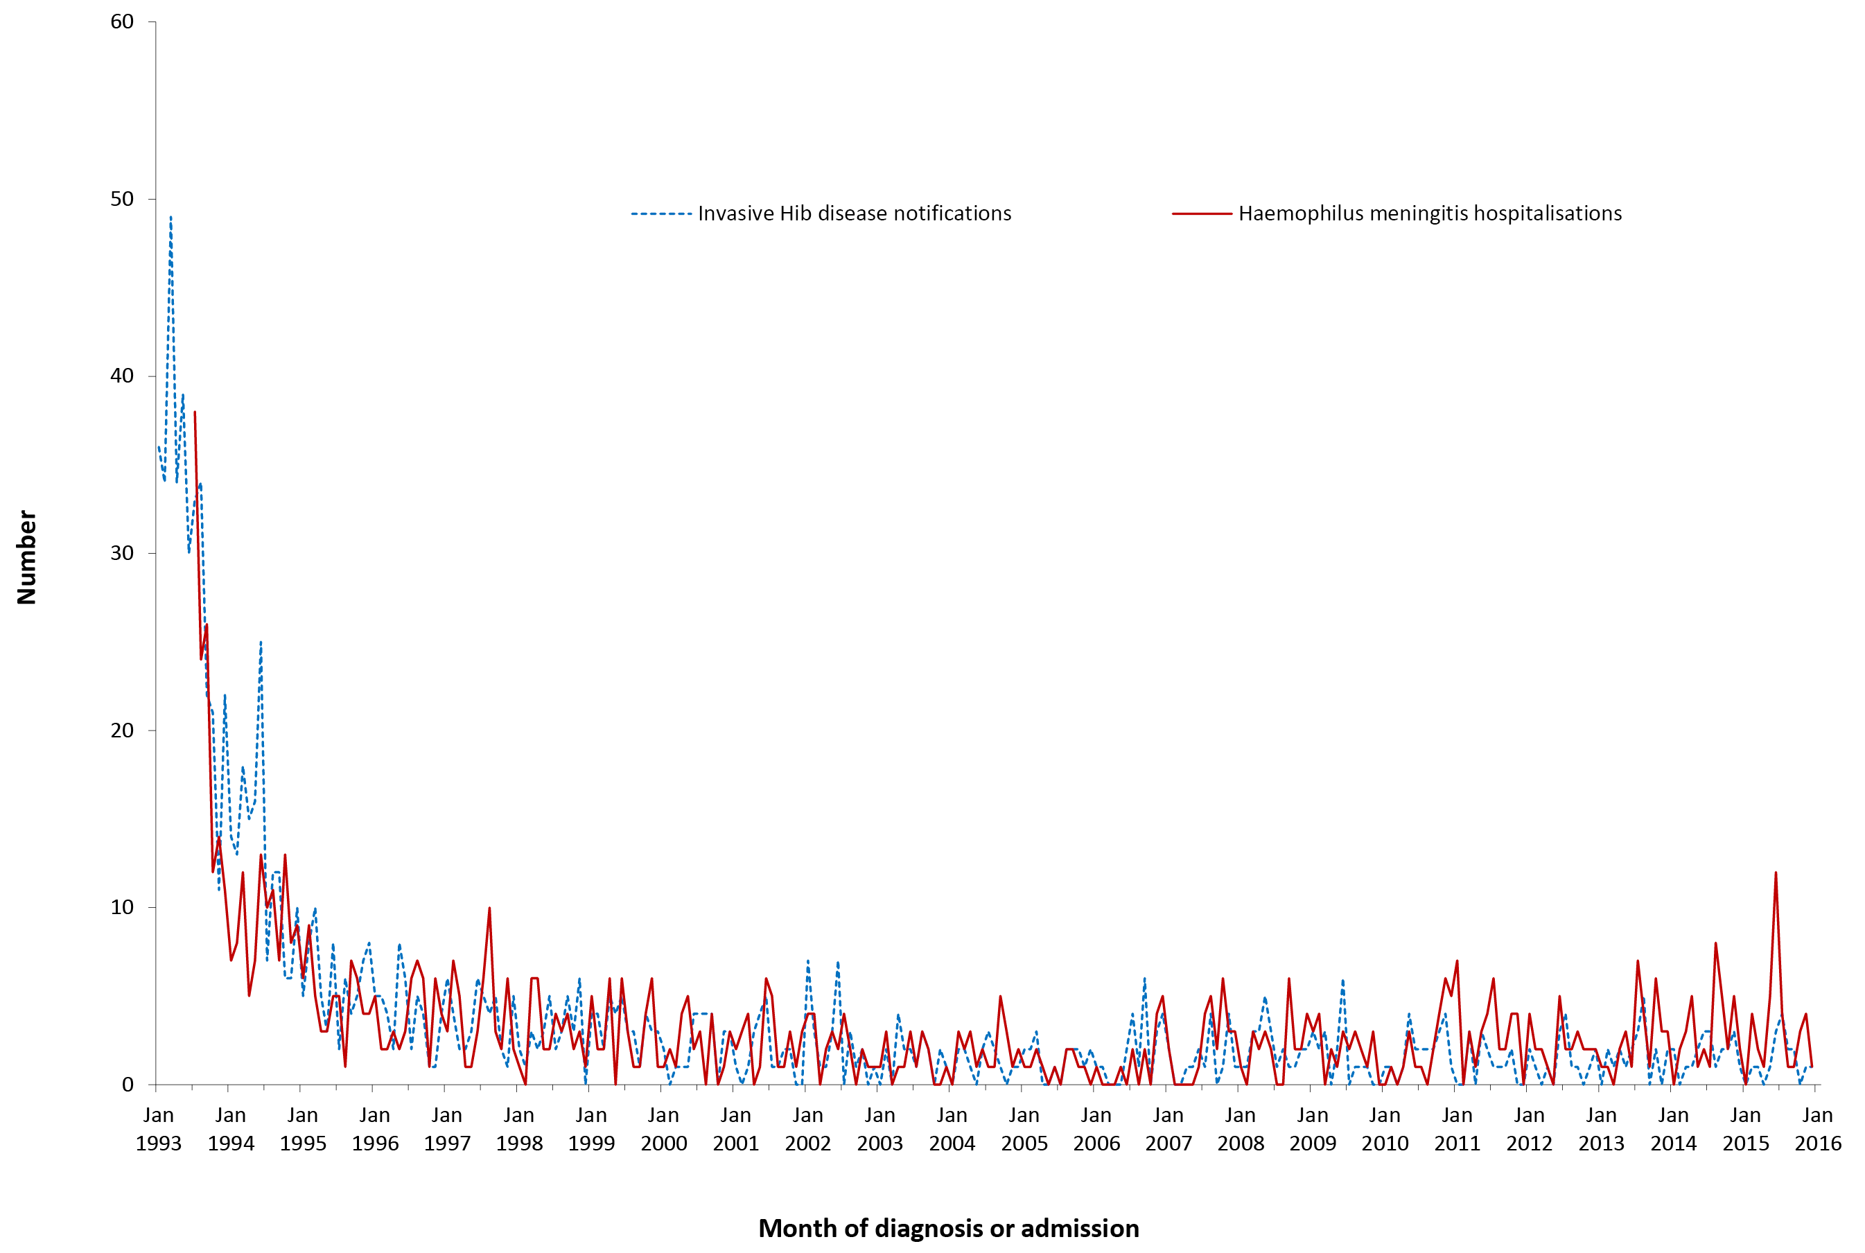
a Notifications where the month of diagnosis was between 1 January 1993 and 31 December 2015; hospitalisations where the month of admission was between 1 July 1993 and 31 December 2015.

Table 3.2.1: Haemophilus influenzae type b notifications, Haemophilus meningitis hospitalisations and Hib deaths, Australia, 2012 to 2015,ª by age group
 | H. influenzae type b  notifications |  | Haemophilus meningitis  hospitalisations |  |  |  | LOS^{b} per admission |  | Hib deaths^{c}
 |  |  | Any diagnosis |  | Principal diagnosis |  | Any diagnosis | Principal diagnosis
Age group (years) | n | (Rate)^{d} | n | (Rate)^{d} | n | (Rate)^{d} | Median days |  | n | (Rate)^{d}
<1 | 21 | (1.71) | 43 | (3.50) | 35 | (2.85) | 10.0 | 9.0 | 1–3 | (0.08)
1–4 | 10 | (0.20) | 20 | (0.41) | 18 | (0.37) | 8.0 | 8.0 | 0 | (–)
5–14 | 8 | (0.07) | np | (0.10) | np | (0.08) | 6.0 | 6.0 | 0 | (–)
15–24 | 1 | (0.01) | 1–4 | (0.02) | 1–4 | (0.02) | 13.0 | 8.5 | 0 | (–)
25–49 | 11 | (0.03) | 18 | (0.05) | 15 | (0.05) | 8.0 | 7.0 | 0 | (–)
50–64 | 5 | (0.03) | 21 | (0.12) | 18 | (0.11) | 7.0 | 8.5 | 0 | (–)
≥65 | 17 | (0.13) | 19 | (0.14) | 13 | (0.10) | 15.0 | 16.0 | 0 | (–)
All ages | 73 | (0.08) | 135 | (0.14) | 110 | (0.12) | 9.0 | 8.0 | 1–3 | (0.001)
a Notifications where the month of diagnosis was between January 2012 and December 2015; hospitalisations where the month of admission was between January 2012 and December 2015.
b LOS = length of stay in hospital.
c Deaths include underlying and associated causes of deaths.
d Average annual age-specific rate per 100,000 population.
np Not provided
There were 135 hospitalisations (average annual rate 0.14 per 100,000) recorded as Haemophilus meningitis (Table 3.2.1), with a median of 2 cases (range 0–12) hospitalised per month (Figure 3.2.1). The hospitalisation rate slightly increased from the previous review period (January 2008 to December 2011), which was 0.12 per 100,000 population.⁸

Severe morbidity and mortality
Notifications of invasive Hib disease and hospitalisations for Haemophilus meningitis were highest for infants <1 year of age (Table 3.2.1) who accounted for 21/73 (29%) invasive Hib notifications, an incidence of 1.71 per 100,000 population, and 43/135 (32%) hospitalisations, a rate of 3.5 per 100,000 population.
Over the 4-year reporting period the total number of hospital bed days recorded for all patients with Haemophilus meningitis was 1,457 (364 bed days per year), a median length of stay of 9 days. There was 1 reported death among the 73 Hib cases reported to the NNDSS in the 4 years from January 2012 to December 2015, and 1–3 deaths recorded in the causes of death data (Table 3.2.1).

Age and sex distribution
There were slightly more notifications for invasive Hib disease for males than females with an average male: female ratio of 1.1:1 over the 4 years from January 2012 to December 2015. Although overall a larger proportion of hospital admissions for Haemophilus meningitis was for males (56%), the male: female ratio was not consistent across the 4 years: males accounted for 61% of hospitalisations for Haemophilus meningitis in 2012 and 54% of hospitalisations in 2015.
Since the introduction of the Hib vaccine in Australia in 1993, invasive Hib disease in children aged 0–4 years has fallen dramatically, with the steepest decline in rates between 1993 and 1995 (Figure 3.2.1). Between January 2012 and December 2015, the annual average notification rate for children 0–4 years of age was 0.5 per 100,000 population, identical to the previous 4 years (January 2008 to December 2011).

Geographical distribution
The majority (84%) of notifications occurred in Queensland (36%), New South Wales (30%) and Victoria (18%), as did 80% of hospital admissions for Haemophilus meningitis (New South Wales (31%), Queensland (27%) and Victoria (22%)) over the 4-year period. Despite its small population, the Northern Territory accounted for 5% of notifications and hospitalisations for Haemophilus meningitis, with the highest rate of notification (0.4 per 100,000) and hospitalisation (0.6 per 100,000) rates, about five times the national averages of 0.08 and 0.1 per 100,000 respectively (Appendix 2, Appendix 3).

Vaccination status
Vaccination status in the NNDSS was evaluated for all notified cases born after 31 December 1987 i.e. the cohort eligible to receive the Hib vaccine. Of the total 73 notifications, there were 40 vaccine-eligible cases. Of the 40 vaccine-eligible cases, vaccination data was not available for 3% (1/40) of cases (1 case coded as 8888 i.e. where the case was followed up but no information was available). Of the 39 cases that had vaccination data available, 9 cases were reported to have received no vaccine doses (unvaccinated), 9 cases had received only 1 dose; 2 cases had received 2 doses; 13 cases had received 3 doses and 6 cases had received 4 doses of the vaccine. The child in the <1 year age group who died in 2012 was recorded in the NNDSS as being partially vaccinated for age.⁶³

Aboriginal and Torres Strait Islander status
Of the 73 notifications of invasive Hib disease over the 2012–2015 period, Indigenous status was reported for 72 (99%). Notification rates of Hib recorded among Aboriginal and Torres Strait Islander people were over 10 times higher than other Australians (0.46 versus 0.03 per 100,000 population respectively).

Comment
Notification rates for invasive Hib disease and hospitalisation rates for Haemophilus meningitis remained low for all ages and in children <5 years of age, and were similar to the previous reporting period (2008–2011).^{8,64} The discrepancy between notification rates for invasive Hib disease and hospitalisation rate for principal diagnosis of Haemophilus meningitis may be due to meningitis hospitalisations caused by serotypes other than type b, or to misclassification of some hospitalisations.

3.3 Hepatitis A
Highlights
The average annual notification rate for hepatitis A was 0.8 per 100,000 population over the 4 years from January 2012 to December 2015 compared with 1.43 per 100,000 population in the previous 4 years. Notably, the notification rate in Aboriginal and Torres Strait Islander people (0.4 per 100,000) was lower than in other Australians (0.8 per 100,000).
Hepatitis A is caused by the hepatitis A virus (HAV), an RNA virus classified within the genus hepatovirus of the picornavirus family. There is only one human HAV serotype.^{65–68} Hepatitis A is an acute inflammatory disease of the liver and can produce either asymptomatic or symptomatic infection. Clinical manifestations of symptomatic infection vary from mild anicteric illness to fulminant hepatic failure. HAV infection typically has a sudden onset of symptoms that can include fever, anorexia, malaise, nausea, abdominal discomfort, jaundice and dark urine.^{69,70} The likelihood of having symptoms with HAV infection is related to age. In young children, hepatitis A is usually asymptomatic or associated with mild illness without jaundice. In adults, symptomatic infection is characteristic and 70%–95% of infected adults show clinical symptoms.⁷⁰

Case definition
Notifications⁷¹
Hepatitis A case definition:
http://www.health.gov.au/internet/main/publishing.nsf/Content/cda-surveil-nndss-casedefs-cd_hepa.htm
Hospitalisations and deaths
The ICD-10-AM/ICD-10 codes B15.0 (hepatitis A with hepatic coma) and B15.9 (hepatitis A without hepatic coma) were used to identify hospitalisations and deaths.

Secular trends
There were 766 notifications of hepatitis A over the 4 years January 2012 to December 2015, with a median of 15 per month and a maximum of 39 (Figure 3.3.1). The average annual notification rate was 0.82 per 100,000 population (Table 3.3.1), highest in 2014 (0.98 per 100,000) and lowest in 2012 (0.73 per 100,000) (Appendix 2). Although total coded hospitalisations (1032) exceeded notifications, only 404 (39%) were coded as the principal diagnosis; and numbers of hospitalisations with hepatitis A coded as the principal diagnosis did not exceed notifications in any age group.

Figure 3.3.1: Hepatitis A notifications and hospitalisations, Australia, 1993 to 2015,ª by month of diagnosis or admission
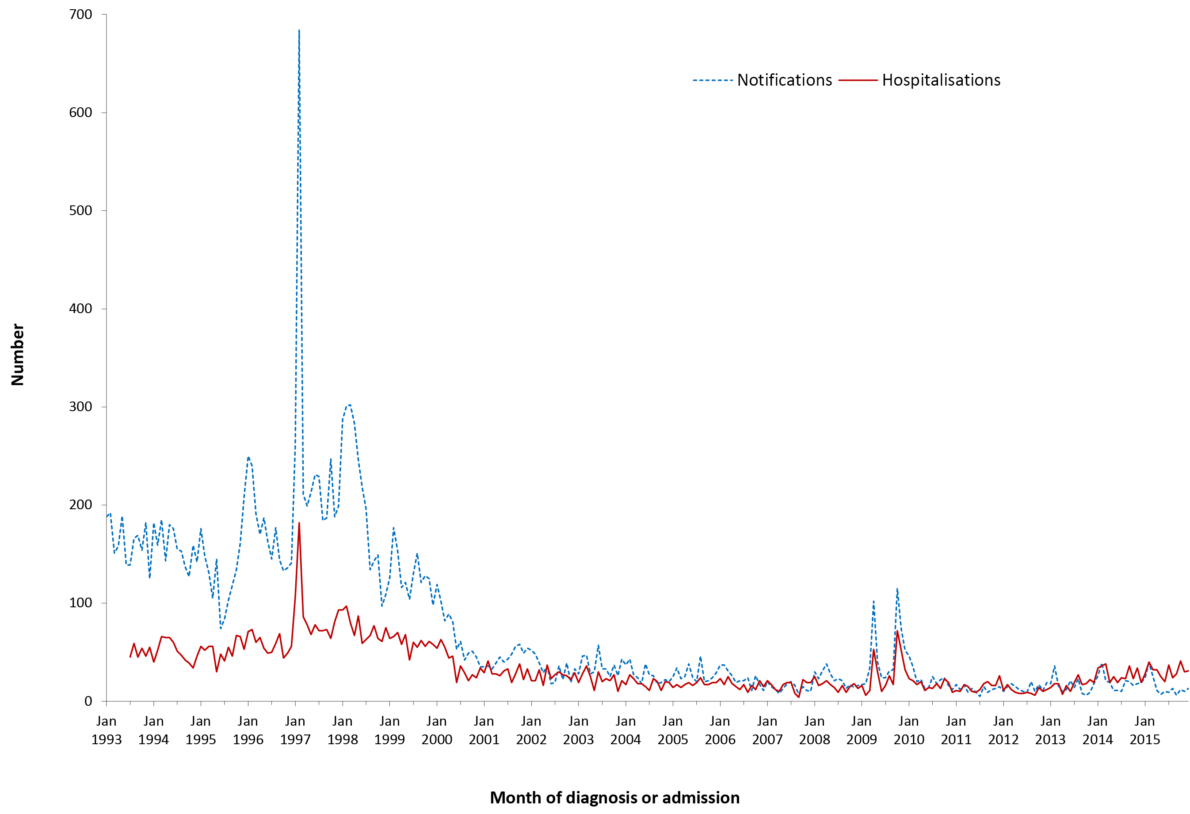
a Notifications where the month of diagnosis was between 1 January 1993 and 31 December 2015; hospitalisations where the month of admission was between 1 July 1993 and 31 December 2015.

Table 3.3.1: Hepatitis A notifications, hospitalisations and deaths, Australia, 2012 to 2015,ª by age group
Age group (years) | Notifications |  | Hospitalisations |  |  |  | LOS^{b} per admission |  | Deaths^{c}
 |  |  | Any diagnosis |  | Principal diagnosis |  | Any diagnosis | Principal diagnosis
 | n | (Rate)^{d} | n | (Rate)^{d} | n | (Rate)^{d} | Median days |  | n | (Rate)^{d}
<1 | 0 | – | 1–4 | (0.08) | 0 | – | 6 | – | 0 | –
1–4 | 53 | (1.08) | np | (0.22) | 9 | (0.18) | 2 | 1 | 0 | –
5–14 | 163 | (1.42) | 67 | (0.58) | 63 | (0.55) | 2 | 2 | 0 | –
15–24 | 153 | (1.22) | 117 | (0.94) | 84 | (0.67) | 2 | 2 | 0 | –
25–49 | 282 | (0.86) | 328 | (1.00) | 147 | (0.45) | 3 | 3 | 5 | (0.02)
50–64 | 75 | (0.45) | 259 | (1.54) | 67 | (0.40) | 2 | 3 | 6 | (0.04)
≥65 | 40 | (0.30) | 249 | (1.84) | 34 | (0.25) | 4 | 4 | 6 | (0.04)
All ages | 766 | (0.82) | 1,032 | (1.11) | 404 | (0.43) | 3 | 3 | 17 | (0.02)
a Notifications where the month of diagnosis was between 1 January 2012 and 31 December 2015; hospitalisations where the month of admission was between 1 January 2012 and 31 December 2015.
b LOS = length of stay in hospital.
c Deaths include underlying and associated causes of deaths.
d Average annual age-specific rate per 100,000 population.
np Not provided

Severe morbidity and mortality
In the 4 years from January 2012 to December 2015, hepatitis A accounted for 5,115 hospital bed days with a median length of stay of 3 days (Table 3.3.1), increasing with increasing age. Over the 4-year reporting period, a total of 17 deaths was recorded in the causes of death data, but hepatitis A was recorded as the underlying cause of death in only 5 of these. No deaths were reported in the NNDSS.

Age and sex distribution
Notification rates were highest for children aged 5–14 and young adults aged 15–24 years and progressively decreased with age. Although the hospitalisation rate for hepatitis A in any diagnosis field progressively increased with age to be highest in those ≥65 years, when restricted to principal diagnosis, hospitalisation rates were highest in those 5–24 years (Table 3.3.1). Notifications and hospitalisations had overall male: female ratios of 1.3:1 and 0.9:1, respectively. This pattern was also observed in the previous reporting period.

Geographical distribution
The highest numbers of notified cases during this reporting period were from New South Wales (256), Victoria (219) and Queensland (157). Tasmania had the lowest average annual rate of notifications. Of small numbers of hospitalised cases, rates per 100,000 population were about twice as high in the Northern Territory (2.6) as in other jurisdictions (South Australia (1.4), Australian Capital Territory (1.4), Victoria (1.2) and New South Wales (1.1); Appendix 3).

Aboriginal and Torres Strait Islander status
Of the 766 notifications of hepatitis A over the 2012–2015 period, Indigenous status was reported for 738 (96%). Of the total 766 hepatitis A notifications, 11 were in Aboriginal and Torres Strait Islander people and 727 in other people (notification rate 0.4 versus 0.8 per 100,000 population, respectively). However, coded hospitalisation rates were higher for Aboriginal and Torres Strait Islander people than for other people (1.5 versus 1.1 per 100,000 population respectively).

Vaccination status
Of the 766 notifications, vaccination data was not available for 35% (267/766) of cases (114 cases coded as 8888 where the case was followed up but no information was available; 97 cases coded as 9999 where there was missing vaccine type data and cases were not followed up; and 56 had no data recorded i.e. the vaccine data field was left blank). Of the 499 cases that had vaccination data available, 485 cases reported to have received no vaccine doses (unvaccinated), and 14 cases received only 1 dose of vaccine.

Comment
Hepatitis A vaccine has been available on the National Immunisation Program (NIP) for Aboriginal and Torres Strait Islander children in the Northern Territory, Queensland, South Australia and Western Australia since 2005. Coverage in Aboriginal and Torres Strait Islander children for whom hepatitis A vaccine is included in the NIP is around 80% for 1 dose⁷² and around 71% for 2 doses.⁷³ As previously reported, the child program has been associated with hepatitis A notification rates decreasing across all age groups in the Aboriginal and Torres Strait Islander population,⁴ to be half that of other population groups in the period covered by this report. Hepatitis A notifications were highest in children and young adults, possibly related to travel, including travel to visit friends and relatives in endemic countries. Australia continues to recommend hepatitis A vaccine for people with an increased risk of acquiring hepatitis A due to occupational or other factors,⁷⁴ but coverage of the vaccine in such groups is unknown.

3.4 Hepatitis B
Highlights
There was a declining trend in the number of notifications of newly-acquired hepatitis B that started in 2007 and continued over the 4-year period from January 2012 to December 2015. There were 10 notifications of newly-acquired hepatitis B for children aged <5 years over the 4-year period from January 2012 to December 2015.
The focus of this chapter is acute infection with hepatitis B virus (HBV), a hepadnavirus. It produces a range of conditions from subclinical infection to acute and, rarely, fulminant hepatitis. The majority of HBV infections are not clinically recognised, with <10% of children and 30%–50% of adults experiencing jaundice.^{75,76} When illness occurs, it is usually insidious, with anorexia, vague abdominal discomfort, nausea and vomiting, sometimes arthralgia and rash, often progressing to jaundice. The main burden of disease is related to chronic HBV infection. The risk of an acute infection becoming chronic varies inversely with age. Chronic HBV infection occurs in about 90% of infants infected at birth, 20%–50% of children infected at 1–5 years of age, with much lower but highly variable risk (1%–10%) in people infected as older children and adults.⁷⁵ Of those chronically infected with HBV, 15%–40% develop cirrhosis of the liver and/or hepatocellular carcinoma.^{77,78}
HBV transmission occurs by percutaneous or permucosal exposure to infective body fluids such as blood, semen, vaginal secretions and any other body fluid containing blood.⁷⁵ Major modes of transmission include sexual or close household contact with an infected person, perinatal transmission from mother to infant, injecting drug use and nosocomial exposure.⁷⁵ The summary below is restricted to newly-acquired hepatitis B notifications and acute hepatitis B hospitalisations.

Case definition
Notifications⁷⁹
Hepatitis B (newly acquired) case definition:
http://www.health.gov.au/internet/main/publishing.nsf/Content/cda-surveil-nndss-casedefs-cd_hepbnew.htm
Hospitalisations and deaths
The ICD-10-AM/ICD-10 code B16 (acute hepatitis B) was used to identify hospital admissions and deaths. As in previous reports only those hospitalisations with B16 as the principal diagnosis were included.

Secular trends
In the 4 years from January 2012 to December 2015, there were 676 notifications of newly-acquired hepatitis B (average annual rate of 0.7 per 100,000) (Table 3.4.1). There was a small decline during the 4-year reporting period, from a median of 16 notifications per month in 2012 to 12 notifications per month in 2015 (Figure 3.4.1). There were 459 hospital admissions with a principal diagnosis of acute hepatitis B over the 4 years (Table 3.4.1). Numbers of hospitalisations decreased compared to the previous 4 years, January 2008 to December 2011⁸ (Figure 3.4.1).

Figure 3.4.1: Hepatitis B notifications and hospitalisations with a principal diagnosis of acute hepatitis B, Australia, 1997 to 2015,ª by month of diagnosis or admission
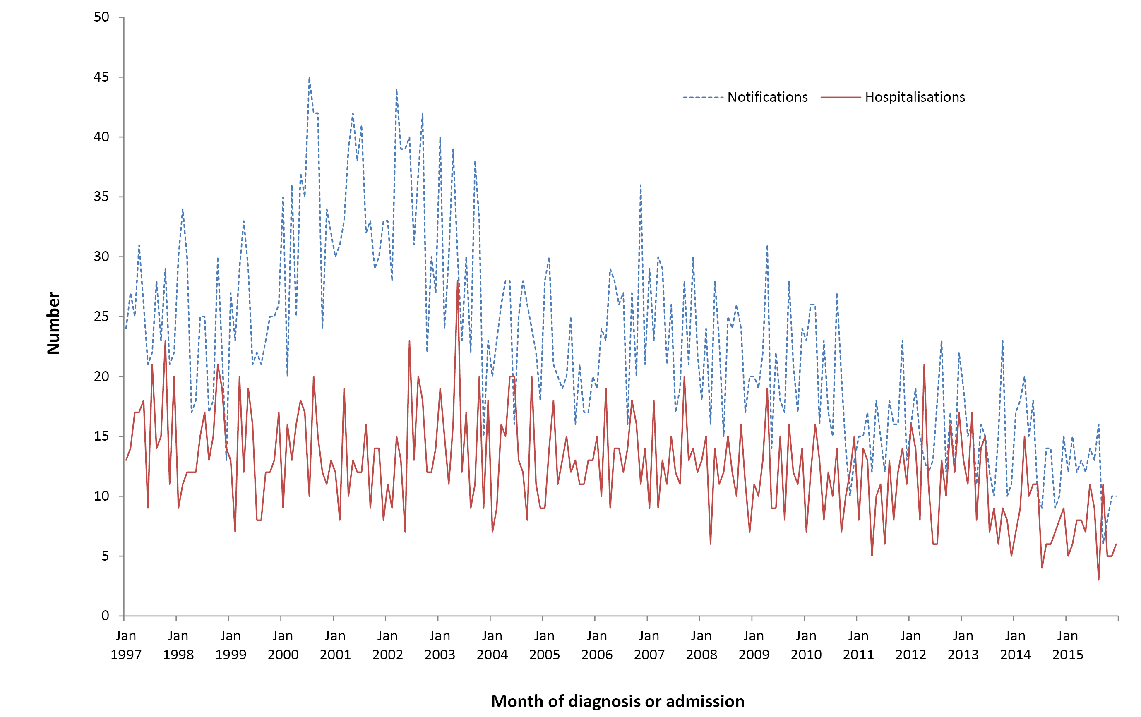
a Notifications with month of diagnosis was between 1 January 1997 and 31 December 2015; hospitalisations where the month of admission was between 1 January 1997 and 31 December 2015. This figure includes data from 1997 onwards since it was not until 1996 that acute hepatitis B became notifiable in all states and territories and prior to 1994 hospitalisations for acute hepatitis B were not distinguished from chronic hepatitis B.

Table 3.4.1: Hepatitis B notifications, hospitalisations and deaths, Australia, 2012 to 2015,ª by age group
 | Notifications |  | Hospitalisations |  | LOS^{b} per admission | Deaths^{c}
 |  |  | Principal diagnosis |  | Principal diagnosis
Age group (years) | n | (Rate)^{d} | n | (Rate)^{d} | Median days | n | (Rate)^{d}
<1 | 3 | (0.24) | 1–4 | (0.08) | 4 | 0 | –
1–4 | 6 | (0.12) | 0 | – | – | 0 | –
5–14 | 5 | (0.04) | np | (0.05) | 1.0 | 0 | –
15–24 | 68 | (0.54) | 32 | (0.26) | 4.0 | 1–3 | (0.02)
25–49 | 441 | (1.35) | 284 | (0.87) | 4.0 | np^{e} | (0.38)
50–64 | 108 | (0.64) | 102 | (0.61) | 5.0 | 248 | (1.47)
≥65 | 45 | (0.33) | 34 | (0.25) | 7.0 | 215 | (1.59)
All ages | 676 | (0.72) | 459 | (0.49) | 4.0 | 589 | (0.63)
a Notifications where the month of diagnosis was between 1 January 2012 and 31 December 2015; hospitalisations where the month of admission was between 1 January 2012 and 31 December 2015.
b LOS = length of stay in hospital.
c Deaths include underlying and associated causes of deaths.
d Average annual age-specific rate per 100,000 population.
e np = not provided

Severe morbidity and mortality
In the 4-year reporting period, hospitalisations for acute hepatitis B infection accounted for 2,568 bed days. The median length of stay in hospital was 4 days, increasing to 7 days for admissions for persons aged ≥65 years (Table 3.4.1).
There were 589 deaths in the causes of death data over the 4-year period with acute hepatitis B infection (ICD-10 code B16) recorded as the underlying or associated cause. Only 80 (13.6%) were coded as the underlying cause of death (14 deaths in people aged 25–49 years, 34 deaths in those aged 50–64 years and 32 deaths in people aged ≥65 years) (Table 3.4.1). Only 3 deaths were recorded among notifications to NNDSS during this reporting period.

Age and sex distribution
From January 2012 to December 2015, the highest rates for notification of newly-acquired hepatitis B infection and hospital admissions for acute hepatitis B were among adults aged 25–49 years (Table 3.4.1). In children 0–4 years, there were 10 notifications of newly-acquired hepatitis B (Table 3.4.1).
Numbers of notifications and hospital admissions were higher for males than for females (male:female ratio for notifications 2.8:1 and hospitalisations 2.4:1).

Geographical distribution
Queensland accounted for 28% of notifications, followed by 26% in Victoria and 17% each in Western Australia and New South Wales over the 4 years from January 2012 to December 2015 (Appendix 2).
Hospitalisation rates were highest in the Northern Territory (average annual rate 1.1 per 100,000 population) and lowest in New South Wales and Tasmania (average annual rate 0.4 per 100,000) over the 4 years from January 2012 to December 2015 (Appendix 2).

Aboriginal and Torres Strait Islander status
Of the 676 notifications of hepatitis B over the 2012–2015 period, Indigenous status was reported for 606 (90%). Of the total 676 notifications, there were 59 notifications among Aboriginal or Torres Strait Islander people. There were also 32 hospitalisations for hepatitis B among Aboriginal or Torres Strait Islander people. Notification rates in Aboriginal or Torres Strait Islander people were more than three times as high (2.1 per 100,000 people) as other people (0.7 per 100,000 population) and hospitalisation rates two times as high (1.1 per 100,000 population versus 0.5 per 100,000 population).

Vaccination status
Of the 14 notifications during January 2012 to December 2015 in children aged <15 years eligible to receive hepatitis B vaccine as part of the universal infant vaccination program, vaccination data was not available for 50% (7/14) of cases (1 case coded as 8888 where the case was followed up but no information was available; 3 cases coded as 9999 for missing vaccine type data where cases were not followed up; and 3 cases had no data recorded i.e. the vaccine data field was left blank). Of the 7 cases that had vaccination data available, there were 5 cases reported to have received no vaccine doses (unvaccinated), 1 case had received 4 doses and 1 case had received 5 doses of hepatitis B-containing vaccine.

Comment
Universal infant hepatitis B immunisation was introduced in May 2000, but targeted programs were in place since the 1980s in all jurisdictions. A progressive downward trend in total notifications of acute hepatitis B is evident from 2007, accelerating during this reporting period of 2012 to 2015.

3.5 Influenza
Highlights
There was a marked increase in winter seasonal peaks of notifications in this reporting period relative to previous years with a very large peak in influenza notifications between July and September 2015 (79,582 cases). Hospitalisation rates for influenza coded as J09, J10 or J11 were highest for infants aged <1 year, followed by children aged 1–4 years.
Influenza, predominantly influenza type A (H1N1 and H3N2) and type B (Yamagata and Victoria lineages) viruses, causes annual epidemics of respiratory disease and is mainly spread by droplet transmission.⁷⁰ The disease is often indistinguishable clinically from that caused by other respiratory viruses. Typical symptoms include abrupt onset of fever, cough, malaise, myalgia, sore throat and headache. Complications of influenza infection include pneumonia, otitis media and exacerbation of chronic medical conditions.⁸⁰ Significant antigenic changes can lead to pandemics with higher rates of illness and death.⁷⁰ Seasonal epidemics occur in Australia mainly between June and September, with year to year variability in terms of severity and age groups affected, based on the viruses predominantly circulating. Influenza can cause severe illness or death in high-risk groups particularly in children younger than 5 years, people older than 65 years, Aboriginal and Torres Strait Islander people, pregnant women, people with chronic medical conditions.⁷⁴

Case definition
Notifications⁸¹
Influenza laboratory-confirmed case definition:
http://www.health.gov.au/internet/main/publishing.nsf/Content/cda-surveil-nndss-casedefs-cd_flu.htm
Hospitalisations and deaths
The ICD-10-AM/ICD-10 codes J09 (influenza due to certain identified influenza virus, including avian influenza and the influenza A/H1N1 pandemic strain), J10 (influenza due to identified virus) and J11 (influenza, virus not identified) were used to identify influenza hospitalisations and deaths. As no avian influenza cases have been reported in Australia, J09 in this report refers to the influenza A/H1N1 pandemic strain.

Secular trends
In the 4 years from January 2012 to December 2015, there were 241,177 notifications of influenza for an average annual rate of 258.7 per 100,000 population (Table 3.5.1). Notifications were highest in 2015, accounting for 42% of cases notified over the 4 years at a rate of 423 per 100,000 (Appendix 2). There were marked increases in the winter seasonal peaks in influenza notifications relative to previous years, with a very large peak in influenza notifications between July and September 2015 (79,582 cases) (Figure 3.5.1). Monthly notifications for influenza during 2015 (median 2,372 cases) were more than twice as high as 2012 (monthly median 1,090).

Figure 3.5.1: Influenza notifications and hospitalisations from 2001 to 2015,ª Australia, by month of diagnosis or admission
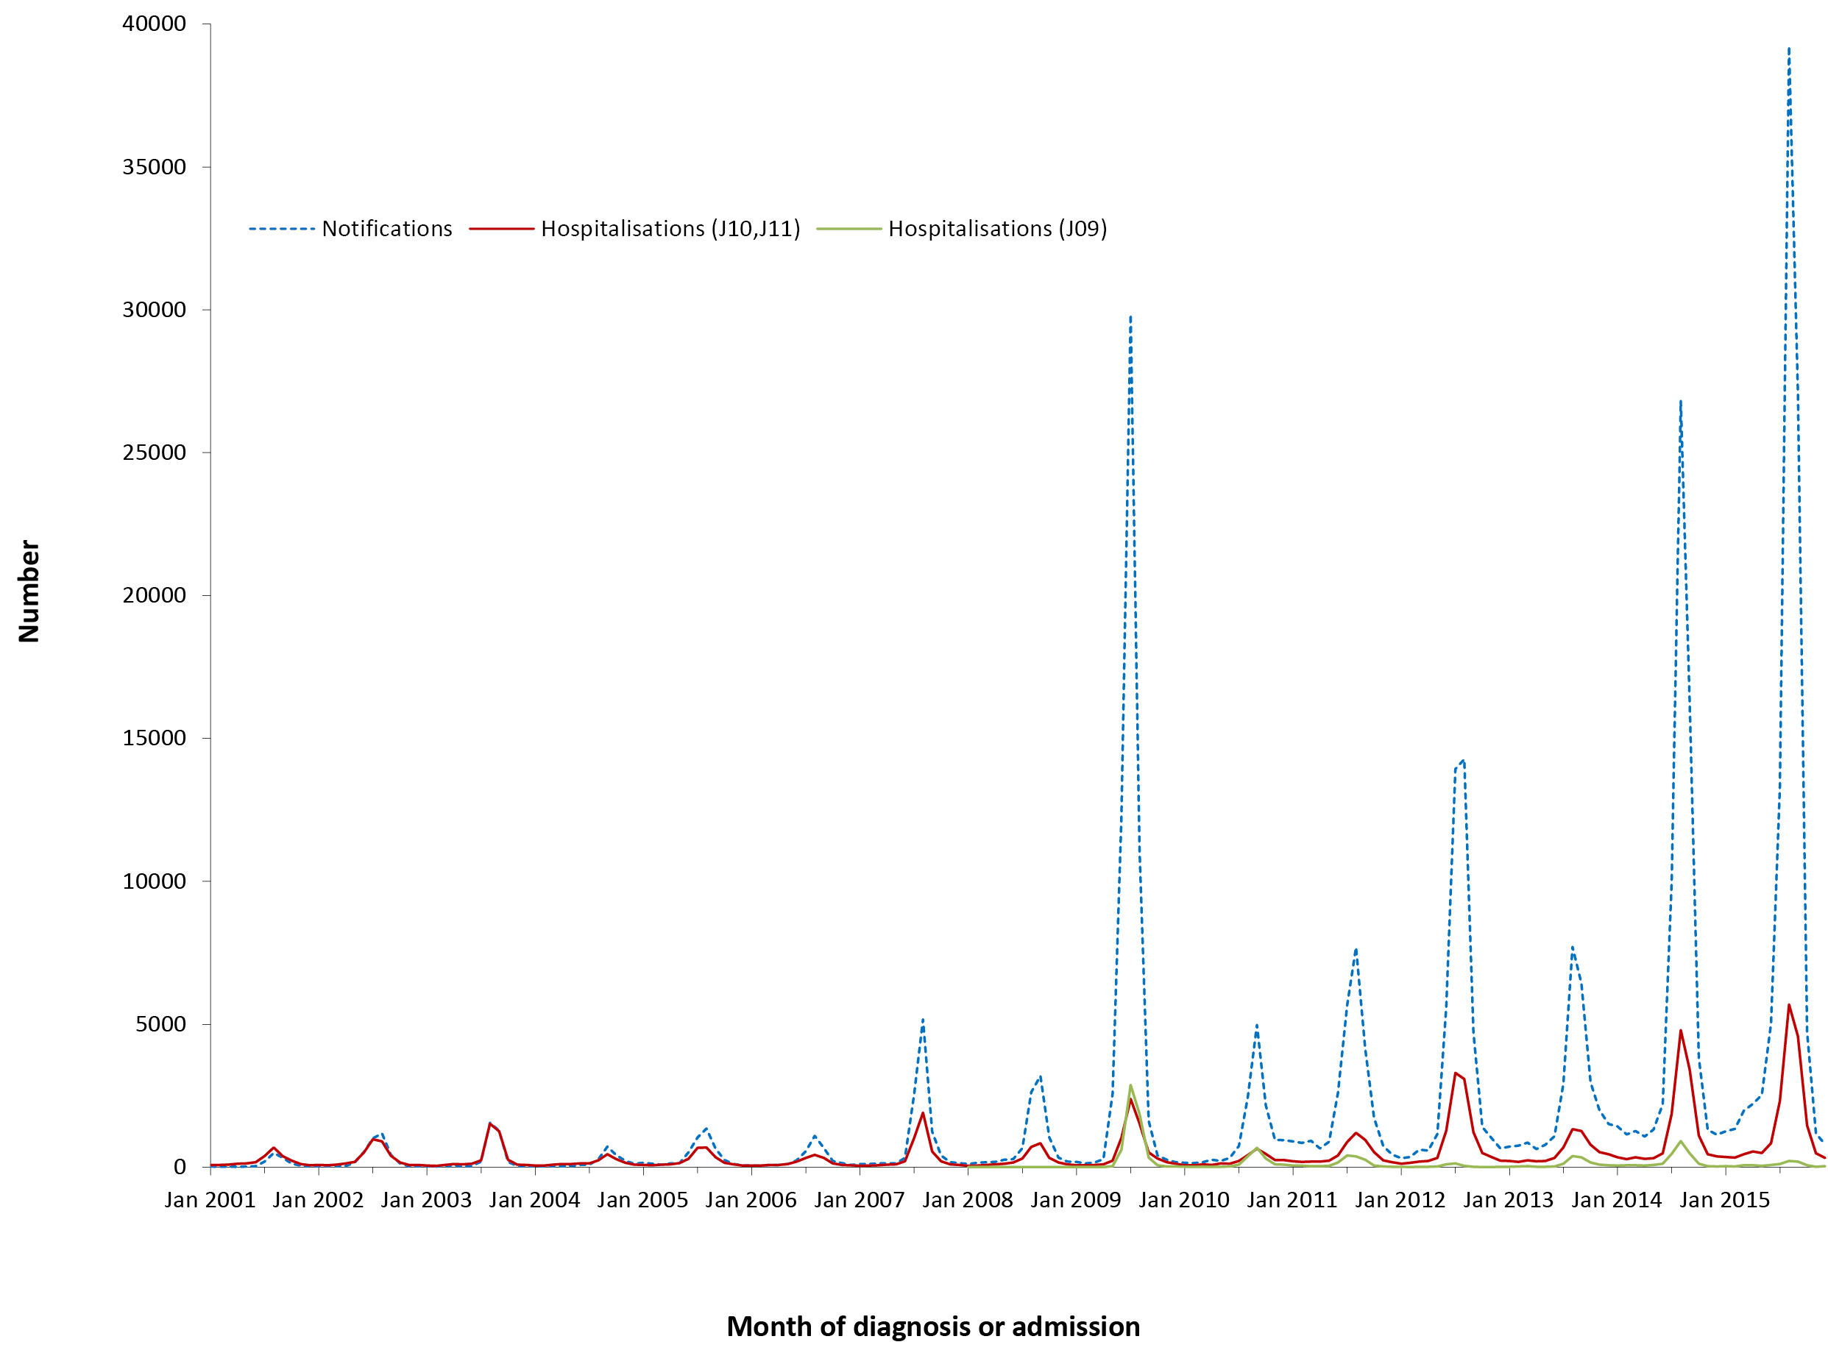
a Notifications where the month of diagnosis was between 1 January 2001 and 31 December 2015; hospitalisations with ICD-10-AM code for general influenza (J10, J11) where the month of admission was between 1 January 2001 and 31 December 2015: hospitalisations for pandemic influenza (ICD-10-AM code J09) where the month of admission was between 1 January 2008 and 31 December 2015.
Table 3.5.1: Influenza notifications, hospitalisations and deaths, Australia, 2012 to 2015,ª by age group
Age group (years) | Notifications |  | Hospitalisations |  |  |  | LOS^{b} per admission |  | Deaths^{c}
 |  |  | Any diagnosis |  | Principal diagnosis |  | Any diagnosis | Principal diagnosis
 | n | (Rate)^{d} | n | (Rate)^{d} | n^{e} | (Rate)^{d} | Median days |  | n | (Rate)^{d}
<1 | 5,400 | (439.1) | 2,988 | (243.0) | 2,140 | (174.0) | 2 | 2 | 1–3 | (0.24)
1–4 | 23,954 | (489.9) | 4,545 | (93.0) | 3,247 | (66.4) | 2 | 2 | 15 | (0.31)
5–14 | 42,998 | (373.6) | 3,194 | (27.8) | 2,119 | (18.4) | 2 | 2 | 9 | (0.08)
15–24 | 24,295 | (194.3) | 2,857 | (22.8) | 1,841 | (14.7) | 2 | 1 | np^{e} | (0.06)
25–49 | 72,637 | (221.9) | 10,657 | (32.6) | 6,742 | (20.6) | 2 | 2 | 61 | (0.19)
50–64 | 33,907 | (201.4) | 8,462 | (50.3) | 4,786 | (28.4) | 4 | 3 | 115 | (0.68)
≥65 | 37,922 | (280.0) | 21,496 | (158.7) | 11,412 | (84.3) | 5 | 5 | 834 | (6.16)
All ages | 241,177 | (258.7) | 54,199 | (58.1) | 32,287 | (34.6) | 3 | 3 | 1,045 | (1.12)
a Notifications where the month of diagnosis was between 1 January 2012 and 31 December 2015; hospitalisations (ICD-10-AM codes J09, J10 and J11) where the month of admission was between 1 January 2012 and 31 December 2015.
b LOS = length of stay in hospital.
c Deaths include underlying and associated causes of deaths.
d Average annual age-specific rate per 100,000 population.
e np = not provided
From January 2012 to December 2015, there were 54,199 hospitalisations with ICD-10-AM influenza codes J09, J10 or J11. There were large peaks in hospitalisations for influenza code J10 or J11 in the winter months of 2014 and 2015, with a smaller peak in 2012 (Figure 3.5.1). Hospitalisations for influenza code J09 also had a larger than average peak in winter 2014 in this reporting period (Figure 3.5.1).

Severe morbidity and mortality
In the 4-year reporting period, there were 321,606 bed days for hospitalisations due to any influenza (J09, J10 or J11). The median length of hospital stay was 3 days, increasing to 5 days for patients aged ≥65 years (Table 3.5.2). From January 2012 to December 2015, in the cause of death data, influenza (ICD-10 codes J09, J10, J11) was recorded as the cause of death in 1,045 cases, an average annual rate of 1.1 deaths per 100,000 population (Table 3.5.1). Coded influenza death data are known to significantly underestimate the true influenza associated death rate.

Age and sex distribution
The highest rate of notifications for influenza was among children aged 1–4 year, followed by infants in the <1 year age group (Table 3.5.1). Hospitalisation rates for influenza coded as J09, J10 or J11 was highest for infants aged <1 year, followed by children aged 1–4 years (Tables 3.5.1).
There were slightly fewer influenza notifications and hospitalisations for males than females (male:female ratio 0.9:1 for notifications and 0.9 for hospitalisations).

Geographical distribution
Notification rates were highest in South Australia followed by Queensland and Northern Territory (Appendix 2). Hospitalisation rates increased markedly in 2014 across all jurisdictions. In 2015, there was an overall increase in hospitalisation rates, particularly in Queensland, South Australia, Tasmania and Victoria (Appendix 3).

Aboriginal and Torres Strait Islander status
Of the 241,177 notifications of influenza over the 2012–2015 period, Indigenous status was reported for 97,285 (40%). Of the total 241,177 notifications for influenza, 2% (5,966) were in Aboriginal and Torres Strait Islander people, with a notification rate overall slightly lower (211 per 100,000 population) than other Australians (261 per 100,000 population). Of the 54,199 hospitalisations for influenza, approximately 5% (2,920) were in Aboriginal and Torres Strait Islander people, with a hospitalisation rate (103 per 100,000 population) almost twice that of other Australians (57 per 100,000 population).

Vaccination status
Vaccination status data have not been provided due to data quality issues.

Comment
Influenza remains the most commonly notified VPD in Australia. Patterns of influenza by age group, and Indigenous status over time were recently reviewed in detail for the period 2006 to 2015.⁵ In this report, the striking increase in notification rate after the pandemic year in 2009 almost certainly reflects greatly increased testing in the context of wide availability of molecular methods of virus detection. Hospitalisation rates also increased in this time frame, also likely influenced by testing practices and an increasing recognition by clinicians of influenza as a cause of disease among hospitalised patients. Differences in notifications across jurisdictions are likely to be at least partially due to different testing practices, although geographic differences were noted in the 2009 pandemic when they were closely monitored.⁵

3.6 Measles
Highlights
Measles notifications remained low in Australia over the reporting period, consistent with continuing elimination of endemic measles. However, number of notifications increased due to outbreaks in 2014, predominantly in NSW, derived from imported cases. Notification rates were highest in infants <1 year of age, as were coded hospitalisations.
Measles is an acute and highly communicable disease caused by a member of the genus Morbillivirus. Before the introduction of a vaccine, measles caused millions of deaths worldwide.⁸² The virus is transmitted directly from person to person by respiratory droplets and is contagious before symptoms develop.⁸² The clinical picture includes a prodromal fever, cough, coryza, conjunctivitis, and Koplik spots on the buccal mucosa, before the onset of rash.^{82,83} Complications include otitis media, pneumonia and encephalitis. Subacute sclerosing panencephalitis (SSPE) occurs very rarely as a late sequel of wild infection but not vaccination.⁸⁴ Complications and deaths occur more commonly in developing countries in children aged <5 years and adults, and in persons with malnutrition or immune deficiencies.⁸³

Case definition
Notifications⁸⁵
Measles case definition:
http://www.health.gov.au/internet/main/publishing.nsf/Content/cda-surveil-nndss-casedefs-cd_measl.htm
Hospitalisations and deaths
The ICD-10-AM/ICD-10 code B05 (measles) was used to identify hospitalisations and deaths. SSPE, a very rare late sequel of measles infection, was not included in this analysis.

Secular trends
In the 4 years from January 2012 to December 2015, there were 770 notifications of measles recorded nationally, an average annual notification rate of 0.8 per 100,000 population (Table 3.6.1). There were increases in notifications in 2012 and 2014 (Figure 3.6.1), with the rate in 2014 (1.4 per 100,000) the highest for a decade (Figure 3.6.1 insert and Appendix 2).

Figure 3.6.1: Measles notifications and hospitalisations, Australia, 1993 to 2015,ª by month of diagnosis or admission
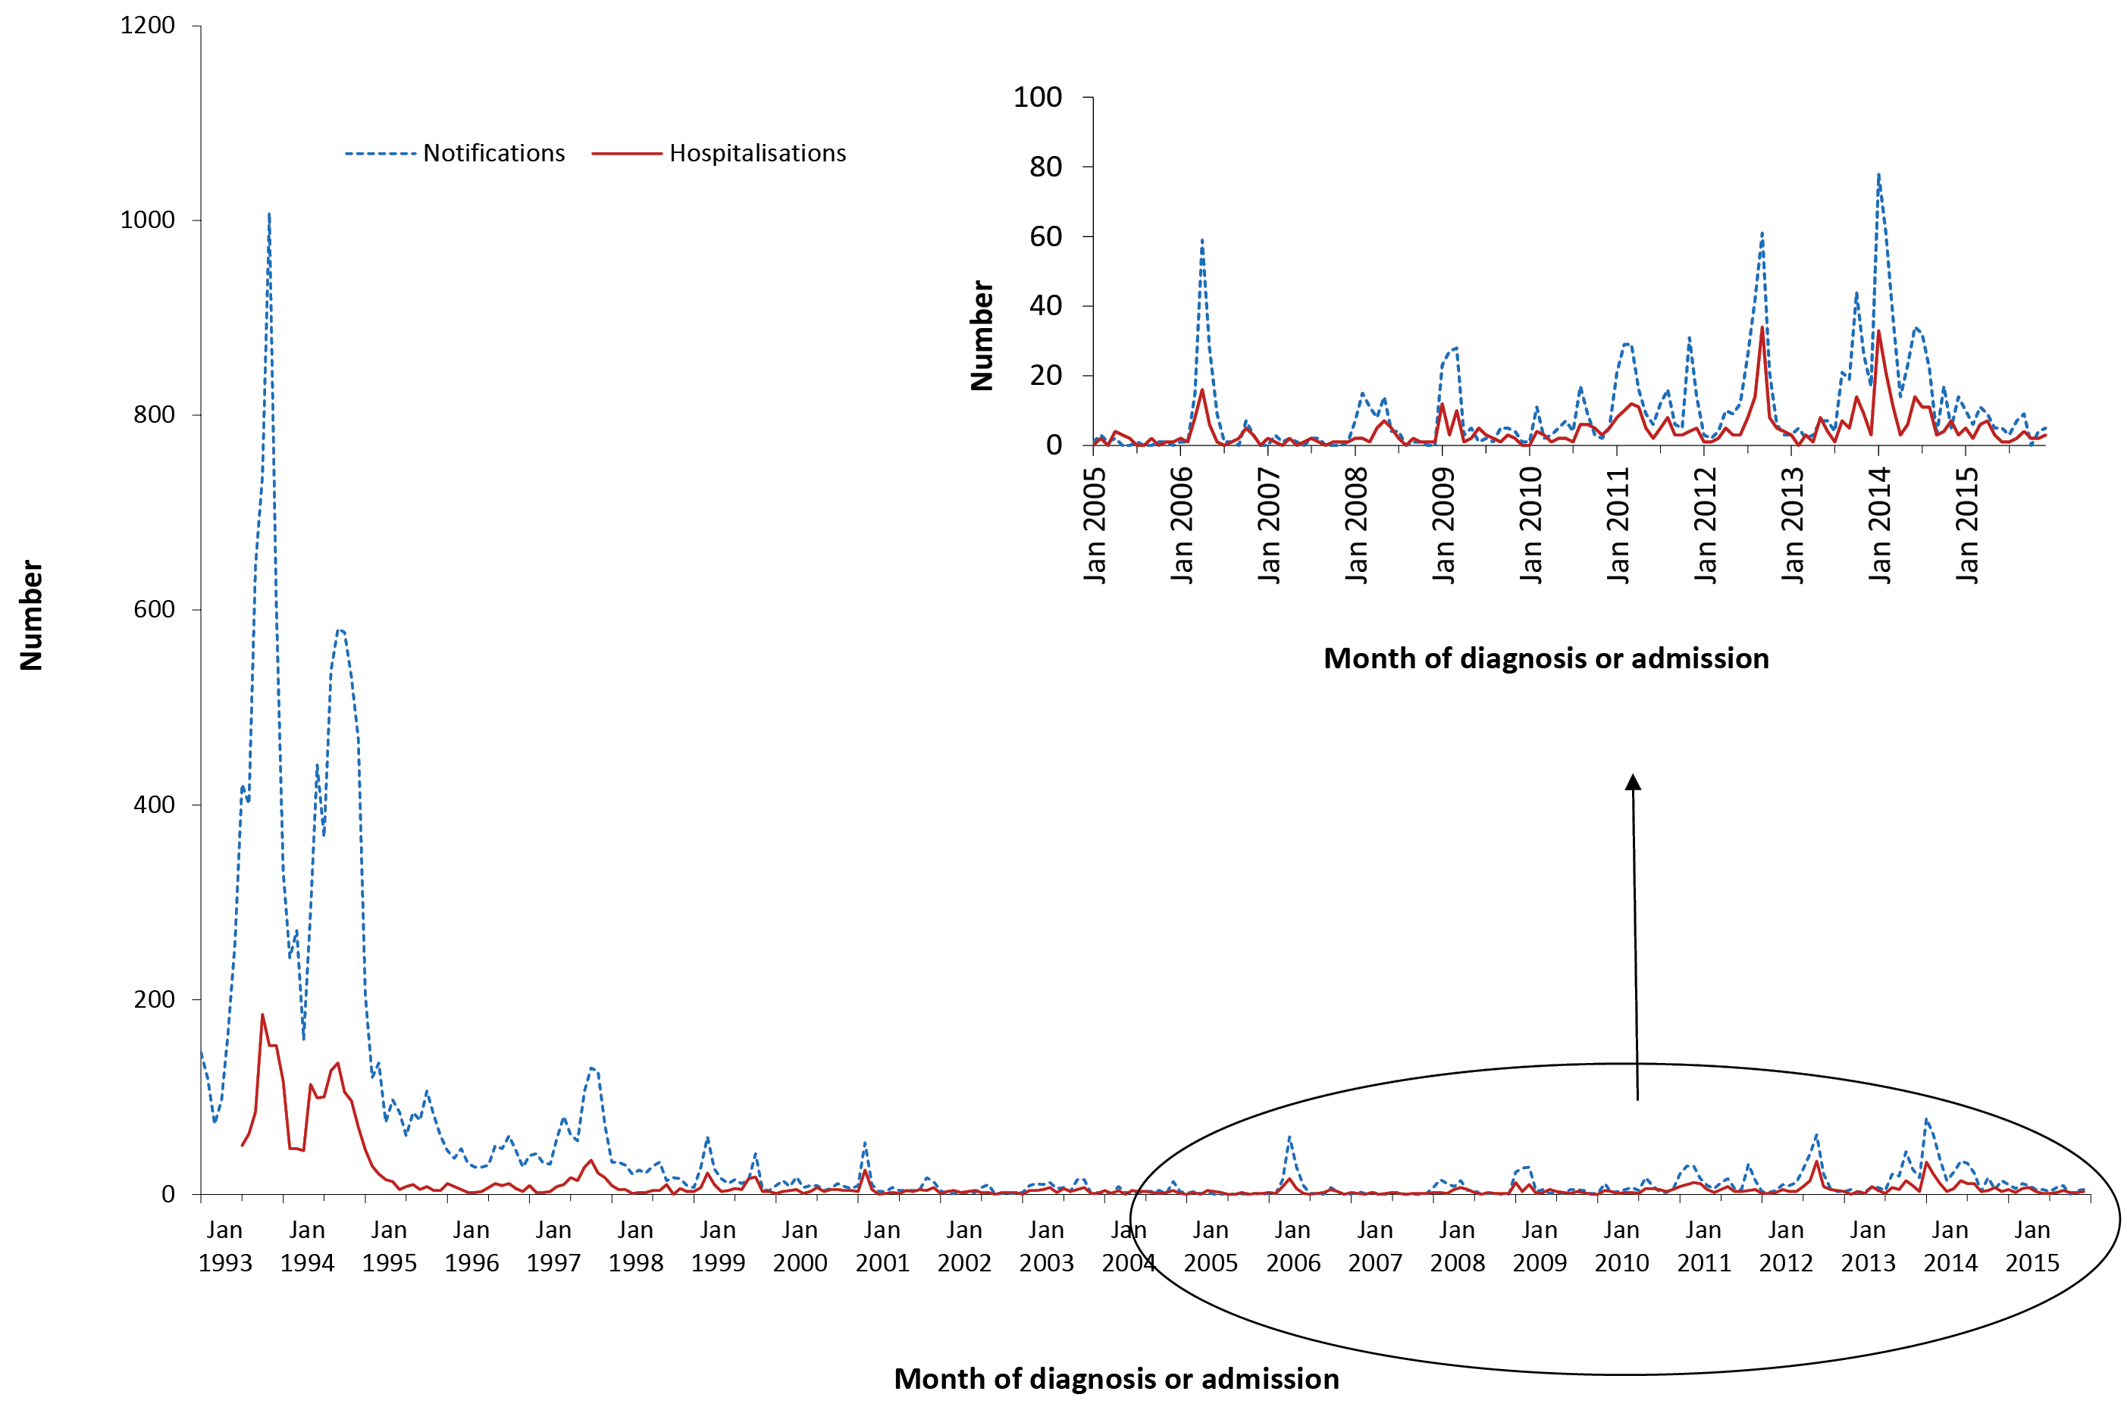
a Notifications where the month of diagnosis was between 1 January 1993 and 31 December 2015; hospitalisations where the month of admission was between 1 July 1993 and 31 December 2015.
Table 3.6.1: Measles notifications, hospitalisations and deaths, Australia, 2012 to 2015,ª by age group
Age group (years) | Notifications |  | Hospitalisations |  |  |  | LOS^{b} per admission |  | Deaths^{c}
 |  |  | Any diagnosis |  | Principal diagnosis |  | Any diagnosis | Principal diagnosis
 | n | (Rate)^{d} | n | (Rate)^{d} | n | (Rate)^{d} | Median days |  | n | (Rate)^{d}
<1 | 87 | (7.07) | 36 | (2.93) | 33 | (2.68) | 3 | 3 | 0 | –
1–4 | 73 | (1.49) | 35 | (0.72) | 35 | (0.72) | 2 | 2 | 0 | –
5–14 | 128 | (1.11) | 24 | (0.21) | 24 | (0.21) | 1 | 1 | 0 | –
15–24 | 204 | (1.63) | 64 | (0.51) | 59 | (0.47) | 3 | 3 | 0 | –
25–49 | 272 | (0.83) | 135 | (0.41) | 123 | (0.38) | 3 | 3 | 0 | –
50–64 | 6 | (0.04) | 9 | (0.05) | np | (0.05) | 3 | 3 | 1–3 | (0.01)
≥65 | 0 | – | 8 | (0.06) | 1–4 | (0.02) | 12 | 7 | 0 | –
All ages | 770 | (0.83) | 311 | (0.33) | 285 | (0.31) | 3 | 3 | 1–3 | (<0.01)
a Notifications where the month of onset was between 1 January 2012 and 31 December 2015; hospitalisations where the month of admission was between 1 January 2012 and 31 December 2015.
b LOS = length of stay in hospital.
c Deaths sourced from the Causes of Death database from the Australian Coordinating Registry. Deaths include underlying and associated causes of deaths.
d Average annual age-specific rate per 100,000 population.
np Not provided
Hospitalisations followed the same general trend as notifications (Figure 3.6.1). From January 2012 to December 2015, there were 311 hospitalisations (approximately 40% of notifications) with the ICD-10-AM code B05 (measles) at an average annual rate of 0.33 per 100,000 population (Table 3.6.1). The lowest rate of hospitalisations during the 4-year period was in 2015 (Appendix 3).

Severe morbidity and mortality
In the 4-year reporting period, hospital admissions for measles accounted for 1,134 hospital bed days. The median length of stay was 3 days, with the length of stay increasing with increasing age (Table 3.6.1). Of the 311 hospitalisations, 285 (92%) had measles recorded as the principal diagnosis (Table 3.6.1). In the causes of death data, 1–3 deaths were recorded with measles as the underlying or associated cause of death for the 4–year reporting period, 2012 to 2015. There were no deaths recorded in the NNDSS for this reporting period.

Age and sex distribution
From January 2012 to December 2015, the highest notification rate (7.1 per 100,000 population) was for infants (Table 3.6.1), declining among children 1–4 years of age to below 2 per 100,000. Age-specific hospitalisation rates reflected notification rates; the highest rate was in infants <1 year of age (Table 3.6.1). Over the 4-year reporting period there were slightly more notifications for males than females (male:female ratio 1.3:1), and similarly for hospitalisations (male:female ratio 1.2:1).

Geographical distribution
Measles notifications over the 4-year reporting period were highest in New South Wales, followed by Victoria and Queensland (Appendix 2). New South Wales accounted for 36% of measles notifications during the 4-year period. Rates of hospitalisations for measles were low across all jurisdictions in each year of the reporting period (Appendix 3).

Aboriginal and Torres Strait Islander status
Measles notifications and hospitalisations were low among Aboriginal and Torres Strait Islander people. Of the 770 notifications of measles over the 2012–2015 period, Indigenous status was reported for 750 (97%). Of the total 770 notifications, only 30 (4%) were reported in Aboriginal and Torres Strait Islander people. Of these, 6 were in children aged <1 year, 13 aged 25–49 years and 7 aged 15–24 years. Similarly, Aboriginal and Torres Strait Islander people accounted for 5% of measles hospitalisations (15/311) in this reporting period.

Vaccination status
Of the 770 notifications, vaccination data was not available for 31% (238/770) of cases (69 cases coded as 8888 where the case was followed up but no information was available; 162 cases coded as 9999 for missing vaccine type data where cases were not followed up; and 7 had no data recorded i.e. the vaccine data field was left blank). Of the 532 cases that had vaccination data available, 404 cases were reported to have received no vaccine doses (unvaccinated) and of these 20% (79/404) were aged <1 year. There were 104 partially vaccinated cases (who had received only 1 dose); 20 cases had received 2 doses; 3 cases had received 3 doses; and 1 case had received 5 doses of measles-containing vaccine.

Comment
During this reporting period, measles notifications and hospitalisations remained low in Australia but significant outbreaks occurred in 2012¹⁶ and 2014,¹⁷ linked to imported cases in travellers from high endemicity regions (e.g. Thailand, Philippines, Papua New Guinea and Vietnam).^{16,17} Evidence continues to support elimination of endemic measles from Australia since at least 2005, and verification of measles elimination by the World Health Organization was achieved in 2014.^{19,20,86,87}

3.7 Invasive meningococcal disease
Highlights
Notifications and hospitalisations for all meningococcal disease have steadily declined since the national meningococcal C vaccination program commenced in 2003, with this decline continuing, although more gradually, over the reporting period 2012 to 2015. Similarly, notification rates of meningococcal serogroup B disease declined over the 4-year period (0.7 per 100,000 in 2012 to 0.5 in 2015). However, serogroup W began to emerge from 2014, with 69 notifications 2012–2015, with 49% of these in 2015, as did serogroup Y with 65 notifications, 34% in 2015.
Invasive meningococcal disease is defined as the isolation of Neisseria meningitidis from cerebrospinal fluid (CSF), blood or other normally sterile sites including skin lesions.⁷⁰ There are 13 Neisseria meningitidis serogroups of which the most common globally are A, B, C, W and Y.⁷⁰ Clinical manifestations include meningitis, septicaemia without meningitis, and septic arthritis. In culture-negative cases with a compatible clinical picture (such as fever, haemorrhagic rash and shock), a diagnosis of meningococcal disease can be supported by a range of laboratory evidence. This includes the identification of Gram-negative intracellular diplococci or meningococcal antigen in blood or CSF, the identification of nucleic acid from N. meningitidis in body fluids or demonstration of a serological response to N. meningitidis.^{88,89}

Case definitions
Notifications⁹⁰
Meningococcal disease (invasive) surveillance case definition:
http://www.health.gov.au/internet/main/publishing.nsf/Content/cda-surveil-nndss-casedefs-cd_mening.htm
Hospitalisations and deaths
The ICD-10-AM/ICD-10 code A39 (meningococcal infection) was used to identify hospitalisations and deaths.

Secular trends
There were 720 notifications of invasive meningococcal disease during the 4 years from January 2012 to December 2015, an average annual notification rate of 0.8 per 100,000 population (Table 3.7.1). Notification rates of meningococcal disease declined, from 1.0 per 100,000 population in 2012 to 0.8 per 100,000 in 2015 (Appendix 2). In this same 4-year period there were 1,156 hospitalisations coded as meningococcal infection at an average rate of 1.2 per 100,000, a monthly median of 14.5 notifications (range 4–33) and 22 hospitalisations (range 9–44) (Figure 3.7.1). Though both notifications and hospitalisations remained relatively stable (Figure 3.7.1 and Appendix 2 and 3), there was a marked increase in serogroup W and Y in 2015 (discussed later in this chapter).

Figure 3.7.1: Meningococcal disease notifications and hospitalisations, Australia, 1993 to 2015,ª by month of diagnosis or admission
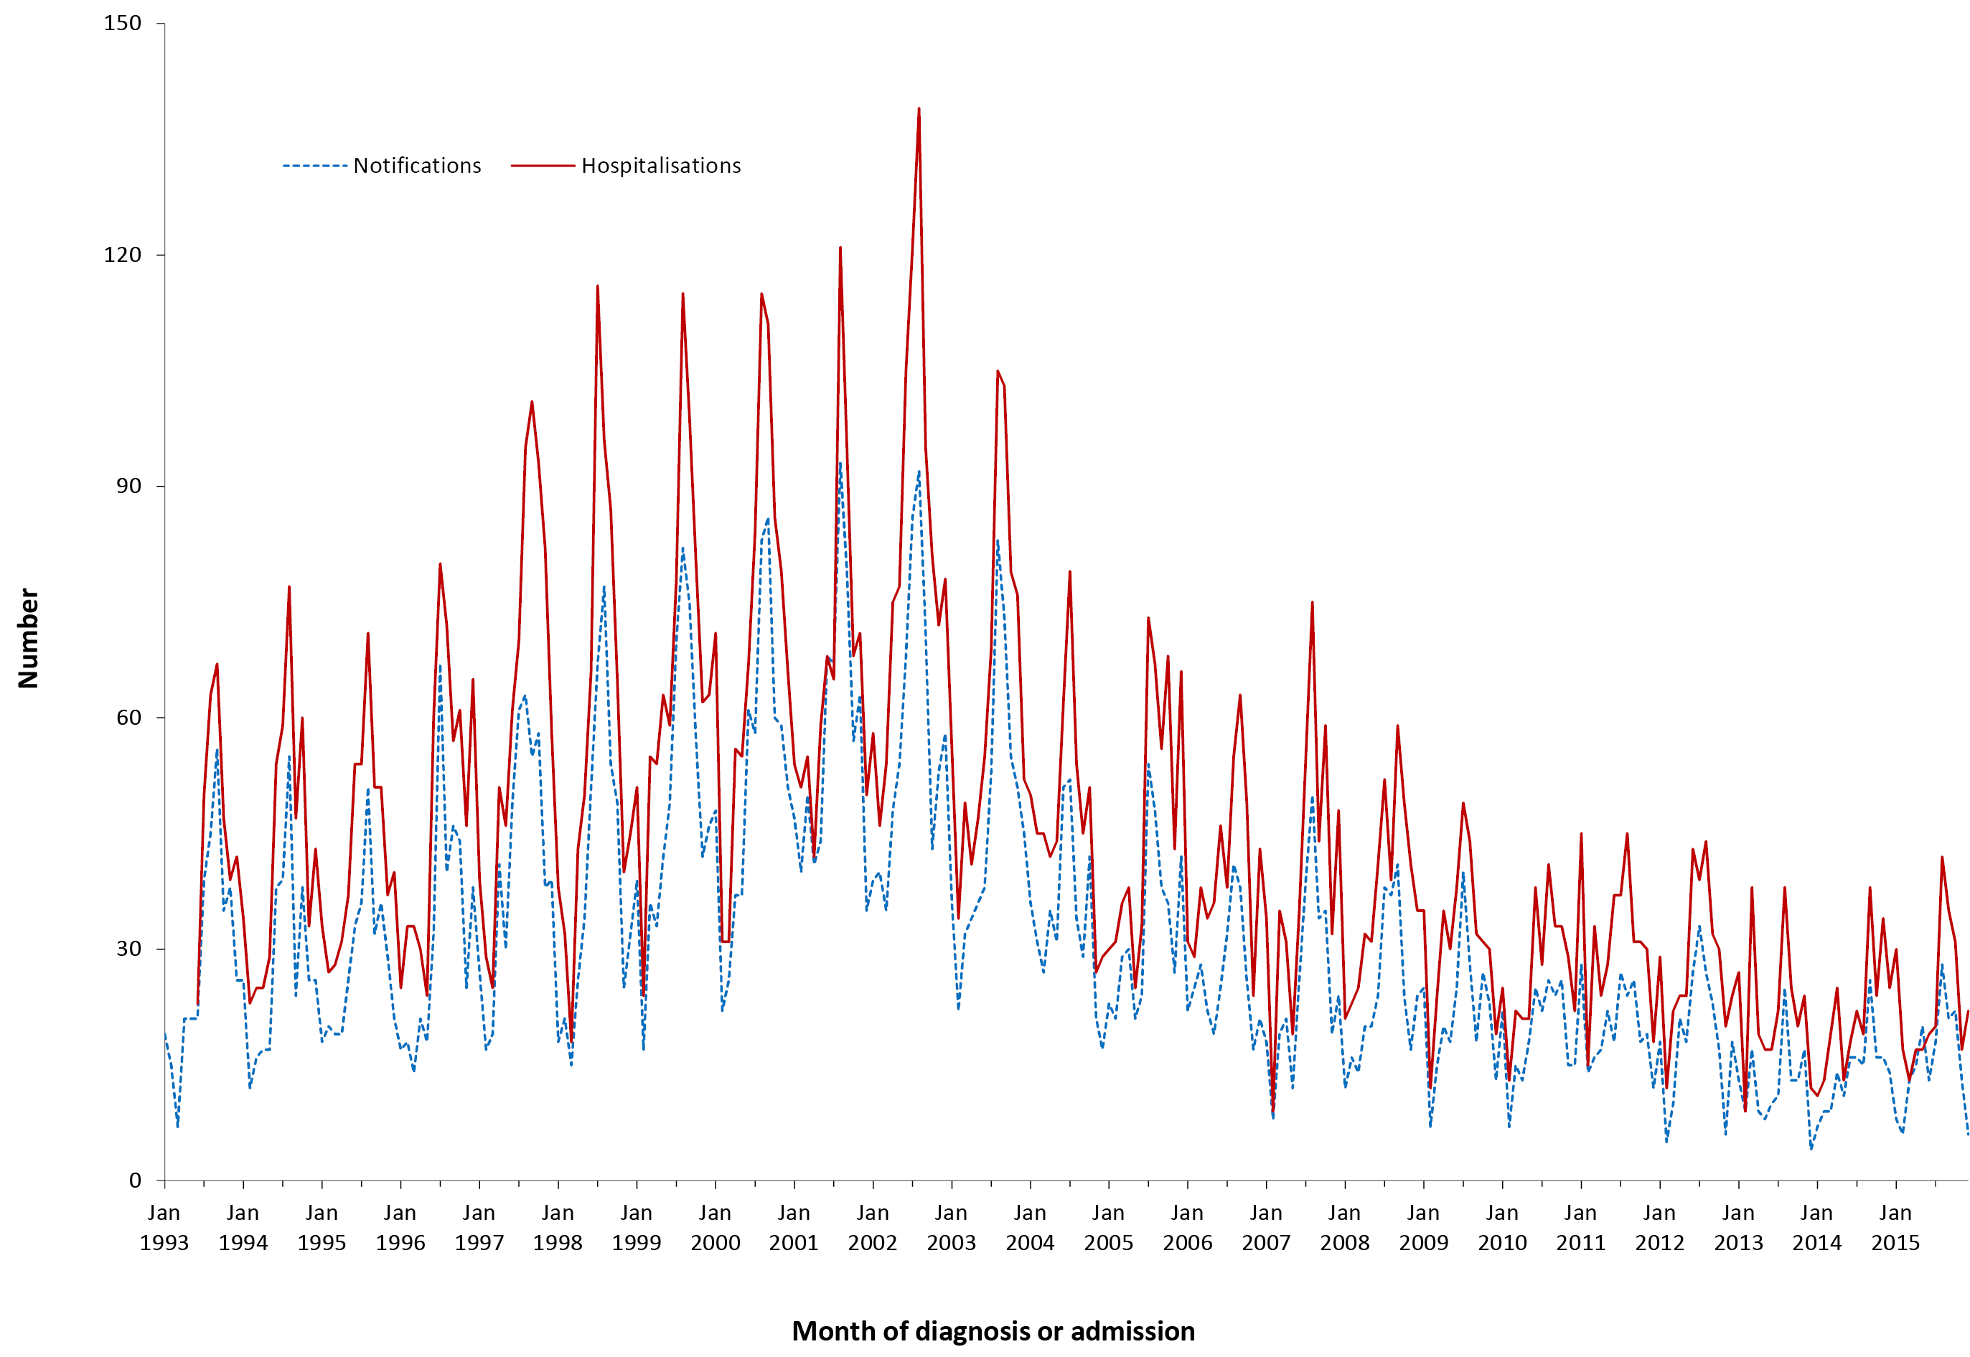
a Notifications where the month of diagnosis was between 1 January 1993 and 31 December 2015; hospitalisations where the month of admission was between 1 July 1993 and 31 December 2015.
Table 3.7.1: Meningococcal disease notifications, hospitalisations and deaths, Australia, 2012 to 2015,ª by age group
 | Notifications |  | Hospitalisations |  |  |  | LOS^{b} per admission |  | Deaths^{c}
 |  |  | Any diagnosis |  | Principal diagnosis |  | Any diagnosis | Principal diagnosis
Age group (years) | n | (Rate)^{d} | n | (Rate)^{d} | n | (Rate)^{d} | Median days |  | n | (Rate)^{d}
<1 | 107 | (8.7) | 164 | (13.3) | 148 | (12.0) | 5 | 6 | 5 | (0.41)
1–4 | 104 | (2.1) | 176 | (3.6) | 172 | (3.5) | 4 | 4 | 6 | (0.12)
5–14 | 55 | (0.5) | 118 | (1.0) | 102 | (0.9) | 3 | 3 | 0 | –
15–24 | 211 | (1.7) | 303 | (2.4) | 242 | (1.9) | 5 | 5 | 7 | (0.06)
25–49 | 99 | (0.3) | 153 | (0.5) | 114 | (0.3) | 6 | 6 | 5 | (0.02)
50–64 | 62 | (0.4) | 99 | (0.6) | 71 | (0.4) | 8 | 7 | 7 | (0.04)
≥65 | 82 | (0.6) | 143 | (1.1) | 480 | (0.6) | 8 | 8 | 10 | (0.07)
All ages | 720 | (0.8) | 1,156 | (1.2) | 929 | (1.0) | 5 | 5 | 40 | (0.04)
a Notifications where the month of diagnosis was between 1 January 2012 and 31 December 2015; hospitalisations where the month of admission was between 1 January 2012 and 31 December 2015.
b LOS = length of stay in hospital.
c Deaths include underlying and associated causes of deaths.
d Average annual age-specific rate per 100,000 population.

Severe morbidity and mortality
In the 4-year reporting period, there were a total of 8,111 hospital bed days with an ICD-10 code of meningococcal infection. The median length of stay was 5 days; longer in adults aged ≥50 years (Table 3.7.1). There were 40 deaths recorded among cases of invasive meningococcal disease over the 4 years January 2012 to December 2015 at a rate of 0.04 deaths per 100,000 population (Table 3.7.1).

Age and sex distribution
The highest notification and hospitalisation rates for meningococcal disease were among infants aged <1 year and young children aged 1–4 years (Table 3.7.1), with a small peak in notification rates in the adolescent and young adult (15–24 years) age group. There were slightly more hospitalisations in males than females (male:female ratio 1.3:1), and similarly for notifications (male:female ratio 1.2:1).

Geographical distribution
The average notification and hospitalisation rates were highest in South Australia (Appendix 2 and 3). However, small numbers of notifications and hospitalisations per year in many jurisdictions resulted in apparently marked fluctuations in annual rates.

Aboriginal and Torres Strait Islander status
Of the 720 notifications of invasive meningococcal disease over the 2012–2015 period, Indigenous status was reported for 704 (98%).Seventy-seven (11%) of the 720 notifications were in Aboriginal and Torres Strait Islander people, with 45 (58%) of these in children <5 years. All age Aboriginal and Torres Strait Islander notification rates were almost four times as high as those of other Australians (2.7 and 0.7 per 100,000 population respectively).

Vaccination status
Of the 720 notifications, vaccination data was not available for 42% (303/720) of cases (130 cases coded as 8888 where the case was followed up but no information was available; 98 cases coded as 9999 for missing vaccine type data where cases were not followed up; and 75 had no data recorded i.e. the vaccine data field was left blank). Of the 417 cases that had vaccination data available, there were 243 cases reported to have received no vaccine doses (unvaccinated) and 174 cases had received 1 dose of a meningococcal vaccine.

Serogroups
The number and rate of notifications of meningococcal serogroup C disease remained low over the 4-year reporting period (24 and 0.03 per 100,000 population respectively). Simultaneously, notification rates of meningococcal serogroup B disease declined from 0.7 per 100,000 in 2012 to 0.5 per 100,000 in 2015) but varied substantially by jurisdiction, with the highest rate observed in South Australia (1.6 per 100,000 population). There were no notifications for serogroup A and X during this reporting period. However, serogroup W (69 notifications, 49% in 2015) and serogroup Y (65 notifications, 34% in 2015) increased substantially, as reported by the Australian meningococcal surveillance program.¹⁴

Comments
The notifications and hospitalisations for meningococcal disease declined over the 4-year reporting period. While serogroup B and C disease declined during this period, there were increases in notifications of serogroup W and Y disease, which accelerated in 2016–2017.^{10–15}

3.8 Mumps
Highlights
During the review period of January 2012 to December 2015, there was a major outbreak of mumps commencing in 2015 in WA. More than 33% (414/1248) of notifications were in Aboriginal and Torres Strait Islander people.
Mumps is an acute viral disease caused by a paramyxovirus. In the pre-vaccine era it was a well-known common childhood viral disease.⁹¹ Mumps infection is systemic with variable pathology and symptomatology. The classical disease is characterised by fever and painful swelling and inflammation of one or more salivary glands, most commonly the parotid glands. Up to 30% of cases, however, are subclinical. Aseptic meningitis develops in up to 10% of cases and 30% of post-pubertal males experience epididymoorchitis.^{24,91}

Case definition
Notifications⁹²
Mumps case definition:
http://www.health.gov.au/internet/main/publishing.nsf/Content/cda-surveil-nndss-casedefs-cd_mumps.htm
Hospitalisations and deaths
The ICD-10-AM/ICD-10 code B26 (mumps) was used to identify hospitalisations and deaths.

Secular trends
This reporting period saw a major outbreak of mumps in 2015 (Figure 3.8.1). In the 4 years from January 2012 to December 2015, there were 1248 notifications of mumps, an average annual notification rate of 1.3 per 100,000 population (Table 3.8.1), highest in 2015 (2.7 per 100,000 population) and lowest in 2014 (0.8 per 100,000) (Appendix 2). From January 2012 to December 2015, there were 350 hospital admissions for ICD-10-AM/ICD-10 code B26 (mumps) (Table 3.8.1). The hospitalisation rate was stable over the 4 years (0.4 per 100,000 population) (Appendix 3).

Figure 3.8.1. Mumps notifications and hospitalisations, Australia,ª 1993 to 2015,^{b} by month of diagnosis or admission
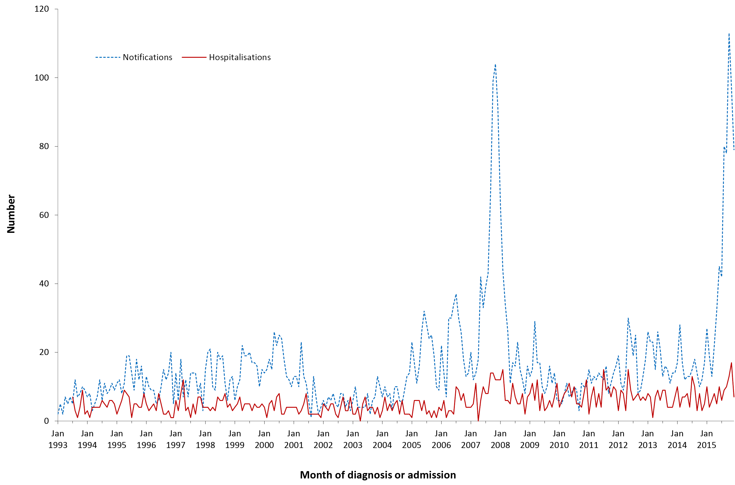
a Note that the number of jurisdictions notifying mumps increased over the review period until July 1996 when mumps became notifiable in all states and territories. From July 1999 until June 2001, mumps was not notifiable in Queensland. Only the Australian Capital Territory, New South Wales and Victoria notified for the entire review period.
b Notifications where the month of diagnosis was between 1 January 1993 and 31 December 2015; hospitalisations where the month of admission was between 1 July 1993 and 31 December 2015.
Table 3.8.1: Mumps notifications, hospitalisations and deaths, Australia, 2012 to 2015,ª by age group
Age group (years) | Notifications |  | Hospitalisations |  |  |  | LOS^{b} per admission |  | Deaths^{c}
 |  |  | Any diagnosis |  | Principal diagnosis |  | Any diagnosis | Principal diagnosis
 | n | (Rate)^{d} | n | (Rate)^{d} | n | (Rate)^{d} | Median days |  | n | (Rate)^{d}
<1 | 7 | (0.57) | 5 | (0.41) | 1–4 | (0.33) | 2.0 | 2.0 | 0 | –
1–4 | 50 | (1.02) | 29 | (0.59) | 29 | (0.59) | 1.0 | 1.0 | 0 | –
5–14 | 181 | (1.57) | 37 | (0.32) | 33 | (0.29) | 1.0 | 2.0 | 0 | –
15–24 | 299 | (2.39) | 59 | (0.47) | 55 | (0.44) | 1.0 | 1.0 | 0 | –
25–49 | 527 | (1.61) | 126 | (0.38) | 104 | (0.32) | 1.0 | 1.0 | 0 | –
50–64 | 133 | (0.79) | 34 | (0.20) | np | (0.17) | 2.0 | 1.0 | 0 | –
≥65 | 51 | (0.38) | 60 | (0.44) | 31 | (0.23) | 8.0 | 4.0 | 5 | (0.04)
All ages | 1,248 | (1.34) | 350 | (0.38) | 284 | (0.30) | 2.0 | 2.0 | 5 | (0.01)
a Notifications where the month of diagnosis was between 1 January 2012 and 31 December 2015; hospitalisations where the month of admission was between 1 January 2012 and 31 December 2015.
b LOS = length of stay in hospital.
c Deaths include underlying and associated causes of deaths.
d Average annual age-specific rate per 100,000 population.
np Not provided

Severe morbidity and mortality
Between January 2012 and December 2015, a total of 1,437 hospital bed days was recorded with a median length of stay of 2 days (Table 3.8.1). There were 5 deaths in people aged ≥65 years recorded in the causes of death data with mumps as an underlying or associated cause (Table 3.8.1).

Age and sex distribution
Over the 4-year reporting period, two-thirds of mumps notifications and over half of hospitalisations occurred in young adults (15–24 years) and those aged between 25–49 years. (Table 3.8.1). From 2012 to 2015, increases in overall notification rates were driven by steep increases in notification rates in adults aged 25–49 years, particularly in 2015. Since 2002, the notification rate of mumps for children aged <5 years has remained low, mostly below 1 per 100,000 population. Over the 4-year reporting period males accounted for 57% of notifications (male:female ratio 1.3:1) and 49% of hospitalisations (male:female ratio 0.9:1).

Geographical distribution
The highest notification rates (Appendix 2) were in Western Australia and the Northern Territory in 2015 (17.6 per 100,000 population and 6.1 per 100,000 population respectively), related to mumps outbreaks among Aboriginal adolescents and young adults. However these high notification rates were not associated with similar high hospitalisation rates (Appendix 3).

Aboriginal and Torres Strait Islander status
Of the 1248 notifications of mumps over the 2012–2015 period, Indigenous status was reported for 87% (1,080/1,248). More than 33% (414 cases) of the total notifications (1248) were in Aboriginal and Torres Strait Islander people, with 95% of these reported from Western Australia and 98% (404) reported in 2015. The majority (70%) of Aboriginal and Torres Strait Islander cases were aged between 15 and 49 years. Overall Aboriginal and Torres Strait Islander notification rates were about 15 times as high as other Australians (14.7 per 100,000 versus 0.9 per 100,000 population).
Aboriginal and Torres Strait Islander people accounted for 6% of 350 hospitalisations, of which only two were in children aged <5 years. In contrast to notifications, hospitalisation rates were twice those of other Australians (0.8 per 100,000 population and 0.4 per 100,000 population).

Vaccination status
A mumps-containing vaccine was introduced onto the NIP in 1982 for infants aged 12 months, and a 2nd dose was introduced for adolescents in 1992.
Of the 1,248 notifications, vaccination data was not available for 44% (551) of cases (72 cases coded as 8888 where the case was followed up but no information was available; 228 cases coded as 9999 for missing vaccine type data where cases were not followed up; and 251 had no data recorded i.e. the vaccine data field was left blank). Of the 697 cases that had vaccination data available, 229 cases reported to have received no vaccine doses (unvaccinated) and of these 3% (7/229) were aged <1 year. There were 132 partially vaccinated cases (who had received only 1 dose); 304 cases had received 2 doses; and 32 cases had received 3 doses of mumps-containing vaccine.

Comment
Previously, mumps outbreaks in young adults in Australia have largely been concentrated in those who had received only one vaccine dose or were unvaccinated.^{2,21–24} The occurrence of localised outbreaks in Aboriginal communities among two-dose-vaccinated young adults is a phenomenon previously seen in Australia only in a 2007–2008 outbreak in the Kimberley,²¹ although well described elsewhere.^{2,22,23} Administration of a third dose of mumps vaccine in such outbreak situations has been recommended by the Advisory Committee on Immunization Practices in the USA.⁹³

3.9 Pertussis
Highlights
There was a decline in pertussis notifications over the 4 years from January 2012 to December 2015 compared with the previous review period (January 2008 to December 2011). Notification rates were highest in the 5–14 year age group (194.5 per 100,000 population). As expected, hospitalisation rates were highest in infants aged <1 year (37% of all pertussis hospital admissions; average annual rate 89.5 per 100,000 population).
Pertussis (whooping cough) is an acute illness, caused by the Bordetella pertussis bacterium, involving the respiratory tract. The illness begins with an irritating cough that gradually becomes paroxysmal and lasts for 1–2 months or longer. Paroxysms are characterised by repeated violent coughs and are followed by a characteristic crowing or high-pitched inspiratory whoop. Infants <6 months of age, adolescents and adults often have fewer classical symptoms than younger children and the greatest morbidity and mortality occur at the extremes of age.⁹⁴

Case definition
Notifications⁹⁵
Pertussis case definition:
http://www.health.gov.au/internet/main/publishing.nsf/Content/cda-surveil-nndss-casedefs-cd_pertus.htm
Hospitalisations and deaths
The ICD-10-AM/ICD-10 code A37 (whooping cough) was used to identify hospitalisations and deaths.

Secular trends
In the 4 years from January 2012 to December 2015, there were 70,830 cases of pertussis notified to the NNDSS, a substantial decrease from the 118,081 cases notified in the four years January 2008 to December 2011.⁸ Annual notification rates declined from 106 per 100,000 population in 2012 to 53.5 in 2013 and 50.6 in 2014, followed by an increase to 94.8 per 100,000 in 2015 (Appendix 2). Seasonal peaks in notifications were seen in summer and autumn (Figure 3.9.1).
Hospitalisation rates also declined from 4.4 per 100,000 in 2012 to 3.3 per 100,000 in 2015 (Figure 3.9.1 and Appendix 3).

Severe morbidity and mortality
Between January 2012 and December 2015, a total of 15,064 hospital bed days were recorded with a median length of stay of 3 days (Table 3.9.1). In the 4-year reporting period, 15 deaths were recorded, 4 of which were in infants aged <1 year (Table 3.9.1). The majority of deaths were in people aged ≥65 years, which is similar to the previous reporting period.

Figure 3.9.1: Pertussis notifications and hospitalisations, Australia, 1995 to 2015,ª by month of diagnosis or admission
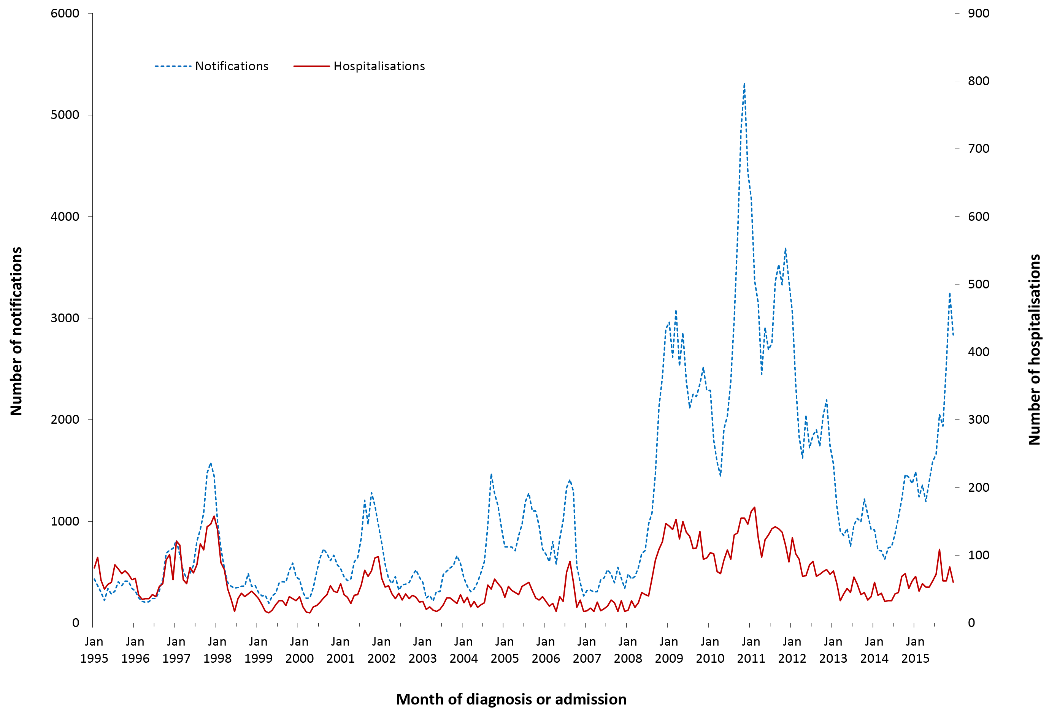
a Notifications where the month of diagnosis was between 1 January 1995 and 31 December 2015; hospitalisations where the month of admission was between 1 January 1995 and 31 December 2015.
Table 3.9.1: Pertussis notifications, hospitalisations and deaths, Australia, 2012 to 2015,ª by age group
Age group (years) | Notifications |  | Hospitalisations |  |  |  | LOS^{b} per admission |  | Deaths^{c}
 |  |  | Any diagnosis |  | Principal diagnosis |  | Any diagnosis | Principal diagnosis
 | n | (Rate)^{d} | n | (Rate)^{d} | n | (Rate)^{d} | Median days |  | n | (Rate)^{d}
<1 | 1,954 | (158.9) | 1,101 | (89.5) | 975 | (79.3) | 2 | 2 | 4e | (0.33)
1–4 | 6,687 | (136.8) | 240 | (4.9) | 191 | (3.9) | 1 | 1 | 0 | –
5–14 | 22,389 | (194.5) | 173 | (1.5) | 116 | (1.0) | 1 | 1 | 0 | –
15–24 | 4,556 | (36.4) | 58 | (0.5) | 34 | (0.3) | 2 | 1 | 0 | –
25–49 | 16,895 | (51.6) | 315 | (1.0) | 175 | (0.5) | 2 | 2 | 0 | –
50–64 | 10,038 | (59.6) | 301 | (1.8) | 159 | (0.9) | 4 | 4 | 1–3 | (0.01)
≥65 | 8,311 | (61.4) | 788 | (5.8) | 348 | (2.6) | 6 | 5 | np | (0.07)
All ages | 70,830 | (76.0) | 2,976 | (3.2) | 1998 | (2.1) | 3 | 2 | 15 | (0.02)
a Notifications where the month of diagnosis was between 1 January 2012 and 31 December 2015; hospitalisations where the month of admission was between 1 January 2012 and 31 December 2015.
b LOS = length of stay in hospital.
c Deaths include underlying and associated causes of deaths.
d Average annual age-specific rate per 100,000 population.
e np = not provided.

Age and sex distribution
Notification rates were highest in the 5–14 year age group (194.5 per 100, 000 population) and lowest among the 15–24 years age group (36.4 per 100,000 population) (Table 3.9.1) over the 4-year reporting period. The greatest burden of hospitalisations was borne by infants aged <1 year who accounted for 37% of hospitalisations (average annual rate of 89.5 per 100,000 population). Over the 4-year reporting period males accounted for 44% of notifications (male:female ratio 0.8:1) and 47% of hospitalisations (male:female ratio 0.9:1).

Geographical distribution
There was an overall decline in pertussis notifications across most states and territories from 2012 to 2014, but a marked increase in notifications was observed in 2015 in all jurisdictions except Tasmania and the Northern Territory (Appendix 2). New South Wales and the Australian Capital Territory had the highest notification rates in 2015 (Appendix 2).

Aboriginal and Torres Strait Islander status
Of the 70,830 notifications of pertussis over the 2012–2015 period, Indigenous status was reported for 38,178 (54%). Of the total notified cases (70,830), only 2% (1,434 cases) were in Aboriginal and Torres Strait Islander people. Notification rates for pertussis were lower for Aboriginal and Torres Strait Islander people than for other people (50.8 per 100,000 population and 76.9 per 100,000 population respectively).
Six per cent (180 cases) of the total hospitalisations (2,976) were in Aboriginal and Torres Strait Islander people. Aboriginal and Torres Strait Islander hospitalisation rates were higher than other Australians (6.4 per 100,000 population and 3.1 per 100,000 population respectively).

Vaccination status
Of the 70,830 notifications, vaccination data was not available for 58% (41,040/70,830) of cases (16,198 cases coded as 8888 where the case was followed up but no information was available; 4,658 cases coded as 9999 for missing vaccine type data where cases were not followed up; and 20,184 had no data recorded i.e. the vaccine data field was left blank). Of the 29,790 cases that had vaccination data available, 11,491 cases were reported to have received no vaccine doses (unvaccinated), 1,353 cases had received only 1 dose; 602 cases had received 2 doses; 5,409 cases received 3 doses; 8,825 cases received 4 doses; 2,077 cases had received 5 doses and 33 cases had received 6 doses of pertussis-containing vaccine.

Comments
Increased laboratory testing of suspected cases of pertussis in Australia may partly explain increases in notifications of pertussis in recent years.^{1,96,97} Increased laboratory notifications of cases may also partly explain the very high percentage of cases with unrecorded vaccination status. Rapid waning of effectiveness following vaccination with acellular compared with whole cell vaccines, exacerbated by cessation of the 18-month dose in the NIP from 2003, could have further contributed to increases in notifications in recent years.^{1,96,97} In response to the increase in notifications, the 18-month booster was reinstated onto the NIP in 2016.^{98,99}

3.10 Pneumococcal disease
Highlights
Notification rates for invasive pneumococcal disease remained relatively stable in the 4 years 2012 to 2015 compared to the previous 4 years (2008–2011). However, there was a small increasing trend in the number of hospitalisations. Older adults aged ≥65 years accounted for a large proportion of notifications and hospitalisations and the majority of deaths.
Pneumococcal disease is caused by the bacterium Streptococcus pneumoniae (pneumococcus). There are over 90 different serotypes of pneumococcus. Pneumococci can be isolated from the upper respiratory tract in adults and, more often, in children, and can spread directly from the nasopharynx to the respiratory tract, which may cause otitis media, sinusitis or pneumonia. Pneumococci are also able to enter the bloodstream to cause invasive disease, which may manifest as meningitis, pneumonia, septicaemia without focal infection or, less commonly, infection of other sites such as pleural, peritoneal or joint fluid. Invasive pneumococcal disease (IPD) is diagnosed by detecting S. pneumoniae from blood, CSF or other sterile site. In the absence of a sterile site isolate, a presumptive diagnosis of pneumococcal pneumonia may be based on a sputum isolate of S. pneumoniae and/or clinical features such as chest X-ray appearance or prompt response to antibiotic therapy.¹⁰⁰

Case definition
Notifications¹⁰¹
Pneumococcal disease (invasive) case definition:
http://www.health.gov.au/internet/main/publishing.nsf/Content/cda-surveil-nndss-casedefs-cd_pnuemo.htm
Hospitalisations and deaths
The ICD-10-AM/ICD-10 codes G00.1 (pneumococcal meningitis), A40.3 (pneumococcal septicaemia), which together are considered to be a proxy for IPD, and J13 (pneumococcal pneumonia) were used to identify pneumococcal disease hospitalisations and deaths.

Secular trends
In the 4 years from January 2012 to December 2015, notification patterns of IPD remained relatively steady; however, there was a small increasing trend in hospital admissions for pneumococcal disease from 2006 (Figure 3.10.1). There was a marked seasonality in notified and hospitalised cases (Figure 3.10.1).

Figure 3.10.1: Pneumococcal disease notifications and hospitalisations, Australia, 1998 to 2015,ª by month of diagnosis or admission
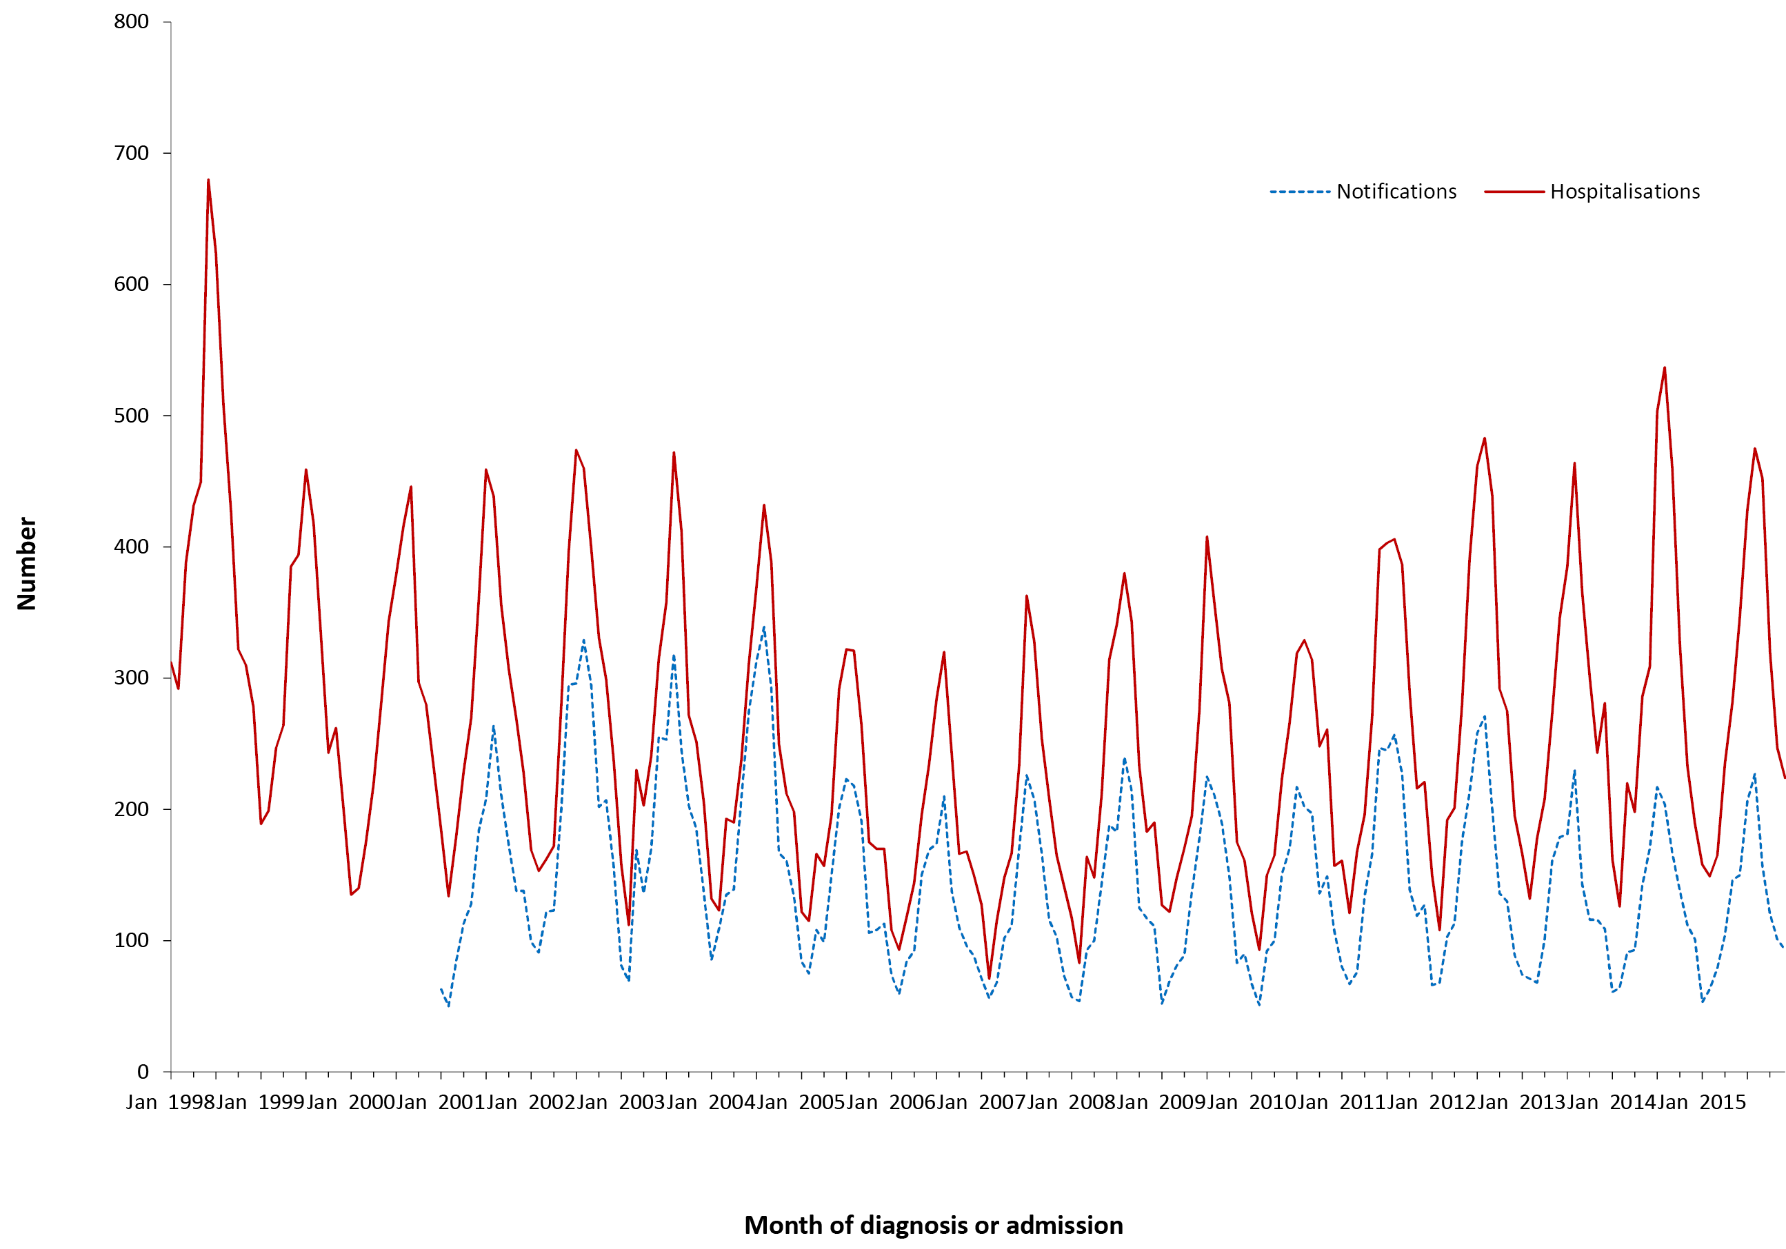
a Notifications where the month of diagnosis was between 1 January 2001 and 31 December 2015; hospitalisations where the month of admission was between 1 January 1998 and 31 December 2015. Hospitalisations include pneumonia, meningitis and septicaemia.
There were 6,437 notifications of IPD over the 4-year reporting period at an average annual rate of 6.9 per 100,000 population (Table 3.10.1), lower than the rate in the previous review period of January 2008 to December 2011 (7.7 per 100,000).⁸
Table 3.10.1: Pneumococcal disease notifications, hospitalisations and deaths, Australia, 2012 to 2015,ª by age group
Age group (years) | Notifications |  | Hospitalisations |  |  |  | LOS^{b} per admission |  | Deaths^{c}
 |  |  | Pneumococcal meningitis or septicaemia |  | Pneumococcal  pneumonia (without meningitis or septicaemia) |  | Pneumococcal meningitis or septicaemia | Pneumococcal pneumonia  (without meningitis or septicaemia)
 | n | (Rate)^{d} | n | (Rate)^{d} | n | (Rate)^{d} | Median days |  | n | (Rate)^{d}
<1 | 191 | (15.5) | 140 | (11.4) | 71 | (5.8) | 7 | 4 | 1–3 | (0.16)
1–4 | 602 | (12.3) | 210 | (4.3) | 329 | (6.7) | 5 | 5 | 5 | (0.10)
5–14 | 317 | (2.8) | 118 | (1.0) | 212 | (1.8) | 6 | 4 | 1–3 | (0.03)
15–24 | 215 | (1.7) | 98 | (0.8) | 279 | (2.2) | 5 | 4 | 1–3 | (0.02)
25–49 | 1,474 | (4.5) | 688 | (2.1) | 2,479 | (7.6) | 7 | 4 | 26 | (0.08)
50–64 | 1,401 | (8.3) | 806 | (4.8) | 2,419 | (14.4) | 10 | 5 | 40 | (0.24)
≥65 | 2,237 | (16.5) | 1,253 | (9.3) | 4,787 | (35.3) | 9 | 6 | 88 | (0.65)
All ages | 6,437 | (6.9) | 3,313 | (3.6) | 10,576 | (11.3) | 8 | 5 | 166 | (0.18)
a Notifications where the month of diagnosis was between 1 January 2012 and 31 December 2015; hospitalisations where the month of admission was between 1 January 2012 and 31 December 2015.
b LOS = length of stay in hospital.
c Deaths sourced from the Causes of Death database from the Australian Coordinating Registry. Deaths include underlying and associated causes of deaths.
d Average annual age-specific rate per 100,000 population.
Between January 2012 and December 2015, there were 13,889 hospitalisations coded as pneumococcal meningitis, septicaemia or pneumonia at an average annual rate of 14.9 per 100,000 population (Table 3.10.1). During that period, seasonal peaks in admissions for pneumococcal disease were highest in 2014 (Figure 3.10.1).
The highest notification rate for IPD over the 4-year reporting period was in 2012 (Appendix 2). The highest hospitalisation rate for IPD over the 4-year reporting period was in 2014 followed by 2012 (Appendix 3).

Severe morbidity and mortality
Between January 2012 and December 2015, there were 119,095 hospital bed days for admissions with pneumococcal disease (an average of 29,774 bed days per year), which included 83,436 hospital bed days for admissions with pneumococcal pneumonia (an average of 20,859 bed days per year). This is slightly more compared to the previous reporting period (2008 to 2011) in which there were 117,808 hospital bed days for admissions with pneumococcal disease with an average of 29,452 bed days per year. The overall median length of stay for hospitalisations coded with pneumococcal disease was 5 days (Table 3.10.1). Median length of stay for admissions with pneumococcal meningitis or septicaemia was 7 days. Median length of stay was longest for infants <1 year of age and adults aged ≥65 years.
For the 4 years from January 2012 to December 2015, the Causes of Death database recorded 166 deaths (average annual rate 0.2 per 100,000 population) with pneumococcal disease-related ICD-10 codes (A40.3, G00.1 and J13) as the cause of death (Table 3.10.1).

Age and sex distribution
For the 4 years from January 2012 to December 2015, the rate of notified IPD was highest in adults aged ≥65 years, next highest in infants aged <1 year, and third highest in children aged 1–4 years (Table 3.10.1). This pattern of higher rates in older adults and very young children is consistent with rates reported in previous years.
Rates of IPD notifications among children aged <5 years remained steady over the 4-year period at around 13 cases per 100,000 population. The death rate in 2012 to 2015 in young children aged <5 years remained low in the causes of death database and comparable with rates reported previously.^{8,34}

Geographical distribution
The Northern Territory had the highest rates of notifications of IPD (average annual rate 24.2 per 100,000 population), and hospitalisations coded as pneumococcal disease (average annual rate 53.8 per 100,000 population), across the 4 years 2012 to 2015, although only accounting for some 4% of the national total. Notification and hospitalisation rates in the other states and territories did not differ appreciably from the national average (average annual notification rate 6.9 per 100,000 population; average annual hospitalisation rate 14.7 per 100,000 population) (Appendix 2 and 3).

Aboriginal and Torres Strait Islander status
Of the 6437 notifications of IPD over the 2012–2015 period, Indigenous status was reported for 5,754 (89%). Of the total notified cases (6,437), 13% (845/6437) were in Aboriginal and Torres Strait Islander people with 40% of these aged between 25–49 years. Notification rates were almost five times as high in Aboriginal and Torres Strait Islander people as in other people (29.9 versus 6.2 per 100,000 population).
Hospitalisations of Aboriginal and Torres Strait Islander people accounted for 1,605/13,889 (12%) of total hospitalisations for this reporting period. Of these 1,605 cases, 46% (739 cases) were reported in adults aged 25–49 years and 26% (416 cases) 50–64 years. Aboriginal and Torres Strait Islander hospitalisation rates were more than four times as high as other Australians (56.8 per 100,000 population versus 13.6 per 100,000 population).

Vaccination status
Of the total 6,437 notifications, vaccination data was not available for 32% (2089) of cases (303 cases coded as 8888 where the case was followed up but no information was available; 1,345 cases coded as 9999 for missing vaccine type data where cases were not followed up; and 441 had no data recorded i.e. the vaccine data field was left blank).
Of 793 notifications in children aged <5 years (a target group for follow up), vaccination data was not available for 3% (24) of cases (12 cases coded as 8888 where the case was followed up but no information was available; 9 cases coded as 9999 for missing vaccine type data where cases were not followed up; and 3 had no data recorded i.e. the vaccine data field was left blank). Of the 769 cases that had vaccination data available, 93 cases were reported to have received no vaccine doses (unvaccinated); 62 cases received only 1 dose; 70 cases received 2 doses; 466 cases received 3 doses; 76 cases received 4 doses; and 2 cases received 5 doses of the vaccine.
Of the 3,638 cases in adults aged ≥50 years, vaccination data was not available for 27% (980) (218 cases coded as 8888 where the case was followed up but no information was available; 725 cases coded as 9999 for missing vaccine type data where cases were not followed up; and 37 had no data recorded i.e. the vaccine data field was left blank). Of the 2658 cases that had vaccination data available, 1596 cases reported to have received no vaccine doses (unvaccinated); 622 cases received only 1 dose; 394 cases received 2 doses; 33 cases received 3 doses; 7 cases received 4 doses; and 6 cases received 5 doses of pneumococcal vaccine.

Comment
From 1 January 2005, children born from January 2003 were eligible for a full course of pneumococcal vaccine funded on the NIP. Since 2005, there have been large reductions in notifications of vaccine type IPD in Australia. For this 4 year reporting period, rates of IPD remained relatively steady, with marked seasonality observed in notified and hospitalised cases. A recent study demonstrated declines in vaccine-type IPD varied by serotype and age group, following PCV13 (13-valent pneumococcal conjugate vaccine) introduction in 2011, but only serotype 19A showed reductions of similar magnitude to those seen in vaccine serotypes post-PCV7 (7-valent pneumococcal conjugate vaccine).

3.11 Poliomyelitis
Highlight
There were no notifications or deaths due to poliomyelitis between January 2012 and December 2015.

Poliomyelitis (polio) is caused by an enterovirus, poliovirus. Infection involves the gastrointestinal tract, and may progress to the nervous system, resulting in paralysis. Acute flaccid paralysis (AFP) occurs in fewer than 1% of infections. More than 90% of infections are asymptomatic, with a minor illness characterised by fever, headache, malaise and nausea/vomiting occurring in about 10%. The maximum extent of paralysis is usually reached within 3–4 days of disease onset. Any paralysis still present after 60 days is likely to be permanent.¹⁰²
Vaccine-associated paralytic poliomyelitis (VAPP) is acute flaccid paralysis due to a Sabin-like poliovirus (i.e. a virus similar to that used in the Sabin live attenuated oral poliovirus vaccine [OPV]). A vaccine-derived poliovirus (VDPV) is defined as having 1%–15% nucleic acid sequence variation from the prototype Sabin strain. The variation is due to long-term (more than 1 year) virus replication after the administration of OPV. Virus replication may occur in an individual with an immunodeficiency (iVDPV) or through sustained person-to-person transmission in areas with low OPV coverage (circulating or cVDPV). VDPVs not clearly assigned to either of these categories are known as ambiguous VDPVs (aVDPV).¹⁰³

Case definition
Notifications¹⁰⁴
Poliovirus Infection:
http://www.health.gov.au/internet/main/publishing.nsf/Content/cda-surveil-nndss-casedefs-cd_polio.htm
Hospitalisations and deaths
The ICD-10-AM/ICD-10 code A80 (acute poliomyelitis) was used to identify hospitalisations and deaths. Note: This code includes VAPP and specific codes for indigenous and imported wild-type poliovirus infection. Sequelae of poliomyelitis (ICD-10 code B91) were not included in these analyses.
There were no acute poliomyelitis notifications or deaths reported during the 4-year period January 2012 to December 2015. However, there were 1–4 hospitalisations with a principal diagnosis of A80.9 (acute poliomyelitis, unspecified). Note that hospitalisations for rare diseases such as poliomyelitis should be interpreted with caution due to possible misclassification, coding and data related issues. Regular case review is undertaken by the Polio Expert Panel (PEP) and existing polio surveillance strategies are considered appropriate for Australia.¹⁰⁵ In the most recent published report, the PEP classified 58 cases as non-polio acute flaccid paralysis (AFP), a rate of 1.4 cases per 100,000 children less than 15 years of age,¹⁰⁶ which exceeded the WHO AFP surveillance performance criterion of 1 case of non-polio AFP per 100,000 children.¹⁰⁶

3.12 Q fever
Highlights
An increase in Q fever notifications was observed during the 2012 to 2015 period but hospitalisations remained stable.
Q fever is a zoonotic disease caused by Coxiella burnetii. It has been identified in a wide range of wild and domestic animal hosts including arthropods, birds, rodents, marsupials and livestock, but the most important reservoirs as a source for human infections are cattle, sheep and goats. Humans become infected primarily by inhaling aerosols contaminated by C. burnetii. Occupations with higher exposure risks include abattoir and farm workers and veterinarians. Windborne spread and indirect exposures in a contaminated environment account for non-occupational infections.^{107–109}
Q fever may present with acute or chronic clinical manifestations, and there is increasing acceptance of an association with long-term sequelae, in particular the post Q fever fatigue syndrome.⁶⁸ High proportions of infected persons are asymptomatic or only experience a self-limiting febrile illness.^{107,108}
Australia has a highly effective licensed Q fever vaccine (Q-VAX; CSL Limited) that requires pre-vaccination screening tests.⁶⁸ This vaccine is currently not recommended for children aged less than 15 years.⁶⁸

Case definition
Notifications¹¹⁰
Q fever case definition:
http://www.health.gov.au/internet/main/publishing.nsf/Content/cda-surveil-nndss-casedefs-cd_qfev.htm
Hospitalisations and deaths
The ICD-10-AM/ICD-10 code A78 (Q fever) was used to identify hospitalisations and deaths.

Secular trends
From January 2012 to December 2015, there were 1,936 cases of Q fever reported to the NNDSS (average annual rate 2.1 per 100,000) (Table 3.12.1) and there were 833 hospital admissions with a Q fever ICD-10-AM diagnosis code (average annual rate 0.9 per 100,000) (Table 3.12.1). The number of cases notified per month was higher in 2012 to 2015 (median 38 per month, range 23–60) than the previous four years 2008 to 2011 (median 28.5 per month)⁸ (Figure 3.12.1). Hospital admissions per month remained relatively stable except for a small peak in early 2013 (Figure 3.12.1).

Figure 3.12.1: Q fever notifications and hospitalisations, Australia, 1993 to 2015,ª by month of diagnosis or admission
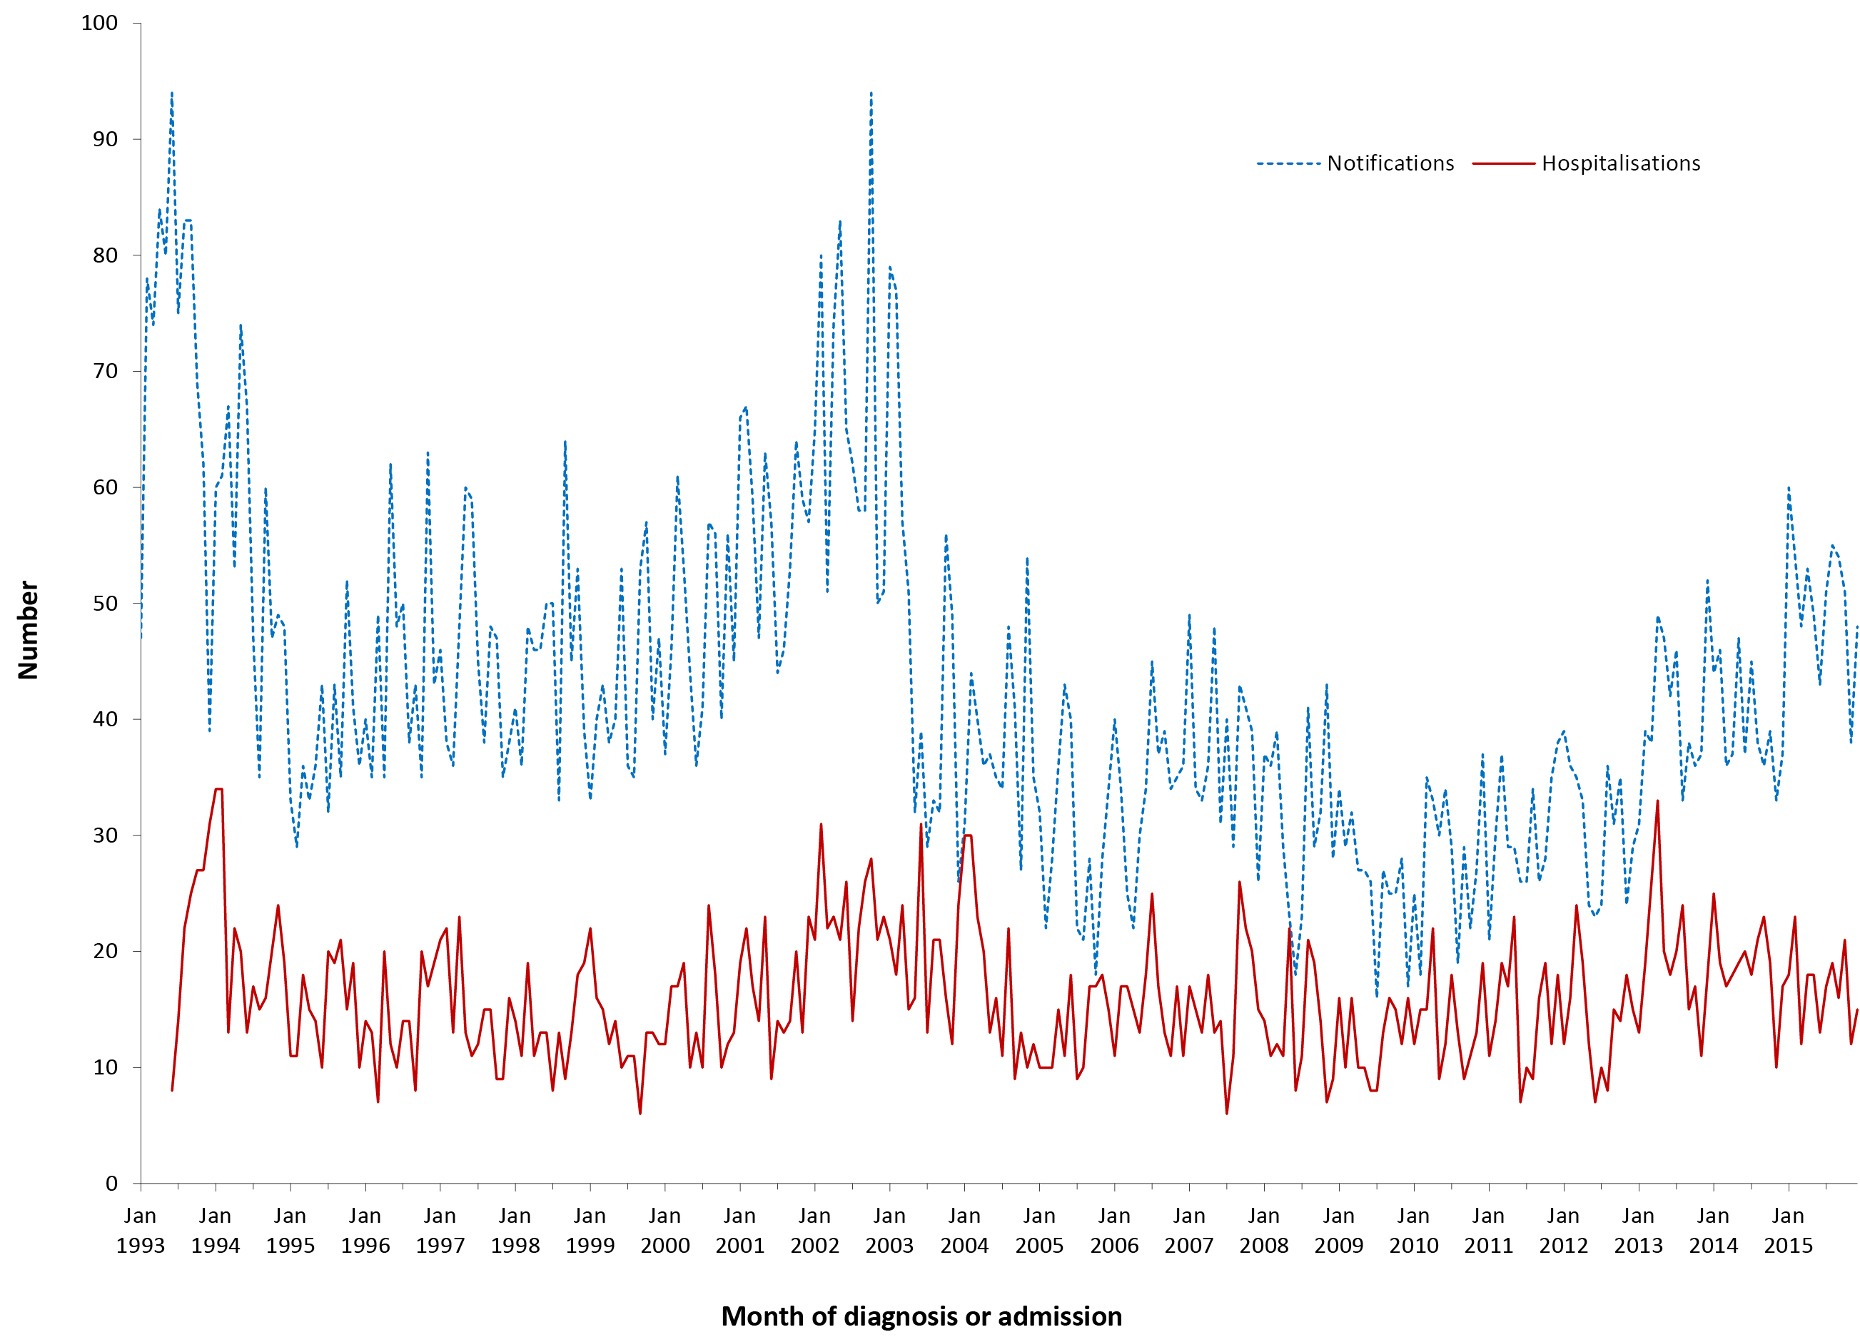
a Notifications where the month of diagnosis was between 1 January 1993 and 31 December 2015; hospitalisations where the month of admission was between 1 July 1993 and 31 December 2015.
Table 3.12.1: Q fever notifications, hospitalisations and deaths, Australia, 2012 to 2015,ª by age group
Age group (years) | Notifications |  | Hospitalisations |  |  |  | LOS^{b} per admission |  | Deaths^{c}
 |  |  | Any diagnosis |  | Principal diagnosis |  | Any diagnosis | Principal diagnosis
 | n | (Rate)^{d} | n | (Rate)^{d} | n | (Rate)^{d} | Median days |  | n | (Rate)^{d}
<1 | 0 | – | 0 | – | 0 | – | – | – | 0 | –
1–4 | 4 | (0.08) | 20 | (0.41) | 0 | – | 3 | – | 0 | –
5–14 | 53 | (0.46) | 23 | (0.20) | 7 | (0.06) | 4 | 3 | 0 | –
15–24 | 206 | (1.65) | 70 | (0.56) | 56 | (0.45) | 3 | 2 | 0 | –
25–49 | 814 | (2.49) | 291 | (0.89) | 240 | (0.73) | 4 | 4 | 1–3 | (<0.01)
50–64 | 615 | (3.65) | 239 | (1.42) | 199 | (1.18) | 5 | 4 | 1–3 | (0.02)
≥65 | 244 | (1.80) | 190 | (1.40) | 114 | (0.84) | 7 | 6 | 5 | (0.04)
All ages | 1,936 | (2.08) | 833 | (0.89) | 616 | (0.66) | 4 | 4 | 9 | (0.01)
a Notifications where the month of diagnosis was between 1 January 2012 and 31 December 2015; hospitalisations where the month of admission was between 1 January 2012 and 31 December 2015.
b LOS = length of stay in hospital.
c Deaths include underlying and associated causes of deaths.
d Average annual age-specific rate per 100,000 population.

Severe morbidity and mortality
There were 5,284 bed days for hospital admissions with an ICD-10 AM code for Q fever over the period January 2012 to December 2015 with a median length of stay of 4 days. Q fever was the principal diagnosis in 74% of these admissions (Table 3.12.1). Over the 4-year reporting period, 9 deaths were recorded as due to Q fever.

Age and sex distribution
The highest notification and hospitalisation rates for Q fever were in adults aged 50–64 years, followed by those aged 25–49 years (Table 3.12.1) with a substantial male excess (male:female ratio 3.3:1 for notifications and 3.5:1 for hospitalisations).
Among children and young adults, notification rates were very low in the 0–4 year age group (0.08 per 100,000), but increased steadily: more than fivefold in those 5–14 years (0.460) and another fourfold in those 15–24 years (1.65).

Geographical distribution
The majority of notifications for Q fever occurred in Queensland (48%), New South Wales (39%) and Victoria (8%) (Appendix 2), with hospitalisations similarly distributed. Queensland had the highest rate of notifications and hospital admissions in each of the 4 years.

Aboriginal and Torres Strait Islander status
Of the 1,936 notifications of Q fever over the 2012–2015 period, Indigenous status was reported for 1,648 (85%). Four per cent (82 cases) of the total notifications (1936) were in Aboriginal and Torres Strait Islander people, with notification rates slightly higher than other people (2.9 per 100,000 population and 1.7 per 100,000 population respectively). Most notifications were for adults aged 25–49 years.

Vaccination status
There is no population vaccination program for Q fever and hence vaccination status data are not available.

Comment
There was an increase in Q fever notifications observed during 2012 to 2015 compared with the previous 4 year period. This increase in rates is likely due to multiple factors including the occurrence of outbreaks, environmental changes (e.g. drought, dust storms),²⁶ changes in testing practices and increasing awareness of providers/public.²⁷ The highest notification rates were among adults aged 50–64 years followed by those aged 25–49 years, consistent with occupational exposure and similar to the previous reporting period. Occupations most frequently listed for Q fever cases involved contact with livestock.²⁷ A recent study reported that adults living on a farm in regional and remote areas were at highest risk of contracting Q fever and the progressive increase in notification rates from 5 to 24 years of age may also be related to incidental rather than occupational exposure.¹¹¹

3.13 Rotavirus
Highlights
Since the funding of rotavirus vaccine on the National Immunisation Program in 2007, there has been a substantial drop in the number of hospitalisations due to rotavirus. There was a continued but smaller decline in hospitalisations in 2012 to 2015 to 5.4 per 100,000 population, compared with 6.6 per 100,000 population in 2008 to 2011.
Rotavirus is a non-enveloped virus that is the major cause of acute gastroenteritis in young children and infants. Infection can be asymptomatic, cause mild to moderate gastroenteritis, or severe gastroenteritis with dehydration requiring hospitalisation.¹¹² Virtually all children worldwide are infected with rotavirus by 5 years of age, but severe disease occurs most commonly in those aged 6 months to 2 years.¹¹³ However, disease does occur in all age groups. Rotaviruses are primarily spread by faecal–oral transmission. Infection with rotavirus confers some protection against subsequent serious disease.¹¹⁴ Rotaviruses are typed based on 2 surface proteins, VP7 (G protein) and VP4 (P protein). Viruses that contain either G1, 2, 3, 4 or 9 (and either P1a or P1b) are the 5 most common virus types currently circulating in Australia.^{115–118}

Case definition
Rotavirus was not nationally notifiable for the period of this report. It was notifiable in all jurisdictions except Victoria and the Australian Capital Territory but notification criteria varied.
Hospitalisations and deaths The ICD-10-AM/ICD-10 code A08.0 (rotavirus enteritis) was used to identify hospitalisations and deaths.

Secular trends
In the 4 years from January 2012 to December 2015, there was a substantial decrease in the number of monthly hospitalisations with an ICD-10-AM code for rotavirus enteritis (Figure 3.13.1). The fall in hospitalisations began in 2007 and by 2008 the large seasonal peaks seen during the winter months in previous years were substantially reduced.

Figure 3.13.1: Rotavirus gastroenteritis hospitalisations for all ages, Australia, 1994 to 2015,ª by month of admission
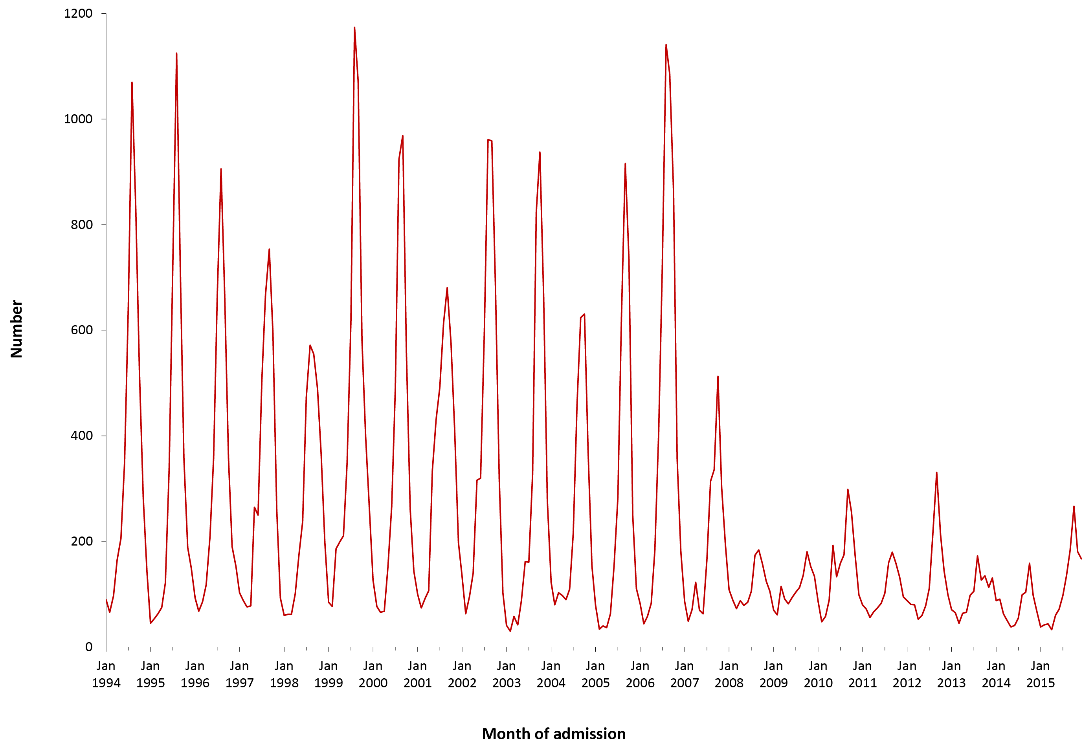
a Hospitalisations where the month of admission was between 1 January 1994 and 31 December 2015.

There were 5,062 hospital admissions over the 4 years with an ICD-10-AM code of rotavirus gastroenteritis. The average annual hospitalisation rate was 5.4 per 100,000 population, an 18% decline in rate compared to the previous review period of January 2008 to December 2011⁸ (6.6 per 100,000) (Table 3.13.1). The biggest peak in the number of hospitalisations per month for the 4-year period was 331 in September 2012, much lower than the previous peak of 1,141 hospitalisations in August 2006.
Table 3.13.1. Rotavirus gastroenteritis hospitalisations and deaths, Australia, 2012 to 2015,ª by age group
Age group (years) | Hospitalisations |  |  |  | LOS^{b} per admission  (days) |  | Deaths^{c,d}
 | Any Diagnosis |  | Principal Diagnosis |  | Any Diagnosis | Principal Diagnosis
 | n | (Rate)^{e} | n | (Rate)^{e} | Median |  | n | (Rate)^{e}
<1 | 1,141 | (92.8) | 748 | (60.8) | 2.0 | 2.0 | 0 | –
1–4 | 1,573 | (32.2) | 1,239 | (25.3) | 2.0 | 2.0 | 0 | –
5–14 | 945 | (8.2) | 827 | (7.2) | 2.0 | 2.0 | 0 | –
15–24 | 110 | (0.9) | 69 | (0.6) | 3.0 | 2.0 | 0 | –
25–49 | 260 | (0.8) | 161 | (0.5) | 3.0 | 3.0 | 0 | –
50–64 | 249 | (1.5) | 127 | (0.8) | 4.0 | 3.0 | 0 | –
≥65 | 784 | (5.8) | 396 | (2.9) | 7.0 | 4.0 | 1–3 | (0.01)
All ages | 5,062 | (5.4) | 3,567 | (3.8) | 2.0 | 2.0 | 1–3 | (0.002)
a Hospitalisations where the month of admission was between 1 January 2012 and 31 December 2015.
b LOS = length of stay in hospital.
c Principal diagnosis (hospitalisations).
d Deaths include underlying and associated causes of deaths.
e Average annual age-specific rate per 100,000 population.

Severe morbidity and mortality
During the 4-year reporting period, rotavirus was recorded as the principal diagnosis in 70% (3567/5062) of hospitalisation admissions with rotavirus gastroenteritis. For those hospitalisations with a principal diagnosis of rotavirus, there were 10,098 bed days recorded (average 2,525 bed days per year) with a median length of stay of 2 days (Table 3.13.1).
There were 1–3 deaths recorded in the causes of death data for the 4 years from January 2012 to December 2015 with rotavirus enteritis (ICD-10 code, A08) as the underlying or associated cause of death; all in adults aged ≥65 years and all reported as the underlying cause of death.

Age and sex distribution
During the 4-year reporting period, rates of hospitalisations with an ICD-10-AM code for rotavirus as a principal diagnosis was highest among infants aged <1 year, followed by children aged 1–4 years (Table 3.13.1), accounting for 56% of hospitalisations with a principal diagnosis of rotavirus infection. There were slightly less males than females (male to female ratio 0.9:1).

Geographical distribution
Over the 4 years January 2012 to December 2015, the Northern Territory recorded the highest rate of hospitalisations with rotavirus gastroenteritis, at nearly 7 times the Australian average (annual average rate 35.9 per 100,000 population) (Appendix 3). Victoria recorded the lowest rate of hospitalisations at approximately half the Australian average.

Aboriginal and Torres Strait Islander status
Of the 5,062 hospitalisations for rotavirus over the 2012–2015 period, 13% (656 cases) were reported as Aboriginal and Torres Strait Islander people. Of these 656 cases, 88% (577 cases) were reported in children aged <5 years. Aboriginal and Torres Strait Islander hospitalisation rates were five times as high as those of other Australians (23.2 per 100,000 population and 4.9 per 100,000 population respectively).

Comment
Since the national rotavirus vaccination program began in July 2007, there has been a decline in hospitalisations particularly in children aged <5 years,¹¹⁹ with a continued small decline in this reporting period. Seasonality continued to be evident but substantially dampened. Prior to the rotavirus program commencing in 2007, thousands of hospitalisations were reported annually.¹²⁰

3.14 Rubella
Highlights
Notification and hospitalisation rates for rubella remained low over the reporting period January 2012 to December 2015. Highest notification rates were among adults aged 25–49 years.
Rubella is caused by the rubella virus (family Togaviridae). Rubella is only found in humans and is transmitted by aerosol droplets. It is usually a mild febrile viral disease characterised by a discrete maculopapular rash, conjunctivitis, sore throat, headache, nausea, and postauricular, suboccipital and cervical lymphadenopathy.¹²¹ However, subclinical infection occurs in up to 50% of cases. Arthralgia and arthritis may occur in up to 70% of infected adult females, but is uncommon in younger females and males. More severe complications, such as encephalitis, are rare. Rubella is important because if a primary infection is acquired by a woman in the first trimester of pregnancy, a fetal infection occurs in 80% of cases, which is associated with spontaneous abortion or congenital rubella syndrome (CRS) which develops in 85% of surviving infants. CRS involves multiple serious defects, including cataract, retinopathy, deafness, heart defects and neurological deficits.¹²¹

Case definition
Notifications^{122,123}
Rubella case definition:
http://www.health.gov.au/internet/main/publishing.nsf/Content/cda-surveil-nndss-casedefs-cd_rubela.htm
Rubella (congenital) case definition:
http://www.health.gov.au/internet/main/publishing.nsf/Content/cda-surveil-nndss-casedefs-cd_conrub.htm
Hospitalisations and deaths
The ICD-10-AM/ICD-10 code B06 (rubella [German measles]) was used to identify hospitalisations and deaths for rubella and P35.0 (congenital rubella syndrome) for hospitalisations and deaths from CRS.

Secular trends
In the 4 years from January 2012 to December 2015, there were 93 notified cases of rubella, an average annual notification rate of 0.1 per 100,000 population (Table 3.14.1). All rubella notifications have remained consistently low since 2004, following a marked decline in the late 1990s and early 2000s (Figure 3.14.1). There were also 4 notifications of congenital rubella syndrome (CRS) during 2012 to 2015. Of these 4 CRS notifications, 3 of them were in male children aged <5 years and 1 in a female child aged <1 year.

Figure 3.14.1. Rubella notifications and hospitalisations, Australia, 1993 to 2015,ª by month of diagnosis or admission
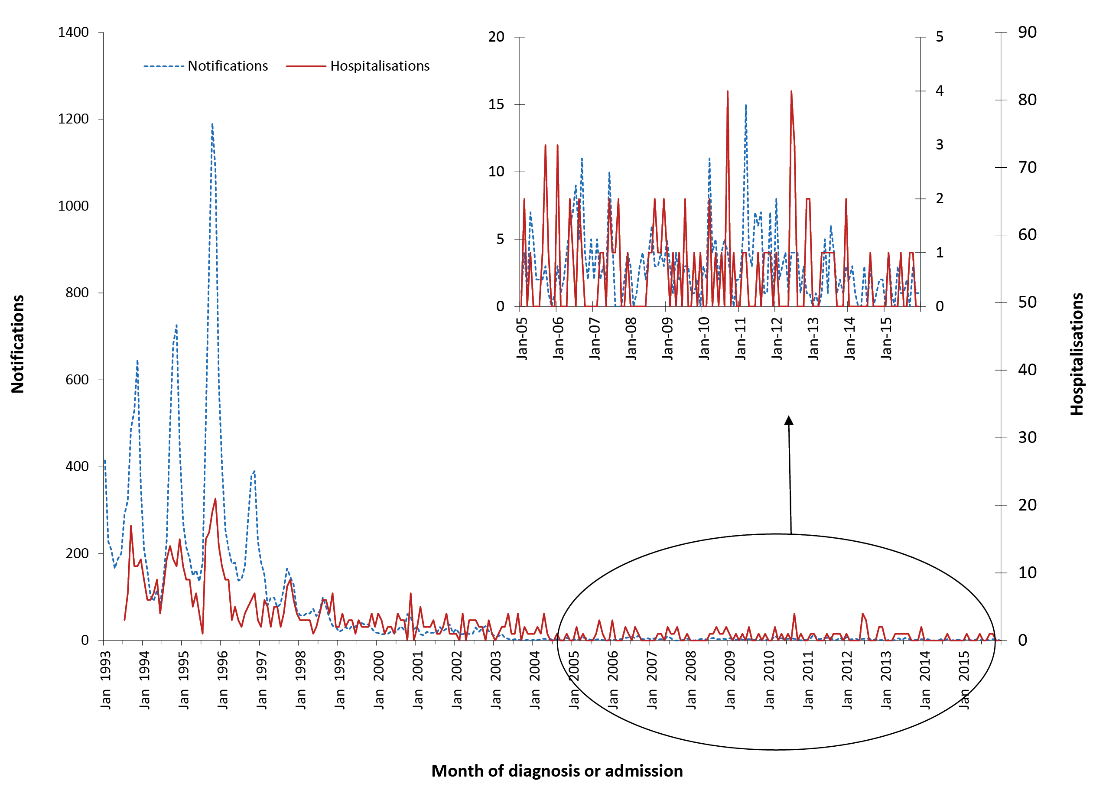
Note: varying scales between notifications and hospitalisations.
a Notifications where the month of diagnosis was between 1 January 1993 and 31 December 2015; hospitalisations where the month of admission was between1 July 1993 and 31 December 2015.
Table 3.14.1: Rubella notifications, hospitalisations and deaths, Australia, 2012 to 2015, by age groupª
 | Notifications |  | Hospitalisations |  |  |  | LOS^{b} per admission |  | Deaths^{c}
 |  |  | Any diagnosis |  | Principal diagnosis |  | Any diagnosis | Principal diagnosis
Age group (years) | n | (Rate)^{d} | n | (Rate)^{d} | n | (Rate)^{d} | Median days |  | n | (Rate)^{d}
<1 | 0 | – | 0 | – | 0 | – | – | – | 0 | –
1–4 | 3 | (0.06) | 1–4 | (0.08) | 1–4 | (0.06) | 4.0 | 2.0 | 0 | –
5–14 | 2 | (0.02) | 1–4 | (0.02) | 1–4 | (0.02) | 1.0 | 1.0 | 0 | –
15–24 | 16 | (0.13) | 1–4 | (0.02) | 1–4 | (0.01) | 1.0 | 1.0 | 0 | –
25–49 | 60 | (0.18) | 11 | (0.03) | 1–4 | (0.01) | 2.0 | 3.0 | 0 | –
50–64 | 9 | (0.05) | 1–4 | (0.02) | 1–4 | (0.01) | 6.0 | 30.0 | 1–3 | (0.01)
≥65 | 3 | (0.02) | 1–4 | (0.01) | 1–4 | (0.01) | 9.0 | 9.0 | 0 | –
All ages | 93 | (0.10) | 24 | (0.03) | 12 | (0.01) | 2.0 | 2.0 | 1–3 | (0.001)
a Notifications where the month of diagnosis was between 1 January 2012 and 31 December 2015; hospitalisations where the month of admission was between 1 January 2012 and 31 December 2015.
b LOS = length of stay in hospital.
c Deaths include underlying and associated causes of deaths.
d Average annual age-specific rate per 100,000 population.
The number of hospitalisations for rubella each year remained very low (range 0–4 admissions per year), at an average annual hospitalisation rate of 0.03 per 100,000 population (Table 3.14.1 and Appendix 3). There were also 60 hospitalisations of CRS during 2012 to 2015. Of these 60 CRS hospitalisations, 30 were people aged 25–49 years, 25 in those aged ≥50 years and 5 in children aged ≤15 years.

Severe morbidity and mortality
From January 2012 to December 2015, there were 123 hospital bed days recorded for hospitalisations with an ICD-10-AM code for rubella with a median length of stay of 2 days (Table 3.14.1). There were 1–3 deaths recorded over the 4 years from January 2012 to December 2015 in the causes of death data with rubella (ICD-10 code B06) as the underlying or associated cause of death.

Age and sex distribution
Adults aged 25–49 years accounted for almost two-thirds (64%) of the rubella notifications for the 4-year reporting period and had the highest rates of notifications (0.18 per 100,000 population) (Table 3.14.1).
Rates of rubella notifications for children <5 years of age have remained very low since 2003 and continued to fall over the 4 years from January 2012 to December 2015.
Hospitalisation rates for rubella for the 4-year period were highest for children aged 1–4 years (Table 3.14.1).
The overall male:female ratio for notifications for the 4-year reporting period was 1 (i.e ratio same between males and females). The overall male:female ratio for hospitalisations was 0.7:1 for the 4-year period.

Geographical distribution
Notification rates for rubella remained low for all states and territories for each year from 2012 to 2015 (range 0–0.2 per 100,000) (Appendix 2). Similarly, hospitalisation rates for rubella in each state and territory were very small between 2012 and 2015 (range 0–0.1 per 100,000 population) (Appendix 3).

Aboriginal or Torres Strait Islander status
Of the 93 notifications of rubella over the 2012–2015 period, Indigenous status was reported for 78 (84%), and there was 1 notified case of rubella identified in an Aboriginal or Torres Strait Islander person.

Vaccination status
Vaccination status should be completed in the NNDSS for all notifications of rubella in women of child-bearing age (15–45 years). There were fewer notifications (37 cases) of rubella among women aged 15–45 years between January 2012 and December 2015 than in the previous reporting period (55 cases).⁸
Of the 37 cases in women aged 15–45 years, vaccination data was not available for 62% (23) of cases (1 case coded as 8888 where the case was followed up but no information was available; 10 cases coded as 9999 for missing vaccine type data where cases were not followed up; and 12 had no data recorded i.e. the vaccine data field was left blank). Of the 14 cases that had vaccination data available, 13 cases were reported to have received no vaccine doses (unvaccinated) and 1 case had received 1 dose of rubella-containing vaccine.

Comment
The epidemiology of rubella during the reporting period (2012–2015) indicates that Australia is in a position to achieve the status of elimination of rubella in the near future.^{3,25} In October 2018, the World Health Organization declared that Australia had eliminated rubella.^{124,125}

3.15 Tetanus
Highlights
The number of notifications (16) and hospitalisations (69) for tetanus remained low over the period January 2012 to December 2015.
Tetanus is a disease caused by an exotoxin of the Clostridium tetani bacterium, which grows anaerobically at the site of an injury and is not transmissible from human to human.⁷⁰ The disease is characterised by painful muscle contractions, primarily of the masseter and neck muscles, secondarily of the trunk muscles. The case-fatality rate ranges from 10% to 90%, with the highest case-fatality rates in infants and the elderly.¹²⁶

Case definition
Notifications¹²⁷
Tetanus case definition:
http://www.health.gov.au/internet/main/publishing.nsf/Content/cda-surveil-nndss-casedefs-cd_tetanus.htm
Hospitalisations and deaths
The ICD-10-AM/ICD-10 codes A33 (tetanus neonatorum), A34 (obstetrical tetanus) and A35 (other tetanus) were used to identify hospitalisations and deaths.

Secular trends
In the 4 years from January 2012 to December 2015, there were 16 notifications of tetanus (an average annual notification rate of 0.02 per 100,000) (Table 3.15.1). The annual number of notifications for tetanus has remained stable since 2005, though a slight increase was seen in 2012 (Figure 3.15.1). There were 69 hospital admissions for tetanus from January 2012 to December 2015 (Table 3.15.1). The annual number of hospital admissions remained relatively stable over the 4-year reporting period (Figure 3.15.1).
Figure 3.15.1: Tetanus notifications and hospitalisations, Australia, 1998 to 2015,ª by year of diagnosis or admission
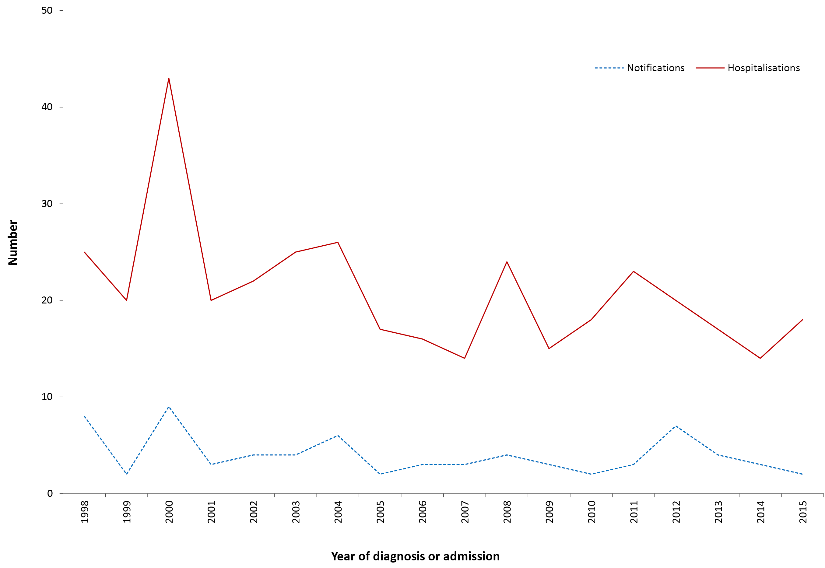
a Notifications where the year of diagnosis was between 1 January1998 and 31 December 2015; hospitalisations where the year of admission was between 1 January 1998 and 31 December 2015.
Table 3.15.1: Tetanus notifications, hospitalisations and deaths, Australia, 2012 to 2015,ª by age group
 | Notifications |  | Hospitalisations |  |  |  | LOS^{b} per admission |  | Deaths^{c}
 |  |  | Any diagnosis |  | Principal diagnosis |  | Any diagnosis | Principal diagnosis
Age group (years) | n | (Rate)^{d} | n | (Rate)^{d} | n | (Rate)^{d} | Median days |  | n | (Rate)^{d}
<1 | 0 | – | 1–4 | (0.08) | 0 | – | 1 | – | 0 | –
1–4 | 0 | – | 0 | – | 0 | – | – | – | 0 | –
5–14 | 0 | – | 1–4 | (0.01) | 1–4 | (0.01) | 1 | 1 | 0 | –
15–24 | 1 | (0.01) | 7 | (0.06) | 6 | (0.05) | 1 | 2 | 0 | –
25–49 | 4 | (0.01) | 17 | (0.05) | 13 | (0.04) | 1 | 1 | 0 | –
50–64 | 1 | (0.01) | 6 | (0.04) | 1–4 | (0.02) | 2 | 2 | 0 | –
≥65 | 10 | (0.07) | 37 | (0.27) | 22 | (0.16) | 27 | 29 | 1–3 | (0.01)
All ages | 16 | (0.02) | 69 | (0.07) | 46 | (0.05) | 6 | 5 | 1–3 | (0.00)
a Notifications where the month of diagnosis was between 1 January 2012 and 31 December 2015; hospitalisations where the month of admission was between 1 January 2012 and 31 December 2015.
b LOS = length of stay in hospital.
c Deaths include underlying and associated causes of deaths.
d Average annual age-specific rate per 100,000 population.

Severe morbidity and mortality
There were 809 hospital bed days recorded for hospitalisations with an ICD-10-AM code for tetanus. None of these were recorded as obstetric tetanus (A34). The median length of stay in hospital was 6 days; adults aged ≥65 years had a longer median stay of 20 days.
Causes of death data recorded 1–3 deaths with tetanus as the underlying or associated cause of death for the 4 years from January 2012 to December 2015, all deaths were in people aged ≥65 years (Table 3.15.1).

Age and sex distribution
During the 4-year reporting period, the majority of both notified cases (10/16, 63%) and hospital admissions (37/69, 54%) were aged ≥65 years, a hospitalisation rate (principal diagnosis only) of 0.16 per 100,000, more than three times as high as the next highest age group (15–24; 0.05 per 100,000). Most notifications and hospitalisations were in individuals aged ≥15 years (Table 3.15.1). There were no differences in the number of notifications by sex (male:female ratio 1:1) but fewer hospitalisations for males (male:female ratio 0.8:1).

Geographical distribution
Notification and hospital admission rates for tetanus were too low to identify any trends across the states and territories (Appendix 2 and 3).

Aboriginal or Torres Strait Islander status
Of the 16 notifications of tetanus over the 2012–2015 period, Indigenous status was reported for 13 (81%), No notified cases were recorded as Aboriginal or Torres Strait Islander people. There were 1–4 hospitalisations identified as Aboriginal or Torres Strait Islander people during this reporting period.

Vaccination status
Of the 16 notifications, vaccination data was not available for 38% (6/16) of cases (3 cases coded as 9999 for missing vaccine type data where cases were not followed up and 3 with no data recorded i.e. the vaccine data field was left blank). Of the 10 cases that had vaccination data available, 8 cases were reported to have received no vaccine doses (unvaccinated) and 2 cases had received 1 dose of tetanus-containing vaccine.

Comment
Tetanus immunisation (complete) induces protective levels of antitoxin throughout childhood and into adulthood.⁷⁴ However, by middle age, approximately 50% of vaccinated persons have low or undetectable levels of antitoxin.^{74,128} In Australia, tetanus remains largely a disease of older adults. Hospitalisation rates are considerably higher than notification rates, as in previous reports.^{8,34} Under-notification by hospital staff, multiple hospital admissions or inter-hospital transfers for true cases and coding errors are all possible contributing factors.¹²⁹ The rates in this reporting period were largely similar to those in the previous report, with slight changes in numbers of notifications and hospitalisations.

3.16 Varicella-zoster virus infection
Highlights
The number of varicella (chickenpox) hospitalisations remained low during the 4-year period January 2012 to December 2015. Since 1993 there has been a trend of increasing numbers of hospitalisations with a diagnosis of herpes zoster and this increasing trend continued over the period 2012 to 2015.
The varicella-zoster virus (VZV) causes two distinct illnesses: varicella (chickenpox) following primary infection and herpes zoster (shingles) following reactivation of latent virus. Varicella is a highly contagious infection with an incubation period of 10–21 days, after which a characteristic rash appears. Acute varicella may be complicated by secondary bacterial skin infections, haemorrhagic complications, encephalitis and pneumonia.^{130,131}
Herpes zoster (HZ) or shingles is a sporadic disease, caused by reactivation of latent VZV in sensory nerve ganglia. It is characterised by severe pain with dermatomal distribution, sometimes followed by post-herpetic neuralgia, which can be chronic and debilitating, particularly in the elderly.^{132,133} A serosurvey conducted in 1997–1999 found that 83% of the Australian population were seropositive by 10–14 years of age¹³⁴ and thus susceptible to HZ.
Detailed notification data are not reported due to the large proportion that are unspecified as to whether varicella or zoster. New South Wales also do not send notification data on varicella-zoster virus infections to the NNDSS. For the current reporting period (2012 to 2015), of the total 75,868 notifications in NNDSS, 11.5% (8,696) were recorded as varicella, 28.2% (21,380) as zoster and the majority (60.4%, 45,792) as unspecified.

Case definition
Hospitalisations and deaths
The ICD-10-AM/ICD-10 code B01 (varicella [chickenpox]) was used to identify varicella hospitalisations and deaths and B02 (zoster [shingles]) was used to identify herpes zoster hospitalisations and deaths.

Secular trends, varicella and herpes zoster hospitalisations
In the 4 years from January 2012 to December 2015, there were 3,142 hospital admissions with an ICD-10-AM code for varicella (chickenpox) (average annual rate of 3.4 per 100,000 population) (Table 3.16.1). The number of hospitalisations per month for varicella (chickenpox) fell in 2015 relative to the previous 3 years with less seasonal fluctuation in hospitalisations per month (Figure 3.16.1).
Monthly hospital admissions with an ICD-10-AM code for herpes zoster (shingles) rose steadily over the 4-year reporting period, continuing an increasing trend in the number of zoster hospitalisations observed since 1993 (Figure 3.16.1).

Figure 3.16.1: Varicella and herpes zoster hospitalisations, Australia, 1993 to 2015,ª by month of admission
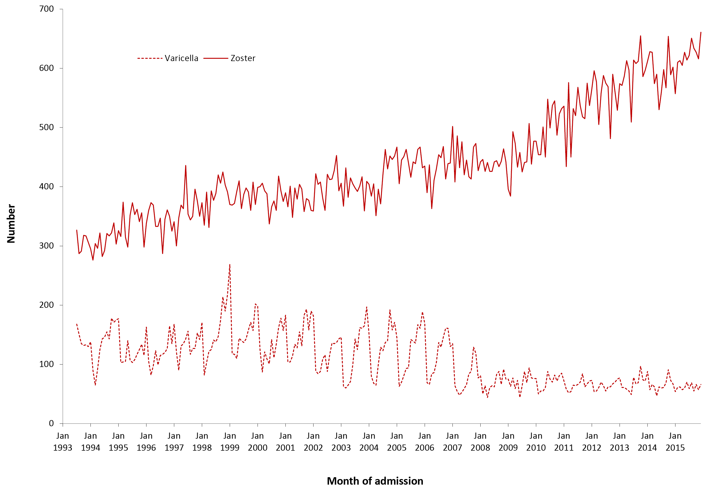
a Hospitalisations where the month of admission was between 1 July 1993 and 31 December 2015.
Table 3.16.1: Varicella hospitalisations and deaths, Australia, 2012 to 2015,ª by age group
Age group (years) | Hospitalisations |  |  |  | LOS^{b} per admission |  | Deaths^{c}
 | Any diagnosis |  | Principal diagnosis |  | Any diagnosis | Principal diagnosis
 | n | (Rate)^{d} | n | (Rate)^{d} | Median days |  | n | (Rate)^{d}
<1 | 138 | (11.2) | 104 | (8.5) | 2 | 2 | 0 | –
1–4 | 219 | (4.5) | 134 | (2.7) | 2 | 2 | 1–3 | (0.02)
5–14 | 256 | (2.2) | 161 | (1.4) | 2 | 2 | 1–3 | (0.01)
15–24 | 237 | (1.9) | 174 | (1.4) | 3 | 3 | 0 | –
25–49 | 825 | (2.5) | 563 | (1.7) | 3 | 3 | 1–3 | (0.01)
50–64 | 428 | (2.5) | 209 | (1.2) | 6 | 5 | 7 | (0.04)
≥65 | 1,039 | (7.7) | 356 | (2.6) | 8 | 6 | 32 | (0.24)
All ages | 3,142 | (3.4) | 1,701 | (1.8) | 4 | 3 | 44 | (0.05)
a Hospitalisations where the month of admission was between 1 January 2012 and 31 December 2015.
b LOS = length of stay in hospital.
c Deaths include underlying and associated causes of deaths.
d Average annual age-specific rate per 100,000 population

Severe morbidity and mortality, varicella
From January 2012 to December 2015, there were 22,502 hospital bed days recorded for admissions with an ICD-10-AM code for chickenpox, with a median length of stay per hospital admission of 4 days (Table 3.16.1). The median length of stay was at least twice as long for adults aged ≥65 years as for younger patients. For the 4-year period, the causes of death data recorded 44 deaths with varicella (chickenpox) as the underlying or associated cause of death (Table 3.16.1).

Age and sex distribution, varicella
During the 4-year reporting period, the highest hospitalisation rate for varicella was among infants aged <1 year, followed by children aged 1–4 years (Table 3.16.1).
There were slightly more admissions for males than females over the 4 years (male:female ratio 1.2:1).

Geographical distribution, varicella
The Northern Territory had higher rates of hospital admissions for chickenpox than other jurisdictions; however, the Northern Territory only accounted for 2% of hospitalisations for varicella (Appendix 3). New South Wales accounted for 30% of admissions with an ICD-10-AM code for chickenpox.

Severe morbidity and mortality, herpes zoster
For hospitalisations with an ICD-10-AM code for herpes zoster, 244,848 hospital bed days (average 61,212 per year) were recorded in the 4 years from January 2012 to December 2015. The median length of stay was 5 days for any herpes zoster diagnosis and 4 days for a principal diagnosis of herpes zoster (Table 3.16.2).

Table 3.16.2: Zoster hospitalisations and deaths, Australia, 2012 to 2015,ª by age group
Age group (years) | Hospitalisations |  |  |  | LOS^{b} per admission |  | Deaths^{c}
 | Any diagnosis |  | Principal diagnosis |  | Any diagnosis | Principal diagnosis
 | n | (Rate)^{d} | n | (Rate)^{d} | Median days |  | n | (Rate)^{d}
<1 | 23 | (1.9) | 6 | (0.5) | 3 | 1 | 0 | –
1–4 | 37 | (0.8) | 17 | (0.3) | 2 | 2 | 0 | –
5–14 | 248 | (2.2) | 149 | (1.3) | 3 | 3 | 0 | –
15–24 | 433 | (3.5) | 215 | (1.7) | 3 | 3 | 0 | –
25–49 | 2,410 | (7.4) | 1,091 | (3.3) | 3 | 2 | 1–3 | (<0.01)
50–64 | 4,330 | (25.7) | 1,745 | (10.4) | 4 | 3 | np^{e} | (0.11)
≥65 | 21,036 | (155.3) | 7,214 | (53.3) | 6 | 4 | 359 | (2.65)
All ages | 28,517 | (30.6) | 10,437 | (11.2) | 5 | 4 | 378 | (0.41)
a Hospitalisations where the month of admission was between 1 January 2012 and 31 December 2015.
b LOS = length of stay in hospital.
c Deaths include underlying and associated causes of deaths.
d Average annual age-specific rate per 100,000 population.
e np = not provided
For the same 4-year period, the causes of death data recorded 378 deaths with zoster (herpes zoster, shingles) as the underlying or associated cause of death; nearly all were aged ≥65 years (Table 3.16.2).

Age and sex distribution, herpes zoster
During the 4-year reporting period the highest hospitalisation rate for herpes zoster was among older adults ≥65 years (Table 3.16.2). There were more herpes zoster admissions for females than males (male:female ratio 1:1.4) and the higher ratio of females to males was constant across the 4 years.

Geographical distribution, herpes zoster
The Northern Territory had lower rates of hospital admissions for herpes zoster than other jurisdictions (average rate 18 per 100,000), while South Australia had higher hospitalisation rates than all other jurisdictions (average rate 34.4 per 100,000). The majority (58%) of hospital admissions for herpes zoster were from New South Wales and Victoria (Appendix 3).

Aboriginal and Torres Strait Islander status
Aboriginal and Torres Strait Islander people accounted for 110/3142 varicella hospitalisations (4%), with 35/110 (32%) in children aged <5 years. Aboriginal and Torres Strait Islander varicella hospitalisation rates were slightly higher than other Australians (3.9 per 100,000 population and 3.4 per 100,000 population respectively). Zoster hospitalisations were reported in 464 Aboriginal and Torres Strait Islander people of a total of 28,517 (2%), most aged 50–64 years. Overall, Aboriginal and Torres Strait Islander zoster hospitalisation rates were lower than other Australians (16.4 per 100,000 population and 31.1 per 100,000 population respectively) but there were higher hospitalisation rates in Aboriginal and Torres Strait Islander adults aged 60 to 69.¹³⁵

Comment
The decline in varicella hospitalisations documented over this 4-year period is consistent with increasing coverage and continued impact of varicella vaccine since its introduction to the NIP in late 2005.^{7,136} Herpes zoster hospitalisations continued on an increasing trend, but as previously reported this may largely be due to population ageing.¹³⁷ In November 2016, a zoster vaccine was included in Australia’s National Immunisation Program (NIP) for all people aged 70, together with a 5-year catch up program for those aged 71–79 years.¹³⁸

Appendix 1. Charts of historical national notification data
Selected vaccine preventable diseases
Figure A.1: Notifications of diphtheria, 1917 to 2015,ª Australia
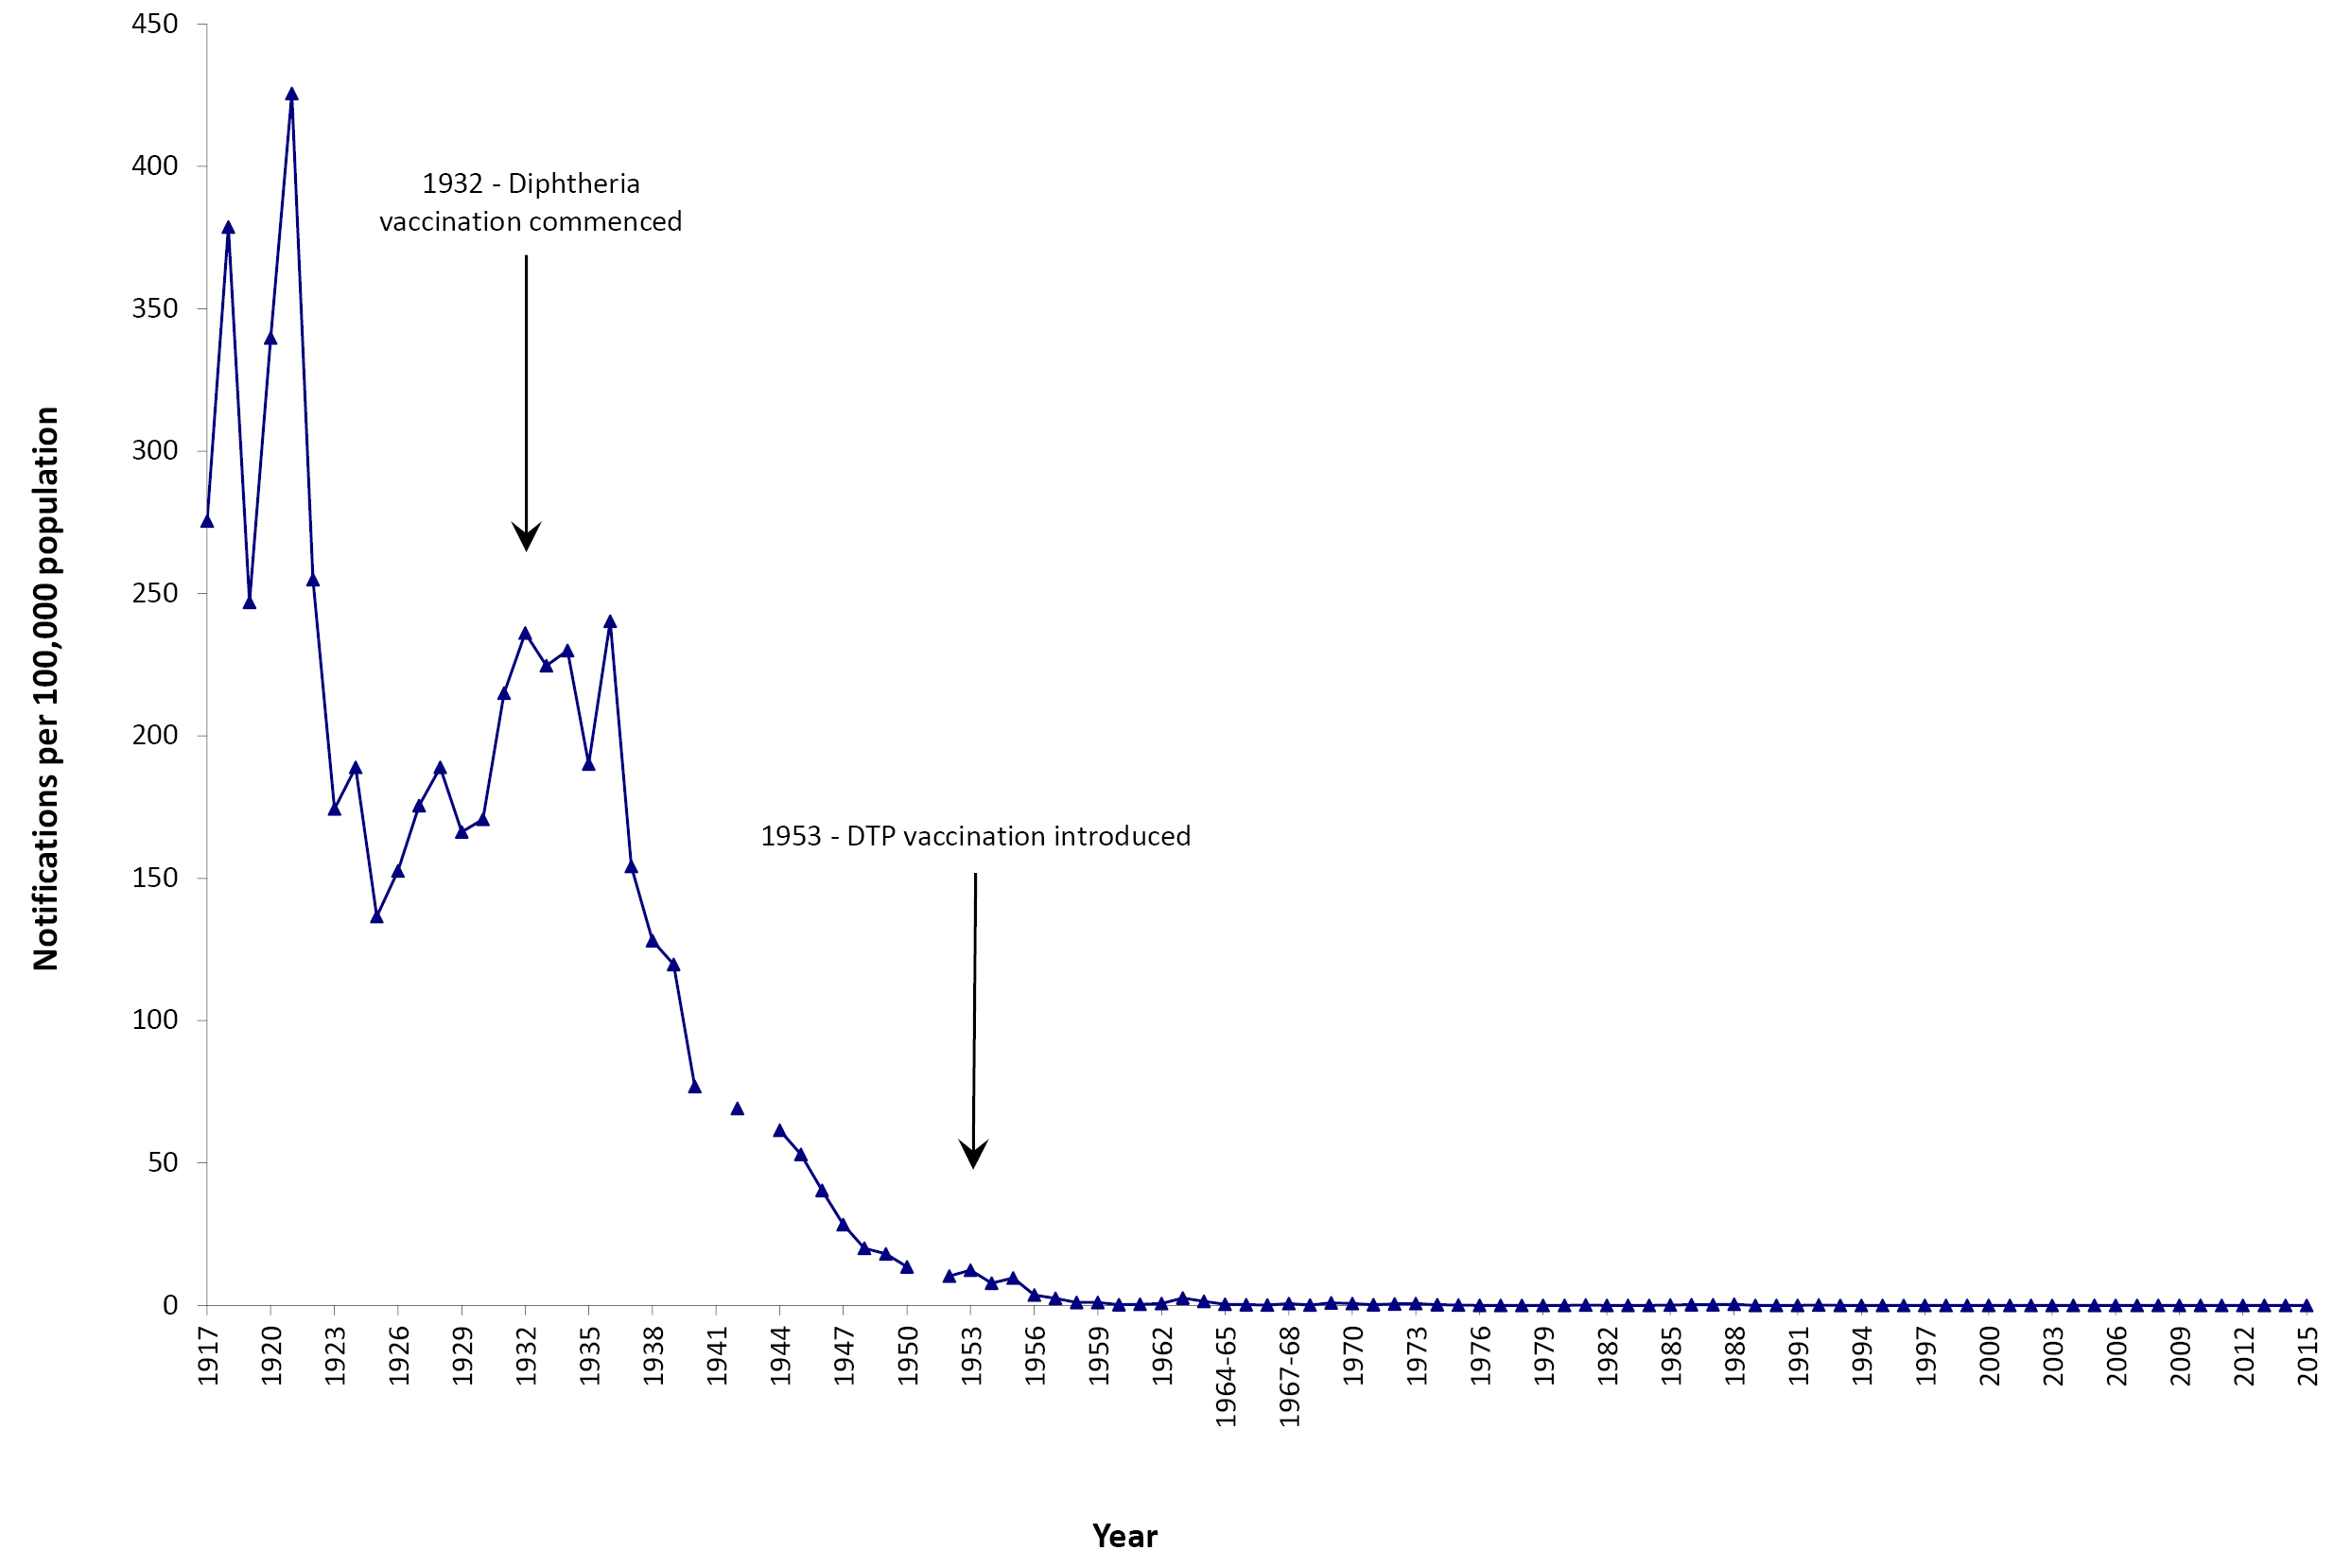
a Data are reported by calendar year from 1917–1963 and 1970–2015 and by financial year 1963/1964–1969/1970. Source: National Notifiable Diseases Surveillance System; and Hall R. Notifiable disease surveillance, 1917 to 1991. Commun Dis Intell 1993;17(11):226–236.
Figure A.2: Notifications of Haemophilus influenzae type b, 1991 to 2015,ª Australia
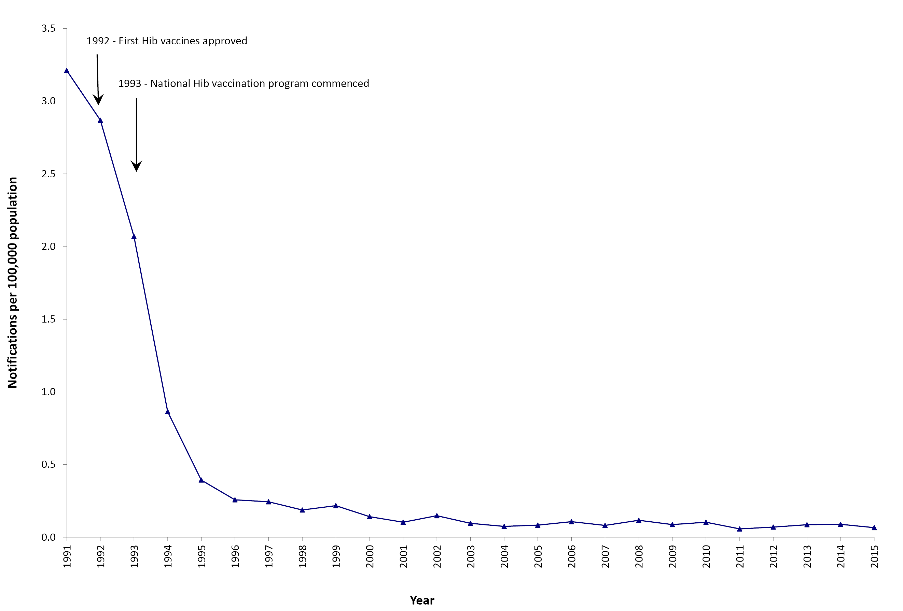
a Data are reported by calendar year from 1991–2015. Source: National Notifiable Diseases Surveillance System; and Hall R. Notifiable disease surveillance, 1917 to 1991. Commun Dis Intell 1993;17(11):226–236.
Figure A.3: Notifications of hepatitis A, 1952 to 2015,ª Australia
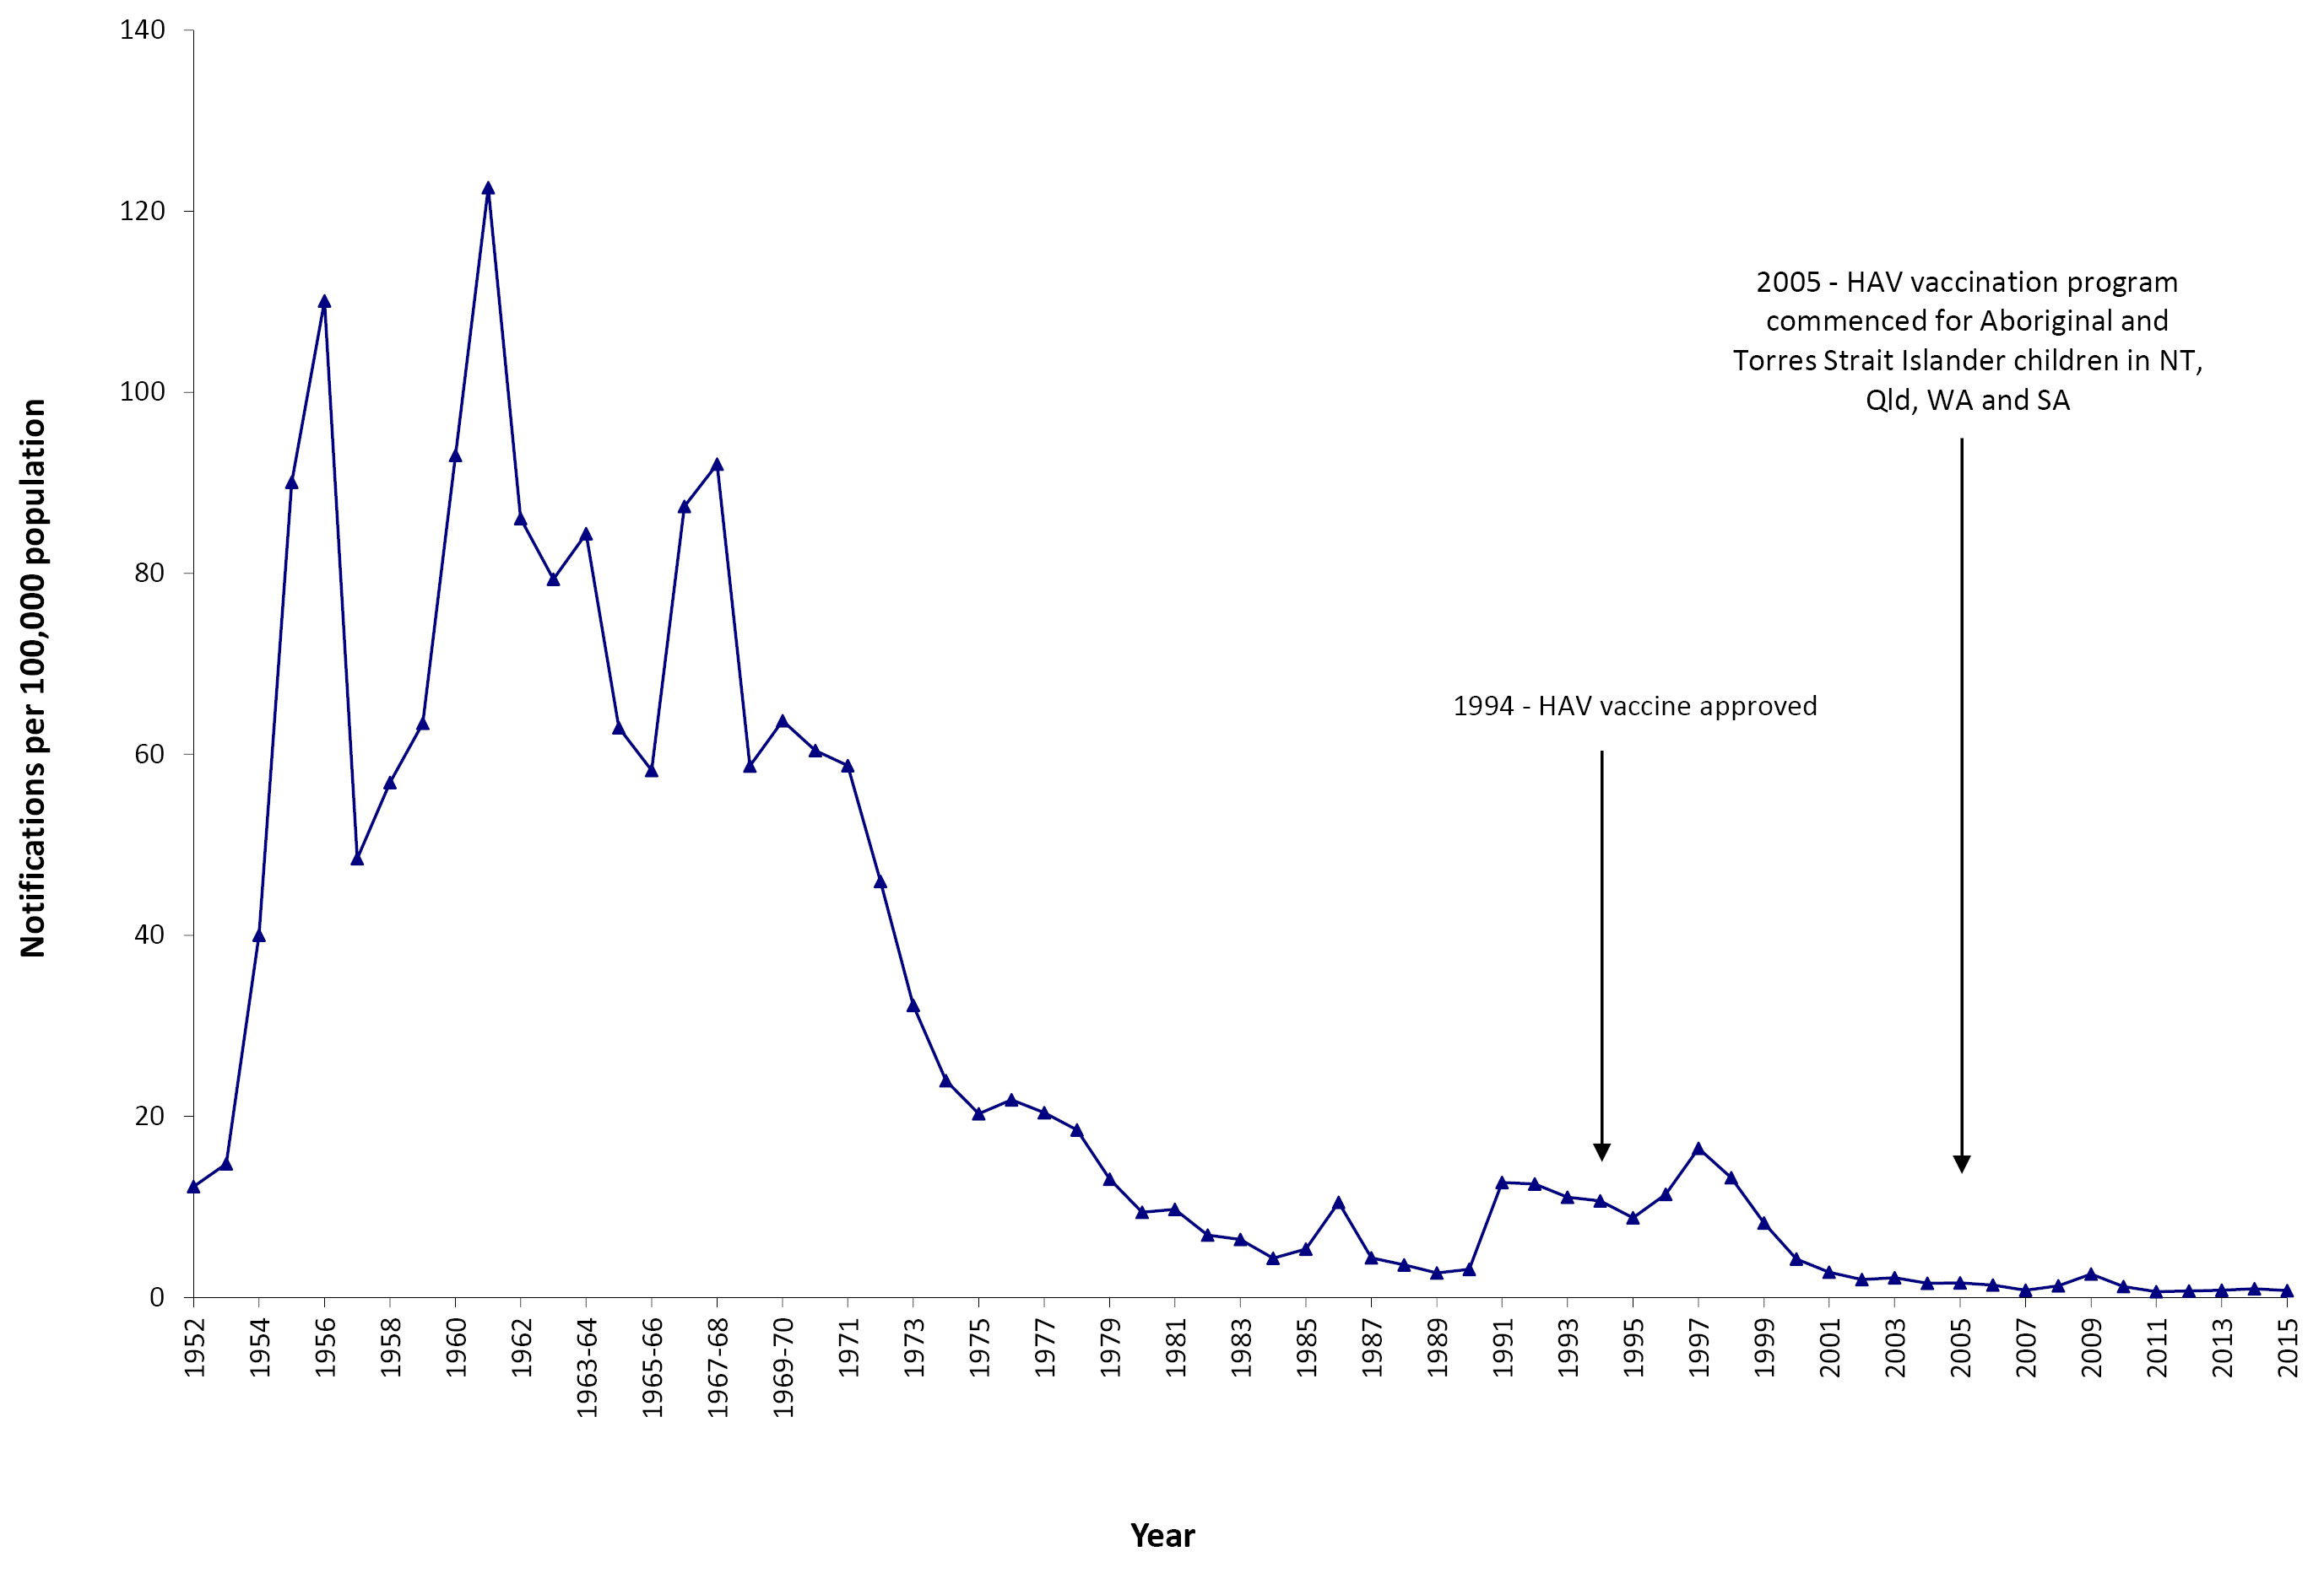
a Data are reported by calendar year from 1952–1963 and 1970–2015 and by financial year 1963/1964–1969/1970. Source: National Notifiable Diseases Surveillance System; and Hall R. Notifiable disease surveillance, 1917 to 1991. Commun Dis Intell 1993;17(11):226–236.
Figure A.4: Notifications of measles, 1917 to 2015,ª Australia
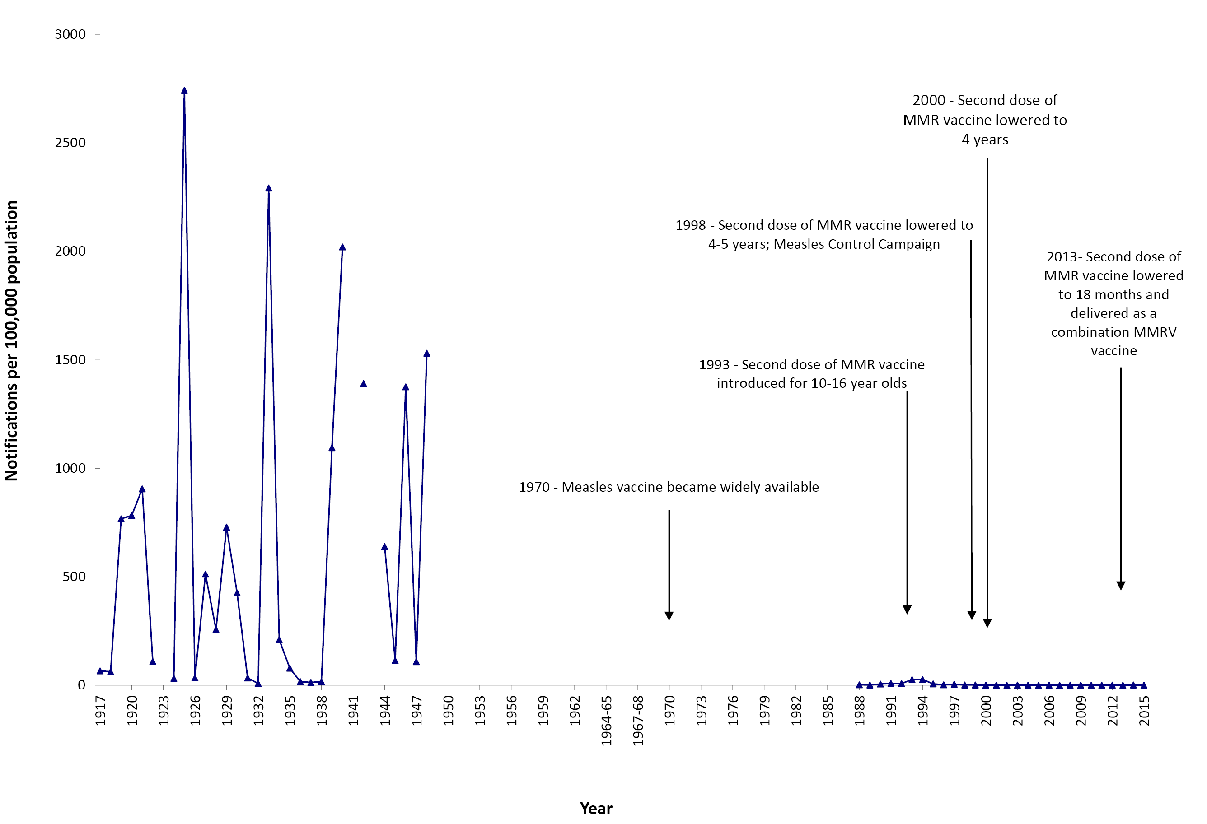
a Data are reported by calendar year from 1917–1963 and 1970–2015 and by financial year 1963/1964–1969/1970. Source: National Notifiable Diseases Surveillance System; and Hall R. Notifiable disease surveillance, 1917 to 1991. Commun Dis Intell 1993;17(11):226–236.
Figure A.5: Notifications of meningococcal disease (invasive), 1949 to 2015,ª Australia
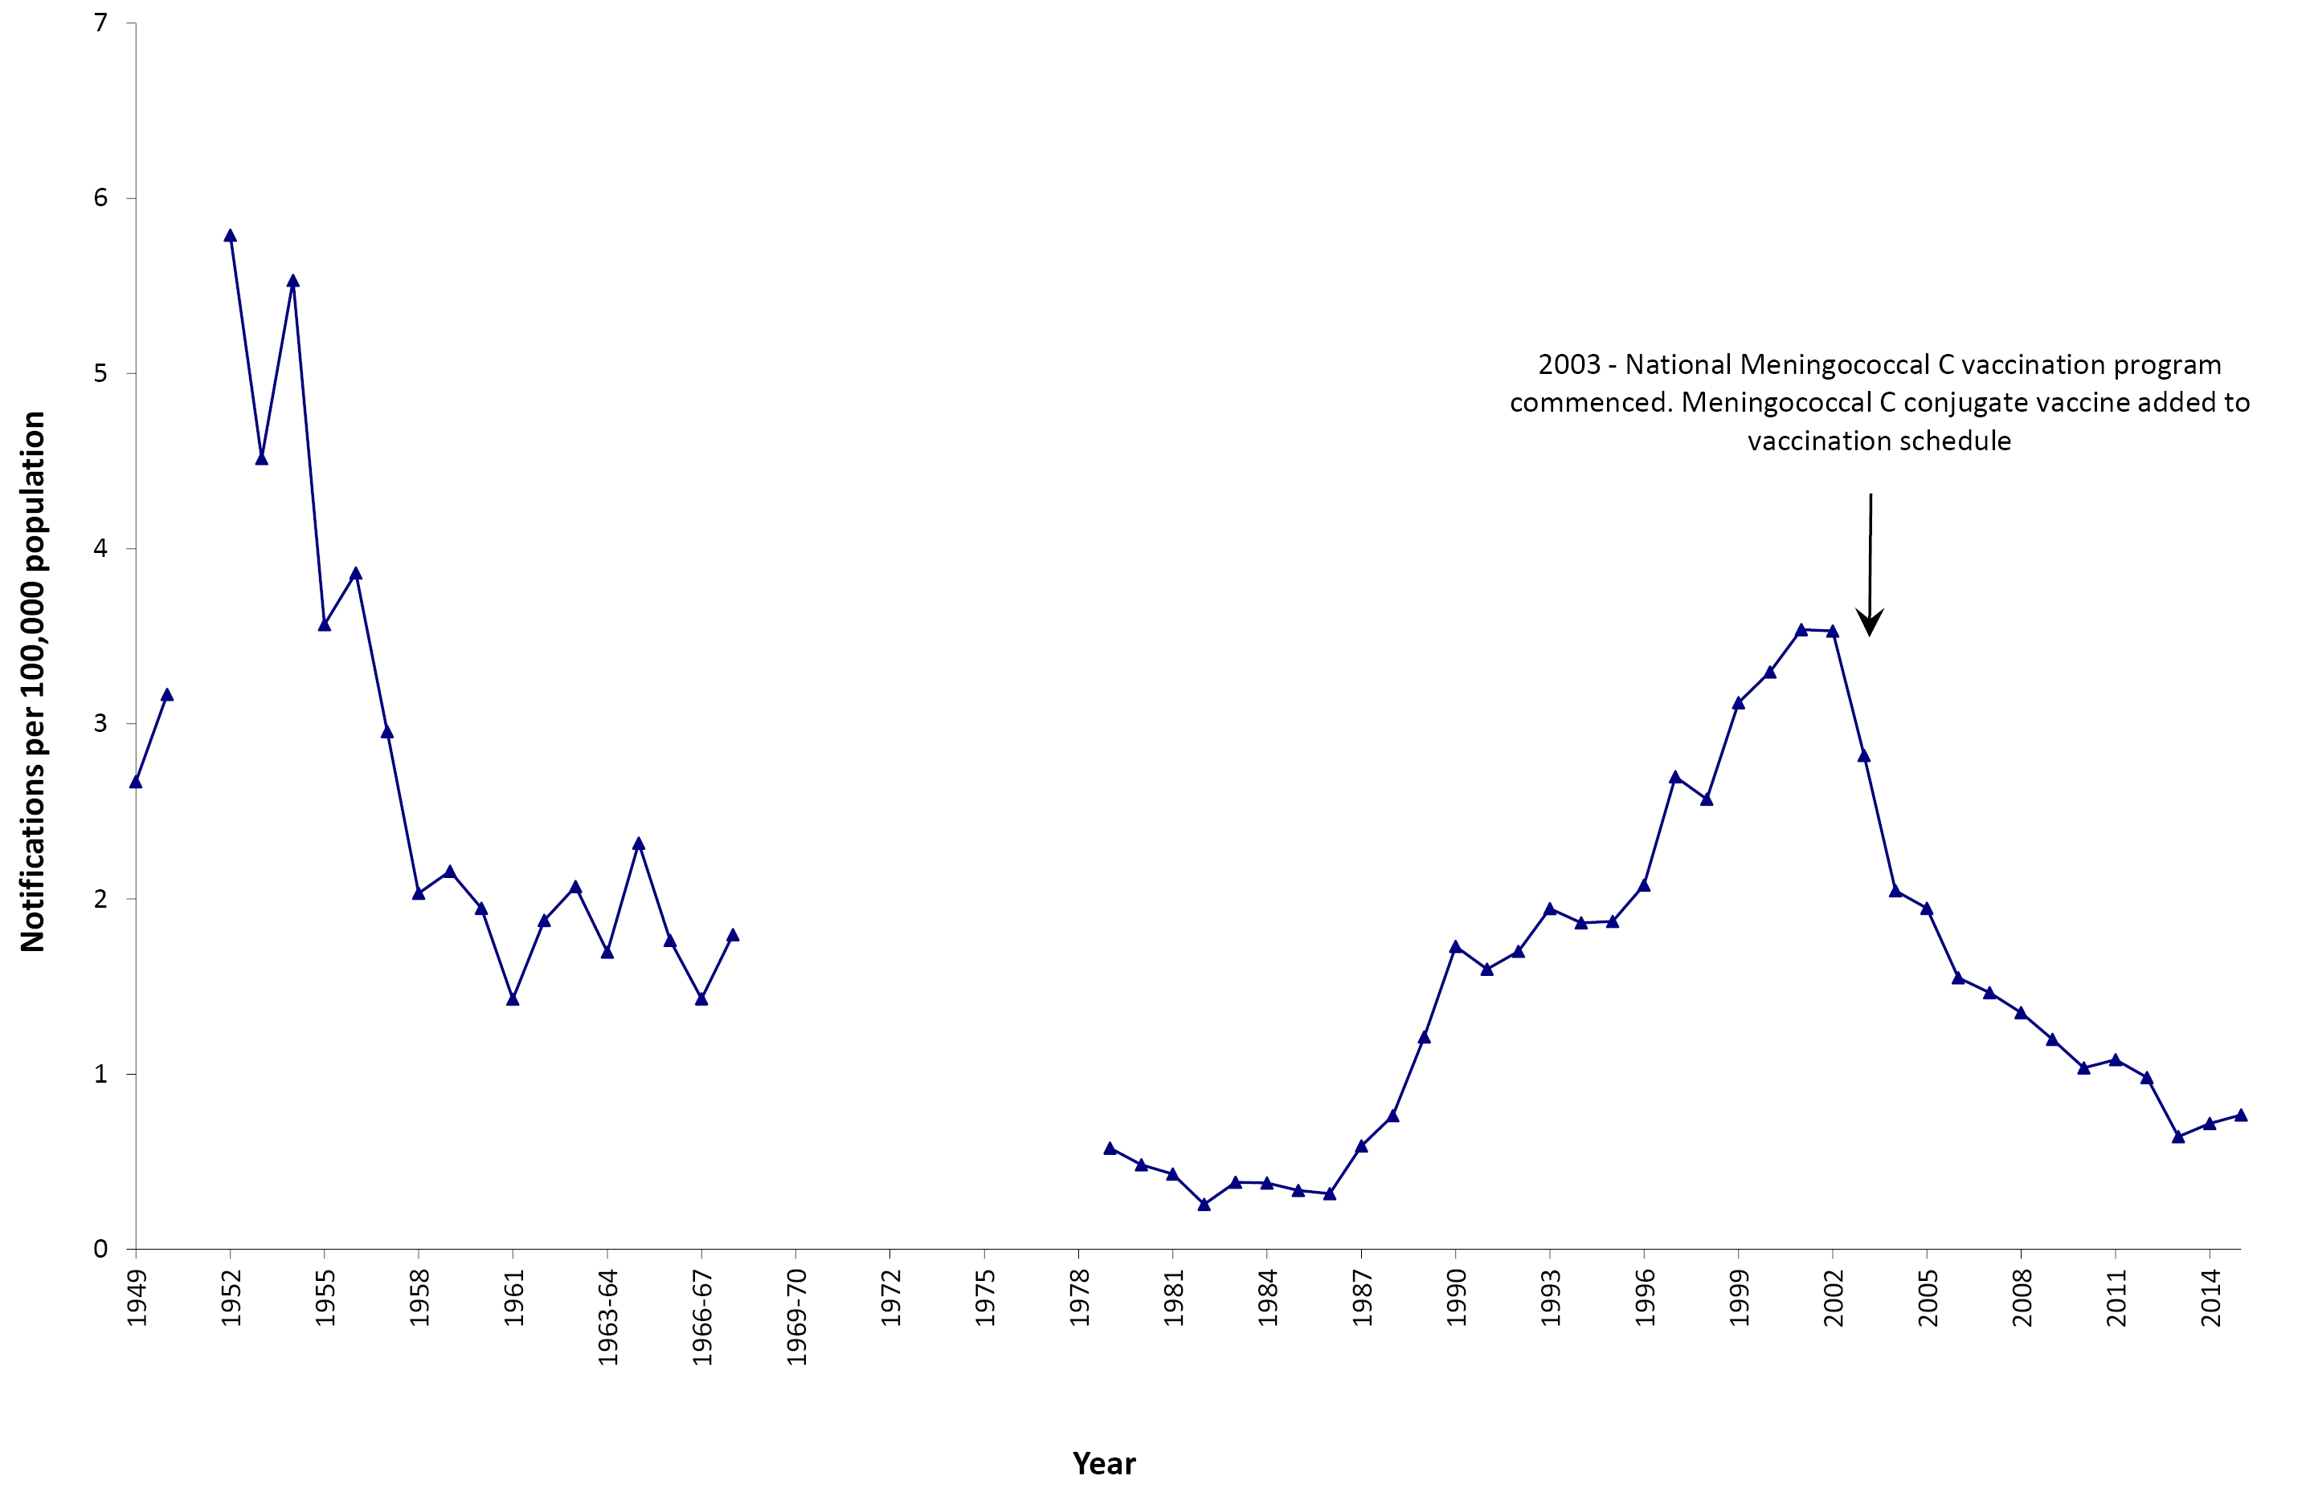
a Data are reported by calendar year from 1949–1963 and 1970–2015 and by financial year 1963/1964–1969/1970. Source: National Notifiable Diseases Surveillance System; and Hall R. Notifiable disease surveillance, 1917 to 1991. Commun Dis Intell 1993;17(11):226–236.
Figure A.6: Notifications of mumps, 1932 to 2015,ª Australia
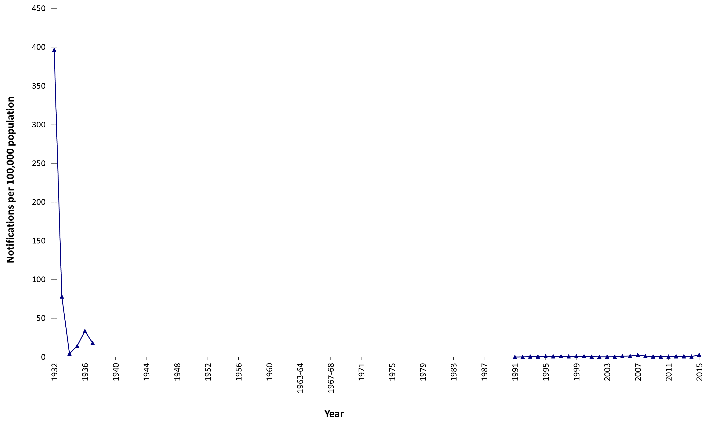
a Data are reported by calendar year from 1932–1963 and 1970–2015 and by financial year 1963/1964–1969/1970. Source: National Notifiable Diseases Surveillance System; and Hall R. Notifiable disease surveillance, 1917 to 1991. Commun Dis Intell 1993;17(11):226–236.
Figure A.7 Notifications of pertussis, 1917 to 2015,ª Australia
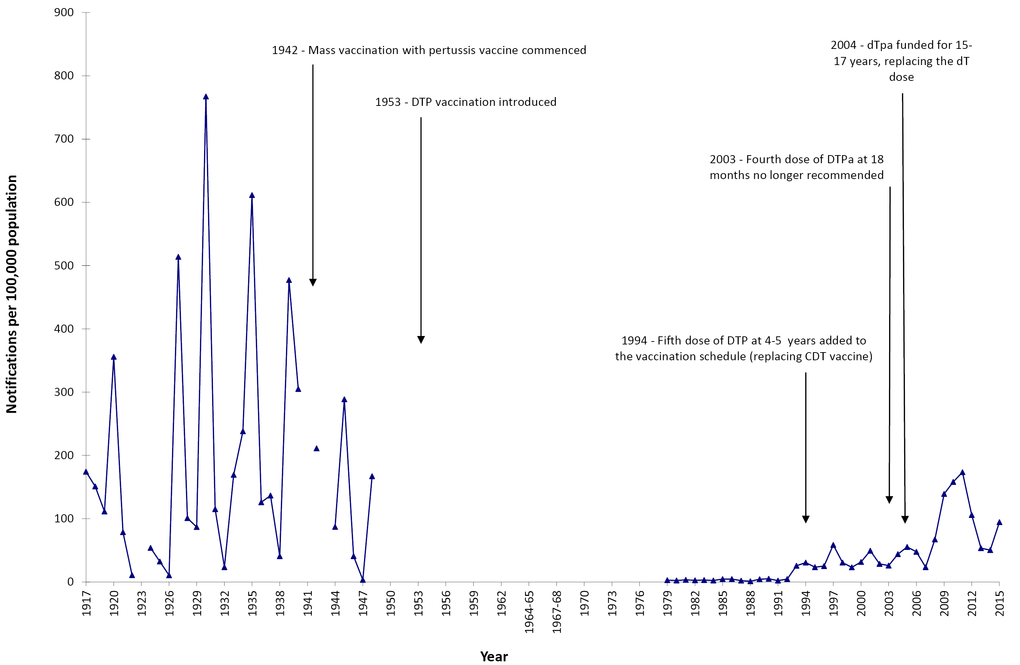
a Data are reported by calendar year from 1917–1963 and 1970–2015 and by financial year 1963/1964–1969/1970. Source: National Notifiable Diseases Surveillance System; and Hall R. Notifiable disease surveillance, 1917 to 1991. Commun Dis Intell 1993;17(11):226–236.
Figure A.8: Notifications of poliomyelitis, 1917 to 2015,ª Australia
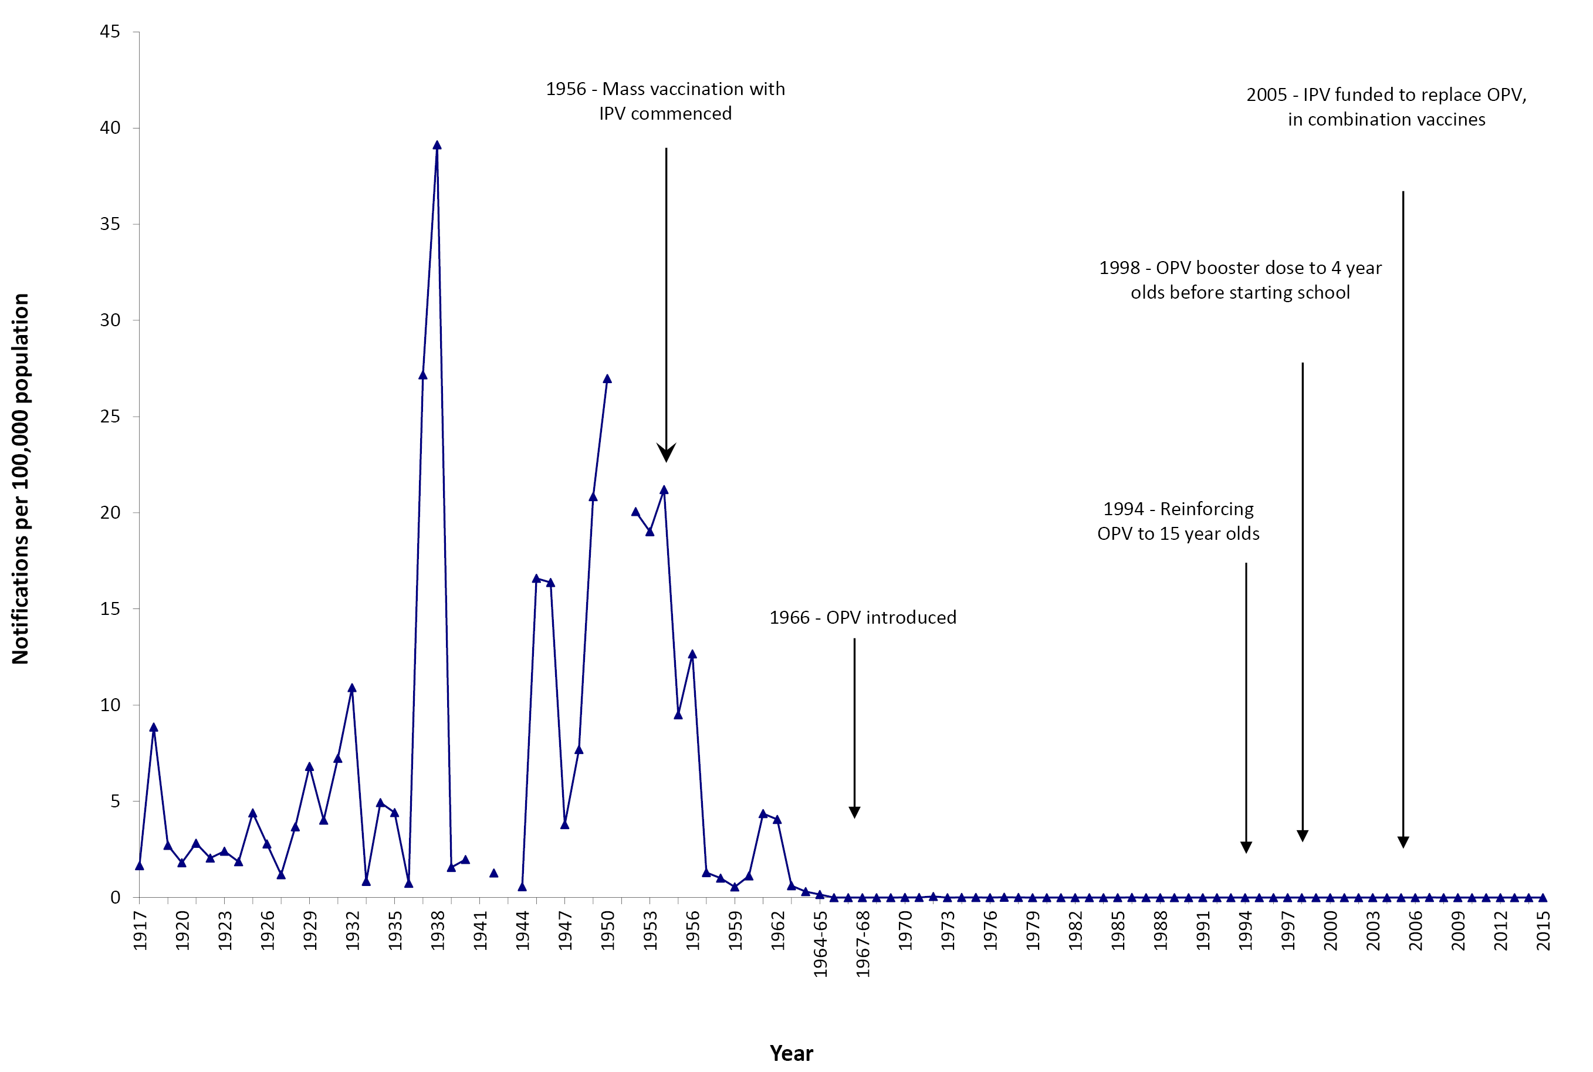
a Data are reported by calendar year from 1917–1963 and 1970–2015 and by financial year 1963/1964–1969/1970. Source: National Notifiable Diseases Surveillance System; and Hall R. Notifiable disease surveillance, 1917 to 1991. Commun Dis Intell 1993;17(11):226–236.
Figure A.9: Notifications of rubella, 1942 to 2015,ª Australia
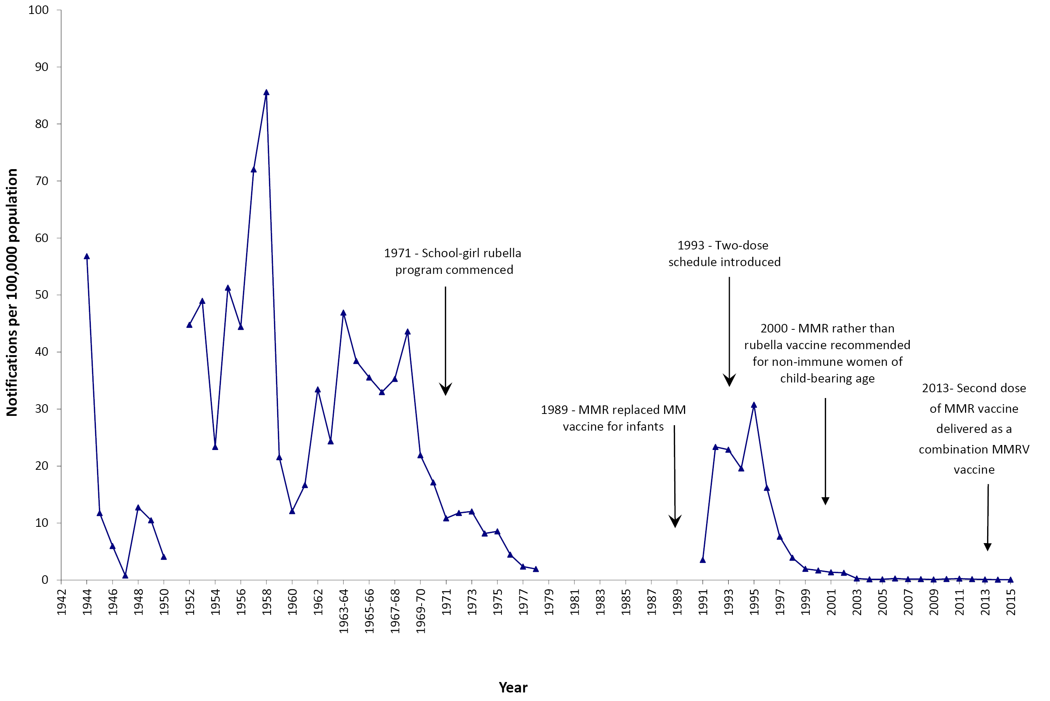
a Data are reported by calendar year from 1942–1963 and 1970–2015 and by financial year 1963/1964–1969/1970. Source: National Notifiable Diseases Surveillance System; and Hall R. Notifiable disease surveillance, 1917 to 1991. Commun Dis Intell 1993;17(11):226–236.
Figure A.10: Notifications of tetanus, 1921 to 2015,ª Australia
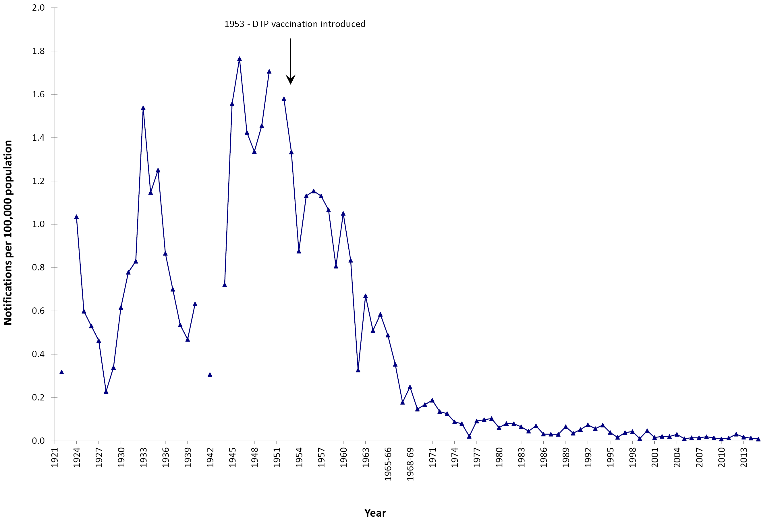
a Data are reported by calendar year from 1921–1963 and 1970–2015 and by financial year 1963/1964–1969/1970. Source: National Notifiable Diseases Surveillance System; and Hall R. Notifiable disease surveillance, 1917 to 1991. Commun Dis Intell 1993;17(11):226–236.

Appendix 2. Notifications by state or territory
Table A.1. Notifications and notification rates for vaccine preventable diseases, Australia, 1 January 2012 to 31 December 2015, by state or territory and year
 | Number of notifications |  |  |  |  |  |  |  |  |  | Notification rate per 100,000 population
Disease | Year | ACT | NSW | NT | Qld | SA | Tas. | Vic. | WA | Total | ACT | NSW | NT | Qld | SA | Tas. | Vic. | WA | Total
Diphtheria | 2012 | 0 | 0 | 0 | 0 | 0 | 0 | 0 | 0 | 0 | 0.00 | 0.00 | 0.00 | 0.00 | 0.00 | 0.00 | 0.00 | 0.00 | 0.00
 | 2013 | 0 | 0 | 0 | 2 | 1 | 0 | 0 | 0 | 3 | 0.00 | 0.00 | 0.00 | 0.04 | 0.06 | 0.00 | 0.00 | 0.00 | 0.01
 | 2014 | 0 | 0 | 0 | 2 | 0 | 0 | 0 | 0 | 2 | 0.00 | 0.00 | 0.00 | 0.04 | 0.00 | 0.00 | 0.00 | 0.00 | 0.01
 | 2015 | 0 | 0 | 0 | 2 | 0 | 0 | 0 | 0 | 2 | 0.00 | 0.00 | 0.00 | 0.04 | 0.00 | 0.00 | 0.00 | 0.00 | 0.01
 | Totalª | 0 | 0 | 0 | 6 | 1 | 0 | 0 | 0 | 7 | 0.00 | 0.00 | 0.00 | 0.03 | 0.01 | 0.00 | 0.00 | 0.00 | 0.01
Haemophilus influenzae type b | 2012 | 0 | 2 | 1 | 5 | 2 | 1 | 4 | 1 | 16 | 0.00 | 0.03 | 0.42 | 0.11 | 0.12 | 0.20 | 0.07 | 0.04 | 0.07
 | 2013 | 0 | 9 | 0 | 7 | 0 | 0 | 4 | 0 | 20 | 0.00 | 0.12 | 0.00 | 0.15 | 0.00 | 0.00 | 0.07 | 0.00 | 0.09
 | 2014 | 0 | 6 | 1 | 9 | 1 | 0 | 3 | 1 | 21 | 0.00 | 0.08 | 0.41 | 0.19 | 0.06 | 0.00 | 0.05 | 0.04 | 0.09
 | 2015 | 0 | 5 | 2 | 5 | 0 | 0 | 2 | 2 | 16 | 0.00 | 0.07 | 0.82 | 0.10 | 0.00 | 0.00 | 0.03 | 0.08 | 0.07
 | Totalª | 0 | 22 | 4 | 26 | 3 | 1 | 13 | 4 | 73 | 0.00 | 0.07 | 0.41 | 0.14 | 0.04 | 0.05 | 0.06 | 0.04 | 0.08
Hepatitis A | 2012 | 1 | 42 | 3 | 34 | 7 | 2 | 63 | 14 | 166 | 0.27 | 0.57 | 1.27 | 0.74 | 0.42 | 0.39 | 1.12 | 0.57 | 0.73
 | 2013 | 4 | 62 | 0 | 46 | 11 | 0 | 53 | 14 | 190 | 1.05 | 0.84 | 0.00 | 0.99 | 0.66 | 0.00 | 0.92 | 0.56 | 0.82
 | 2014 | 5 | 83 | 2 | 44 | 7 | 1 | 70 | 19 | 231 | 1.30 | 1.10 | 0.82 | 0.93 | 0.42 | 0.19 | 1.20 | 0.74 | 0.98
 | 2015 | 3 | 69 | 5 | 33 | 10 | 1 | 33 | 25 | 179 | 0.77 | 0.91 | 2.04 | 0.69 | 0.59 | 0.19 | 0.55 | 0.97 | 0.75
 | Totalª | 13 | 256 | 10 | 157 | 35 | 4 | 219 | 72 | 766 | 0.85 | 0.86 | 1.03 | 0.84 | 0.52 | 0.19 | 0.95 | 0.71 | 0.82
Hepatitis B (acute) | 2012 | 2 | 29 | 5 | 50 | 17 | 10 | 54 | 25 | 192 | 0.53 | 0.40 | 2.12 | 1.09 | 1.03 | 1.95 | 0.96 | 1.03 | 0.84
 | 2013 | 4 | 32 | 6 | 43 | 8 | 3 | 37 | 39 | 172 | 1.05 | 0.43 | 2.47 | 0.92 | 0.48 | 0.58 | 0.65 | 1.55 | 0.74
 | 2014 | 2 | 27 | 3 | 48 | 7 | 5 | 53 | 24 | 169 | 0.52 | 0.36 | 1.23 | 1.02 | 0.42 | 0.97 | 0.91 | 0.94 | 0.72
 | 2015 | 0 | 28 | 2 | 45 | 7 | 1 | 31 | 29 | 143 | 0.00 | 0.37 | 0.82 | 0.94 | 0.41 | 0.19 | 0.52 | 1.12 | 0.60
 | Totalª | 8 | 116 | 16 | 186 | 39 | 19 | 175 | 117 | 676 | 0.52 | 0.39 | 1.66 | 0.99 | 0.58 | 0.92 | 0.76 | 1.16 | 0.73
Influenza | 2012 | 667 | 7998 | 443 | 16841 | 6286 | 1093 | 5994 | 5240 | 44562 | 177.8 | 109.5 | 187.8 | 368.7 | 379.6 | 213.4 | 106.4 | 214.9 | 196.1
 | 2013 | 552 | 8407 | 481 | 5509 | 4827 | 297 | 5848 | 2395 | 28316 | 144.9 | 113.5 | 198.3 | 118.4 | 289.0 | 57.9 | 102.0 | 95.2 | 122.5
 | 2014 | 1261 | 20888 | 810 | 17929 | 11041 | 673 | 9850 | 5249 | 67701 | 327.2 | 278.0 | 332.8 | 379.9 | 655.0 | 130.7 | 168.7 | 205.3 | 288.6
 | 2015 | 1204 | 30316 | 676 | 28059 | 15650 | 1434 | 17266 | 5993 | 100598 | 307.7 | 397.8 | 276.3 | 587.2 | 921.2 | 277.6 | 290.4 | 231.4 | 422.8
 | Totalª | 3684 | 67609 | 2410 | 68338 | 37804 | 3497 | 38958 | 18877 | 241177 | 237.1 | 223.4 | 247.0 | 359.8 | 559.0 | 169.5 | 165.2 | 183.6 | 255.2
Measles | 2012 | 0 | 170 | 2 | 4 | 6 | 0 | 11 | 6 | 199 | 0.0 | 2.3 | 0.8 | 0.1 | 0.4 | 0.0 | 0.2 | 0.2 | 0.9
 | 2013 | 1 | 34 | 0 | 52 | 16 | 0 | 41 | 14 | 158 | 0.3 | 0.5 | 0.0 | 1.1 | 1.0 | 0.0 | 0.7 | 0.6 | 0.7
 | 2014 | 7 | 67 | 52 | 72 | 16 | 5 | 77 | 43 | 339 | 1.8 | 0.9 | 21.4 | 1.5 | 0.9 | 1.0 | 1.3 | 1.7 | 1.4
 | 2015 | 2 | 9 | 0 | 21 | 4 | 0 | 30 | 8 | 74 | 0.5 | 0.1 | 0.0 | 0.4 | 0.2 | 0.0 | 0.5 | 0.3 | 0.3
 | Totalª | 10 | 280 | 54 | 149 | 42 | 5 | 159 | 71 | 770 | 0.7 | 0.9 | 5.6 | 0.8 | 0.6 | 0.2 | 0.7 | 0.7 | 0.8
Meningococcal disease (invasive) | 2012 | 1 | 65 | 4 | 64 | 29 | 7 | 35 | 18 | 223 | 0.3 | 0.9 | 1.7 | 1.4 | 1.8 | 1.4 | 0.6 | 0.7 | 1.0
 | 2013 | 3 | 46 | 2 | 33 | 20 | 3 | 25 | 15 | 147 | 0.8 | 0.6 | 0.8 | 0.7 | 1.2 | 0.6 | 0.4 | 0.6 | 0.6
 | 2014 | 2 | 37 | 3 | 40 | 33 | 2 | 33 | 18 | 168 | 0.5 | 0.5 | 1.2 | 0.8 | 2.0 | 0.4 | 0.6 | 0.7 | 0.7
 | 2015 | 2 | 44 | 1 | 31 | 29 | 2 | 56 | 17 | 182 | 0.5 | 0.6 | 0.4 | 0.6 | 1.7 | 0.4 | 0.9 | 0.7 | 0.8
 | Totalª | 8 | 192 | 10 | 168 | 111 | 14 | 149 | 68 | 720 | 0.5 | 0.6 | 1.0 | 0.9 | 1.7 | 0.7 | 0.6 | 0.7 | 0.8
Mumps | 2012 | 6 | 106 | 0 | 32 | 7 | 1 | 30 | 19 | 201 | 1.6 | 1.5 | 0.0 | 0.7 | 0.4 | 0.2 | 0.5 | 0.8 | 0.9
 | 2013 | 1 | 91 | 6 | 39 | 5 | 5 | 24 | 45 | 217 | 0.3 | 1.2 | 2.5 | 0.8 | 0.3 | 1.0 | 0.4 | 1.8 | 0.9
 | 2014 | 2 | 79 | 1 | 46 | 19 | 5 | 11 | 23 | 186 | 0.5 | 1.1 | 0.4 | 1.0 | 1.1 | 1.0 | 0.2 | 0.9 | 0.8
 | 2015 | 5 | 66 | 14 | 46 | 33 | 8 | 18 | 455 | 646 | 1.3 | 0.9 | 5.7 | 1.0 | 1.9 | 1.5 | 0.3 | 17.6 | 2.7
 | Totalª | 14 | 342 | 21 | 163 | 64 | 19 | 83 | 542 | 1248 | 0.9 | 1.1 | 2.2 | 0.9 | 1.0 | 0.9 | 0.4 | 5.4 | 1.3
Pertussis | 2012 | 429 | 5838 | 298 | 7520 | 908 | 1277 | 4448 | 3375 | 24093 | 114.3 | 79.9 | 126.3 | 164.6 | 54.8 | 249.4 | 79.0 | 138.4 | 106.0
 | 2013 | 238 | 2342 | 108 | 3812 | 813 | 522 | 2896 | 1637 | 12368 | 62.5 | 31.6 | 44.5 | 82.0 | 48.7 | 101.7 | 50.5 | 65.1 | 53.5
 | 2014 | 233 | 3134 | 83 | 1397 | 505 | 68 | 4694 | 1749 | 11864 | 60.5 | 41.7 | 34.1 | 29.6 | 30.0 | 13.2 | 80.4 | 68.4 | 50.6
 | 2015 | 486 | 12247 | 59 | 1861 | 1332 | 31 | 4658 | 1866 | 22540 | 124.2 | 160.7 | 24.1 | 38.9 | 78.4 | 6.0 | 78.3 | 72.0 | 94.7
 | Totalª | 1386 | 23561 | 548 | 14590 | 3558 | 1898 | 16696 | 8627 | 70864 | 90.4 | 78.9 | 56.7 | 77.9 | 53.0 | 92.3 | 72.1 | 85.4 | 76.1
Pneumococcal disease (invasive) | 2012 | 27 | 581 | 72 | 347 | 131 | 45 | 385 | 236 | 1824 | 7.2 | 8.0 | 30.5 | 7.6 | 7.9 | 8.8 | 6.8 | 9.7 | 8.0
 | 2013 | 14 | 472 | 58 | 272 | 111 | 37 | 395 | 193 | 1552 | 3.7 | 6.4 | 23.9 | 5.8 | 6.6 | 7.2 | 6.9 | 7.7 | 6.7
 | 2014 | 15 | 515 | 43 | 230 | 133 | 39 | 382 | 207 | 1564 | 3.9 | 6.9 | 17.7 | 4.9 | 7.9 | 7.6 | 6.5 | 8.1 | 6.7
 | 2015 | 17 | 490 | 61 | 242 | 125 | 43 | 353 | 166 | 1497 | 4.3 | 6.4 | 24.9 | 5.1 | 7.4 | 8.3 | 5.9 | 6.4 | 6.3
 | Totalª | 73 | 2058 | 234 | 1091 | 500 | 164 | 1515 | 802 | 6437 | 4.8 | 6.9 | 24.2 | 5.8 | 7.5 | 8.0 | 6.5 | 7.9 | 6.9
Q fever | 2012 | 0 | 130 | 4 | 194 | 10 | 0 | 24 | 7 | 369 | 0.0 | 1.8 | 1.7 | 4.2 | 0.6 | 0.0 | 0.4 | 0.3 | 1.6
 | 2013 | 0 | 179 | 1 | 242 | 17 | 0 | 41 | 8 | 488 | 0.0 | 2.4 | 0.4 | 5.2 | 1.0 | 0.0 | 0.7 | 0.3 | 2.1
 | 2014 | 2 | 181 | 1 | 242 | 10 | 0 | 34 | 5 | 475 | 0.5 | 2.4 | 0.4 | 5.1 | 0.6 | 0.0 | 0.6 | 0.2 | 2.0
 | 2015 | 0 | 261 | 1 | 255 | 13 | 0 | 62 | 12 | 604 | 0.0 | 3.4 | 0.4 | 5.3 | 0.8 | 0.0 | 1.0 | 0.5 | 2.5
 | Totalª | 2 | 751 | 7 | 933 | 50 | 0 | 161 | 32 | 1,936 | 0.1 | 2.5 | 0.7 | 5.0 | 0.7 | 0.0 | 0.7 | 0.3 | 2.1
Rubella | 2012 | 1 | 10 | 0 | 8 | 2 | 1 | 11 | 2 | 35 | 0.3 | 0.1 | 0.0 | 0.2 | 0.1 | 0.2 | 0.2 | 0.1 | 0.2
 | 2013 | 1 | 12 | 0 | 6 | 2 | 0 | 3 | 1 | 25 | 0.3 | 0.2 | 0.0 | 0.1 | 0.1 | 0.0 | 0.1 | 0.0 | 0.1
 | 2014 | 0 | 19 | 0 | 2 | 2 | 0 | 2 | 1 | 16 | 0.0 | 0.1 | 0.0 | 0.0 | 0.1 | 0.0 | 0.0 | 0.0 | 0.1
 | 2015 | 1 | 7 | 0 | 4 | 2 | 1 | 0 | 2 | 17 | 0.3 | 0.1 | 0.0 | 0.1 | 0.1 | 0.2 | 0.0 | 0.1 | 0.1
 | Totalª | 3 | 38 | 0 | 20 | 8 | 2 | 16 | 6 | 93 | 0.2 | 0.1 | 0.0 | 0.1 | 0.1 | 0.1 | 0.1 | 0.1 | 0.1
Tetanus | 2012 | 0 | 1 | 0 | 2 | 1 | 0 | 2 | 1 | 7 | 0.0 | 0.0 | 0.0 | 0.0 | 0.1 | 0.0 | 0.0 | 0.0 | 0.0
 | 2013 | 0 | 2 | 0 | 0 | 1 | 0 | 0 | 1 | 4 | 0.0 | 0.0 | 0.0 | 0.0 | 0.1 | 0.0 | 0.0 | 0.0 | 0.0
 | 2014 | 0 | 1 | 0 | 1 | 0 | 0 | 0 | 1 | 3 | 0.0 | 0.0 | 0.0 | 0.0 | 0.0 | 0.0 | 0.0 | 0.0 | 0.0
 | 2015 | 0 | 1 | 0 | 0 | 0 | 0 | 1 | 0 | 2 | 0.0 | 0.0 | 0.0 | 0.0 | 0.0 | 0.0 | 0.0 | 0.0 | 0.0
 | Totalª | 0 | 5 | 0 | 3 | 2 | 0 | 3 | 3 | 16 | 0.0 | 0.0 | 0.0 | 0.0 | 0.0 | 0.0 | 0.0 | 0.0 | 0.0
a Total cases for 4-year period and average annual rate per 100,000 population. Notifications source: National Notifiable Diseases Surveillance System, Office of Health Protection, Department of Health. Data extracted in April 2017 version and subject to retrospective revision

Appendix 3. Hospitalisations by state or territory
Table A.2. Hospitalisation rates for vaccine preventable diseases, Australia, 1 January 2012 to 31 December 2015, by state or territory and year
 |  |  |  | Hospitalisation rate per 100,000 population
Disease | Year | ACT | NSW | NT | Qld | SA | Tas. | Vic. | WA | Total
Diphtheriaª | 2012 | 0.0 | 0.0 | 2.5 | 0.0 | 0.1 | 0.0 | 0.1 | 0.0 | 0.1
 | 2013 | 0.0 | 0.0 | 1.6 | 0.2 | 0.0 | 0.2 | 0.0 | 0.0 | 0.1
 | 2014 | 0.0 | 0.1 | 2.5 | 0.1 | 0.0 | 0.0 | 0.0 | 0.0 | 0.1
 | 2015 | 0.0 | 0.0 | 0.0 | 0.0 | 0.1 | 0.0 | 0.0 | 0.0 | 0.0
 | Total^{b} | 0.0 | 0.0 | 1.7 | 0.1 | 0.0 | 0.0 | 0.0 | 0.0 | 0.1
Haemophilus influenzae meningitis^{c} | 2012 | 0.0 | 0.0 | 0.8 | 0.2 | 0.1 | 0.0 | 0.1 | 0.2 | 0.1
 | 2013 | 0.3 | 0.1 | 0.0 | 0.2 | 0.1 | 0.0 | 0.2 | 0.0 | 0.1
 | 2014 | 0.0 | 0.2 | 1.2 | 0.1 | 0.1 | 0.0 | 0.2 | 0.1 | 0.1
 | 2015 | 0.0 | 0.2 | 0.4 | 0.3 | 0.1 | 0.0 | 0.1 | 0.2 | 0.2
 | Total^{b} | 0.1 | 0.1 | 0.6 | 0.2 | 0.1 | 0.0 | 0.1 | 0.1 | 0.1
Hepatitis A | 2012 | 0.3 | 0.3 | 1.7 | 0.4 | 0.8 | 0.2 | 0.8 | 0.5 | 0.5
 | 2013 | 0.0 | 0.8 | 3.3 | 0.8 | 1.5 | 0.6 | 0.9 | 0.7 | 0.9
 | 2014 | 2.3 | 1.6 | 1.6 | 1.1 | 1.6 | 0.8 | 1.4 | 0.9 | 1.4
 | 2015 | 2.8 | 1.7 | 3.7 | 1.4 | 1.7 | 0.4 | 1.5 | 1.5 | 1.6
 | Total^{b} | 1.4 | 1.1 | 2.6 | 0.9 | 1.4 | 0.5 | 1.2 | 0.9 | 1.1
Hepatitis B (acute) (principal diagnosis only) | 2012 | 0.5 | 0.4 | 0.8 | 0.5 | 1.1 | 0.8 | 0.7 | 1.1 | 0.6
 | 2013 | 0.5 | 0.4 | 2.5 | 0.5 | 0.2 | 0.2 | 0.7 | 0.6 | 0.5
 | 2014 | 0.8 | 0.4 | 0.8 | 0.3 | 0.4 | 0.6 | 0.3 | 0.7 | 0.4
 | 2015 | 0.3 | 0.3 | 0.4 | 0.4 | 0.3 | 0.0 | 0.3 | 0.5 | 0.3
 | Total^{b} | 0.5 | 0.4 | 1.1 | 0.5 | 0.5 | 0.4 | 0.5 | 0.7 | 0.5
Influenza | 2012 | 35.2 | 34.1 | 91.1 | 67.9 | 78.2 | 59.9 | 35.1 | 59.8 | 48.3
 | 2013 | 24.4 | 33.9 | 89.0 | 25.0 | 57.0 | 25.1 | 28.7 | 27.5 | 32.0
 | 2014 | 72.4 | 67.0 | 166.0 | 88.3 | 133.9 | 43.9 | 50.6 | 43.7 | 70.1
 | 2015 | 61.3 | 60.6 | 102.6 | 116.6 | 154.6 | 93.7 | 66.2 | 42.3 | 79.1
 | Total^{b} | 48.5 | 49.1 | 112.4 | 74.8 | 106.2 | 55.7 | 45.4 | 43.2 | 57.6
Measles | 2012 | 0.0 | 0.9 | 0.4 | 0.1 | 0.2 | 0.0 | 0.1 | 0.2 | 0.4
 | 2013 | 0.0 | 0.2 | 0.0 | 0.4 | 0.2 | 0.0 | 0.3 | 0.2 | 0.2
 | 2014 | 0.5 | 0.3 | 7.4 | 0.5 | 0.3 | 0.6 | 0.6 | 0.4 | 0.5
 | 2015 | 0.0 | 0.1 | 0.0 | 0.1 | 0.2 | 0.2 | 0.3 | 0.2 | 0.2
 | Total^{b} | 0.1 | 0.4 | 2.0 | 0.3 | 0.2 | 0.2 | 0.3 | 0.2 | 0.3
Meningococcal disease | 2012 | 0.3 | 1.5 | 2.1 | 2.2 | 2.2 | 2.0 | 1.0 | 0.9 | 1.5
 | 2013 | 0.8 | 1.1 | 1.6 | 1.3 | 2.6 | 1.2 | 0.6 | 0.8 | 1.1
 | 2014 | 2.3 | 0.9 | 1.6 | 1.2 | 2.4 | 0.4 | 1.1 | 0.7 | 1.1
 | 2015 | 0.5 | 0.9 | 0.4 | 1.0 | 2.2 | 0.8 | 1.6 | 0.9 | 1.2
 | Total^{b} | 1.0 | 1.1 | 1.4 | 1.4 | 2.4 | 1.1 | 1.1 | 0.8 | 1.2
Mumps | 2012 | 0.5 | 0.4 | 0.0 | 0.3 | 0.4 | 0.0 | 0.4 | 0.4 | 0.4
 | 2013 | 0.0 | 0.4 | 0.8 | 0.5 | 0.1 | 0.2 | 0.2 | 0.3 | 0.3
 | 2014 | 0.0 | 0.4 | 0.8 | 0.4 | 0.3 | 0.6 | 0.3 | 0.3 | 0.3
 | 2015 | 0.0 | 0.4 | 0.8 | 0.4 | 0.5 | 0.4 | 0.4 | 0.7 | 0.4
 | Total^{b} | 0.1 | 0.4 | 0.6 | 0.4 | 0.3 | 0.3 | 0.3 | 0.4 | 0.4
Pertussis | 2012 | 3.2 | 4.1 | 5.5 | 6.1 | 2.1 | 6.8 | 3.5 | 5.2 | 4.4
 | 2013 | 1.6 | 2.2 | 1.2 | 3.4 | 2.3 | 3.9 | 2.2 | 2.5 | 2.5
 | 2014 | 1.6 | 2.0 | 2.1 | 3.3 | 1.6 | 1.6 | 3.0 | 2.2 | 2.5
 | 2015 | 2.6 | 3.9 | 0.4 | 3.8 | 3.2 | 1.5 | 3.2 | 1.7 | 3.3
 | Total^{b} | 2.2 | 3.1 | 2.3 | 4.1 | 2.3 | 3.5 | 3.0 | 2.9 | 3.2
Pneumococcal disease^{d} | 2012 | 13.6 | 15.2 | 53.4 | 14.5 | 12.0 | 16.4 | 14.5 | 13.8 | 14.9
 | 2013 | 8.1 | 15.4 | 46.6 | 11.6 | 12.6 | 15.6 | 14.5 | 11.9 | 14.0
 | 2014 | 13.5 | 16.2 | 46.0 | 12.7 | 13.8 | 14.0 | 15.2 | 13.3 | 15.0
 | 2015 | 12.3 | 16.0 | 69.1 | 12.7 | 12.5 | 19.6 | 14.4 | 11.4 | 14.7
 | Total^{b} | 11.9 | 15.7 | 53.8 | 12.9 | 12.7 | 16.4 | 14.6 | 12.6 | 14.7
Q fever | 2012 | 0.0 | 0.8 | 0.4 | 2.1 | 0.1 | 0.2 | 0.1 | 0.2 | 0.7
 | 2013 | 0.0 | 1.1 | 0.4 | 2.4 | 0.5 | 0.0 | 0.2 | 0.4 | 1.0
 | 2014 | 0.0 | 0.8 | 1.6 | 2.7 | 0.3 | 0.0 | 0.3 | 0.0 | 0.9
 | 2015 | 0.3 | 0.7 | 1.6 | 2.3 | 0.3 | 0.0 | 0.4 | 0.1 | 0.8
 | Total^{b} | 0.1 | 0.9 | 1.0 | 2.4 | 0.3 | 0.0 | 0.2 | 0.2 | 0.9
Rotavirus | 2012 | 7.5 | 10.2 | 25.9 | 6.7 | 9.4 | 5.5 | 2.3 | 3.1 | 6.7
 | 2013 | 2.1 | 2.7 | 55.2 | 7.4 | 10.7 | 8.2 | 2.7 | 3.3 | 4.9
 | 2014 | 1.0 | 4.2 | 21.4 | 5.7 | 8.9 | 6.4 | 1.3 | 1.9 | 4.0
 | 2015 | 3.6 | 4.9 | 40.9 | 6.6 | 17.5 | 5.8 | 2.7 | 2.3 | 5.7
 | Total^{b} | 3.5 | 5.5 | 35.9 | 6.6 | 11.6 | 6.5 | 2.2 | 2.6 | 5.3
Rubella | 2012 | 0.3 | 0.2 | 0.0 | 0.1 | 0.0 | 0.0 | 0.1 | 0.0 | 0.1
 | 2013 | 0.0 | 0.1 | 0.0 | 0.1 | 0.2 | 0.0 | 0.1 | 0.1 | 0.1
 | 2014 | 0.0 | 0.0 | 0.0 | 0.1 | 0.1 | 0.0 | 0.0 | 0.0 | 0.0
 | 2015 | 0.0 | 0.1 | 0.0 | 0.2 | 0.1 | 0.2 | 0.1 | 0.1 | 0.1
 | Total^{b} | 0.1 | 0.1 | 0.0 | 0.1 | 0.1 | 0.0 | 0.1 | 0.1 | 0.1
Tetanusª | 2012 | 0.0 | 0.1 | 0.0 | 0.1 | 0.2 | 0.2 | 0.1 | 0.2 | 0.1
 | 2013 | 0.0 | 0.1 | 0.0 | 0.0 | 0.1 | 0.0 | 0.0 | 0.2 | 0.1
 | 2014 | 0.0 | 0.1 | 0.0 | 0.0 | 0.0 | 0.0 | 0.0 | 0.1 | 0.1
 | 2015 | 0.0 | 0.1 | 0.0 | 0.1 | 0.1 | 0.0 | 0.0 | 0.2 | 0.1
 | Total^{b} | 0.0 | 0.1 | 0.0 | 0.1 | 0.1 | 0.0 | 0.0 | 0.1 | 0.1
Varicella | 2012 | 1.9 | 3.3 | 4.2 | 3.2 | 3.4 | 3.3 | 3.4 | 3.4 | 3.3
 | 2013 | 3.4 | 3.4 | 6.2 | 3.7 | 3.8 | 2.9 | 3.2 | 3.1 | 3.4
 | 2014 | 4.4 | 3.3 | 2.1 | 3.6 | 4.1 | 3.1 | 3.4 | 2.6 | 3.4
 | 2015 | 4.3 | 2.6 | 8.6 | 3.9 | 4.4 | 2.3 | 3.3 | 1.8 | 3.2
 | Total^{b} | 3.5 | 3.2 | 5.3 | 3.6 | 3.9 | 2.9 | 3.3 | 2.7 | 3.3
Zoster | 2012 | 27.2 | 30.2 | 12.7 | 27.0 | 30.7 | 24.6 | 32.3 | 25.2 | 29.2
 | 2013 | 24.4 | 28.9 | 19.4 | 31.4 | 34.2 | 30.6 | 30.8 | 28.9 | 30.1
 | 2014 | 22.8 | 29.9 | 20.1 | 30.9 | 35.8 | 31.9 | 32.3 | 24.2 | 30.3
 | 2015 | 31.7 | 30.5 | 19.6 | 32.9 | 36.9 | 26.9 | 33.9 | 25.3 | 31.5
 | Total^{b} | 26.6 | 29.9 | 18.0 | 30.6 | 34.4 | 28.5 | 32.3 | 25.9 | 30.3
a Hospitalisations for rare diseases such as diphtheria should be interpreted with caution due to possible misclassification, coding and data related issues. Diphtheria hospitalisations coded here include nonrespiratory and non-toxigenic diphtheria infections.
b Average annual rate per 100,000 population. The rates are based on hospitalisations (in public and private hospitals) by date of admission and state of residence.
c Haemophilus influenzae (Hib) hospitalisations include only G00.0 (Hib meningitis). J05.1 (acute epiglottitis) used in previous reports is no longer included due to evidence that the specificity of epiglottitis for Hib infection is now extremely low in Australia.
d Pneumococcal meningitis, septicaemia or pneumonia

Author details
Aditi Dey1
Han Wang2
Frank Beard1
Kristine Macartney1
Peter McIntyre1

- National Centre for Immunisation Research and Surveillance, The University of Sydney and The Children’s Hospital at Westmead, Sydney, Australia
- National Centre for Immunisation Research and Surveillance, The Children’s Hospital at Westmead, Sydney, Australia

Corresponding author
Dr Aditi Dey
National Centre for Immunisation Research and Surveillance
Locked Bag 4001
Westmead NSW 2145
Phone: (02) 9845 1416
Fax: (02) 9845 1418
Email: aditi.dey@health.nsw.gov.au

References
- Pillsbury A, Quinn HE, McIntyre PB. Australian vaccine preventable disease epidemiological review series: pertussis, 2006–2012. Commun Dis Intell Q Rep. 2014;38(3):E179–94.
- Bag SK, Dey A, Wang H, Beard FH. Australian vaccine preventable disease epidemiological review series: mumps 2008–2012. Commun Dis Intell Q Rep. 2015;39(1):E10–E8.
- Chan J, Dey A, Wang H, Martin N, Beard F. Australian vaccine preventable disease epidemiological review series: rubella 2008–2012. Commun Dis Intell Q Rep. 2015;39(1):E19–26.
- Thompson C, Dey A, Fearnley E, Polkinghorne B, Beard F. Impact of the national targeted Hepatitis A immunisation program in Australia: 2000–2014. Vaccine. 2017;35(1):170–6.
- Li-Kim-Moy J, Yin JK, Patel C, Beard FH, Chiu C, Macartney KK et al. Australian vaccine preventable disease epidemiological review series: Influenza 2006 to 2015. Commun Dis Intell Q Rep. 2016;40(4):E482–95.
- Jayasinghe S, Menzies R, Chiu C, Toms C, Blyth CC, Krause V et al. Long-term impact of a “3 + 0” schedule for 7- and 13-valent pneumococcal conjugate vaccines on invasive pneumococcal disease in Australia, 2002–2014. Clin Infect Dis. 2017;64(2):175–83.
- Sheel M, Quinn H, Beard F, Dey A, Kirk M, Koehler A et al. Australian vaccine preventable disease epidemiological review series: varicella-zoster virus infections, 1998–2015. Commun Dis Intell (2018). 2018;42. pii: S2209-6051(18)00002-7.
- Dey A, Knox S, Wang H, Beard FH, McIntyre PB. Summary of national surveillance data on vaccine preventable diseases in Australia, 2008–2011. Commun Dis Intell Q Rep. 2016;40(Suppl):S1–70.
- Wattiaux AL, Yin JK, Beard F, Wesselingh S, Cowie B, Ward J et al. Hepatitis B immunization for indigenous adults, Australia. Bull World Health Organ. 2016;94(11):826–34A.
- Archer BN, Chiu CK, Jayasinghe SH, Richmond PC, McVernon J, Lahra MM et al. Epidemiology of invasive meningococcal B disease in Australia, 1999–2015: priority populations for vaccination. Med J Aust. 2017;207(9):382–7.
- Veitch MG, Owen RL. Rise in invasive serogroup W meningococcal disease in Australia 2013–2015 (Editorial). Commun Dis Intell Q Rep. 2016;40(4):E451–3.
- Martin NV, Ong KS, Howden BP, Lahra MM, Lambert SB, Beard FH et al. Rise in invasive serogroup W meningococcal disease in Australia 2013–2015. Commun Dis Intell Q Rep. 2016;40(4):E454–9.
- Lawrence GL, Wang H, Lahra M, Booy R, McIntyre PB. Meningococcal disease epidemiology in Australia 10 years after implementation of a national conjugate meningococcal C immunization programme. Epidemiol Infect. 2016;144(11):2382–91.
- Lahra MM, Enriquez RP. Australian Meningococcal Surveillance Programme annual report, 2015. Commun Dis Intell Q Rep. 2016;40(4):E503–11.
- Lahra MM. Australian Meningococcal Surveillance Programme, 1 January to 31 March 2017. Commun Dis Intell Q Rep. 2017;41(2):E201.
- Najjar Z, Hope K, Clark P, Nguyen O, Rosewell A, Conaty S. Sustained outbreak of measles in New South Wales, 2012: risks for measles elimination in Australia. Western Pac Surveill Response J. 2014;5(1):14–20.
- NNDSS Annual Report Working Group. Australia’s notifiable disease status, 2014: Annual report of the National Notifiable Diseases Surveillance System. Commun Dis Intell Q Rep. 2016;40(1):E48–145.
- Chiew M, Dey A, Martin N, Wang H, Davis S, McIntyre PB. Australian vaccine preventable disease epidemiological review series: measles 2000–2011. Commun Dis Intell Q Rep. 2015;39(1):E1–E9.
- Measles & Rubella Initiative. Four Western Pacific Countries and areas are the first in their Region to be measles-free. [Internet.] Measles & Rubella Initiative, 2014. [Accessed: 15 February 2018.] Available from: https://measlesrubellainitiative.org/measles-news/four-western-pacific-countries-areas-first-region-measles-free/.
- Gidding HF, Martin NV, Stambos V, Tran T, Dey A, Dowse GK et al. Verification of measles elimination in Australia: Application of World Health Organization regional guidelines. J Epidemiol Glob Health. 2016;6(3):197–209.
- Bangor-Jones RD, Dowse GK, Giele CM, Van Buynder PG, Hodge MM, Whitty MM. A prolonged mumps outbreak among highly vaccinated Aboriginal people in the Kimberley region of Western Australia. Med J Aust. 2009;191(7):398–401.
- Westphal D, Davies J, Huppatz C, Eastwood A, Gilles M, Lyttle H et al. The epidemiology of a large mumps outbreak in Western Australia. Government of Western Australia, Department of Health, 2017. [Accessed: 15 February 2018.] Available from: https://www.phaa.net.au/documents/item/2228.
- Aratchige PE, McIntyre PB, Quinn HE, Gilbert GL. Recent increases in mumps incidence in Australia: the “forgotten” age group in the 1998 Australian Measles Control Campaign. Med J Aust. 2008;189(8):434–7.
- Senanayake SN. Mumps: a resurgent disease with protean manifestations. Med J Aust. 2008;189(8):456–9.
- Song N, Gao Z, Wood JG, Hueston L, Gilbert GL, MacIntyre CR et al. Current epidemiology of rubella and congenital rubella syndrome in Australia: progress towards elimination. Vaccine. 2012;30(27):4073–8.
- Archer BN, Hallahan C, Stanley P, Seward K, Lesjak M, Hope K, et al. Atypical outbreak of Q fever affecting low-risk residents of a remote rural town in New South Wales. Commun Dis Intell Q Rep. 2017;41(2):E125–33.
- Sloan-Gardner TS, Massey PD, Hutchinson P, Knope K, Fearnley E. Trends and risk factors for human Q fever in Australia, 1991–2014. Epidemiol Infect. 2017;145(4):787–95.
- Public Health Committee, National Health and Medical Research Council (NHMRC). Surveillance case definitions. Canberra: NHMRC, 1994.
- Communicable Diseases Network Australia. Surveillance case definitions for the Australian National Notifiable Diseases Surveillance System, 1 January 2004 to 1 November 2014. Australian Government, Department of Health, Communicable Diseases Network Australia, 2014. Available from: http://www.health.gov.au/internet/main/publishing.nsf/Content/cdna-casedefinitions.htm/$File/consolidated-case-definitions-nov2014.pdf.
- McIntyre P, Amin J, Gidding H, Hull B, Torvaldsen S, Tucker A et al. Vaccine preventable diseases and vaccination coverage in Australia, 1993–1998. Commun Dis Intell. 2000; 24(Suppl):iii–S83.
- McIntyre P, Gidding H, Gilmour R, Lawrence G, Hull B, Horby P et al. Vaccine preventable diseases and vaccination coverage in Australia, 1999 to 2000. Commun Dis Intell Q Rep. 2002;26(Suppl):i–xi, 1–111.
- Brotherton J, McIntyre P, Puech M, Wang H, Gidding H, Hull B et al. Vaccine preventable diseases and vaccination coverage in Australia, 2001 to 2002. Commun Dis Intell Q Rep. 2004;28(Suppl 2):vii–S116.
- Brotherton J, Wang H, Schaffer A, Quinn H, Menzies R, Hull B et al. Vaccine preventable diseases and vaccination coverage in Australia, 2003 to 2005. Commun Dis Intell Q Rep. 2007;31(Suppl):S1–152.
- Chiu C, Dey A, Wang H, Menzies R, Deeks S, Mahajan D et al. Vaccine preventable diseases in Australia, 2005 to 2007. Commun Dis Intell Q Rep. 2010;34(Suppl):S1–167.
- Australian Government, Department of Health. Australian national notifiable diseases and case definitions. [Internet.] Australian Government, Department of Health, 2018. [Accessed: 15 March 2018.] Available from: http://www.health.gov.au/casedefinitions.
- National Centre for Immunisation Research and Surveillance (NCIRS). History of immunisation in Australia. [Internet.] Available from: http://www.ncirs.org.au/health-professionals/history-immunisation-australia.
- Australian Institute of Health and Welfare (AIHW). Admitted patient care, 2015–16. Australian Hospital Statistics. Health Services Series, Number 75. Canberra: AIHW, 2017. [Accessed: 1 March 2018.] Available from: https://www.aihw.gov.au/getmedia/3e1d7d7e-26d9-44fb-8549-aa30ccff100a/20742.pdf.aspx?inline=true.
- Australian Institute of Health and Welfare (AIHW). Technical Note: Potentially preventable hospitalisations in 2015–16. Canberra: AIHW, 2017. [Accessed: 1 March 2018.] Available from: https://www.aihw.gov.au/reports/hospitals/potentially-preventable-hospitalisations-2015-16/contents/technical-note.
- Australian Institute of Health and Welfare (AIHW). Indigenous identification in hospital separations data–Quality report. Cat. no. IHW 90. Canberra: AIHW, 2013. [Accessed: 30 April 2018.] Available from: https://www.aihw.gov.au/reports/indigenous-australians/indigenous-identification-in-hospital-separations/contents/table-of-contents
- Diphtheria. In Heymann DL, ed. Control of Communicable Diseases Manual, 19th ed. Washington, DC: American Public Health Association, 2008;195–200.
- Tiwari TS, Wharton M. Diphtheria toxoid. In Plotkin SA, Orenstein WA, Offit PA, eds. Vaccines. 6th ed. Philadelphia, PA: Elsevier Saunders, 2013;153–66.
- Hatanaka A, Tsunoda A, Okamoto M, Ooe K, Nakamura A, Miyakoshi M et al. Corynebacterium ulcerans diphtheria in Japan. Emerg Infect Dis. 2003;9(6):752–3.
- DeWinter LM, Bernard KA, Romney MG. Human clinical isolates of Corynebacterium diphtheriae and Corynebacterium ulcerans collected in Canada from 1999 to 2003 but not fitting reporting criteria for cases of diphtheria. J Clin Microbiol. 2005;43(7):3447–9.
- Tiwari TS, Golaz A, Yu DT, Ehresmann KR, Jones TF, Hill HE et al. Investigations of 2 cases of diphtheria-like illness due to toxigenic Corynebacterium ulcerans. Clin Infect Dis. 2008;46(3):395–401.
- Elden S, Coole L, Efstratiou A, Doshi N. Laboratory-confirmed case of toxigenic Corynebacterium ulcerans. Euro Surveill. 2007;12(13):E070329.3.
- Moore LSP, Leslie A, Meltzer M, Sandison A, Efstratiou A, Sriskandan S. Corynebacterium ulcerans cutaneous diphtheria. Lancet Infect Dis. 2015;15(9):1100–7.
- Communicable Diseases Network Australia. Diphtheria case definition. [Internet.] Australian Government, Department of Health, 2017. [Accessed: 15 March 2018.] Available from: http://www.health.gov.au/internet/main/publishing.nsf/Content/cda-surveil-nndss-casedefs-cd_dipth.htm.
- NNDSS Annual Report Writing Group. Australia’s notifiable disease status, 2013: Annual report of the National Notifiable Diseases Surveillance System. Commun Dis Intell Q Rep. 2015;39(3):E387–478.
- Queensland Health. Notifiable conditions annual reporting. Data extracted: 19 Dec 2017. [Internet.] Queensland Government, Queensland Health, 2017. [Accessed: 8 January 2018.] Available from: https://www.health.qld.gov.au/clinical-practice/guidelines-procedures/diseases-infection/surveillance/reports/notifiable/annual.
- Abdul Rahim NR, Koehler AP, Shaw DD, Graham CR. Toxigenic cutaneous diphtheria in a returned traveller. Commun Dis Intell Q Rep. 2014;38(4):E298–300.
- NNDSS Annual Report Writing Group. Australia’s notifiable disease status, 2015: Annual report of the National Notifiable Diseases Surveillance System. Commun Dis Intell (2018). 2019;43. https://doi.org/10.33321/cdi.2019.43.6.
- Queensland Health. Diphtheria: Public Health Significance and Occurrence. [Internet.] Queensland Government, Queensland Health, 2012. [Accessed: 9 July 2015.] Available from: https://www.health.qld.gov.au/cdcg/index/diphtheria.asp#phso.
- NNDSS Annual Report Writing Group. Australia’s notifiable disease status, 2011: annual report of the National Notifiable Diseases Surveillance System. Commun Dis Intell Q Rep. 2013;37(4):E313–93.
- Gordon CL, Fagan P, Hennessy J, Baird R. Characterization of Corynebacterium diphtheriae isolates from infected skin lesions in the Northern Territory of Australia. J Clin Microbiol. 2011;49(11):3960–2.
- McIntyre P. Vaccines against invasive Haemophilus influenzae type b disease. J Paediatr Child Health. 1994;30(1):14–8.
- Wang H, Deeks S, Glasswell A, McIntyre P. Trends in invasive Haemophilus influenzae type b disease in Australia, 1995–2005. Commun Dis Intell Q Rep. 2008;32(3):316–25.
- Hanna JN, Wild BE. Bacterial meningitis in children under five years of age in Western Australia. Med J Aust. 1991;155(3):160–4.
- McIntyre PB, O’Brien KL, Greenwood B, van de Beek D. Effect of vaccines on bacterial meningitis worldwide. Lancet. 2012;380(9854):1703–11.
- McIntyre PB, Leeder SR, Irwig LM. Invasive Haemophilus influenzae type b disease in Sydney children 1985–1987: a population-based study. Med J Aust. 1991;154(12):832–7.
- Heath PT, Booy R, Azzopardi HJ, Slack MP, Fogarty J, Moloney AC et al. Non-type b Haemophilus influenzae disease: clinical and epidemiologic characteristics in the Haemophilus influenzae type b vaccine era. Pediatr Infect Dis J. 2001;20(3):300–5.
- Hanna JN, Hills SL, Humphreys JL. Impact of hepatitis A vaccination of Indigenous children on notifications of hepatitis A in north Queensland. Med J Aust. 2004;181(9):482–5.
- Communicable Diseases Network Australia. Haemophilus influenzae type B (Hib) infection (invasive) case definition.[Internet.] Australian Government, Department of Health, 2014. [Accessed: 15 March 2018.] Available from: http://www.health.gov.au/internet/main/publishing.nsf/Content/cda-surveil-nndss-casedefs-cd_hib.htm.
- NNDSS Annual Report Writing Group. Australia’s notifiable disease status, 2012: Annual report of the National Notifiable Diseases Surveillance System. Commun Dis Intell Q Rep. 2015;39(1):E46–136.
- Menzies RI, Bremner KM, Wang H, Beard FH, McIntyre PB. Long-term trends in invasive Haemophilus influenzae type B disease among indigenous Australian children following use of PRP-OMP and PRP-T vaccines. Pediatr Infect Dis J. 2015;34(6):621–6.
- Francki R, Fauquet C, Knudson D, Brown F. Classification and Nomenclature of Viruses. Archives of Virology: Suppl. 2. Springer-Verlag/Wien. 1991;320–6.
- Koff RS. Hepatitis A. Lancet. 1998;351(9116):1643–9.
- Lemon SM, Jansen RW, Brown EA. Genetic, antigenic and biological differences between strains of hepatitis A virus. Vaccine. 1992;10(Suppl 1):S40–4.
- World Health Organization (WHO). Hepatitis A vaccines: WHO position paper. Wkly Epidemiol Rec. 2000;75(5):38–44.
- Koff RS. Clinical manifestations and diagnosis of hepatitis A virus infection. Vaccine. 1992;10(Suppl 1):S15–7.
- Plotkin S, Orenstein W, Offit P, Edwards K. Vaccines, 7th Edition. Philadelphia, PA: Elsevier, 2017.
- Communicable Diseases Network Australia. Hepatitis A case definition. [Internet.] Australian Government, Department of Health, 2013. [Accessed: 15 March 2018.] Available from: http://www.health.gov.au/internet/main/publishing.nsf/Content/cda-surveil-nndss-casedefs-cd_hepa.htm.
- Hull BP, Hendry AJ, Dey A, Beard FH, Brotherton JM, McIntyre PB. Immunisation coverage annual report, 2014. Commun Dis Intell Q Rep. 2017;41(1):E68–90.
- Hull BP, Hendry AJ, Dey A, Beard FH, Brotherton JM, McIntyre PB. Immunisation coverage annual report, 2015. Commun Dis Intell (2018). 2019;43. https://doi.org/10.33321/cdi.2019.43.11.
- Australian Technical Advisory Group on Immunisation (ATAGI). The Australian Immunisation Handbook, 10th Edition. Updated 01 August 2017. Canberra: Australian Government, Department of Health, 2017. [Accessed: 2 March 2018.] Available from: https://immunisationhandbook.health.gov.au/.
- Hepatitis, viral. II. Viral hepatitis B. In: In Heymann DL, ed. Control of Communicable Diseases Manual, 19th ed. Washington, DC: American Public Health Association, 2008;284–93.
- Kaldor JM, Plant AJ, Thompson SC, Longbottom H, Rowbottom J. The incidence of hepatitis B infection in Australia: an epidemiological review. Med J Aust. 1996;165(6):322–6.
- O’Sullivan BG, Gidding HF, Law M, Kaldor JM, Gilbert GL, Dore GJ. Estimates of chronic hepatitis B virus infection in Australia, 2000. Aust N Z J Public Health. 2004;28(3):212–6.
- Ryder SD, Beckingham IJ. ABC of diseases of liver, pancreas, and biliary system: chronic viral hepatitis. BMJ. 2001;322(7280):219–21.
- Communicable Diseases Network Australia. Hepatitis B (newly acquired) case definition. [Internet.] Australian Government, Department of Health, 2015. [Accessed: 15 March 2018.] Available from: http://www.health.gov.au/internet/main/publishing.nsf/Content/cda-surveil-nndss-casedefs-cd_hepbnew.htm.
- Nicholson KG, Wood JM, Zambon M. Influenza. Lancet. 2003;362(9397):1733–45.
- Communicable Diseases Network Australia. Influenza laboratory-confirmed. [Internet.] Australian Government, Department of Health, 2008. [Accessed: 15 March 2018.] Available from: http://www.health.gov.au/internet/main/publishing.nsf/Content/cda-surveil-nndss-casedefs-cd_flu.htm.
- Moss W, Griffin DE. Measles. Lancet. 2012;379(9811):153–64.
- Perry RT, Halsey NA. The clinical significance of measles: a review. J Infect Dis. 2004;189(Suppl 1):S4–16.
- Campbell H, Andrews N, Brown KE, Miller E. Review of the effect of measles vaccination on the epidemiology of SSPE. Int J Epidemiol. 2007;36(6):1334–48.
- Communicable Diseases Network Australia. Measles case definition. [Internet.] Australian Government, Department of Health, 2004. [Accessed: 15 March 2018.] Available from: http://www.health.gov.au/internet/main/publishing.nsf/Content/cda-surveil-nndss-casedefs-cd_measl.htm.
- Heywood AE, Gidding HF, Riddell MA, McIntyre PB, MacIntyre CR, Kelly HA. Elimination of endemic measles transmission in Australia. Bull World Health Organ. 2009;87(1):64–71.
- Australian Government, Department of Health. Measles – Elimination Achieved in Australia. [Internet.] Australian Government, Department of Health, 2014. [Accessed: 15 February 2018.] Available from: http://www.health.gov.au/internet/main/publishing.nsf/Content/ohp-measles-elim-announce-2014.htm.
- Apicella MA. Neisseria meningitidis. In Mandell GL, Bennett JE, Dolin R, eds. Mandell, Douglas, and Bennett’s Principles and practice of infectious diseases. 7th ed. Philadelphia, PA: Churchill Livingstone Elsevier, 2010;2737–52.
- Granoff DM, Pelton S, Harrison LH. Meningococcal vaccines. In Plotkin SA, Orenstein WA, Offit PA, eds. Vaccines. 6th ed. Philadelphia, PA: Elsevier Saunders, 2013;388–418.
- Communicable Diseases Network Australia. Meningococcal disease (invasive) surveillance case definition. [Internet.] Australian Government, Department of Health, 2010. [Accessed: 15 March 2018.] Available from: http://www.health.gov.au/internet/main/publishing.nsf/Content/cda-surveil-nndss-casedefs-cd_mening.htm.
- Hivid A, Rubin S, Mühlemann K. Mumps. Lancet. 2008;371(9616):932–44.
- Communicable Diseases Network Australia. Mumps case definition. [Internet.] Australian Government, Department of Health, 2004. [Accessed: 15 March 2018.] Available from: http://www.health.gov.au/internet/main/publishing.nsf/Content/cda-surveil-nndss-casedefs-cd_mumps.htm.
- Marin M, Marlow M, Moore KL, Patel M. Recommendation of the Advisory Committee on Immunization Practices for use of a third dose of mumps virus-containing vaccine in persons at increased risk for mumps during an outbreak. MMWR Morb Mortal Wkly Rep. 2018;67(1):33–8.
- Pertussis and parapertussis. In Heymann DL, ed. Control of Communicable Diseases Manual, 19th ed. Washington, DC: American Public Health Association, 2008;In Heymann DL455–61.
- Communicable Diseases Network Australia. Pertussis case definition. [Internet.] Australian Government, Department of Health, 2014. [Accessed: 15 March 2018.] Available from: http://www.health.gov.au/internet/main/publishing.nsf/Content/cda-surveil-nndss-casedefs-cd_pertus.htm.
- Quinn HE, McIntyre PB. The impact of adolescent pertussis immunization, 2004–2009: lessons from Australia. Bull World Health Organ. 2011;89(9):666–74.
- Quinn HE, Snelling TL, Macartney KK, McIntyre PB. Duration of protection after first dose of acellular pertussis vaccine in infants. Pediatrics. 2014;133(3):e513–9.
- Allen TJ, Georgousakis M, Macartney K. Childhood immunisation in Australia 2015 update. MedicineToday. 2015;16(7):16–23.
- National Centre for Immunisation Research and Surveillance. Significant events in diphtheria, tetanus and pertussis vaccination practice in Australia. [Internet.] Canberra, AIHW, 2017. [Accessed: 5 March 2018.] Available from: http://www.ncirs.edu.au/assets/provider_resources/history/Diphtheria-tetanus-pertussis-history-August-2017.pdf.
- Musher DM. Streptococcus pneumoniae. In Mandell GL, Bennett JE, Dolin R, eds. Mandell, Douglas, and Bennett’s Principles and practice of infectious diseases. 7th ed. Philadelphia, PA: Churchill Livingstone Elsevier, 2010;2623–42.
- Communicable Diseases Network Australia. Pneumococcal disease (invasive) case definition. [Internet.] Australian Government, Department of Health, 2004. [Accessed: 15 March 2018.] Available from: http://www.health.gov.au/internet/main/publishing.nsf/Content/cda-surveil-nndss-casedefs-cd_pnuemo.htm.
- Poliomyelitis, acute.In Heymann DL, ed. Control of Communicable Diseases Manual, 19th ed. Washington, DC: American Public Health Association, 2008;In Heymann DL484–91.
- Centers for Disease Control and Prevention (CDC). Update on vaccine-derived polioviruses. MMWR Morb Mortal Wkly Rep. 2006;55(40):1093–7.
- Communicable Diseases Network Australia. Poliovirus infection case definition. [Internet.] Australian Government, Department of Health, 2015. [Accessed: 15 March 2018.] Available from: http://www.health.gov.au/internet/main/publishing.nsf/Content/cda-surveil-nndss-casedefs-cd_polio.htm.
- Paterson BJ, Durrheim DN. Review of Australia’s polio surveillance. Commun Dis Intell Q Rep. 2013;37(2):E149–55.
- Roberts J, Hobday L, Ibrahim A, Aitken T, Thorley B. Australian National Enterovirus Reference Laboratory annual report, 2014. Commun Dis Intell Q Rep. 2017;41(2):E161–80.
- Maurin M, Raoult D. Q fever. Clin Microbiol Rev. 1999;12(4):518–53.
- Parker NR, Barralet JH, Bell AM. Q fever. Lancet. 2006;367(9511):679–88.
- Wade AJ, Cheng AC, Athan E, Molloy JL, Harris OC, Stenos J et al. Q fever outbreak at a cosmetics supply factory. Clin Infect Dis. 2006;42(7):e50–2.
- Communicable Diseases Network Australia. Q fever case definition. [Internet.] Australian Government, Department of Health, 2004. [Accessed: 15 March 2018.] Available from: http://www.health.gov.au/internet/main/publishing.nsf/Content/cda-surveil-nndss-casedefs-cd_qfev.htm.
- Karki S, Gidding HF, Newall AT, McIntyre PB, Liu BC. Risk factors and burden of acute Q fever in older adults in New South Wales: a prospective cohort study. Med J Aust. 2015;203(11):438.
- Clark HF, Offit PA, Parashar UD. Rotavirus vaccines. In Plotkin SA, Orenstein WA, Offit PA, eds. Vaccines. 6th ed. Philadelphia, PA: Elsevier Saunders, 2013;715–34.
- Parashar UD, Gibson CJ, Bresse JS, Glass RI. Rotavirus and severe childhood diarrhea. Emerg Infect Dis. 2006;12(2):304–6.
- Velázquez FR, Matson DO, Calva JJ, Guerrero L, Morrow AL, Carter-Campbell S et al. Rotavirus infection in infants as protection against subsequent infections. N Engl J Med. 1996;335(14):1022–8.
- Kirkwood CD, Boniface K, Bishop RF, Barnes GL. Australian Rotavirus Surveillance Program: annual report, 2009/2010. Commun Dis Intell Q Rep. 2010;34(4):427–34.
- Kirkwood CD, Boniface K, Bishop RF, Barnes GL; Australian Rotavirus Surveillance Group. Australian Rotavirus Surveillance Program annual report, 2008/2009. Commun Dis Intell Q Rep. 2009;33(4):382–8.
- Kirkwood CD, Cannan D, Boniface K, Bishop RF, Barnes GL; Australian Rotavirus Surveillance Group. Australian Rotavirus Surveillance Program annual report, 2007/08. Commun Dis Intell Q Rep. 2008;32(4):425–9.
- Kirkwood CD, Roczo S, Boniface K, Bishop RF, Barnes GL; Australian Rotavirus Surveillance Group. Australian Rotavirus Surveillance Program annual report, 2010/11. Commun Dis Intell Q Rep. 2011;35(4):281–7.
- Dey A, Wang H, Menzies R, Macartney K. Changes in hospitalisations for acute gastroenteritis in Australia after the national rotavirus vaccination program. Med J Aust. 2012;197(8):453–7.
- Newall AT, MacIntyre R, Wang H, Hull B, Macartney K. Burden of severe rotavirus disease in Australia. J Paediatr Child Health. 2006;42(9):521–7.
- Best JM. Rubella. Semin Fetal Neonatal Med. 2007;12(3):182–92.
- Communicable Diseases Network Australia. Rubella case definition. [Internet.] Australian Government, Department of Health, 2016. [Accessed: 15 March 2018.] Available from: http://www.health.gov.au/internet/main/publishing.nsf/Content/cda-surveil-nndss-casedefs-cd_rubela.htm.
- Communicable Diseases Network Australia. Rubella (congenital) case definition. [Internet.] Australian Government, Department of Health, 2016. [Accessed: 15 March 2018.] Available from: http://www.health.gov.au/internet/main/publishing.nsf/Content/cda-surveil-nndss-casedefs-cd_conrub.htm.
- World Health Organization. Singapore wipes out measles; Australia, Brunei Darussalam and Macao SAR (China) eliminate rubella. [Internet.] World Health Organization, 2018. [Accessed: 8 January 2019.] Available from: https://www.who.int/westernpacific/news/detail/31-10-2018-singapore-wipes-out-measles-australia-brunei-darussalam-and-macao-sar-(china)-eliminate-rubella.
- Gidding H, Dey A, Macartney K. Australia has eliminated rubella – but that doesn’t mean it can’t come back. [Internet.] The Conversation, 2018. [Accessed: 9 January 2019.] Available from: https://theconversation.com/australia-has-eliminated-rubella-but-that-doesnt-mean-it-cant-come-back-106056.
- Tetanus. In Heymann DL, ed. Control of Communicable Diseases Manual, 19th ed. Washington, DC: American Public Health Association, 2008;602–8.
- Communicable Diseases Network Australia. Tetanus case definition. [Internet.] Australian Government, Department of Health, 2012. [Accessed: 15 March 2018.] Available from: http://www.health.gov.au/internet/main/publishing.nsf/Content/cda-surveil-nndss-casedefs-cd_tetanus.htm.
- Gidding HF, Backhouse JL, Burgess MA, Gilbert GL. Immunity to diphtheria and tetanus in Australia: a national serosurvey. Med J Aust. 2005;183(6):301–4.
- Quinn HE, McIntyre PB. Tetanus in the elderly – an important preventable disease in Australia. Vaccine. 2007;25(7):1304–9.
- Chickenpox/Herpes zoster. In Heymann DL, ed. Control of Communicable Diseases Manual, 19th ed. Washington, DC: American Public Health Association, 2008;In Heymann DL109–16.
- Gershon AA, Takahashi M, Seward JF. Varicella vaccine. In Plotkin SA, Orenstein WA, Offit PA, eds. Vaccines. 6th ed. Philadelphia, PA: Elsevier Saunders, 2013;837–69.
- Bowsher D. The lifetime occurrence of Herpes zoster and prevalence of post-herpetic neuralgia: a retrospective survey in an elderly population. Eur J Pain. 1999;3(4):335–42.
- Schmader K. Herpes zoster in older adults. Clin Infect Dis. 2001;32(10):1481–6.
- Gidding HF, MacIntyre CR, Burgess MA, Gilbert GL. The seroepidemiology and transmission dynamics of varicella in Australia. Epidemiol Infect. 2003;131(3):1085–9.
- Sheel M, Beard FH, Dey A, Macartney K, McIntyre PB. Rates of hospitalisation for herpes zoster may warrant vaccinating Indigenous Australians under 70. Med J Aust. 2017;207(9):395–6.
- Heywood AE, Wang H, Macartney KK, McIntyre P. Varicella and herpes zoster hospitalizations before and after implementation of one-dose varicella vaccination in Australia: an ecological study. Bull World Health Organ. 2014;92(8):593–604.
- MacIntyre R, Stein A, Harrison C, Britt H, Mahimbo A, Cunningham A. Increasing trends of herpes zoster in Australia. PLoS One. 2015;10(4):e0125025.
- Australian Government, Department of Health. Shingles vaccine Zostavax® to be provided free for 70–79 year olds from November 2016. [Internet.] Australian Government, Department of Health, 2016. [Accessed: 5 February 2018.] Available from: http://www.immunise.health.gov.au/internet/immunise/publishing.nsf/Content/news-20152307.
Communicable Diseases Intelligence
ISSN: 2209-6051 Online

Communicable Diseases Intelligence (CDI) is a peer-reviewed scientific journal published by the Office of Health Protection, Department of Health. The journal aims to disseminate information on the epidemiology, surveillance, prevention and control of communicable diseases of relevance to Australia.

Editor: Cindy Toms
Deputy Editor: Simon Petrie
Design and Production: Kasra Yousefi
Editorial Advisory Board: David Durrheim, Mark Ferson, John Kaldor, Martyn Kirk and Linda Selvey

Website: http://www.health.gov.au/cdi

Contacts
Communicable Diseases Intelligence is produced by:
Health Protection Policy Branch, Office of Health Protection, Australian Government Department of Health
GPO Box 9848, (MDP 6) CANBERRA ACT 2601

Email: cdi.editor@health.gov.au

Submit an Article
You are invited to submit your next communicable disease related article to the Communicable Diseases Intelligence (CDI) for consideration. More information regarding CDI can be found at: http://health.gov.au/cdi.
Further enquiries should be directed to: cdi.editor@health.gov.au.

This journal is indexed by Index Medicus and Medline.

Creative Commons Licence - Attribution-NonCommercial-NoDerivatives CC BY-NC-ND
© 2019 Commonwealth of Australia as represented by the Department of Health
This publication is licensed under a Creative Commons Attribution-NonCommercial-NoDerivatives 4.0 International Licence from https://creativecommons.org/licenses/by-nc-nd/4.0/legalcode (Licence). You must read and understand the Licence before using any material from this publication.

Restrictions
The Licence does not cover, and there is no permission given for, use of any of the following material found in this publication (if any):
- the Commonwealth Coat of Arms (by way of information, the terms under which the Coat of Arms may be used can be found at www.itsanhonour.gov.au);
- any logos (including the Department of Health’s logo) and trademarks;
- any photographs and images;
- any signatures; and
- any material belonging to third parties.

Disclaimer
Opinions expressed in Communicable Diseases Intelligence are those of the authors and not necessarily those of the Australian Government Department of Health or the Communicable Diseases Network Australia. Data may be subject to revision.

Enquiries
Enquiries regarding any other use of this publication should be addressed to the Communication Branch, Department of Health, GPO Box 9848, Canberra ACT 2601, or via e-mail to: copyright@health.gov.au

Communicable Diseases Network Australia
Communicable Diseases Intelligence contributes to the work of the Communicable Diseases Network Australia.
http://www.health.gov.au/cdna

http://www.ncirs.org.au/health-professionals/history-immunisation-australia
www.health.gov.au/casedefinitions

