Right sizing for vaccine effectiveness studies: how many is enough for reliable estimation?
Olivia H Price, Kylie S Carville and Sheena G Sullivan

Abstract

Background
The precision of vaccine effectiveness (VE) estimates is dependent on sample size and sampling methods. In Victoria, participating general practitioners (GPs) are not limited by the number of influenza-like illness (ILI) patients they collect respiratory samples (swabs) from in sentinel surveillance. However, in the context of scarce resources it is of interest to determine the minimum sample size needed for reliable estimates.

Methods
Following the test-negative design, patients with ILI were recruited by GPs and tested for influenza. Descriptive analyses were conducted to assess possible selection bias introduced by GPs. VE was calculated by logistic regression as [1 – odds ratio] x 100% and adjusted for week of presentation and age. Random 20% and 50% samples were selected without replacement to estimate the effect of swab rates on VE estimates.

Results
GPs swabbed a smaller proportion of patients aged ≥65 years (45.9%, n=238) than those <5 (75.6%, n=288), 5–17 (67.9%, n=547) and 18–64 (75.6%, n=2662) years. Decreasing the swab rate did not alter VE point estimates significantly. However, it reduced the precision of estimates and in some instances resulted in too small a sample size to estimate VE.

Conclusion
Imposing a 20% or 50% swabbing rate produces less robust VE estimates. The number of swabs required per year to produce precise estimates should be dictated by seasonal severity, rather than an arbitrary rate. It would be beneficial for GPs to swab patients systematically by age group to ensure there are sufficient data to investigate VE against a particular subtype in a given age group.
Keywords: influenza, sentinel surveillance, vaccine effectiveness, random sampling

Introduction
Influenza is a vaccine-preventable illness that causes seasonal outbreaks associated with significant disease burden and increased utilisation of healthcare services. It is estimated that an average of 85 deaths and 4,800 hospitalisations are attributable to influenza in Australia each year.¹ This is widely recognised to be an underestimation, as symptoms of influenza are not disease-specific and infection is often not laboratory-confirmed.² Vaccination remains the cornerstone of public health intervention against influenza.
Antigenic variation of circulating influenza viruses results in differing severity and duration of influenza seasons and dictates the need for annual updates of the vaccine formulation.³ Each year, prior to the flu season, the World Health Organization collaborating centres select the four strains believed to be most likely to circulate. Given the time-constrained nature of seasonal vaccine production, there is not adequate time to undertake large-scale clinical trials to measure vaccine efficacy. Therefore, to monitor the success of vaccination programs, influenza vaccine effectiveness (VE) is estimated annually.^{4,5} The measured effectiveness of a vaccine reflects a number of factors: the vaccinated individual’s characteristics, including their age and health, the match between the influenza strains included in the vaccine, and the predominant circulating influenza type and subtype.⁶ The precision of these estimates is dependent on total sample size and the distribution of patient characteristics within levels of vaccination and influenza status, while the accuracy is dependent on the method by which the patients in the study are sampled (for example, oversampling unvaccinated patients may introduce bias into the VE estimate derived).
In Victoria, influenza surveillance is conducted by the Victorian Sentinel Practice Influenza Network (VicSPIN), wherein participating general practitioners (GPs) recruit patients presenting with an influenza-like illness (ILI), defined as a symptom complex of fever or history of fever, cough and fatigue.⁷ Annual VE estimates have been generated in Victoria since 2009,⁸ and have been used to analyse VE across age groups and to measure the type- and subtype-specific protection afforded by the vaccine.^{9,10} VicSPIN GPs are encouraged to collect respiratory tract samples (swabs) from all ILI patients for influenza testing. Some systems follow a regimen of collecting swabs from a selected percentage of patients, e.g. 20% or 50%.¹¹ In the Australian Sentinel Practices Research Network (ASPREN), for example, with which VicSPIN data are pooled for Australia-wide estimates, only 20–40% of patients are swabbed.¹² This presents a competing demand for the data generated by VicSPIN: data need to be sufficient to inform policy makers in Victoria, while also following a similar sampling scheme to enable pooling with the ASPREN data.
We aimed to assess how certain GP swabbing practices may influence the precision of VE estimates. First, we searched for evidence of selection bias in how VicSPIN GPs choose to swab patients with ILI. Then, we investigated the impact of different swabbing rates on the influenza VE estimates, by comparing estimates gained from a 20% and 50% sample of ILI patients. These two factors directly impact how robust seasonal VE estimates are and understanding them better will provide an insight into optimal practice to produce precise seasonal VE estimates.

Methods

Study design
Recruitment of participants followed the test-negative design, which is an extension of the traditional case-control study design.⁴ This method for data collection to estimate influenza VE is well established, both in Australia and internationally.^{9,13} In brief, patients presenting to participating VicSPIN GPs with ILI were prospectively sampled and tested for influenza. Those who tested positive were designated cases, and those who tested negative were controls.

Sentinel surveillance
During the influenza season (weeks 18–46), VicSPIN GPs provided weekly reports of the number of consultations per week and the number of patients presenting with ILI per week. Demographic data, vaccination status and date of vaccination were recorded for ILI patients and GPs were requested to collect nose/throat swabs from as many patients as they felt appropriate. The samples were then forwarded to the Victorian Infectious Diseases Reference Laboratory (VIDRL) and influenza virus infection was confirmed by an in-house reverse transcription polymerase chain reaction assay, which has previously been demonstrated to have 90% sensitivity and 100% specificity.¹⁴ For this study, data collected by 149 total sentinel GPs from 2010 to 2016 were used; an average of 74 GPs participated each year.

Descriptive analyses
Vaccination status, age and sex were compared by case status using Pearson’s chi-squared test. To assess the possible introduction of selection bias by VicSPIN GPs, descriptive analyses were conducted. Specifically, the distribution of vaccination status, age and sex among those who were and were not swabbed was ascertained and tested for independence using Pearson’s chi-squared test. All descriptive analyses were conducted using Stata (version 14.2, StataCorp, College Station, Texas).

Estimating influenza vaccine effectiveness
Influenza VE was calculated as [1 – odds ratio] x 100%, where the odds ratio is the odds of vaccination in cases divided by the odds of vaccination in controls. It was estimated using logistic regression, and adjusted for calendar week of specimen collection (cubic spline with four knots) and age group (stratified into groups <5, 5–17, 18–64 and ≥65 years). Ninety-five percent confidence intervals were generated as profile limits. VE estimates were calculated separately for influenza types A and B and a pooled estimate was also derived.
Patients were excluded from the primary VE analysis if vaccination status was unknown, if the date of symptom onset was unknown, or if there was an interval of greater than seven days between symptom onset and specimen collection. As per previous studies, patients were considered vaccinated only if the vaccine was administered more than 14 days prior to symptom onset to allow for seroconversion.^{6,15} Analyses were conducted using R (version 3.4.1).

Sampling
Sampling analyses were undertaken in R (version 3.4.1). For each influenza season, random 20% and 50% samples of patients were selected without replacement, meaning each patient could only be sampled once. The values for the samples were calculated as proportions of the total number of ILI reported each season. The average of 1000 iterations of the general linear model, which was adjusted for age and calendar week (as above), was taken.

Ethics
The Victorian Public Health and Wellbeing Act 2008 provide the legislative authority to collect, analyse and report VicSPIN data.

Results

Participant data
During influenza seasons across 2010–2016, 188 GPs recorded 1,205,296 consultations, of which 5,229 were for a patient presenting with ILI, at a rate of 434 ILI patients per 100,000 consultations. Nose/throat swabs were collected from 3,735 of these patients (71.4%). The seasonal swabbing rates over 2010–2016 ranged from 62.9% (2012) to 80.3% (2014). Records were excluded by ILI onset and vaccination status (n=575), resulting in 3,160 eligible records for inclusion in the VE analysis (Figure 1).

Figure 1 Participant inclusion and exclusion criteria
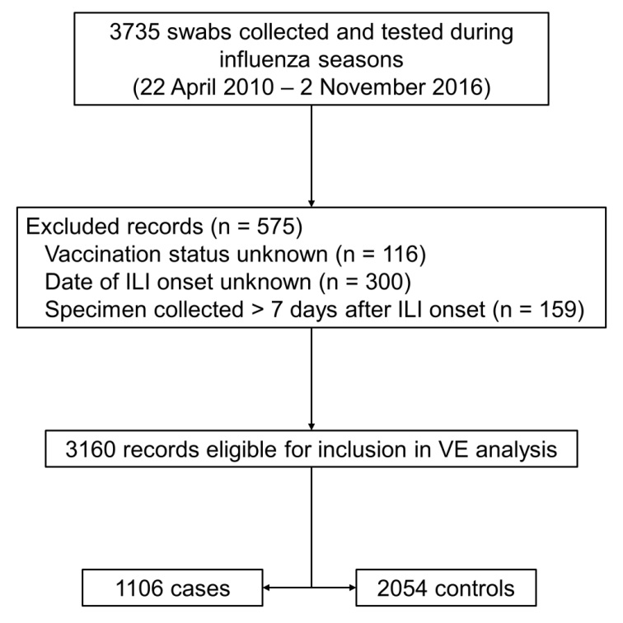
Participants with missing vaccination data did not differ by influenza status: 2.5%, 3.3% and 3.3% of influenza A, influenza B and influenza negative patients were missing vaccination status, respectively. Participants missing symptom onset date did not differ by influenza status (7.8%, 11.0% and 11.4% of influenza A, B and negative patients, respectively) or vaccination status (8.9% and 8.0% of vaccinated and unvaccinated patients, respectively). The proportion of participants with missing vaccination status remained stable over the study period, however the proportion missing symptom onset date increased relatively steadily from 6.7% in 2010 to 13.2% in 2016. There were 1,106 (35.0%) swabs that tested positive for influenza and were designated as cases, and 2,054 that tested negative (65.0%) and were designated as controls. Cases were detected in every week of each season, with seasonal peaks occurring between weeks 33 and 36.
Cases and controls differed in vaccination status (p<0.001). Overall, 27.8% (n=570) of controls and 17.7% (n=196) of cases were vaccinated (Table 1). Cases and controls were comparable in terms of the sex distribution (p=0.104), but cases were younger than controls with median ages of 32 (range: 0–86, IQR: 14–45) and 35 years (range: 0–100, IQR: 22–49), respectively. However, when stratified by season, median age only differed by case status in three seasons (2010, 2011 and 2014, data not shown). The proportion of participants vaccinated increased with age group: 5.6% in those aged under 5 years, 6.3% in 5–17 years, 25.7% in 18–64 years and 75.6% in 65 years and older. The proportion of participants vaccinated did not differ by gender (p=0.150). Of the cases, 76.2% (n=844) had an influenza type A infection and 23.8% (n=263) had an influenza type B infection. 22.7% of participants infected with A(H3N2) were vaccinated compared to 13.5% and 15.2% of participants with A(H1N1) and B, respectively.

Table 1 Characteristics of study participants (n=3160) after exclusions for missing vaccination and influenza data
Characteristic |  |  | Influenza status |  |  |  | Vaccination status*
 | Total | (%) | Negative | (%) | Positive | (%) | Negative | (%) | Positive | (%)
Total | 3160 |  | 2054 | (65.0) | 1106 | (35.0) | 2394 | (75.8) | 766 | (24.2)
Sex
Female | 1556 | (49.2) | 1003 | (48.8) | 553 | (50.0) | 1158 | (74.4) | 398 | (25.6)
Male | 1553 | (49.1) | 1025 | (49.9) | 528 | (47.7) | 1194 | (76.9) | 359 | (23.1)
Unknown | 51 | (1.6) | 26 | (1.3) | 25 | (2.3) | 42 | (82.4) | 9 | (17.6)
Age group
<5 years | 249 | (7.9) | 169 | (8.2) | 80 | (7.2) | 235 | (94.4) | 14 | (5.6)
5-17 years | 462 | (14.6) | 223 | (10.9) | 239 | (21.6) | 433 | (93.7) | 29 | (6.3)
18-64 years | 2260 | (71.5) | 1528 | (74.4) | 732 | (66.2) | 1679 | (74.3) | 581 | (25.7)
≥65 years | 189 | (6.0) | 134 | (6.5) | 55 | (5.0) | 47 | (24.9) | 142 | (75.1)
Vaccinated
No | 2394 | (75.8) | 1484 | (72.2) | 910 | (82.3)
Yes | 766 | (24.2) | 570 | (27.8) | 196 | (17.7)
RT-PCR results†
A (H1N1) | 341 | (30.8) |  |  |  |  | 295 | (86.5) | 46 | (13.5)
A (H3N2) | 467 | (42.2) |  |  |  |  | 361 | (77.3) | 106 | (22.7)
A (untyped) | 36 | (3.3) |  |  |  |  | 32 | (88.9) | 4 | (11.1)
B | 263 | (23.8) |  |  |  |  | 223 | (84.8) | 40 | (15.2)
* reported as the percentages by vaccination status for each row variable
† One unvaccinated patient in 2015 was positive for both influenza A and influenza B

Table 2 Characteristics of ILI patients from which samples were taken (n=3735) as a proportion of all ILI patients (n=5229)
Characteristic | All ILI | Sampled | (%)
Total | 5229 | 3735 | (71.4)
Sex
Female | 2703 | 1853 | (68.6)
Male | 2521 | 1826 | (72.4)
Age group
<5 years | 381 | 288 | (75.6)
5-17 years | 806 | 547 | (67.9)
18-64 years | 3523 | 2662 | (75.6)
≥65 years | 519 | 238 | (45.9)
Vaccinated
No | 3865 | 2718 | (69.9)
Yes | 1285 | 901 | (69.8)

VicSPIN GP swabbing practices
VicSPIN GP swabbing rates did not differ by vaccination status (p=0.976): 69.9% (n=2718) of vaccinated ILI presentations and 69.8% (n=901) of unvaccinated ILI presentations were swabbed (Table 2). Swabbing rates did differ by age group. GPs swabbed 75.6% (n=288) of those aged less than five years, 67.9% (n=547) of 5–17 years, 75.6% of 18–64 years (n=2662) and 45.9% (n=238) of those aged 65 years and older (p<0.001).

The effect of swabbing rate on VE estimates
The overall VE for each season ranged from 16.2% to 74.7% (Figure 2). VE for type A ranged from 7.6% to 74.2% and VE for type B ranged from 46.3% to 79.6%. Three seasons (2010, 2014, and 2016) had sample sizes too small to derive a VE estimate for influenza type B. Apart from 2012, the seasons for which VE for influenza type B could be calculated all produced wide confidence intervals that crossed the null value.
The effect of reducing the swab rate to 20% on sample size for statistical analysis is displayed in Figures 2 and 3. Decreasing the swab rate from the seasonal proportion (mean: 72%) to 50% and 20% did not alter the point VE estimate significantly within any type or year. However, reducing the swab rate widened the 95% confidence intervals, often to the point where they crossed the null value. On six occasions, swabbing at lower rates resulted in too small a sample size to calculate a VE estimate that had been calculated using the actual seasonal proportion data (2011 type A, 2011 type B, 2012 type B, 2013 pooled estimate, 2013 type A, 2013 type B).

Figure 2 Adjusted VE estimates for 2010-2016 for the actual proportion swabbed that season, a 50% sample and a 20% sample. The estimates are stratified by influenza type. VE estimates that were not possible due to small sample size are marked with an asterisk (*). All estimates were adjusted for age group (<5, 5-17, 18-64, ≥65 years) and calendar time (cubic spline function with 4 knots).
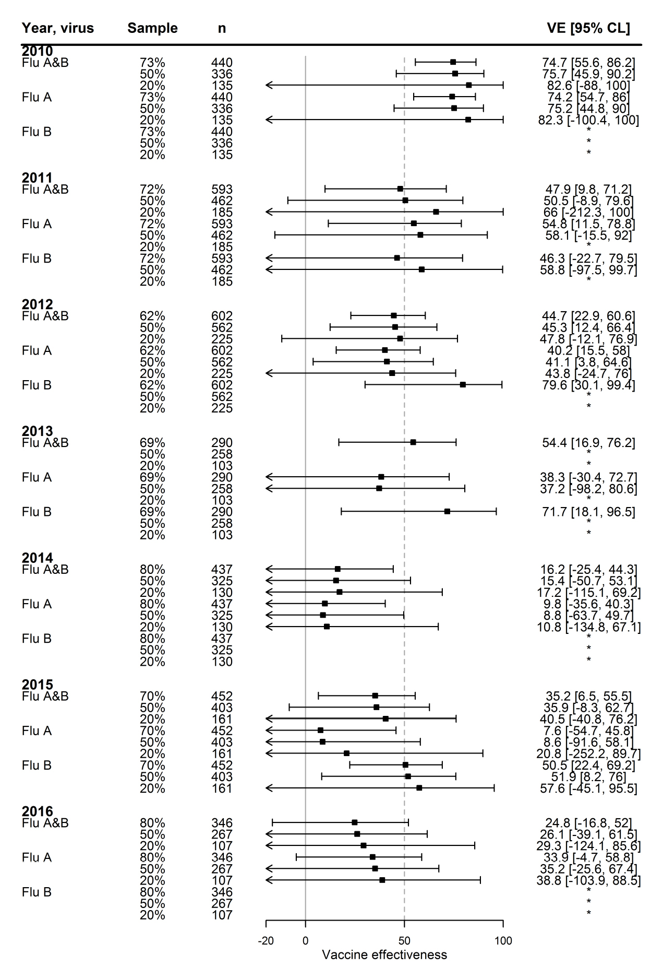

Discussion
Currently, VicSPIN GPs are requested to swab as many ILI patients as possible during the influenza season. As there is no systematic method for this, the patients selected for swabbing and the frequencies at which they are swabbed are not necessarily consistent among GPs. This has the propensity to introduce selection bias¹⁶ and affect rigour of analysis. Factors which may influence the selection of participants include the patient’s vaccination status,¹⁷ actual or perceived seasonal influenza incidence¹⁸ and the GP’s individual preferences.¹⁶
In Victoria during 2010–2016, there was no difference in swabbing rates between vaccinated and unvaccinated patients. However, there was a difference in swabbing rates among age groups. Patients aged 65 years and older were swabbed at a rate of 45.9%, while those aged younger than 65 years were swabbed at a rate of 67.9–75.6%. This underrepresentation of older patients has been acknowledged in the literature.¹⁹ While this study controlled for differences in age by using adjusted logistic regression, many studies in the literature stratify VE estimates by age^{8,9,20,21} or investigate VE for a particular age group,^{13,22} as this may have a bearing on future publicly funded vaccination strategies. Using data from 2012, the season with the highest prevalence of influenza during this study period, VE estimates stratified by age group and virus type could be produced. However, when reduced to a 20% sample, this was no longer possible (data not shown).
Therefore, it may be useful to introduce a strategy wherein sentinel GPs systematically swab a higher proportion of ILI patients aged over 65 years so there are more data available to estimate VE in the elderly, who represent a high-risk group for influenza infection and are associated with poorer disease outcomes^{23,24} and lower VE.²⁵ It would be reasonable to expect the elderly to be disproportionately represented in the ILI surveillance system. However, this age group, which makes up 16% of Victoria’s total population,²⁶ represented only 10% of total ILIs recorded by VicSPIN in 2010–2016. The bulk of patients in the surveillance system are working age adults who are more likely to require medical certificates (67%, compared to 60% of the Victorian population)²⁶. Moreover, the elderly, who are associated with poorer health outcomes, may be more likely to attend hospital. Indeed, the Influenza Complications Alert Network, which is an Australia-wide sentinel hospital-based surveillance system, reported that individuals aged 65 years and older represented almost half of those admitted to hospital with confirmed influenza infection.^{27,28} Therefore, the effect of the low swabbing rate of the elderly on VE estimates was exacerbated by the small number of this age group presenting with an ILI to sentinel GPs.
While decreasing the swabbing rates did not alter the VE point estimates significantly, the sample size of VE analyses is directly reflected in the precision of the derived estimates. The wider confidence intervals observed in this study for smaller samples are consistent with other observations in the literature.²⁹ Additionally, for some years and influenza types, reducing the swabbing rate made it impossible to calculate the VE, further emphasising the need for larger samples for VE analysis. It should be noted that the sample sizes for 50% and 20% swabbing rate estimations were taken as a proportion of total ILI for that season, and assumed no exclusions due to vaccination or influenza status, whereas the VE estimates for actual seasonal data were affected by these exclusions. Approximately 15% (n=575) of specimens were excluded from this analysis, which would further increase the confidence interval width as the sample size decreased.
Ideally, the sample size for VE calculations should be large enough that estimates can be derived by age-group and influenza subtype or a combination of the two, e.g. the protection afforded against H3N2 in the elderly. This is of particular importance given the considerable disparities in VE against influenza in differing age-groups and influenza sub-types.⁹ Moreover, with the smaller number of influenza B cases each season, a greater number of swabs are required to determine VE against influenza B. Improving the study power by increasing the sample size may also ultimately allow stratification on other variables such as vaccine brand,¹⁰ although this would require a more detailed questionnaire, which may be a burden on time-constrained sentinel GPs.
The sample size required to meet these desired outcomes depends on two seasonal factors: the incidence of circulating influenza and the proportion of the source population that is vaccinated. There is variability in the number of ILIs reported each year as a direct result of severity and timing of the epidemic. Thus, assigning an optimal proportion of ILI cases to be swabbed each season is not necessarily an effective technique in enhancing VE analyses and negatively impacts VE estimates in a milder season. This is distinctly apparent when comparing data from the 2012 and 2013 influenza seasons in Victoria. In the period 2010–2016, 2012 produced the largest number of swab samples (n=708), while 2013 produced the smallest (n=359). However, the swabbing rate in 2012 was only 62.9% compared to 69.4% in 2013, suggestive of a more severe influenza season in 2012. Thus, the number of swab samples per year analysed by VicSPIN to produce robust VE estimates should be dictated by the size and severity of the epidemic, rather than an arbitrary systematic rate. Extending the VicSPIN surveillance program by increasing the number of participating GPs should also be considered, though this would be contingent on availability of resources.
While the test-negative design is the favoured method for estimating VE, there remain intrinsic biases that are characteristic of observational studies. A limitation of this study is that it did not control for the confounding effect of certain comorbidities, which can increase an individual’s propensity for influenza infection and their access to free vaccination via public health campaigns.^{19,20,30,31} However, a previous Victorian study found that while comorbidity should theoretically be included in a logistic regression model as a covariate, it was not significant in practice and did not improve model fit.³² This was attributed to the nature of VicSPIN comorbidity data collection, which is recorded as only yes/no for comorbidities targeted by the Australian vaccination program and thus cannot be separated into immunocompromising and non-immunocompromising conditions. Furthermore, the model used in this study did not adjust for prior exposure to influenza by either previous vaccination or infection. Therefore, cross-protection and immunity were not accounted for during statistical analysis which may have resulted in unmeasurable residual confounding.³³ While data on previous influenza infection status is impractical, or more likely impossible, to obtain, given the increasing evidence to suggest previous influenza vaccination affects current season VE³⁴ it may be beneficial for sentinel GPs to collect prior vaccination status in future seasons. Thus, prior exposure to influenza results in unmeasurable residual confounding.³³
We conclude that imposing a swab rate on influenza surveillance GPs reduces the precision of VE estimates. In many cases, the increased uncertainty rendered the estimate ambiguous, particularly where confidence intervals were unhelpfully wide. The descriptive analyses of methods used by VicSPIN GPs to swab patients presenting with ILI stress the importance of systematically sampling the same proportion of patients in each age group, and perhaps the need to oversample the elderly given their underrepresentation in the surveillance system. These findings should be communicated to GPs to refine their swabbing practices, so as to circumvent discrepancies in age groups in future seasons, especially given that influenza infection in the elderly is associated with lower VE and poorer health outcomes.

Figure 3 Comparison of the sample size generated from actual swab numbers by sentinel GPs and the sample size generated using a theoretical 20% swabbing rate, using data from 2012.
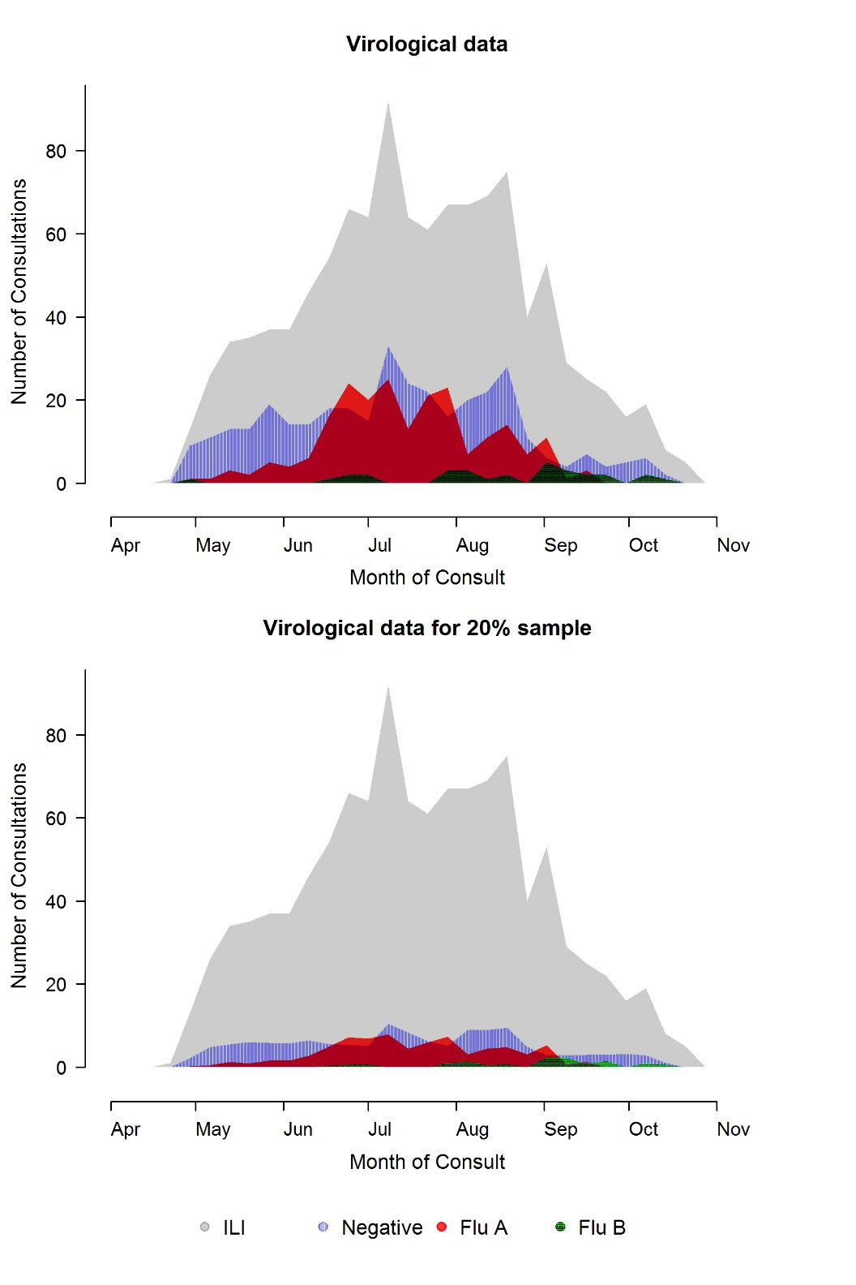

Acknowledgements
We thank the general practitioners, nurse practitioners and practice staff that participated and contributed to VicSPIN. VicSPIN is supported by the Victorian Department of Health and Human Services. The WHO Collaborating Centre for Reference and Research on Influenza is supported by the Australian Government Department of Health.

Author details
Ms Olivia H. Price, Epidemiologist^{1,2}
Ms Kylie S. Carville, Epidemiologist³
Dr Sheena G. Sullivan, Senior Epidemiologist^{1,2}
- WHO Collaborating Centre for Reference and Research on Influenza, at the Peter Doherty Institute for Infection and Immunity, Victoria 3000 Australia
- School of Population and Global Health, University of Melbourne, Melbourne, Australia
- Victorian Infectious Diseases Reference Laboratory, at the Peter Doherty Institute for Infection and Immunity, Victoria 3000 Australia

Corresponding author
Dr Sheena Sullivan
WHO Collaborating Centre for Reference and Research on Influenza
Peter Doherty Institute for Infection and Immunity
792 Elizabeth Street
Melbourne 3000
P: 03 9342 9317
E: sheena.sullivan@influenzacentre.org

References
- Li-Kim-Moy J, Yin JK, Patel C, Beard FH, Chiu C, Macartney KK, et al. Australian vaccine preventable disease epidemiological review series: Influenza 2006 to 2015. Commun Dis Intell Q Rep 2016;40(4):E482– 495.
- Beard F, McIntyre P, Gidding H, Watson M. Influenza related hospitalisations in Sydney, New South Wales, Australia. Arch Dis Child. 2006;91(1):20–25.
- Wood J, Levandowski R. The influenza vaccine licensing process. Vaccine. 2003;21(16):1786–1788.
- Jackson ML, Nelson JC. The test-negative design for estimating influenza vaccine effectiveness. Vaccine. 2013;31(17):2165–2168.
- Barr IG, McCauley J, Cox N, Daniels R, Engelhardt OG, Fukuda K, et al. Epidemiological, antigenic and genetic characteristics of seasonal influenza A (H1N1), A (H3N2) and B influenza viruses: basis for the WHO recommendation on the composition of influenza vaccines for use in the 2009–2010 Northern Hemisphere season. Vaccine. 2010;28(5):1156–1167.
- Sullivan SG, Feng S, Cowling BJ. Potential of the test-negative design for measuring influenza vaccine effectiveness: a systematic review. Expert Rev Vaccines. 2014;13(12):1571–1591.
- Thursky K, Cordova SP, Smith D, Kelly H. Working towards a simple case definition for influenza surveillance. J Clin Virol. 2003;27(2):170–179.
- Kelly H, Carville K, Grant K, Jacoby P, Tran T, Barr I. Estimation of influenza vaccine effectiveness from routine surveillance data. PLoS One. 2009;4(3):e5079.
- Fielding JE, Grant KA, Papadakis G, Kelly HA. Estimation of type-and subtype-specific influenza vaccine effectiveness in Victoria, Australia using a test negative case control method, 2007–2008. BMC Infect Dis. 2011;11(1):170.
- Sullivan S, Carville K, Chilver M, Fielding J, Grant K, Kelly H, et al. Pooled influenza vaccine effectiveness estimates for Australia, 2012–2014. Epidemiol Infect. 2016;144(11):2317–2328.
- Kissling E, Valenciano M, Cohen JM, Oroszi B, Barret A-S, Rizzo C, et al. I-MOVE multi-centre case control study 2010–11: overall and stratified estimates of influenza vaccine effectiveness in Europe. PloS One. 2011;6(11):e27622.
- Chilver M, Blakeley D, Stocks NP. The Australian Sentinel Practices Research Network, 1 October to 31 December 2016. Commun Dis Intell Q Rep. 2017;41(1):E111–E113.
- Kissling E, Valenciano M, Falcao J, Larrauri A, Widgren K, Pitigoi D, et al. I-MOVE towards monitoring seasonal and pandemic influenza vaccine effectiveness: lessons learnt from a pilot multi-centric case-control study in Europe, 2008–9. Euro Surveill. 2009;14(44): pii: 19388.
- Druce J, Tran T, Kelly H, Kaye M, Chibo D, Kostecki R, et al. Laboratory diagnosis and surveillance of human respiratory viruses by PCR in Victoria, Australia, 2002–2003. J Med Virol. 2005;75(1):122–129.
- Nicol K. Efficacy/clinical effectiveness of inactivated influenza virus vaccines in adults. In Nicholson KG, Webster RG, Hay AJ, eds. Textbook of influenza, London: Blackwell Science,1998. p. 358–372.
- Cowie GA, Cowie BC, Fielding JE. Influenza testing trends in sentinel surveillance general practices in Victoria 2007 to 2014. Commun Dis Intell Q Rep. 2017;41(1):E4–9.
- Carville KS, Grant KA, Sullivan SG, Fielding JE, Lane CR, Franklin L, et al. Understanding influenza vaccine protection in the community: an assessment of the 2013 influenza season in Victoria, Australia. Vaccine. 2015;33(2):341–345.
- Moore K, Black J, Rowe S, Franklin L. Syndromic surveillance for influenza in two hospital emergency departments. Relationships between ICD-10 codes and notified cases, before and during a pandemic. BMC Public Health. 2011;11(1):338.
- Kelly HA, Sullivan SG, Grant KA, Fielding JE. Moderate influenza vaccine effectiveness with variable effectiveness by match between circulating and vaccine strains in Australian adults aged 20–64 years, 2007–2011. Influenza Other Respir Viruses. 2013;7(5):729–737.
- Fielding J, Grant K, Tran T, Kelly H. Moderate influenza vaccine effectiveness in Victoria, Australia, Euro Surveill. 2012;17(11):pii:20115.
- Kissling E, Valenciano M, Buchholz U, Larrauri A, Cohen J, Nunes B, et al. Influenza vaccine effectiveness estimates in Europe in a season with three influenza type/subtypes circulating: the I-MOVE multicentre case-control study, influenza season 2012/13. Euro Surveill. 2014;19:pii: 20701.
- Cowling BJ, Chan K-H, Feng S, Chan EL, Lo JY, Peiris JM, et al. The effectiveness of influenza vaccination in preventing hospitalizations in children in Hong Kong, 2009–2013. Vaccine. 2014;32(41):5278–5284.
- Iuliano AD, Roguski KM, Chang HH, Muscatello DJ, Palekar R, Tempia S, et al. Estimates of global seasonal influenza-associated respiratory mortality: a modelling study. Lancet. 2018;391(10127):1285–1300.
- Newall AT, Wood JG, Macintyre CR. Influenza-related hospitalisation and death in Australians aged 50 years and older. Vaccine. 2008;26(17):2135–2141.
- Rondy M, El Omeiri N, Thompson MG, Leveque A, Moren A, Sullivan SG. Effectiveness of influenza vaccines in preventing severe influenza illness among adults: A systematic review and meta-analysis of test-negative design case-control studies. J Infect. 2017;75(5):381–394.
- ‘Victoria (C) (Statistical Region)’ [Internet]. Australian Bureau of Statistics,. 2016 [cited 10 December 2018]. Available from: https://www.abs.gov.au/websitedbs/D3310114.nsf/home/census.
- Cheng AC, Holmes M, Dwyer DE, Irving LB, Korman TM, Senenayake S, et al. Influenza epidemiology in patients admitted to sentinel Australian hospitals in 2015: the Influenza Complications Alert Network. Commun Dis Intell Q Rep. 2016;40(4):E521–E526.
- Cheng AC, Holmes M, Dwyer DE, Irving L, Korman T, Senenayake S, et al. Influenza epidemiology in patients admitted to sentinel Australian hospitals in 2016: the Influenza Complications Alert Network (FluCAN). Commun Dis Intell Q Rep. 2017;41(4):E337–E347. PubMed.
- Valenciano M, Kissling E, Ciancio BC, Moren A. Study designs for timely estimation of influenza vaccine effectiveness using European sentinel practitioner networks. Vaccine. 2010;28(46):7381–7388.
- Department of Health. Influenza Canberra, Australia: Australian Government Department of Health 2017 [cited 2018 February 5]. Available from: http://www.immunise.health.gov.au/internet/immunise/publishing.nsf/Content/Handbook10-home~handbook10part4~handbook10-4-7 .
- Beck CR, McKenzie BC, Hashim AB, Harris RC, Zanuzdana A, Agboado G, et al. Influenza vaccination for immunocompromised patients: systematic review and meta-analysis from a public health policy perspective. PLoS One. 2011;6(12):e29249.
- Lane C, Carville KS, Pierse N, Kelly H. Seasonal influenza vaccine effectiveness estimates: Development of a parsimonious case test negative model using a causal approach. Vaccine. 2016;34(8):1070–1076.
- Sullivan SG, Tchetgen Tchetgen EJ, Cowling BJ. Theoretical basis of the test-negative study design for assessment of influenza vaccine effectiveness. Am J Epidemiol. 2016;184(5):345–353.
- Petrie JG, Monto AS. Untangling the Effects of Prior Vaccination on Subsequent Influenza Vaccine Effectiveness. J Infect Dis. 2017;215(6):841–843.

Communicable Diseases Intelligence
ISSN: 2209-6051 Online

Communicable Diseases Intelligence (CDI) is a peer-reviewed scientific journal published by the Office of Health Protection, Department of Health. The journal aims to disseminate information on the epidemiology, surveillance, prevention and control of communicable diseases of relevance to Australia.

Editor: Cindy Toms
Deputy Editor: Simon Petrie
Design and Production: Kasra Yousefi
Editorial Advisory Board: David Durrheim, Mark Ferson, John Kaldor, Martyn Kirk and Linda Selvey

Website: http://www.health.gov.au/cdi

Contacts
Communicable Diseases Intelligence is produced by:
Health Protection Policy Branch, Office of Health Protection, Australian Government Department of Health
GPO Box 9848, (MDP 6) CANBERRA ACT 2601

Email: cdi.editor@health.gov.au

Submit an Article
You are invited to submit your next communicable disease related article to the Communicable Diseases Intelligence (CDI) for consideration. More information regarding CDI can be found at: http://health.gov.au/cdi.
Further enquiries should be directed to: cdi.editor@health.gov.au.

This journal is indexed by Index Medicus and Medline.

Creative Commons Licence - Attribution-NonCommercial-NoDerivatives CC BY-NC-ND
© 2019 Commonwealth of Australia as represented by the Department of Health
This publication is licensed under a Creative Commons Attribution-NonCommercial-NoDerivatives 4.0 International Licence from https://creativecommons.org/licenses/by-nc-nd/4.0/legalcode (Licence). You must read and understand the Licence before using any material from this publication.

Restrictions
The Licence does not cover, and there is no permission given for, use of any of the following material found in this publication (if any):
- the Commonwealth Coat of Arms (by way of information, the terms under which the Coat of Arms may be used can be found at www.itsanhonour.gov.au);
- any logos (including the Department of Health’s logo) and trademarks;
- any photographs and images;
- any signatures; and
- any material belonging to third parties.

Disclaimer
Opinions expressed in Communicable Diseases Intelligence are those of the authors and not necessarily those of the Australian Government Department of Health or the Communicable Diseases Network Australia. Data may be subject to revision.

Enquiries
Enquiries regarding any other use of this publication should be addressed to the Communication Branch, Department of Health, GPO Box 9848, Canberra ACT 2601, or via e-mail to: copyright@health.gov.au

Communicable Diseases Network Australia
Communicable Diseases Intelligence contributes to the work of the Communicable Diseases Network Australia.
http://www.health.gov.au/cdna

