Respiratory viruses in adults hospitalised with Community-Acquired Pneumonia during the non-winter months in Melbourne: Routine diagnostic practice may miss large numbers of influenza and respiratory syncytial virus infections.
Lucy A Desmond, Melanie A Lloyd, Shelley A Ryan, Edward D Janus and Harin A Karunajeewa

Abstract

Background
Community-Acquired Pneumonia (CAP) is one of the highest health burden conditions in Australia. Disease notifications and other data from routine diagnosis suffers from selection bias that may misrepresent the true contribution of various aetiological agents. However existing Australian prospective studies of CAP aetiology have either under-represented elderly patients, not utilised Polymerase Chain Reaction (PCR) diagnostics or been limited to winter months. We therefore sought to re-evaluate CAP aetiology by systematically applying multiplex PCR in a representative cohort of mostly elderly patients hospitalised in Melbourne during non-winter months and compare diagnostic results with those obtained under usual conditions of care.

Methods
Seventy two CAP inpatients were prospectively enrolled over 2 ten-week blocks during non-winter months in Melbourne in 2016-17. Nasopharyngeal and oropharyngeal swabs were obtained at admission and analysed by multiplex-PCR for 7 respiratory viruses and 5 atypical bacteria.

Results
Median age was 74 (interquartile range 67-80) years, with 38 (52.8%) males and 34 (47.2%) females. PCR was positive in 24 (33.3%), including 12 Picornavirus (50.5% of those with a virus), 4 RSV (16.7%) and 4 influenza A (16.7%). CAP-Sym questionnaire responses were similar in those with and without viral infections. Most (80%) pathogens detected by the study, including all 8 cases of influenza and RSV, were not otherwise detected by treating clinicians during hospital admission.

Conclusion
One third of patients admitted with CAP during non-winter months had PCR-detectable respiratory viral infections, including many cases of influenza and RSV that were missed by existing routine clinical diagnostic processes.
Keywords: Lower Respiratory Tract Infection (LRTI), Community-Acquired Pneumonia (CAP) Polymerase Chain Reaction (PCR), Influenza, Respiratory Syncytial Virus

Background
Community Acquired Pneumonia (CAP) is Australia’s sixth leading cause of death and the leading non-obstetric cause of hospital admission.^{1,2} A number of factors may have compromised our understanding of CAP aetiology in Australia. Firstly, information on the microbial aetiology of CAP derived from notification data and other routine diagnosis is compromised by selection and ascertainment biases, highly variable approaches to diagnostic testing and the limited scope of existing surveillance and mandatory reporting processes. Secondly, most of Australia’s CAP healthcare burden manifests in patients over age 65 who now account for 73% of hospital bed stays for CAP.² However this group has, in many ways been understudied relative to younger, more diagnostically homogeneous populations.³ Research studies of CAP aetiology therefore risk under-representing the population in which the greatest burden occurs. Thirdly, previous Australian studies examining CAP aetiology have been limited mainly to winter months⁴⁻⁹ even though these months may only account for <30% of the total annual burden of CAP in Australia.¹⁰ Therefore, we designed a prospective study with the following objectives:
- To describe respiratory viral and atypical bacterial pathogen prevalence by multiplex Polymerase Chain Reaction (PCR) in a representative group of adult patients with CAP during non-winter months.
- To compare diagnostic yields from systematic application of multiplex PCR in all CAP patients with those achieved by routine clinician-initiated testing under usual conditions of clinical care.

Methodology

Study Site and Population
Patients admitted under the General Internal Medicine (GIM) service at Sunshine and Footscray campuses of Western Health, a 890 bed tertiary health service servicing >700,000 people in Western Melbourne. GIM manages approximately 70% of all CAP admissions (approximately 1000 per year).¹¹

Ascertainment and Eligibility
Participants were enrolled as a sub-study of a currently ongoing health services improvement program evaluation, “Evaluating the impact of a new model of care designed to improve evidence-based management of community acquired pneumonia (IMPROVE-GAP)” (Clinical trials registration number: NCT02835040). IMPROVE-GAP prospectively identifies all GIM admissions (adults≥18) meeting a standardised case definition of CAP: new evidence of consolidation on chest X-ray plus at least one of cough, sputum production, dyspnoea, core body temperature ≥38.0C°, auscultatory findings of abnormal breathing sounds or rales, leucocyte count >10,000/μl or <4000/μl. Patients palliated on admission were not included. Exclusion criteria for this sub-study included inability to provide informed consent whether due to: cognitive impairment, impaired conscious state, receiving airway/ventilatory support, or poor English. Consecutive eligible participants identified during two discrete 10-week blocks during spring, summer and autumn (10 October-18 December 2016 (Round 1) and 14 February-24 April 2017 (Round 2)) were invited to participate.

Enrolment procedures
Written informed consent was obtained from all participants. Each participant had both a nasopharyngeal and oropharyngeal swab taken with a flocked swab rotated 5 times and held in place for 5-10 seconds before transfer to 1-3ml of viral transport media, with interim storage at -20°C. In subjects able to expectorate, sputum was stored at -20°C. Enrolment and sampling occurred on the first morning following admission (generally 12-24 hours after presentation) and was performed independently of treating clinical teams, regardless of whether or not separate requests for PCR testing had already been made through routine care processes. Research samples generated by this study were performed many weeks after collection so results were not available to clinicians in “real time” during the patient’s hospital stay. However, for ethical reasons, positive results were communicated to treating clinicians and notified to the Victorian Department of Health once they became available.

Laboratory investigations
Swabs and sputum specimens were evaluated using a proprietary 16PLEX-PCR kit (Ausdiagnostics). The panel included respiratory viruses (Respiratory Syncytial Virus (RSV), Influenza A, Influenza B, Parainfluenza, Adenovirus, Human Metapneumovirus, Picornavirus), Bordetella species (Bordetella Pertussis, Bordetella Parapertussis) and atypical bacteria (Mycoplasma pneumoniae, Chlamydiaceae, Legionella species). We also recorded when PCR testing was requested separately by the treating team as part of routine care and whether infection prevention measures were instituted.

Additional demographic and clinical data
Prospectively collected data included demographic information, co-morbidities (including 19 co-morbidity groupings used to generate a Charlson’s co-morbidity score¹²), vital signs, a pneumonia severity assessment (CORB score)¹¹ and a standardised symptomatology questionnaire designed specifically for CAP (the CAP-Sym questionnaire)¹³. Results of all routine investigations were also recorded including estimated glomerular filtration rate (eGFR), C-reactive protein, white cell count and chest X-ray (based on the final radiologist report and classified as “normal”, “new unilateral infiltrate”, “new bilateral infiltrate” or “no new changes”).

Statistical Analysis
Study data were collected and managed using REDCap electronic data capture tools hosted at The University of Melbourne. For analysis, all data was exported to Microsoft Excel and STATA (STATA Corp, version 14).
Continuous variables are presented as mean ± standard deviation (SD) or, if non-normally distributed, as median (range or interquartile range). Categorical variables are presented as proportions (%).

Results

Patient characteristics
Of the 204 CAP patients admitted under GIM and enrolled in IMPROVE-GAP during the recruitment periods, 114 (56%) were eligible of whom 72 (63%) consented to participate). Participants’ median age was 74 (interquartile range 67 – 80 years). Those with a PCR-detected influenza or RSV had similar baseline demographic and clinical characteristics to those without (Table 1), although the influenza/RSV infection group was somewhat younger (62.8 vs 73.9). Markers of disease severity at baseline, including CORB score, CRP, white cell count and chest X-ray report were also broadly similar in the two groups.
Table 1: Baseline characteristics of 72 hospitalised adult patients with Community-Acquired Pneumonia according to presence or absence of influenza or RSV.
Variable |  | Influenza, rsv detected  (N = 8) |  | Influenza, rsv not detected  (n = 64)
Age (years) |  | 62.8 | +/- 19.3 | 72.9 | +/- 11.6
Sex male |  | 6 | (75.0) | 32 | (50.0)
Living in supported accommodation or aged care facility |  | 1 | (12.5) | 6 | (9.4)
Comorbidity | Chronic obstructive pulmonary disease (copd) | 4 | (50.0) | 41 | (64.0)
 | Chronic cardiac failure (ccf) | 1 | (12.5) | 19 | (29.7)
 | Chronic kidney disease | 0 | (0) | 6 | (9.4)
 | Dementia | 0 | (0) | 1 | (1.6)
 | Diabetes | 1 | (12.5) | 28 | (43.8)
 | Myocardial infarction (mi) | 2 | (25.0) | 17 | (26.6)
Charlson cormorbidity index | ≤ 2 | 6 | (75.0) | 34 | (53.1)
 | > 2 | 2 | (25.0) | 30 | (46.9)
Number baseline medications |  | 5.3 | +/- 4.7 | 7.7 | +/- 5.3
Laboratory investigations | Egfr (ml/min/1.73M2) | 73 | [68.5 – 79.8] | 67 | [44.8 – 83.8]
 | C-reactive protein (mg/l) | 87 | [54.5 – 224.3] | 114 | [57.3 – 226.0]
 | White cell count (x109/l) | 13.1 | [9.9 – 16.9] | 11.7 | [9.9 – 15.9]
 | Mycoplasma (pcr and serology) | 0 | (0) | 1 | (1.6)
Radiologist’s chest radiograph report | Clear lung fields | 2 | (25.0) | 13 | (20.3)
 | New unilateral infiltrate | 3 | (37.5) | 29 | (45.3)
 | New multilateral infiltrate | 3 | (37.5) | 17 | (26.6)
 | Nil new changes | 0 | (0) | 5 | (7.8)
Corb score | ≤ 1 | 6 | (75.0) | 48 | (75.0)
 | ≥ 2 | 2 | (25.0) | 16 | (25.0)
Data are mean +/- SD, median [interquartile range] or number (%).

Figure 1: PCR detection by pathogen in 72 participants hospitalised with CAP.
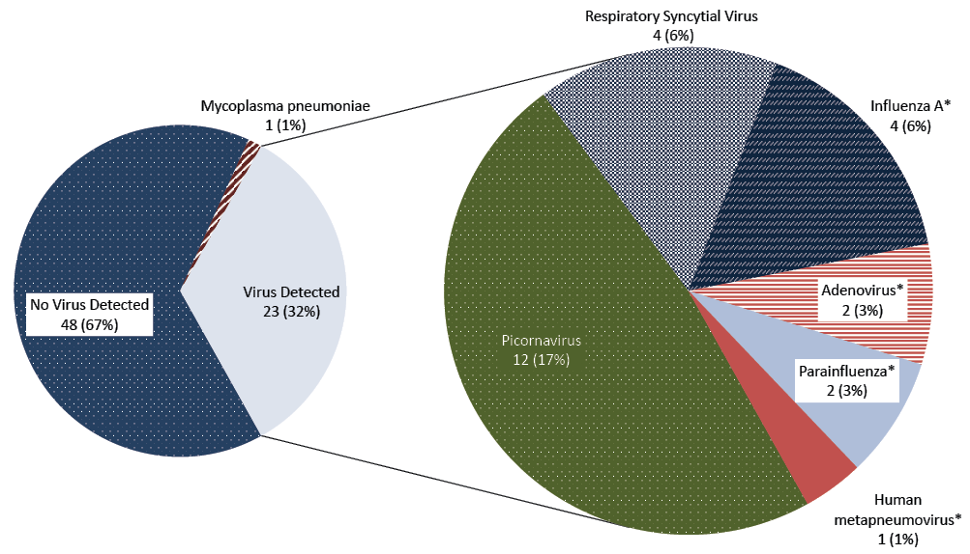
* In two participants two viruses were detected (Parainfluenza & Influenza A, Adenovirus & Human Metapneumovirus) hence % does not add up to 32%.

Pathogen prevalence by multiplex-PCR
A pathogen was detected in 24 individuals (33.3%) including two with co-infections with >1 virus. Because sputum samples were available in only 11 (15%), most were detected in upper respiratory swab specimens. Oral and nasal swabs yielded concordant results for most viruses (data not shown) except that of 4 RSV infections detected on oral swab, only one was positive by nasal swab. Picornavirus was the most commonly identified followed by RSV (four participants aged 32, 38, 69 and 87) and influenza A (four participants aged 59, 64, 72 and 81) (Figure 1). On further enquiry, 3 of 4 participants with positive influenza A PCR had a recent history of international travel (all recently returned from separate cruise ship holidays). Mycoplasma pneumoniae was the only atypical bacteria detected by PCR (a single case in a female aged 37 - confirmed by positive Mycoplasma IgM). Serology (for Chlamydia, Legionella pneumophila, Legionella longbeachae and Mycoplasma pneumoniae performed in 16) and urinary legionella antigen testing (n=39) requested by treating teams (i.e. non-research investigations performed at the discretion of clinicians) did not identify other possible atypical bacterial infections. Bacteriologic investigations performed by treating teams on the same 72 patients identified possible pneumococcal infection in 1 of 23 (4%) sputum samples, 2 of 38 (5%) urinary pneumococcal antigen assays and 0 of 46 (0%) blood cultures. No other pathogens were detected through investigations ordered by clinical teams.

Symptomatology
CAP-Sym questionnaire responses in those with either influenza or RSV infections were broadly similar to those without (Figure 2).

Figure 2: CAP-Sym questionnaire responses in participants with influenza or RSV infections vs those without influenza or RSV.
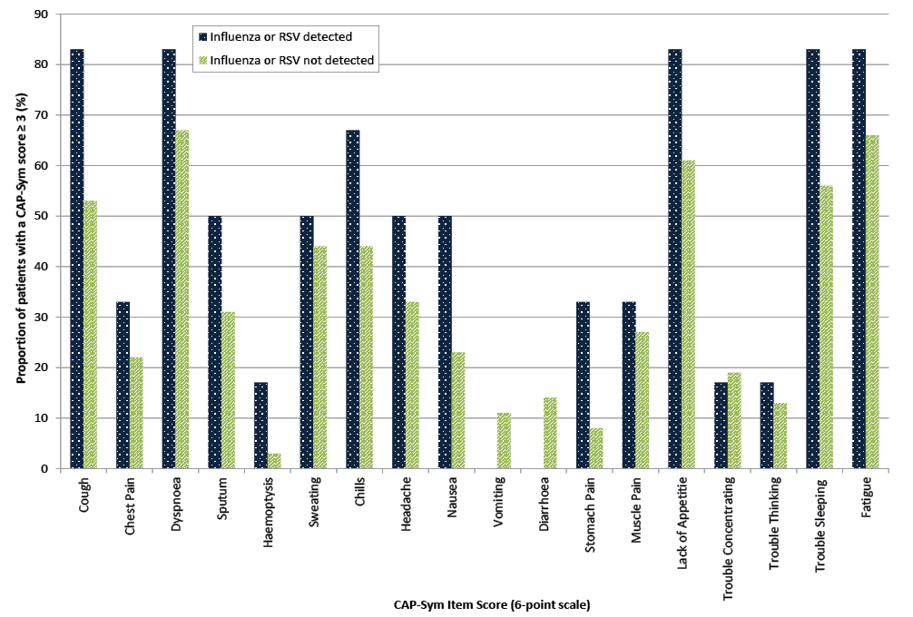

Comparison with viral testing performed through routine clinical diagnostic practice
Treating teams managing enrolled participants requested viral PCR testing in only 4 patients, yielding positive results in only one (parainfluenza) and instituted infection prevention precautions (respiratory isolation) in only 3 patients, including the sole parainfluenza PCR-positive patient and 2 others who had negative PCR testing. Therefore, once results of research testing had become available it became clear that 23 PCR-positive participants, including 4 with influenza A and 4 with RSV had been managed on the ward without respiratory precautions, and had not been notified to public health authorities prior to these research results becoming available.

Discussion
This prospective study, performed in a representative sample of hospitalised, mostly elderly CAP patients in an urban Australian setting, adds to existing information by demonstrating unexpectedly high overall rates of respiratory virus detection in non-winter months. These included cases of RSV and influenza that appear to be being “missed” by routine clinical diagnostic processes and that therefore may be posing a previously under-recognized threat of nosocomial infection. It suggests that the importance of respiratory viruses in CAP during the non-winter months may be under-appreciated simply because they are not being tested for during this time of the year. Large recent increases in the numbers of Australians traveling to the Northern hemisphere and tropical regions during Southern hemisphere non-winter months may also be a factor, as demonstrated by 3 of our participants with influenza having recently returned from cruise ship holidays.

Prevalence of respiratory viruses in CAP patients
By way of comparison, the most comprehensive existing evaluation of CAP aetiology in Australia is a multi-site study conducted over 3 years (2004-2006) by the Australian CAP Study (ACAPS) collaboration.⁴ Utilising a combination of PCR diagnostics and serology and enrolling cases predominantly (>95%) in winter, they demonstrated an overall prevalence of respiratory viruses of 15%, less than half that seen in our study. Consequently, the much higher prevalence seen during non-winter months in our 2016/17 study was unexpected. Possible explanations could include, firstly, that ours was a relatively small study conducted over a 6-month period at just 2 sites in close geographic proximity. Therefore, it may have reflected local or short-term epidemiological factors coinciding with our enrolment period. Secondly, our population was generally somewhat older and with higher prevalence of co-morbidities than the ACAPS study. This is consistent with previous data suggesting higher rates of virus detection in elderly patients with CAP^{14,15} and may reflect a lower threshold for hospital admission in this group due to their underlying frailty. Thirdly, technical factors (related to specimen collection, storage or the particular PCR platform used) may have influenced the diagnostic yields in the two studies.¹⁶
The observed difference in viral detection compared with ACAPS was due mainly to the high rates of picornavirus in our study. Although this might have reflected local factors, existing data suggests that although transmission peaks in winter, unlike influenza, year-round transmission is the norm.¹⁷⁻¹⁹ Moreover, studies from Europe and North America have shown similar rates to ours, especially in elderly CAP patients.²⁰⁻²³ The picornavirus genera (which includes rhinovirus) are generally considered low-grade viral pathogens.^{18,24} Nonetheless it is notable that in the ACAPS study, of all pathogens, the identification of picornavirus carried the strongest association with requirement for ventilator or vasopressor support.⁴ Other recent studies have described a higher mortality than with influenza in the hospitalised elderly.²⁵

Symptomatology of viral infections.
CAP can present with any combination of respiratory, gastrointestinal, neurological and systemic symptoms.²⁶ We were able to characterize these in a standardised way in our sample using an established, validated tool (the CAP-Sym questionnaire). Although our sample size was small, symptom patterns for the 18 individual symptoms evaluated by CAP-Sym were broadly similar in those with and without influenza or RSV. This is consistent with the poor utility of symptomatology in predictive aetiological diagnostic models for differentiating “viral” from “non-viral” CAP^{27,28} and for “ruling-out” influenza on purely clinical grounds.²⁹⁻³² At our centre, as in most Australian hospitals, PCR testing for influenza and RSV is performed at the discretion of treating clinicians. Therefore, individual clinicians are likely to base decisions on whether or not to test on their own perceived “pre-test probability” of the likelihood of infection. This perception may be influenced by (1) the clinical symptoms and (2) epidemiological factors (such as the season during which the illness occurs). Our study, together with existing evidence²⁹⁻³², suggests the basis of this decision making may be flawed on both counts, as borne out by the high proportion of “missed” cases of influenza and RSV at our centre.

Limitations and Strengths
Our study’s strengths included its use of a suitably representative population and systematic application of a consistent diagnostic strategy. In Australia, >70% of hospital bed occupancy for adult CAP is in patients aged ≥70 and 55% in those ≥75.² Therefore, our study’s median age of 74 whilst higher than in other studies⁴, was representative of Australia’s true healthcare burden. By enrolling participants in the non-winter months, it addresses an important local knowledge gap. However, caution should be exercised in generalising its results due to its dual-centre design, small sample size and narrow sampling timeframe. Also, because asymptomatic carriage of many respiratory viruses is common, assumptions regarding causality can be difficult in a study such as ours that lacked a healthy control group for comparison.

Conclusion
This study adds to existing knowledge by detecting viral respiratory pathogens in one third of adult patients admitted with a diagnosis of CAP under a GIM service during the non-winter months. It reinforces how difficult, if not impossible, it is to predict the presence of viral infections at the time of admission based purely on symptomatology, existing routine diagnostic tests and “seasonality”. It demonstrates how discretionary testing based on “clinical suspicion” can miss a large proportion of influenza and RSV infections. These are highly transmissible in healthcare settings where they are associated with significant morbidity and mortality, especially in vulnerable populations such as the frail elderly admitted to GIM wards.⁶ Our study adds to existing data suggesting that, rather than the application of clinical algorithms or “discretionary” testing that have poor negative predictive value, the only way to reliably exclude these important potential agents of nosocomial infection in CAP patients is routine use of an appropriately high sensitivity diagnostic test.^{21,33} However, at present complex issues of diagnostic costs, diagnostic delay and other resource utilisation implications (such as the availability and use of suitable isolation facilities) also need to be factored into the “risk-benefit equation” when considering alternative approaches. At our study hospitals, like many others in Australia, the need to institute respiratory isolation procedures in anyone tested for influenza (pending results that may not be available for >24 hours) creates additional stresses on hospital resources, and can therefore represent a perverse disincentive that actually discourages testing. This may have been a factor explaining the high numbers of “missed” influenza and RSV in our study. Newer testing platforms with more rapid turnaround times may help alleviate this problem but the clinical utility and cost effectiveness of these tools has not yet been reported. Our study suggests that a more comprehensive testing strategy (applying high sensitivity diagnostics to all CAP patients) could unmask a currently hidden significant disease burden and therefore could help reduce risks of nosocomial infection. Our study also suggests it is important that review of current hospital policy approaches should be considered for both winter and non-winter months.

List of abbreviations
Abbreviation | Definition
ACAPS | Australian CAP Study⁴
CAP | Community Acquired Pneumonia
eGFR | Estimated Glomerular Filtration Rate
GIM | General Internal Medicine
IMPROVE-GAP | “Evaluating the impact of a new model of care designed to improve evidence-based management of community acquired pneumonia” (Clinical trials registration number: NCT02835040)
PCR | Polymerase Chain Reaction
RSV | Respiratory Syncytial Virus
SD | Standard Deviation

Declarations

Ethics approval and consent to participate
The study was approved by the Melbourne Health Human Research Ethics Committee (MH2016.178).
Written informed consent was obtained from all participants. Patient anonymity is preserved within the text of this manuscript.

Consent for publication
Not applicable.

Competing interests
The authors declare that they have no competing interests

Funding
The study was supported by a grant from the HCF research foundation. The funder had no role in study design or analysis. Harin Karunajeewa is supported by an Australian National Health Medical Research Career Development Fellowship. Melanie Lloyd is supported by an Australian Research Training Scheme Scholarship.

Authors’ contributions
LD coordinated data collection and participant recruitment, analysed and interpreted data, and drafted and revised the manuscript. HK conceived and designed the study, contributed to finalisation of the study protocol, analysis and interpretation of results, and revised the manuscript for intellectually important content. EJ and ML contributed to the conception and design of the study, coordinated the ethics submission and statistical analysis, and assisted with preparation of the manuscript. SR contributed significantly to participant recruitment and data collection. All authors read and approved the final manuscript.

Acknowledgements
Codey Lyon, Kate Ryan, Stephanie Lowe, Emma Jovanovic and Mia Wolff contributed significantly to patient recruitment and assessment.

Author Details
Dr. Lucy A Desmond, B-BMED MD, Doctor¹
Ms Melanie A Lloyd, BComm, BA, MPhtySt, Physiotherapist, PhD candidate¹
Ms Shelley A Ryan, BN , Registered Nurse²
Prof Edward D Janus, MD, PhD FRACP, Head of Unit, General Internal Medicine³
A/Prof Harin A Karunajeewa, MBBS, PhD, FRACP,Director, Clinical Research^{4,5}
- Department of Medicine, Melbourne Medical School – Western Health, University of Melbourne
- Western Health
- Department of Medicine, Melbourne Medical School – Western Health, University of Melbourne General Internal medicine Unit, Western Health, St Albans, Vic
- Department of Medicine, Melbourne Medical School – Western Health, University of Melbourne General Internal medicine Unit, Western Health, St Albans, Vic
- The Walter and Eliza Hall Institute of Medical Research, Parkville

Corresponding author
Lucy A Desmond
Postal Address: Western Health, 176 Furlong Road, St. Albans 3021
Email Address: lucyannedesmond@gmail.com

References
- Australian Institute of Health and Welfare (AIHW). Australia’s hospitals 2015-16 at a glance [Internet]. Canberra: Australian Institute of Health and Welfare. https://www.aihw.gov.au/reports/hospitals/australias-hospitals-at-a-glance-2015-16/contents/table-of-contents. Accessed 14 September 2017.
- Australian Institute of Health and Welfare (AIHW). Separation statistics by principal diagnosis in ICD-10-AM, Australia, 2013−14 to 2014−15 [Internet]. Canberra: Australian Institute of Health and Welfare. https://reporting.aihw.gov.au/Reports/openRVUrl.do. Accessed 14 September 2017.
- Williams, E., E. Janus, and H. Karunajeewa, Author reply. Int Med J. 2014;44(11):1149.
- Charles P, Whitby M, Fuller A, Stirling R, Wright A, Korman T et al. The Etiology of Community‐Acquired Pneumonia in Australia: Why Penicillin plus Doxycycline or a Macrolide Is the Most Appropriate Therapy. Clin Infect Dis. 2008;46(10):1513-21.
- Druce J, Tran T, Kelly H, Kaye M, Chibo D, Kostecki R et al. Laboratory diagnosis and surveillance of human respiratory viruses by PCR in Victoria, Australia, 2002-2003. J Med Virol. 2004;75(1):122-9.
- Sharma S, Sneath E, Cheng AC, Friedman ND. Community-acquired syndromes causing morbidity and mortality in Australia. Commun Dis Intell Q Rep, 2017;41(1):E49-57.
- Wilson P, Ferguson J. Severe community-acquired pneumonia: an Australian perspective. Intern Med J. 2005;35(12):699-705.
- Arden K, McErlean P, Nissen M, Sloots T, Mackay I. Frequent detection of human rhinoviruses, paramyxoviruses, coronaviruses, and bocavirus during acute respiratory tract infections. J Med Virol. 2006;78(9):1232-40.
- Ingarfield S, Celenza A, Jacobs I, Riley T. The bacteriology of pneumonia diagnosed in Western Australian emergency departments. Epidemiol Infect. 2007;135(8):1376-83.
- Australian Institute of Health and Welfare (AIHW). Asthma, chronic obstructive pulmonary disease and other respiratory diseases in Australia. Canberra: Australian Institute of Health and Welfare (AIHW). https://www.aihw.gov.au/getmedia/0b5e6ea6-0a53-4d3e-890b-87688b233216/10518.pdf.aspx?inline=true. Accessed 14 September 2017.
- Williams E, Girdwood J, Janus E, Karunajeewa H. CORB is the best pneumonia severity score for elderly hospitalised patients with suspected pneumonia. Intern Med J. 2014;44(6):613-615.
- Charlson M, Pompei P, Ales K, MacKenzie C. A new method of classifying prognostic comorbidity in longitudinal studies: Development and validation. J Chronic Dis. 1987;40(5):373-383.
- Lamping DL, Schroter S, Marquis P, Marrel A, Duprat-Lomon I, Sagnier PP. The Community-Acquired Pneumonia Symptom Questionnaire: A New, Patient-Based Outcome Measure To Evaluate Symptoms in Patients With Community-Acquired Pneumonia. Chest, 2002;122(3):920-9.
- Millett E, Quint J, Smeeth L, Daniel R, Thomas S. Incidence of Community-Acquired Lower Respiratory Tract Infections and Pneumonia among Older Adults in the United Kingdom: A Population-Based Study. PLoS ONE. 2013;8(9):e75131.
- High K. Pneumonia in older adults. Postgrad Med J. 2005;118(4):18-28.
- Chan Y, Morris A. Molecular diagnostic methods in pneumonia. Curr Opin Infect Dis. 2007;20(2):157-64.
- Metlay JP, Fishman NO, Joffe M, Edelstein PH. Impact of pediatric vaccination with pneumococcal conjugate vaccine on the risk of bacteremic pneumococcal pneumonia in adults. Vaccine. 2006;24(4):468-75.
- Jacobs S, Lamson D, St. George K, Walsh T. Human Rhinoviruses. Clin Micro Rev. 2013;26(1):135-62.
- Atmar R. Editorial Commentary: Uncommon(ly Considered) Manifestations of Infection with Rhinovirus, Agent of the Common Cold. Clin Infect Dis. 2005;41(2):266-7.
- Jain S, Self WH, Wunderink RG, Fakhran S, Balk R, Bramley AM et al. Community-Acquired Pneumonia Requiring Hospitalization among U.S. Adults. N Engl J Med. 2015;373(5):415-27.
- Jennings L, Anderson T, Beynon K, Chua A, Laing R, Werno A et al. Incidence and characteristics of viral community-acquired pneumonia in adults. Thorax. 2008;63(1):42-8.
- Holter J, Müller F, Bjørang O, Samdal H, Marthinsen J, Jenum P et al. Etiology of community-acquired pneumonia and diagnostic yields of microbiological methods: a 3-year prospective study in Norway. BMC Infect Dis. 2015;15(1):64
- Gadsby N, Russell C, McHugh M, Mark H, Conway Morris A, Laurenson I et al. Comprehensive Molecular Testing for Respiratory Pathogens in Community-Acquired Pneumonia. Clin Infect Dis. 2016;62(7):817-23.
- Pavia AT, What is the Role of Respiratory Viruses in Community-Acquired Pneumonia?: What is the Best Therapy for Influenza and Other Viral Causes of Community-Acquired Pneumonia? Infect Dis Clin North Am. 2013;27(1):157-75.
- Hung I, Zhang A, To K, Chan J, Zhu S, Zhang R et al. Unexpectedly Higher Morbidity and Mortality of Hospitalized Elderly Patients Associated with Rhinovirus Compared with Influenza Virus Respiratory Tract Infection. Int J Mol Sci. 2017;18(2):259.
- Prina E, Ranzani O, Torres A. Community-acquired pneumonia. Lancet. 2015;386(9998):1097-108.
- Liu Y, Gao Y, Chen M, Cao B, Yang X, Wei L. Etiological analysis and predictive diagnostic model building of community-acquired pneumonia in adult outpatients in Beijing, China. BMC Infect Dis. 2013;13(1).
- Angeles Marcos M, Camps M, Pumarola T, Antonio Martinez J, Martinez E, Mensa J et al. The role of viruses in the aetiology of community-acquired pneumonia in adults. Antivir Ther, 2006;11(3):351-9.
- Clinical Aspects of Pandemic 2009 Influenza A (H1N1) Virus Infection. N Engl J Med. 2010;362(18):1708-19.
- Macesic N, Kotsimbos T, Kelly P, Cheng A. Hospital-acquired influenza in an Australian sentinel surveillance system. Med J Aust. 2013;198(7):370-2.
- Metlay J. Does this patient have community-acquired pneumonia? Diagnosing pneumonia by history and physical examination. JAMA. 1997;278(17):1440-5.
- Wipf J, Lipsky B, Hirschmann J, Boyko E, Takasugi J, Peugeot R et al. Diagnosing Pneumonia by Physical Examination. Arch Intern Med. 1999;159(10):1082.
- Lidman C, Burman L, Lagergren Å, Örtqvist Å. Limited Value of Routine Microbiological Diagnostics in Patients Hospitalized for Community-acquired Pneumonia. Scand J Infect Dis. 2002;34(12):873-9.

Communicable Diseases Intelligence
ISSN: 2209-6051 Online

Communicable Diseases Intelligence (CDI) is a peer-reviewed scientific journal published by the Office of Health Protection, Department of Health. The journal aims to disseminate information on the epidemiology, surveillance, prevention and control of communicable diseases of relevance to Australia.

Editor: Cindy Toms
Deputy Editors: Phil Wright and Simon Petrie
Editorial and Production Staff: Leroy Trapani and Kasra Yousefi
Editorial Advisory Board: David Durrheim, Mark Ferson, John Kaldor, Martyn Kirk and Linda Selvey

Website: http://www.health.gov.au/cdi

Contacts
Communicable Diseases Intelligence is produced by:
Health Protection Policy Branch, Office of Health Protection, Australian Government Department of Health
GPO Box 9848, (MDP 6) CANBERRA ACT 2601

Email: cdi.editor@health.gov.au

Submit an Article
You are invited to submit your next communicable disease related article to the Communicable Diseases Intelligence (CDI) for consideration. More information regarding CDI can be found at: http://health.gov.au/cdi.
Further enquiries should be directed to: cdi.editor@health.gov.au.

This journal is indexed by Index Medicus and Medline.

Creative Commons Licence - Attribution-NonCommercial-NoDerivatives CC BY-NC-ND
© 2019 Commonwealth of Australia as represented by the Department of Health
This publication is licensed under a Creative Commons Attribution-NonCommercial-NoDerivatives 4.0 International Licence from https://creativecommons.org/licenses/by-nc-nd/4.0/legalcode (Licence). You must read and understand the Licence before using any material from this publication.

Restrictions
The Licence does not cover, and there is no permission given for, use of any of the following material found in this publication (if any):
- the Commonwealth Coat of Arms (by way of information, the terms under which the Coat of Arms may be used can be found at www.itsanhonour.gov.au);
- any logos (including the Department of Health’s logo) and trademarks;
- any photographs and images;
- any signatures; and
- any material belonging to third parties.

Disclaimer
Opinions expressed in Communicable Diseases Intelligence are those of the authors and not necessarily those of the Australian Government Department of Health or the Communicable Diseases Network Australia. Data may be subject to revision.

Enquiries
Enquiries regarding any other use of this publication should be addressed to the Communication Branch, Department of Health, GPO Box 9848, Canberra ACT 2601, or via e-mail to: copyright@health.gov.au

Communicable Diseases Network Australia
Communicable Diseases Intelligence contributes to the work of the Communicable Diseases Network Australia.
http://www.health.gov.au/cdna

