Invasive Pneumococcal Disease Surveillance, 1 April to 30 June 2018
Kate Pennington and the Enhanced Invasive Pneumococcal Disease Surveillance Working Group, for the Communicable Diseases Network Australia

Summary
The number of notified cases of invasive pneumococcal disease (IPD) in the second quarter of 2018 was greater than the previous quarter, and slightly higher than the second quarter of 2017. Following the July 2011 replacement of the 7-valent pneumococcal conjugate vaccine (7vPCV) in the childhood immunisation program with the 13-valent pneumococcal conjugate vaccine (13vPCV), there was an initial relatively rapid decline in disease due to the additional six serotypes covered by 13vPCV across all age groups; however, more recently this decline is no longer evident. Over this period there has been a steady increase across all age groups (Figure 1) in the number of cases due to the eleven serotypes additionally covered by the 23-valent pneumococcal polysaccharide vaccine (23vPPV) and also to those serotypes not covered by any available vaccine.

Key points
IPD exhibits seasonal variations with incidence increasing over the winter months in temperate countries. In the second quarter of 2018, there were 514 cases of IPD reported to the National Notifiable Disease Surveillance System (NNDSS). Compared to the number of cases notified in the previous quarter (n=244), this represented a substantial increase in cases, but was only slightly higher than the number of cases reported in the same quarter in 2017 (n=499) (Table 1). In the second quarter of 2018, the most common pneumococcal serotype causing IPD continued to be serotype 3 (10%; 49/514), followed by 19F (7%; 34/514) and 22F (7%; 34/514) (Table 2).
Among non-Indigenous Australians this quarter, the number of notified cases continued to be highest in children aged less than 5 years and in older adult age groups, especially those aged 55 years or older (Table 3). Among Indigenous Australians, notifications tended to be highest among children aged less than 5 years and adults aged 45 to 49 years. The proportion of cases reported as Indigenous Australians this quarter (11%; 56/514) was similar to the proportion observed in the previous quarter (13%; 32/244), but higher than the second quarter of 2017 (8%; 41/499) (Table 1).
Children aged less than 5 years comprised 17% (88/514) of all cases reported in this quarter, which was similar to the proportions in the first quarter in 2018 (18%; 43/244) and in the second quarter of 2017 (17%; 85/499). Serotype information was available for 59 (67%) of the cases aged less than 5 years this quarter. Just under half of these cases (46%; 27/59) had a serotype included in 13vPCV, similar to the previous quarter (44%; 12/27) and the second quarter of 2017 (50%; 28/56) (Figure 2). The most frequent serotypes among cases aged less than 5 years this quarter were serotype 19A (20%; 12/59) and 3 (19%; 11/59), both of which are included in 13vPCV. Of the 27 cases aged less than 5 years with 13vPCV serotypes, 19 cases were fully vaccinated and considered to be 13vPCV failures. These 13vPCV failures were due to serotypes 19A (n=10), 3 (n=7), 19F (n=1) and 23F (n=1) (Table 4).
Among Indigenous Australians aged 50 years and over, there were 16 cases of IPD reported this quarter. Of those cases with a reported serotype (n=13), 10 (77%) were due to a serotype included in 23vPPV (Figure 3). Whilst there were a number of serotypes reported amongst this group this quarter, the majority only had one case attributed, except for serotype 22F for which there were 4 cases reported. The number of notified cases of IPD in this population group was similar to the number of cases reported in the previous quarter (n=15), and slightly lower than the number reported in the second quarter of 2017 (n=18).
Among non-Indigenous Australians aged 65 years and over there were 191 cases of IPD reported this quarter. The number of notified cases of IPD in this population group was twice as high as the number of cases reported in the previous quarter (n=94) and slightly higher than the number reported in the second quarter of 2017 (n=187). Of those cases with a reported serotype (n=162), 56% (91/162) were due to a serotype included in 23vPPV (Figure 4). This was similar to the proportion in the previous quarter (56%; 47/83) and slightly lower than the second quarter of 2017 (61%; 109/178). For this quarter, serotypes 3 (n=21), 23A (n=17) and 6C (n=15) were the most common serotypes for this population group. Only serotype 3 is included in 23vPPV.
During this quarter there were 36 deaths attributed to a variety of IPD serotypes. Seventeen (47%) of the cases had a serotype covered by currently available pneumococcal vaccines, 15 were due to a non-vaccine serotype, and four were reported as being untyped. All of the reported deaths this quarter occurred in non-Indigenous Australians.^{ii} The median age of those cases reported to have died this quarter was 81 years (range 39 to 101 years).

Notes
The data in this report are provisional and subject to change as laboratory results and additional case information become available. More detailed data analysis of IPD in Australia and surveillance methodology are described in the IPD annual report series published in Communicable Diseases Intelligence.
In Australia, pneumococcal vaccination is recommended as part of routine immunisation for children, individuals with specific underlying conditions associated with increased risk of IPD and older Australians. More information on the scheduling of the pneumococcal vaccination can be found on the Immunise Australia Program website (www.immunise.health.gov.au).
In this report, a ‘vaccine failure’ is reported when a child aged less than 5 years is diagnosed with IPD due to a serotype found in 13vPCV and they have received 3 primary scheduled doses of 13vPCV at least 2 weeks prior to disease onset with at least 28 days between doses of vaccine.
There are currently two pneumococcal vaccines available in Australia via the National Immunisation Program, each targeting multiple serotypes (13vPCV and 23vPPV). Note that in this report serotype analysis is generally grouped according to vaccine composition, both historic and current (Table 5).
Follow-up of all notified cases of IPD is undertaken in all states and territories except New South Wales and Victoria who conduct targeted follow-up of notified cases aged under 5 years, and 50 years or over, for enhanced data. Follow-up of notified cases of IPD in Queensland is undertaken in all areas except Metro South and Gold Coast Public Health Units who conduct targeted follow-up of notified cases for those aged under 5 years only. However, in these areas where targeted case follow-up is undertaken, some enhanced data may also be available outside these targeted age groups.

Acknowledgements
Report prepared with the assistance of Mr Mark Trungove and Ms Rachael Corvisy on behalf of the Enhanced Invasive Pneumococcal Disease Surveillance Working Group.
Enhanced Invasive Pneumococcal Disease Surveillance Working Group contributors to this report include (in alphabetical order): Frank Beard (NCIRS), Rowena Boyd (NT), Heather Cook (NT and secretariat), Lucinda Franklin (Vic.), Carolien Giele (WA), Robin Gilmour (NSW), Michelle Harlock (Tas.), Ben Howden (Microbiological Diagnostic Unit, University of Melbourne), Sanjay Jayasinghe (NCIRS), Vicki Krause (NT and chair), Shahin Oftadeh (Centre for Infectious Diseases and Microbiology Laboratory Services, NSW Health Pathology), Sue Reid (ACT), Vitali Sintchenko (Centre for Infectious Diseases and Microbiology, Public Health, Westmead Hospital), Helen Smith (Queensland Health Forensic and Scientific Services), Janet Strachan (Vic.), Hannah Vogt (SA) and Angela Wakefield (Qld).

Author details

Corresponding author
Kate Pennington,
Communicable Disease Epidemiology and Surveillance Section, Office of Health Protection, Australian Government Department of Health, GPO Box 9484, MDP 14, Canberra, ACT 2601.
Telephone: +61 2 6289 2725.
Facsimile: +61 2 6289 1070.
Email: cdess@health.gov.au

Figure 1: Notifications of invasive pneumococcal disease, Australia, 1 January 2002 to 30 June 2018, by vaccine serotype group, year and quarter
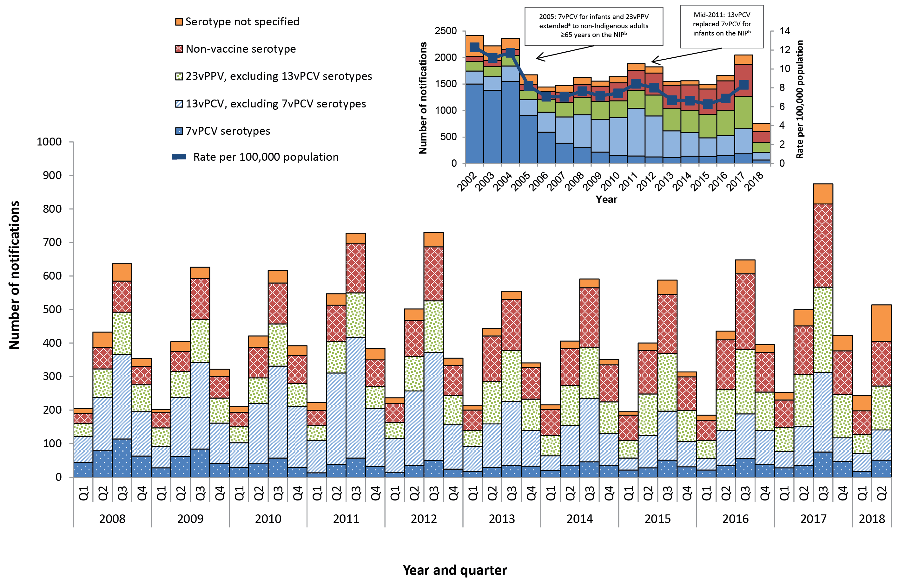
a In 1999, the 23vPPV was funded for all Indigenous Australians aged 50 years and over, as well as younger Indigenous Australian adults with risk factors.
b NIP - National Immunisation Program

Figure 2: Notifications and annual ratesª of invasive pneumococcal disease in children aged less than 5 years, Australia, 1 January 2008 to 30 June 2018, by vaccine serotype group
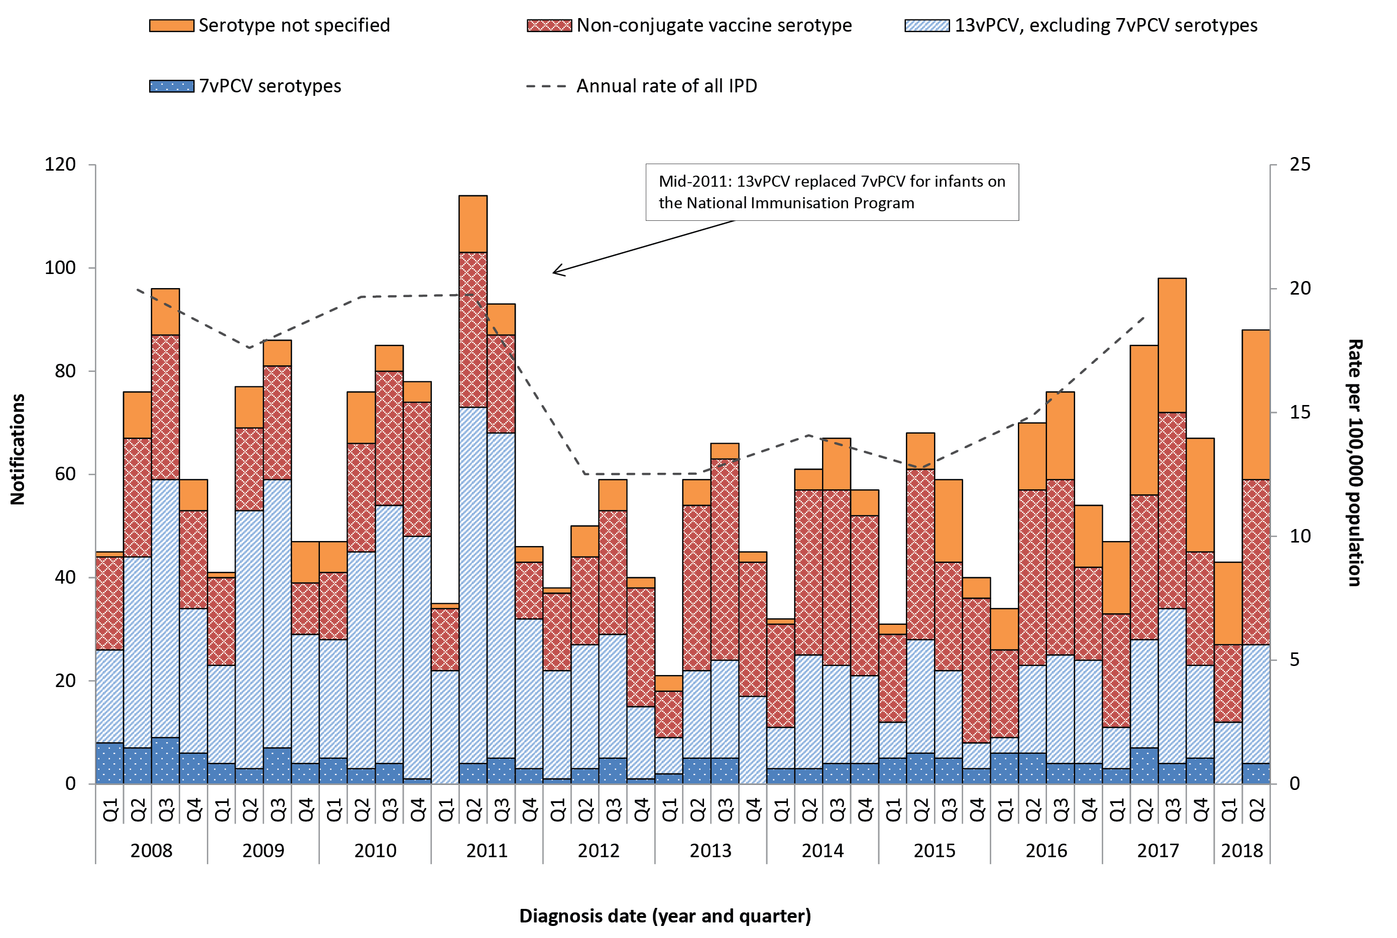
a Annual rates are shown on quarter 2, excluding 2018.

Figure 3: Notifications and annual ratesª of all invasive pneumococcal disease in Indigenous Australians aged 50 years or over, Australia, 1 January 2008 to 30 June 2018, by vaccine serotype group
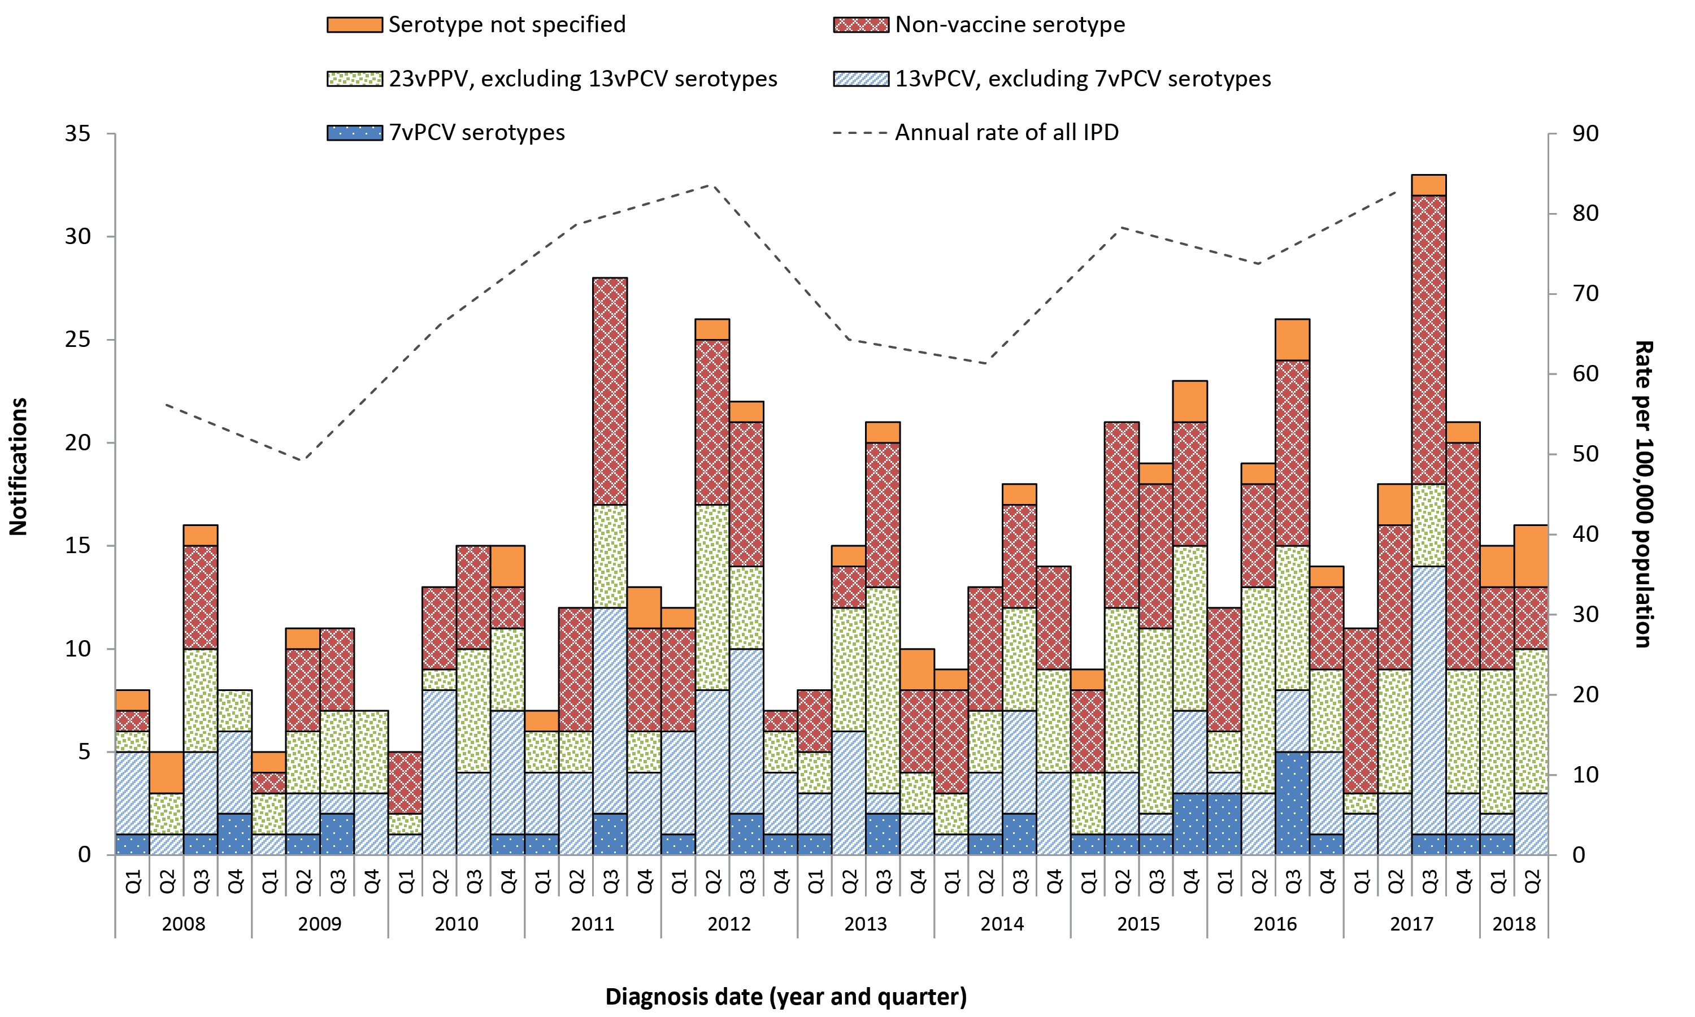
a Annual rates are shown on quarter 2, excluding 2018.

Figure 4: Notifications and annual ratesª of all invasive pneumococcal disease in non-indigenous Australians^{b} aged 65 years or over, Australia, 1 January 2008 to 30 June 2018, by vaccine serotype group
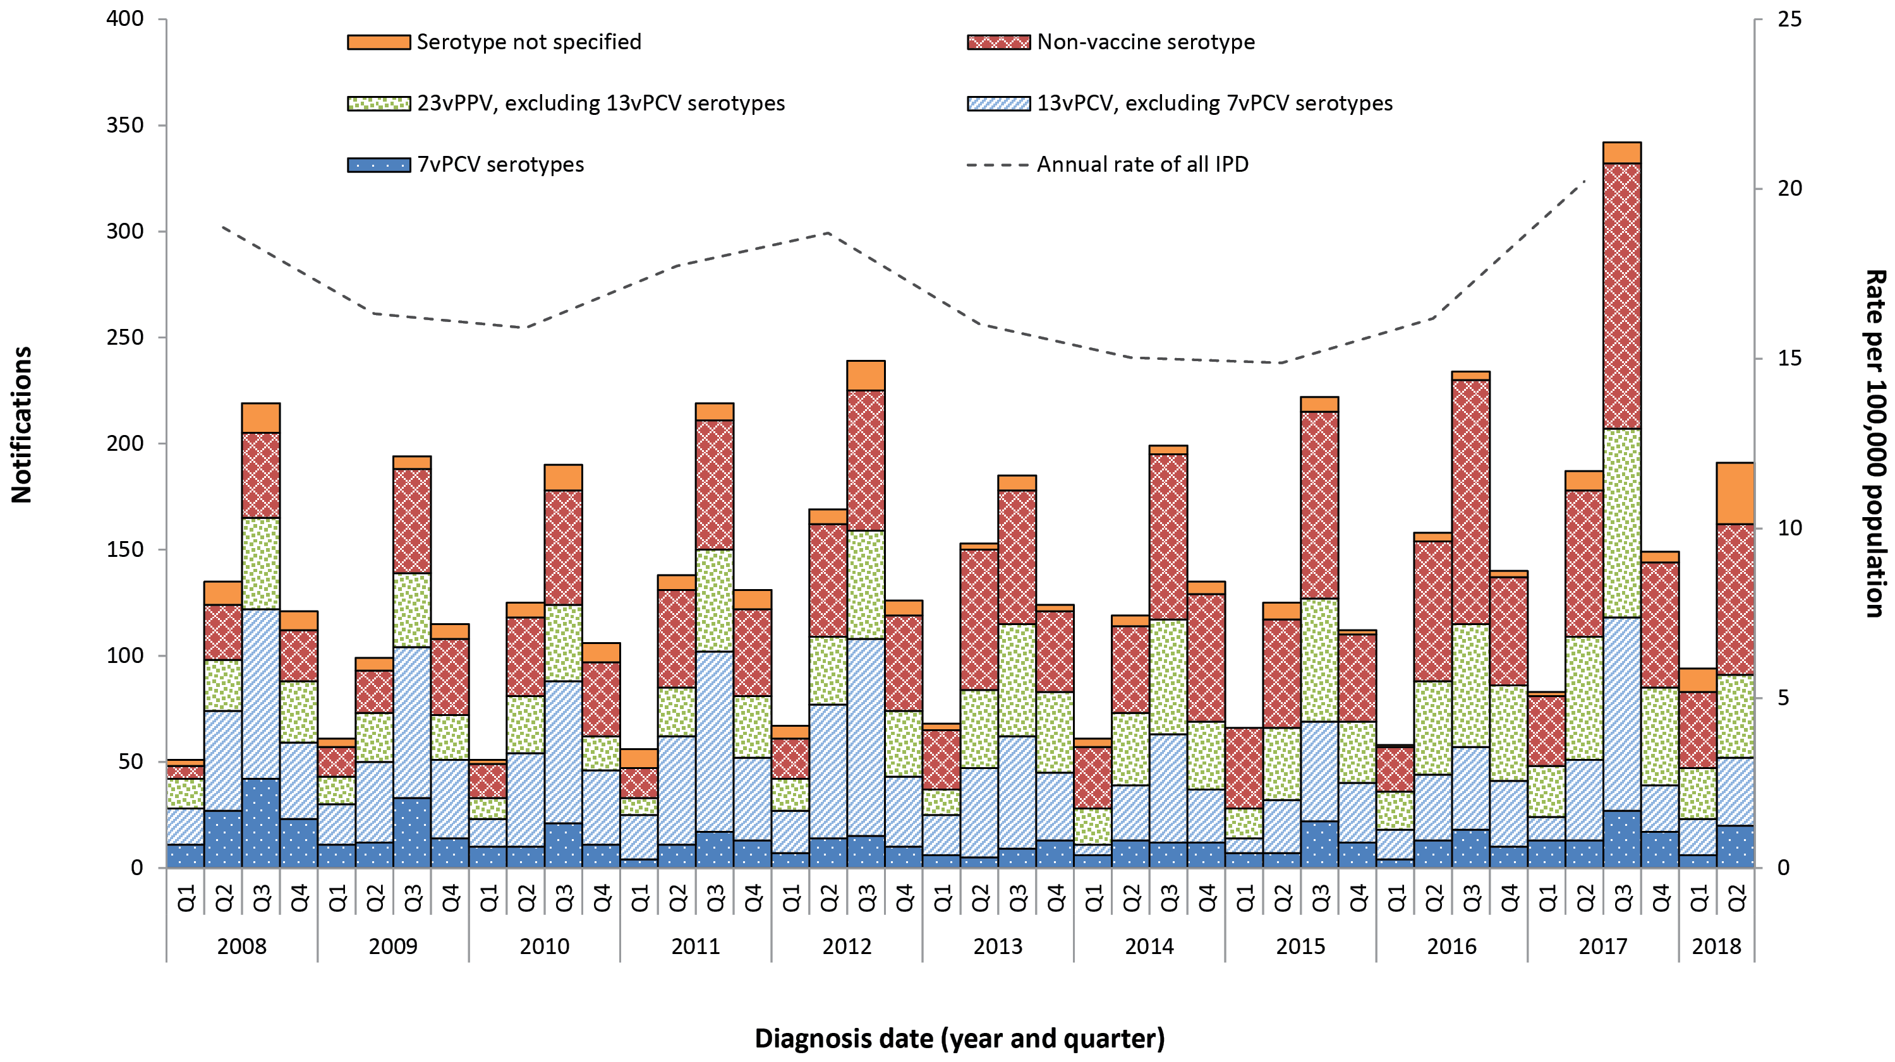
a Annual rates are shown on quarter 2, excluding 2018.
b Non-Indigenous Australians includes cases reported with as non-Indigenous, not stated, blank or unknown.

Table 1: Notified cases of invasive pneumococcal disease, Australia, 1 April to 30 June 2018, by Indigenous status, serotype completeness and state or territory
Indigenous status | ACT | NSW | NT | Qld | SA | Tas | Vic | WA | Total 2nd qtr 2018 | Total 1st qtr 2018 | Total 2nd qtr 2017 | Year to date 2018
Indigenous | 0 | 7 | 7 | 16 | 8 | 0 | 1 | 17 | 56 | 32 | 41 | 88
Non-Indigenous | 4 | 123 | 3 | 80 | 34 | 13 | 102 | 39 | 398 | 188 | 412 | 586
Not stated / Unknown | 0 | 32 | 0 | 0 | 0 | 0 | 28 | 0 | 60 | 24 | 46 | 84
Total | 4 | 162 | 10 | 96 | 42 | 13 | 131 | 56 | 514 | 244 | 499 | 758
Indigenous status completenessª (%) | 100 | 80 | 100 | 100 | 100 | 100 | 79 | 100 | 88 | 90 | 91 | 89
Indigenous status completeness in targeted groups^{a,b} (%) | 100 | 88 | 100 | 100 | 100 | 100 | 94 | 100 | 95 | 96 | 96 | 95
Serotype completeness^{c} (%) | 100 | 55 | 100 | 92 | 57 | 77 | 98 | 95 | 79 | 83 | 95 | 80
a Indigenous status completeness is defined as the reporting of a known Indigenous status, excluding the reporting of not stated or unknown Indigenous status.
b Targeted groups for follow-up by almost all jurisdictions and public health units are cases aged less than 5 years and 50 years and over.
c Serotype completeness is the proportion of all cases of invasive pneumococcal disease that were reported with a serotype or reported as non-typable. Incomplete serotype data can occur in cases when (i) no isolate was available as diagnosis was by polymerase chain reaction and no molecular typing was attempted or was not possible due to insufficient genetic material; (ii) the isolate was not referred to the reference laboratory or was not viable; (iii) typing was pending at the time of reporting, or no serotype was reported by the notifying jurisdiction to the National Notifiable Diseases Surveillance System.

Table 2: Distribution of serotypes causing invasive pneumococcal disease in notified cases, Australia, 1 April to 30 June 2018, by age group
 | Age groups
Vaccine type and serotype | Under 5 | 5–64 | 65+ | Serotype total
7vPCV
4 | 0 | 3 | 1 | 4
14 | 0 | 4 | 2 | 6
19F | 3 | 18 | 13 | 34
23F | 1 | 1 | 1 | 3
13vPCV non-7vPCV
3 | 11 | 17 | 21 | 49
7F | 0 | 7 | 1 | 8
19A | 12 | 9 | 10 | 31
23vPPV non-13vPCV
8 | 1 | 19 | 0 | 20
9N | 1 | 16 | 8 | 25
10A | 1 | 6 | 1 | 8
11A | 0 | 2 | 7 | 9
12F | 1 | 1 | 1 | 3
15B | 2 | 3 | 2 | 7
17F | 0 | 4 | 0 | 4
22F | 4 | 15 | 15 | 34
33F | 4 | 8 | 8 | 20
Non-vaccine type
6C | 1 | 4 | 15 | 20
15A | 2 | 5 | 2 | 9
15C | 1 | 2 | 4 | 7
16F | 0 | 4 | 5 | 9
18A | 0 | 3 | 0 | 3
22A OR 22F | 0 | 0 | 0 | 2
23A | 1 | 6 | 17 | 24
23B | 4 | 9 | 7 | 20
35B | 3 | 1 | 3 | 7
24 | 1 | 0 | 1 | 2
31 | 0 | 1 | 5 | 6
38 | 0 | 2 | 3 | 5
35F | 0 | 2 | 4 | 6
Other
Other serotypesª | 5 | 9 | 8 | 20
Unknown^{b} | 29 | 50 | 30 | 109
Total | 88 | 231 | 195 | 514
a Serotypes that only occur in less than 5 cases per quarter are grouped as ‘Other’ and include ‘non-typable’ isolates this quarter.
b ‘Serotype unknown’ includes those serotypes reported as ‘no isolate’, ‘not referred’, ‘not viable’, ‘typing pending’ and ‘untyped’.

Table 3: Notified cases of invasive pneumococcal disease, Australia, 1 April to 30 June 2018, by Indigenous status and age group
Age group | Indigenous status |  |  | Total
 | Indigenous | Non-Indigenous | Not reportedª
00-04 | 7 | 78 | 3 | 88
05-09 | 0 | 11 | 3 | 14
10-14 | 1 | 2 | 1 | 4
15-19 | 2 | 1 | 2 | 5
20-24 | 3 | 6 | 3 | 12
25-29 | 1 | 6 | 10 | 17
30-34 | 4 | 6 | 5 | 15
35-39 | 5 | 10 | 7 | 22
40-44 | 5 | 6 | 4 | 15
45-49 | 12 | 7 | 5 | 24
50-54 | 4 | 16 | 2 | 22
55-59 | 5 | 32 | 1 | 38
60-64 | 3 | 37 | 3 | 43
65-69 | 1 | 39 | 0 | 40
70-74 | 0 | 28 | 3 | 31
75-79 | 1 | 31 | 2 | 34
80-84 | 0 | 31 | 3 | 34
85+ | 2 | 51 | 3 | 56
Total | 56 | 398 | 60 | 514
a Not reported is defined as not stated, blank or unknown Indigenous status.

Table 4: Characteristics of 13vPCV failures in children aged less than 5 years, Australia, 1 April to 30 June 2018
Age | Indigenous status | Serotype | Clinical category | Risk factor(s)
10 months | Unknown | 23F | No data provided | No risk factor identified
1 year | Non-Indigenous | 19A | Pneumonia | Childcare attendee
1 year | Non-Indigenous | 3 | Pneumonia and other (pleural effusion) | No data available
1 year | Non-Indigenous | 3 | Pneumonia | Other
1 year | Non-Indigenous | 19A | Pneumonia | Childcare attendee
1 year | Non-Indigenous | 19A | Other | Other
1 year | Non-Indigenous | 19A | Bacteraemia | Congenital or chromosomal abnormality
1 year | Non-Indigenous | 19A | Pneumonia | Childcare attendee
2 years | Non-Indigenous | 3 | Pneumonia and other (pleural empyema) | No risk factor identified
2 years | Non-Indigenous | 3 | Pneumonia and other (pleural effusion) | No data available
2 years | Indigenous | 3 | Bacteraemia | Congenital or chromosomal abnormality
2 years | Non-Indigenous | 19A | Pneumonia | Other
3 years | Non-Indigenous | 3 | Other (pleural effusion) | Other
3 years | Non-Indigenous | 19A | Pneumonia | Childcare attendee
3 years | Non-Indigenous | 3 | Pneumonia | Childcare attendee
3 years | Non-Indigenous | 19A | Pneumonia | No data available
4 years | Non-Indigenous | 19F | Pneumonia and other (pleural empyema) | Unknown
4 years | Non-Indigenous | 19A | Pneumonia | Childcare attendee
4 years | Non-Indigenous | 19A | Pneumonia | No risk factor identified

Table 5: Streptococcus pneumoniae serotypes targeted by pneumococcal vaccines
Serotypes | 7-valent pneumococcal conjugate vaccine (7vPCV) | 10-valent pneumococcal conjugate vaccine (10vPCV) | 13-valent pneumococcal conjugate vaccine (13vPCV) | 23-valent pneumococcal polysaccharide vaccine (23vPPV)
1 |  | ✔ | ✔ | ✔
2 |  |  |  | ✔
3 |  |  | ✔ | ✔
4 | ✔ | ✔ | ✔ | ✔
5 |  | ✔ | ✔ | ✔
6A |  |  | ✔
6B | ✔ | ✔ | ✔ | ✔
7F |  | ✔ | ✔ | ✔
8 |  |  |  | ✔
9N |  |  |  | ✔
9V | ✔ | ✔ | ✔ | ✔
10A |  |  |  | ✔
11A |  |  |  | ✔
12F |  |  |  | ✔
14 | ✔ | ✔ | ✔ | ✔
15B |  |  |  | ✔
17F |  |  |  | ✔
18C | ✔ | ✔ | ✔ | ✔
19A |  |  | ✔ | ✔
19F | ✔ | ✔ | ✔ | ✔
20 |  |  |  | ✔
22F |  |  |  | ✔
23F | ✔ | ✔ | ✔ | ✔
33F |  |  |  | ✔

Communicable Diseases Intelligence
ISSN: 2209-6051 Online

Communicable Diseases Intelligence (CDI) is a peer-reviewed scientific journal published by the Office of Health Protection, Department of Health. The journal aims to disseminate information on the epidemiology, surveillance, prevention and control of communicable diseases of relevance to Australia.

Editor: Cindy Toms
Deputy Editor: Simon Petrie
Design and Production: Kasra Yousefi
Editorial Advisory Board: David Durrheim, Mark Ferson, John Kaldor, Martyn Kirk and Linda Selvey

Website: http://www.health.gov.au/cdi

Contacts
Communicable Diseases Intelligence is produced by:
Health Protection Policy Branch, Office of Health Protection, Australian Government Department of Health
GPO Box 9848, (MDP 6) CANBERRA ACT 2601

Email: cdi.editor@health.gov.au

Submit an Article
You are invited to submit your next communicable disease related article to the Communicable Diseases Intelligence (CDI) for consideration. More information regarding CDI can be found at: http://health.gov.au/cdi.
Further enquiries should be directed to: cdi.editor@health.gov.au.

This journal is indexed by Index Medicus and Medline.

Creative Commons Licence - Attribution-NonCommercial-NoDerivatives CC BY-NC-ND
© 2019 Commonwealth of Australia as represented by the Department of Health
This publication is licensed under a Creative Commons Attribution-NonCommercial-NoDerivatives 4.0 International Licence from https://creativecommons.org/licenses/by-nc-nd/4.0/legalcode (Licence). You must read and understand the Licence before using any material from this publication.

Restrictions
The Licence does not cover, and there is no permission given for, use of any of the following material found in this publication (if any):
- the Commonwealth Coat of Arms (by way of information, the terms under which the Coat of Arms may be used can be found at www.itsanhonour.gov.au);
- any logos (including the Department of Health’s logo) and trademarks;
- any photographs and images;
- any signatures; and
- any material belonging to third parties.

Disclaimer
Opinions expressed in Communicable Diseases Intelligence are those of the authors and not necessarily those of the Australian Government Department of Health or the Communicable Diseases Network Australia. Data may be subject to revision.

Enquiries
Enquiries regarding any other use of this publication should be addressed to the Communication Branch, Department of Health, GPO Box 9848, Canberra ACT 2601, or via e-mail to: copyright@health.gov.au

Communicable Diseases Network Australia
Communicable Diseases Intelligence contributes to the work of the Communicable Diseases Network Australia.
http://www.health.gov.au/cdna

Based on data extracted from the National Notifiable Diseases Surveillance System (NNDSS) on 30 June 2018. Due to the dynamic nature of the NNDSS, data on this extract is subject to retrospective revision and may vary from data reported in published NNDSS reports and reports of notification data by states and territories.
Non-Indigenous Australians includes cases reported with an Indigenous status of non-Indigenous, not stated, blank or unknown.

