Improving the accuracy of ACIR data and increasing vaccination rates
Thaïs A Miles, Linda V Granger and Colleen L Gately

Abstract
Immunisation at the earliest appropriate age and high levels of vaccine coverage at milestone ages are important in preventing the spread of vaccine-preventable diseases. At the Central Coast Public Health Unit, the authors sought to determine if follow-up of children said by the Australian Childhood Immunisation Register (ACIR) to be overdue for vaccination improved both of these factors.
In a quality improvement activity, monthly ACIR lists of overdue Central Coast children aged 9 to 10 months of age were examined. The study alternated three months of intervention with three months of no intervention. The intervention was designed to find evidence of vaccination, first from the last known provider, and then if this was unsuccessful, from the parent. If no information was available, a letter was sent to the parents. If the child was indeed vaccinated, the register was updated. If the child was missing any vaccinations, the parent(s) were encouraged to complete the schedule.
On reviewing routinely-published quarterly ACIR data at three-monthly intervals for 24 months after the intervention (or non-intervention), timeliness of vaccination improved in the intervention cohort. Central Coast fully vaccinated rates diverged from NSW rates during the study. In addition, the ACIR quarters that contained two out of three months of intervention rather than one out of three months of intervention had the highest rates of fully vaccinated children. The authors concluded that the intervention improved both timeliness of vaccination and the proportion of fully vaccinated children.
Keywords: ACIR data accuracy, immunisation rates, timeliness

Introduction
Two factors are particularly important in preventing the spread of vaccine-preventable diseases. These are immunisation at the earliest appropriate age (timeliness) and high levels of vaccine coverage at milestone ages.¹ In Australia, scheduled childhood immunisations have been recorded on the Australian Childhood Immunisation Register (ACIR) since 1996 and immunisation rates are published quarterly. ACIR rates are considered estimates because follow-up has shown many said to be overdue were actually up-to-date.^{1–3}
One of the roles of the Central Coast Public Health Unit (CCPHU) is to improve immunisation rates in children in the Central Coast area. To do this, and to understand what factors contributed to the proportions of unvaccinated children, staff in the Immunisation Section of the CCPHU follow up children recorded by ACIR as overdue. Some of the follow-up has been opportunistic, but two larger intervention studies were conducted, one in 2005 and another in the three years 2008 to 2010 (unpublished data).
In both projects the investigators reported frequent findings of children incorrectly recorded as not completely vaccinated, and ACIR was subsequently updated. They also reported that many parents thanked them for the reminder and promised to organise prompt vaccination, which proved to be carried out on subsequently checking ACIR. While these data were never quantified, the sheer number of anecdotal reports and the suspicion that the intervention might have been in part responsible for the apparently increased Central Coast immunisation rates following the interventions prompted the authors to plan a quality improvement activity so a formal analysis of the intervention could be carried out.
The project was approved retrospectively as a quality improvement activity by the Central Coast Local Health District Executive Director Clinical Governance.

Figure 1. Process of identifying children for follow-up
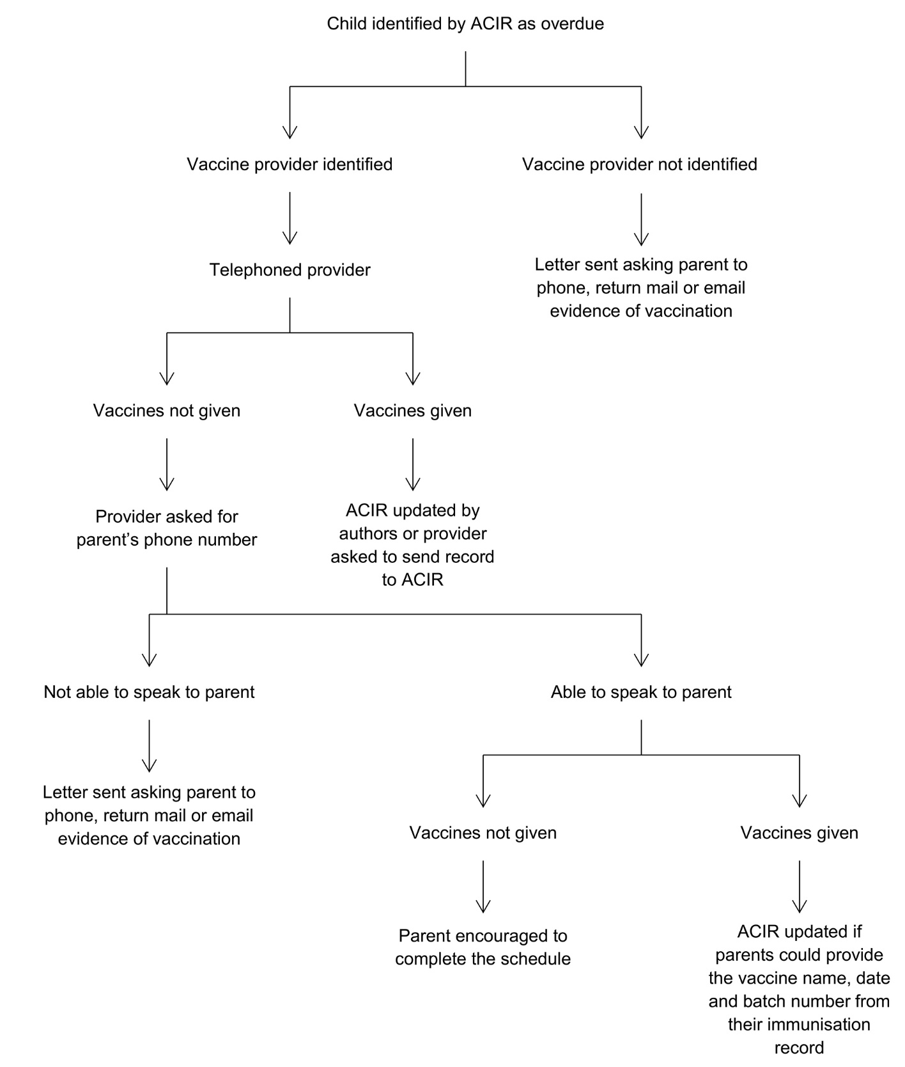

Methods
ACIR (now AIR) makes routine reports available to public health units. Every month during this study the authors downloaded the list of all Central Coast children deemed by ACIR to be overdue for some or all of their scheduled vaccines on the first of the month.
The quality improvement activity alternated three months of intervention with three months of no intervention for children 9–10 months of age said to be at least 60 days overdue for some or all of the three Infanrix-hexa and Prevenar vaccines scheduled at 2, 4 and 6 months. This age group and the overdue time period of 60 days were chosen as the most appropriate to facilitate these children to become up to date before their next scheduled vaccines at 12 months. Aboriginal children in the intervention cohorts were not contacted, since they were (and still are) followed up by the Aboriginal Immunisation Officer in a separate program.
The intervention was designed to find evidence of vaccination, first from the last known provider, and then if this was unsuccessful, from the parent (Figure 1). If no information could be obtained, a letter was sent to the parent asking them to phone, mail or email evidence of vaccination.
From July 2011 to June 2013 the authors established monthly cohorts of overdue children and examined each child’s ACIR record at three-month intervals for a total of 24 months and recorded whether there was any change. This comparison was used to assess any change in timeliness of vaccination.
The data were defined as follows:
- Up to date = up to date for the three Infanrix-hexa and Prevenar vaccines scheduled at 6 weeks, 4 and 6 months only (including using the third dose assumption); whether they were up to date for their scheduled 12 months vaccines was not included in the definition,
- Record corrected = the missing vaccination(s) occurred before the ACIR download on 1st of the month,
- Vaccinated = the missing vaccination(s) occurred after ACIR download on 1st of the month, and
- Record corrected and vaccinated = some missing vaccinations occurred before the ACIR download and some after the download.
Central Coast vaccination rates were also compared with NSW rates for children aged 12 to less than 15 months of age, this being the ACIR cohort directly affected by the intervention. The intervention / non-intervention three-month cohorts did not align directly with ACIR routinely published data, since the ACIR data for a three month cohort were calculated on a single day (the last day of the quarter) whereas the study cohorts were defined as all children who turned 9 months of age during a calendar month (Figure 2). This comparison was used to assess the effectiveness of the intervention.

Figure 2. ACIR and scheduling of intervention study
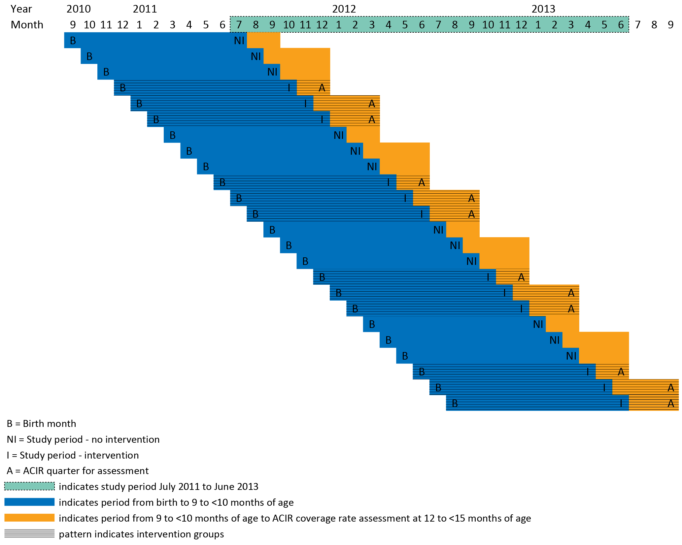

Results
The total numbers of children overdue in non-intervention and intervention groups can be seen in Table 1.
Table 1. Numbers and proportions of children not fully vaccinated and vaccinated by the end of the study
Study months (NI or I) | Birth months | Total Overdue | Unable to view | Total for analysis | Not fully vaccinated | Not fully vaccinated % | Fully vaccinated | Fully vaccinated %
Jul 2011 to Sep 2011 (NI) | Sep 2010 to Nov 2010 | 108 | 15 | 93 | 26 | 28.0 | 67 | 72.0
Oct 11 to Dec 2011 (I) | Dec 2010 to Feb 2011 | 91 | 10 | 81 | 15 | 18.5 | 66 | 81.5
Jan 2012 to Mar 2012 (NI) | Mar 2011 to May 2011 | 125 | 8 | 117 | 32 | 27.4 | 85 | 72.6
Apr 2012 to Jun 2012 (I) | Jun 2011 to Aug 2011 | 108 | 11 | 97 | 18 | 18.6 | 79 | 81.4
Jul 2012 to Sep 2012 (NI) | Sep 2011 to Nov 2011 | 115 | 17 | 98 | 23 | 23.5 | 75 | 76.5
Oct 2012 to Dec 2012 (I) | Dec 2011 to Feb 2012 | 100 | 15 | 85 | 11 | 12.9 | 74 | 87.1
Jan 2013 to Mar 2013 (NI) | Mar 2012 to May 2012 | 110 | 20 | 90 | 18 | 20.0 | 72 | 80.0
Apr 2013 to Jun 2013 (I) | Jun 2012 to Aug 2012 | 134 | 16 | 118 | 16 | 13.6 | 102 | 86.4
Total non-intervention |  | 458 | 60 | 398 | 99 | 24.9 | 299 | 75.1
Total intervention |  | 433 | 52 | 381 | 60 | 15.7 | 321 | 84.3
NI = No intervention
I = Intervention

The large number of records which could not be viewed on the ACIR (112/841, 12.6%) is likely to be due to a number of factors, including the child being under the care of the Department of Family and Community Services, or to being registered as a “conscientious objector” on ACIR.

Timeliness
The proportions of children remaining not fully vaccinated dropped faster in the intervention cohorts and stayed lower when compared with the non-intervention cohorts (Table 2, Figure 3) thus improving the timeliness of fully vaccinated status on ACIR. It is tempting to regard this as improved timeliness of vaccination, but a significant part of this decrease could also be due to record correction, that is the children had been vaccinated on time but not recorded as vaccinated on ACIR.
Table 2. Numbers and proportions of children remaining not fully vaccinated
Time since intervention in months | Non-intervention | Non-intervention  % | Intervention | Intervention  %
0 | 398 | 100.0 | 381 | 100.0
3 | 240 | 60.3 | 127 | 33.3
6 | 176 | 44.2 | 103 | 27.0
9 | 149 | 37.4 | 80 | 21.0
12 | 127 | 31.9 | 73 | 19.2
15 | 117 | 29.4 | 68 | 17.8
18 | 103 | 25.9 | 63 | 16.5
21 | 99 | 24.9 | 62 | 16.3
24 | 99 | 24.9 | 60 | 15.7
Figure 3. Proportion of children remaining not fully vaccinated
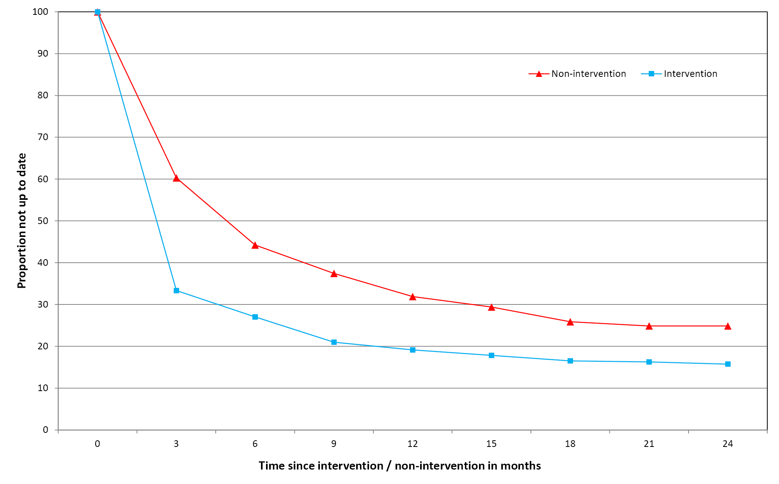
The records for all the children in the intervention months were then examined to determine whether they became up to date as a result of a record correction, a vaccination that occurred after the intervention, or both.
From Table 3 it can be seen that in the intervention cohorts two-thirds (66%) of those who became up to date were record errors. One quarter (25%) completed their remaining vaccinations after the download date and the remaining 9% had both record corrections and vaccinations after the download date. While the proportion of children fully vaccinated at the end of the study in the non-intervention cohorts was lower than in the intervention cohorts, the proportions of record errors, vaccinations and both record errors and vaccinations were similar.

Table 3. How children became fully vaccinated
Study months (NI or I) | Birth months | Fully vaccinated | Record corrected | Record corrected % | Vaccinated | Vaccinated % | Record corrected and vaccinated | Record corrected and vaccinated %
Jul 2011 to Sep 2011 (NI) | Sep 2010 to Nov 2010 | 67 | 43 | 64.2 | 10 | 14.9 | 14 | 20.9
Oct 2011 to Dec 2011 (I) | Dec 2010 to Feb 2011 | 66 | 37 | 56.1 | 20 | 30.3 | 9 | 13.6
Jan 2012 to Mar 2012 (NI) | Mar 2011 to May 2011 | 85 | 49 | 57.6 | 27 | 31.8 | 9 | 10.6
Apr 2012 to Jun 2012 (I) | Jun 2011 to Aug 2011 | 79 | 51 | 64.6 | 18 | 22.8 | 10 | 12.7
Jul 2012 to Sep 2012 (NI) | Sep 2011 to Nov 2011 | 75 | 52 | 69.3 | 12 | 16.0 | 12 | 16.0
Oct 2012 to Dec 2012 (I) | Dec 2011 to Feb 2012 | 74 | 54 | 73.0 | 16 | 21.6 | 4 | 5.4
Jan 2013 to Mar 2013 (NI) | Mar 2012 to May 2012 | 72 | 47 | 65.3 | 21 | 29.2 | 4 | 5.6
Apr 2013 to Jun 2013 (I) | Jun 2012 to Aug 2012 | 102 | 70 | 68.6 | 25 | 24.5 | 7 | 6.9
Total non-intervention |  | 299 | 191 | 63.9 | 70 | 23.4 | 39 | 13.0
Total intervention |  | 321 | 212 | 66.0 | 79 | 24.6 | 30 | 9.3
NI = No intervention
I = Intervention

Effectiveness
During the Quality Improvement activity (Figure 4, blue shaded section) quite a divergence occurred between rates of fully vaccinated Central Coast children compared with NSW as a whole. Furthermore, all but one of the quarters with 2 out of 3 intervention months showed higher rates than the quarters with 1 out of 3 intervention months. This convinced the authors that the intervention was making a difference, and thus there was a need to follow up all 9–10 month children said to be overdue by ACIR. This ongoing program commenced in January 2014 with the April 2013 birth cohort, and Central Coast rates have subsequently remained consistently above NSW rates.

Figure 4. ACIR vaccination rates for Central Coast and NSW children 12–15 months of age
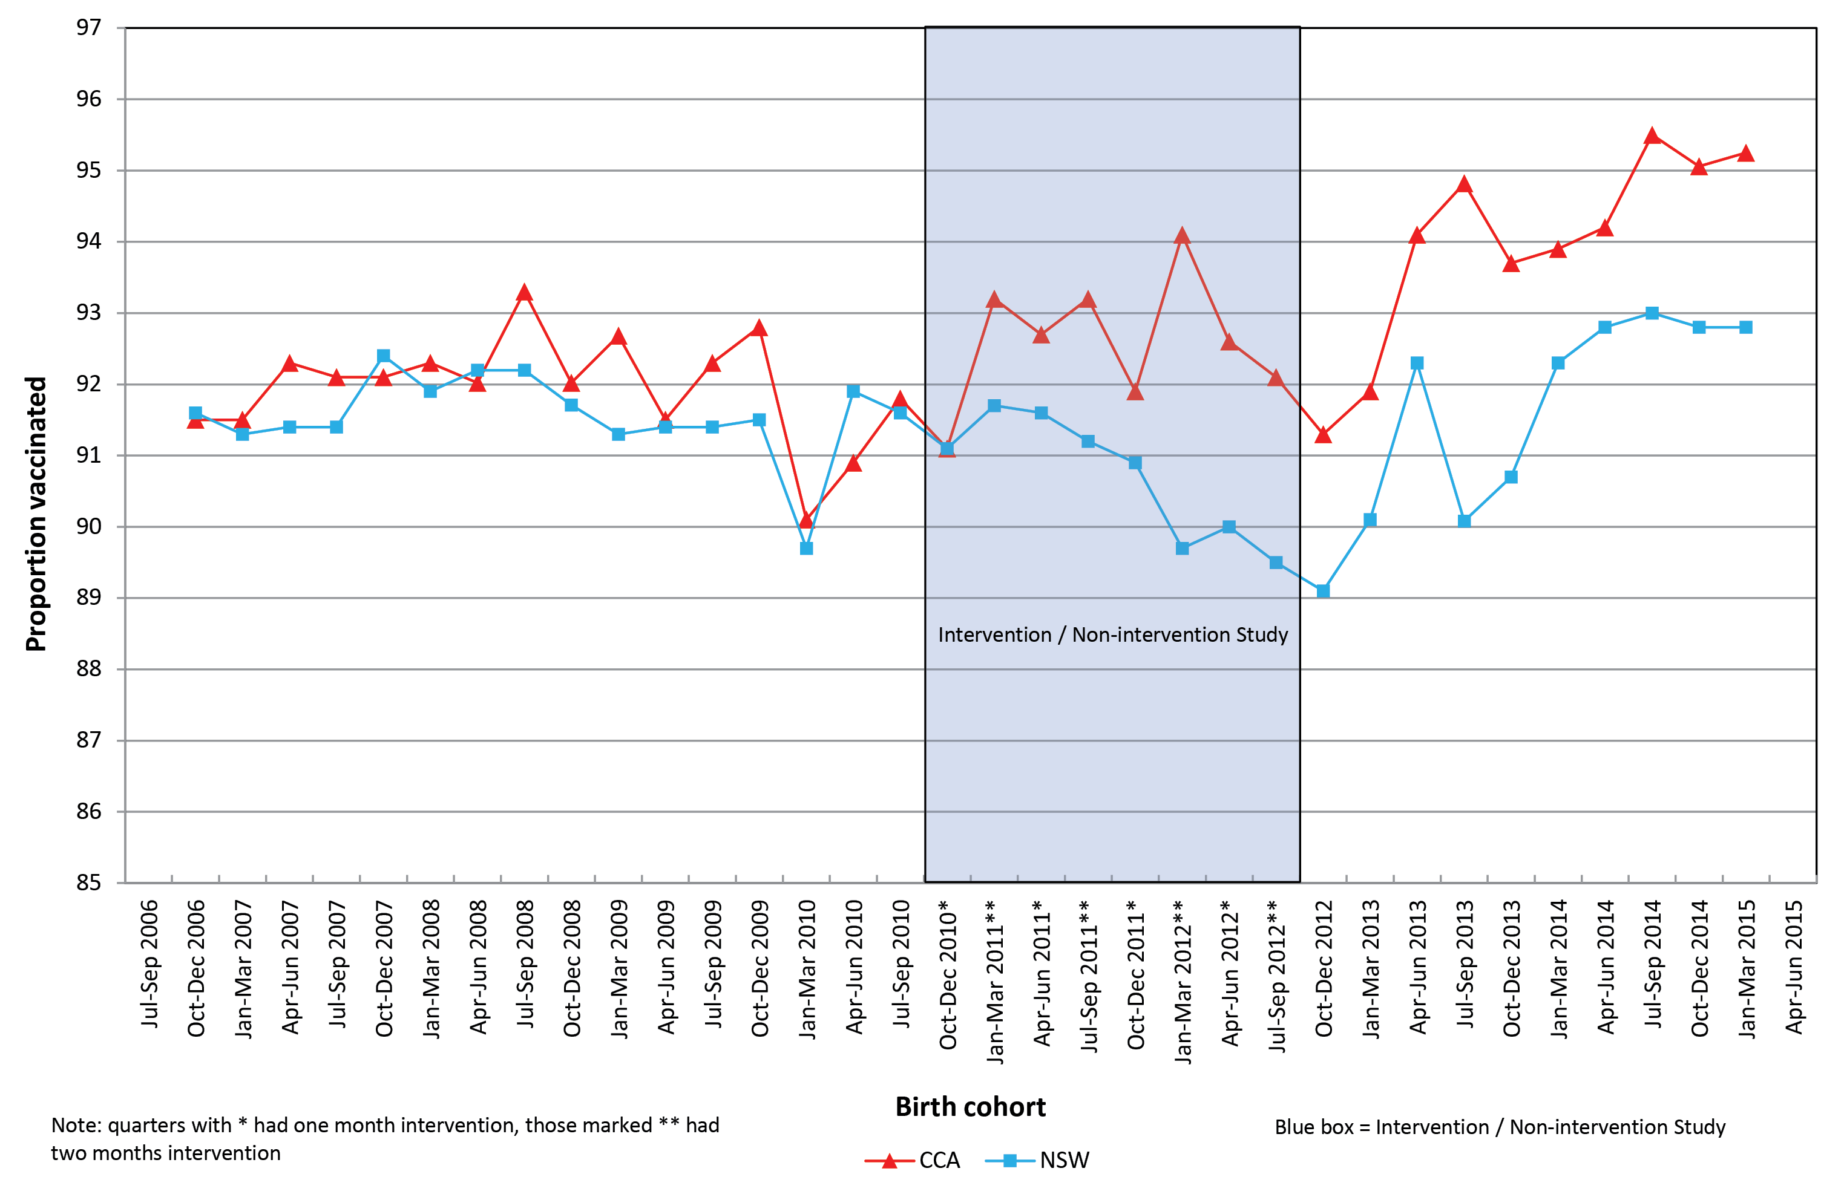

Discussion
Reporting on Australian immunisation coverage in 2014, Hull et al. noted that while high levels of vaccine coverage at milestone ages have been achieved, timeliness of vaccination could be improved.⁶ A number of state and federal strategies have contributed to these high levels, the Immunise Australia Program in 1997 being one of the early strategies. This program included financial incentives for providers and parents, and the incentives have been refined over the years. The most recent iterations are the No Jab, No Pay measure and the No Jab, No Play legislation.^{7,8} These national and state efforts have been supplemented by more focussed interventions in some smaller jurisdictions.
While active follow-up of children said to be overdue for immunisation can be quite resource-intensive,³ a range of interventions designed to improve immunisation rates and timeliness of vaccinations have been used in different populations in Australia.
Elia et al.⁹ targeted children with medical conditions in the Royal Children’s Hospital in Melbourne. They identified that during admission one quarter of children were not up to date for their routine scheduled immunisations. Approximately 42% of these were then brought up to date, either during admission or within a month of discharge.
In 2007 Central Sydney General Practice Network and the University of Sydney targeted Central Sydney general practices with immunisation coverage rates less than 90%.¹⁰ The intervention consisted of education to encourage the practices to identify and recall overdue children. At the end of the study there was a marked improvement in the proportion of practices with coverage rates of greater than 90%. The barriers to increasing immunisation rates included the substantial transient population and communication and language barriers in the culturally and linguistically diverse population. Lack of staff resources was another barrier.
Successful interventions in Aboriginal populations include personalised calendars,¹¹ telephoning families before the due date for immunisation¹² and the introduction of the Aboriginal Immunisation Healthcare Worker Program in New South Wales.¹³
In a before-after study, Western Sydney Aboriginal children who received a personalised calendar showed improved timeliness of vaccination.¹¹ The Hunter New England (HNE) pre-call strategy was introduced around the time when Aboriginal immunisation workers were being introduced in all jurisdictions in NSW.¹² The families of HNE Aboriginal babies were telephoned two weeks before the first scheduled vaccine and encouraged to get their vaccinations on time. There was a significant increase in immunisation coverage for HNE Aboriginal children at 12 months while the coverage for Aboriginal children in the rest of NSW increased but not significantly. These findings were mirrored by Hendry et al. when they compared the gaps between immunisation rates for Indigenous and non-Indigenous children in New South Wales and Australia before and after the introduction of the Aboriginal Immunisation Healthcare Worker Program in New South Wales.¹³ The gap reduced more in NSW when compared with Australia.
In an international systematic review of different interventions to improve immunisation uptake Harvey et al. noted that while all interventions were effective to a degree, receiving both telephone and postal reminders was the most effective reminder-based intervention.¹⁴ This review reinforces the common theme gleaned from the Australian interventions, that is, that personal contact works well.
The ability to use personal contact, with telephone calls to vaccine providers and to parents, and also personally addressed letters is one of the strengths of the CCPHU intervention. Central Coast’s relatively small geographical area has allowed the CCPHU’s immunisation staff to develop and maintain excellent relationships with local vaccine providers, particularly because they are able to visit the practices when needed.
Another strength of the intervention was the population-based comparison. By including all non-Aboriginal children aged 9 to less than 10 months in the study the opportunity for bias has been reduced. The results may therefore be considered generalizable to the rest of the NSW population.
The intervention did not consume a lot of resources. By confining the intervention to a population of about 30 children per month, about 8 hours per week of staff time was needed (provided the time was relatively uninterrupted). The intervention was also able to identify systematic errors of reporting. By noting the vaccine providers the authors quickly identified patterns of potential errors. For example, one practice seemed to have difficulty reporting the third Prevenar vaccination. One author (CG) had several discussions with the practice staff, and this issue has now been corrected.
One limitation of this study is the possibility of errors in attributing the reason for a child to become up to date. If the vaccination(s) occurred before the download date, it can be stated with some confidence that this is a record error. This error may be a problem with the provider recording the vaccination, a problem with transmission of those data to ACIR or a problem with recording on the ACIR.
However if the vaccination occurred after the ACIR download date the reason is less clear-cut. It is conceivable that the intervention may have prompted the vaccination, and conversations with parents suggest that this does happen, but there are other influences on parents’ decisions to vaccinate.
One such influence may be the proximity of the follow-up to subsequent scheduled vaccinations. Any activity such as reminders for the 12 month vaccinations could focus attention on the earlier vaccinations targeted in the current study. Another possible influence is the range of financial incentives for vaccination.⁷ These have included financial incentives for general practice and incentives for parents, particularly linking the Family Tax Benefit to a child’s immunisation status.
The authors have shown that a simple intervention can improve timeliness of vaccination as well as vaccination rates. While a quarter of those becoming up to date were as a result of vaccinations after the intervention, about two thirds of children initially said to be overdue were not late vaccinations but late reports.
Central Coast rates have been generally better than NSW, but during the intervention Central Coast rates diverged further from NSW rates, more particularly in the three-month periods where there were two months of intervention compared with one month of intervention. This difference convinced the authors that a quality improvement study needed to be extended to an ongoing program for all children age 9–10 months.

Acknowledgements
The authors acknowledge the valuable assistance of Paul Cook from the Public Health Unit who prepared the data each month. The authors also acknowledge the cheerful willingness of Central Coast immunisers and the commitment of Central Coast parents. Without the enthusiasm of these people we would be unable to maintain our current high rates of vaccination. The thoughtful comments by the reviewers of an earlier draft of this manuscript were greatly appreciated.

Author details
Dr Thaïs A Miles, Public Health Physician¹
Ms Linda V Granger, Immunisation Nurse¹
Mrs Colleen L Gately, Immunisation Co-ordinator¹
- Central Coast Public Health Unit

Corresponding author
Dr Thaïs A Miles, Public Health Physician, Central Coast Public Health Unit, PO Box 361, Gosford 2250 thais.miles@bigpond.com

References
- Hull BP, McIntyre PB. Timeliness of childhood immunisation in Australia. Vaccine. 2006;24(20):4403–8.
- Ferson M, Orr K. Some truths about the “low” vaccination coverage in Sydney’s eastern suburbs. Med J Aust. 2015;203(3):153–4.
- Botham SJ, Poulos RG, McFarland KJ, Ferson MJ. Getting it right – the Australian Childhood Immunisation Register and immunisation rates in south-eastern Sydney. Aust N Z J Public Health. 2004;28(1):68–71.
- Hull BP, McIntyre PB. Immunisation coverage reporting through the Australian Childhood Immunisation Register – an evaluation of the third-dose assumption. Aust N Z J Public Health. 2000;24(1):17–21.
- Hull BP, Lawrence GL, MacIntyre CR, McIntyre PB. Estimating immunisation coverage: is the “third dose assumption” still valid? Commun Dis Intell Q Rep. 2003;27(3):357–61.
- Hull BP, Hendry AJ, Dey A, Beard FH, Brotherton JM, McIntyre PB. Immunisation coverage annual report, 2014. Commun Dis Intell Q Rep. 2017;41(1):E68–90.
- Ward K, Hull BP, Leask J. Financial incentives for childhood immunisation – a unique but changing Australian initiative. Med J Aust. 2013;198(11):590–2.
- Beard FH, Leask J, McIntyre PB. No Jab, No Pay and vaccine refusal in Australia: the jury is still out. Med J Aust. 2017;206(9):381–3.
- Elia S, Perrett K, Newall F. Providing opportunistic immunisations for at risk inpatients in a tertiary paediatric hospital. J Spec Pediatr Nurs. 2017;22: https://doi.org/10.1111/jspn.12167.
- Ali H, Zwar N, Wild J. Improving childhood immunisation coverage rates. Evaluation of a divisional program. Aust Fam Physician. 2009;38(10):833–5.
- Abbott P, Menzies R, Davison J, Moore L, Wang H. Improving immunisation timeliness in Aboriginal children through personalised calendars. BMC Public Health. 2013;13:598.
- Cashman PM, Allan NA, Clark KK, Butler MT, Massey PD, Durrheim DN. Closing the gap in Australian Aboriginal infant immunisation rates – the development and review of a pre-call strategy. BMC Public Health. 2016;16:514.
- Hendry AJ, Beard FH, Dey A, Meijer D, Campbell-Lloyd S, Clark KK et al. Closing the vaccination coverage gap in New South Wales: the Aboriginal Immunisation Healthcare Worker Program. Med J Aust. 2018;209(1):24–8.
- Harvey H, Reissland N, Mason J. Parental reminder, recall and educational interventions to improve early childhood immunisation uptake: A systematic review and meta-analysis. Vaccine. 2015;33(25):2862–80.

Communicable Diseases Intelligence
ISSN: 2209-6051 Online

Communicable Diseases Intelligence (CDI) is a peer-reviewed scientific journal published by the Office of Health Protection, Department of Health. The journal aims to disseminate information on the epidemiology, surveillance, prevention and control of communicable diseases of relevance to Australia.

Editor: Cindy Toms
Deputy Editor: Simon Petrie
Design and Production: Kasra Yousefi
Editorial Advisory Board: David Durrheim, Mark Ferson, John Kaldor, Martyn Kirk and Linda Selvey

Website: http://www.health.gov.au/cdi

Contacts
Communicable Diseases Intelligence is produced by:
Health Protection Policy Branch, Office of Health Protection, Australian Government Department of Health
GPO Box 9848, (MDP 6) CANBERRA ACT 2601

Email: cdi.editor@health.gov.au

Submit an Article
You are invited to submit your next communicable disease related article to the Communicable Diseases Intelligence (CDI) for consideration. More information regarding CDI can be found at: http://health.gov.au/cdi.
Further enquiries should be directed to: cdi.editor@health.gov.au.

This journal is indexed by Index Medicus and Medline.

Creative Commons Licence - Attribution-NonCommercial-NoDerivatives CC BY-NC-ND
© 2019 Commonwealth of Australia as represented by the Department of Health
This publication is licensed under a Creative Commons Attribution-NonCommercial-NoDerivatives 4.0 International Licence from https://creativecommons.org/licenses/by-nc-nd/4.0/legalcode (Licence). You must read and understand the Licence before using any material from this publication.

Restrictions
The Licence does not cover, and there is no permission given for, use of any of the following material found in this publication (if any):
- the Commonwealth Coat of Arms (by way of information, the terms under which the Coat of Arms may be used can be found at www.itsanhonour.gov.au);
- any logos (including the Department of Health’s logo) and trademarks;
- any photographs and images;
- any signatures; and
- any material belonging to third parties.

Disclaimer
Opinions expressed in Communicable Diseases Intelligence are those of the authors and not necessarily those of the Australian Government Department of Health or the Communicable Diseases Network Australia. Data may be subject to revision.

Enquiries
Enquiries regarding any other use of this publication should be addressed to the Communication Branch, Department of Health, GPO Box 9848, Canberra ACT 2601, or via e-mail to: copyright@health.gov.au

Communicable Diseases Network Australia
Communicable Diseases Intelligence contributes to the work of the Communicable Diseases Network Australia.
http://www.health.gov.au/cdna

From 30 September 2016, the ACIR expanded to become the Australian Immunisation Register (AIR), recording immunisations given to people of all ages.
The third dose assumption states that if a child has received their scheduled six-month vaccines it is assumed that the earlier vaccinations in the sequence have been given. This assumption has been shown to be valid.^{4,5}

