Free range eggs does not mean safe eggs: an outbreak of Salmonella Typhimurium linked to free range eggs
Timothy S Sloan-Gardner, Natasha Waters, Alexandra Marmor and William Mude

Abstract
An outbreak of Salmonella enterica serovar Typhimurium with closely related Multiple Locus Variable-number Tandem Repeat Analysis (MLVA) patterns was detected by routine surveillance by the Australian Capital Territory Health Protection Service in May 2018. The outbreak consisted of three cases in 2018 (MLVA 03-10-10-09-496) and one in 2016 (MLVA 03-10-09-09-496), who reported eating home-cooked eggs from the same local producer. Environmental investigations found significant problems with egg cleaning, hand hygiene and documentation of food safety procedures on farm. Environmental samples collected from the farm were found to have the same MLVA pattern as the 2018 cases. Although poor farm practices most likely led to contamination of the eggs, this outbreak highlights the need for consumer education about safe handling of eggs in the home.
Keywords: outbreak, gastroenteritis, public health, Salmonella, eggs

Background and methods
In May 2018, a cluster of three cases of Salmonella enterica serovar Typhimurium with Multiple Locus Variable-number Tandem Repeat Analysis (MLVA) pattern 03-10-10-09-496 was detected by routine surveillance at the Australian Capital Territory (ACT) Health Protection Service. This pattern had not previously been identified in the ACT. A retrospective review of ACT salmonellosis cases identified a further three S. Typhimurium cases from 2016 with a similar MLVA pattern (03-10-09-09-496).
This MLVA pattern of 03-10-9/10-09-496 is relatively rare, with the only five other cases notified in Australia between 2008 to 2015.
The subsequent investigation aimed to describe the outbreak, determine the source of infection and prevent further cases. Information for the investigation was obtained from interviews with cases conducted during routine surveillance using standard salmonellosis questionnaires, and from environmental health site inspections. Faeces samples were examined for a range of foodborne pathogens by primary pathology laboratories. Environmental samples were tested by the microbiology unit of the ACT Government Analytical Laboratory (ACTGAL), ACT Health Protection Service, Holder, ACT. Samples were tested for the presence of Salmonella spp. using in-house methods including a polymerase chain reaction (PCR) screen and cultural confirmation. Isolated Salmonella spp. colonies were confirmed using matrix assisted laser desorption ionization-time of flight mass spectrometry (MALDI-TOF MS). All Salmonella isolates from faecal and environmental samples were sent to the Melbourne Diagnostic Unit, Public Health Laboratory, The University of Melbourne, Parkville, Victoria, for further testing.
Ethics approval was not sought for this investigation as it was conducted under the auspices of public health legislation.¹

Description of outbreak
The onset dates of gastroenteritis for the three 2016 cases were spread over more than five months. In contrast, the three 2018 cases occurred within 19 days of each other. The median age of all six cases was 12.5 years (range 9–57 years) and half were female. Three cases presented to the emergency department and two cases were hospitalised.
None of the cases reported any recent travel outside the ACT before onset of symptoms. Two-thirds (4/6) of cases, including all of the 2018 cases, reported purchasing free-range eggs from the same ACT producer. The remaining two 2016 cases were siblings and had onset of symptoms less than a day apart. While neither reported eating eggs, the older child had handled eggs from chickens at their school and did not subsequently wash his hands. Person-to-person transmission between these two cases could not be ruled out.

Laboratory, traceback and environmental investigations
The day after the outbreak was detected, the investigation team, consisting of a Public Health Officer (PHO), a microbiologist and an epidemiologist, inspected the implicated free-range egg farm. Eggs were processed in a converted shipping container (Figure 1), which was not vermin-proof, and the team observed hens roaming in the processing area (Figure 2). After collection, eggs which appeared visibly clean were passed through the machine for grading only.

Figure 1 External view of the egg processing facility at the free-range egg farm at the initial site inspection, ACT, May 2018.
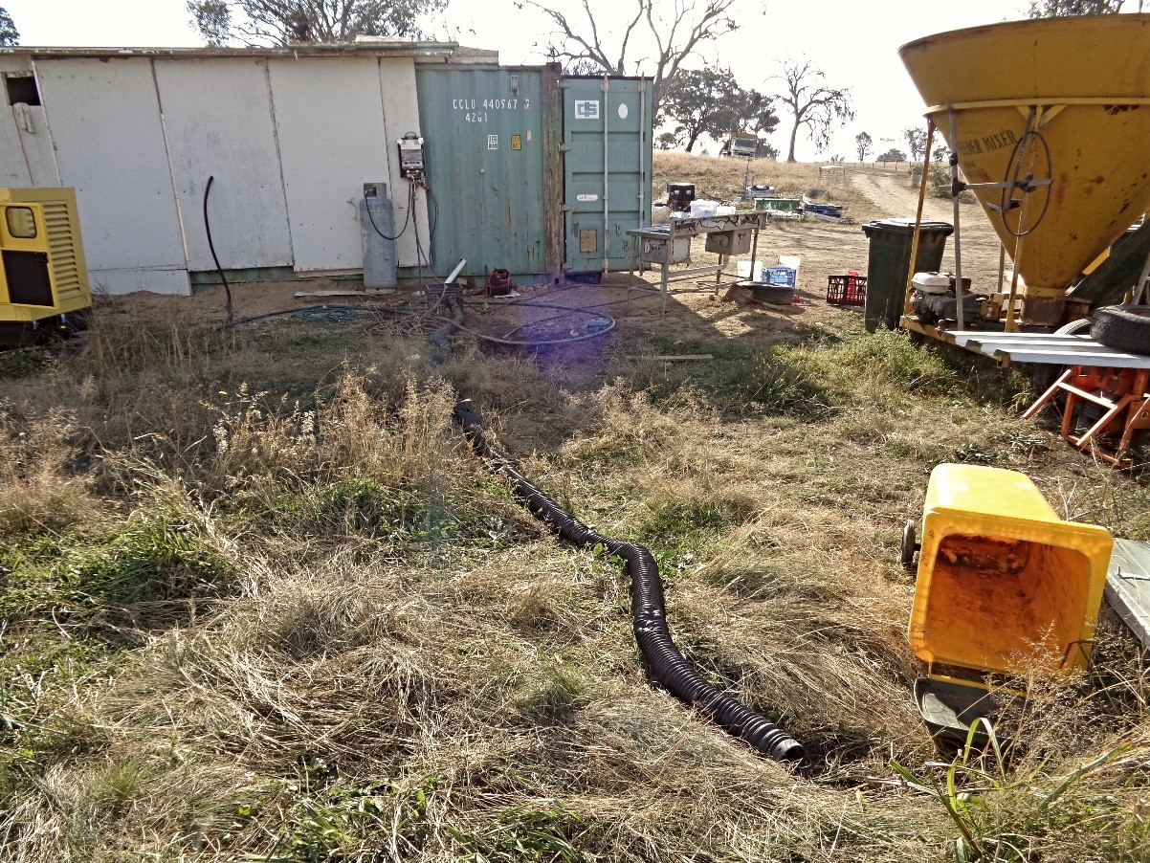
Source: Health Protection Service, ACT Health Directorate

Figure 2 Hens inside the egg processing facility at the free-range egg farm at the initial site inspection, ACT, May 2018.
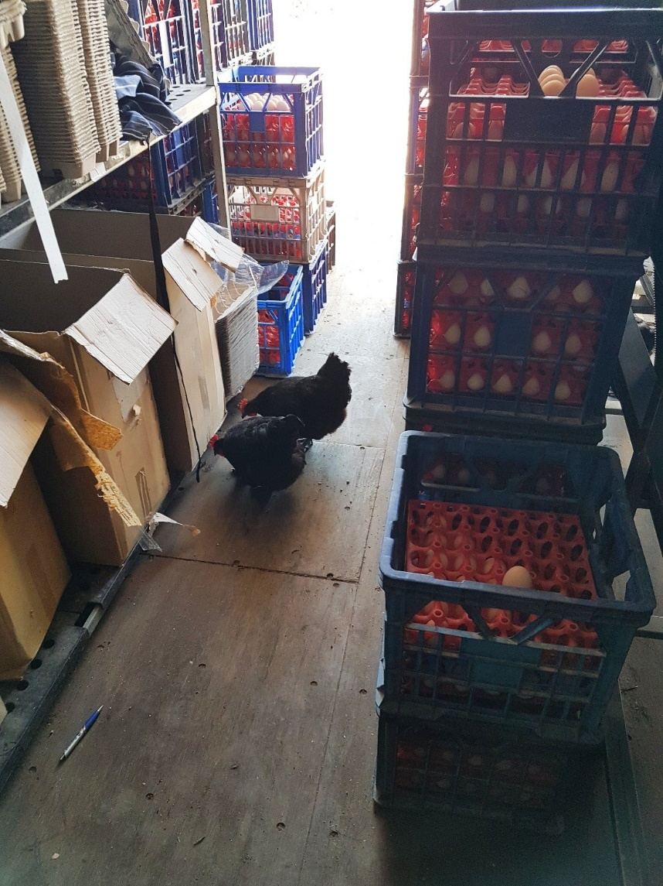
Source: Health Protection Service, ACT Health Directorate
Visibly dirty eggs were soaked for two minutes in a chlorine solution, with the concentration measured by smell. After soaking, these eggs were washed and sanitised in the machine. The brushes on the egg washing and grading machine, which had been in operation since March 2018, were visibly dirty. There was no documented procedure, schedule or records for cleaning the machine. Furthermore, the egg sanitiser function on the machine, and the hot water system that supplied it, were faulty. The only hand hygiene facility available onsite consisted of a small bottle of alcohol-based hand rub, and one staff member was observed rinsing their hands in a puddle of waste water. The proprietor could not produce a risk assessment strategy, mitigation strategy, staff training manuals or cleaning records during the inspection.
During the initial inspection, 15 environmental samples were collected, including eggs, chicken faeces, waste water, shoe covers and swabs of the processing environment. S. Typhimurium MLVA pattern 03-10-10-09-496 was detected from a shoe cover and water from the egg processing machine wastewater hose. The proprietor reported that, although the business had previously sold live old layer hens for meat, he was not aware that any were sold to schools as layers.

Public Health Response
Following the initial inspection, an Improvement Notice was issued to the proprietor of the egg farm. The notice was revoked six weeks later, after the PHO confirmed at a second inspection that all problems had been rectified.

Discussion
The results of this investigation indicate that four cases of S. Typhimurium infection with a rare MLVA pattern likely occurred as a result of poor processing procedures on a local free-range egg farm. It is evidence that a breakdown in farm procedures and machinery maintenance can increase the risk of salmonellosis in consumers.
Given the inadequacy of food safety infrastructure and procedures at the implicated farm, it is surprising that more cases were not detected. This highlights the importance of investigating small outbreaks in order to mitigate serious public health risks and to improve food safety.
Eggs are the most common food vehicle associated with S. Typhimurium outbreaks in Australia.² Free-range eggs made up nearly 50% of the Australian market share in 2018.³ Poor practices at the farm most likely led to the distribution of contaminated eggs. However, proper handling of eggs in the home would have prevented illness.
The ACT Food Business Egg Guide informs food businesses of the risks associated with eggs and provides advice on best practice and the minimum requirements for handing eggs safely in a food business.⁴ The Food Safety Information Council does have an egg information page for consumers.⁵ Currently, there is no consumer equivalent information on the safe handling of eggs in the ACT. Since this outbreak, one is being developed.
The two additional cases with MLVA 03-10-09-09-496 could not be linked epidemiologically to the outbreak. Whole-genome sequencing may confirm a close genetic relationship to the outbreak cases, but would not shed any light on the mode of transmission of these infections. It is possible that live hens from the farm ended up at the cases’ school, or that those interviewed were not able to recall the brand of eggs that were purchased.

Acknowledgements
The authors acknowledge the following persons and organisations for their assistance with the investigation: Roxanne Jones, Master of Philosophy (Applied Epidemiology) Scholar with the Australian National University; staff at the Communicable Disease Control section at the ACT Health Protection Service; Environmental Health officers at the ACT Health Protection Service; staff at the ACT Government Analytical Laboratory; and Mary Valcanis and staff at the Microbiological Diagnostic Unit, Melbourne, Victoria.

Author details
Timothy S. Sloan-Gardner¹
Natasha Waters²
Alexandra Marmor¹
William Mude³
- OzFoodNet, Communicable Disease Control Section, Health Protection Service, ACT Health, Holder, Australian Capital Territory
- Australian Capital Territory Government Analytical Laboratory, ACT Health, Holder, Australian Capital Territory.
- Environmental Health Section, Health Protection Service, ACT Health, Holder, Australian Capital Territory.

Corresponding author
Mr Timothy S. Sloan-Gardner
OzFoodNet, Communicable Disease Control Section, Health Protection Service, ACT Health, 25 Mulley Street, Holder, Australian Capital Territory, Australia.
Telephone: +61 2 51249210
Email: Timothy.Sloan-Gardner@act.gov.au.

References
- Australian Capital Territory. Public Health Act 1997. Available from: http://www.legislation.act.gov.au/a/1997-69/.
- Moffatt CR, Musto J, Pingault N, Miller M, Stafford R, Gregory J et al. Salmonella Typhimurium and Outbreaks of Egg-Associated Disease in Australia, 2001 to 2011. Foodborne Pathog Dis. 2016;13(7):379–85.
- Australian Eggs Limited. Annual report 2017/18. North Sydney, Australian Eggs Limited, 2018. Available from: https://www.australianeggs.org.au/who-we-are/annual-reports/
- ACT Health, Food Business Egg Guide. ACT Government, ACT Health, Health Protection Service 2018. Available from: https://health.act.gov.au/businesses/food-safety-regulation/food-safety-training-and-resources
- Food Safety Information Council. Eggs. [Internet.] Food safety Information Council. [Accessed: 25 Feb 2019.] Available from: http://foodsafety.asn.au/eggs/.

Communicable Diseases Intelligence
ISSN: 2209-6051 Online

Communicable Diseases Intelligence (CDI) is a peer-reviewed scientific journal published by the Office of Health Protection, Department of Health. The journal aims to disseminate information on the epidemiology, surveillance, prevention and control of communicable diseases of relevance to Australia.

Editor: Cindy Toms
Deputy Editor: Simon Petrie
Design and Production: Kasra Yousefi
Editorial Advisory Board: David Durrheim, Mark Ferson, John Kaldor, Martyn Kirk and Linda Selvey

Website: http://www.health.gov.au/cdi

Contacts
Communicable Diseases Intelligence is produced by:
Health Protection Policy Branch, Office of Health Protection, Australian Government Department of Health
GPO Box 9848, (MDP 6) CANBERRA ACT 2601

Email: cdi.editor@health.gov.au

Submit an Article
You are invited to submit your next communicable disease related article to the Communicable Diseases Intelligence (CDI) for consideration. More information regarding CDI can be found at: http://health.gov.au/cdi.
Further enquiries should be directed to: cdi.editor@health.gov.au.

This journal is indexed by Index Medicus and Medline.

Creative Commons Licence - Attribution-NonCommercial-NoDerivatives CC BY-NC-ND
© 2019 Commonwealth of Australia as represented by the Department of Health
This publication is licensed under a Creative Commons Attribution-NonCommercial-NoDerivatives 4.0 International Licence from https://creativecommons.org/licenses/by-nc-nd/4.0/legalcode (Licence). You must read and understand the Licence before using any material from this publication.

Restrictions
The Licence does not cover, and there is no permission given for, use of any of the following material found in this publication (if any):
- the Commonwealth Coat of Arms (by way of information, the terms under which the Coat of Arms may be used can be found at www.itsanhonour.gov.au);
- any logos (including the Department of Health’s logo) and trademarks;
- any photographs and images;
- any signatures; and
- any material belonging to third parties.

Disclaimer
Opinions expressed in Communicable Diseases Intelligence are those of the authors and not necessarily those of the Australian Government Department of Health or the Communicable Diseases Network Australia. Data may be subject to revision.

Enquiries
Enquiries regarding any other use of this publication should be addressed to the Communication Branch, Department of Health, GPO Box 9848, Canberra ACT 2601, or via e-mail to: copyright@health.gov.au

Communicable Diseases Network Australia
Communicable Diseases Intelligence contributes to the work of the Communicable Diseases Network Australia.
http://www.health.gov.au/cdna

Mary Valcanis, personal communication, Microbiological Diagnostic Unit (MDU)
OzFoodNet, unpublished data

