Arboviral diseases and malaria in Australia, 2014–15: Annual report of the National Arbovirus and Malaria Advisory Committee
Katrina Knope, Stephen L Doggett, Cassie C Jansen, Cheryl A Johansen, Nina Kurucz, Rebecca Feldman, Stacey E Lynch, Michaela P Hobby, Angus Sly, Andrew Jardine, Sonya Bennett, Bart J Currie, and the National Arbovirus and Malaria Advisory Committee

Abstract
This report describes the epidemiology of mosquito-borne diseases of public health importance in Australia during the 2014–15 season (1 July 2014 to 30 June 2015) and includes data from human notifications, sentinel chicken, vector and virus surveillance programs. The National Notifiable Diseases Surveillance System received notifications for 12,849 cases of disease transmitted by mosquitoes during the 2014–15 season. The Australasian alphaviruses Barmah Forest virus and Ross River virus accounted for 83% (n=10,723) of notifications. However, over-diagnosis and possible false positive diagnostic test results for these two infections mean that the true burden of infection is likely overestimated, and as a consequence, revised case definitions were implemented from 1 January 2016. There were 151 notifications of imported chikungunya virus infection. There were 74 notifications of dengue virus infection acquired in Australia and 1,592 cases acquired overseas, with an additional 34 cases for which the place of acquisition was unknown. Imported cases of dengue were most frequently acquired in Indonesia (66%). There were 7 notifications of Zika virus infection. No cases of locally-acquired malaria were notified during the 2014–15 season, though there were 259 notifications of overseas-acquired malaria and one notification for which no information on the place of acquisition was supplied. Imported cases of malaria were most frequently acquired in southern and eastern Africa (23%) and Pacific Island countries (20%). In 2014–15, arbovirus and mosquito surveillance programs were conducted in most of the states and territories. Surveillance for exotic mosquitoes at international ports of entry continues to be a vital part of preventing the establishment of vectors of mosquito-borne diseases such as dengue to new areas of Australia. In 2014-15, there was a sharp increase in the number of exotic mosquitoes detected at the Australian border, with 36 separate exotic mosquito detections made, representing a 280% increase from the 2013-14 period where there were 13 exotic mosquito detections. Commun Dis Intell 2016;40(3):e401–436.
Keywords: arbovirus; Barmah Forest virus, chikungunya, dengue, Zika, disease surveillance, epidemiology, flavivirus, Japanese encephalitis, West Nile virus, Kunjin virus, malaria, mosquito-borne disease, mosquitoes, Murray Valley encephalitis virus, Ross River virus, yellow fever, West Nile virus, exotic mosquitoes

Introduction
This report describes the epidemiology of mosquito-borne diseases of public health importance in Australia during the period 1 July 2014 to 30 June 2015.
This report includes a summary of cases of the following nationally notifiable pathogens that are transmitted by mosquitoes:
- alphaviruses – comprising Barmah Forest virus (BFV), Ross River virus (RRV), and chikungunya virus (CHIKV);
- flaviviruses – comprising dengue virus (DENV), Murray Valley encephalitis virus (MVEV), West Nile virus (WNV) and the Kunjin lineage of West Nile virus (KUNV), Japanese encephalitis virus (JEV), yellow fever virus (YFV) and unspecified; and
- malaria.
Both locally acquired and overseas acquired cases are described. Vector, climate and sentinel chicken surveillance measures for arboviruses conducted by states and territories, and vector surveillance at international first ports of entry are described.
The National Arbovirus and Malaria Advisory Committee (NAMAC) provides expert technical advice on arboviruses and malaria to the Australian Health Protection Principal Committee through the Communicable Diseases Network Australia (CDNA). Members of NAMAC have expertise in virus and disease surveillance, epidemiology, virology, vector ecology, vector and disease control and biosecurity, and represent agencies with substantial interest in this area. NAMAC makes recommendations about surveillance and reporting systems, strategic approaches for disease and vector management and control, and laboratory support and outlines research priorities. NAMAC assists in the prevention, detection, management and control of outbreaks of arboviruses or malaria and provides advice on the risk posed to Australia by these viruses or exotic vectors that may be imported from overseas.

Methods
Human cases of arbovirus infection and malaria are monitored using the National Notifiable Diseases Surveillance System (NNDSS). All Australian states and territories require doctors and/or pathology laboratories to notify cases of infectious diseases that are important to public health. The National Health Security Act 2007 (NHS Act 2007) provides the legislative basis for the national notification of communicable diseases and authorises the exchange of health information between the Commonwealth and the states and territories. The NHS Act 2007 provides for the establishment of the National Notifiable Diseases List, which specifies the diseases about which personal information can be exchanged between the states and territories and the Commonwealth. State and territory health departments transfer these notifications regularly to the NNDSS. The primary responsibility for public health action resulting from a notification resides with state and territory health departments.
This report presents case data from a snap-shot of NNDSS taken during July 2016 and analysed by date of diagnosis. This derived field is the disease onset date, or where the date of onset was not known, for vectorborne diseases, it is the earliest of the specimen collection date, the notification date, or the notification received date. Since the data are from a snap-shot, numbers in this report may vary slightly from those reported elsewhere due to changes in diagnostic validation or classification. Data were verified with state and territory public health surveillance managers. Detailed notes on the interpretation of NNDSS are available in the 2014 NNDSS annual report.¹ Case definitions for the diseases included in this report are available on the Australian Government Department of Health web site (http://www.health.gov.au/casedefinitions). CHIKV infection was made nationally notifiable in 2015, though a national case definition was implemented from 2010. Prior to this, CHIKV infections were notified under the disease category arbovirus not elsewhere classified (NEC), and all notifications have now been included under CHIKV in NNDSS.
Data were analysed by financial year to reflect the seasonal cycle of arboviral activity in most areas of Australia. Crude notification rates or counts for the 2014–15 season were compared with those for the previous 5 seasons. Notification rates were not calculated for diseases that are primarily acquired overseas because resident populations are not an appropriate denominator. Rates are not provided for rare diseases (n<20 notifications for the year) because these rates typically have large standard errors and therefore cannot be meaningfully compared across time or geographical location.
Notification rates were calculated using the Australian Bureau of Statistics (ABS) estimated resident populations for Australia and each state or territory.² Population data are supplied as an estimate for calendar years; for this report, the population for the second half of the financial year was applied to that year (2015 population applied to the 2014–15 financial year). Additional spatial analyses were performed using the ABS Statistical Area level 3 classifications,³ and using ABS defined ratios to allocate notifications by their postcode of residence to a statistical area. Analyses were conducted using Microsoft Excel® and Stata SE version 13. Maps were produced using Arc GIS (ESRI).
Additional information on the details of some notifications were obtained from state and territory public health surveillance managers. Data on sentinel chicken surveillance, vector (including detection of exotic mosquitoes at International ports of entry, hereafter referred to as the border) and virus surveillance are also reported.

Vertebrate, vector and climate surveillance in states and territories
Sentinel chicken flavivirus surveillance programs aim to provide early warning of the endemic arboviruses MVEV and KUNV as well as exotic flaviviruses such as JEV in some parts of the country.⁴ Public health messaging or other response measures can be implemented in response to surveillance signals. Public health messaging may advise at-risk residents or target groups such as campers or fishermen of the need to take added precautions to avoid mosquito bites. Sentinel chicken flocks are an important component of the early warning system in several jurisdictions, and these are located geographically to detect flavivirus activity, while surveillance for the presence of virus in mosquitoes can also indicate both flavivirus and alphavirus activity. These surveillance sites are strategically located and can provide a timely and accurate indication of the risk of transmission to people (Map 1).⁵ Detailed descriptions of the sentinel chicken, vector and virus surveillance programs, as well as contact details for jurisdictional arbovirus reference or research laboratories are included in the Appendix A.

Results
During the 2014–15 season, there were 12,849 notifications of mosquito-borne diseases in humans (Table 1). This represented a 47% increase from the mean of 8,683.6 notifications for the previous 5 years.

Map 1: Location of surveillance sites for arboviruses, Australia, 2014–15, by surveillance type
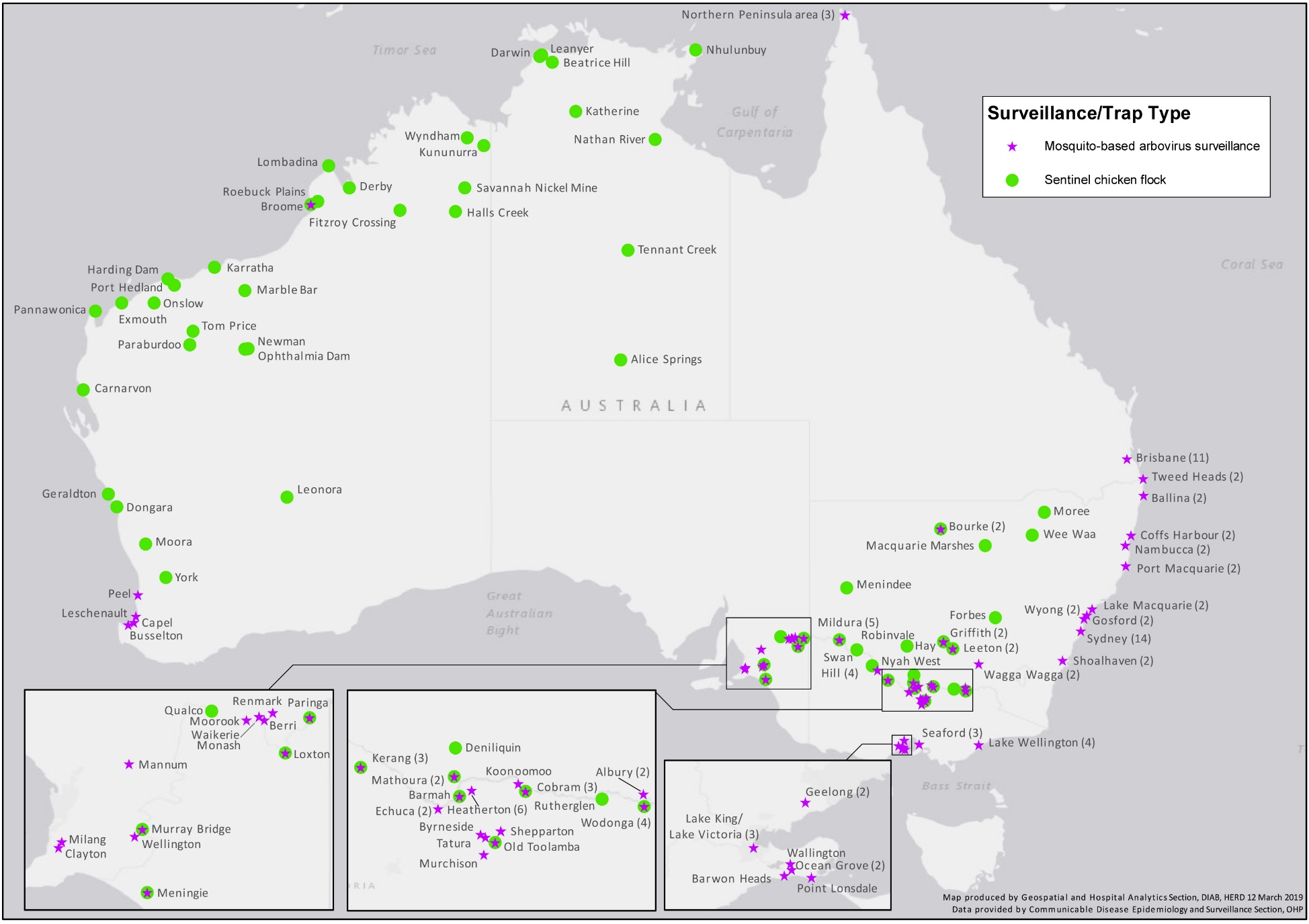
For more detailed information on sites, see Appendix B

Table 1: Number of notified human cases, notification rate* and 5 year mean for mosquito-borne disease, Australia, 2014–15, by disease and state or territory
 |  | ACT | NSW | NT | Qld | SA | Tas. | Vic. | WA | Australia
Barmah Forest virus infection | Cases 2014–15 | 3 | 188 | 28 | 365 | 1 | 0 | 21 | 43 | 649
 | 5 year mean cases | 3.2 | 353.2 | 138.2 | 1,134.2 | 65.2 | 1.6 | 78.2 | 307.6 | 2,081.4
 | Rate 2014-15 | 0.8 | 2.5 | 11.5 | 7.6 | 0.1 | 0 | 0.4 | 1.7 | 2.7
 | 5 year mean rate | 0.9 | 4.8 | 57.7 | 24.7 | 3.9 | 0.3 | 1.4 | 12.4 | 9.1
Chikungunya virus infection | Cases 2014–15 | 0 | 43 | 6 | 37 | 5 | 0 | 44 | 16 | 151
 | 5 year mean cases | 0.0 | 12.6 | 3.0 | 5.8 | 3.6 | 0.6 | 17.8 | 18.8 | 62.2
 | Rate 2014-15 | – | – | – | – | – | – | – | – | –
 | 5 year mean rate | – | – | – | – | – | – | – | – | –
Dengue virus infection | Cases 2014–15 | 10 | 300 | 63 | 259 | 89 | 16 | 367 | 596 | 1,700
 | 5 year mean cases | 17.2 | 255.8 | 48.6 | 315.0 | 42.8 | 9.8 | 238.0 | 434.2 | 1361.4
 | Rate 2014-15 | – | – | – | – | – | – | – | – | –
 | 5 year mean rate | – | – | – | – | – | – | – | – | –
Flavivirus unspecified† | Cases 2014–15 | 0 | 2 | 0 | 5 | 1 | 0 | 1 | 1 | 10
 | 5 year mean cases | 0.0 | 1.0 | 0.2 | 7.0 | 0.2 | 0.0 | 4.4 | 0.2 | 12.8
 | Rate 2014-15 | – | – | – | – | – | – | – | – | –
 | 5 year mean rate | – | – | – | – | – | – | – | – | –
Japanese encephalitis virus infection | Cases 2014–15 | 0 | 1 | 0 | 0 | 1 | 0 | 1 | 0 | 3
 | 5 year mean cases | 0.0 | 0.2 | 0.0 | 0.6 | 0.2 | 0.0 | 0.2 | 0.2 | 1.0
 | Rate 2014-15 | – | – | – | – | – | – | – | – | –
 | 5 year mean rate | – | – | – | – | – | – | – | – | –
West Nile virus/Kunjin virus infection | Cases 2014–15 | 0 | 0 | 0 | 0 | 0 | 0 | 0 | 0 | 0
 | 5 year mean cases | 0.0 | 0.2 | 0.4 | 0.6 | 0.0 | 0.0 | 0.2 | 0.0 | 1.4
 | Rate 2014-15 | – | – | – | – | – | – | – | – | –
 | 5 year mean rate | – | – | – | – | – | – | – | – | –
Malaria | Cases 2014–15 | 8 | 51 | 10 | 75 | 2 | 5 | 65 | 44 | 260
 | 5 year mean cases | 10.2 | 91.4 | 17.2 | 116.8 | 10.0 | 6.8 | 85.4 | 63.2 | 401.0
 | Rate 2014-15 | – | – | – | – | – | – | – | – | –
 | 5 year mean rate | – | – | – | – | – | – | – | – | –
Murray Valley encephalitis virus infection | Cases 2014–15 | 0 | 0 | 2 | 0 | 0 | 0 | 0 | 0 | 2
 | 5 year mean cases | 0.0 | 0.6 | 0.4 | 0.2 | 0.4 | 0.0 | 0.0 | 1.8 | 3.4
 | Rate 2014-15 | – | – | – | – | – | – | – | – | –
 | 5 year mean rate | – | – | – | – | – | – | – | – | –
Ross River virus infection | Cases 2014–15 | 11 | 1,618 | 374 | 6,371 | 119 | 6 | 339 | 1,236 | 10,074
 | 5 year mean cases | 9.8 | 678.6 | 290.4 | 1,849.0 | 411.2 | 18.6 | 462.0 | 1,039.0 | 4,758.6
 | Rate 2014-15 | 2.8 | 21.2 | 153.0 | 133.3 | 7.0 | 1.2 | 5.7 | 47.7 | 42.4
 | 5 year mean rate | 2.7 | 9.3 | 122.7 | 40.6 | 25 | 3.6 | 8.3 | 42.2 | 21.0
Yellow fever | Cases 2014–15 | 0 | 0 | 0 | 0 | 0 | 0 | 0 | 0 | 0
 | 5 year mean cases | 0.0 | 0.0 | 0.0 | 0.4 | 0.0 | 0.0 | 0.0 | 0.0 | 0.4
 | Rate 2014-15 | – | – | – | – | – | – | – | – | –
 | 5 year mean rate | – | – | – | – | – | – | – | – | –
Total 2014-15 |  | 32 | 2,203 | 483 | 7,111 | 218 | 27 | 838 | 1,936 | 12,849
* Rates are not provided for diseases with less than 20 cases, or for diseases predominantly acquired overseas.
† Flavivirus (NEC) replaced Arbovirus (NEC) from 1 January 2004. Arbovirus (NEC) replaced Flavivirus (NEC) from 2008. Flavivirus (unspecified) replaced arbovirus (NEC) from 14 January 2015.
NEC Not elsewhere classified.

Alphaviruses
In Australia, the most frequently notified viruses in the genus Alphavirus are RRV and BFV. RRV and BFV occur exclusively in the Australasian region.⁶ Infection with RRV or BFV can cause illness characterised by fever, rash and polyarthritis. These viruses are transmitted by numerous species of mosquitoes that inhabit diverse environments (freshwater habitats, coastal regions, salt marshes, floodwaters, established wetlands and urban areas).⁷ It is important to note that seasonal trends vary between and within states and territories according to differences in mosquito vectors, hosts and climate. In addition, comparisons between regions are likely to be influenced by accuracy of case-ascertainment, which may vary between jurisdictions because of some differences in reporting criteria and the quality of diagnostic tests used, leading to over diagnosis particularly during the off-season.⁸ Revised case definitions for RRV and BFV were implemented on 1 January 2016.⁹ Over-diagnosis and possible false positive diagnostic test results for these two infections in 2014-15 and prior reporting periods mean that the true burden of RRV and BFV infection has likely been overestimated. Therefore comparisons of data from 2014-15 and prior years with data to be reported in future years will be problematic.
Local transmission of the alphavirus CHIKV has not occurred in Australia, but the infection is regularly reported in travellers returning from overseas. The illness is characterised by an abrupt onset of fever, rash and severe joint pain. The acute disease lasts 1 to 10 days, but convalescence may include prolonged joint swelling and pain lasting months. Haemorrhagic manifestations may occur occasionally.¹⁰ Humans are amplification hosts for CHIKV and other vertebrates are not required for transmission to occur. There is the potential for transmission of CHIKV in areas where a suitable mosquito vector exists. Internationally, CHIKV is most commonly transmitted by Aedes aegypti and Ae. albopictus. In Australia, Ae. aegypti is present in parts of Northern, Central and South West Queensland and Ae. albopictus is found on Cocos Island, Christmas Island and in some areas of the Torres Strait Islands.¹¹ Other Australian mosquito species have been shown to be competent vectors of CHIKV in the laboratory,¹² but any role in field transmission is likely to be minor compared with either Ae. aegypti or Ae. albopictus.¹³

Barmah Forest virus infections
There were 649 notifications of BFV infections during the 2014–15 season, representing a rate of 2.7 per 100,000 population, a decrease from the mean of 2,081.4 cases (9.1 per 100,000) for the previous 5 years (Table 1, Figure 1). Queensland reported the largest number of notifications of BFV infection (n=365) while the highest rate was reported in the Northern Territory (11.5 per 100,000 population)(Figure 2). Rates in 2014–15 were below the 5-year mean for all states and territories.

Figure 1: Notifications of Barmah Forest virus infection, 1 July 2009 to 30 June 2015, by month and year and state or territory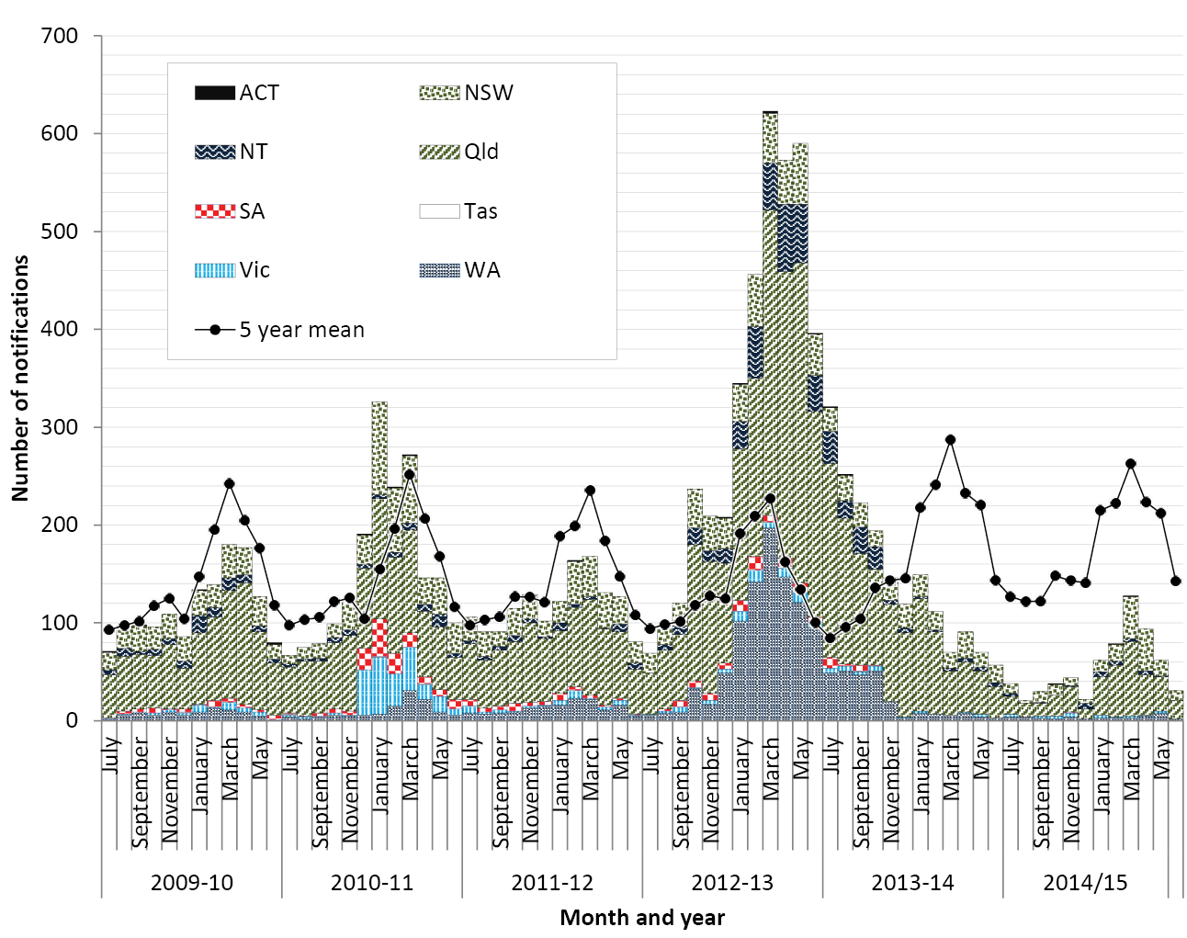

Figure 2: Notification rate for Barmah Forest virus infection, Australia, 1 July 2009 to 30 June 2015, by year and state or territory 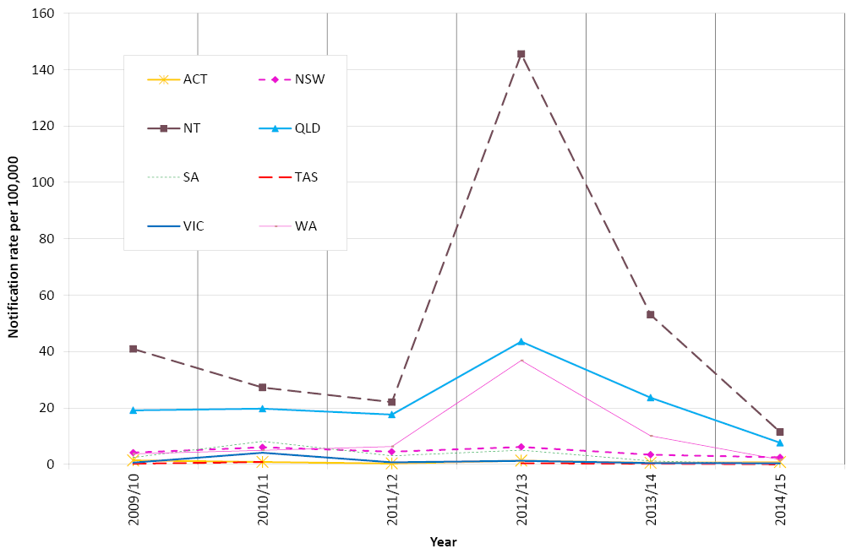
Figure 3: Notification rate for Barmah Forest virus infection, Australia, 2014–15, by age group and sex (n=649)
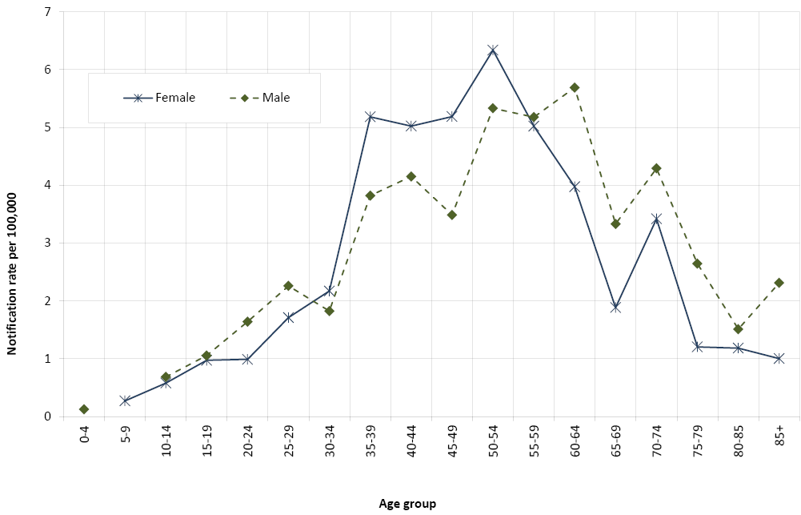
Rates of BFV in 2014–15 by Statistical Area Level 3 (SA3) were highest in Kempsey-Nambucca in northern coastal New South Wales (39 per 100,000), Litchfield in the area surrounding Darwin (36 per 100,000) , the Clarence Valley in northern coastal New South Wales (35 per 100,000), the Sunshine Coast Hinterland in Queensland (27 per 100,000) and Nambour-Pomona on the Sunshine Coast in Queensland (26 per 100,000)(Map 2). In New South Wales other SA3s with high rates were Port Macquarie (20.3 per 100,000), Richmond Valley-coastal (23.9 per 100,000), and Richmond Valley-hinterland (19.7 per 100,000).
Rates by SA3 in 2014–15 were lower than or similar to those published previously for 2013–14 in almost all SA3s,¹⁴ except a small number where the rates were markedly higher, including South Coast (NSW), Gippsland East (Victoria), Gascoyne (WA) and Coffs Harbour (NSW).
BFV infections are unexpected outside of the warmer months when suitable mosquito vectors are abundant and when environmental conditions favour viral replication. In 2014–15, infections were most frequently notified between January and May, with 65% of cases having a date of diagnosis during these months (Figure 1).
In 2014–15, BFV notifications were most common among adults, with notification rates peaking in the 50–54 years age group for women and 40–44 year age group for men (Figure 3). In 2014–15, the median age was 49 years (range 3 to 96) and 51% of cases were male. The proportion of cases that were male was higher than in 2012–13 and 2013–14 (41%) when an epidemic of false positive notifications was occurring,¹⁴ but was similar to the 3 years prior to that (50% to 52%).

Map 2: Notification rates for Barmah Forest virus infection, 2014–15, by Statistical Area Level 3
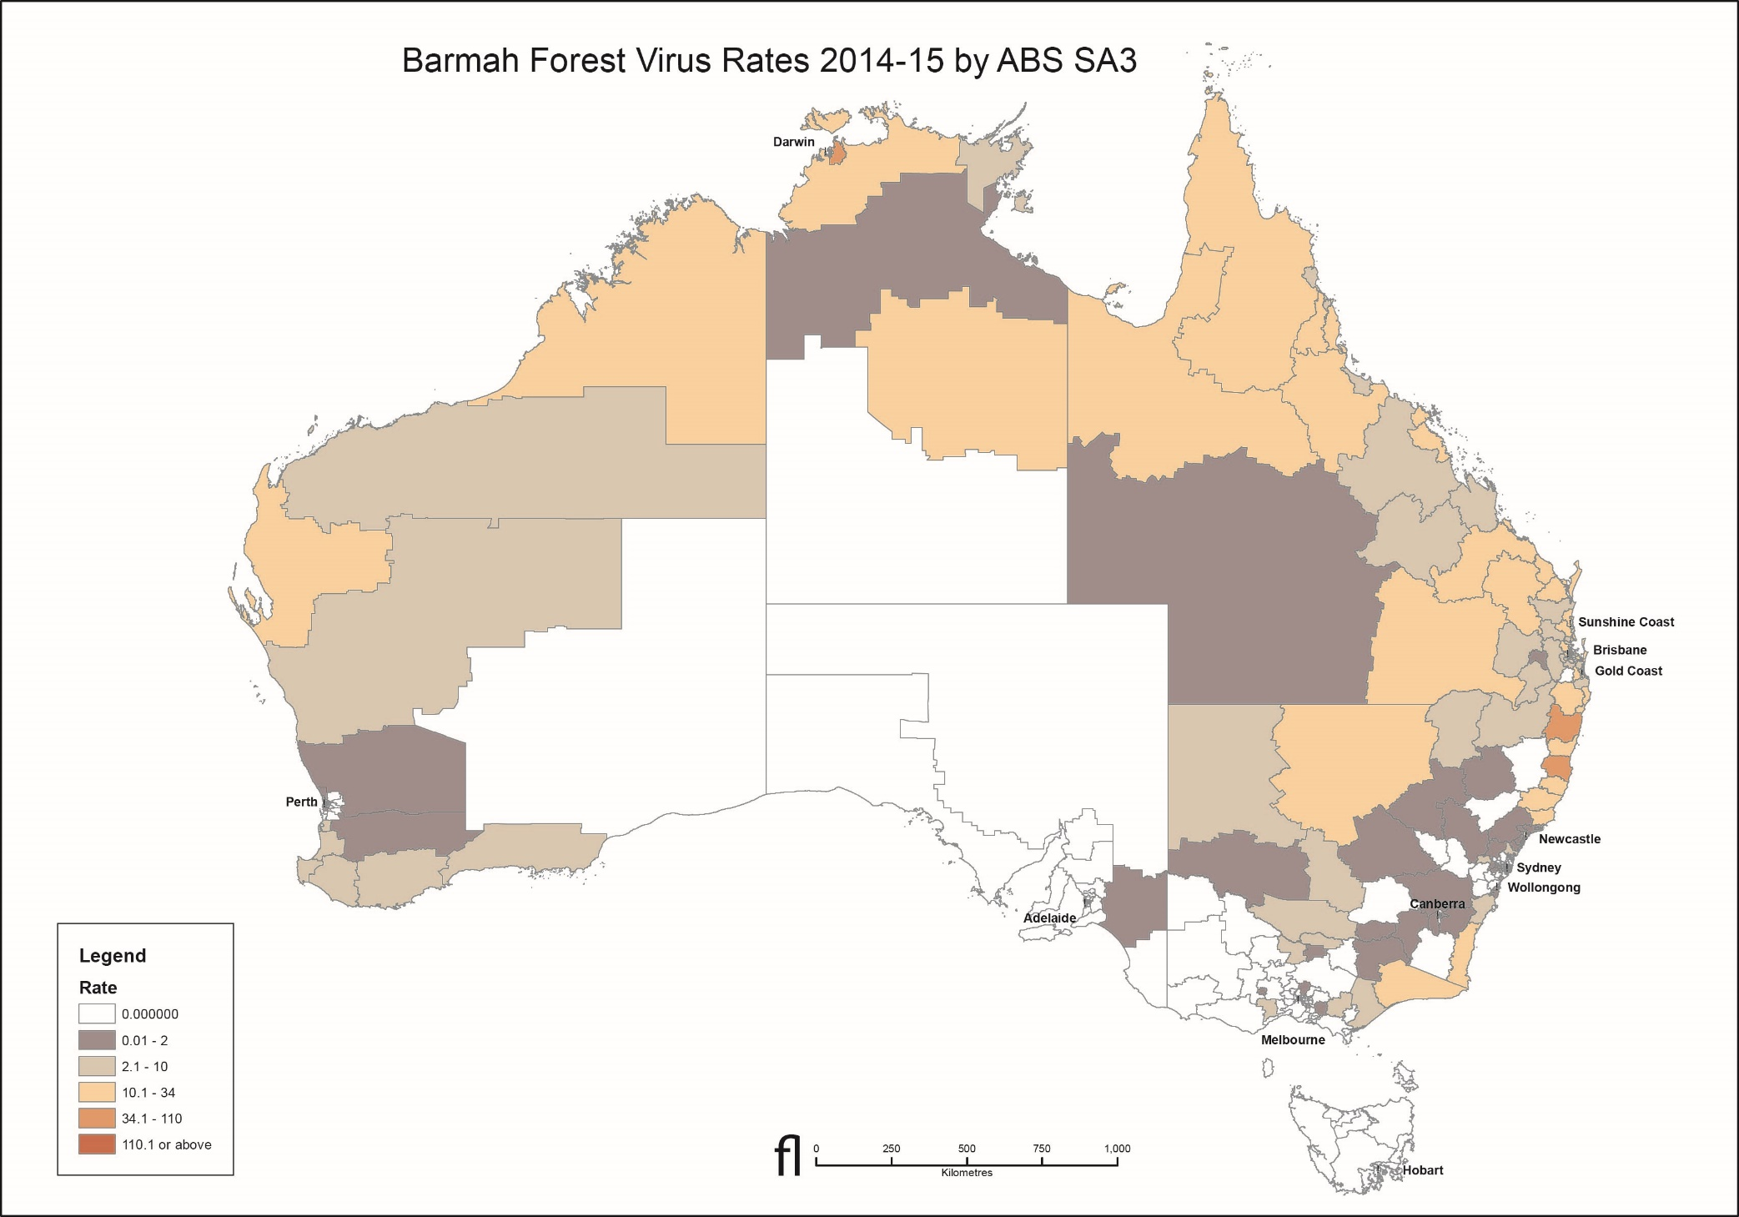

Ross River virus infections
There were 10,074 notifications of RRV infection during the 2014–15 season, representing a rate of 42.4 per 100,000 population, compared with a 5-year mean of 4,758.6 notifications (21.0 per 100,000) (Table 1). Queensland reported the largest number of cases (n=6,371, more than three times the five year mean), while the highest rate was in the Northern Territory (153.0 per 100,000, 1.2 times the 5 year mean)(Figure 5). Rates of RRV were 2.3 and 3.3 times the 5-year mean in New South Wales and Queensland respectively.
Nationally, rates of RRV by SA3 in 2014–15 were highest in the Gascoyne (639 per 100,000), Litchfield surrounding Darwin (396 per 100,000) and Port Douglas (380 per 100,000)(Map 3).
Rates by SA3 were higher across much of Australia in 2014–15 than those published previously for 2013–14¹⁴, including in the Gascoyne in WA, Gold Coast Hinterland, Mudgereeba-Tallebudgera and Port Douglas in Queensland, and Kempsey–Nambucca in NSW.
RRV infections are unexpected outside of the warmer months when suitable mosquito vectors are abundant and when environmental conditions favour replication. Similar to previous years, in 2014–15, infections were most frequently notified between February and April, with 59% of cases having a date of diagnosis during these three months (Figure 4).

Figure 4: Notifications of Ross River virus infection, 1 July 2009 to 30 June 2015, by month and year and state or territory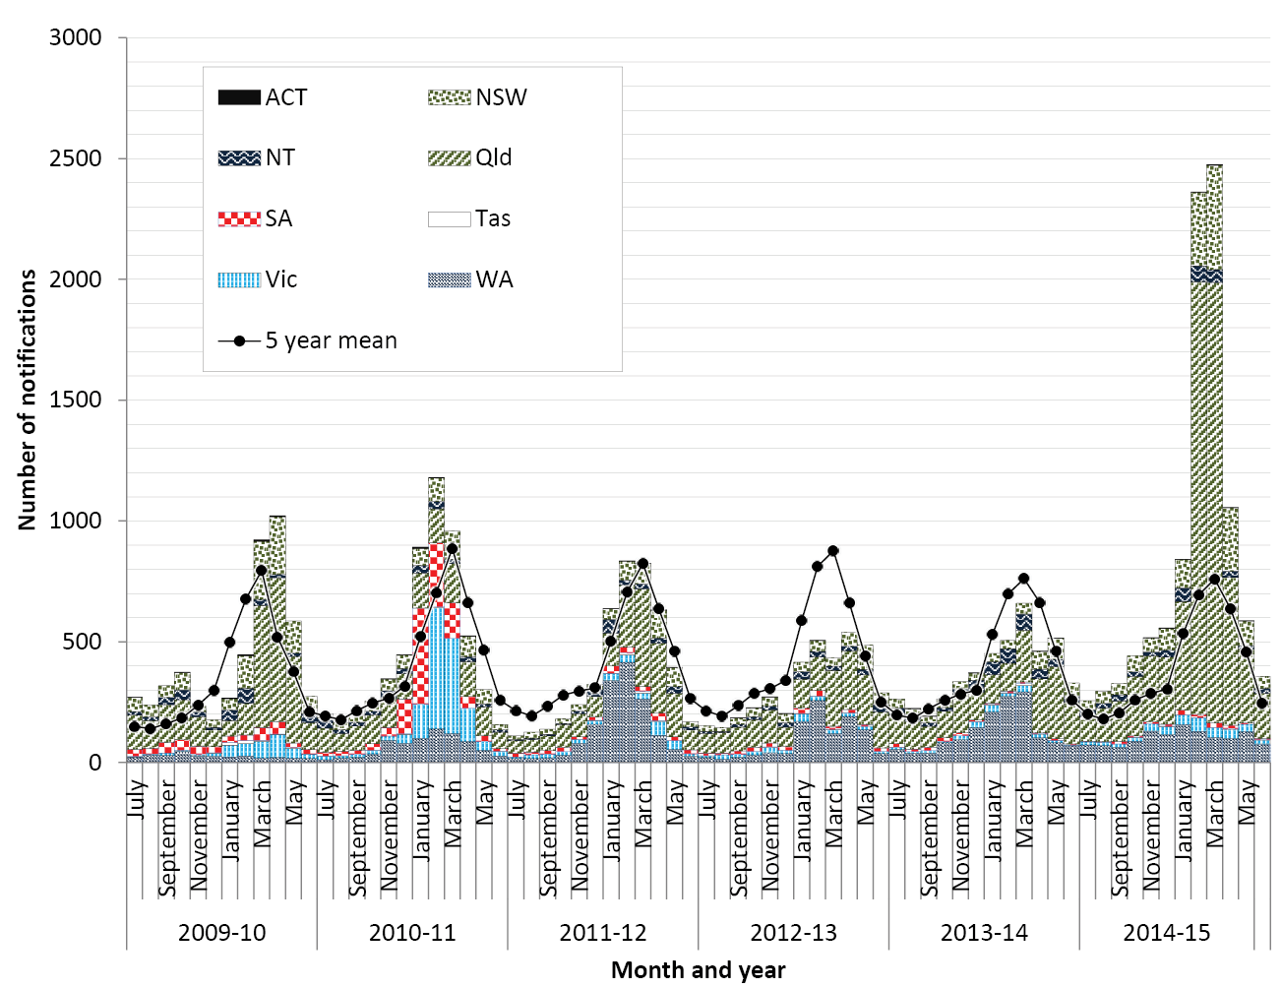

Figure 5: Notification rate for Ross River virus infection, Australia, 1 July 2009 to 30 June 2015, by year and state or territory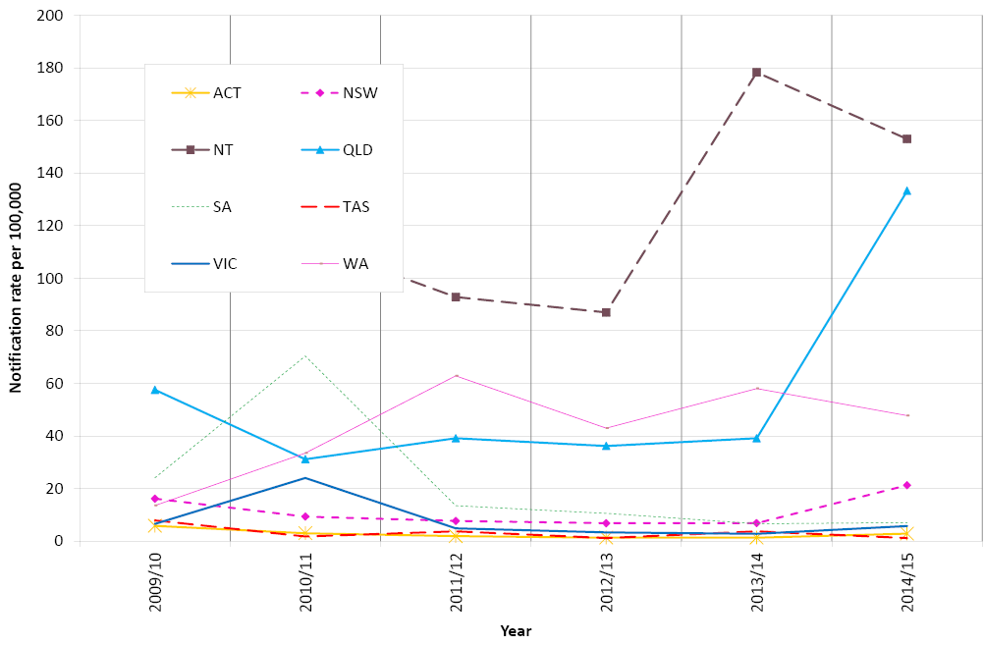
Figure 6: Notification rate for Ross River virus infection, Australia, 2014–15, by age group and sex (n=10,074)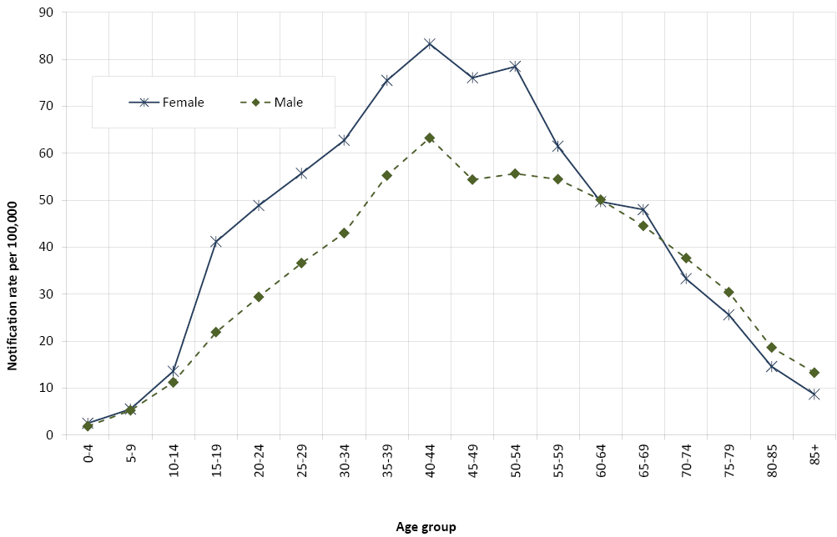
* Sex for 1 notification was not available and this notification is excluded.
RRV notifications were most common among adults, with notification rates peaking in the 40–44 years age group for men and women (83.3 and 63.3 per 100,000 respectively)(Figure 6). In 2014–15, the median age of cases was 43 years (range 0 to 98) and 43% of cases were male, slightly lower than the 5 year mean (46% male).
It is important to note that as for BFV, seasonal trends for RRV vary between and within states and territories according to differences in mosquito vectors, hosts and climate. In addition, as for BFV, comparisons between regions are likely to be influenced by accuracy of case-ascertainment, which may vary between jurisdictions because of some differences in reporting criteria and the quality of diagnostic tests used.^{8, 15}

Chikungunya virus infection
There were 151 notifications of CHIKV infection during the 2014–15 season compared with a 5–year mean of 62.2 cases (Table 1, Figure 7). New South Wales, Queensland and Victoria reported the largest numbers of cases (43, 37 and 44 respectively). All cases were known to have been acquired overseas, with complete information supplied on the country or region of acquisition for 99% (149/151) of these cases (Table 2). For cases with a known country of acquisition, the most frequently reported countries of acquisition in 2014–15 were Samoa (45 cases, 30%) and Indonesia (32 cases, 21%). Indonesia is usually the source of a large proportion of cases, but those acquired in Samoa represent a noteworthy increase from previous years. An outbreak of chikungunya was reported in Samoa in July 2014,¹⁶ with 4,524 suspected cases as of 9 March 2015 according to a summary posted on the Pacific Public Health Surveillance Network (PacNET) early warning system on 16 March 2015.¹⁷ This was part of a wave of chikungunya across the Pacific Islands between 2011 and 2015.¹⁸
In 2014–15, CHIKV infection was most frequently notified among young and middle aged adults (Figure 8). The median age was 45 years (range 14 to 84) and 45% per cent of cases were male.

Figure 7: Notifications of chikungunya virus infection, Australia, 2014–15, by month and year and state or territory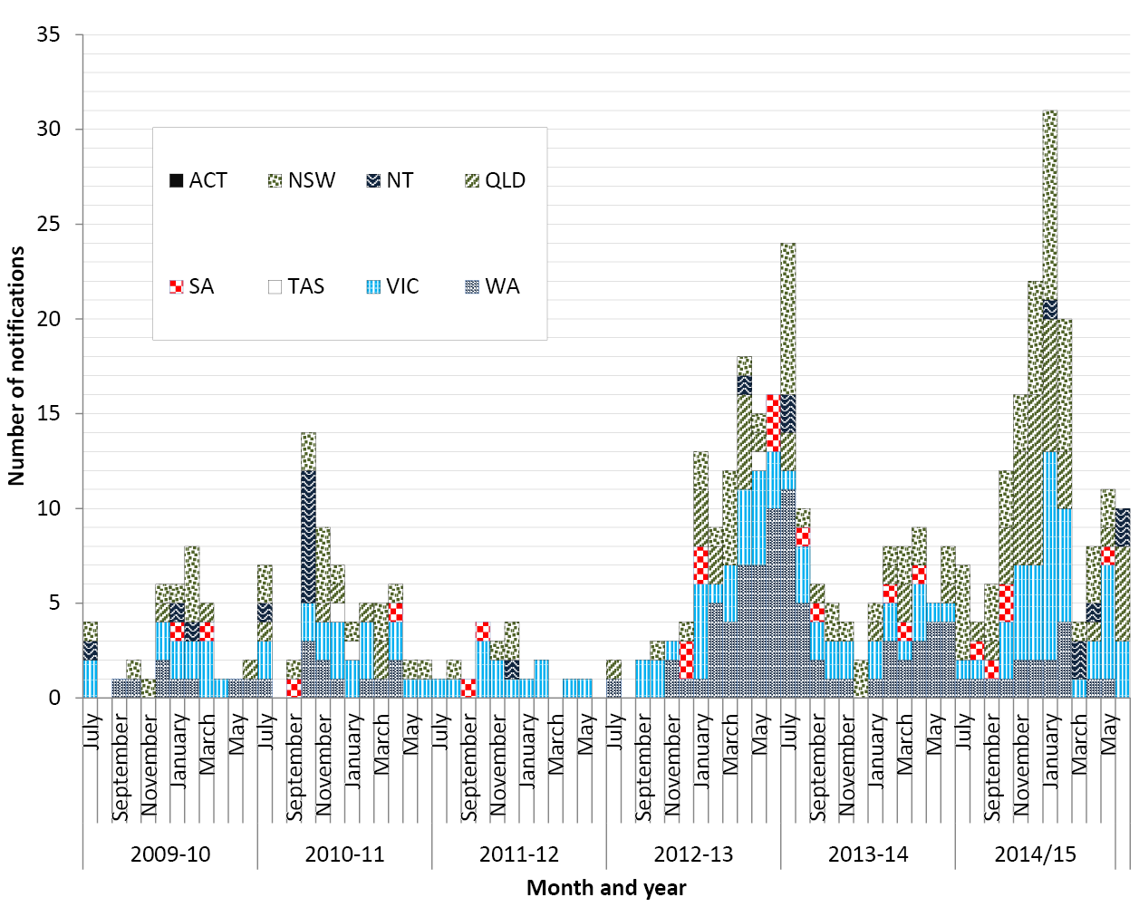

Table 2: Notifications of chikungunya virus infection, Australia, by year and country or region of acquisition *
Country of acquisition | 2009–10 | 2010–11 | 2011–12 | 2012–13 | 2013–14 | 2014–15
Samoa | 0 | 0 | 0 | 0 | 0 | 45
Indonesia | 7 | 33 | 2 | 72 | 64 | 32
Timor-Leste | 7 | 2 | 0 | 0 | 0 | 9
Colombia | 0 | 0 | 0 | 0 | 0 | 8
Philippines | 1 | 0 | 2 | 2 | 4 | 5
Kiribati | 0 | 0 | 0 | 0 | 0 | 5
Jamaica | 0 | 0 | 0 | 0 | 0 | 5
Nauru | 0 | 0 | 0 | 0 | 0 | 5
Caribbean, nfd* | 0 | 0 | 0 | 0 | 0 | 4
India | 14 | 11 | 6 | 3 | 11 | 4
Cook Islands | 0 | 0 | 0 | 0 | 0 | 4
French Polynesia | 0 | 0 | 0 | 0 | 0 | 3
El Salvador | 0 | 0 | 0 | 0 | 0 | 3
United States of America | 0 | 0 | 0 | 0 | 0 | 2
Grenada | 0 | 0 | 0 | 0 | 0 | 2
Sub-Saharan Africa, nfd | 0 | 0 | 0 | 0 | 0 | 1
Tonga | 0 | 0 | 0 | 0 | 7 | 1
Thailand | 0 | 2 | 3 | 2 | 1 | 1
Barbados | 0 | 0 | 0 | 0 | 0 | 1
Sri Lanka | 0 | 1 | 1 | 0 | 0 | 1
Malaysia | 4 | 1 | 1 | 1 | 0 | 1
Taiwan | 0 | 0 | 0 | 0 | 0 | 1
Nicaragua | 0 | 0 | 0 | 0 | 0 | 1
Dominican Republic | 0 | 0 | 0 | 0 | 0 | 1
Venezuela, Bolivarian Republic of | 0 | 0 | 0 | 0 | 0 | 1
Trinidad and Tobago | 0 | 0 | 0 | 0 | 0 | 1
Samoa, American | 0 | 0 | 0 | 0 | 0 | 1
Ethiopia | 0 | 0 | 0 | 0 | 0 | 1
Place of acquisition unknown | 0 | 0 | 1 | 1 | 1 | 2
Total | 37 | 63 | 20 | 97 | 94 | 151
* nfd– Not further defined

Figure 8: Notifications of chikungunya virus infection, Australia, 2014–15, by age and sex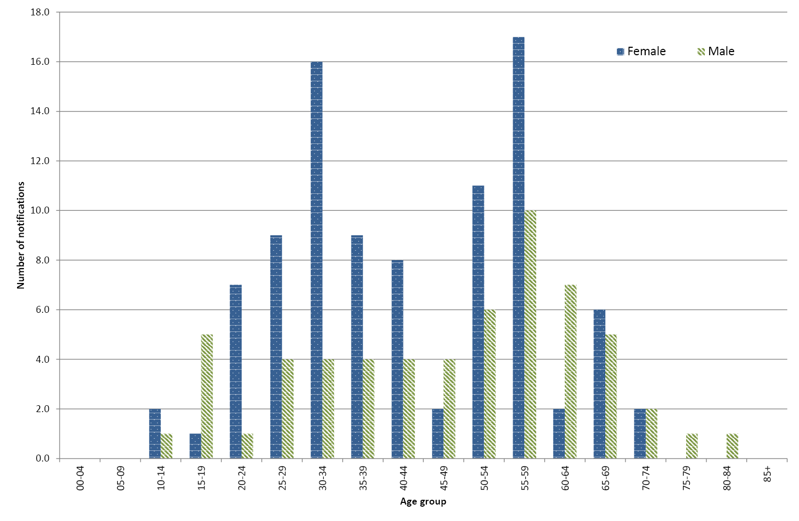

Flaviviruses
This section provides information on several flaviviruses notified to NNDSS including DENV, MVEV, WNV/KUNV and JEV. Other flaviviruses may be notified under the flavivirus (unspecified) category.
Four serotypes of dengue virus have been described and all 4 are reported in imported cases to varying degrees each year, some of which may result in local outbreaks. The clinical illness is characterised by mild to severe febrile illness with fever, headache, muscle or joint pain and sometimes a rash. A minority of cases progress to severe dengue with haemorrhage and shock, more commonly where, in a second or subsequent infection, a person is infected with a different DENV serotype to the first infection. Local transmission of dengue in Australia is restricted to areas of northern Queensland where the key mosquito vector, Ae. aegypti is present in sufficient numbers and with human populations of sufficient density.¹⁹ Dengue is not endemic in north Queensland, but local transmission can occur upon introduction of the virus to the mosquito vector by a viraemic tourist or a resident returning from a dengue-affected area overseas.²⁰
Infection with MVEV, KUNV or JEV is usually asymptomatic or produces a non-specific illness, but a small percentage of cases progress to encephalomyelitis of variable severity. Culex annulirostris is the major vector of MVEV, KUNV and potentially JEV in Australia. A vaccine is available to prevent JEV infection (available for residents in areas of Queensland where there is a risk of acquiring JEV and for long term travellers to endemic areas),²¹ but there are no vaccines currently available for DENV, MVEV or KUNV. YFV does not occur in Australia, but travellers to affected areas overseas need to be aware of the risks and vaccination requirements, and there is the potential for transmission in the areas of north Queensland where the vector Ae. aegypti is present.
No specific treatment is available for these diseases and care is largely supportive.

Dengue virus infection
There were 1,700 notifications of DENV infection during the 2014–15 season, with the largest number of cases reported by Western Australia (596 cases) followed by Victoria (367 cases)(Table 1). There were 74 cases acquired in Australia, while the majority (1,592 cases) acquired the infection overseas (Figure 9). For the remaining 34 cases, no information on place of acquisition was supplied. In 2014–15, DENV infection was most frequently reported amongst younger and middle aged adults (Figure 10), and the median age of cases was 39 years (range 0 to 83 years), and 50% (n=852) of cases were male.

Figure 9: Notifications of dengue virus infection, Australia, 2014–15, by month and year and place of acquisition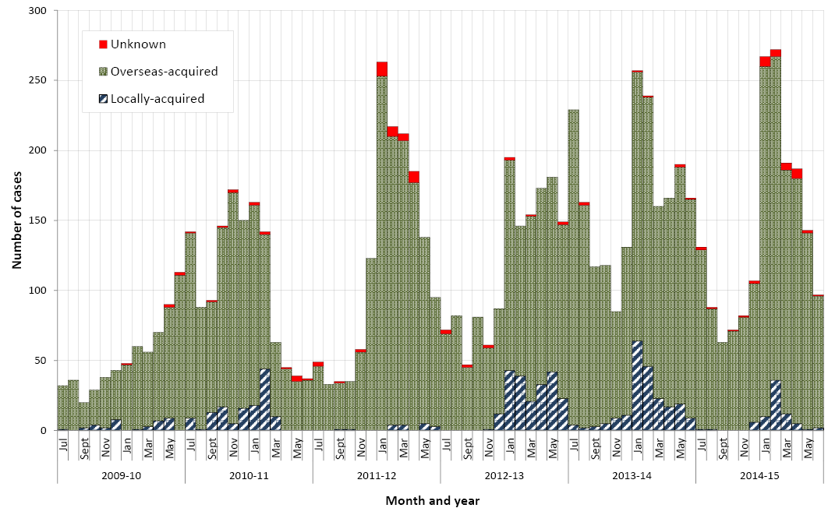
Figure 10: Notifications of dengue virus infection, Australia, 2014–15, by age and sex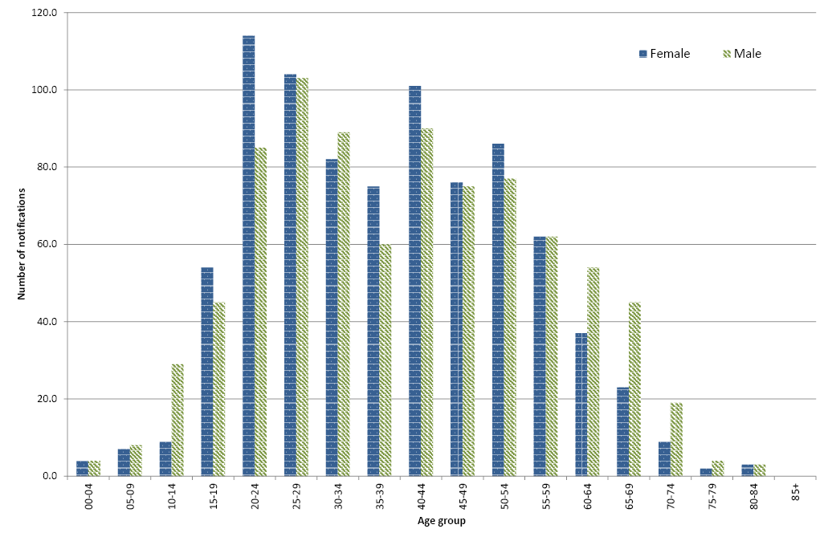

Locally-acquired dengue virus infection
The number of locally acquired cases of DENV infection in Australia during 2014–15 (74) was below the 5 year mean for locally acquired cases (122.8). Queensland reported 71 cases, with 3 notified by other states. Under the cross-border notification protocol, cases are notified by their state or territory of residence where this differs from the diagnosing state or territory, and all cases in 2014-15 were known to have been, or thought likely to have been, acquired in north Queensland.
In Queensland, a single case of locally-acquired dengue is considered to be an outbreak. Four dengue outbreaks were identified by Queensland Health in the 2014–15 season, all located in the north of the state (Map 4). A total of 70 dengue notifications were reported to have been associated with a specific outbreak, with cases in each outbreak ranging from 1 to 38. All of the outbreaks in 2014–15 were serotype 1, and all notifications were either serotype 1 or untyped/unknown. From 2009-10 to 2014-15, dengue serotype 1 has been the identified serotype in 62% of dengue outbreaks in Queensland.
Map 4: Outbreaks of dengue virus infection, 2014–15, Australia
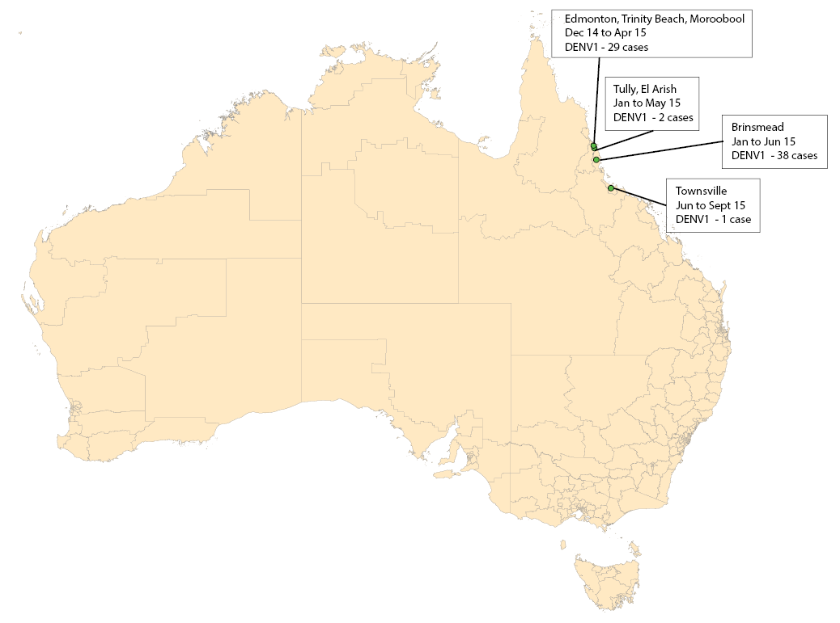

Overseas-acquired dengue virus infection
Most of the overseas-acquired dengue cases in 2014–15 were acquired in Indonesia (66%, 1,046/1,592) or elsewhere in South-east Asia (21%, 334/1,592) (Table 3). A high proportion of cases acquired in Indonesia have previously been shown, for Western Australian cases, to be related to travel to Bali.²² The infecting serotype was most frequently unknown (71%, 1,124/1,592). Where a serotype was available, it was most frequently reported as serotype 2 (43%, 201/468) or serotype 1 (35%, 162/468). While these data are incomplete, the data that are available indicate that multiple serotypes were circulating in some countries during the same year, such as in Indonesia, Thailand, Malaysia and the Philippines, however it cannot be determined from these data whether these were circulating simultaneously in the same regions.
Of the 187 dengue cases imported into Queensland, 39 were imported into the receptive regions of Cairns and Hinterland, Townsville and Torres Strait and Cape York Peninsula (defined as state Hospital and Health Service districts of Cairns and Hinterland, Townsville, and Torres Strait and Cape York Peninsula²³) (Dr Cassie Jansen, Queensland Health, personal communication).
In 2014, a unique strain of dengue was isolated from a viraemic patient returning from Brunei to Queensland, representing a new genotype within dengue serotype 1.²⁴ This sylvatic strain of dengue virus is the most divergent dengue serotype 1 recorded and laboratory tests indicate that its replication in mosquito cells and Ae. aegypti mosquitoes is comparable to other dengue serotype 1 strains.

Table 3: Overseas-acquired cases of dengue virus infection, Australia, 2014–15, by serotype, region and country of acquisition
Region | Country | Percentage of cases * | Unknown / Untyped | Serotype 1 | Serotype 1 and 3 | Serotype 1 and 4 | Serotype 2 | Serotype 3 | Serotype 4 | Total
South east Asia | Indonesia | 66% | 723 | 120 | 1 | 0 | 140 | 59 | 3 | 1,046
 | Thailand | 7% | 72 | 10 | 0 | 0 | 18 | 7 | 6 | 113
 | Malaysia | 6% | 71 | 8 | 0 | 0 | 11 | 3 | 0 | 93
 | Philippines | 4% | 48 | 3 | 0 | 0 | 8 | 1 | 2 | 62
 | Singapore | 1% | 8 | 5 | 0 | 0 | 1 | 0 | 0 | 14
 | Timor-Leste | 1% | 7 | 0 | 0 | 0 | 6 | 0 | 0 | 13
 | Myanmar, The Republic of the Union of | 1% | 8 | 0 | 0 | 0 | 3 | 0 | 0 | 11
 | Viet Nam | 1% | 5 | 1 | 0 | 0 | 3 | 0 | 1 | 10
 | Cambodia | 1% | 8 | 0 | 0 | 0 | 1 | 0 | 1 | 10
 | South-East Asia, nfd | <1% | 6 | 0 | 0 | 0 | 0 | 0 | 0 | 6
 | Mainland South-East Asia, nfd | <1% | 1 | 0 | 0 | 0 | 0 | 0 | 0 | 1
 | Brunei Darussalam | <1% | 0 | 1 | 0 | 0 | 0 | 0 | 0 | 1
Pacific island countries | Tonga | 3% | 32 | 0 | 0 | 1 | 0 | 10 | 0 | 43
 | Papua New Guinea | 1% | 12 | 2 | 0 | 0 | 3 | 3 | 0 | 20
 | Fiji | 1% | 11 | 0 | 0 | 0 | 0 | 0 | 0 | 11
 | French Polynesia | 1% | 7 | 1 | 0 | 0 | 0 | 0 | 0 | 8
 | Solomon Islands | 1% | 5 | 0 | 0 | 0 | 0 | 3 | 0 | 8
 | New Caledonia | <1% | 2 | 0 | 0 | 0 | 0 | 0 | 0 | 2
 | Polynesia (excludes Hawaii), nfd | <1% | 2 | 0 | 0 | 0 | 0 | 0 | 0 | 2
 | Vanuatu | <1% | 1 | 0 | 0 | 0 | 0 | 0 | 0 | 1
North Asia | China (excludes SARs and Taiwan) | <1% | 2 | 0 | 0 | 0 | 0 | 0 | 0 | 2
 | Japan | <1% | 1 | 0 | 0 | 0 | 0 | 0 | 0 | 1
South Asia | Sri Lanka | 2% | 30 | 5 | 0 | 0 | 1 | 0 | 3 | 39
 | India | 2% | 32 | 2 | 0 | 0 | 3 | 1 | 0 | 38
 | Maldives | <1% | 4 | 2 | 0 | 0 | 1 | 0 | 0 | 7
 | Bangladesh | <1% | 1 | 0 | 0 | 0 | 0 | 0 | 0 | 1
 | Pakistan | <1% | 1 | 0 | 0 | 0 | 0 | 0 | 0 | 1
Americas | Brazil | <1% | 5 | 0 | 0 | 0 | 0 | 0 | 0 | 5
 | Costa Rica | <1% | 2 | 1 | 0 | 0 | 0 | 0 | 0 | 3
 | Nicaragua | <1% | 2 | 0 | 0 | 0 | 0 | 0 | 0 | 2
 | Northern America, nfd | <1% | 1 | 1 | 0 | 0 | 0 | 0 | 0 | 2
 | Honduras | <1% | 0 | 0 | 0 | 0 | 1 | 0 | 0 | 1
 | Barbados | <1% | 1 | 0 | 0 | 0 | 0 | 0 | 0 | 1
 | Mexico | <1% | 1 | 0 | 0 | 0 | 0 | 0 | 0 | 1
 | Colombia | <1% | 1 | 0 | 0 | 0 | 0 | 0 | 0 | 1
 | Central America, nfd | <1% | 1 | 0 | 0 | 0 | 0 | 0 | 0 | 1
 | Panama | <1% | 1 | 0 | 0 | 0 | 0 | 0 | 0 | 1
 | South America, nfd | <1% | 1 | 0 | 0 | 0 | 0 | 0 | 0 | 1
 | Cuba | <1% | 1 | 0 | 0 | 0 | 0 | 0 | 0 | 1
 | Guatemala | <1% | 1 | 0 | 0 | 0 | 0 | 0 | 0 | 1
Africa | Ethiopia | <1% | 1 | 0 | 0 | 0 | 0 | 0 | 0 | 1
 | Uganda | <1% | 1 | 0 | 0 | 0 | 0 | 0 | 0 | 1
 | Kenya | <1% | 1 | 0 | 0 | 0 | 0 | 0 | 0 | 1
Overseas acquired- country not specified |  | <1% | 3 | 0 | 0 | 0 | 1 | 0 | 0 | 4
Total |  | 100% | 1,124 | 162 | 1 | 1 | 201 | 87 | 16 | 1,592
* The denominator excludes cases with place of acquisition ‘Overseas–country unknown’. Percentages do not add up due to rounding.
nfd Not further defined.

Flavivirus (unspecified)
This disease category enables the capture and epidemiological analysis of emerging infections within this very broad disease group. Emerging diseases can be made nationally notifiable if required, according to the Protocol for making a change to the National Notifiable Diseases List in Australia, which is available on the Department of Health website. An unspecified category is particularly important for the flaviviruses, because it is recognised that some infections cannot be attributed to a single flavivirus.
There were 9 notifications of flavivirus (unspecified) in 2014–15, which was 0.7 times the 5-year mean of 12.8 notifications. Seven of these notifications were for Zika virus (ZIKV) infection acquired in Vanuatu (3 cases), Solomon Islands (2 cases), Fiji (1 case) and Indonesia (1 case)(Table 4). Outbreaks of ZIKV in the Pacific Islands were first reported in Yap State Micronesia in 2007,²⁵ and then on PacNet¹⁷ in February 2013 in the Cook Islands, and later New Caledonia and French Polynesia. These outbreaks continued to mid-2014.
Table 4: Notifications of flavivirus (unspecified), Australia, 2014–15
Virus species | Month | State or territory | Country of acquisition
Unspecified | September | Qld | Papua New Guinea
Unspecified | December | NSW | Place of acquisition unknown
Zika | December | Vic | Vanuatu
Zika | January | WA | Indonesia
Zika | March | NSW | Solomon Islands
Zika | March | Qld | Solomon Islands
Zika | March | Qld | Vanuatu
Zika | March | Qld | Vanuatu
Zika | May | SA | Fiji

The largest number of notifications were from Queensland (n=4). In Queensland, an extensive panel of flaviviruses is used for testing, leading to better detection. Flaviviruses may be more prevalent particularly in the north of the State, so patients may be more likely to be exposed to more than 1 flavivirus, and these 2 factors could increase the probability of cross-reacting antibodies (Dr Sonya Bennett, Queensland Health, personal communication) resulting in more notifications of flavivirus (unspecified). All of the ZIKV cases notified in Queensland in 2014–15 were resident in the southeast of the state in locations without known populations of Ae. aegypti or Ae. albopictus.

Japanese encephalitis virus infections
There were 3 notifications of JEV infection in Australia during 2014–15, compared with a 5 year mean of 1 case. The 3 cases in 2014-15 were:
A 52-year-old man who was resident in South Australia. The man acquired the infection during a 7 day trip to Bali, Indonesia. He had a non-encephalitic illness and recovered. While the patient fulfilled the criteria for case definition, as it was a non encephalitic illness with full recovery it may or may not represent acute JE infection and alternative explanations include recent or past infection with JEV, recent or past vaccination with JEV (with possible persistent IgM), past vaccination with JEV with a recent infection with another flavivirus or possibly a false positive result.
A 26-year-old woman who was resident in NSW. The woman acquired the infection in Indonesia after travelling for 32 days mainly on the island of Bali, but also Lombok and other nearby islands. The case recovered fully.
A 45-year-old man who was a resident of Victoria. The man acquired the infection in Indonesia while travelling for 9 days in Bali (Seminyak and Canggu).²⁶ The man was hospitalised with an encephalitic illness. The man recovered but with some residual disease.

West Nile virus/Kunjin virus infection
This category includes all WNV infections, including KUNV, which is an Australian lineage and has not been isolated from anywhere except on the Australian mainland and Torres Strait, and other WNV infections that are acquired overseas. While infection with KUNV is probably not uncommon in northern Australia, clinical KUNV cases are rare in Australia.²⁷
There were no notifications of WNV/KUNV infection in Australia in 2014-15.

Murray Valley encephalitis virus infection
There were 2 notifications of MVEV infection in Australia in 2014–15, compared with the 5 year mean of 3.4 cases.
Both of the cases in 2014–15 were notified by and acquired in the Northern Territory. One case was a female aged <1 year old in the Barkley region in February 2015, and the other a male aged 8 years in the Katherine region in May 2015. Both cases had an encephalitic illness, and recovered, but with some sequelae.

Yellow fever
There were no notifications of yellow fever in 2014–15. The only previous notifications of yellow fever were in 2011, and while the notifications met the surveillance case definition at the time, they were thought to have been vaccine-associated. The surveillance case definition has since been revised to exclude vaccine associated cases.

Malaria
Malaria is a serious acute febrile illness that is transmitted from person to person through the bite of an infected mosquito of the genus Anopheles. It is caused by a protozoan parasite in the genus Plasmodium that includes 5 species that infect humans: Plasmodium vivax, Plasmodium falciparum, Plasmodium malariae, Plasmodium ovale and Plasmodium knowlesi.^{28,29} Australia is free of endemic malaria, but suitable vectors are present in northern Australia, and the area remains malaria-receptive. Malaria in Australia is therefore a disease associated with residing or travelling overseas in areas with endemic transmission. A case series in the Northern Territory showed that malaria cases were reported in travellers returning from endemic areas, but also reflected current events such as military operations and increased refugee arrivals from malaria endemic areas.³⁰ The last cases acquired on mainland Australia were during an outbreak in north Queensland in 2002.³¹ Limited transmission occurs occasionally in the Torres Strait following importation. The most recent locally-acquired cases of malaria in Australia were a single case in 2013 acquired on Saibai Island in the Torres Strait and 7 locally-acquired cases in the Torres Strait in 2011.
There were 260 notifications of malaria during 2014–15 (Table 1, Figure 11), a 35% decrease compared with the mean of 401.0 notifications during the past 5 years. This was consistent with the trend of significant decline in the number of notifications since 2004–05,¹⁴ and consistent with the steady decline in malaria incidence globally between 2000 and 2015.³² The largest number of cases was reported by Queensland (n=75), followed by Victoria (n=65). There were no locally-acquired cases of malaria in Australia in 2014–15, and complete information on the overseas country or region of acquisition was supplied for 92% of cases (343/373). Papua New Guinea was the most frequently reported country of acquisition (44/260, 17%) followed by India ( 13% ,34/260)(Table 5).
The infecting species was reported for 95% (247/260) of notifications during 2014–15. P. falciparum and P. vivax were the predominant species (Table 5). No cases were attributable to infection with P. knowlesi. P. vivax infections were commonly associated with travel to Asia or Pacific nations while P. falciparum infections were frequently associated with travel to the Middle East, Africa and Papua New Guinea.
Malaria was most frequently reported among people aged 20-29 years, with 66 notified cases in these age groups (Figure 12). Similar to previous years, the majority of cases were male (71%, n=189), and males predominated in every age group except in those aged under 5 years.
Figure 11: Notifications of malaria, Australia, 1 July 2009 to 30 June 2015, by month, year and region of acquisition
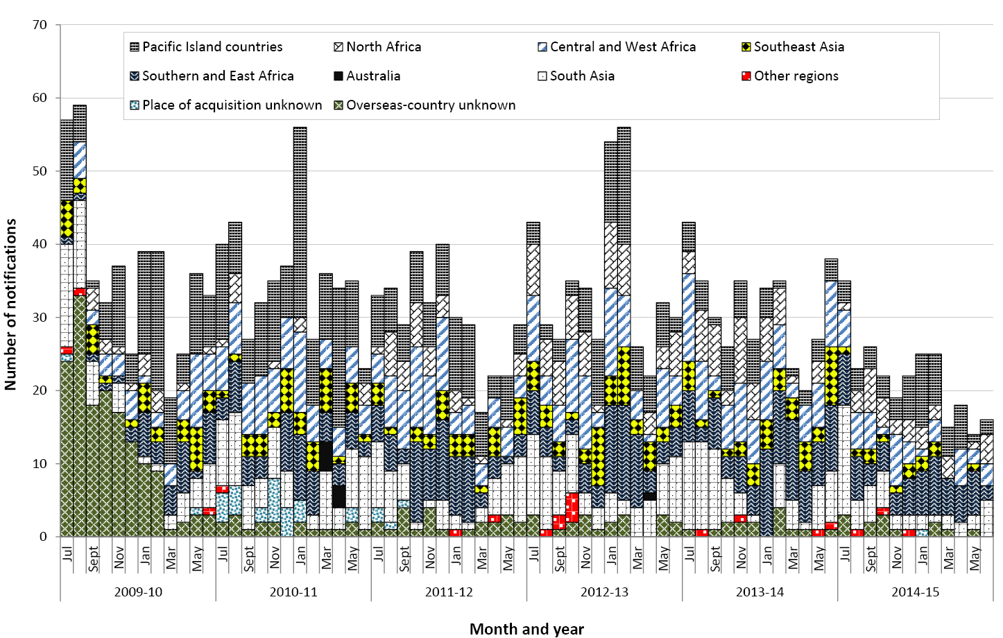
Figure 12: Notifications of malaria, Australia, 2014–15, by age group and sex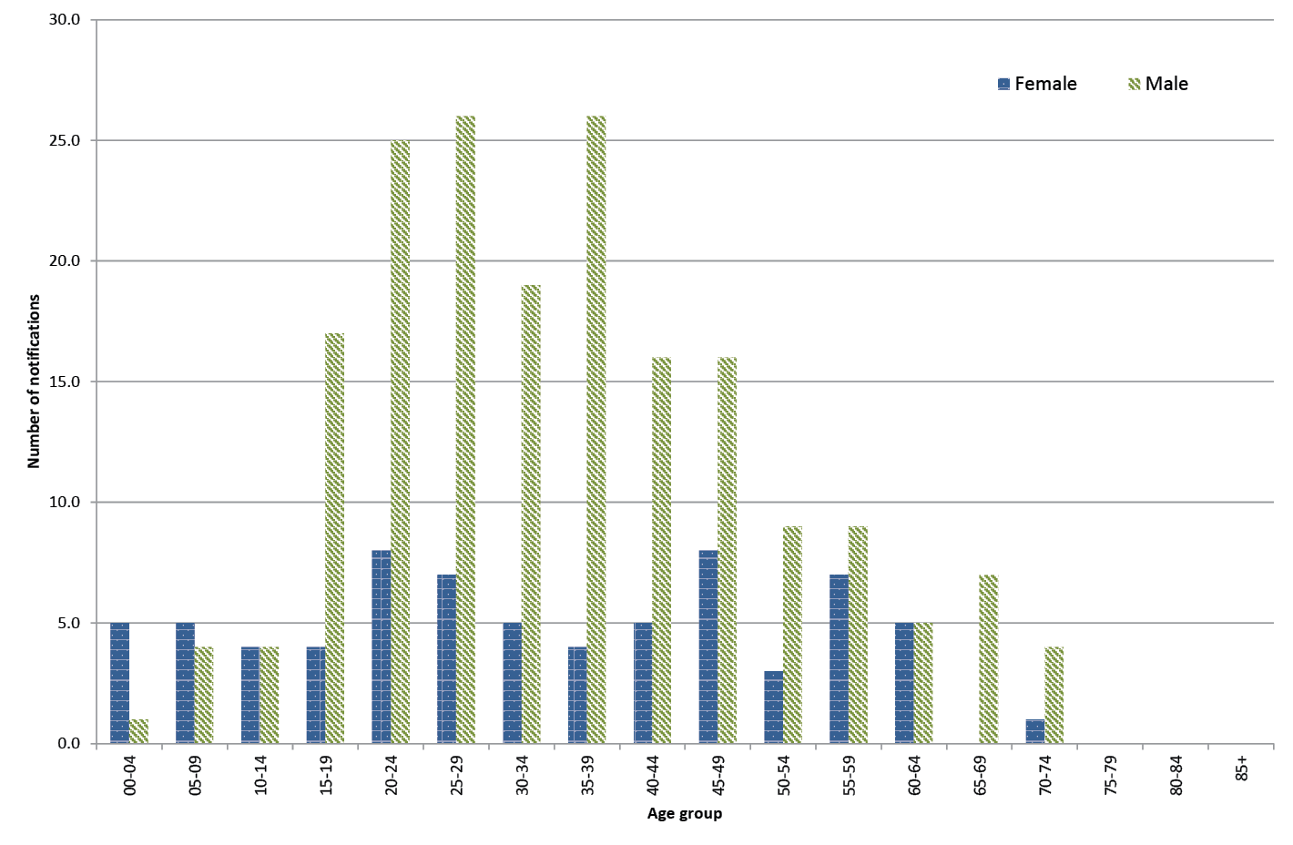
Table 5: Cases of malaria, Australia, 2014–15, by Plasmodium species, region and country of acquisition
Region | Country | Plasmodium falciparum | Plasmodium vivax | Plasmodium malariae | Plasmodium ovale | Plasmodium species | Total | % of all cases
Southern and East Africa | Uganda | 8 | 1 | 4 | 1 | 0 | 14 | 5%
 | Kenya | 10 | 0 | 0 | 2 | 0 | 12 | 5%
 | Zambia | 7 | 0 | 1 | 0 | 0 | 8 | 3%
 | Ethiopia | 3 | 4 | 0 | 0 | 0 | 7 | 3%
 | Tanzania | 5 | 0 | 1 | 0 | 0 | 6 | 2%
 | Rwanda | 4 | 0 | 0 | 0 | 0 | 4 | 2%
 | Southern and East Africa, nfd | 2 | 0 | 0 | 0 | 0 | 2 | 1%
 | Zimbabwe | 2 | 0 | 0 | 0 | 0 | 2 | 1%
 | Eritrea | 0 | 0 | 0 | 2 | 0 | 2 | 1%
 | Mozambique | 1 | 0 | 0 | 0 | 0 | 1 | 0%
 | Southern and East Africa, nfd | 1 | 0 | 0 | 0 | 0 | 1 | 0%
 | South Africa | 1 | 0 | 0 | 0 | 0 | 1 | 0%
Southern and East Africa Total |  | 44 | 5 | 6 | 5 | 0 | 60 | 23%
Pacific Island countries | Papua New Guinea | 15 | 26 | 0 | 1 | 2 | 44 | 17%
 | Solomon Islands | 1 | 5 | 0 | 0 | 1 | 7 | 3%
Pacific Island countries Total |  | 16 | 31 | 0 | 1 | 3 | 51 | 20%
South Asia | India | 0 | 30 | 0 | 0 | 4 | 34 | 13%
 | Pakistan | 0 | 9 | 0 | 0 | 2 | 11 | 4%
 | Afghanistan | 0 | 2 | 0 | 0 | 0 | 2 | 1%
South Asia Total |  | 0 | 41 | 0 | 0 | 6 | 47 | 18%
Central and West Africa | Ghana | 8 | 0 | 0 | 0 | 0 | 8 | 3%
 | Sierra Leone | 6 | 0 | 0 | 1 | 0 | 7 | 3%
 | Nigeria | 5 | 0 | 0 | 1 | 0 | 6 | 2%
 | Congo, Republic of | 4 | 0 | 0 | 0 | 0 | 4 | 2%
 | Mali | 3 | 0 | 0 | 0 | 0 | 3 | 1%
 | Cameroon | 3 | 0 | 0 | 0 | 0 | 3 | 1%
 | Central and West Africa, nfd | 1 | 1 | 0 | 0 | 0 | 2 | 1%
 | Cote d’Ivoire | 1 | 0 | 0 | 1 | 0 | 2 | 1%
 | Liberia | 0 | 0 | 2 | 0 | 0 | 2 | 1%
 | Senegal | 1 | 0 | 0 | 0 | 0 | 1 | 0%
 | Togo | 1 | 0 | 0 | 0 | 0 | 1 | 0%
 | Gabon | 1 | 0 | 0 | 0 | 0 | 1 | 0%
Central and West Africa Total |  | 34 | 1 | 2 | 3 | 0 | 40 | 15%
North Africa | Sudan | 24 | 2 | 0 | 1 | 1 | 28 | 11%
 | South Sudan | 3 | 0 | 0 | 0 | 0 | 3 | 1%
 | Egypt | 0 | 0 | 1 | 0 | 0 | 1 | 0%
North Africa Total |  | 27 | 2 | 1 | 1 | 1 | 32 | 12%
Southeast Asia | Indonesia | 3 | 6 | 0 | 0 | 1 | 10 | 4%
 | Cambodia | 0 | 2 | 0 | 0 | 0 | 2 | 1%
 | Myanmar, The Republic of the Union of | 0 | 1 | 0 | 0 | 0 | 1 | 0%
Southeast Asia Total |  | 3 | 9 | 0 | 0 | 1 | 13 | 5%
Other regions | Korea, Republic of (South) | 0 | 1 | 0 | 0 | 0 | 1 | 0%
 | United Arab Emirates | 1 | 0 | 0 | 0 | 0 | 1 | 0%
 | Peru | 0 | 1 | 0 | 0 | 0 | 1 | 0%
Other regions Total |  | 1 | 2 | 0 | 0 | 0 | 3 | 1%
Overseas-country unknown | Overseas-country unknown | 5 | 5 | 1 | 0 | 2 | 13 | 5%
Place of acquisition unknown | Place of acquisition unknown | 0 | 0 | 1 | 0 | 0 | 1 | 0%
Total |  | 130 | 96 | 11 | 10 | 13 | 260 | 100%
nfd Not further defined.

Other surveillance for vectors and vectorborne diseases
In addition to human case surveillance, some states and territories conduct additional surveillance for mosquitoes and vector borne diseases. Typically, this comprises one, or a combination, of animal sentinel surveillance, mosquito trapping and, more recently, sugar-based arbovirus surveillance techniques.¹² For details of what surveillance is undertaken in each state or territory, refer to the Appendix A.
The use of sentinel animals for arbovirus surveillance poses a number of challenges; the placement of animals in optimal locations is often not possible, there are ethical implications in using animals, while van den Hurk & colleagues³³ point out that some testing laboratories have issues with cross reactivity in the serological tests. Thus alternative technologies not employing animals would appear to have several advantages.
A method that has recently been under investigation is the use of sugar-based arbovirus surveillance techniques which employ mosquito traps containing nucleic acid preservation cards (FTA® cards) placed on the inside that are coated with honey. Mosquitoes enter the trap, feed on the honey and in the process expectorate (spit out) viruses. The viruses then bind to the paper which has been manufactured to preserve viral nucleic acid. The paper is subsequently tested via molecular assays to determine which viruses are present. This system has been demonstrated as being more sensitive than sentinel animals for the detection of flaviviruses in the field,^{12, 33} offers the benefit of being a rapid technique for arbovirus identification, with detections usually being identified within two days of samples coming into the laboratory, plus the technique has labour saving potentials as not every mosquito has to be identified prior to testing. The main limitations with this systems is that it is impossible to determine which mosquitoes are transmitting the viruses (as is the case if sentinel animals are used), and live virus is not isolated, and therefore not available for further studies such as vector competence investigations.

New South Wales
The 2014-15 season began on 5 November 2014 with the first sentinel chicken bleed and ended on 14 May 2015 with the last. There were no seroconversions to MVEV or KUNV in the sentinel chickens.
Temperature directly affects mortality, life span, and development rates for mosquitoes, with an optimal range of temperatures that may vary between species.³⁴ Temperatures in New South Wales for the last half of 2014 were above average by 2 to 3 degrees, with temperatures well above (4-6ºC) average during October and November. December was slightly above average (12ºC). January had slightly cooler than normal conditions, and weather patterns during the remainder of the mosquito season tended to be hotter than normal. Neither the Forbes nor the Nicholls hypotheses were suggestive of a potential MVEV epidemic for the season.
Overall, 213,401 mosquitoes representing 57 species were collected in NSW during 2014-15, which was more than double upon the previous season. Cx. annulirostris was the most abundant and most important of the inland mosquito species during the summer months, whereas Aedes vigilax, Culex sitiens, Aedes notoscriptus, Cx. annulirostris, Coquillettidia linealis, Aedes procax, and Verrallina funerea were the most numerous species on the coast:
- Inland – The total of 88,111 mosquitoes comprising 16 species was over double the previous season total of 43,252 trapped in 2013-2014. Cx.annulirostris was the dominant species yielded at most sites and comprised 76.8% of the total inland collections. Anopheles annulipes (21.0%) was the next most common species.
  - During the first quarter of 2014 (i.e. January to March), above average rainfall fell across inland NSW. For the second quarter of 2014 (April to June), the south west of the state had above normal rainfall. During the third quarter of 2014 (July to September) inland areas of the state experienced very low precipitation patterns especially in the Murray/Murrumbidgee basins. The dry inland conditions persisted into the last quarter of 2014 (October to December) and the entire western region had very low rainfall amounts.
  - The first quarter of 2015 (January to March) had mostly average rainfall for much of the state, although was above average in January. The entire state had above average rainfall through the second quarter of 2015 (April to June).
- Coastal – In total, 71,780 mosquitoes comprising 49 species were collected from coastal NSW and this was almost three times the previous season’s collection. The most common species collected were Cx. annulirostris (23.8%), Culex sitiens (15.5%), Ae. vigilax (12.9%), Aedes multiplex (11.8%), Ae. notoscriptus (8.7%), and Verrallina funerea (6.6%). For most years, Ae.vigilax is usually by far the most predominant species and generally comprises 50-60% of the coastal collections.
  - During the first quarter of 2014 (i.e. January to March) the coastal strip was mostly dry, with below average rainfall especially along the north coast. For the second quarter of 2014 (April to June), the north east had below average rainfall, but the coast as a whole experienced normal rainfall patterns. The significantly warmer conditions over the last half of 2014 coupled with spring tides and early summer rains led to several sites experiencing an early rise in vector numbers. As a result, mosquito numbers were well up this season, particularly of freshwater breeding species such as Cx. annulirostris. As above, the first quarter of 2015 (January to March) had mostly average rainfall for much of the state, although was above average in January. The entire state had above average rainfall through the second quarter of 2015 (April to June).
  - There were 41 isolates, this is similar to the expected numbers, and included 6 BFV, 29 RRV, 4 Edge Hill Virus, and 2 Stratford Virus. In New South Wales, alphavirus case numbers in coastal areas were higher than in any season since records began in 1985, refer to the sections Barmah Forest virus infections and Ross River Virus infections.
- Metropolitan Sydney– A total of 51,473 mosquitoes, comprising 37 species, was collected from metropolitan Sydney and this was around double the previous season’s total collection. Ae. vigilax (51.7% of the total Sydney mosquitoes trapped) was the most common species, followed by Cx. annulirostris (17.1%), Ae. notoscriptus (8.2%), and Culex sitiens (5.7%).
  - The Sydney region also experienced an early rise in mosquito numbers which resulted in collections totalling around twice that of the previous season. There were 20 arboviral isolates, including 2BFV, 15 RRV and 3 EHV, with most (13) being from Georges River.

Sugar based arbovirus surveillance
Before implementing sugar-based arbovirus surveillance using passive traps (PTs) on a routine basis as part of the NSW Arbovirus Surveillance Program, it was necessary to undertake a comparison with current technologies for evaluation purposes. An initial limited comparison of the mosquito trapping capability of the PTs vs Encephalitis Vector Surveillance trap (EVS; these are the traps in current use) was undertaken during the mosquito season of 2012-2013, and further investigations were undertaken in the previous season of 2013-2014. The results of these were presented in the respective annual reports.³⁵
Initial results indicate that the honey-baited card system is considerably more sensitive at detecting alphaviruses than traditional cell culture and hence cards were placed in all traps for the 2014-2015 season. However, due to limited flavivirus activity in recent years, the relative sensitivity of the two assay systems at detecting this group of arboviruses has yet to be fully elucidated. Thus for the season of 2014-2015, continuing evaluation of the sensitivity of sugar-based arbovirus surveillance versus cell culture was again undertaken, mostly at inland locations where the threat of serious flavivirus activity is greater.
To compare sugar based arbovirus surveillance versus cell culture, honey-baited FTA cards were placed into the EVS traps and operated overnight as per normal. The trapped mosquitoes were identified and processed for arboviruses via cell culture, while the FTA cards were processed via PCR, with both procedures as described in the methods. A total of 681 traps were used in this evaluation and the results are presented in the Table below. Overall, the FTA cards were more than twice as sensitive at detecting arboviruses compared with cell culture. However in this comparison, cell culture was more sensitive at detecting the flaviviruses. Thus virus isolation via cell culture of the trapped mosquitoes will still continue at inland sites in conjunction with the use of FTA cards. For coastal sites, only FTA cards will be employed for arbovirus surveillance in the future.
Further detail can be found in New South Wales Arbovirus Surveillance Program annual reports, available on the NSW Health web site (http://medent.usyd.edu.au/arbovirus/information/publications.htm)
Table 6. Comparison of arboviral detection between the sugar based arbovirus surveillance cards and Cell Culture (CC) over the 2014-15 NSW arbovirus surveillance season.
 | Sugar-based arbovirus surveillance |  |  | CC
No. Traps | RRV | BFV | Total | RRV | BFV | EHV | KOKV | STRV | Total
681 | 23 | 4 | 27 | 5 | 2 | 3 | 1 | 1 | 12

Northern Territory
The number of notifications of RRV in the Northern Territory in 2014-15 was the fourth highest since records began in 1990-91. Most cases were recorded in the Darwin region, and rates were highest in SA3 Litchfield, surrounding Darwin, see section Ross River Virus infections. Cases occurred throughout the year, with highest numbers recorded in January, February and March, coinciding with an increase in Ae. vigilax numbers in early December to above the long term average in January, followed by an increase in Cx. annulirostris numbers above the long term average in January, reaching an unparalleled peak in February. The high vector numbers were most likely due to the unusual ‘dry’ wet season in 2014-15, with conditions similar to the ‘build up season’ characterised by intermittent rain, resulting in high numbers of vector mosquitoes breeding in isolated pools. The high rates in the Darwin rural area (SA3 Litchfield) were due to the large number of lagoons, swamps and wetlands near residences, producing high numbers of vector mosquitoes during the high risk period for RRV. This case distribution pattern within the greater Darwin area is very similar to previous years.
In 2015, three sentinel chickens in Tennant Creek tested positive to MVEV antibodies in May. However, seroconversions could have occurred any time between late February and May, as no chickens were tested in March or April. Seroconversions to KUNV were recorded in Tennant Creek in February and May, at Beatrice Hill Research Farm in May and June and at Leanyer (Darwin) in early June.
In November 2011, the dengue mosquito, Ae. aegypti was detected in Tennant Creek. A comprehensive dengue mosquito elimination program was immediately established with house to house surveillance and control, with the last Ae. aegypti detected in June 2013. Following a full wet season without further exotic vector detections, the program was completed on 30 April 2014, with the successful elimination declared in early July 2014.
Further details are available from the Northern Territory Medical Entomology annual reports, available on the Northern Territory government web site (http://www.health.nt.gov.au/Medical_Entomology/index.aspx).

Queensland
Early and consistent rain in Queensland saw the proliferation of freshwater mosquito species, including Cx. annulirostris, particularly in southeast Queensland. All councils in the southeast reported higher than usual numbers of Cx. annulirostris, and most aerial control programs experienced their busiest season for some years. For example, the Brisbane City Council mosquito monitoring program documented at least a doubling in total mosquito numbers collected when compared with the previous year. As noted under the section Ross River Virus infections, there was a more than threefold increase in the number of notifications of RRV and the notification rate in Queensland in 2014-15.

Sugar-based arbovirus surveillance
A pilot 16-week alphavirus surveillance program (conducted by Queensland Health/Brisbane City Council/Mosquito and Arbovirus Research Committee) deployed in the Brisbane City Council area, comprising sugar-based virus detection methods in weekly light traps at nine sites, detected RRV on 12 occasions, spanning the peak of the RRV outbreak period (February to March 2015).
Sugar-based arbovirus surveillance in the Northern Peninsular Area (NPA) of Queensland by the Australian Government Department of Agriculture and Water Resources detected MVEV activity on one occasion from a total of 24 trap nights in the period January-May 2015, representing the first detection of MVEV using a sugar-based surveillance system in Queensland. KUNV was also detected on 10 occasions in the NPA using this method. No JEV was detected.

Ae. aegypti and Ae. albopictus surveillance
Surveillance using Gravid Aedes Traps (GATs) confirmed the presence of Ae. aegypti in south-western regions of the State (including towns of Charleville and Wondai), but this species was not detected in the urban centres of Southeast Queensland. The ongoing presence of Ae. aegypti in the central Queensland townships of Longreach, Theodore and Emerald was confirmed in October 2014. Ae. aegypti presence was also reconfirmed in Gin Gin.
Routine monitoring of container-inhabiting mosquitoes in Cairns using GATs and BGs showed an apparent peak of Ae. aegypti populations in mid-January 2015. During the 2014/15 year, the Cairns Dengue Action Response Team (DART) inspected approximately 10,000 properties, and conducted over 1,700 interior residual sprays. Approximately 5,890 lethal ovitraps or BG traps were deployed. Routine GATs deployed in Townsville demonstrated a slight but gradual rise in Ae. aegypti numbers over the reporting period.
Ae. albopictus was not detected during any surveillance activity on mainland Australia.

Torres Strait Aedes albopictus Prevention and Control Program
The exotic Asian tiger mosquito, Ae. albopictus was first found on the outer islands of Torres Strait in April 2005.³⁶
This mosquito is a competent vector of a number of arboviruses including DENV and CHIKV, and is a serious nuisance biting mosquito. Since 2005, the Australian Government has funded Queensland Health for a mosquito elimination program in the Torres Strait. The initial aim of the program was to eliminate Ae. albopictus from the Torres Strait islands but this was revised in May 2008 to a cordon sanitaire approach (a barrier designed to prevent spread) focused on Thursday and Horn islands. Harbourage treatment on Horn and Thursday Islands remained the focus of the program. Whilst this provided good control of Ae. albopictus, relatively high numbers of Ae. aegypti persisted, particularly on Thursday Island.
Between June 2014 and May 2015, Ae. albopictus was detected only once as adults from a single isolated site on Horn Island (using adult sweep-net sampling) and only twice as larvae from containers on Thursday Island. Adult mosquito surveys on nearby Hammond Island during May 2015 detected relatively high densities of Ae. albopictus. The dominant mosquito species identified during surveys of the Northern Peninsula Area in April, May 2015 included Ae. aegypti and Ae. notoscriptus, but no Ae. albopictus were detected on the mainland.

Rapid Surveillance for Vector Presence – a novel Ae. aegypti surveillance method
Development of the Rapid Surveillance for Vector Presence (RSVP) program to detect key container-inhabiting mosquito species verified the absence of Ae. aegypti in the Brisbane City Council region. This novel program employs molecular methods to identify the potential presence of target species in mixed egg collections from ovitraps.³⁷

South Australia
The South Australian state-wide average rainfall during summer was 8.4% above the long-term average. Rainfall was highest in the northeast, predominantly owing to a widespread rainfall event between 8 and 11 January 2015 which resulted in the eighth wettest January on record for South Australia. Rainfall was near average across central and southeast districts while some western districts recorded very much below average summer rainfall. Rainfall was generally near average during December whereas very much below average rainfall was recorded across much of the state during February. Both maximum and minimum temperatures were above average during summer. Daytime temperatures were near average during December across southern districts, and tended cooler than average during January across much of the state. February daytime temperatures were 3 to 4 °C above average across large parts of the state.³⁸
Mosquito traps along the Murray River during the 2014-15 season contained higher than average numbers of Aedes camptorhynchus during spring. This was the major feature of the 2014-15 season and it represented a major change in mosquito fauna from the previous three seasons in the upper river councils.
The Mid-Murray Council, Rural City of Murray Bridge and Alexandrina Councils all recorded increased numbers of mosquitoes over the summer period. This was due to a mixture of species including the cool weather mosquito Ae. camptorhynchus, a mixture of Cx. pipiens spp. and Cq. linealis. Cq. linealis is an ongoing issue along the river where it is locally abundant.
Overall a total of 14,693 adult mosquitoes were collected from the 35 regular monitoring sites over the 2014-15 season compared to 46,713 in the 2013-14 season (31.5% of the previous season’s total mosquito catch). However, this decrease was not uniform across all councils. In the three northernmost councils the total mosquito catch doubled from 2,029 mosquitoes in 2013-14 to 4,112 in 2014-15. In contrast, the three southernmost councils recorded only 23% of the mosquitoes trapped in the previous season. The overall mosquito catch within Mid-Murray Council was around 80% of the previous season.
Arbovirus risk monitoring was supported by sentinel chicken flock testing and the deployment of honey baited FTA cards in council areas along the Murray River and in North Western Adelaide. Honey baited FTA cards were inserted into two of the EVS traps set in each Murray River council and in one of the City of Salisbury traps.³⁹ Traps fitted with FTA cards were chosen on the basis of the likelihood of high mosquito numbers and the mix of vectors commonly caught. In addition to this program, five passive CO₂ baited traps were also deployed on two occasions (October-November and February-March) adjacent to SA Health’s five sentinel chicken flocks located along the Murray River. Each trap contained two honey baited FTA cards and remained in situ for over three weeks. The viral analysis of the FTA cards was undertaken by the Arbovirus Reference Laboratory in NSW. Passive traps deployed adjacent to the sentinel chicken flocks and the FTA cards fitted to the regular mosquito surveillance traps did not indicate the presence of any arboviruses during the 2014-15 season.
Following review in 2013, SA Health’s longstanding Fight the Bite Arbovirus Prevention Program was relaunched with new artwork in 2014. The revised campaign has been well received in South Australia and the new campaign is underpinned by a communications strategy involving traditional print press advertisements, as well as a stronger online presence and distribution of Fight the Bite branded merchandise in high risk areas. Through a Memorandum of Understanding, SA Health agreed to share the Fight the Bite campaign material with WA Health.

Tasmania
No viruses were isolated in 2014–15 from mosquitoes trapped during ad hoc collections undertaken in the Sorrell Council region.

Victoria
Through the standard chicken program, weekly blood samples were tested from the 9 flocks between November 2014 and April 2015. No seroconversions to flaviviruses were detected during the season, which involved the testing of 3,774 samples.
Adult mosquito monitoring was conducted through the Victorian Arbovirus Disease Control Program by 10 local government areas. At the six monitoring sites along the Murray River and inland Victoria, 16,004 mosquitoes were trapped. This number is two-fold lower than long-term average (2003-2010). Cx. annulirostris was the dominant mosquito species at the 21 out of 24 surveillance sites accounting for between 25 and 80% of the total catch. At other sites Culex quinquefasciatus, Ae. notoscriptus and Culex molestus were the dominant mosquito species. Mosquito abundance was low throughout the season in Mildura, Moira, Swan Hill and Wodonga, with intermittent moderate increases in mosquito number, all of which resulted in less than 100 mosquitoes per trap. In Gannawarra and Shepparton, mosquito numbers were higher throughout the season with over 100 mosquitoes reported on many occasions. Coastal adult mosquito surveillance conducted in Gippsland yielded a total of 52,615 mosquitoes. This is consistent with the long-term average for this site. Aedes camptorhynchus was the dominant species at all four sites, accounting for between 53 and 98% of the total trap. Mosquito numbers peaked in late November 2015 and in early January 2015.
Ross River virus was isolated from a pool of 10 Ae. camptorhynchus trapped around Lake Wellington (Gippsland) in March 2015

Western Australia
- Average or near average rainfall was recorded in the north and interior regions of WA in 2014-15. Exceptions were above to very much above average rainfall in the Kimberley and northeast Pilbara regions in the July to September quarter, the west Pilbara and Gascoyne regions in the January to March quarter and the east Pilbara region in the April to June quarter. Tropical Cyclone (TC) Olwyn had a major impact when it crossed the Western Australian coast near Exmouth on 13 March 2015. TC Olwyn caused extensive damage on the Pilbara and Gascoyne coast between Onslow and Kalbarri, leading to severe flooding of the Gascoyne River. A second cyclone, TC Quang, crossed the Pilbara coast near Exmouth on 1 May 2015. In the southwest of WA, rainfall was generally below average to very much below average for most of the 2014-15 season. Maximum and minimum temperatures were above to very much above average for most of WA, the exception being the northeast Kimberley region, where minimum temperatures were average to very much below average.
- Under the influence of the relatively dry climatic conditions in certain regions, the level of flavivirus activity in sentinel chickens was moderately low. A total of 40 flavivirus seroconversions were detected in 4,777 samples (0.8%) tested for flavivirus antibodies. Five of these seroconversions were associated with extension of flavivirus activity from the 2013-14 season. Flavivirus activity was first observed in WA when antibodies to MVEV were detected at Derby and Kununurra in early March 2015. Shortly afterwards, evidence of KUNV infection was detected at Halls Creek, Derby and Kununurra, and later it was detected at Newman in the Pilbara region in 2015. In total there were 11 seroconversions to MVEV, 22 to KUNV and one seroconversion to an unidentified flavivirus (not MVEV, KUNV or JEV). MVEV activity persisted in the Kimberley region through to May 2015, and KUNV seroconversions were detected through to June. Five media warnings related to increased risk of disease caused by flavivirus infection were released by WA Medical Entomology during the season. The first was released in March after the detection of MVEV activity in the Kimberley region. The second media release was issued in late March following widespread detections of MVEV and KUNV antibodies in sentinel chickens in the Kimberley region. A third media warning was issued in April after further widespread flavivirus detections in the Kimberley region. Continued flavivirus detections in the Kimberley region and the detection of KUNV activity at Newman in the Pilbara region prompted a fourth media release, and late season detections stimulated the final media release for the season.
- Mosquito abundance was below average for most of 2014-15 in the southwest of WA, likely influenced by the very low rainfall and warmer than usual temperatures observed during the season, particularly during the October to December quarter. During the peak risk season, mosquito homogenates were tested by virus isolation and real-time RT-PCR. There were 16 RRV detections, including 15 by PCR and 11 by virus isolation. The first RRV detections were from vector mosquitoes collected in the Peel region, however the majority of subsequent detections were from mosquitoes collected further south, in the Leschenault region, approximately one month prior to the peak incidence of RRV disease in that area. One media release was issued by the WA DOH in late October following the RRV detections. There were no detections of BFV in mosquitoes in the southwest of WA in 2014-15, and this is consistent with the low incidence of BFV disease in WA in 2014-15 (refer to the section Barmah Forest Virus infections).
- In addition to the routine adult mosquito and RRV/BFV surveillance in the southwest, a study was conducted between August and December 2014 using FTA cards placed inside routine adult mosquito traps (carbon-dioxide baited EVS traps) set in parallel at up to seven routine monitoring sites. A total of 87 honey-baited FTA card traps (i.e. sugar-based arbovirus surveillance) were set during the peak risk season. Overall, FTA cards in 15 traps were positive for RRV by real-time RT-PCR. RRV was detected in 7/17 of the weeks of the study, compared with RRV-positive mosquito homogenates 3/17 weeks. During this period only five routine mosquito traps were positive for RRV by virus isolation and/or PCR. The RRV-positive FTA cards generally matched the RRV detections in mosquito homogenates, although FTA cards were positive approximately one week prior to the first RRV-positive mosquito homogenate and six weeks after the last RRV-positive homogenate. No BFV was detected in mosquito homogenates or FTA cards during the season.
- Flooding of the Gascoyne River caused by TC Olwyn in March 2015 resulted in an outbreak of RRV in Carnarvon, located at the mouth of the river. At total of 59 RRV cases were reported from Carnarvon between April and June 2015, more than the previous 10 years combined. As noted under the section Ross River Virus infections, rates of Ross River Virus by SA3 were higher in the Gascoyne (containing Carnarvon) than any anywhere else in Australia.
Further detail can be found in the 2014-15 Western Australian Medical Entomology annual report (https://ww2.health.wa.gov.au/Articles/A_E/Arbovirus-surveillance-and-research).

Table 7: Virus and sentinel chicken surveillance in Australia for selected regions, by surveillance method and virus genus, 2014–15.
State or territory | Region | Flaviviruses |  |  | Alphaviruses
 |  | Number positive or seroconverted/number tested* | First positive date | Last positive date | Number positive or seroconverted/number tested* | First positive date | Last positive date
Sentinel chickens
NSW | Bourke | 0/88 |  |  | N/A
NSW | Deniliquin | 0/223 |  |  | N/A
NSW | Forbes | 0/420 |  |  | N/A
NSW | Griffith | 0/329 |  |  | N/A
NSW | Hay | 0/330 |  |  | N/A
NSW | Leeton | 0/285 |  |  | N/A
NSW | Macquarie Marshes | 0/187 |  |  | N/A
NSW | Menindee | 0/223 |  |  | N/A
NSW | Moama | 0/179 |  |  | N/A
NSW | Moree | 0/416 |  |  | N/A
NSW | Wee Waa | 0/355
NT | Darwin region | 3 KUN/255  5 unidentified flaviviruses/255 | 7 May 2015  7 May 2015 | 4 June 2015  2 June 2015 | N/A
NT | East Arnhem region | 2 unidentified flaviviruses /50 | 14 June 2015 | 14 June 2015 | N/A
NT | Katherine region | 0/77 |  |  | N/A
NT | Barkly region | 4 KUN/45  3 MVE/45  1 unidentified flaviviruses /45 | 26 Feb 2015  6 May 2015  24 June 2015 | 6 May 2015  6 May 2015  24 June 2015 | N/A
NT | Alice Springs region | 0/108 |  |  | N/A
SA | Paringa | 0/35 |  |  | 0/35
SA | Loxton | 0/35 |  |  | 0/35
SA | Waikerie (Qualco) | 0/35 |  |  | 0/35
SA | Murray Bridge | 0/35 |  |  | 0/35
Vic. | Barmah | 0/335 |  |  | N/A
Vic. | Koonoomoo | 0/439 |  |  | N/A
Vic. | Kerang | 0/480 |  |  | N/A
Vic. | Mildura | 0/444 |  |  | N/A
Vic. | Robinvale | 0/324 |  |  | N/A
Vic. | Rutherglen | 0/519 |  |  | N/A
Vic. | Nyah West | 0/500 |  |  | N/A
Vic. | Toolamba | 0/296 |  |  | N/A
Vic. | Wodonga | 0/437 |  |  | N/A
WA | Wyndham | 0/179 |  |  | N/A
WA | Kununurra | 12/160 | 11/3/15 | 8/6/15 | N/A
WA | Savannah Nickel Mine | 3/60¹ | 27/8/14 | 30/3/15 | N/A
WA | Halls Creek | 3/227 | 16/3/15 | 30/3/15 | N/A
WA | Fitzroy Crossing | 7/156² | 15/7/14 | 1/5/15 | N/A
WA | Derby | 7/339 | 6/3/15 | 17/4/15 | N/A
WA | Lombadina | 3/65 | 8/5/15 | 8/6/15 | N/A
WA | Broome | 1/86³ | 29/7/14 | 29/7/14 | N/A
WA | Roebuck Plains | 1/174 | 17/3/15 | 17/3/15 | N/A
WA | Port Hedland | 0/46 |  |  | N/A
WA | Karratha | 0/263 |  |  | N/A
WA | Harding Dam | 0/473 |  |  | N/A
WA | Marble Bar | 1/794 | 7/8/14 | 7/8/14 | N/A
WA | Pannawonica | 0/185
WA | Tom Price | 0/245 |  |  | N/A
WA | Paraburdoo | 0/248 |  |  | N/A
WA | Newman | 1/259 | 21/4/15 | 21/4/15
WA | Ophthalmia Dam | 1/234⁵ | 16/7/14 | 16/7/14 | N/A
WA | Onslow | 0/230
WA | Exmouth | 0/248 |  |  | N/A
WA | Carnarvon | 0/169 |  |  | N/A
WA | Geraldton | 0/98 |  |  | N/A
WA | Dongara | 0/180 |  |  | N/A
WA | Moora | 0/113 |  |  | N/A
WA | York | 0/102 |  |  | N/A
WA | Leonora | 0/99 |  |  | N/A
Sugar-based arbovirus surveillance cards
NSW (Inland) | Albury | 0/1,082 |  |  | 0/1,082
NSW (Inland) | Bourke | 0/1 |  |  | 0/1
NSW (Inland) | Griffith | 0/58,398 |  |  | 4BFV/58,398 | 19/01/15 | 10/03/15
NSW (Inland) | Leeton | 0/27,638 |  |  | 1BFV,4RRV/27,638 | 23/01/15 | 23/01/15
NSW (Inland) | Macquarie Marshes | 0/27 |  |  | 1RRV/27 | 6/03/15 | 6/03/15
NSW (Inland) | Moama | 0/2,870 |  |  | 0/2,870
NSW (Inland) | Wagga Wagga | 0/527 |  |  | 0/527
NSW (Coastal) | Ballina | 0/25,571 |  |  | 0/25,571
NSW (Coastal) | Central Coast | 0/6,355 |  |  | 1BFV, 1RRV/6,355 | 20/01/15 | 4/03/15
NSW (Coastal) | Coffs Harbour | 0/1,699 |  |  | 0/1,699
NSW (Coastal) | Lake Macquarie | 0/2,528 |  |  | 3BFV, 1RRV/2,528 | 20/01/15 | 10/03/15
NSW (Coastal) | Nambucca | 0/944 |  |  | 0/944
NSW (Coastal) | Port Macquarie | 1EHV, 1STRV/8,103 | 23/04/15 | 5/05/15 | 0/8,103
NSW (Coastal) | Shoalhaven | 0/293 |  |  | 0/293
NSW (Coastal) | Tweed Heads | 0/17,197 |  |  | 8RRV/17,197 | 24/02/15 | 8/04/15
NSW (Sydney) | Bankstown | 0/8,590 |  |  | 1RRV/8,590 | 17/12/14 | 17/12/14
NSW (Sydney) | Blacktown | 0/2,275 |  |  | 0/2,275
NSW (Sydney) | Georges River | 0/24,916 |  |  | 10RRV/24,916 | 11/02/15 | 31/03/15
NSW (Sydney) | Hawkesbury | 0/1,436 |  |  | 1RRV/1,436 | 3/03/15 | 3/03/15
NSW (Sydney) | Homebush | 0/18,656 |  |  | 4RRV/18,656 | 24/02/15 | 18/03/15
NSW (Sydney) | Penrith | 0/1,105 |  |  | 0/1,105
NSW (Sydney) | Ryde | 0/1,832 |  |  | 0/1,832
Qld | Brisbane | N/A |  |  | 12 RRV detections / 135 trap nights
Qld | Brisbane | N/A |  |  | 4 BFV detections/ 135 trap nights
Qld | Northern Peninsula Area | 1 trap detection MVEV/24 traps deployed | 16/3/15 | 16/3/15 | N/A
Qld | Northern Peninsula Area | 10 trap detections WNV(Kunjin)/ 24 traps deployed | 2/3/15 | 27/4/15 | N/A
SA | Murray River | 0/107
SA | Globe Derby Park | 0/15
WA | Peel |  |  |  | 8/8254 | 23/9/15 | 9/12/15
WA | Leschenault |  |  |  | 2/4823 | 30/9/15 | 11/11/15
WA | Capel-Busselton |  |  |  | 5/6,987⁶ | 30/9/15 | 12/11/15
Virus isolation/polymerase chain reaction detection from mosquitoes
NSW (Inland) | Albury | 0/1,082 |  |  | 0/1,082
NSW (Inland) | Bourke | 0/1 |  |  | 0/1
NSW (Inland) | Griffith | 1KOKV/58,398 | 11/02/15 | 11/02/15 | 1RRV/58,398 | 18/02/15 | 18/02/15
NSW (Inland) | Leeton | 0/27,638 |  |  | 1RRV/27,638 | 3/03/15 | 3/03/15
NSW (Inland) | Macquarie Marshes | 0/27 |  |  | 0/27
NSW (Inland) | Moama | 0/2,870 |  |  | 0/2,870
NSW (Inland) | Wagga Wagga | 0/527 |  |  | 0/527
NSW (Coastal) | Ballina | 0/25,571 |  |  | 0/25,571
NSW (Coastal) | Central Coast | 0/6,355 |  |  | 0/6,355
NSW (Coastal) | Coffs Harbour | 0/1,699 |  |  | 0/1,699
NSW (Coastal) | Lake Macquarie | 0/2,528 |  |  | 0/2,528
NSW (Coastal) | Nambucca | 0/944 |  |  | 0/944
NSW (Coastal) | Port Macquarie | 0/8,103 |  |  | 0/8,103
NSW (Coastal) | Shoalhaven | 0/293 |  |  | 0/293
NSW (Coastal) | Tweed Heads | 1STRV/17,197 |  |  | 0/17,197 | 9/02/15 | 9/02/15
NSW (Sydney) | Bankstown | 0/8,590 |  |  | 1BFV/8,590 | 27/01/15 | 27/01/15
NSW (Sydney) | Blacktown | 0/2,275 |  |  | 0/2,275
NSW (Sydney) | Georges River | 2EHV/24,916 | 24/02/15 | 3/03/15 | 1BFV/24,916 | 17/02/15 | 17/02/15
NSW (Sydney) | Hawkesbury | 0/1,436 |  |  | 3RRV/1,436 | 3/03/15 | 3/03/15
NSW (Sydney) | Homebush | 1EHV/18,656 | 9/02/15 | 9/02/15 | 0/18,656
NSW (Sydney) | Penrith | 0/1,105 |  |  | 0/1,105
NSW (Sydney) | Ryde | 0/1,832 |  |  | 0/1,832
Vic. | Inland North West | 0/6,924 |  |  | 0/6,924
Vic. | Inland North East | 0/9,150 |  |  | 0/9,150
Vic. | Gippsland – Lake Wellington | 0/52,615 |  |  | 1RRV^/52,615
WA | Peel | 0/39,667 |  |  | 2/39,667 | 30/9/14 | 30/9/14
WA | Leschenault | 0/15,317 |  |  | 14/15,317 | 14/10/14 | 28/10/14
WA | Capel-Busselton | 0/14,539 |  |  | 0/14,539
1 1 KUNV seroconversion was from August 2013/14 season.
2 1 MVEV seroconversion was from July 2013/14 season.
3 1 KUNV seroconversion was from July 2013/14 season.
4 1 KUNV seroconversion was from August 2013/14 season.
5 1 KUNV seroconversion was from July 2013/14 season.
6 Combined flaviviruses and alphaviruses
* For virus detections/isolations, the number tested is the number of individual mosquitoes or chickens tested, unless otherwise noted. The number tested is not always known.
^ One pool of 10 mosquitoes
Note: Sentinel chickens are not screened for antibodies to Alphaviruses.

Table 8: Key mosquito vector abundance in selected regions of Australia in 2013–14, by species, state or territory, region and month#
Species | State or territory | Region/ locality | Month
 |  |  | July | August | Sept | Oct | Nov | Dec | Jan | Feb | Mar | Apr | May | Jun
Saltwater
Aedes vigilax | NSW | North Coast | - | - | - | - | - | LOW | LOW | MED | LOW | LOW | LOW | -
Ae. vigilax | NSW | Mid-North Coast | - | - | - | - | - | LOW | MED | LOW | LOW | LOW | LOW | -
Ae. vigilax | NSW | Central Coast | - | - | - | - | - | LOW | MED | MED | LOW | LOW | LOW | -
Ae. vigilax | NSW | Sydney – Georges River | - | - | - | - | - | HIGH | HIGH | HIGH | MED | LOW | - | -
Ae. vigilax | NSW | Sydney – Homebush | - | - | - | - | HIGH | HIGH | HIGH | HIGH | LOW | LOW | - | -
Ae. vigilax | NSW | Sydney – Western | - | - | - | - | - | LOW | LOW | LOW | LOW | - | - | -
Ae. vigilax | NSW | South Coast | - | - | - | - | - | LOW | LOW | LOW | LOW | - | - | -
Ae. vigilax | NT | Darwin region | LOW | LOW | LOW | HIGH | LOW | HIGH | HIGH | LOW | LOW | LOW | LOW | LOW
Ae. vigilax | NT | East Arnhem region | LOW | - | LOW | LOW | LOW | LOW | HIGH | HIGH | - | HIGH | LOW | LOW
Ae. vigilax | Qld | Brisbane coastal - Bracken Ridge | LOW | LOW | MEDIUM | MEDIUM | HIGH | HIGH | VERY HIGH | HIGH | HIGH | MEDIUM | MEDIUM | LOW
 | Qld | Brisbane coastal -Banyo | LOW | LOW | HIGH | HIGH | VERY HIGH | EXTREME | VERY HIGH | VERY HIGH | VERY HIGH | HIGH | HIGH | LOW
 | Qld | Brisbane coastal -Hemmant | LOW | LOW | HIGH | HIGH | VERY HIGH | HIGH | HIGH | HIGH | HIGH | LOW | LOW | LOW
 | Qld | Brisbane coastal - Lota | - | LOW | LOW | LOW | MEDIUM | MEDIUM | HIGH | HIGH | MEDIUM | HIGH | LOW | -
 | Qld | Brisbane coastal - Ascot | LOW | LOW | HIGH | LOW | MEDIUM | HIGH | HIGH | HIGH | HIGH | LOW | LOW | -
 | Qld | Brisbane coastal - Indooroopilly Island | - | - | LOW | MEDIUM | HIGH | HIGH | VERY HIGH | VERY HIGH | HIGH | HIGH | MEDIUM | LOW
 | SA | Globe Derby | - | HIGH | MEDIUM | HIGH | VERY HIGH | VERY HIGH | VERY HIGH | VERY HIGH | VERY HIGH | HIGH | - | -
 | SA | Torrens Island | - | VERY HIGH | LOW | HIGH | VERY HIGH | VERY HIGH | HIGH | VERY HIGH | HIGH | HIGH | - | -
Ae. camptorhynchus | Vic. | Gippsland / Lake Wellington | - | - | - | - | HIGH | HIGH | VERY HIGH | HIGH | HIGH | HIGH | - | -
Ae. camptorhynchus | WA | Peel region | MED | HIGH | HIGH | HIGH | LOW | LOW | LOW | LOW | LOW | HIGH | - | HIGH
Ae. vigilax | WA | Peel region | NIL | NIL | NIL | LOW | LOW | LOW | LOW | MED | HIGH | HIGH | - | NIL
Ae. camptorhynchus | WA | Leschenault region | MED | HIGH | HIGH | HIGH | LOW | LOW | LOW | LOW | LOW | LOW | - | MED
Ae. vigilax | WA | Leschenault region | NIL | NIL | NIL | NIL | LOW | LOW | LOW | LOW | LOW | LOW | - | NIL
Ae. camptorhynchus | WA | Capel-Busselton region | MED | HIGH | HIGH | HIGH | MED | LOW | LOW | LOW | LOW | LOW | - | MED
Ae. vigilax | WA | Broome | - | - | - | - | - | - | - | - | LOW | LOW | - | -
Freshwater
Culex annulirostris | NSW | Inland – Riverina | - | - | - | - | LOW | HIGH | VERY  HIGH | VERY  HIGH | HIGH | - | - | -
Cx. annulirostris | NSW | Inland – Murray region | - | - | - | - | LOW | LOW | LOW | LOW | LOW | - | - | -
Cx. annulirostris | NSW | Inland, West & Nth West | - | - | - | - | LOW | LOW | LOW | LOW | LOW | - | - | -
Cx. annulirostris | NT | Darwin region | HIGH | HIGH | MED | LOW | LOW | LOW | MED | HIGH | MED | MED | LOW | MED
Cx. annulirostris | NT | East Arnhem region | LOW | - | LOW | HIGH | LOW | LOW | LOW | HIGH | - | HIGH | LOW | LOW
Cx. annulirostris | NT | Katherine region | - | - | - | - | LOW | - | - | LOW | LOW | LOW | - | LOW
Cx. annulirostris | NT | Barkly region | - | - | - | - | - | - | HIGH | - | LOW | LOW | - | -
Cx. annulirostris | NT | Alice Springs region | LOW | LOW | LOW | LOW | LOW | LOW | LOW | LOW | LOW | LOW | LOW | LOW
 | Qld | Brisbane coastal - Bracken Ridge | LOW | LOW | LOW | LOW | LOW | MED | HIGH | VERY HIGH | HIGH | HIGH | HIGH | LOW
 | Qld | Brisbane coastal Banyo | LOW | LOW | MED | LOW | MED | VERY HIGH | VERY HIGH | VERY HIGH | VERY HIGH | VERY HIGH | HIGH | HIGH
 | Qld | Brisbane coastal Hemmant | LOW | LOW | LOW | LOW | LOW | HIGH | HIGH | VERY HIGH | HIGH | HIGH | HIGH | MED
 | Qld | Brisbane coastal - Lota | LOW | LOW | LOW | LOW | LOW | HIGH | HIGH | VERY HIGH | HIGH | HIGH | HIGH | HIGH
 | Qld | Brisbane Inland - Ascot | LOW | LOW | LOW | LOW | LOW | HIGH | HIGH | VERY HIGH | VERY HIGH | HIGH | HIGH | MED
 | Qld | Brisbane Inland - Corinda | - | LOW | LOW | LOW | LOW | HIGH | VERY HIGH | VERY HIGH | VERY HIGH | HIGH | MED | LOW
 | Qld | Brisbane Inland - Indooroopilly Island | - | LOW | LOW | LOW | LOW | HIGH | VERY HIGH | VERY HIGH | HIGH | HIGH | MED | LOW
Ae. camptorhyncus | SA | Renmark Paringa | - | MED | MED | LOW | LOW | LOW | LOW | LOW | LOW | LOW | - | -
Ae. camptorhyncus | SA | Berri Barmera | - | MED | MED | LOW | LOW | LOW | LOW | LOW | LOW | LOW | - | -
Cx. annulirostris | SA | Berri Barmera | - | LOW | LOW | LOW | LOW | LOW | LOW | LOW | LOW | LOW | - | -
Cx. quinquefasciatus | SA | Berri Barmera | - | LOW | LOW | LOW | LOW | LOW | LOW | LOW | LOW | LOW | - | -
Ae. camptorhyncus | SA | Loxton Waikerie | - | HIGH | HIGH | HIGH | LOW | LOW | LOW | LOW | LOW | LOW | - | -
Cx. annulirostris | SA | Loxton Waikerie | - | LOW | LOW | LOW | LOW | LOW | LOW | LOW | LOW | LOW | - | -
Ae. camptorhyncus | SA | Mid Murray | - | LOW | LOW | MED | MED | LOW | LOW | LOW | LOW | LOW | - | -
An. annulipes | SA | Mid Murray | - | LOW | LOW | LOW | LOW | LOW | LOW | LOW | LOW | LOW | - | -
Ae. camptorhyncus | SA | Murray Bridge | - | HIGH | MED | MED | MED | MED | MED | LOW | LOW | LOW | - | -
Ae. camptorhyncus | SA | Coorong | - | HIGH | HIGH | HIGH | MED | HIGH | LOW | MED | LOW | LOW | - | -
Ae. camptorhyncus | SA | Alexandrina | - | HIGH | HIGH | HIGH | LOW | LOW | LOW | LOW | LOW | LOW | - | -
Cq. linealis | SA | Alexandrina | - | LOW | LOW | LOW | LOW | LOW | HIGH | LOW | LOW | LOW | - | -
Cx. annulirostris | Vic. | North West | - | - | - | - | LOW | MED | MED | LOW | LOW | LOW | - | -
Cx. annulirostris | Vic. | North East | - | - | - | - | LOW | LOW | MED | MED | LOW | LOW | - | -
Cx. annulirostris | WA | Broome | - | - | - | - | - | - | - | - | LOW | LOW | - | -
Calculated as an average for traps across the region and rated as:
LOW (<50) | MED (50–100) | HIGH (101–1,000) | VERY HIGH (1,001–10,000) | EXTREME (>10,000)
* Trap fail
– Denotes no data collected.
# Saltwater refers to Ae. vigilax, Freshwater refers to total of all freshwater-breeding species in the collections. Traps are typically operated one night per week.

Table 9: Exotic mosquito detections at the border, Australia, 2014–15
Date | Species | Location | Method of detection | Source / origin | Action/ mitigation | Surveillance results
23 July 2014 | Ae. aegypti | Perth (Int* Airport) | BG Trap | DNA suggests SE Asian origin. | Residual harbourage treatments, receptacle treatment surveys and increased trapping. | No further exotic mosquitoes detected.
02 Sept 2014 | Ae. aegypti | Darwin (Port) | BG Trap | DNA suggests SE Asian origin. | ULV fogging, receptacle treatment surveys and increased trapping. | No further exotic mosquitoes detected.
26 Nov 2014 to 16 Feb 2015 | Ae. aegypti (20 separate detections in total) | Perth (Int Airport) | BG Trap x 11  Sticky Ovitrap x  4 Sentinel Tyre Trap x 4  Knocked down during survey (adult) x 1 | DNA suggests SE Asian origin. | Thermal fogging treatments, residual harbourage treatments, receptacle treatment surveys and increased trapping. | Ongoing detections occurred between 26 November 2014 and 16 Feb 2015. No further detections post 16 Feb 2015.
02 Dec 2014 | Ae. aegypti | Perth (Air Cargo Facility) | Standard Ovitrap | DNA suggests SE Asian origin. | Thermal fogging, residual harbourage treatment, receptacle treatments and increased trapping. | No further exotic mosquitoes detected.
11 Dec 2014 | Ae. aegypti | Adelaide (Int Airport) | Standard Ovitrap | DNA suggests SE Asian origin. | Thermal fogging, residual harbourage treatments, receptacle treatment surveys and increased trapping. | No further exotic mosquitoes detected.
24 Dec 2014 | Ae. aegypti | Melbourne (Air Cargo Facility 1) | Standard Ovitrap | Unknown/unable to identify source. | Thermal fogging, residual harbourage treatment, receptacle treatments and increased trapping. | No further exotic mosquitoes detected.
12 Jan 2015 | Ae. aegypti | Darwin (Port) | BG Trap | Unknown/unable to identify source. | ULV fogging, receptacle treatment surveys and increased trapping. | No further exotic mosquitoes detected.
20 Jan 2015 | Ae. aegypti | Melbourne (Int Airport) | BG Trap | DNA suggests SE Asian origin. | Thermal fogging, residual harbourage treatment, receptacle treatments and increased trapping. | Further detection on 20 Feb 2015.
02 Feb 2015 | Ae. aegypti | Melbourne (Air Cargo Facility) | BG Trap | Unknown/unable to identify source. | Thermal fogging, residual harbourage treatment, receptacle treatments and increased trapping. | No further exotic mosquitoes detected.
11 & 16 Feb 2015 | Ae. aegypti | Darwin (Int Airport) | Sentinel Tyre Trap | DNA suggests SE Asian origin. | Receptacle treatment surveys and increased trapping. | Detection on 16 Feb related to detection on 11 Feb 2015.
18 Feb 2015 | Ae. aegypti | Brisbane (Int Airport) | BG Trap | DNA suggests SE Asian origin. | Thermal fogging, residual harbourage treatment, receptacle treatments and increased trapping. | Further detection on 30 Mar 2015.
20 Feb 2015 | Ae. aegypti | Melbourne (Int Airport) | Standard Ovitrap | Unknown/unable to identify source. | Receptacle treatments and increased trapping continued. A residual treatment was applied in response to the previous detection. | No further exotic mosquitoes detected.
30 Mar & 1 Apr 2015 | Ae. aegypti (2 separate detections) | Brisbane (Int Airport) | BG Trap x2 | DNA suggested possible north Qld origin. | Thermal fogging, residual harbourage treatment, receptacle treatments and increased trapping. | No further exotic mosquitoes detected.
21 & 24 Apr 2015 | Ae. aegypti (2 separate detections) | Brisbane (Air Cargo Facility) | Hand collected (adults) x 2 | DNA suggests SE Asian origin. | Thermal fogging, residual harbourage treatment, receptacle treatments and increased trapping. | No further exotic mosquitoes detected.
25 May 2015 | Ae. albopictus | Perth / Fremantle (Port) | Cargo inspection | Imported new oversize tyres from Japan | Water in tyres chlorinated and tyres fumigated. Increased trapping and ground surveillance conducted. | No further exotic mosquitoes detected.
* Int- International

Exotic mosquito detections at the border
The July 2014 to June 2015 period saw a high number of exotic mosquitoes detected by the Australian Government Department of Agriculture and Water Resources at the Australian border with 36 separate exotic mosquito detections made. This represents a 280% increase from the 2013-14 period where there were 13 exotic mosquito detections. Detections of Ae. aegypti mosquitoes at international airports through vector monitoring activities accounted for the majority of the detections during the period, with 33 separate detections. Detections were made at Perth, Adelaide, Melbourne, Brisbane and Darwin international airports predominately in close proximity to baggage breakdown areas however there were also five separate detections at air cargo facilities in Perth, Melbourne and Brisbane. These air cargo facilities deconsolidate imported air cargo and are located within the international airport precincts. Extensive treatments and enhanced surveillance was conducted in response to these detections involving the relevant State Health jurisdiction, the Airport Authority, Local Government and the Department of Agriculture and Water Resources. No evidence of localised breeding was identified at any of the international airports and Microsatellite DNA testing⁴⁰ suggested SE Asia as the likely origin with the exception of two successive detections at Brisbane International Airport which possibly originated from north Queensland. In response to these detections, enhanced mitigation measures were implemented whereby additional on-arrival insecticide treatments of aircraft cargo holds was conducted for all passenger aircraft arriving from targeted SE Asian origins where a common pathway was identified. This enhanced measure was introduced at Perth, Adelaide and Melbourne on 25 February 2015, extended to include Brisbane on 13 April 2015 and ceased in all locations on 25 July 2015. The Australian Government Department of Health initiated communication with relevant government organisations in a number of SE Asian countries to advise about the increase in exotic mosquito detections at international airports in Australia and seek relevant information but was unable to identify a likely cause or origin. Pathway analysis is continuing and the Department of Agriculture is trialling an Enzyme-linked immunosorbent assay (ELISA) technique as a means for verifying aircraft disinsection compliance.
There were two detections of Ae. aegypti at the international port in Darwin through routine vector monitoring activities during the period. The source of these detections was unable to be identified although it is thought they were likely associated with imports of break bulk cargo imported into the port. There was also a detection of a single Ae. albopictus larva within water pooling inside a new oversize tyre imported from Japan. These detections reinforce that exposed imported cargo continue to present a pathway risk for the introduction of exotic mosquitoes.

Discussion
NAMAC contributes to a ‘One-Health’ approach to the control of arboviral disease and malaria by uniting experts from a range of fields to provide strategic advice on the epidemiology, surveillance and management of these diseases. This report describes the epidemiology of nationally notifiable arboviral diseases and malaria for the season 1 July 2014 to 30 June 2015, activities undertaken by health authorities in response to human cases, and evidence of virus activity. Sentinel chicken and vector monitoring continue to be an important part of the early warning system for arboviruses in Australia, with the adoption of new sugar-based arbovirus surveillance techniques augmenting current practices.
For inland NSW, the last three months of 2014 were exceptionally warm, and as a result, mosquito numbers were well up early in the season and considerably greater than usual, with the total number of mosquitoes trapped being double that of the previous season. This was despite the fact that rainfall patterns were below average for most of the second half of 2014. January did experience above average rainfall, however no widespread increase in mosquito numbers were observed as a consequence.
Relatively few arboviral detections were made in the 2014-15 season from the inland; with no seroconversions in the sentinel chickens, and human notifications were slightly below the normal. There were no recorded cases of human flavivirus infection from inland NSW.
The coastal region of NSW was significantly warmer than usual over the last half of 2014, with several sites experiencing an earlier rise in vector abundance and the heavy coastal rains through December and January. This resulted in large mosquito collections, almost three times that of the previous season. With this heavy rain, the predominate species was Cx. annulirostris, while Aedes vigilax populations were well below average.
Notwithstanding the issues noted above regarding diagnosis and case definition, this season in New South Wales saw the largest RRV outbreak since notifications began being actively documented in 1985. The 1,392 human cases of Alphavirus infection reported from the coastal region was almost double the average of 711, and was dominated by RRV cases (Table 7, Figures 10 & 11). In terms of notifications for SALs along the coast, Tweed had the highest number of Ross River Virus notifications, and also the highest rates (Map 3). There were no human flavivirus infections notified from the region. It would appear that elevated temperatures, accompanied by the high spring tides, allowed for a build-up of arbovirus cycles. These factors may be responsible for the magnitude of the RRV outbreak. Again, this season may point to the future, when impacts of climate change may become more apparent. The number of viral isolates in New South Wales may be considered fewer than expected in light of the major RRV outbreak.
Map 3: Notification rates for Ross River virus infection, 2014–15, by Statistical Area Level 3
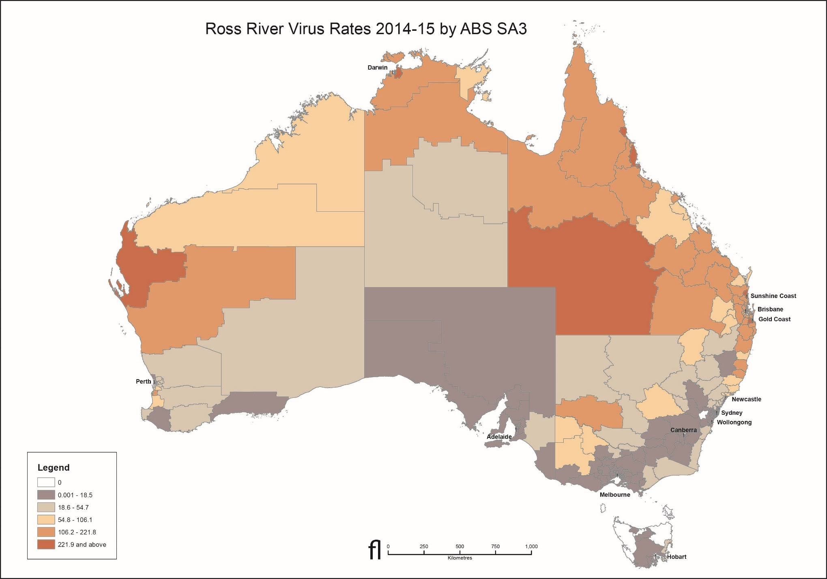

As per previous years, the highest number of RRV notifications was reported from Queensland in 2014–15. However, the 6,371 notifications from Queensland in 2014–15 represent the largest outbreak on record for at least 20 years. The notification rate of RRV across Queensland was 133.3 per 100,000 population, compared with a historical average of 40.6 per 100,000 population. During the outbreak period (1 Oct 2014-30 April 2015), there were 5,473 notifications of RRV in Queensland. High numbers of mosquitoes (particularly freshwater species Cx. annulirostris) collected during routine monitoring programs in southeast Queensland coincided with early and consistent rains and high numbers of RRV notifications, likely contributing to the magnitude of the RRV outbreak in 2015. The geographically widespread nature of RRV transmission was reflected in the results of sugar-based arbovirus surveillance with numerous detections across the Brisbane region. In Queensland, RRV notifications are seasonal, with considerable variation between seasons.Whilst the specific circumstances underlying the 2015 outbreak remain unclear, low reservoir host immunity, in combination with high mosquito densities and wet conditions, may have contributed to the increased number of cases in humans.
An MVE media warning was issued for the Barkly and Alice Springs regions in mid-January 2015 due to heavy rainfall in the Northern Territory, associated with the monsoon activity in the northwest, creating favourable environmental conditions for an early MVE season. A total of 317mm rainfall was recorded in Tennant Creek in January, with 195mm recorded in Alice Springs. Subsequent KUNV activity was detected in Tennant Creek in late February, with an MVE case also reported that month. A total of 33 hectares of the Ilparpa Swamp, the largest mosquito breeding site in Alice Springs, was aerially controlled in January 2015. No sentinel chickens seroconverted to MVEV or KUNV in Alice Springs and no cases were recorded.
The Torres Strait Ae. albopictus Prevention and Control Program continues to be successful in reducing numbers of this mosquito species collected and also preventing establishment on the mainland. The single detection of Ae. albopictus on Horn Island and detection of larvae only twice from Thursday island between June 2014 and May 2015 represents the lowest population densities recorded over the last five years since these two islands became infested with Ae. albopictus in 2005, despite similar rainfall patterns over the years. Interestingly, adult mosquito surveys on nearby Hammond Island during the dry period (May 2015) showed that the density of Ae. albopictus was > 60 times that which has been recorded on Horn and Thursday Islands during the wet season. This suggests very effective mosquito suppression on Thursday and Horn islands, but also demonstrates that the threat of reinvasion from outer islands remains high.
In 2014–15, the number of notifications of BFV infection and the population rates declined markedly for the second year in a row, following the recognition of the ‘epidemic’ of false positive IgM diagnoses that was reported previously,⁴¹ and which began in October 2012. Under the revised case definition for BFV which was implemented on 1 January 2016, a single IgM positive result will no longer constitute laboratory evidence for infection, and where a single result is IgM and IgG positive, it may be notified as a probable case. A confirmed case will require IgG seroconversion or a significant increase in IgG antibody level (e.g. 4-fold or greater rise in titre). There is currently no plan to undertake a retrospective revision of notifications to apply the revised case definitions because there is insufficient information on the diagnosis method information available in NNDSS. Therefore, the historical data prior to the change of case definition will continue to be considered unreliable.
There were only seven notifications of ZIKV infections reported in Australia in 2014–15. Most were acquired in Pacific Island countries (Vanuatu, the Solomon Islands and Fiji) with one acquired in Indonesia. These infections were not thought to be cause for serious public health concern at the time, due to the high rate of asymptomatic infection, and symptomatic cases were generally mild, notwithstanding the reports of a possible association with Guillain Barré syndrome.⁴² Subsequent to the 2014–15 season, ZIKV spread rapidly through many countries in the Americas after being first confirmed in Brazil in May 2015.^{43, 44} The virus was thought to have been introduced to Brazil during the August 2014 World Sprint Championship canoe race, held in Rio de Janeiro, which attracted participants from 4 Pacific Island nations, including French Polynesia, which has active ZIKV transmission.⁴⁵ An increase in microcephaly in Brazil with geographical and temporal links to ZIKV was reported in November 2015, and the World Health Organization declared the clusters of microcephaly and neurological disorders a Public Health Event of International Concern on 1 February 2016.⁴⁶ There is strong scientific consensus that the virus can be transmitted in utero and can cause severe birth defects such as microcephaly,⁴⁷ and that it can cause Guillain Barré syndrome.^{48,49} ZIKV also emerged in a number of Pacific Island countries between 2014 and 2016, including large outbreaks in American Samoa, Samoa, Kosrae state in Micronesia and Tonga.
During 2014–15, the number of cases of CHIKV was 2.4 times the 5 year mean. Indonesia continues to be a major source country for CHIKV infections in Australia, but in 2014-15, the largest number reported were acquired in Samoa. Recent widespread emergence and re-emergence of CHIKV, DENV and ZIKV in the south Pacific have had serious impacts for local populations. CHIKV infection was first reported in the Pacific Islands in February 2011 in New Caledonia, and in 2013 and 2014, it emerged in Papua New Guinea, New Caledonia, Yap State, Tonga, American Samoa, Tokelau, Samoa, and in French Polynesia where an outbreak affected up to 25% of the local population. There is no evidence of any local transmission of CHIKV in Australia to date, but these outbreaks in the South Pacific have been cause for particular concern in areas of Queensland where there is a risk of local transmission. In July 2014, Queensland Health released the Queensland Chikungunya Management Plan 2014–2019, available on the Queensland health web site (https://www.health.qld.gov.au/publications/clinical-practice/guidelines-procedures/diseases-infection/governance/chikungunya-management-plan.pdf).
With a number of detections of Ae. aegypti and Ae. albopictus at international airports around Australia during the year, there is the threat of establishment of these vectors of DENV, ZIKV and CHIKV in novel locations. There is also the risk of isolated cases where transient incursions of infected mosquitoes occur, as seen in Western Australia in 2013–14,¹⁴ and previously reported in the Northern Territory in 2010.⁵⁰ Used tyres and exposed machinery continue to be a high risk pathway for the introduction of exotic mosquitoes. Australia is in the process of finalising National Guidelines that aim to strengthen Australia’s defence against the introduction and spread of vectors and vector-borne diseases and form part of the Australian Government response to the increase in exotic mosquito detections at Australian first points of entry. The guidelines also aim to ensure that the risk of entry and establishment of exotic mosquitoes capable of carrying and transmitting diseases is addressed consistently across all jurisdictions. The guidelines will be an important tool to ensure the use of best practice around the country and could serve as a reference internationally. The guidelines are expected to be released in late 2017.
Prevention of the incursion of DENV vectors into densely populated areas of South-East Queensland where imported DENV cases are regularly notified is a continuing priority in Queensland. Despite regular seasonal outbreaks relating to transmission from imported cases, mosquito and infection control measures undertaken by public health authorities and by residents have ensured that DENV has not become endemic in north Queensland. The Queensland Dengue Management Plan 2015–20 provides clear guidance on ongoing prevention, sporadic case response and outbreak management.⁵¹
The number of imported cases of dengue in Australia continues to increase each year, reflecting the continuing increase in dengue in source countries such as Indonesia, and elsewhere in South East Asia. While there is progress towards development of a dengue vaccine, efficacy in prevention of infection by the most promising candidate is disappointing, and the results on whether it can prevent hospitalisations with severe dengue are mixed.⁵² Along with the failure of traditional prevention through vector control in endemic countries, this highlights the need for development and application of novel strategies such as the use of Wolbachia to prevent transmission of dengue in mosquitoes infected with the bacterium.⁵³
Continued vigilance and the involvement of all relevant sectors enable the rapid detection of and early response to the threat of arboviral disease and malaria in Australia. The expert advice provided by NAMAC to the Australian Health Protection Principal Committee, CDNA and health departments has a vital role in mitigating mosquito-borne disease threats. Into the future, NAMAC strives for a reduction in the number of arbovirus cases in Australia, improved sensitivity and specificity of arbovirus diagnostics, a strengthened disease prediction capacity to allow planning for response, and to retain, build and disseminate expertise and knowledge pertaining to mosquito-borne diseases.

Acknowledgements
NAMAC members during 2014–15 were (in alphabetical order): Sonya Bennett, Bart Currie, Peter Daniels, Stephen Doggett, Debra El Saadi, Rebecca Feldman, Jenny Firman, Michaela Hobby, Katrina Knope, Ann Koehler, Nina Kurucz, Rogan Lee, Mike Lindsay, John Mackenzie, Mike Muller, Scott Ritchie, Richard Russell, Lance Sanders, Angus Sly, David Smith, Peter Whelan, Craig Williams and David Williams. Jennifer Wall and Phil Wright (Secretariat).
The data on which this report is based is the work of many people. We thank public health laboratories, state and territory communicable disease control units and public health units and staff in state and territory arbovirus surveillance and monitoring programs. We thank the state health departments for surveillance program funding. We thank the Northern Australia Quarantine Strategy staff. Maps were produced by James Newhouse in the Research Data and Evaluation Division, Australian Government Department of Health.

Author details
Katrina E Knope¹
Stephen L Doggett²
Cassie C. Jansen³
Cheryl A Johansen⁴
Nina Kurucz⁵
Rebecca Feldman⁶
Stacey E. Lynch⁷
Michaela Hobby⁸
Angus J. Sly⁹
Andrew Jardine¹⁰
Sonya Bennett³
Bart J. Currie¹¹
The National Arbovirus and Malaria Advisory Committee.
- Zoonoses, Foodborne and Emerging Infectious Diseases Section, Health Protection Policy Branch, Office of Health Protection, Department of Health, Canberra, Australian Capital Territory
- Department of Medical Entomology, Pathology West, Institute for Clinical Pathology and Medical Research, Westmead Hospital, Westmead, New South Wales
- Communicable Diseases Branch, Department of Health, Queensland Government, Herston, Qld 4006
- Arbovirus Surveillance and Research Laboratory, School of Pathology and Laboratory Medicine, Faculty of Medicine, Dentistry and Health Sciences, The University of Western Australia, Nedlands, Western Australia. As of July 2015: Division of Microbiology and Infectious Diseases, PathWest Laboratory Medicine WA, QEII Medical Centre, Western Australian Department of Health, Nedlands, Western Australia.
- Medical Entomology, Centre for Disease Control, Health Protection Division, Northern Territory Department of Health, Royal Darwin Hospital, Casuarina, Northern Territory
- Communicable Disease Prevention and Control, Department of Health, Melbourne, Victoria
- Agriculture Victoria Research, AgriBio Centre for AgriBioscience, 5 Ring Road, Bundoora, Victoria, 3083, Australia.
- Health Protection, Public Health, South Australian Department of Health, Adelaide, South Australia
- Department of Agriculture and Water Resources, Compliance Division, Eagle Farm, Queensland
- Medical Entomology, Environmental Health Directorate, Department of Health, Western Australia
- Royal Darwin Hospital Northern Territory; Menzies School of Health Research, Darwin, Northern Territory
- Corresponding author: Ms Katrina Knope, Zoonoses, Foodborne and Emerging Infectious Diseases Section, Health Emergency Management Branch, Office of Health Protection, Australian Government Department of Health, MDP 14, GPO Box 9848, CANBERRA ACT 2601. Telephone: +61 2 6289 2751. Email: Katrina.Knope@health.gov.au

References
- NNDSS Annual Report Working Group. Australia’s notifiable disease status, 2014: Annual report of the National Notifiable Diseases Surveillance System. Commun Dis Intell Q Rep 2016;40(1):E48-E145.
- Australian Bureau of Statistics. Australian Demographic Statistics, December 2014. Canberra: Australian Bureau of Statistics; 2015. Report No.: ABS Catalogue: 3101.0. 2015. Accessed on. Available from:
- Australian Bureau of Statistics. 1216.0 Australian Standard Geographical Classification (ASGC), July 2011. In; 2011.
- Broom AK, Azuolas J, Hueston L, Mackenzie JS, Melville L, Smith DW, et al. Australian encephalitis: Sentinel Chicken Surveillance Programme. Commun Dis Intell 2001;25(3):157-160.
- Broom AK. Sentinel Chicken Surveillance Program in Australia, July 2002 to June 2003. Commun Dis Intell 2003;27(3):367-369.
- Mackenzie JS, Lindsay MD, Coelen RJ, Broom AK, Hall RA, Smith DW. Arboviruses causing human disease in the Australasian zoogeographic region. Arch Virol 1994;136(3-4):447-467.
- Russell RC, Dwyer DE. Arboviruses associated with human disease in Australia. Microbes Infect 2000;2(14):1693-1704.
- Selvey LA, Donnelly JA, Lindsay MD, Pottumarthy Boddu S, D’Abrera VC, Smith DW. Ross River virus infection surveillance in the Greater Perth Metropolitan Area - has there been an increase in cases in the winter months? Commun Dis Intell 2014;38(2):E114-E122.
- Case Definitions Working Group. Revised surveillance case definitions: Barmah Forest virus infection, Ross River virus infection, congenital rubella infection. Commun Dis Intell 2015;39(04).
- Parida MM, Santhosh SR, Dash PK, Lakshmana Rao PV. Rapid and real-time assays for detection and quantification of chikungunya virus. Future Virol 2008;3(2):179-192.
- Harrington S, Lindsay M, Douglas A. Christmas Island and Cocos (Keeling) Islands, Indian Ocean: Mosquito fauna and mosquito-borne disease risk assessment and management recommendations. Final report of investigations undertaken in 2007-08: Public Health Division, Western Australian Department of Health; 2009.
- Hall-Mendelin S, Ritchie SA, Johansen CA, Zborowski P, Cortis G, Dandridge S, et al. Exploiting mosquito sugar feeding to detect mosquito-borne pathogens. Proc Natl Acad Sci U S A 2010;107(25):11255-11259.
- Jansen CC, Williams CR, van den Hurk AF. The usual suspects: Comparison of the relative roles of potential urban chikungunya virus vectors in Australia. PLoS One 2015;10(8):e0134975.
- Knope K, Muller M, Kurucz N, Doggett S, Feldman R, Johansen C, et al. Arboviral diseases and malaria in Australia, 2013-14: annual report of the National Arbovirus and Malaria Advisory Committee. Commun Dis Intell 2016;40(3).
- Rich G, McKechnie J, McPhan I, Richards B. Laboratory diagnosis of Ross River virus infection. Commun Dis Intell 1993;17(10):208–209.
- Roth A, Mercier A, Lepers C, Hoy D, Duituturaga S, Benyon E, et al. Concurrent outbreaks of dengue, chikungunya and Zika virus infections - an unprecedented epidemic wave of mosquito-borne viruses in the Pacific 2012-2014. Euro Surveill 2014;19(41): pii: 20929.
- Souarès Y, Pacific Public Health Surveillance Network. Telehealth and outbreak prevention and control: the foundations and advances of the Pacific Public Health Surveillance Network. Pac Health Dialog 2000;7(2):11–28.
- Pacific Public Health Surveillance Network. Chikungunya in the Pacific region. In: Email to members of PacNet; 2015.
- Hanna JN, Ritchie SA, Richards AR, Humphreys JL, Montgomery BL, Ehlers GJ, et al. Dengue in north Queensland, 2005-2008. Commun Dis Intell 2009;33(2):198-203.
- Queensland Health. Queensland Dengue Management Plan 2010-2015, 2011. Queensland: Queensland Health.
- Australian Technical Advisory Group on Immunisation. The Australian Immunisation Handbook 10th edn. Canberra, Australia: Department of Health and Ageing; 2013.
- Bali travel behind spike in dengue fever. Disease WAtch 2012;16(5).
- Hospital and Health Service Maps https://www.health.qld.gov.au/maps Queensland Health, 18 January 2017.
- Pyke AT, Moore PR, Taylor CT, Hall-Mendelin S, Cameron JN, Hewitson GR, et al. Highly divergent dengue virus type 1 genotype sets a new distance record. Scientific reports 2016;6.
- Duffy MR, Chen TH, Hancock WT, Powers AM, Kool JL, Lanciotti RS, et al. Zika virus outbreak on Yap Island, Federated States of Micronesia. N Engl J Med 2009;360(24):2536-2543.
- Romanes F. Japanese Encephalitis - Australia: (Victoria) ex Indonesia. Promed 2015.
- Gray TJ, Burrow JN, Markey PG, Whelan PI, Jackson J, Smith DW, et al. West Nile virus (Kunjin subtype) disease in the Northern Territory of Australia—A case of encephalitis and review of all reported cases. Am J Trop Med Hyg 2011;85(5):952-956.
- Heymann DL. Control of Communicable Diseases Manual. 19th edn: American Public Health Association; 2008.
- Cox-Singh J, Davis TM, Lee KS, Shamsul SS, Matusop A, Ratnam S, et al. Plasmodium knowlesi malaria in humans is widely distributed and potentially life threatening. Clin Infect Dis 2008;46(2):165-171.
- Gray TJ, Trauer JM, Fairley M, Krause VL, Markey PG. Imported malaria in the Northern Territory, Australia-428 consecutive cases. Commun Dis Intell 2012;36(1):107-113.
- Hanna JN, Ritchie SA, Eisen DP, Cooper RD, Brookes DL, Montgomery BL. An outbreak of Plasmodium vivax malaria in Far North Queensland, 2002. Med J Aust 2004;180(1):24-28.
- World Health Organization. World Malaria Report 2015. Accessed on 8 July 2016. Available from: http://apps.who.int/iris/bitstream/10665/200018/1/9789241565158_eng.pdf?ua=1
- van den Hurk AF, Hall-Mendelin S, Johansen CA, Warrilow D, Ritchie SA. Evolution of mosquito-based arbovirus surveillance systems in Australia. BioMed Research International 2012;2012.
- Mpho M, Callaghan A, Holloway GJ. Temperature and genotypic effects on life history and fluctuating asymmetry in a field strain of Culex pipiens. Heredity (Edinb) 2002;88(4):307-312.
- Doggett S. CJ, Haniotis J., Webb C., Russell R.C., Hueston L., McIntyre L., Lim H. and Dwyer D.E. (2013). The NSW Arbovirus Surveillance and Mosquito Monitoring Program, 2012-2013. ICPMR, Westmead. 32pp. ISBN 1-74080-148-2.
- Ritchie SA, Moore P, Carruthers M, Williams C, Montgomery B, Foley P, et al. Discovery of a widespread infestation of Aedes albopictus in the Torres Strait, Australia. J Am Mosq Control Assoc 2006;22(3):358-365.
- Montgomery BL, Shivas MA, Hall-Mendelin S, Edwards J, Hamilton NA, Jansen CC, et al. Rapid Surveillance for Vector Presence (RSVP): Development of a novel system for detecting Aedes aegypti and Aedes albopictus. PLoS Negl Trop Dis 2017;11(3):e0005505.
- Australian Government Bureau of Meteorology. Accessed on Unknown. Available from: http://www.bom.gov.au/
- Flies EJ, Toi C, Weinstein P, Doggett SL, Williams CR. Converting Mosquito Surveillance to Arbovirus Surveillance with Honey-Baited Nucleic Acid Preservation Cards. Vector Borne Zoonotic Dis 2015;15(7):397-403.
- Maynard AJ, Ambrose L, Cooper RD, Chow WK, Davis JB, Muzari MO, et al. Tiger on the prowl: Invasion history and spatio-temporal genetic structure of the Asian tiger mosquito Aedes albopictus (Skuse 1894) in the Indo-Pacific. PLoS Negl Trop Dis 2017;11(4):e0005546.
- Knope K, Kurucz N, Doggett S, Muller M, Johansen C, Feldman R, et al. Arboviral diseases and malaria in Australia, 2012-13: annual report of the National Arbovirus and Malaria Advisory Committee. Commun Dis Intell 2016;40(1):E17-E46.
- Musso D, Roche C, Robin E, Nhan T, Teissier A, Cao-Lormeau VM. Potential sexual transmission of Zika virus. Emerg Infect Dis 2015;21(2):359-361.
- Ministério da Saúde (Brazil). Confirmação do Zika Vírus no Brasil, [Internet]. Brasília: Ministério da Saúde (Brazil); 2015 [updated 14 May 2015; cited 14 May 2015]. Available from: http://portalsaude.saude.gov.br/index.php/cidadao/principal/agencia-saude/17701-confirmacao-do-zika-virus-no-brasil .
- Cardoso CW, Paploski IA, Kikuti M, Rodrigues MS, Silva MM, Campos GS, et al. Outbreak of exanthematous illness associated with Zika, chikungunya, and dengue viruses, Salvador, Brazil. Emerg Infect Dis 2015;21(12):2274-2276.
- Musso D. Zika Virus Transmission from French Polynesia to Brazil. Emerg Infect Dis 2015;21(10):1887.
- World Health Organization. WHO statement on the first meeting of the International Health Regulations (2005) (IHR 2005) Emergency Committee on Zika virus and observed increase in neurological disorders and neonatal malformations. 2016. Accessed on 17 February 2016. Available from: http://www.who.int/mediacentre/news/statements/2016/1st-emergency-committee-zika/en/
- Rasmussen SA, Jamieson DJ, Honein MA, Petersen LR. Zika virus and birth defects - reviewing the evidence for causality. N Engl J Med 2016;374(20):1981-1987.
- Cao-Lormeau VM, Blake A, Mons S, Lastere S, Roche C, Vanhomwegen J, et al. Guillain-Barré syndrome outbreak associated with Zika virus infection in French Polynesia: a case-control study. Lancet 2016;387(10027):1531-1539.
- Paploski IA, Prates AP, Cardoso CW, Kikuti M, Silva MM, Waller LA, et al. Time lags between exanthematous illness attributed to Zika virus, Guillain-Barré syndrome, and microcephaly, Salvador, Brazil. Emerg Infect Dis 2016;22(8):1438-1444.
- Whelan P, Nguyen H, Hajkowicz K, Davis J, Smith D, Pyke A, et al. Evidence in Australia for a case of airport dengue. PLoS Negl Trop Dis 2012;6(9):e1619.
- Queensland Health. Queensland Dengue Management Plan 2015-2020.
- Simmons CP. A candidate dengue vaccine walks a tightrope. N Engl J Med 2015;373(13):1263-1264.
- Lambrechts L, Ferguson NM, Harris E, Holmes EC, McGraw EA, O’Neill SL, et al. Assessing the epidemiological effect of Wolbachia for dengue control. Lancet Infect Dis 2015;15(7):862-866.
- Appuhamy R, Webb C. Mosquito-borne viral diseases in the ACT. ACT Population Health Bulletin 2016;5(1).
- Doggett S, Clancy J, Haniotis J, Russell RC, Hueston L, Marchetti M, et al. The New South Wales Arbovirus Surveillance and Mosquito Monitoring Program. 2003 – 2004 Annual Report. Department of Medical Entomology, Westmead; 2004.
- Van den Hurk AF, Hall-Mendelin S, Townsend M, Kurucz N, Edwards J, Ehlers G, et al. Applications of a sugar-based surveillance system to track arboviruses in wild mosquito populations. Vector Borne Zoonotic Dis 2014;14(1):66-73.
- Forbes JA. Murray Valley encephalitis 1974. The epidemic variance since 1914 and predisposing rainfall patterns. Sydney; 1978.
- Nicholls N. A method for predicting Murray Valley encephalitis in south-east Australia using the Southern Oscillation. Aust J Exp Biol Mod Sci 1986;64:587-594.
- Hall RA, Broom AK, Hartnett AC, Howard MJ, Mackenzie JS. Immunodominant epitopes on the NS1 protein of MVE and KUN viruses serve as targets for a blocking ELISA to detect virus-specific antibodies in sentinel animal serum. J Virol Methods 1995;51(2-3):201-210.

Appendix A

Australian Capital Territory
There were no vertebrate, vector and climate surveillance programs in the Australian Capital Territory.
A mosquito survey during a previous year (2012–13) confirmed the low numbers of mosquitoes in the territory, and the small seasonal window during which mosquitoes might increase in number.⁵⁴

New South Wales
Surveillance mechanisms include monitoring environmental conditions that could be indicative of potential mosquito breeding, mosquito monitoring, virus isolation from mosquitoes, and sentinel chicken surveillance. The New South Wales Arbovirus Surveillance and Vector Monitoring Program is funded and coordinated by the NSW Ministry of Health (NSW Health), and laboratory services are contracted to the Institute of Clinical Pathology and Medical Research, Pathology West at Westmead Hospital. Mosquito trapping occurs from mid-spring to mid-autumn (November to April), and mosquitoes are collected weekly for species identification and quantification, and processed for isolation of arboviruses. Data on the Southern Oscillation Index, rainfall and temperature obtained from the Bureau of Meteorology are used by members of the program to predict mosquito-breeding capabilities and potential arboviral activity, while climatic data are used to predict MVEV outbreaks. Sentinel chickens are operated along with mosquito monitoring and viral isolation at inland locations of major population centres at risk of MVEV, while along the coast where MVEV does not occur, only mosquito monitoring and viral isolation are undertaken.
The NSW Chicken Sentinel Program was approved by the Western Sydney Local Health Network Animal Ethics Committee. This approval requires that the chicken handlers undergo training to ensure the chickens are cared for appropriately and that blood sampling is conducted in a manner that minimises trauma to the chickens. The chickens are cared for and bled by local council staff and members of the public. Laboratory staff members are responsible for training the chicken handlers. A veterinarian (usually the Director of Animal Care at Westmead) must inspect all new flock locations prior to deployment to ensure animal housing is adequate. Existing flocks are inspected approximately every two years. The health of each flock is reported weekly, and is independently monitored by the Animal Ethics Committee via the Director of Animal Care. Full details of the bleeding method and laboratory testing regimen were detailed in the 2003–04 NSW Arbovirus Surveillance Program annual report.⁵⁵ A total of eleven flocks each containing up to 15 Isa Brown pullets was deployed in 2014-15, with one flock each at Bourke, Deniliquin, Forbes, Griffith, Hay, Leeton, Macquarie Marshes, Menindee, Moama (near Mathoura), Moree, and Wee Waa. A total of 3,035 samples were received from the ten flocks in NSW over the six-month period in 2014-15. This represented 6,070 ELISA tests (excluding controls and quality assurance samples), with each specimen being tested for MVEV and KUNV antibodies.
The results of chicken serology are disseminated via email to the relevant government groups as determined by NSW Health and are placed on the NSW Arbovirus Surveillance website. Confirmed positives are notified by telephone to NSW Health and CDNA. A weekly report of all surveillance activities is disseminated to key health personnel.

Northern Territory
Sentinel chicken flocks in the Northern Territory are maintained, bled and tested for MVEV and KUNV in a combined program between the Northern Territory Department of Health, the Berrimah Veterinary Laboratory of the Northern Territory Department of Primary Industries and Fisheries and volunteers.
Surveillance consists of monthly routine sentinel chicken surveillance during the high risk period for MVE, with flocks located in Leanyer (Darwin), Howard Springs, Coastal Plains Research Station at Beatrice Hill (Darwin region), Katherine, Nhulunbuy, Nathan River, Tennant Creek and Alice Springs. When chickens from a flock show antibodies to MVEV during a prime risk period, a media warning is issued for the general region. These warnings advise Northern Territory residents and visitors of the need to take added precautions to avoid mosquito bites. In 2014–15, sentinel chickens were bled between December 2014 and July 2015.
In addition, ad hoc virus isolation from mosquitoes is carried out when MVEV or KUNV disease cases are reported. The Northern Territory Medical Entomology unit conducts and assists regional authorities with mosquito monitoring. In 2014–15, routine adult mosquito trapping consisted of 16 trapping sites throughout the Darwin urban area. In other Northern Territory regions, adult mosquito trapping is carried out in liaison with Environmental Health, local government and mining companies, with 6 routine traps located in Nhulunbuy, 3 in Alyangula on Groote Eylandt, 4 in Katherine, 3 in Tennant Creek and 6 in Alice Springs. Climate information from the Bureau of Meteorology is used in conjunction with chicken and vector surveillance. Rainfall patterns, daily rainfall records and rain threshold models are used to assist in predicting mosquito and virus activity.

Queensland
Mosquito monitoring is performed by some local councils, primarily for salt water and fresh water mosquitoes. Some councils perform surveillance for container-inhabiting mosquitoes in domestic and commercial premises as part of a joint Queensland Health and local government initiative. This surveillance comprises various methods including the use of Biogents (BG) traps, GATs, ovitraps and larval survey. GATs (in combination with larval survey in some locations) were deployed in the Sunshine Coast, Somerset, Toowoomba, South Burnett, Southern Downs, Goondiwindi, Balonne, Maranoa, Cherbourg, Western Downs, Murweh, Blackwater and Rockhampton regions between October 2014 and February 2015. GATs and ovitraps were also deployed in the Fraser Coast, Emerald, Longreach and Theodore regions, and a combination of GATs and BG traps were deployed in the Bundaberg region. The Rapid Surveillance for Vector Presence (RSVP) program is a novel strategy for upscaling surveillance for container-inhabiting mosquito species and underwent field validation in 2014/15. During the field validation, 477 ovitraps were deployed in Brisbane and 45 in Rockhampton. Routine monitoring of dengue vector populations in Cairns was based on weekly inspection of 70 GAT traps and 14 BG traps deployed in selected suburbs. A mosquito surveillance network comprising 45-60 GATs was maintained throughout Townsville in 2014/2015.
Since the first detection of Aedes albopictus in the Torres Strait in 2005, the Torres Strait Aedes albopictus Prevention and Control Program has been conducted by Tropical Public Health Services, Cairns, under funding by the Australian Government. Key field activities include several cycles of comprehensive monitoring of mosquito densities and distribution, as well as mosquito prevention and control activities to suppress Ae. albopictus on Horn and Thursday islands. The vector control teams conducted six such cycles between June 2014 and May 2015. Specifically, mosquito surveillance and control activities were conducted in Horn and Thursday Islands in August, November, and December 2014 and in January, February, March and May 2015. Mosquito surveillance was conducted on Hammond Island in August 2014, September-October 2014 and May 2015. Mosquito surveys were conducted on Yam, Poruma and Warraber islands in April 2015, while an Ae. albopictus behavioural ecology study was conducted on Masig (Yorke) island in February. Mosquito surveillance is conducted using sweep-net collections and larval survey during yard inspections. Vector control on Thursday and Horn islands is comprised of treatment, elimination or covering potential larval habitats in all residential and commercial premises and the treatment of harbourage sites with residual pyrethroids. Inspection, repair and maintenance of 220 rainwater tanks was conducted on Thursday Island in September 2014. The Northern Peninsula Area was the subject of mainland mosquito surveys in April and May 2015, with property inspections and sweep-net collections conducted at Seisia, New Mapoon, Bamaga, Injinoo and Umagico.
The Northern Australian Quarantine Strategy (NAQS; part of Australian Government’s Department of Agriculture and Water Resources) conducts targeted surveillance for Japanese encephalitis virus in North Queensland comprising fortnightly carbon dioxide-baited passive box traps containing sugar-based arbovirus surveillance methods at three locations (Seisia, Injinoo and NPA rubbish tip (near Injinoo)) between January and May, and monthly serological monitoring of a herd of 12 cattle at Seisia. No animal survey was conducted by NAQS in the reporting period 2014-15.
A Mosquito and Arbovirus Research Committee-funded project evaluated a sugar-based virus surveillance system using light traps in peri-urban locations across the Brisbane City Council region. Routine light traps baited with carbon dioxide and containing sugar feeding stations with nucleic acid preservation cards were deployed weekly at nine sites between 3 February and 20 May 2015. Cards were analysed by real-time TaqMan RT-PCR for the presence of RRV and BFV RNA.⁵⁶

South Australia
Across South Australia, mosquito management activities are conducted in partnership between SA Health, and local government with strong support from The University of South Australia’s (Uni SA’s) Healthy Environments, Healthy People Research Group. The program is focused on the Riverland and Murraylands areas where arbovirus is endemic, and extends to specific coastal areas and other metropolitan localities of the State. SA Health funds half of local government costs for mosquito surveillance and control on public land through the South Australian Mosquito Management Subsidy.
Uni SA’s Healthy Environments, Healthy People Research Group conducted mosquito surveillance trapping at 35 locations on 11 occasions from August 2014 to April 2015 for seven South Australian local councils along the Murray River (Renmark Paringa Council, Berri Barmera Council, the District Council of Loxton Waikerie, the Mid-Murray Council, the Rural City of Murray Bridge, the Coorong District Council and Alexandrina Council).
SA Health continued to administer the South Australian Sentinel Surveillance Program (SASSP) which consists of five backyard flocks of five chickens located along the Murray River in South Australia in Paringa, Loxton, Waikerie (Qualco), Murray Bridge and Meningie.
Mosquito surveillance and control is also conducted by SA Health in North Western Adelaide adjacent the suburb of Globe Derby Park.

Tasmania
No state-wide systematic mosquito abundance, virus isolation or sentinel chicken surveillance activities are undertaken due to the relatively low risk of arbovirus transmission in the State. However, mosquito collections are undertaken ad hoc in Sorell Council region (which includes mosquito breeding areas, is fairly populous, and is close to Hobart). This is undertaken during high risk periods over January to March when tidal inundation floods salt marsh habitat, thereby leading to egg hatching and subsequent increased abundance of the main local vector, Ae. camptorhynchus. These samples are sent to Westmead Hospital for species identification and viral isolation.

Victoria
The Victorian Department of Health and Human Services contracts the Victorian Department of Economic Development, Jobs, Transport and Resources to conduct sentinel chicken surveillance, mosquito species identification and arbovirus detection during the arbovirus season from November to April. The routine sentinel chicken monitoring program involves the weekly collection of blood samples from 20 chickens located at each of nine sites in northern Victoria along the Murray River or in the surrounding region. This program has been in place in Victoria since the 1974 MVEV outbreak and acts as an early warning system for possible human infections with flaviviruses. Flocks are replaced annually. Seven councils undertake mosquito surveillance as part of the routine mosquito monitoring program, which involves the weekly trapping of mosquitoes at four sites within each area. Six councils are located along the Murray and Goulburn River and one a coastal site in Gippsland. Collections are also received from three additional councils located on the Murray River, Bellarine Peninsula and Melbourne. Mosquitoes are sent on cold storage to the Victorian Department of Economic Development, Jobs, Transport and Resources for identification, enumeration and virus isolation. The Victorian Arbovirus Taskforce examines the risk of outbreaks of MVEV using meteorological surveillance data such as the Southern Oscillation Index and rainfall deciles, and Indian Ocean Dipole using respectively the Forbes,⁵⁷ and Nicholls⁵⁸ and Bennett models.

Western Australia
During 2014–15 the University of Western Australia Arbovirus Surveillance and Research Laboratory (ASRL) was funded by the Western Australian Department of Health to coordinate the sentinel chicken program and mosquito surveillance, and to provide confirmatory serological testing for other sentinel chicken programs in Australia, as required. The flavivirus sentinel chicken program in Western Australia was undertaken by the ASRL at The University of Western Australia, on behalf of the Western Australian Department of Health. The sentinel chicken surveillance program was approved by The University of Western Australia Animal Ethics Committee. Many state and local government authorities and community volunteers also took part in the program. Twenty-eight sentinel chicken flocks (of up to 12 chickens) were located at major towns and communities in the Kimberley, Pilbara, Gascoyne, Goldfields, Mid-West and Wheatbelt regions of Western Australia (Map 1). The Western Australian flavivirus sentinel chicken program operated all year around. Blood samples were collected from the chickens by environmental health officers or trained volunteers at fortnightly intervals during the peak flavivirus risk season (December to June). At other times, monthly samples were collected unless prolonged flavivirus activity warranted continued fortnightly sampling. Samples were transported to ASRL where they were tested for antibodies to flaviviruses using an epitope blocking ELISA.⁵⁹
In the south-west of Western Australia, adult mosquitoes were collected by the ASRL on a regular basis in the Peel, Leschenault and Capel-Busselton regions for surveillance of RRV and BFV. In the 2014–15 season, mosquito homogenates from these regions were tested by both virus isolation and RT-PCR. In addition, adult mosquito traps with honey-baited FTA cards were deployed at some locations in parallel with routine adult mosquito collection traps between August and December 2015.

Arbovirus research and surveillance laboratories in Australia

Commonwealth Scientific and Industrial Research Organisation
CSIRO Australian Animal Health Laboratory
Private Bag 24 (5 Portarlington Road)
GEELONG Vic 3220
Telephone: +61 3 5227 5000

New South Wales
Department of Medical Entomology, CIDMLS, Pathology West – ICPMR, Westmead Hospital.
Postal address: Locked Bag 9001
Westmead NSW 2145
Australia
Tel: +61 2 9845 7279, Fax: +61 2 9893 8659.
Email: Stephen.Doggett@health.nsw.gov.au

Northern Territory
Berrimah Veterinary Laboratory
Northern Territory Department of Primary Industries and Fisheries Northern Territory Government
GPO Box 3000, Darwin NT 0801
Phone: 0889992251 Fax: 0889992024
The Berrimah Veterinary Laboratory tests the sentinel chicken blood from the NT program for flavivirus. In the past the laboratory has also tested FTA cards for flavivirus but no FTA cards were submitted for testing in 2014–15.

Queensland
Queensland Health Forensic and Scientific Services
39 Kessells Road
Coopers Plains
PO Box 594
ARCHERFIELD Qld 4108
Telephone: +61 7 3274 9151
The Public Health Virology laboratory at Queensland Health Forensic and Scientific Services provides a state wide diagnostic and tertiary referral service for viral and rickettsial diseases of public health importance to Queensland.

Victoria
Victorian Infectious Diseases Reference Laboratory (Human)
10 Wrecklyn Street
NORTH MELBOURNE Vic 3051
Telephone: +61 3 9342 2600
Victorian Department of Economic Development, Jobs, Transport and Resources
AgriBio, The Centre for AgriBioscience
5 Ring Road, Bundoora
BUNDOORA Vic 3083
Telephone: +61 3 9032 7515
Arbovirus and vector surveillance, sentinel chicken flavivirus surveillance, equine arbovirus testing (fee-for service diagnostics) through Victorian Laboratory Services.

Western Australia
PathWest Laboratory Medicine WA Division of Microbiology and Infectious Diseases (Human)
Hospital Avenue
NEDLANDS WA 6009
Telephone: +61 8 9346 3122
Arbovirus Surveillance and Research Laboratory
Discipline of Microbiology and Immunology (animal/vector)
School of Pathology and Laboratory Medicine
The University of Western Australia
35 Stirling Highway
CRAWLEY WA 6009
Telephone: +61 8 9346 2212
(Note that the laboratory was moved from UWA to PathWest in July 2015)

Appendix B
State/Territory | City/Town | Suburb/Site | Surveillance/trap type | Notes
NSW | Bourke |  | Sentinel chicken flock
NSW | Deniliquin |  | Sentinel chicken flock
NSW | Forbes |  | Sentinel chicken flock
NSW | Griffith |  | Sentinel chicken flock
NSW | Hay |  | Sentinel chicken flock
NSW | Leeton |  | Sentinel chicken flock
NSW | Macquarie Marshes |  | Sentinel chicken flock
NSW | Mathoura |  | Sentinel chicken flock
NSW | Menindee |  | Sentinel chicken flock
NSW | Moree |  | Sentinel chicken flock
NSW | Wee Waa |  | Sentinel chicken flock
NSW | Albury |  | Sugar-based arbovirus surveillance of trapped mosquitoes
NSW | Ballina |  | Sugar-based arbovirus surveillance of trapped mosquitoes
NSW | Bourke |  | Sugar-based arbovirus surveillance of trapped mosquitoes
NSW | Coffs Harbour |  | Sugar-based arbovirus surveillance of trapped mosquitoes
NSW | Gosford |  | Sugar-based arbovirus surveillance of trapped mosquitoes
NSW | Griffith |  | Sugar-based arbovirus surveillance of trapped mosquitoes
NSW | Lake Macquarie |  | Sugar-based arbovirus surveillance of trapped mosquitoes
NSW | Leeton |  | Sugar-based arbovirus surveillance of trapped mosquitoes
NSW | Mathoura |  | Sugar-based arbovirus surveillance of trapped mosquitoes
NSW | Nambucca |  | Sugar-based arbovirus surveillance of trapped mosquitoes
NSW | Port Macquarie |  | Sugar-based arbovirus surveillance of trapped mosquitoes
NSW | Shoalhaven |  | Sugar-based arbovirus surveillance of trapped mosquitoes
NSW | Sydney |  | Sugar-based arbovirus surveillance of trapped mosquitoes
NSW | Sydney | Blacktown | Sugar-based arbovirus surveillance of trapped mosquitoes
NSW | Sydney | Bankstown | Sugar-based arbovirus surveillance of trapped mosquitoes
NSW | Sydney | Georges River | Sugar-based arbovirus surveillance of trapped mosquitoes
NSW | Sydney | Hawkesbury | Sugar-based arbovirus surveillance of trapped mosquitoes
NSW | Sydney | Penrith | Sugar-based arbovirus surveillance of trapped mosquitoes
NSW | Sydney | Ryde | Sugar-based arbovirus surveillance of trapped mosquitoes
NSW | Sydney | Sydney Olympic Park | Sugar-based arbovirus surveillance of trapped mosquitoes
NSW | Tweed Heads |  | Sugar-based arbovirus surveillance of trapped mosquitoes
NSW | Wagga Wagga |  | Sugar-based arbovirus surveillance of trapped mosquitoes
NSW | Wyong |  | Sugar-based arbovirus surveillance of trapped mosquitoes
NSW | Albury |  | Virus detection from trapped mosquitoes
NSW | Ballina |  | Virus detection from trapped mosquitoes
NSW | Bourke |  | Virus detection from trapped mosquitoes
NSW | Coffs Harbour |  | Virus detection from trapped mosquitoes
NSW | Gosford |  | Virus detection from trapped mosquitoes
NSW | Griffith |  | Virus detection from trapped mosquitoes
NSW | Lake Macquarie |  | Virus detection from trapped mosquitoes
NSW | Leeton |  | Virus detection from trapped mosquitoes
NSW | Mathoura |  | Virus detection from trapped mosquitoes
NSW | Nambucca |  | Virus detection from trapped mosquitoes
NSW | Port Macquarie |  | Virus detection from trapped mosquitoes
NSW | Shoalhaven |  | Virus detection from trapped mosquitoes
NSW | Sydney | Blacktown | Virus detection from trapped mosquitoes
NSW | Sydney | Bankstown | Virus detection from trapped mosquitoes
NSW | Sydney | Georges River | Virus detection from trapped mosquitoes
NSW | Sydney | Hawkesbury | Virus detection from trapped mosquitoes
NSW | Sydney | Penrith | Virus detection from trapped mosquitoes
NSW | Sydney | Ryde | Virus detection from trapped mosquitoes
NSW | Sydney | Sydney Olympic Park | Virus detection from trapped mosquitoes
NSW | Tweed Heads |  | Virus detection from trapped mosquitoes
NSW | Wagga Wagga |  | Virus detection from trapped mosquitoes
NSW | Wyong |  | Virus detection from trapped mosquitoes
NT | Alice Springs |  | Sentinel chicken flock
NT | Beatrice Hill |  | Sentinel chicken flock
NT | Darwin |  | Sentinel chicken flock
NT | Katherine |  | Sentinel chicken flock
NT | Leanyer |  | Sentinel chicken flock
NT | Nathan River |  | Sentinel chicken flock
NT | Nhulunbuy |  | Sentinel chicken flock
NT | Tennant Creek |  | Sentinel chicken flock
Qld | Brisbane | Hemmant | Sugar based arbovirus surveillance of trapped mosquitoes
Qld | Brisbane | Banyo | Sugar based arbovirus surveillance of trapped mosquitoes
Qld | Brisbane | Bracken Ridge | Sugar based arbovirus surveillance of trapped mosquitoes
Qld | Brisbane | Wishart | Sugar based arbovirus surveillance of trapped mosquitoes
Qld | Brisbane | Chermside West | Sugar based arbovirus surveillance of trapped mosquitoes
Qld | Brisbane | Corinda | Sugar based arbovirus surveillance of trapped mosquitoes
Qld | Brisbane | Indooroopilly | Sugar based arbovirus surveillance of trapped mosquitoes
Qld | Brisbane | Lota | Sugar based arbovirus surveillance of trapped mosquitoes
Qld | Brisbane | Ascot | Sugar based arbovirus surveillance of trapped mosquitoes
Qld | Brisbane | The Gap | Sugar based arbovirus surveillance of trapped mosquitoes
Qld | Brisbane | Corinda | Sugar based arbovirus surveillance of trapped mosquitoes
Qld | Northern Peninsula area | NPA Rubbish Tip | Sugar based arbovirus surveillance of trapped mosquitoes
Qld | Northern Peninsula area | Injinoo Piggery | Sugar based arbovirus surveillance of trapped mosquitoes
Qld | Northern Peninsula area | Seisia Meatworks | Sugar based arbovirus surveillance of trapped mosquitoes
SA | Loxton |  | Sentinel chicken flock
SA | Meningie |  | Sentinel chicken flock
SA | Murray Bridge |  | Sentinel chicken flock
SA | Paringa |  | Sentinel chicken flock
SA | Qualco |  | Sentinel chicken flock
SA | Loxton |  | Mosquito-based arbovirus surveillance
SA | Meningie |  | Mosquito-based arbovirus surveillance | Flock relocated in December 2014 to alternate location within same township.
SA | Murray Bridge |  | Mosquito-based arbovirus surveillance
SA | Paringa |  | Mosquito-based arbovirus surveillance
SA | Qualco |  | Mosquito-based arbovirus surveillance
SA | Berri |  | Mosquito-based arbovirus surveillance
SA | Clayton |  | Mosquito-based arbovirus surveillance
SA | Mannum |  | Mosquito-based arbovirus surveillance
SA | Meningie |  | Mosquito-based arbovirus surveillance
SA | Milang |  | Mosquito-based arbovirus surveillance
SA | Monash |  | Mosquito-based arbovirus surveillance
SA | Moorook |  | Mosquito-based arbovirus surveillance
SA | Murray Bridge |  | Mosquito-based arbovirus surveillance
SA | Paringa |  | Mosquito-based arbovirus surveillance
SA | Renmark |  | Mosquito-based arbovirus surveillance
SA | Waikerie |  | Mosquito-based arbovirus surveillance
SA | Wellington |  | Mosquito-based arbovirus surveillance
Vic | Barmah |  | Sentinel chicken flock
Vic | Cobram |  | Sentinel chicken flock
Vic | Kerang |  | Sentinel chicken flock
Vic | Mildura |  | Sentinel chicken flock
Vic | Nyah West |  | Sentinel chicken flock
Vic | Old Toolamba |  | Sentinel chicken flock
Vic | Robinvale |  | Sentinel chicken flock
Vic | Rutherglen |  | Sentinel chicken flock
Vic | Wodonga |  | Sentinel chicken flock
Vic | Barmah |  | Virus detection from trapped mosquitoes
Vic | Barwon Heads |  | Virus detection from trapped mosquitoes
Vic | Cobram |  | Virus detection from trapped mosquitoes | 3 sites. 26^ trapping weeks. Irregular trapping conducted by Geelong council.
Vic | Echuca |  | Virus detection from trapped mosquitoes | 2 sites. 9^ trapping weeks
Vic | Geelong |  | Virus detection from trapped mosquitoes | 2 sites. 1^ trapping week. Irregular trapping conducted by Geelong council.
Vic | Heatherton |  | Virus detection from trapped mosquitoes | 6 sites. 5^ trapping weeks. Conducted by Kingston council in response to earlier A.albopictus detections (ad-hoc).
Vic | Kerang |  | Virus detection from trapped mosquitoes | 3 sites. 26^ trapping weeks
Vic | Koonoomoo |  | Virus detection from trapped mosquitoes | 26^ trapping weeks
Vic | Lake King/Lake Vic |  | Virus detection from trapped mosquitoes | 3 sites. 6^ trapping weeks
Vic | Lake Wellington |  | Virus detection from trapped mosquitoes | 4 sites. 26^ trapping weeks
Vic | Mildura |  | Virus detection from trapped mosquitoes | 5 sites. 26^ trapping weeks
Vic | Ocean Grove |  | Virus detection from trapped mosquitoes | 2 sites. 6^ trapping weeks. Irregular trapping conducted by Geelong council.
Vic | St Leonards |  | Virus detection from trapped mosquitoes | 2 sites. 1^ trapping week. Irregular trapping conducted by Geelong council.
Vic | Point Lonsdale |  | Virus detection from trapped mosquitoes | 2^ trapping weeks. Irregular trapping conducted by Geelong council.
Vic | Wallington |  | Virus detection from trapped mosquitoes | 2 sites. 1^ trapping week. Irregular trapping conducted by Geelong council.
Vic | Old Toolamba |  | Virus detection from trapped mosquitoes | 26^ trapping weeks
Vic | Seaford |  | Virus detection from trapped mosquitoes | 3 sites. 5^ trapping weeks. Conducted by Melbourne water (adhoc)
Vic | Tatura |  | Virus detection from trapped mosquitoes | 26^ trapping weeks
Vic | Byrneside |  | Virus detection from trapped mosquitoes | 26^ trapping weeks
Vic | Murchison |  | Virus detection from trapped mosquitoes | 26^ trapping weeks
Vic | Swan Hill |  | Virus detection from trapped mosquitoes | 4 sites. 26^ trapping weeks
Vic | Wodonga |  | Virus detection from trapped mosquitoes | 4 sites. 26^ trapping weeks
WA | Broome |  | Sentinel chicken flock
WA | Carnarvon |  | Sentinel chicken flock
WA | Derby |  | Sentinel chicken flock
WA | Dongara |  | Sentinel chicken flock
WA | Exmouth |  | Sentinel chicken flock
WA | Fitzroy Crossing |  | Sentinel chicken flock
WA | Geraldton |  | Sentinel chicken flock
WA | Halls Creek |  | Sentinel chicken flock
WA | Harding Dam |  | Sentinel chicken flock
WA | Karratha |  | Sentinel chicken flock
WA | Kununurra |  | Sentinel chicken flock
WA | Leonora |  | Sentinel chicken flock
WA | Lombadina |  | Sentinel chicken flock
WA | Marble Bar |  | Sentinel chicken flock
WA | Moora |  | Sentinel chicken flock
WA | Newman |  | Sentinel chicken flock
WA | Onslow |  | Sentinel chicken flock
WA | Ophthalmia Dam |  | Sentinel chicken flock
WA | Pannawonica |  | Sentinel chicken flock
WA | Paraburdoo |  | Sentinel chicken flock
WA | Port Hedland |  | Sentinel chicken flock
WA | Roebuck Plains |  | Sentinel chicken flock
WA | Savannah Nickel Mine |  | Sentinel chicken flock
WA | Tom Price |  | Sentinel chicken flock
WA | Wyndham |  | Sentinel chicken flock
WA | York |  | Sentinel chicken flock
WA | Broome |  | Mosquito-based arbovirus surveillance
WA | Busselton |  | Mosquito-based arbovirus surveillance
WA | Capel |  | Mosquito-based arbovirus surveillance
WA | Leschenault |  | Mosquito-based arbovirus surveillance
WA | Peel |  | Mosquito-based arbovirus surveillance
^ Approximate number of trapping weeks

Communicable Diseases Intelligence
ISSN: 2209-6051 Online

Communicable Diseases Intelligence (CDI) is a peer-reviewed scientific journal published by the Office of Health Protection, Department of Health. The journal aims to disseminate information on the epidemiology, surveillance, prevention and control of communicable diseases of relevance to Australia.

Editor: Cindy Toms
Deputy Editors: Phil Wright and Simon Petrie
Editorial and Production Staff: Leroy Trapani and Kasra Yousefi
Editorial Advisory Board: David Durrheim, Mark Ferson, John Kaldor, Martyn Kirk and Linda Selvey

Website: http://www.health.gov.au/cdi

Contacts
Communicable Diseases Intelligence is produced by:
Health Protection Policy Branch, Office of Health Protection, Australian Government Department of Health
GPO Box 9848, (MDP 6) CANBERRA ACT 2601

Email: cdi.editor@health.gov.au

Submit an Article
You are invited to submit your next communicable disease related article to the Communicable Diseases Intelligence (CDI) for consideration. More information regarding CDI can be found at: http://health.gov.au/cdi.
Further enquiries should be directed to: cdi.editor@health.gov.au.

This journal is indexed by Index Medicus and Medline.

Creative Commons Licence - Attribution-NonCommercial-NoDerivatives CC BY-NC-ND
© 2019 Commonwealth of Australia as represented by the Department of Health
This publication is licensed under a Creative Commons Attribution-NonCommercial-NoDerivatives 4.0 International Licence from https://creativecommons.org/licenses/by-nc-nd/4.0/legalcode (Licence). You must read and understand the Licence before using any material from this publication.

Restrictions
The Licence does not cover, and there is no permission given for, use of any of the following material found in this publication (if any):
- the Commonwealth Coat of Arms (by way of information, the terms under which the Coat of Arms may be used can be found at www.itsanhonour.gov.au);
- any logos (including the Department of Health’s logo) and trademarks;
- any photographs and images;
- any signatures; and
- any material belonging to third parties.

Disclaimer
Opinions expressed in Communicable Diseases Intelligence are those of the authors and not necessarily those of the Australian Government Department of Health or the Communicable Diseases Network Australia. Data may be subject to revision.

Enquiries
Enquiries regarding any other use of this publication should be addressed to the Communication Branch, Department of Health, GPO Box 9848, Canberra ACT 2601, or via e-mail to: copyright@health.gov.au

Communicable Diseases Network Australia
Communicable Diseases Intelligence contributes to the work of the Communicable Diseases Network Australia.
http://www.health.gov.au/cdna

