Undetected serovars: leptospirosis cases in the Cairns region during the 2021 wet season
Caroline Taunton, Carol El Hayek, Emma Field, Sally Rubenach, Juliet Esmonde, Simon Smith, Annie Preston-Thomas

Abstract

Background
Leptospirosis infection can lead to serious renal and cardiopulmonary complications and can be fatal. Following heavy rainfall and localised flooding in early 2021, Tropical Public Health Services in Cairns were alerted to an increase in leptospirosis cases in the region, with notifications almost three times higher than usual by mid-February. An epidemiological investigation was undertaken.

Methods
Leptospirosis notification data were obtained from the Queensland Notifiable Conditions System. Confirmed and probable cases residing in the Cairns region, with an onset date between 1 January and 31 May 2021, were included in the investigation. Case demographics, pathology results, symptoms, hospital stay information and presumed exposure sources were obtained from Queensland Health records; local rainfall data was obtained from the Australian Bureau of Meteorology. Case characteristics and rainfall were compared to the prior ten-year period and the distribution of cases by week of onset, address, exposure source and infecting serovar analysed.

Results
A total of 43 leptospirosis cases were notified between January and May 2021, the highest number recorded for the region since 2011. Presumed exposure sources were available for 40 cases (93.0%), with 33 cases (82.5%) exposed occupationally, including 25 cases working on banana farms. Infecting Leptospira serovars were identified for five cases (11.6%), with four infected with serovar Australis and one with serovar Zanoni. Limited information about the specific exposure sites for each case and a low serovar detection rate hampered the ability to confirm the presence or absence of a leptospirosis outbreak. While heavy rainfall is likely to have contributed to the spike in cases, no factors were identified as clearly associated with the increase.

Conclusions
A number of pathways are proposed to improve the collection of exposure site data and the identification of infecting serovars, in order to strengthen local leptospirosis surveillance and the ability to detect outbreaks in the Cairns region.
Keywords: Leptospirosis; Cairns; Queensland; serovar; banana; cattle, rainfall; surveillance.

Introduction
Leptospirosis, caused by spirochaetes of the genus Leptospira, is a bacterial infection of public health importance and is considered the most widespread zoonotic disease globally.¹ Humans acquire infection through mucosal or percutaneous exposure to environments contaminated with urine from infected animals or through ingestion of contaminated food or water.² Cases are more common in humid and tropical parts of the world, with Leptospira excreted by infected animals able to survive for weeks in water or moist soil and vegetation.² Outbreaks frequently occur following heavy rainfall and flooding.^{1,3–6} Early phase leptospirosis illness is characterised by sudden onset fever, headache, chills and severe myalgia, particularly of the calves and thighs.⁷ Infection can lead to serious renal, liver, cardiopulmonary and haemorrhagic complications and can be fatal, with a case fatality rate exceeding 50% among severe cases in some settings.⁸
Leptospirosis is endemic in some parts of Australia. Many cases occur around Cairns in the wet tropics of Far North Queensland, a region which reports one of the highest rates of leptospirosis among developed countries.^{9,10} Here, cases often occur seasonally, with the hot, humid wet season environment providing optimal conditions for organism survival. Rodents and livestock are commonly implicated in the spread of pathogenic Leptospira in the region; however, there is a wide variety of known hosts among feral and domestic animal species.² In Far North Queensland, leptospirosis predominantly affects agricultural workers who are at risk of occupational exposure to pathogenic Leptospira while working in contaminated environments. Workers on local banana farms are at particular risk, with tropical banana plantations known to harbour large populations of rodents and small marsupials which nest in the trees and feed off uncovered fruit. Farm workers can come into contact with the urine of infected animals when cutting down bunches or walking through wet undergrowth.
Previous leptospirosis outbreaks in Australia have been attributed to changes in environmental conditions, such as flooding and increases in animal hosts, along with increased organism exposure associated with reduced use of personal protective equipment.^{4,11,12} Animal host carriage of Leptospira serovar can vary by species and geographic area. While identifying animals implicated in leptospirosis outbreaks can be challenging, particularly when protected or endangered species may be involved, knowledge of infecting serovars can be crucial in identifying the source of an outbreak and intervening to prevent further cases. Changes identified in occupational practices or recreational activities that increase the risk of exposure to Leptospira in the environment can also provide opportunities for public health intervention.
Probable and confirmed leptospirosis cases are notifiable in Queensland; the Tropical Public Health Services, Cairns (TPHS) monitors leptospirosis notifications for the Cairns and Hinterland Hospital and Health Service (CHHHS) region.⁷ As leptospirosis is endemic to the region, routine follow-up including case interview is limited to severe cases identified by review of clinical notes, to geographical case clusters, and to clusters self-reported by agricultural employers in the region.
Following heavy rainfall and localised flooding in early 2021, TPHS was alerted to an increase in leptospirosis cases, with notifications almost three times as high, by mid-February 2021, as during the prior five-year comparison period. An epidemiological investigation was launched with the aims, firstly, of detecting any local outbreaks by identifying epidemiological or exposure location links between cases, and secondly, of identifying whether any factors were associated with the increase in leptospirosis cases during the 2021 wet season.

Methods
The investigation included confirmed and probable leptospirosis cases notified to the Queensland Notifiable Conditions System (NOCS) with a residential address within the CHHHS region and a date of onset between 1 January and 31 May 2021. The Queensland Health leptospirosis case definition was used. A confirmed case required laboratory evidence of (a) isolation of pathogenic Leptospira species, or (b) a fourfold or greater rise in Leptospira micro-agglutination titre (MAT) between acute and convalescent phase sera obtained at least two weeks apart, or (c) a single Leptospira MAT ≥400 supported by a positive enzyme-linked immunosorbent assay immunoglobulin M (IgM) result. A probable case required detection of Leptospira by nucleic acid testing, including by polymerase chain reaction (PCR). While probable cases become notifiable nationally from 1 January 2022, the Australian surveillance case definition included only confirmed cases during the 2021 period of this investigation.¹³
Follow-up and case interview with most leptospirosis cases was suspended during 2020 and 2021 as TPHS public health resources were redeployed to manage the local COVID-19 response. For this reason, case demographics, occupational and recreational exposure sources, presenting symptoms and clinical outcomes were collected from emergency department notes and hospital discharge summaries in The Viewer, Queensland Health’s electronic clinical patient summary system. The date of symptom onset was calculated using the duration of symptoms reported at hospital presentation. Leptospirosis laboratory test results were reviewed in NOCS and in Queensland Health’s electronic pathology results system, AUSCARE. In order to review the specimen collection timings, the time in days from symptom onset to specimen collection was calculated for each test result, with equivocal results considered negative for these purposes. Infecting serovars were identified from the text comment provided by the leptospirosis laboratory scientist on each pathology report. Rainfall data were obtained for four local weather stations from the Australian Bureau of Meteorology.¹⁴ To support the identification of clusters, cases were mapped by residential address using MapInfo Pro GIS.
Crude annual leptospirosis notification rates by month and for the investigation period were calculated along with the notification rate of confirmed cases across Australia using estimated resident populations from Queensland Health and the Australian Bureau of Statistics, and notifications from the National Notifiable Disease Surveillance System.^{15–17} Data for the investigation period were compared to available data for the same months during the prior five- and ten-year periods. Where comparison data were not available, descriptive data were compared with the published epidemiology of leptospirosis. Descriptive summary statistics were calculated and graphs generated in Microsoft Excel 2016. One-sample t-tests, two-sample chi-square tests and Mann-Whitney-U tests were employed for statistical comparison, with p values below 0.05 considered significant. Statistical analysis was undertaken using Stata 15.1. An ethics exemption for this investigation was granted by the Far North Queensland Human Research Ethics Committee under reference EX/2022/QCH/81949 (Jan ver 1) - 1583QA.

Results

Distribution
A total of 43 notified cases met the Queensland leptospirosis case definition during the January to May 2021 investigation period, comprising 34 confirmed cases and nine probable cases. The total number of cases was significantly higher than the mean reported for the same months in the prior five-year (27.8 cases, p < 0.05) and ten-year periods (29.4 cases, p < 0.01), and was the highest number recorded for the region since 2011 (Figure 1). Thirty cases (30/43; 69.8%) were resident in the Cassowary Coast Local Government area (LGA); six cases (6/43; 14.0%) in the Tablelands LGA; four cases (4/43; 9.3%) in the Cairns LGA; and three cases (3/43; 7.0%) in other LGAs in the region (Figure 2) (Figure 3).

Figure 1: Leptospirosis cases in the Cairns region, January to May, by case status and year
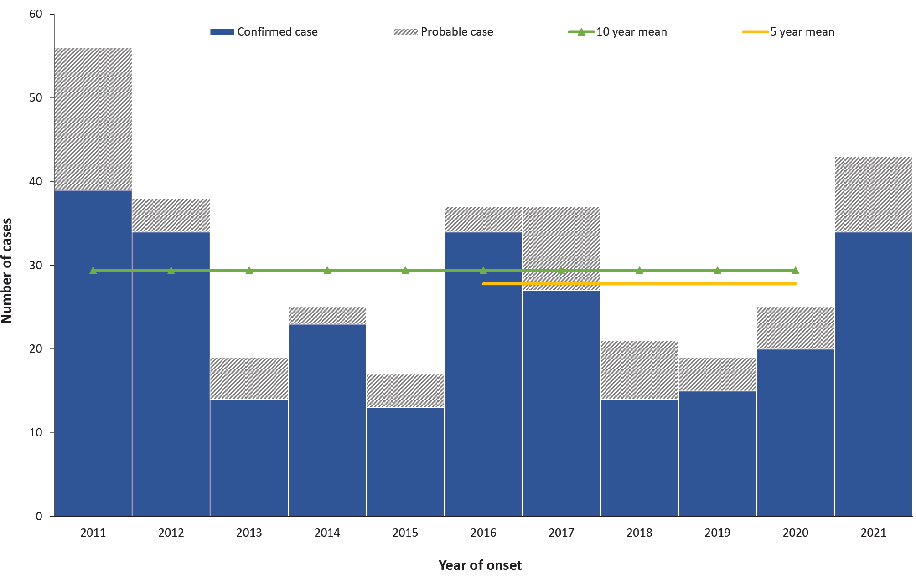
Figure 2: Leptospirosis cases in the Cairns region in 2021, by LGAª and week of onset
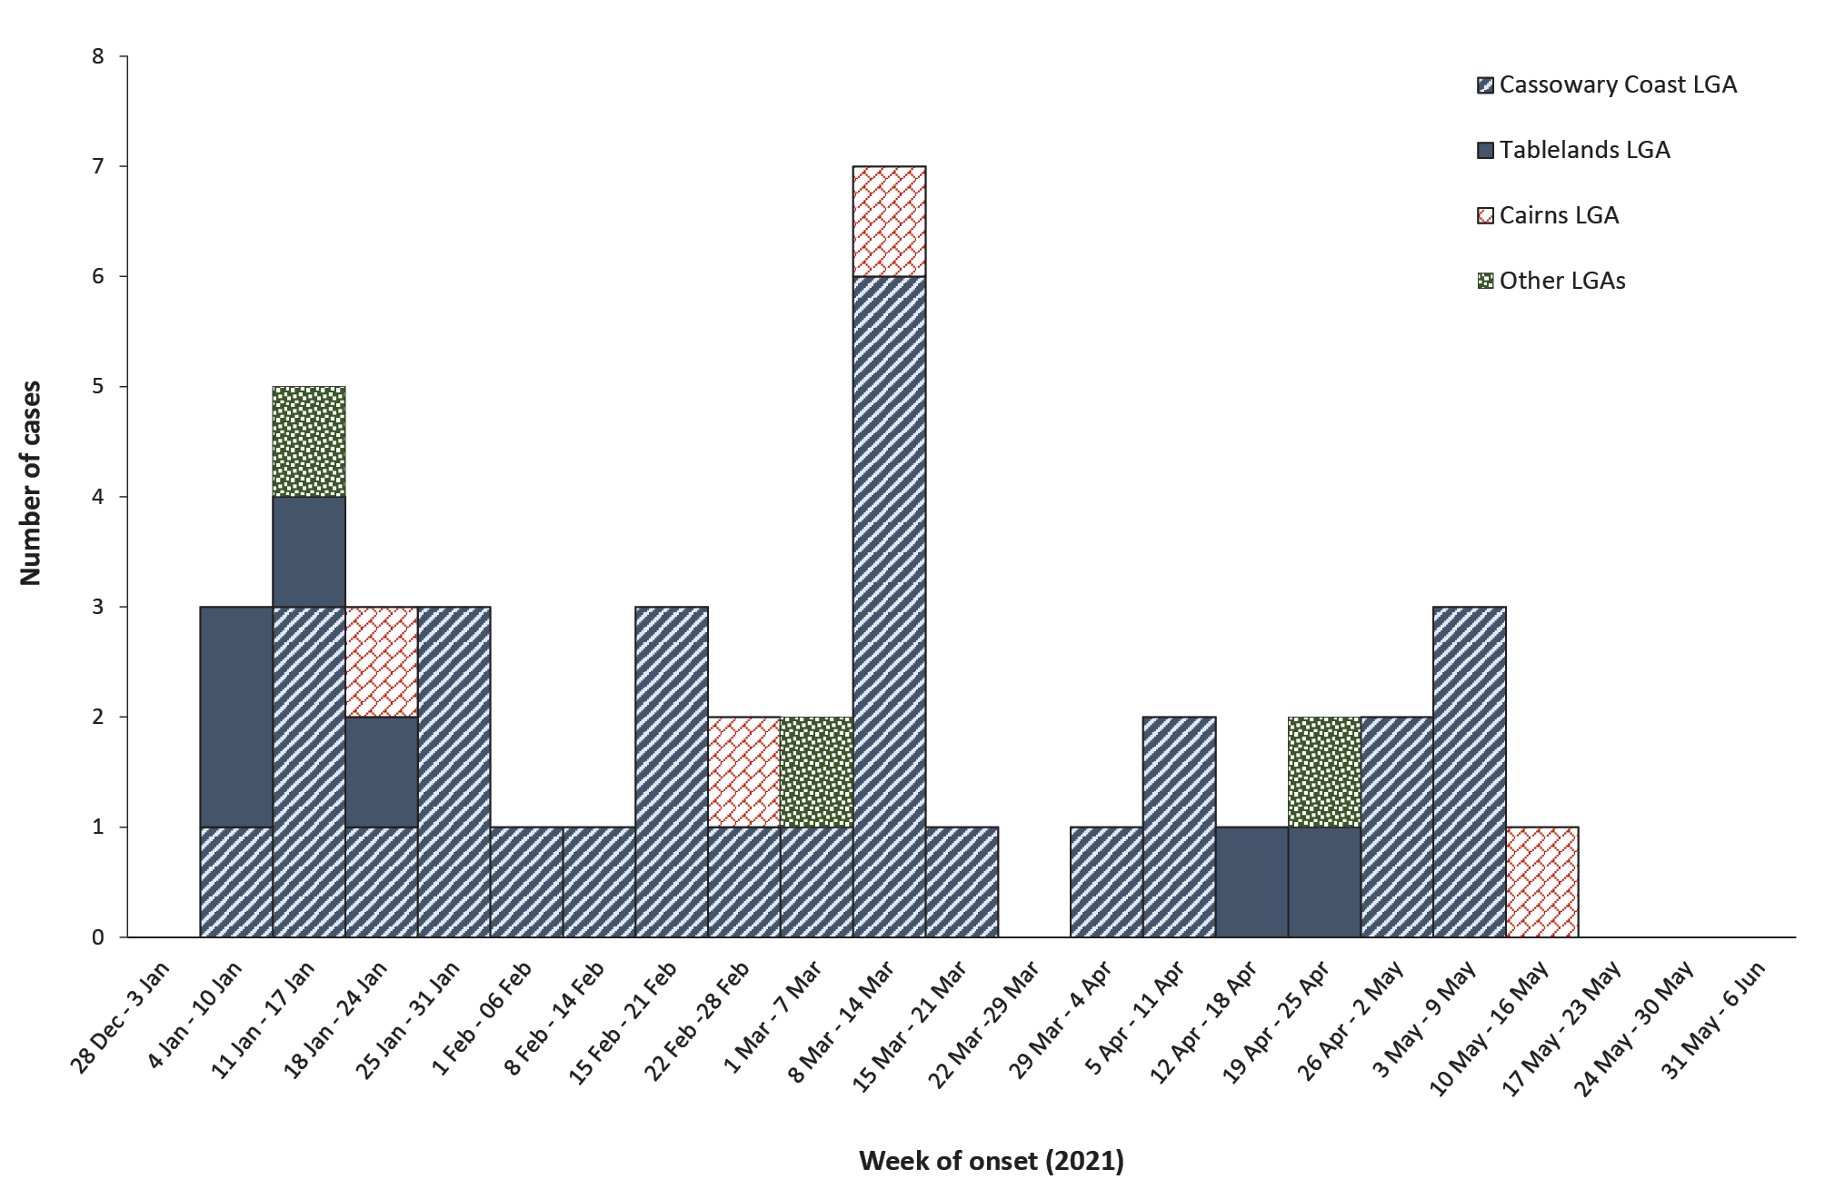
a LGA: Local Government Area.
Figure 3: Selected LGAsª and weather stations in the Cairns region
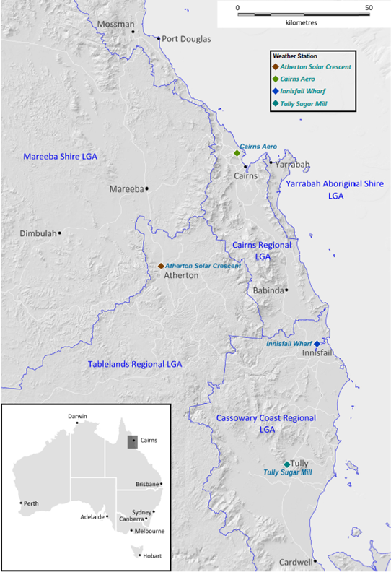
a Local Government Area.
The crude annual notification rate of confirmed and probable leptospirosis cases for the CHHHS region was 39.0 per 100,000 population during the investigation period, compared to a mean notification rate of 26.5 per 100,000 population during the same months for the prior five-year period. The crude annual notification rate of confirmed leptospirosis cases for the CHHHS region during the investigation period was 30.8 notifications per 100,000 population, compared to 1.6 per 100,000 population across Australia during the same period.

Demographic characteristics
The distribution of cases by age, sex and LGA of residence was consistent with leptospirosis notifications received in the prior ten-year comparison period (Table 1). First Nations people accounted for 20.9% of leptospirosis cases during the 2021 investigation period, compared to 8.2% of cases during the comparison period (p < 0.01).
Table 1: Characteristics of leptospirosis cases, January to May 2021 and prior 10-year comparison period
 | 2021  (January to May) |  | 2011-2020  (January to May) |  | p-value
Sex
Male | 42 | 97.7% | 262 | 89.1% | 0.08
Female | 1 | 2.3% | 32 | 10.9% | 0.08
Other / unknown | 0 | 0.0% | 0 | 0.0% | —
Total | 43 | 100.0% | 294 | 100.0%
Age
< 18 years | 5 | 11.6% | 33 | 11.2% | 0.94
18–29 years | 18 | 41.9% | 103 | 35.0% | 0.38
30–39 years | 6 | 14.0% | 48 | 16.3% | 0.70
40–49 years | 4 | 9.3% | 41 | 13.9% | 0.41
50–59 years | 4 | 9.3% | 39 | 13.3% | 0.46
> 59 years | 6 | 14.0% | 30 | 10.2% | 0.45
Total | 43 | 100.0% | 294 | 100.0%
Median age (range) | 29 years | (13-69 years) | 33 years | (4-80 years) | 0.63
First Nations people
First Nations people | 9 | 20.9% | 24 | 8.2% | < 0.01ª
Non First Nations people | 34 | 79.1% | 270 | 91.8%
Total | 43 | 100.0% | 294 | 100.0%
Country of birth^{b}
Australia | 28 | 65.1% | — |  | —
Pacific Islands | 5 | 11.6% | — |  | —
Europe | 5 | 11.6% | — |  | —
New Zealand | 2 | 4.7% | — |  | —
India | 2 | 4.7% | — |  | —
Other | 1 | 2.3% | — |  | —
Total | 43 | 100.0% | n/a
Local Government Area (LGA) of residence
Cassowary Coast | 30 | 69.8% | 175 | 59.5% | 0.20
Tablelands | 6 | 14.0% | 34 | 11.6% | 0.65
Cairns | 4 | 9.3% | 54 | 18.4% | 0.14
Other^{c} | 3 | 7.0% | 31 | 10.5% | 0.48
Total | 43 | 100.0% | 294 | 100.0%
a This field meets the criterion for a statistically significant difference between 2021 and the comparison period.
b Country of birth data is not presented for the comparison period due to very low rates of completion.
c Other LGAs in the CHHHS region include Mareeba, Douglas, Etheridge and Yarrabah.

Clinical presentation
All 43 leptospirosis cases for the 2021 investigation period presented to an emergency department at a Queensland public hospital and had clinical information available within The Viewer. Clinical notes revealed that two cases (4.7%) made a prior presentation to a general practitioner, while 41 cases (95.3%) presented directly to a hospital emergency department. A total of 40 cases (93.0%) presented to regional hospitals and three cases (7.0%) to a tertiary referral hospital. Cases accounted for a total of 50 hospital presentations, with 36 cases (83.7%) presenting once and seven cases (16.3%) presenting a second time on the same or following day.
The median length of stay (LoS) for all cases admitted to hospital was two days (range 0–6 days). A total of 30 cases (30/43, 69.8%) were admitted for at least one overnight stay (LoS ≥ 1 day); nine cases (9/43, 20.9%) were admitted to a bed for a short period before discharge (LoS = 0 day); and four cases (4/43, 9.3%) were treated and discharged from the emergency department (no LoS). A total of 8/40 cases (20.0%) were transferred from a regional hospital to a tertiary referral hospital during their stay, including two by air ambulance and six by road ambulance. Four cases were admitted to an intensive care unit (ICU) for treatment (4/43, 9.3% of all cases). No deaths were reported.
A symptom onset date was available for 42 cases (42/43, 97.7%), with median onset two days prior to first hospital presentation (range 0–7 days). Presenting signs and symptoms were available for all 43 cases, with fever (40/43; 93.0%), headache (32/43; 74.4%) and myalgia (30/43; 69.8%) the most frequently reported (Table 2).
Table 2: Presenting leptospirosis signs and symptoms, Cairns region, January to May 2021
Sign or symptomª | Number | % | Sign or symptomª | Number | %
Fever | 40 | 93.0% | Sweats | 5 | 11.6%
Headache | 32 | 74.4% | Calf tenderness | 4 | 9.3%
Myalgia | 30 | 69.8% | Sore throat | 4 | 9.3%
Chills | 21 | 48.8% | Dizziness | 4 | 9.3%
Nausea | 20 | 46.5% | Thirst | 3 | 7.0%
Fatigue | 13 | 30.2% | Shortness of breath | 3 | 7.0%
Vomiting | 13 | 30.2% | Runny nose | 3 | 7.0%
Diarrhoea | 12 | 27.9% | General malaise | 3 | 7.0%
Cough | 11 | 25.6% | Rash | 2 | 4.7%
Arthralgia | 7 | 16.3% | Conjunctival suffusion | 2 | 4.7%
Chest pain | 7 | 16.3% | Bilateral flank pain | 2 | 4.7%
Abdominal pain | 5 | 11.6% | Shoulder pain | 2 | 4.7%
Photophobia | 5 | 11.6%
Total cases |  |  |  | 43 | 100%
a Frequency of signs and symptoms reported by ≥ 2 cases.

Table 3: Leptospirosis exposure sources in the Cairns region, January to May 2021
Exposure type | Exposure source | Number | %
Occupational | Banana farm exposure | 25 | 58.1%
 | Cattle contact | 4 | 9.3%
 | Other occupational | 4 | 9.3%
Recreational | Swimming in freshwater creeks | 3 | 7.0%
 | Fishing | 3 | 7.0%
 | Other recreational | 1 | 2.3%
Unknown | Not recorded | 3 | 7.0%
Total |  | 43 | 100.0%

Exposure sources
A presumed leptospirosis exposure source was recorded in clinical notes for 40 cases (40/43; 93.0%), with the majority exposed occupationally while working on banana farms (25/43; 58.1%) (Table 3). Comparison data for leptospirosis exposures in the CHHHS region during prior years were not available.
Clinical notes suggest that at least five cases (5/43; 11.6%) reported a prior leptospirosis infection and evidence of a previous Queensland notification was located in NOCS for two of these cases. At least four cases (4/43; 9.3%) reported recent travel within Australia. Prior infection and travel data were not recorded consistently in clinical notes to support further analysis. Geospatial mapping of cases by residential address suggested a clustering of cases exposed to banana farms during January and February in the Tully area, and during March in the Innisfail area; however, no other clustering by residential address and exposure source was identified.

Rainfall
Rainfall in parts of the Cairns region during the 2021 investigation period was much wetter than usual in January, February and April, and much drier than usual during March (Table 4). In addition to the annual monsoon trough, heavy rainfall during January and February was due to the presence of four tropical cyclones in and around North Queensland. An overlay of daily rainfall and the distribution of leptospirosis cases in the Tully and Innisfail areas, where most cases occurred, did not suggest a strong relationship between infections and periods following heavy or prolonged rainfall (see Appendix A, Figures A.1 and A.2).
Table 4: Monthly rainfall in 2021 compared to 2011-2020 mean, by geographical area
 | January | February | March | April | May
Cairns  (Cairns LGA) | Wetter  p < 0.05 | Similar  p = 0.22 | Similar  p = 0.48 | Wetter  p < 0.001 | Similar  p = 0.13
Tully  (Cassowary Coast LGA) | Wetter  p < 0.001 | Wetter  p < 0.001 | Drier  p < 0.01 | Wetter  p < 0.001 | Similar  p = 0.05
Innisfail  (Cassowary Coast LGA) | Wetter  p < 0.001 | Wetter  p < 0.05 | Drier  p < 0.05 | Wetter  p < 0.001 | Similar  p = 0.29
Atherton  (Tablelands LGA) | Similar  p = 0.83 | Similar  p = 0.07 | Drier  p < 0.01 | Wetter  p < 0.001 | Drier  p < 0.001

Infecting serovars
Infecting serovars were identified for 5/43 cases (11.6%), with four cases infected with serovar Australis and one with serovar Zanoni. No similar case characteristics or exposure sources were identified among the cases infected with serovar Australis.
In order to better understand reasons for the low serovar detection rate, laboratory results by test type and collection timeframe were reviewed for each case (Table 5). Of the 24 cases with serum collected for acute IgM/MAT testing, only two (2/24, 8.3%) were collected at least 7 days from onset as recommended by guidelines. Of the 11 cases with convalescent MAT testing undertaken, seven (7/11, 63.6%) were collected at least 14 days after collection of the acute MAT specimen as recommended by guidelines.
Table 5: Leptospirosis laboratory test results
 | Tests (n) | Tests (%) | Positive (n) | Positive (%)
PCR (serum)
˂ 7 days from onset (recommended)ª | 36 | 92.3% | 36 | 100.0%
≥ 7 days from onset | 3 | 7.7% | 1 | 33.3%
Total with PCR result | 39 | 100.0% | 37 | 94.9%
Culture (blood)
≤ 10 days from onset (recommended)ª | 31 | 93.9% | 30 | 96.7%
> 10 days from onset | 2 | 6.1% | 2 | 100.0%
Total with culture result | 33 | 76.7% | 32 | 97.0%
Acute IgM (serum)^{b}
˂ 7 days from onset | 21 | 87.5% | 7 | 33.3%
≥ 7 days from onset (recommended)ª | 2 | 8.3% | 2 | 100.0%
Unknown timeframe | 1 | 4.2% | 1 | 100.0%
Total with acute IgM result | 24 | 100.0% | 10 | 41.7%
 | Tests (n) | Tests (%) | Infecting serovar identified (n) | Infecting serovar identified (%)
Acute MAT (serum)^{c}
< 7 days from onset | 7 | 70.0% | 1 | 14.3%
≥ 7 days from onset (recommended)ª | 2 | 20.0% | 0 | 0.0%
Unknown timeframe | 1 | 10.0% | 0 | 0.0%
Total with acute MAT result | 10 | 100.0% | 1 | 10.0%
Convalescent MAT (serum)
< 14 days from acute MAT | 4 | 36.4% | 0 | 0.0%
≥ 14 days from acute MAT (recommended)ª | 7 | 63.6% | 4 | 57.1%
Total with convalescent MAT result | 11 | 100.0% | 4 | 40.0%
a Timeframe recommended by Queensland Health Leptospirosis Guidelines for Public Health Units.⁷
b Does not include non-reactive acute Immunoglobulin M (IgM) specimens that were micro-agglutination titre (MAT) tested in parallel with convalescent specimens.
c All positive acute IgM specimens were MAT tested.

Discussion

Outbreak identification
The criterion for declaring a community outbreak of leptospirosis in Queensland is the presence of two or more epidemiologically linked confirmed cases with a suspected local source of exposure.⁷ While this investigation identified some clustering of cases by residential address, time and exposure source, only limited information about possible case exposure sites and workplace locations was available from patient clinical records. Very few cases were contacted for case interviews during the investigation period, as local public health staff were almost exclusively deployed to COVID-19 contact tracing and outbreak preparation throughout 2021. Ultimately, the lack of case interview information prohibited the identification of any clear epidemiological links between individual cases; investigators were unable to confirm the presence or absence of a leptospirosis outbreak.
The ability to identify an outbreak was further hampered by the low serovar detection rate, with infecting serovars identified for only five cases, four of them serovar Australis and one serovar Zanoni. In North Queensland, both serovars are carried by rodents, small marsupials and feral pigs, with Zanoni also carried by dairy cattle.^{18,19} Both serovars have previously accounted for the majority of infections in the local region and both are associated with severe disease.^{12,20,21}
The detection of infecting serovars is currently reliant on Leptospira MAT testing, with identification requiring either a fourfold or greater rise in MAT between acute and convalescent phase sera or a positive IgM and a single Leptospira MAT ≥ 400 without cross-reacting serovars producing similar titres.⁷ The challenges in leptospirosis laboratory diagnosis, timing of specimen collection and serovar detection are well documented;² however, the systematic early collection of serum, along with suboptimal rates of serum collection for any IgM/MAT testing, resulted in an extremely low serovar detection rate among cases included in this investigation. While serovar identification is of particular public health importance, it has little clinical relevance and confirmatory convalescent serology is rarely required clinically if Leptospira have already been detected by PCR.
Recent developments in genomic sequencing of pathogenic Leptospira suggest the potential for infecting serovars to be identified by nucleic acid testing in future, a possibility welcomed by public health services to help improve the timely detection of outbreaks.²² A probable leptospirosis case definition for cases detected by nucleic acid testing was recently added to the Australian surveillance case definition, bringing national reporting for leptospirosis with that in place for Queensland since 2011. While the addition will support increased detection and monitoring of leptospirosis at the national level, the move may compromise serovar identification in some regions if accompanied by an increased reliance on PCR testing and a corresponding decrease in serology testing.
Local pathways are required in North Queensland to improve the collection of case exposure sources and the identification of infecting serovars, particularly during periods of increased case numbers or suspected outbreaks. Ideally, attempts should be made by local public health services to interview all notified leptospirosis cases and to facilitate the collection of convalescent serology. Consideration should also be given to mechanisms that enhance local clinical practices, such as: increased public health liaison with local clinicians about the importance of collecting convalescent serology; the routine documentation of specific case exposure sites by hospital clinicians; and improving Queensland Health leptospirosis specimen collection recommendations.⁷

Factors associated with the increase in cases
Males accounted for 97.7% of cases, and 82.5% of leptospirosis infections were acquired occupationally during this investigation. These findings align with the known epidemiology of leptospirosis as predominantly an occupational disease affecting males in agricultural industries.^{12,23} The 58.1% rate of exposure to banana farms was somewhat higher than reported elsewhere in the literature;^{9,12} however, this likely reflects the local agricultural industry, with almost half of Queensland’s bananas grown in the Far North Queensland region.²⁴ First Nations people were found to be over-represented in case numbers in 2021. This may have been due to an increase in local First Nations people working in agricultural occupations during the COVID-19 pandemic when Australian borders were closed. The pandemic may also have led to an increase in leptospirosis testing for people presenting to hospital with febrile illness and testing negative to COVID-19 during the investigation period; however, changes in leptospirosis testing rates were not analysed as part of this investigation.
Strict biosecurity measures are in place on all banana farms in the Cairns region to prevent the spread of Panama disease, a serious fungal disease of bananas that permanently destroys plantations.²⁵ These measures include disinfecting machinery, equipment, vehicles and footwear before entry to farms, as well as limitations on the movement of farm machinery; the extent to which adherence to these measures might impact leptospirosis acquisition among banana workers is not known. While some biosecurity measures may reduce human exposure to soil contaminated with Leptospira, recent increases in the culling of feral pig populations to prevent the spread of panama spores may alter future Leptospira transmission dynamics between feral pigs, rodents and humans, a matter which warrants ongoing surveillance.
Clinical presentation and severity of the cases included in this investigation appeared in line with the published epidemiology of leptospirosis in Australia. The hospitalisation rate of 69.8% was generally higher than that described elsewhere, though rates between 32% and 100% have been previously reported in Australia.^{4,11,12,26} The 9.3% of cases admitted to ICU was consistent with that previously found in the region and approximated the 10% of infections which progress to severe leptospirosis.¹ There were no case fatalities during the investigation period, with Cairns Hospital reporting some of the lowest leptospirosis fatality rates in the world among cases with severe disease.²⁰
This investigation found a median symptom onset just two days prior to hospital presentation. While previous campaigns delivered by TPHS to the banana and dairy industries have highlighted the importance of seeking early treatment for leptospirosis (with delayed treatment previously correlated with the development of severe disease),²¹ it is now more than ten years since a targeted local campaign was delivered. Given worker turnover and the seasonal nature of these industries, state and local commitment to the ongoing delivery of leptospirosis public health campaigns will help retain local leptospirosis awareness in high-risk industries.
The Cassowary Coast area south of Cairns receives the highest annual rainfall in Australia. The presence of four tropical cyclones in and around the coast during early 2021 saw the region record some of the wettest months on record. While the investigation did not identify any factors that were clearly associated with the increase in cases, it is likely that high rainfall and localised flooding played some role, with moist conditions supporting Leptospira survival in the environment, and with flood waters dispersing organisms across a wide local geography. Climate modelling for Far North Queensland suggests the region will experience higher temperatures, more intense heavy rainfall, and less frequent but more intense tropical cyclones, which may increase the frequency and magnitude of future leptospirosis outbreaks in the region.⁶ Strong public health surveillance systems are paramount.

Limitations
There were a number of limitations to this investigation, many of which arose from the limited availability of enhanced surveillance information during both the investigation and comparison periods. The inability to collect this information from case interviews meant the investigation was reliant on clinician documented exposure sources which may have introduced bias towards known high-risk occupations without due consideration for the full range of potential case exposures. There was also a reliance on residential addresses; however, many infections were likely acquired elsewhere. A review of notifications for strict adherence with the case definition undertaken for the investigation period was not performed for previous year comparison periods. Finally, a degree of detection bias was likely present, as no notifications were received for cases who did not present to hospital.

Conclusion
Leptospirosis remains a neglected tropical disease of public health importance in Far North Queensland. The suspension of most case interviews during the investigation period, due to COVID-19 contact tracing and outbreak preparation, resulted in limited availability of case exposure site information. In addition to a low serovar detection rate, this hampered the ability for this investigation to identify a leptospirosis outbreak. While heavy rainfall in early 2021 is likely to have contributed to the spike in cases, no factors were found to be clearly associated with the increase. Pathways to improve collection of case exposure sources and the identification of infecting serovars will strengthen the detection of future outbreaks and the monitoring of changes in leptospirosis epidemiology across the Cairns region.

Acknowledgement
We thank Dr Scott Craig and Craig Thompson for their advice which informed our interpretation of leptospirosis laboratory test results and the identification of infecting serovars, and Di Brooks for her guidance early in the investigation. Caroline Taunton is supported by a Master of Philosophy (Applied Epidemiology) scholarship through the Burnet Institute and the Australian National University.

Author details
Caroline Taunton,^{1,2,3}
Carol El Hayek,^{3,4,5}
Dr Emma Field,²
Sally Rubenach,¹
Juliet Esmonde,¹
Dr Simon Smith,⁶
Dr Annie Preston-Thomas.¹
- Tropical Public Health Services, Cairns, Queensland, Australia.
- Research School of Population Health, Australian National University, Canberra, Australian Capital Territory, Australia.
- Disease Elimination, Burnet Institute, Melbourne, Victoria, Australia.
- Melbourne School of Population and Global Health, University of Melbourne, Melbourne, Victoria, Australia.
- School of Public Health and Preventive Medicine, Monash University, Melbourne, Australia.
- Department of Medicine, Cairns Hospital, Cairns, Queensland, Australia.

Corresponding Author
Dr Annie Preston-Thomas
Tropical Public Health Services, Cairns and Hinterland Hospital and Health Service, Level 7, 5b Sheridan Street, Cairns Qld 4870.
Phone: (07) 4226 5555
Email: Annie.Preston-Thomas@health.qld.gov.au

References
- Budihal SV, Perwez K. Leptospirosis diagnosis: competancy of various laboratory tests. J Clin Diagn Res. 2014;8(1):199-202. doi: https://doi.org/10.7860/JCDR/2014/6593.3950.
- Tulsiani SM, Lau CL, Graham GC, Van Den Hurk AF, Jansen CC, Smythe LD et al. Emerging tropical diseases in Australia. Part 1. Leptospirosis. Ann Trop Med Parasitol. 2010;104(7):543–56. doi: https://doi.org/10.1179/136485910X12851868779867.
- Lau CL, Townell N, Stephenson E, van den Berg D, Craig SB. Leptospirosis: An important zoonosis acquired through work, play and travel. Aust J Gen Pract. 2018;47(3):105–10. doi: https://doi.org/10.31128/AFP-07-17-4286.
- Smith JKG, Young MM, Wilson KL, Craig SB. Leptospirosis following a major flood in Central Queensland, Australia. Epidemiol Infect. 2013;141(3):585–90. doi:https://doi.org/10.1017/S0950268812001021.
- Wright H, Goot K, Rogers B. Spirochaetes and sunshine: leptospirosis in the aftermath of the Queensland floods. Med J Aust. 2012;196(8):500–2. doi: https://doi.org/10.5694/mja12.10046.
- Lau CL, Smythe LD, Craig SB, Weinstein P. Climate change, flooding, urbanisation and leptospirosis: fuelling the fire? Trans R Soc Trop Med Hyg. 2010;104(10):631–8. doi: https://doi.org/10.1016/j.trstmh.2010.07.002.
- Queensland Health. Leptospirosis. Queensland Health Guidelines for Public Health Units. [Internet.] Brisbane: Queensland Government, Queensland Health; 7 August 2017. [Accessed on 30 August 2021.] Available from: https://www.health.qld.gov.au/cdcg/index/lepto.
- Chawla V, Trivedi TH, Yeolekar ME. Epidemic of leptospirosis: an ICU experience. J Assoc Physicians India. 2004;52:619–22.
- Lau CL, Skelly C, Dohnt M, Smythe LD. The emergence of Leptospira borgpetersenii serovar Arborea in Queensland, Australia, 2001 to 2013. BMC Infect Dis. 2015;15:230. doi: https://doi.org/10.1186/s12879-015-0982-0.
- Lau C, Smythe L, Weinstein P. Leptospirosis: an emerging disease in travellers. Travel Med Infect Dis. 2009;8(1):33–9. doi: https://doi.org/10.1016/j.tmaid.2009.12.002.
- Katelaris AL, Glasgow K, Lawrence K, Corben P, Zheng A, Sumithra S et al. Investigation and response to an outbreak of leptospirosis among raspberry workers in Australia, 2018. Zoonoses Public Health. 2020;67(1):35–43. doi: https://doi.org/10.1111/zph.12652.
- Smythe L, Dohnt M, Symonds M, Barnett L, Moore M, Brookes D et al. Review of leptospirosis notifications in Queensland and Australia: January 1998 – June 1999. Commun Dis Intell. 2000;24(6):153–7.
- Australian Government Department of Health and Aged Care. Leptospirosis – Surveillance case definition. [Internet.] Canberra: Australian Government Department of Health and Aged Care; 12 March 2004. [Accessed on 22 July 2021.] Available from: https://www.health.gov.au/resources/publications/leptospirosis-surveillance-case-definition.
- Australian Government Bureau of Meterology (BoM). Climate Data Online. [Webpage.] Melbourne: BoM; 2021. [Accessed on 24 August 2021.] Available from: http://www.bom.gov.au/climate/data/.
- Queensland Health Statistical Services Branch. InfoBank - Demography. [Intranet site.] Brisbane: Queensland Government, Queensland Health; 8 January 2021. [Accessed on 8 October 2021.] Available from: https://qheps.health.qld.gov.au/hsu/infobank/infobank-demography#estimated.
- Australian Government Department of Health and Aged Care. National Notifiable Diseases Surveillance System (NNDSS) fortnightly reports – 21 June to 4 July 2021. Canberra: Australian Government Department of Health and Aged Care; 4 July 2021. [Accessed on 21 July 2021.] Available from: https://www.health.gov.au/resources/publications/nndss-fortnightly-report-21-june-4-july-2021.
- Australian Bureau of Statistics. National, state and territory population. Reference period: March 2021. [Internet.] Canberra: Australian Bureau of Statistics; 16 September 2021. [Accessed on 4 October 2021.] Available from: https://www.abs.gov.au/statistics/people/population/national-state-and-territory-population/mar-2021.
- Queensland Health. What is Leptospirosis. [Internet.] Brisbane: Queensland Government, Queensland Health; 11 September 2020. [Accessed on 1 September 2021.] Available from: https://www.health.qld.gov.au/public-health/forensic-and-scientific-services/testing-analysis/disease-investigation-and-analysis/leptospirosis-reference-laboratory/what-is-leptospirosis.
- Heise-Pavlov PM, Heise-Pavlov SR. Feral pigs in tropical lowland rainforest of northeastern Australia: ecology, zoonoses and management. Wildlife Biol. 2003;9(4):21–7. doi: https://doi.org/10.2981/wlb.2003.060.
- Smith S, Liu YH, Carter A, Kennedy BJ, Dermedgoglou A, Poulgrain SS et al. Severe leptospirosis in tropical Australia: optimising intensive care unit management to reduce mortality. PLoS Negl Trop Dis. 2019;13(12):e0007929. doi: https://doi.org/10.1371/journal.pntd.0007929.
- Smith S, Kennedy BJ, Dermedgoglou A, Poulgrain SS, Paavola MP, Minto TL et al. A simple score to predict severe leptospirosis. PLoS Negl Trop Dis. 2019;13(2):e0007205. doi: https://doi.org/10.1371/journal.pntd.0007205.
- Vincent AT, Schiettekatte O, Goarant C, Neela VK, Bernet E, Thibeaux R et al. Revisiting the taxonomy and evolution of pathogenicity of the genus Leptospira through the prism of genomics. PLoS Negl Trop Dis. 2019;13(5):e0007270. doi: https://doi.org/10.1371/journal.pntd.0007270.
- McBride AJA, Athanazio DA, Reis MG, Ko AI. Leptospirosis. Curr Opin Infect Dis. 2005;18(5):376–86. doi: https://doi.org/10.1097/01.qco.0000178824.05715.2c.
- Australian Banana Growers Council (ABGC). Key Facts: The Australian Banana Industry. [Internet.] Brisbane: ABGC; 2018. [Accessed on 12 November 2021.] Available from: https://abgc.org.au/our-industry/key-facts/.
- Queensland Government Department of Agriculture and Fisheries. Panama disease. [Internet.] Brisbane: Queensland Government Department of Agriculture and Fisheries; 1 September 2021. [Accessed on 12 October 2021.] Available from: https://www.daf.qld.gov.au/business-priorities/biosecurity/plant/eradication-surveillance-control/panama-disease.
- Trubiano JA, Sutton BA, Franklin LJ. The look of leptospirosis in Victoria — recent trends. Med J Aust. 2013;199(7):465. doi: https://doi.org/10.5694/mja13.10089.

Appendix A: Supplementary data
Figure A.1: Leptospirosis cases in 2021 in the Tully area, with local daily rainfall overlay
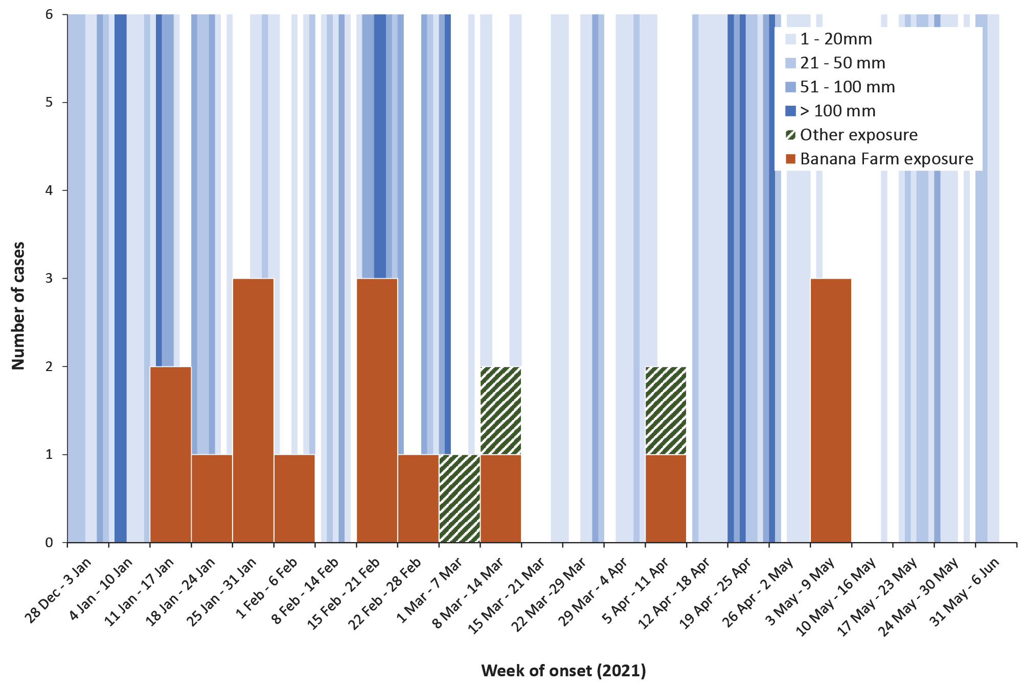
Figure A.2: Leptospirosis cases in 2021 in the Inisfail area, with local daily rainfall overlay
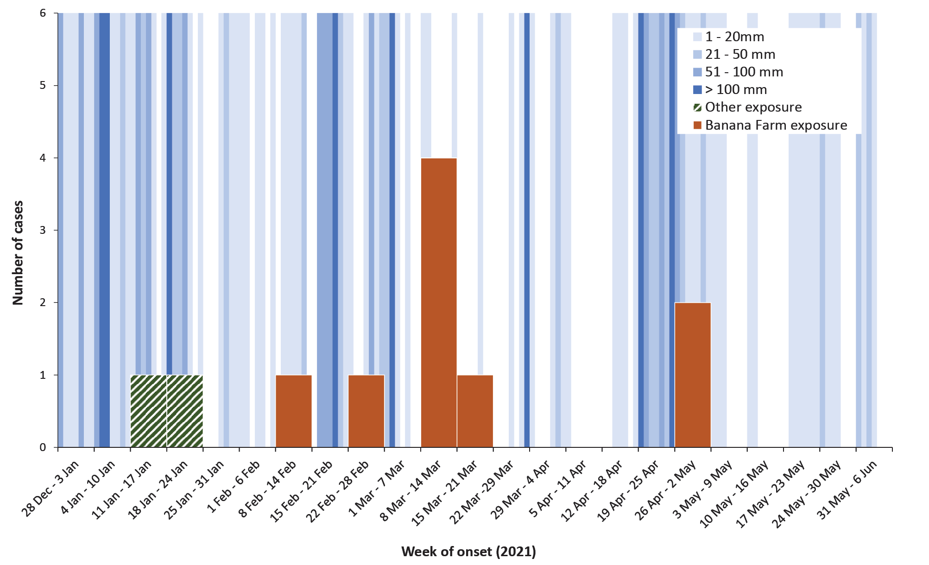

Communicable Diseases Intelligence
ISSN: 2209-6051 Online

Communicable Diseases Intelligence (CDI) is a peer-reviewed scientific journal published by the Office of Health Protection and Response, Department of Health and Aged Care. The journal aims to disseminate information on the epidemiology, surveillance, prevention and control of communicable diseases of relevance to Australia.

Editor: Noel Lally
Deputy Editor: Simon Petrie
Design and Production: Kasra Yousefi
Editorial Advisory Board: David Durrheim, Mark Ferson, John Kaldor, Martyn Kirk and Linda Selvey

Website: http://www.health.gov.au/cdi

Contacts
CDI is produced by the Office of Health Protection and Response, Australian Government Department of Health and Aged Care, GPO Box 9848, (MDP 6) CANBERRA ACT 2601

Email: cdi.editor@health.gov.au

Submit an Article
You are invited to submit your next communicable disease related article to the Communicable Diseases Intelligence (CDI) for consideration. More information regarding CDI can be found at: http://health.gov.au/cdi.
Further enquiries should be directed to: cdi.editor@health.gov.au.

This journal is indexed by Index Medicus and Medline.

Creative Commons Licence - Attribution-NonCommercial-NoDerivatives CC BY-NC-ND
© 2022 Commonwealth of Australia as represented by the Department of Health and Aged Care
This publication is licensed under a Creative Commons Attribution-NonCommercial-NoDerivatives 4.0 International Licence from https://creativecommons.org/licenses/by-nc-nd/4.0/legalcode (Licence). You must read and understand the Licence before using any material from this publication.

Restrictions
The Licence does not cover, and there is no permission given for, use of any of the following material found in this publication (if any):
- the Commonwealth Coat of Arms (by way of information, the terms under which the Coat of Arms may be used can be found at www.itsanhonour.gov.au);
- any logos (including the Department of Health and Aged Care’s logo) and trademarks;
- any photographs and images;
- any signatures; and
- any material belonging to third parties.

Disclaimer
Opinions expressed in Communicable Diseases Intelligence are those of the authors and not necessarily those of the Australian Government Department of Health and Aged Care or the Communicable Diseases Network Australia. Data may be subject to revision.

Enquiries
Enquiries regarding any other use of this publication should be addressed to the Communication Branch, Department of Health and Aged Care, GPO Box 9848, Canberra ACT 2601, or via e-mail to: copyright@health.gov.au

Communicable Diseases Network Australia
Communicable Diseases Intelligence contributes to the work of the Communicable Diseases Network Australia.
http://www.health.gov.au/cdna

https://www.health.qld.gov.au/clinical-practice/innovation/digital-health-initiatives/queensland/the-viewer.

