Queensland typhoid cluster linked to twelve-year carriage of Salmonella Typhi
Marguerite Dalmau, Shuo Meng Song, Megan Young, Stephen Lambert, Rikki Graham, Gino Micalizzi, Emma Field, Robert Bell, Amy V Jennison, Russell Stafford

Abstract
In September 2021, a household cluster of three typhoid cases was investigated by Queensland public health authorities. Through case interviews and molecular typing, the investigation revealed chronic carriage of Salmonella Typhi persisting at least 12 years in the index case. This case report summarises the investigation and highlights the complexity of chronic pathogen carriage in the control and management of typhoid disease. Our findings raise considerations for prevention and treatment guidelines in Australia and demonstrate the beneficial role of molecular typing for complex case investigations.
Keywords: typhoid; Salmonella; chronic carriage; S. Typhi

Background
Typhoid, a disease of the gastrointestinal tract, is caused by the bacterium Salmonella enterica subspecies enterica serovar Typhi ( Salmonella Typhi). ¹ This bacterium is spread via the faecal-oral route, predominately transmitted through the ingestion of contaminated food or water. ² Clinically, typhoid can present as asymptomatic infection or mild disease, through to a severe multisystem disease that can be life-threatening. ¹ Most people with typhoid will recover with appropriate treatment. Some fail to clear the infection and progress to be carriers, intermittently shedding S. Typhi in their faeces. ³ There are three categories of typhoid carriage, classified by the duration of shedding: convalescent (between three weeks and three months); temporary (three to twelve months); and chronic (greater than twelve months). ³ Approximately 2–5% of people diagnosed with typhoid progress to chronic carriage. ⁴ For chronic persistence of S . Typhi, the organism must evade innate immune-mediated killing responses; must breach the intestinal epithelial barrier; and must localise to a permissive niche, such as the gallbladder, or less commonly, the urinary tract.^{3,4}
Typhoid is a notifiable condition in all Australian jurisdictions. ² In Queensland, typhoid is notified by laboratories upon isolation or detection of S. Typhi from any clinical specimen. ⁵ There are, on average (2015–2019), 25 sporadic cases of S . Typhi notified per year in Queensland. ⁶ These arise directly or indirectly from international importation from a variety of locations. Genetic distances between the isolates of approximately 500–800 single nucleotide polymorphisms (SNPs) are typically observed. All confirmed cases are followed up by the local public health unit (PHU). Typhoid is rare in Australia and is generally identified in travellers entering or returning to Australia from endemic areas.²

Case report

Case investigation
On 21 September 2021, a typhoid notification was reported to Queensland Health for a hospitalised 11-year-old male. The notification was based on the laboratory confirmed evidence of positive bacterial culture and serological typing of S. Typhi from faecal and blood specimens. The case had presented with fever, malaise, diarrhoea, vomiting, and headache. Screening activities were undertaken for household contacts; S . Typhi was isolated by culture in the faecal specimens of a symptomatic seven-year-old female (sister) and a 39-year-old female (mother) who was asymptomatic. The cases had no recent history of overseas travel, no contact with a recent confirmed typhoid case, and no other risk factors of note.
Further investigation revealed the mother had previously been diagnosed with an acute episode of typhoid in 2009 in Queensland. During the 2009 investigation, recent overseas travel to Northern Africa—with exposure to untreated water while travelling—was identified as the likely source of acquisition. At the time of diagnosis in 2009, the mother was in her third trimester of pregnancy and treated with amoxycillin for two weeks. Two follow-up stool specimens, taken two months apart, were culture negative for S . Typhi. Further overseas travel to Northern Africa was noted in 2017 for the mother.
Ethics approval was not sought for this investigation as all activities were conducted as part of the standard response under the Queensland Public Health Act 2005.⁷

Laboratory investigation
The Queensland Public Health Microbiology Laboratory performed whole genome phylogenetic analysis to assess genetic relatedness of the three 2021 and the 2009 isolates. This was undertaken in the context of previously-sequenced S. Typhi isolates and publicly available sequences of the same multilocus sequence type (MLST), ST3677. These isolates originated from a range of countries, mostly in Europe. Sequences were generated using the Illumina NextSeq genome sequencing platform. The 2021 isolates demonstrated a high degree of similarity to each other with 0–1 SNPs difference ( Figure 1 ). The 2009 isolate was less genetically similar, demonstrating 5–6 SNPs difference from the 2021 isolates. In contrast, the publicly available unrelated ST3677 sequences were 24–64 SNPs different. In line with published literature on the adaptation of S. Typhi to its host environment during carriage, ³ the level of genetic similarity between the 2009 and 2021 isolates was deemed suggestive of a chronic carriage event with relapse, rather than acquisition of a new infection with subsequent transmission in 2021.

Figure 1: Phylogenetic analysis of S. Typhi isolates received by the Queensland Public Health Microbiology Laboratory^{a,b}
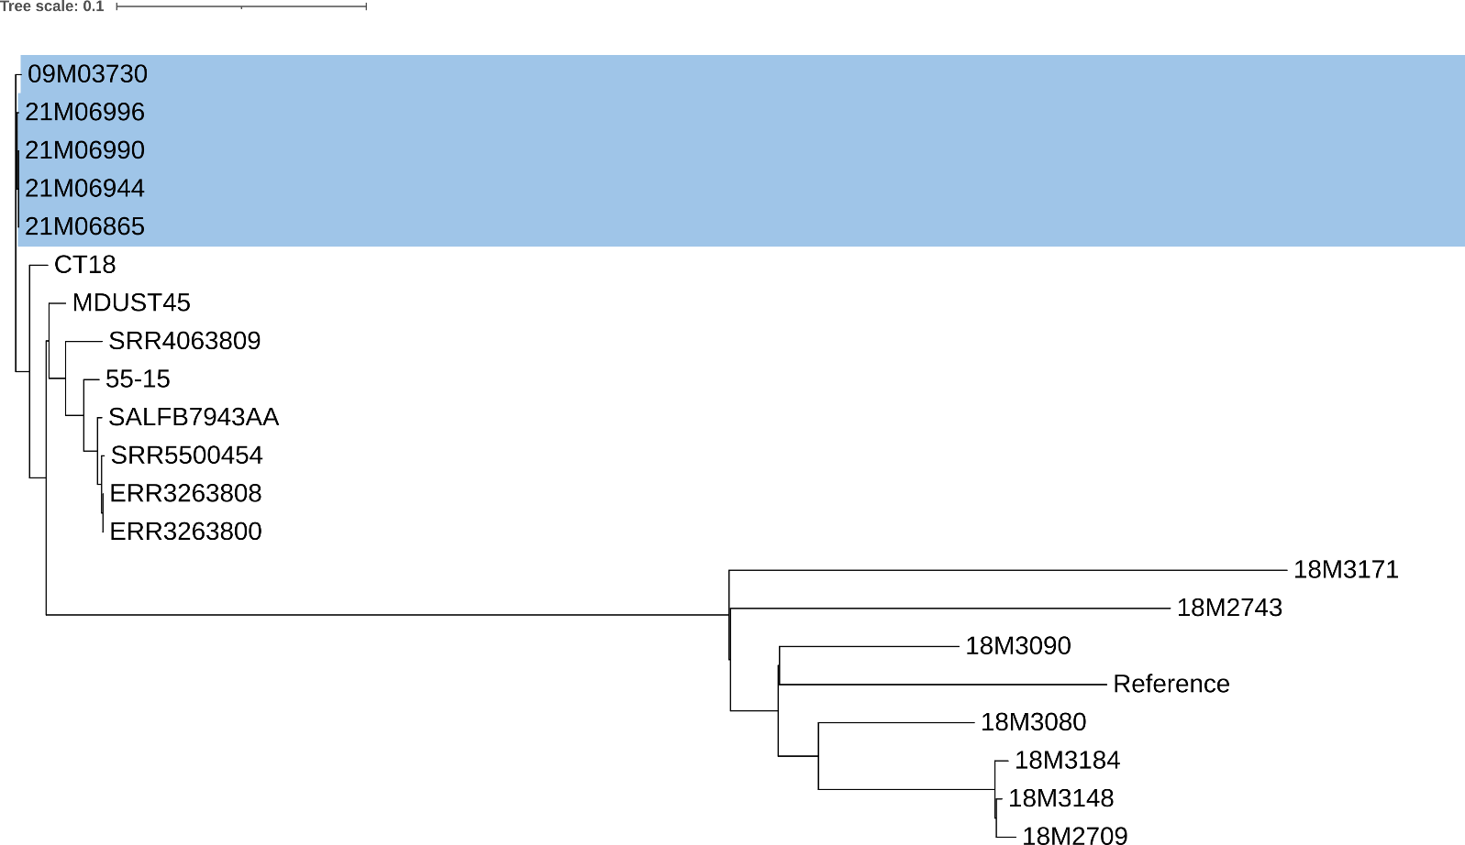
a Maximum likelihood tree built using SNP differences. The cluster including the recent isolates is highlighted in blue (isolates commencing with 21M are those collected in 2021, 09M03730 was collected in 2009). There are four 2021 isolates as two specimens were processed from one case (21M6865, 21M6944).
b The length of branches represents distance between groups as indicated by the scale bar.

Public health response
Public health guidelines ² were followed by the local PHU. No evidence of typhoid fever vaccination was recorded for any of the cases.
Confirmed cases received antibiotic treatment and were excluded from work or school settings until 48 hours after resolution of symptoms. Hygiene education was provided for all cases and for household and household-like contacts. Stool samples were requested for all household and household-like contacts. Other than the three cases discussed above, all specimens were polymerase chain reaction (PCR) negative for S . Typhi. The mother, once identified as a chronic carrier, was referred to an infectious diseases physician (IDP) for management. The mother provided two clearance samples, at least 48 hours after cessation of antibiotic therapy and at least 48 hours apart, which were PCR and culture negative for S. Typhi. The mother was cleared by the IDP without recommendation for cholecystectomy.

Discussion
This case study highlights the complexity of S. Typhi chronic carriage in the management and control of typhoid. The index case in the 2021 typhoid cluster returned two culture negative faecal specimens, more than two months apart, following an acute episode of typhoid in 2009. This met the clearance criteria according to Queensland public health guidelines at the time. ⁸ Culture sensitivity to assess for S . Typhi is 30% in faecal specimens, < 1% in urine specimens, and relies on testing during a period of bacterial shedding. ⁹ Sensitivity is reported to be higher in more invasive specimens: up to 80% in blood cultures of untreated patients and 40% in those treated, and > 80% in bone marrow aspirate culture. ⁹ Nucleic acid amplification tests of blood specimens have reported sensitivities consistent with blood culture, with some studies reporting clinically suspected typhoid cases that are PCR positive and blood culture negative. ⁹ In the absence of highly sensitive clearance tests, clinicians should consider chronic carriage in the differential diagnosis process for any typhoid case. Currently, the evolution of S. Typhi within the gallbladder is poorly understood, as is duration of carriage. ^{3,4} Some chronic carriers have been found to periodically excrete bacteria in their stools and urine for decades. ¹⁰ The disease progression of this cluster, in the context of the sensitivity of faecal culture and duration of chronic carriage, raises the question of the rigour required for establishing clearance.
Typhoid vaccination recommendations relevant to this cluster include vaccination for children ≥ 2 years and adults travelling to typhoid-endemic regions,¹¹ and for household contacts of chronic carriers.² The former requires individuals to seek and self-fund travel-specific vaccinations; the latter requires detection of chronic carriage and likely self-funding of vaccination. This cluster highlights the difficulty of the latter in that, in the presence of compliant clearance specimens, disease transmission is required to identify a chronic carrier.
Current public health guidelines recommend referral to an infectious diseases physician for treatment in cases of chronic carriage. ² This is because current recommended antimicrobial therapy is not always effective against the persistence of typhoidal Salmonella. ¹⁰ Treatment for chronic carriage can include combination or extended antibiotic therapy, depending on susceptibility of the organism, or cholecystectomy if there are indications for surgical intervention.⁹
An important element highlighted by this case study was the role of molecular typing in distinguishing possible sources of infection. Prior to the whole genome phylogenetic analysis of the 2009 and 2021 isolates, more recent acquisition of infection and household spread was considered, particularly given overseas travel in 2017 and negative clearance stool samples in 2009. Whole genome sequencing continues to advance our ability to understand and define enteric pathogen epidemiology. In the last twenty years, whole genomic sequencing of S . Typhi strains has contributed to increased understanding of disease pathogenicity, host adaption, and antimicrobial resistance. ¹² Increased collection of strain provenance information, including the identification of acute or chronic carrier status, is important to better define the differences between healthy individuals and asymptomatic carriers.¹²

Author details
Mrs Marguerite Dalmau ^{1,2}
Ms Shuo Meng Song ³
Dr Megan Young ^{3,4}
Dr Stephen Lambert ^{1,2,5}
Dr Rikki Graham ⁶
Mr Gino Micalizzi ⁶
Dr Emma Field ²
Mr Robert Bell ⁷
A/Prof. Amy V Jennison ⁶
Dr Russell Stafford ⁷
- Communicable Diseases Branch, Department of Health, Queensland Health, Brisbane.
- National Centre for Epidemiology and Population Health, The Australian National University, Canberra.
- Metro North Public Health Unit, Metro North Health, Queensland Health, Brisbane.
- School of Medicine and Dentistry, Griffith University, Gold Coast.
- National Centre for Immunisation Research and Surveillance, Westmead.
- Molecular Epidemiology Public Health Microbiology and Queensland Public Health and Infectious Diseases Reference Genomics (Q-PHIRE Genomics), Forensic and Scientific Services, Queensland Health.
- OzFoodNet, Communicable Diseases Branch, Department of Health, Queensland Health, Brisbane.

Corresponding author
Marguerite Dalmau
Telephone: (07) 3328 9724
Email: meg.dalmau@health.qld.gov.au

References
- Queensland Government. Typhoid and Paratyphoid Fever. [Internet.] Brisbane: Queensland Government; 9 April 2018. [Accessed on 12 November 2021.] Available from: http://conditions.health.qld.gov.au/HealthCondition/condition/14/33/146/typhoid-and-paratyphoid-fever.
- Australian Government Department of Health. Typhoid and Paratyphoid Fevers: CDNA National Guidelines for Public Health Units. [Internet.] Canberra: Australian Government Department of Health; 15 March 2017. [Accessed on 12 November 2021.] Available from: https://www1.health.gov.au/internet/main/publishing.nsf/Content/cdna-song-typhoid-paratyphoid.htm.
- Thanh Duy P, Thieu NTV, Nguyen Thi Nguyen T, Ngoc Dan Thanh H, Dongol S, Karkey A et al. Gallbladder carriage generates genetic variation and genome degradation in Salmonella Typhi. PLoS Pathog . 2020;16(10):e1008998. doi: https://doi.org/10.1371/journal.ppat.1008998.
- Gunn JS, Marshall JM, Baker S, Dongol S, Charles RC, Ryan ET. Salmonella chronic carriage: epidemiology, diagnosis, and gallbladder persistence. Trends Microbiol. 2014;22(11):648–55. doi: https://doi.org/10.1016/j.tim.2014.06.007.
- Queensland Health. Typhoid and Paratyphoid (Enteric Fever). Notification procedure. [Internet.] Brisbane: Queensland Government, Queensland Health; 7 November 2014. [Accessed on 12 November 2021.] Available from: https://www.health.qld.gov.au/cdcg/index/typhoid#np.
- Queensland Health. Notifiable conditions annual reporting. [Internet.] Brisbane: Queensland Government, Queensland Health; 2021. [Accessed on 12 November 2021.] Available from: https://www.health.qld.gov.au/clinical-practice/guidelines-procedures/diseases-infection/surveillance/reports/notifiable/annual.
- Queensland Government. Public Health Act 2005 . [Legislation.] Brisbane: Queensland Government; 9 September 2021. [Accessed on 12 November 2021.] Available from: https://www.legislation.qld.gov.au/view/pdf/inforce/current/act-2005-048.
- Queensland Health. Communicable Disease Control Manual: Typhoid and paratyphoid (enteric fever). Brisbane: Queensland Government; 2005.
- Crump JA, Sjolund-Karlsson M, Gordon MA, Parry CM. Epidemiology, clinical presentation, laboratory diagnosis, antimicrobial resistance, and antimicrobial management of invasive Salmonella infections. Clin Microbiol Rev . 2015;28(4):901–37. doi: https://doi.org/10.1128/CMR.00002-15.
- Gal-Mor O. Persistent infection and long-term carriage of typhoidal and nontyphoidal Salmonellae . Clin Microbiol Rev . 2019;32(1). doi: https://doi.org/10.1128/CMR.00088-18.
- Australian Government Department of Health. Australian Immunisation Handbook: Typhoid fever. [Internet.] Canberra: Australian Government Department of Health; 1 June 2018. [Accessed on 15 November 2021.] Available from: https://immunisationhandbook.health.gov.au/vaccine-preventable-diseases/typhoid-fever.
- Yap KP, Thong KL. Salmonella Typhi genomics: envisaging the future of typhoid eradication. Trop Med Int Health . 2017;22(8):918–25. doi: https://doi.org/10.1111/tmi.12899.

Communicable Diseases Intelligence
ISSN: 2209-6051 Online

Communicable Diseases Intelligence (CDI) is a peer-reviewed scientific journal published by the Office of Health Protection and Response, Department of Health. The journal aims to disseminate information on the epidemiology, surveillance, prevention and control of communicable diseases of relevance to Australia.

Editor: Noel Lally
Deputy Editor: Simon Petrie
Design and Production: Kasra Yousefi
Editorial Advisory Board: David Durrheim, Mark Ferson, John Kaldor, Martyn Kirk and Linda Selvey

Website: http://www.health.gov.au/cdi

Contacts
CDI is produced by the Office of Health Protection and Response, Australian Government Department of Health, GPO Box 9848, (MDP 6) CANBERRA ACT 2601

Email: cdi.editor@health.gov.au

Submit an Article
You are invited to submit your next communicable disease related article to the Communicable Diseases Intelligence (CDI) for consideration. More information regarding CDI can be found at: http://health.gov.au/cdi.
Further enquiries should be directed to: cdi.editor@health.gov.au.

This journal is indexed by Index Medicus and Medline.

Creative Commons Licence - Attribution-NonCommercial-NoDerivatives CC BY-NC-ND
© 2022 Commonwealth of Australia as represented by the Department of Health
This publication is licensed under a Creative Commons Attribution-NonCommercial-NoDerivatives 4.0 International Licence from https://creativecommons.org/licenses/by-nc-nd/4.0/legalcode (Licence). You must read and understand the Licence before using any material from this publication.

Restrictions
The Licence does not cover, and there is no permission given for, use of any of the following material found in this publication (if any):
- the Commonwealth Coat of Arms (by way of information, the terms under which the Coat of Arms may be used can be found at www.itsanhonour.gov.au);
- any logos (including the Department of Health’s logo) and trademarks;
- any photographs and images;
- any signatures; and
- any material belonging to third parties.

Disclaimer
Opinions expressed in Communicable Diseases Intelligence are those of the authors and not necessarily those of the Australian Government Department of Health or the Communicable Diseases Network Australia. Data may be subject to revision.

Enquiries
Enquiries regarding any other use of this publication should be addressed to the Communication Branch, Department of Health, GPO Box 9848, Canberra ACT 2601, or via e-mail to: copyright@health.gov.au

Communicable Diseases Network Australia
Communicable Diseases Intelligence contributes to the work of the Communicable Diseases Network Australia.
http://www.health.gov.au/cdna

A/Prof Amy V Jennison, personal communication, March 2022.
Bioproject accession: PRJNA785009.

