Household transmission of COVID-19 in 2020 in New South Wales, Australia
Anna A Sordo, Andrew Dunn, Evangeline RK Gardiner, Tracie A Reinten, Tracy SF Tsang, Lucy Deng, Bette C Liu

Abstract
Households are high-risk settings for the transmission of severe acute respiratory syndrome coronavirus 2 (SARS-CoV-2). This study examines factors associated with transmission among cases diagnosed with coronavirus disease 2019 (COVID-19) and their household contacts, in New South Wales (NSW), Australia, during July–October 2020.
A register of all laboratory-confirmed COVID-19 cases was used to extract demographic and clinical information for cases and household contacts. Secondary attack rates (SARs) among household members were calculated and generalised estimating equations were used to estimate risks of transmission in relation to various characteristics of the primary case and the household contacts.
In total, 229 households were included; they consisted of 229 primary cases and 659 close contacts. The overall household SAR was 22.5% (148/659). After adjusting for symptoms, age and sex of primary case, spouse status of household contacts and household size, the odds of secondary transmission were lower in primary cases who were asymptomatic at diagnosis than in symptomatic cases (odds ratio, OR: 0.13; 95% confidence interval (95% CI): 0.04–0.48); and higher in primary cases aged 60 years and over than in those aged 19–39 years (OR: 3.45; 95% CI: 1.53– 7.75). Being a spouse of the primary case was also associated with increased transmission compared to non-spouses (OR: 1.93; 95% CI: 1.24–3.02). After adjustments, there was no significant effect on transmission of the primary case’s sex, or of the number of people in the household.
This study documents demographic and clinical characteristics that increase transmission rates in households in the period prior to the introduction of SARS-CoV-2 variants. These data can be used as a baseline from which to compare household transmission in outbreaks dominated by new variants.
Keywords: Coronavirus, SARS-CoV-2, household, transmission, secondary, attack

Introduction
Households are considered high-risk settings for the transmission of severe acute respiratory syndrome coronavirus 2 (SARS-CoV-2), the virus that causes coronavirus disease 2019 (COVID-19). To limit the spread of COVID-19 in the community in Australia, in 2020, cases diagnosed with COVID-19 and their close contacts were required to isolate or quarantine for 14 days after their last exposure to a case, and to get tested at least once during this period.¹ In the Australian state of New South Wales (NSW), in most circumstances, quarantine of community-acquired cases has occurred at home. Therefore, understanding the factors that may increase secondary transmission within a household setting becomes important for developing strategies for intervention and prevention. The secondary attack rate (SAR) is often used as a measure of person-to-person transmission and is a good estimate of the likelihood of transmission within a household setting.²
A meta-analysis of 87 household transmission studies, with more than 1.24 million participants from October 2020 to June 2021, reported that the SAR for symptomatic cases was substantially higher than that for asymptomatic cases (20.2% vs 3.0%) and transmission was higher in adult contacts than in children (29.9% vs 17.5%). It also showed that households with one contact have a higher SAR than those with three or more (35.5% vs 21.2%). However, this meta-analysis had notable heterogeneity across studies in the estimate of SAR (I² = 99.4%: p < 0.01).³
Identifying and quantifying the risk factors associated with transmission in a household setting is important when considering intervention strategies such as: the need for mask-wearing; household environmental cleaning; or the prompt removal of cases from the household setting to a centralised health facility where isolation can be managed. This retrospective cohort study aims to quantify demographic and clinical factors that may be associated with increased household transmission from cases diagnosed with laboratory-confirmed COVID-19 in NSW, Australia. As this study was also conducted in the period prior to potentially-more-transmissible variants of SARS-CoV-2, the findings can also provide a baseline from which to compare household transmission associated with more-transmissible variants.

Methods

Population and data sources
This study used data extracted from the NSW Notifiable Conditions Information Management System (NCIMS) infectious disease database. This is a register of all people who have a disease notifiable under the NSW Public Health Act 2010,⁴ and includes those who have been tested for COVID-19 in NSW. The database is used for surveillance, monitoring and the public health management of COVID-19. It collects sociodemographic, testing and specimen details on all individuals tested for COVID-19. A confirmed COVID-19 case is defined as an individual with a laboratory-confirmed SARS-CoV-2 infection determined by polymerase chain reaction (PCR) or immunoglobulin G (IgG) seroconversion or a fourfold or greater increase in a SARS-CoV-2 antibody of any subclass in acute or convalescent sera.¹ For all confirmed cases, additional demographic and clinical information is collected as well as information on their close contacts.
For this study, all cases classified as having confirmed COVID-19 (based on a positive PCR test between 1 July and 31 October 2020) and their close contacts were extracted from NCIMS. Cases that were determined by serology alone were not included in this study. To ensure capture of all household members, cases and close contacts had their residential address geocoded first. They were then manually checked to ensure addresses matched and the type of residence met inclusion criteria (see below). Close contacts were considered to be part of the same household if they had the same address as the case. Households were included in the study if they consisted of at least two people and if all cases were locally acquired: that is, the source of their infection was from within NSW. In addition, the residential address had to be a domestic residence or dwelling or group of dwellings with a shared kitchen or common opening onto a shared household space. Residential institutions, such as boarding schools, dormitories, hostels or prisons were not included (see Figure 1).
The primary case within a household was considered as the case with the earliest reported onset of COVID-19. For symptomatic cases, the earliest reported onset of COVID-19 was defined by their symptom onset date, whereas for asymptomatic cases it was defined by their first positive test date. Cases who were asymptomatic at the time of their first positive test were considered asymptomatic regardless of whether they went on to develop symptoms. Secondary cases were defined when a household contact became a confirmed COVID-19 case and had a symptom onset or diagnosis 2–14 days after the onset date of COVID-19 in the primary case. Households were further excluded if there was more than one case in the household but the primary case could not be determined and co-exposure could not be excluded; that is, if there was less than two calendar days between the case with the earliest reported onset in the household and subsequent cases.
This study was conducted as part of public health surveillance under the NSW Public Health Act 2010,⁴ and as such no ethics approval was required.
Figure 1: Flow chart showing how cases and household contacts were included in the final analysis
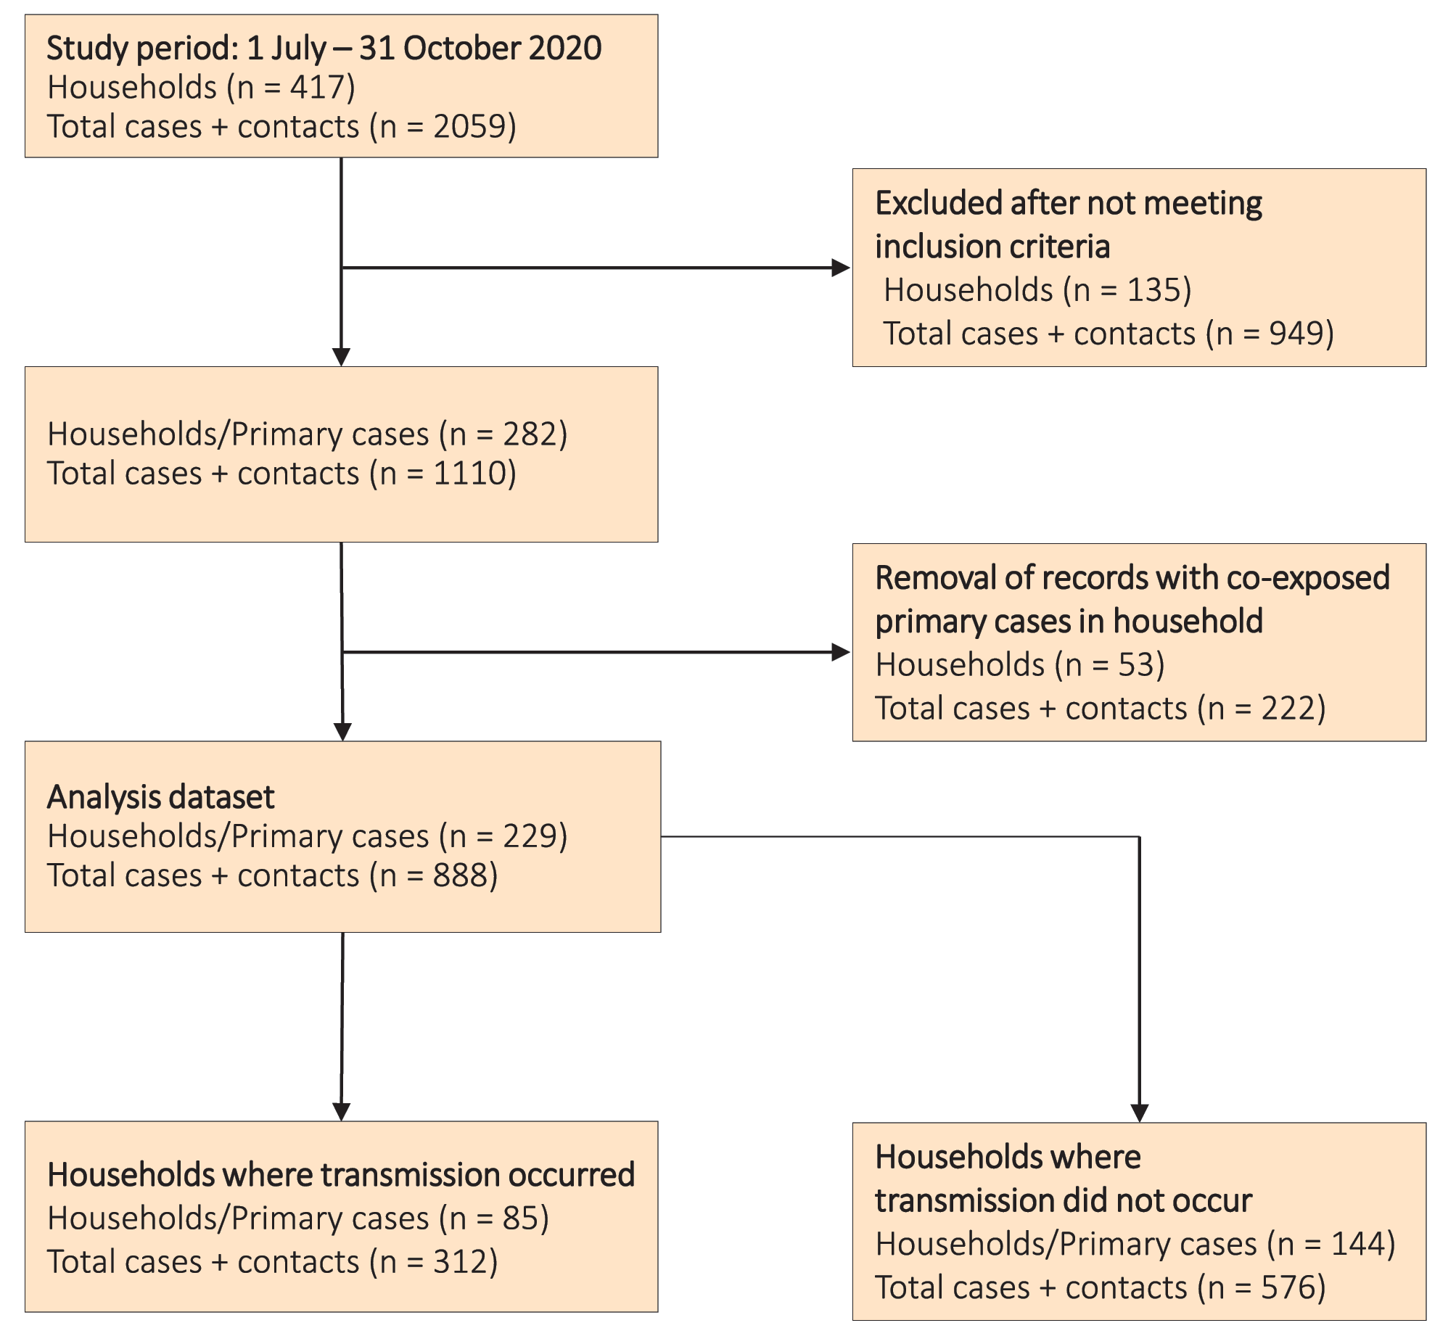

Analysis
The characteristics examined in analyses were based on those reported in the NCIMS. To estimate the association between the characteristics of the cases, their household contacts and secondary infection, we used generalised estimating equations with a logit link function and exchangeable correlation function to account for the correlations within households. A p value less than 0.05 suggested evidence of association. The characteristics examined included: in the primary case, whether they were symptomatic or not, their age (in categories of 0–18,19–39, 40–49, 50–59, and 60+ years), and sex; in the household contacts, their age, and among the adult contacts if they were the spouse of the primary case (defined if any person had been named as a “spouse”, “wife”, “husband” or “partner” in their NCIMS records); and the number of people in the household (2, 3–4, 5+). Crude and adjusted odds ratios (OR), their 95% confidence intervals (95% CI), and p-values were calculated.

Results

Study cohort
From 1 July 2020 to 31 October 2020, there were 2,059 locally-acquired cases and close contacts identified. Through the geocoding and subsequent checking of case and contact residential address, these individuals were classified into 417 households. Of these, 135 households (with 949 cases and contacts) were excluded. The most common reason for exclusion of households from analysis was that there was only one person in the household (n = 75). Other households were excluded because they were duplicate records, or because the case was in hotel quarantine. Contacts were also excluded because they were geocoded to an apartment block common to identified cases but found to not be in the same household as the case. A further 53 households (with 222 cases and contacts) were excluded as the primary case could not be distinguished (i.e. the earliest reported onset date between cases was within 2 days and therefore co-exposure could not be excluded). The final analysis dataset therefore consisted of 229 households with 888 individuals (see Figure 1).
In the 229 included households, the median number of people in a household was 4 (range 2–10). The median age of primary cases was 36 years (range 2–93 years) with a higher proportion of females (57.2%) than males. No primary cases were removed from their household to alternate accommodation prior to their infectious period. Across the 229 households, there was a total of 659 household contacts with a median age of 28 years (range 0–94 years). Transmission occurred in 85/229 (37.1%) of the households; of the 659 household contacts, 148 were later diagnosed with COVID-19, giving an overall SAR of 22.5%.

Secondary attack rate among household contacts
Table 1 shows the overall SAR according to demographic and clinical characteristics of the primary case and the household contacts. Symptomatic primary cases were more likely to transmit than were asymptomatic cases (SAR 25.3% vs 3.5%), as were females than were males (SAR 26.0% vs 17.2%). The SAR also increased with increasing age of the primary case (SAR 12.2% in those aged 0–18 years, 22.4% in those aged 40–49 years, 49.3% in those aged 60+ years; see Table 1 for other age groups). Among household contacts, the SARs were higher among those who were the spouses of primary cases than among non-spouse household contacts (SAR 39.1% vs 17.7%) The SARs were also higher in 2-person households (SAR 43.3%) than in 3–4 person households (SAR 24.7%) or in those with 5 or more people (SAR 17.5%).

Multivariate analysis of factors associated with household transmission
Figure 2 shows the multivariate analysis estimating the likelihood of transmission to a household contact, according to sociodemographic and clinical characteristics of the primary case and the household. After adjustment, primary cases who were asymptomatic at diagnosis had significantly lower odds of transmission than did symptomatic cases (adjusted OR: 0.13; 95% CI: 0.04–0.48). Primary cases aged 60 years and over had significantly higher odds of transmission to a household contact than did primary cases aged 19–39 years (adjusted OR: 3.45; 95% CI: 1.53–7.75), and there was a significant trend showing an increasing likelihood of transmission with increasing age of the primary case (𝜒² = 39.9; p < 0.001). After adjustments, there was also a trend towards reduced risk of transmission with increasing household size (𝜒²=17.8, p < 0.001).
Adult household contacts who were spouses of the primary case had significantly higher odds of infection than did adult contacts who were not a spouse (adjusted OR: 1.93; 95% CI: 1.24–3.02) and this pattern was consistent when the adult contacts were sub-grouped by age (see Appendix Table 1). After adjustments, there was no significant effect of the primary case’s sex on likelihood of household transmission, although the odds ratio was still substantially lower for men than for women (adjusted OR: 0.64; 95%CI: 0.37–1.10).
Table 1: Secondary attack rate (SAR) in households based on characteristics of the primary case and the household
 | Number of primary cases | Number of secondary cases | Total secondary contacts | SAR (%)
General household transmission rate
Overall transmission | 229 | 148 | 659 | 22.5
Primary case characteristics
By symptoms
Primary case asymptomatic | 26 | 3 | 85 | 3.5
Primary case symptomatic | 203 | 145 | 574 | 25.3
Age of primary case (years)
0–18 | 32 | 16 | 131 | 12.2
19–39 | 93 | 42 | 245 | 17.1
40–49 | 33 | 24 | 107 | 22.4
50–59 | 34 | 30 | 103 | 29.1
60+ | 37 | 36 | 73 | 49.3
Sex of primary case
Female | 131 | 102 | 392 | 26.0
Male | 98 | 46 | 267 | 17.2
Household contact characteristics and size
Age of household contacts (years)
0–18 |  | 38 | 205 | 18.5
19–39 |  | 43 | 212 | 20.3
40–49 |  | 18 | 86 | 20.9
50–59 |  | 22 | 94 | 23.4
60+ |  | 27 | 61 | 44.3
Spouse status among adults (19+ years)
No spouse |  | 56 | 316 | 17.7
Spouse |  | 54 | 138 | 39.1
Sex of household contacts
Female |  | 69 | 333 | 20.7
Male |  | 79 | 326 | 24.2
Number in household
2 | 60 | 26 | 60 | 43.3
3–4 | 93 | 59 | 239 | 24.7
5+ | 76 | 63 | 360 | 17.5

Figure 2: Adjusted odds ratios for household transmission according to sociodemographic and clinical characteristics

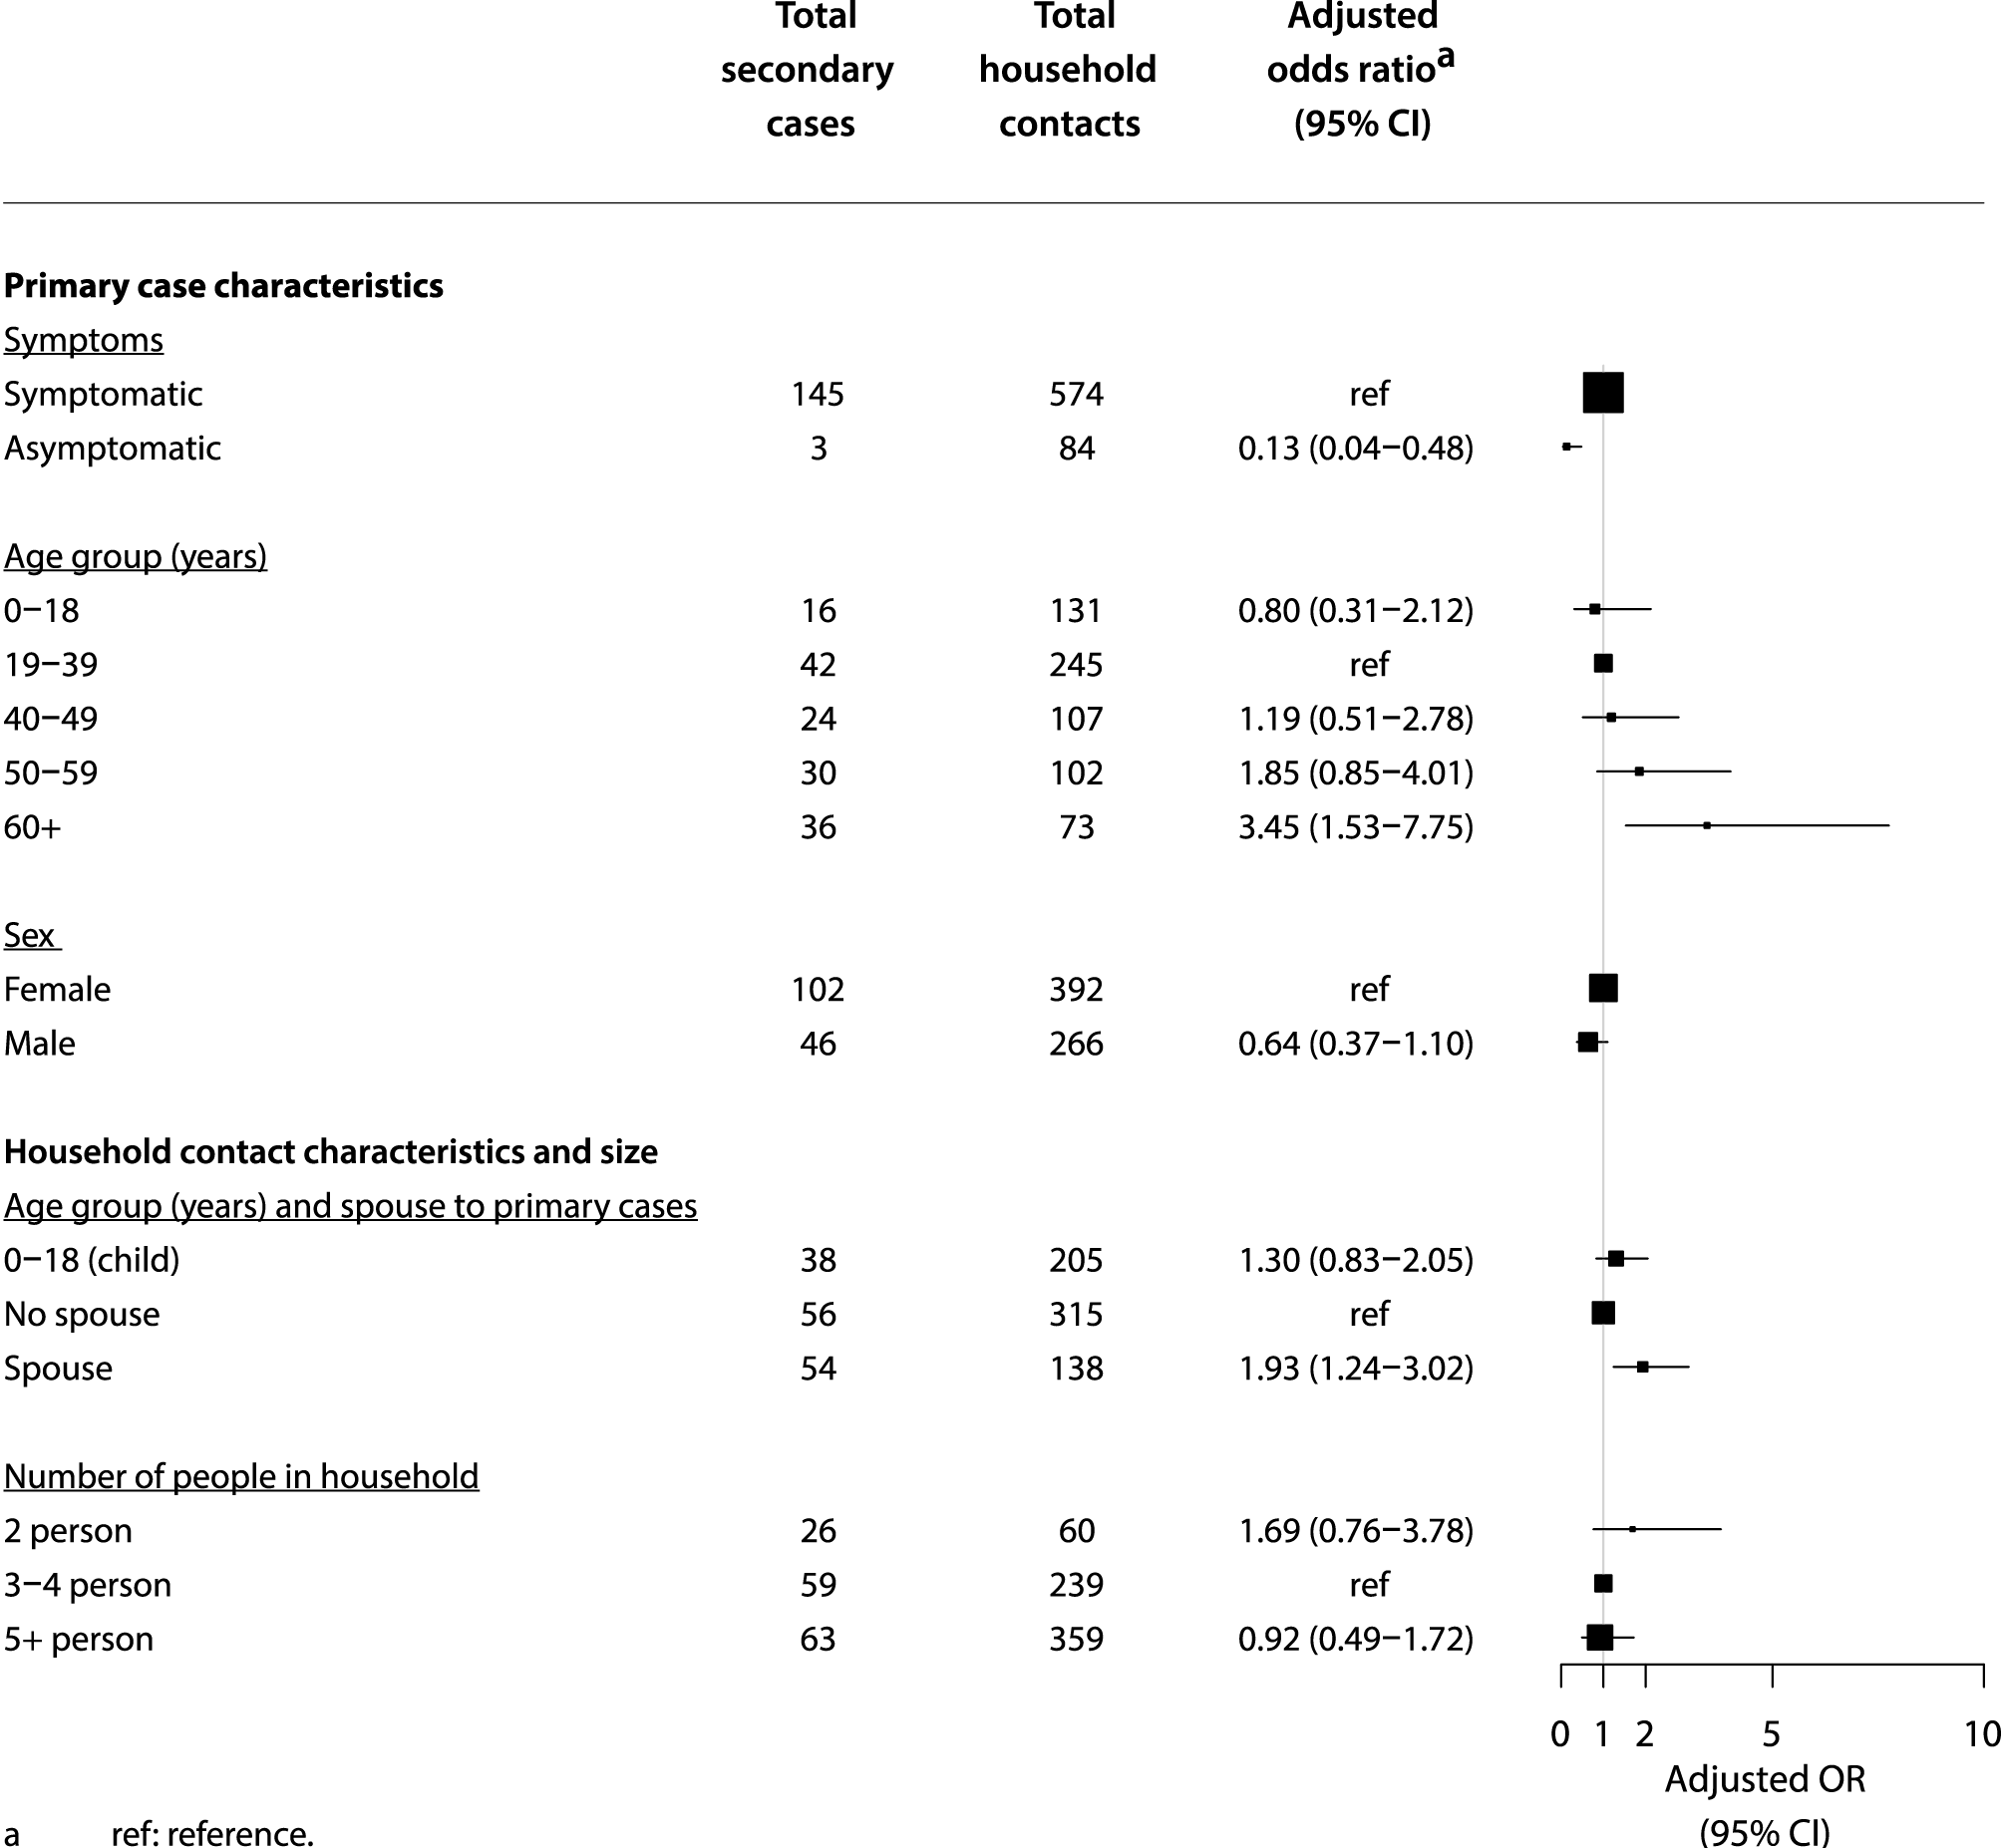

Discussion
This is one of the largest studies of household transmission of COVID-19 in Australia. In total, our analysis included 377 locally-acquired COVID-19 cases in NSW, representing 60.7% of the total cases reported in NSW during this same period. We found that approximately one in every four household contacts of COVID-19 cases became infected. Of the characteristics examined, the most influential on household transmission included whether the primary case was symptomatic or not; the age of the primary case; and whether the household contact was the spouse of the primary case. Our findings support the view that households are a high-risk setting for SARS-CoV-2 transmission.³ The major strength of this study on household transmission in NSW is that it benefits from rigorous data collection standards, a timely and comprehensive contact tracing system, low positivity levels in the community and high testing rates among close contacts.⁵ These factors, along with early identification of cases and close contacts, ensure that we were able to attribute, with a good level of confidence, that the secondary cases acquired their infection in the household rather than through other community exposures.
Our findings regarding household transmission are consistent with other household transmission studies conducted internationally; although notably, our current study was conducted during a period prior to the appearance of more contagious variants of concern.⁶ The aforementioned meta-analysis reported a combined household SAR of 18.9% (95% CI:16.2–22.0%). In relation to household transmission characteristics, several studies have reported that symptomatic primary cases had higher household SARs when compared to asymptomatic or cases.^{3,7–9} This was quantified in the meta-analysis, which showed a higher mean household SAR in symptomatic cases than in asymptomatic cases [(20.2%; 95% CI: 13.9–28.3%) vs (3.0%; 95% CI: 1.7–5.4%) respectively]. Our findings showed lower household SARs among asymptomatic primary cases; however, we were limited by the smaller number of index cases classified as such.
Our study showed that primary cases aged 60 years and over were more likely to transmit to household contacts than were primary cases aged 19–39 years, and that there was a trend to increasing likelihood of transmission with increasing age. Previous studies have found that paediatric primary cases had lower levels of household secondary transmission,^{8,16} with the meta-analysis reporting lower mean levels of secondary transmission in children (17.5%; 95% CI: 12.6–23.7%) than in adults (29.9%; 95% CI: 24.0–36.6%).³ Other studies have also shown that household transmission in adult primary cases is higher than that in younger primary cases.³ Further, adult household contacts also have a higher risk of infection, specifically those aged 60 and over.^{3,9,17–22}
Similar to our findings, a number of studies have reported that the spouse of the primary case is much more likely to become a case than are other household contacts,^{3,9,16,22–25} with the meta-analysis estimating a mean SAR of 39.8% (95% CI: 30.0–50.5%) for spouses compared a mean SAR of 18.3% for other household contacts (95% CI: 12.1–26.7%).³ Studies have also shown that two-person households had higher mean SARs than did households of three or more contacts (35.5%; 95% CI: 26.2–46.2% compared with 21.2%; 95% CI: 14.8–29.4%).³ After adjusting for other factors, we found a significant trend towards increasing risk with smaller household size. However, notably in our study, 78% of two-person households consisted of those with a spouse, therefore the effects seen for two-person households likely relate to those households in spousal relationships. While after adjustments we did not find a difference between men and women in the likelihood of transmission to household members (which is similar to what has been reported in other work),³ the adjusted odds ratio point estimate was 0.64, suggesting that there may still be an association, but we lacked statistical power to show this.
There are challenges in comparing our results to previously-reported studies due to significant heterogeneity among studies. Density of living, testing protocols for close contacts, and primary case definitions vary significantly across studies. For example, several studies in the meta-analysis had tested all household contacts, while other studies tested only symptomatic household contacts.^{3,26} This may account for the higher SAR observed in our study than those included in the meta-analysis. Further, there were variations in the primary case definition within the studies in the meta-analysis, and the management of co-exposed primary cases and of tertiary transmission within households was often not adequately described. For example, some studies classified subsequent cases in a household as secondary cases regardless of timing of symptoms. The meta-analysis also included studies with more-transmissible strains; however, most studies were ancestral. Reassuringly, despite these differences, our results were similar to the pooled estimates from these earlier studies.
The strength of this study is that during July–October 2020 in NSW and until at least November 2021, there has been comprehensive testing of practically all close contacts of cases diagnosed with COVID-19. High testing rates, which have included testing of both asymptomatic and symptomatic contacts, has led to high levels of case ascertainment among household contacts. High case ascertainment in combination with the comparatively low levels of community transmission has allowed us to more confidently attribute secondary infection to the household setting.
This study has a few limitations. Information on the household layout and size, including the number of bathrooms or bedrooms, was not known. We used a cutoff for a secondary transmission event of 14 days, as earlier studies estimated 97.5% of those who develop symptoms do so within 11.5 days of infection.²⁷ However, we cannot be certain that there were no tertiary cases within the 14-day interval. The inadvertent inclusion of tertiary cases would result in slight overestimation of the SAR. A further limitation is the cutoff used to exclude co-exposed cases of less than 2 days. Our modelling approach does not consider the distribution of incubation periods which can include instances of short or negative serial intervals;²⁸ that is, when the secondary case develops symptoms before the primary case. Our approach, although common in the literature, may have biased our SAR downwards as we would have excluded cases with short or negative serial intervals. Further bias may have occurred for asymptomatic cases by using test date, a proxy for exposure, as this may not be reflective of their true exposure date. Bias in this sense may have been upwards or downwards; we cannot be certain of the direction. We were also limited by the number of primary cases in children under 12 years of age, and therefore did not have enough statistical power to adequately differentiate transmission in younger age groups.
Our findings support the view, in Australia and internationally, that households are a high-risk setting for SARS-CoV-2 transmission. They show that symptom status and age of primary case influence the likelihood of transmission, as does the spousal relationship of the household contacts with the primary case. Understanding these risks can help inform future management of COVID-19 cases and contacts within households. With more transmissible variants of concern now dominating outbreaks worldwide, and increasing proportions of the community now vaccinated, additional analyses are also needed; our measures here could be used as a baseline from which to compare transmission risks.

Authors
Anna A Sordo¹
Andrew Dunn²
Evangeline RK Gardiner²
Tracie A Reinten¹
Tracy SF Tsang¹
Lucy Deng²
Bette C Liu^{1,3}
- Public Health Response Branch, NSW Ministry of Health
- National Centre for Immunisation Research and Surveillance
- School of Population Health, University of New South Wales

Corresponding author
Anna Sordo; Public Heath Response Branch, NSW Ministry of Health, Sydney; AUSTRALIA
Email: anna.sordo@health.nsw.gov.au
Mobile: 0402 394 597

References
- Australian Government Department of Health, Communicable Diseases Network Australia (CDNA). Coronavirus disease 2019 (COVID-19): CDNA national guidelines for public health units. [Internet.] Canberra: Australian Government Department of Health; 2021. [Accessed on 19 July 2021.] Available from: https://www1.health.gov.au/internet/main/publishing.nsf/Content/cdna-song-novel- coronavirus.htm.
- Liu Y, Eggo RM, Kucharski AJ. Secondary attack rate and superspreading events for SARS-CoV-2. Lancet. 2020;395(10227):e47. doi: https://doi.org/10.1016/S0140-6736(20)30462-1.
- Madewell ZJ, Yang Y, Longini IM, Halloran ME, Dean NE. Factors associated with household transmission of SARS-CoV-2: an updated systematic review and meta-analysis. JAMA Netw Open. 2021;4(8):e2122240. doi: https://doi.org/10.1001/jamanetworkopen.2021.22240.
- New South Wales Government. Public Health Act 2010. [Legislation.] Sydney: New South Wales Government, NSW Legislation; 2010. [Accessed on 19 July 2021.] Available from: https://legislation.nsw.gov.au/view/html/inforce/current/act-2010-127.
- New South Wales Government. COVID-19 weekly surveillance in NSW. Epidemiological week 39, ending 26 September 2020. Sydney: New South Wales Government, NSW Health; 30 September 2020. [Accessed on 19 July 2021.] Available from: https://www.health.nsw.gov.au/Infectious/covid- 19/Documents/covid-19-surveillance-report-20200926.pdf.
- Li B, Deng A, Li K, Hu Y, Li Z, Xiong Q et al. Viral infection and transmission in a large well-traced outbreak caused by the SARS- CoV-2 Delta variant. medRxiv. 2021. doi: https://doi.org/10.1101/2021.07.07.21260122.
- Chaw L, Koh WC, Jamaludin SA, Naing L, Alikhan MF, Wong J. Analysis of SARS-CoV-2 transmission in different settings, Brunei. Emerg Infect Dis. 2020;26(11);2598–606.
- Li F, Li YY, Liu MJ, Fang LQ, Dean NE, Wong GW et al. Household transmission of SARS-CoV-2 and risk factors for susceptibility and infectivity in Wuhan: a retrospective observational study. Lancet Infect Dis. 2021;21(5):617–28.
- Shah K, Saxena D, Mavalankar D. Secondary attack rate of COVID-19 in household contacts: a systematic review. QJM. 2020;113(12):841–50.
- Laws RL, Chancey RJ, Rabold EM, Chu VT, Lewis NM, Fajans M et al. Symptoms and transmission of SARS-CoV-2 among children—Utah and Wisconsin, March–May 2020. Pediatrics. 2021;147(1). doi: https://doi.org/10.1542/peds.2020-027268.
- Zhu Y, Bloxham CJ, Hulme KD, Sinclair JE, Tong ZWM, Steele LE et al. A meta-analysis on the role of children in severe acute respiratory syndrome coronavirus 2 in household transmission clusters. Clin Infect Dis. 2021;72(12):e1146–53.
- Maltezou HC, Vorou R, Papadima K, Kossyvakis A, Spanakis N, Gioula G et al. Transmission dynamics of SARS‐ CoV‐2 within families with children in Greece: a study of 23 clusters. J Med Virol. 2021;93(3):1414–20.
- van der Hoek W, Backer JA, Bodewes R, Friesema I, Meijer A, Pijnacker R et al. The role of children in the transmission of SARS-CoV-2. Ned Tijdschr Geneeskd. 2020;164:D5140.
- Aherfi S, Gautret P, Chaudet H, Raoult D, La Scola B. Clusters of COVID-19 associated with Purim celebration in the Jewish community in Marseille, France, March 2020. Int J Infect Dis. 2020:100:88–94.
- Kim J, Choe YJ, Lee J, Park YJ, Park O, Han MS et al. Role of children in household transmission of COVID-19. Arch Dis Child. 2021;106(7):709–11.
- Fung HF, Martinez L, Alarid-Escudero F, Salomon JA, Studdert DM, Andrews JR et al. The household secondary attack rate of severe acute respiratory syndrome Coronavirus 2 (SARS-CoV-2): a rapid review. Clin Infect Dis. 2021;73(Suppl 2):S138–45.
- Lewis NM, Chu VT, Ye D, Conners EE, Gharpure R, Laws RL et al. Household transmission of SARS-CoV-2 in the United States. Clin Infect Dis. 2020;ciaa1166. doi: https://doi.org/10.1093/cid/ciaa1166.
- Pung R, Park M, Cook AR, Lee VJ. Age-related risk of household transmission of COVID-19 in Singapore. Influenza Other Respir Viruses. 2021;15(2):206–8.
- Jing QL, Liu MJ, Zhang ZB, Fang LQ, Yuan J, Zhang AR et al. Household secondary attack rate of COVID-19 and associated determinants in Guangzhou, China: a retrospective cohort study. Lancet Infect Dis. 2020;20(10):1141–50.
- Lei H, Xu X, Xiao S, Wu X, Shu Y. Household transmission of COVID-19—a systematic review and meta-analysis. J Infect. 2020;81(6):979–97.
- Pitzer VE, Cohen T. Household studies provide key insights on the transmission of, and susceptibility to, SARS-CoV-2. Lancet Infect Dis. 2020;20(10):1103–4.
- Xu XK, Liu XF, Wang L, Ali ST, Du Z, Bosetti P et al. Household transmissions of SARS-CoV-2 in the time of unprecedented travel lockdown in China. medRxiv. 2020. doi: https://doi.org/10.1101/2020.03.02.20029868.
- Horchinbilig U, Gao Y, Chang H, Xi P, Wu J, Wang J et al. Investigation of 100 SARS-CoV-2 infected families in Wuhan: transmission patterns and follow-up. J Glob Health. 2020;10(2). doi: https://doi.org/10.7189/jogh.10.021103.
- Li W, Zhang B, Lu J, Liu S, Chang Z, Peng C et al. Characteristics of household transmission of COVID-19. Clin Infect Dis. 2020;71(8):1943–6.
- Koh WC, Naing L, Chaw L, Rosledzana MA, Alikhan MF, Jamaludin SA et al. What do we know about SARS-CoV-2 transmission? A systematic review and meta-analysis of the secondary attack rate and associated risk factors. PLoS One. 2020;15(10). doi: https://doi.org/10.1371/journal.pone.0240205.
- Madewell ZJ, Yang Y, Longini IM, Halloran ME, Dean NE. Household transmission of SARS-CoV-2: a systematic review and meta-analysis. JAMA Netw Open. 2020;3(12):e2031756. doi: https://doi.org/10.1001/jamanetworkopen.2020.31756.
- Lauer SA, Grantz KH, Bi Q, Jones FK, Zheng Q, Meredith HR et al. The incubation period of coronavirus disease 2019 (COVID-19) from publicly reported confirmed cases: estimation and application. Ann Intern Med. 2020;172(9):577–82.
- Knight J, Mishra S. Estimating effective reproduction number using generation time versus serial interval, with application to COVID-19 in the Greater Toronto Area, Canada. Infect Dis Model. 2020;5:889–96.

Appendix A: Adjusted odds ratios for household transmission with spouse and contact age
Figure A.1: Adjusted odds ratios for household transmission with spouse and contact age
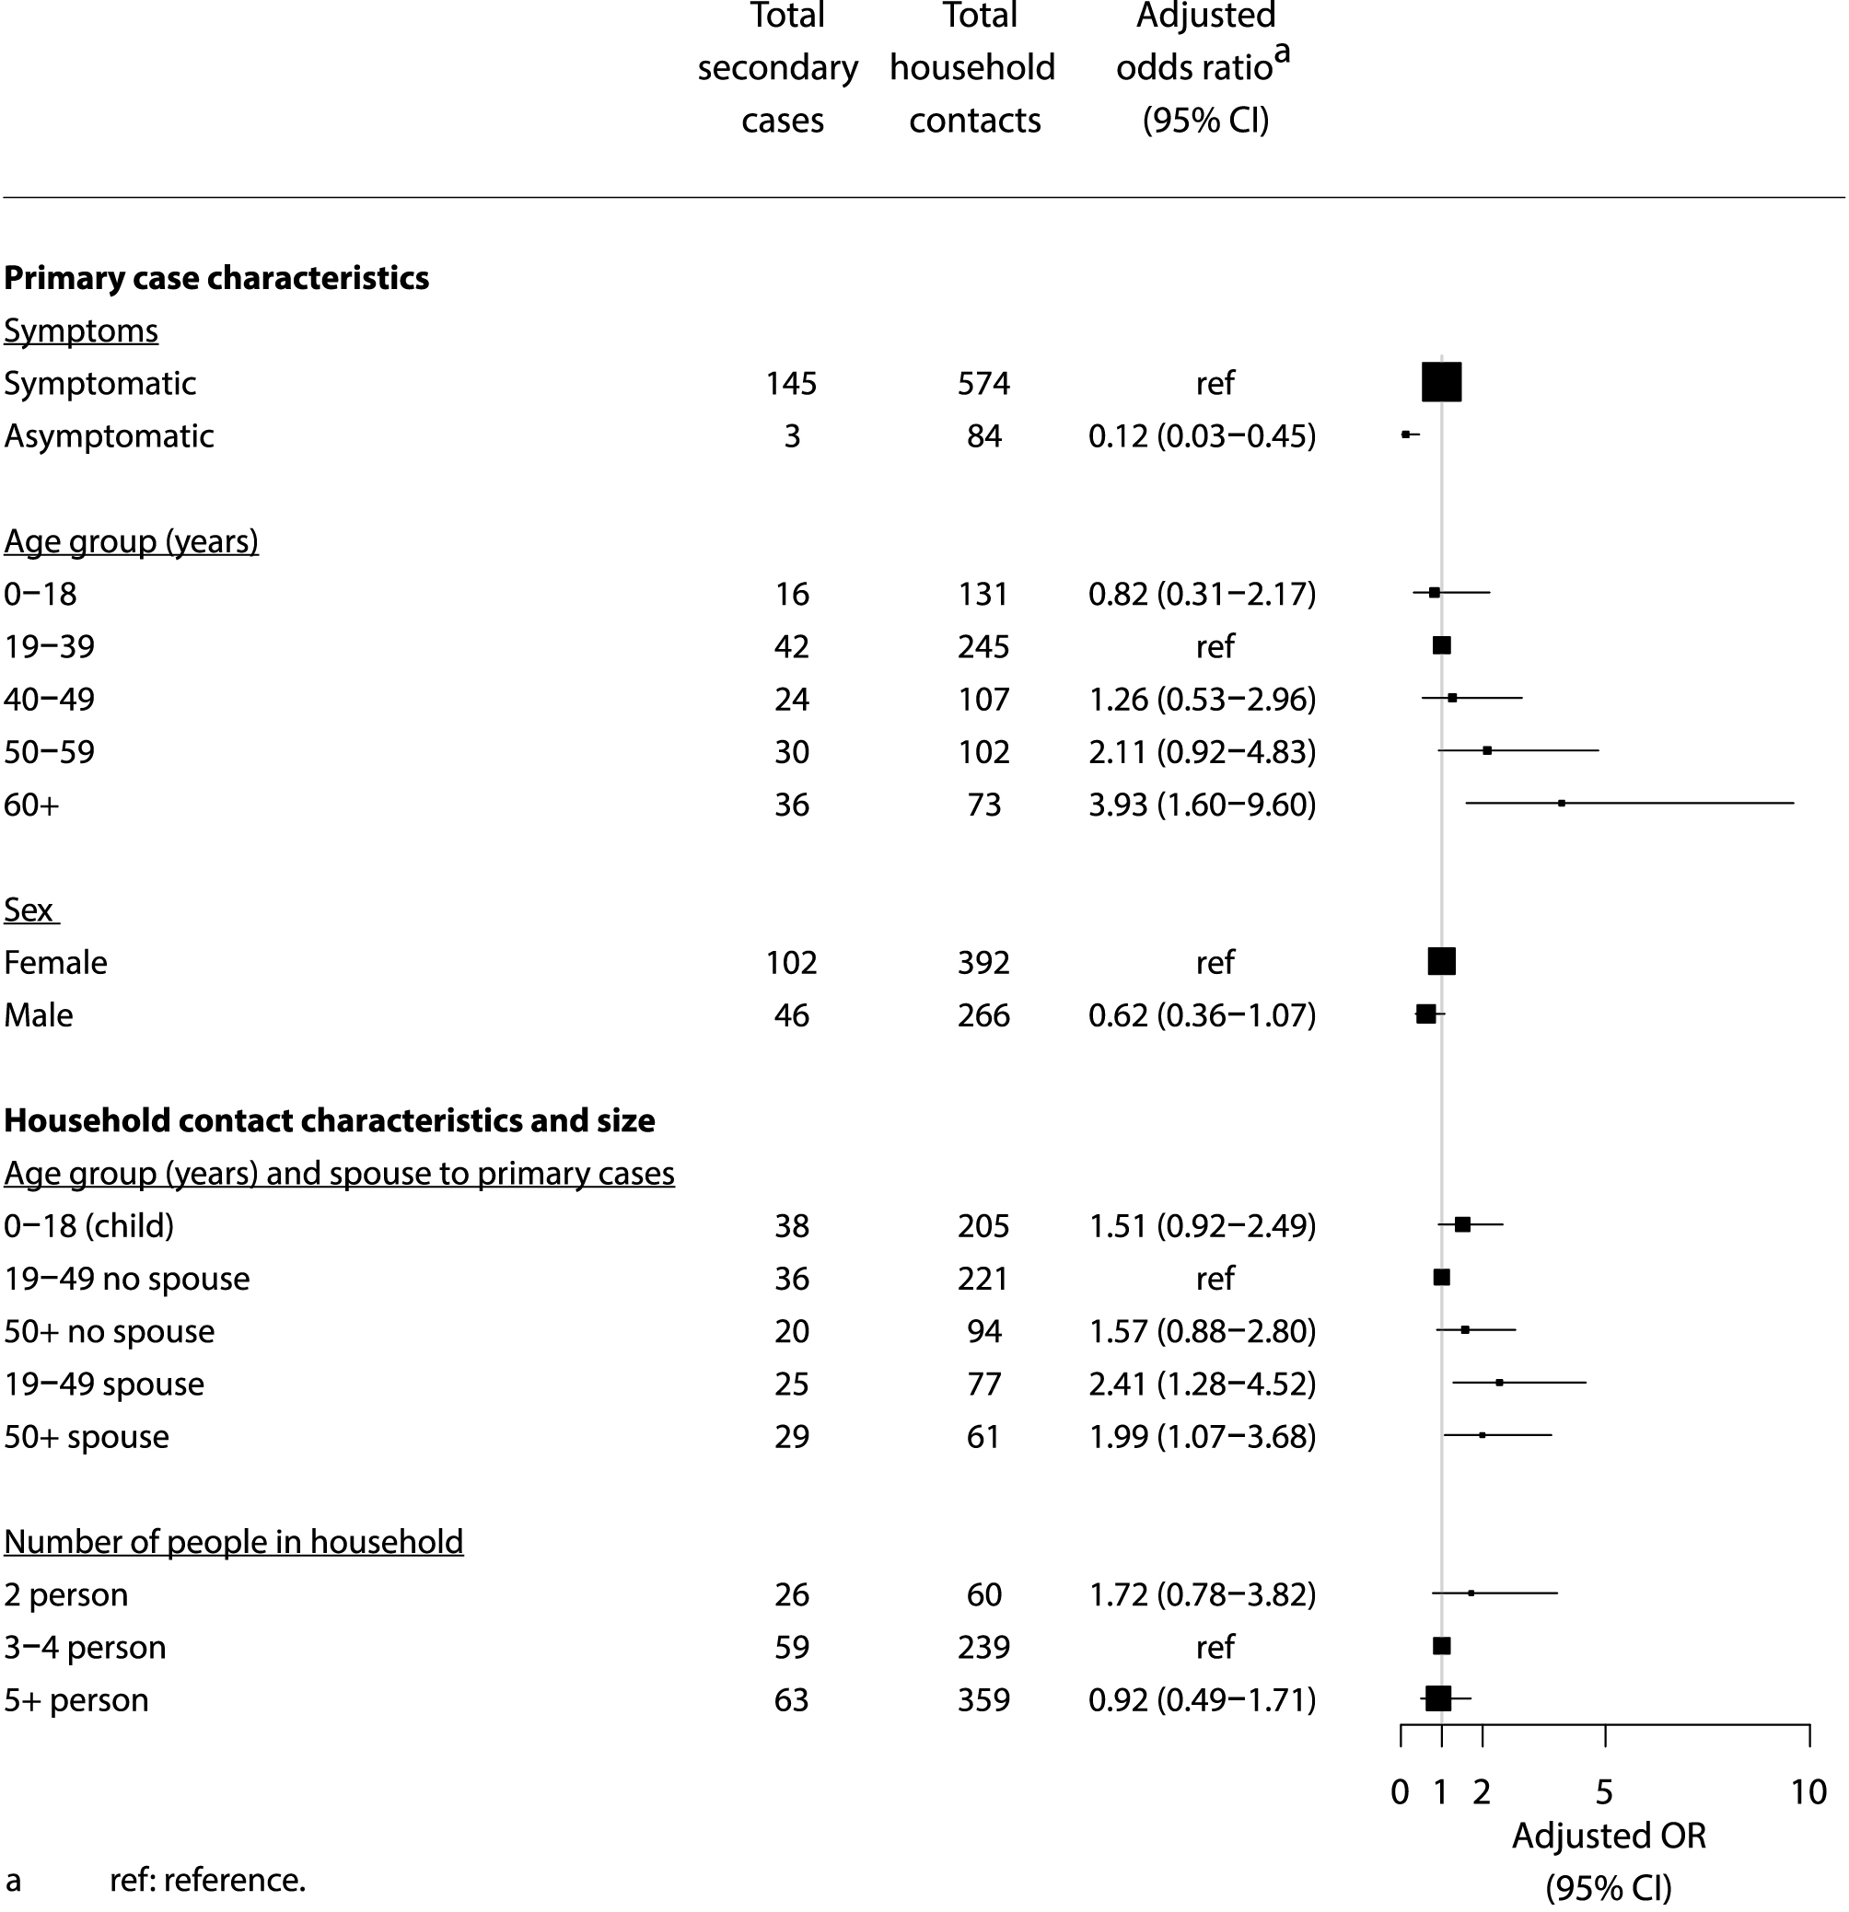

Communicable Diseases Intelligence
ISSN: 2209-6051 Online

Communicable Diseases Intelligence (CDI) is a peer-reviewed scientific journal published by the Office of Health Protection and Response, Department of Health. The journal aims to disseminate information on the epidemiology, surveillance, prevention and control of communicable diseases of relevance to Australia.

Editor: Jennie Hood and Noel Lally
Deputy Editor: Simon Petrie
Design and Production: Kasra Yousefi
Editorial Advisory Board: David Durrheim, Mark Ferson, John Kaldor, Martyn Kirk and Linda Selvey

Website: http://www.health.gov.au/cdi

Contacts
CDI is produced by the Office of Health Protection and Response, Australian Government Department of Health, GPO Box 9848, (MDP 6) CANBERRA ACT 2601

Email: cdi.editor@health.gov.au

Submit an Article
You are invited to submit your next communicable disease related article to the Communicable Diseases Intelligence (CDI) for consideration. More information regarding CDI can be found at: http://health.gov.au/cdi.
Further enquiries should be directed to: cdi.editor@health.gov.au.

This journal is indexed by Index Medicus and Medline.

Creative Commons Licence - Attribution-NonCommercial-NoDerivatives CC BY-NC-ND
© 2022 Commonwealth of Australia as represented by the Department of Health
This publication is licensed under a Creative Commons Attribution-NonCommercial-NoDerivatives 4.0 International Licence from https://creativecommons.org/licenses/by-nc-nd/4.0/legalcode (Licence). You must read and understand the Licence before using any material from this publication.

Restrictions
The Licence does not cover, and there is no permission given for, use of any of the following material found in this publication (if any):
- the Commonwealth Coat of Arms (by way of information, the terms under which the Coat of Arms may be used can be found at www.itsanhonour.gov.au);
- any logos (including the Department of Health’s logo) and trademarks;
- any photographs and images;
- any signatures; and
- any material belonging to third parties.

Disclaimer
Opinions expressed in Communicable Diseases Intelligence are those of the authors and not necessarily those of the Australian Government Department of Health or the Communicable Diseases Network Australia. Data may be subject to revision.

Enquiries
Enquiries regarding any other use of this publication should be addressed to the Communication Branch, Department of Health, GPO Box 9848, Canberra ACT 2601, or via e-mail to: copyright@health.gov.au

Communicable Diseases Network Australia
Communicable Diseases Intelligence contributes to the work of the Communicable Diseases Network Australia.
http://www.health.gov.au/cdna

