Australian Rotavirus Surveillance Program:
Annual Report, 2021
Susie Roczo-Farkas, Sarah Thomas, Nada Bogdanovic-Sakran, Celeste M Donato, Eleanor A Lyons, Julie E Bines and the Australian Rotavirus Surveillance Group

Abstract
This report from the Australian Rotavirus Surveillance Program describes the circulating rotavirus genotypes identified in children and adults during the period 1 January to 31 December 2021. During this period, 521 faecal specimens had been referred for rotavirus G- and P- genotype analysis, of which 474 were confirmed as rotavirus positive. Of these, 336/474 were wildtype rotavirus strains and 138/474 were identified as vaccine-like. Of the 336 wildtype samples, 87.5% (n = 294/336) were identified as G8P[8], and were detected in five of the six jurisdictions that provided samples for the reporting period. Two rotavirus outbreaks, located in the Northern Territory and Western Australia, were also attributed to G8P[8]. As with the 2020 reporting period, a low number of stool samples were received for this reporting period as a result of the COVID-19 pandemic. However, an unexpectedly high proportion of samples with unusual genotypes were identified which were potentially zoonotic in nature, including feline G3, P[9], bovine-like G8, P[14], and porcine-like G4, G6, P[1], and P[6]. Ongoing rotavirus surveillance is crucial to identify changes in genotypic patterns and to provide diagnostic laboratories with quality assurance by reporting incidences of wildtype, vaccine-like, or false positive rotavirus results.
Keywords: rotavirus; gastroenteritis; genotype; surveillance; Australia; vaccine; G8P[8]

Introduction
Group A rotaviruses have been identified as the cause of 128,500 deaths and 258 million episodes of diarrhoea among children < 5 years of age in 2016.¹ To ease this burden, two rotavirus vaccines, Rotarix™ [GlaxoSmithKline] and RotaTeq™ [Merck], have been successfully introduced in the National Immunisation Programs (NIP) of 112 countries, drastically reducing the rotavirus burden of disease.² In Australia, the Australian NIP implemented both vaccines on 1 July 2007, leading to a significant reduction in both rotavirus-coded and non-rotavirus-coded hospitalisations of children ≤ 5 years of age with acute gastroenteritis.^{3–5} Within the first six years of vaccine introduction, an estimated 77,000 hospitalisations were prevented, 90% of which were in children ≤ 5 years, with indications of herd protection occurring in older age groups.⁵ RotaTeq was administered in Queensland, South Australia, and Victoria, whereas Rotarix was administered in the Australian Capital Territory, New South Wales, the Northern Territory, and Tasmania. Western Australia initially administered Rotarix and changed to RotaTeq in May 2009. On 1 July 2017, all states and territories in Australia changed to Rotarix.^{6,7}
Rotavirus surveillance programs utilise a binary classification system based on the two outer capsid proteins, VP7 (G, glycoprotein) and VP4 (P, protease-sensitive), to describe rotavirus genotypes.⁸ Globally, there are five common genotype combinations identified in humans: G1P[8], G2P[4], G3P[8], G4P[8], and G9P[8], although G8P[8] and G12P[8] have also been described as globally important genotypes.^{9–11} Additionally, whole genome classification assigns genotypes to each of the 11 genes: Gx-P[x]-Ix-Rx-Cx-Mx-Ax-Nx-Tx-Ex-Hx, denoting the VP7-VP4-VP6-VP1-VP2-VP3-NSP1-NSP2-NSP3-NSP4-NSP5/6 genes.^{12,13} The majority of human rotavirus genomes fall under two genotype constellations: Wa-like (genogroup 1: G1/3/4/9/12-P[8]-I1-R1-C1-M1-A1-N1-T1-E1-H1), and DS-1-like (genogroup 2: G2-P[4]-I2-R2-C2-M2-A2-N2-T2-E2-H2).^{12,13} A third genogroup, AU-1-like, is also detected in humans, however less frequently (genogroup 3: G3-P[9]-I3-R3-C3-M3-A3-N3-T3-E3-H3).^{12,13} Numerous mechanisms contribute to rotavirus diversity including genetic drift, reassortment and zoonotic transmission. The segmented genome allows for reassortment both within and between human and animal strains, leading to the emergence of novel strains and unusual genotype combinations.
Since 1999, the Australian Rotavirus Surveillance Program (ARSP) has characterised rotavirus genotypes causing severe disease in Australian children ≤ 5 years of age. Genotype surveillance data has revealed changes in diversity, as well as temporal and geographic fluctuations over time.¹⁴ Furthermore, differences in genotype diversity and dominance were observed when comparing vaccines by jurisdictions, suggesting that RotaTeq and Rotarix exert different immunological pressures.¹⁴ The continued surveillance and characterisation of rotavirus genotypes circulating in Australia will provide important insights into whether changes in vaccine immunisation programs could impact virus epidemiology and alter strain diversity, which could have ongoing consequences for the success of current and future vaccination programs.
This report describes the G- and P- genotype distribution of rotavirus strains causing severe gastroenteritis in Australia for the period 1 January to 31 December 2021.

Methods
Faecal samples were tested for the presence of rotavirus by quantitative reverse transcription polymerase chain reaction (RT-qPCR), enzyme immunoassay (EIA), or latex agglutination by collaborating laboratories Australia-wide. Positive samples were frozen and sent to the National Rotavirus Reference Centre (NRRC) Melbourne, together with available metadata including date of collection (DOC), date of birth (DOB), gender, postcode, and the RT-qPCR cycle threshold (Ct) values generated, by the collaborating laboratory. Specimens were received from the following ten collaborating centres located in the Australian Capital Territory (ACT), New South Wales (NSW), Northern Territory (NT), Queensland (Qld), Victoria (Vic.), and Western Australia (WA) (n = number of specimens received):
- Microbiology Department, Canberra Hospital, ACT (n = 2);
- Microbiology Department, SEALS-Randwick, Prince of Wales Hospital, NSW (n = 5);
- Virology Department, The Children’s Hospital, Westmead, NSW (n = 18);
- Douglass Hanly Moir Pathology, NSW (n = 7);
- The Microbiology Department, John Hunter Hospital, Newcastle, NSW (n = 6);
- Territory Pathology, Royal Darwin Hospital, Tiwi, NT (n = 90);
- Pathology Queensland, Royal Brisbane and Women’s Hospital, Herston, Qld (n = 146);
- Department of Microbiology, Monash Medical Centre, Clayton, Vic. (n = 45);
- Laboratory Services, Royal Children’s Hospital, Parkville, Vic. (n = 7); and
- QEII Microbiology Department, PathWest Laboratory Medicine, Nedlands, WA (n = 195).
No samples were submitted from Tasmanian (Tas.) or South Australian (SA) collaborators in 2021; however, three samples from South Australian residents were received from Territory Pathology, Royal Darwin Hospital and from the Microbiology Department, John Hunter Hospital.
Samples were allocated a unique laboratory code and entered into the NRRC database (Excel and REDCap). Samples were stored at -80 ⁰C until analysed.
Viral RNA was extracted from 10–20% faecal extracts using the QIAamp Viral RNA mini extraction kit (QIAGEN), according to the manufacturer’s instructions. Rotavirus G- and P- genotypes were determined using an in-house hemi-nested multiplex RT-PCR assay. The first-round RT-PCR reactions were performed using the One Step RT-PCR kit (QIAGEN), in conjunction with VP7 (VP7F/VP7R) or VP4 (VP4F/VP4R) conserved primers.^{15,16} The second-round genotyping PCR reactions were conducted using specific oligonucleotide primers for G types G1, G2, G3, G4, G8, and G9, or P types P[4], P[6], P[8], P[9], P[10], and P[11].^{15,17,18} The G- and P- genotype was determined using agarose gel electrophoresis of second-round PCR products. Samples failing to generate a second-round PCR amplicon or with inconclusive results were further tested by VP6-specific RT-PCR using the Superscript III One-Step RT-PCR System with Platinum Taq DNA Polymerase (Invitrogen) and primers Rot3 and Rot5 as described previously.^{19,20}
Sanger sequencing was used to determine the VP7 and/or VP4 nucleotide sequence for PCR non-typeable or VP6 positive samples. The current set of primers in the second-round G-typing protocol is not able to assign genotypes to equine-like G3, G12, and unusual rotavirus strains. The VP7 gene of each G1P[8] sample was sequenced to determine if wildtype or Rotarix vaccine strain was detected. Samples which had no first-round PCR amplicon were re-amplified using the Superscript III One-Step RT-PCR System with Platinum Taq DNA Polymerase (Invitrogen), in conjunction with VP7 (Beg9/End9) or VP4 (Con2/Con3) primers, as described previously.^{17,18,21} First-round VP7, VP4 and VP6 amplicons were purified using the Wizard SV Gel for PCR Clean-Up System (Promega) or the QIAquick Gel Extraction Kit (QIAGEN), according to the manufacturer’s protocol. Purified DNA and oligonucleotide primers (Rot3/Rot5, VP7F/VP7R, VP4F/VP4R, Beg9/End9, or Con2/Con3) were sent to the Australian Genome Research Facility (AGRF), Melbourne, and sequenced using an ABI PRISM BigDye Terminator Cycle Sequencing Reaction Kit (Applied Biosystems) in an Applied Biosystems 3730xl DNA Analyzer (Applied Biosystems). Electropherograms were visually analysed and edited using Sequencher v.5.4.6. Genotype assignment was determined using BLAST.
Rotavirus has been a notifiable disease in Australia since 2010, with all states and territories reporting through the National Notifiable Diseases Surveillance System (NNDSS) in 2021.²² Ethics approval was not required as all samples are provided as de-identified with no clinical data.

Results

Number of specimens
A total of 521 specimens determined to be rotavirus positive by collaborating laboratories were sent to the NRRC during the period 1 January to 31 December 2021 (Figure 1). A subset of samples were not analysed further due to sample being duplicate (n = 5), insufficient (n = 6), missing (not received; n = 2), or not confirmed as rotavirus positive by VP6 PCR analysis at MCRI (n = 34).
A total of 474 samples were genotyped. Samples were then classified as wildtype (no vaccine component identified) or vaccine-like (Rotarix vaccine component identified), based on genotype and the analysis of the top BLAST hits of any G1 VP7 sequence. Of the 336 samples confirmed as wildtype, 170 (50.6%) were collected from children < 5 years of age, and 166 (49.4%) were obtained from children ≥ 5 years of age and from adults (Table 1). An additional 138 samples were identified as vaccine-like by VP7 sequencing, with the majority (120/138; 87%) obtained from infants ≤ 3 months of age and only one sample from a subject ≥ 12 months of age.

Figure 1: Consort diagram of rotavirus positive stool samples included in the 2021 ARSP; 1 January to 31 December 2021
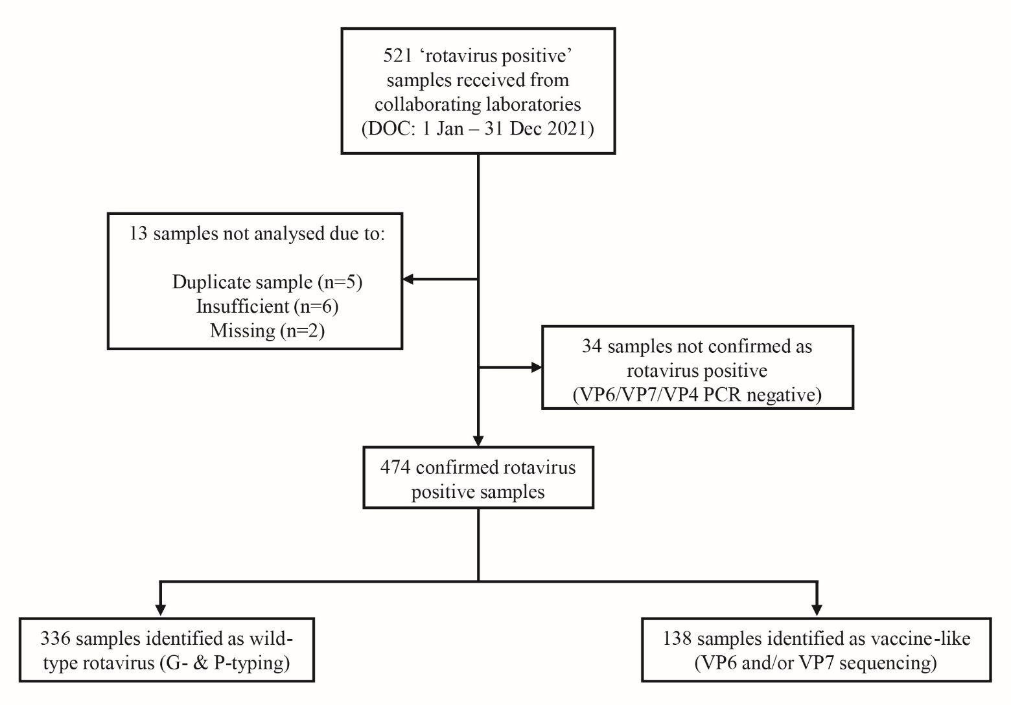
Table 1: Age distribution of wildtype rotavirus gastroenteritis cases, Australia, 1 January to 31 December 2021ª
Age (months) | Age (years) | n | % of total | % < 5 years of age
0–6 |  | 36 | 10.7 | 21.2
7–12 | ≤ 1 | 14 | 4.2 | 8.2
13–24 | 1 – ≤ 2 | 41 | 12.2 | 24.1
25–36 | 2 – ≤ 3 | 44 | 13.1 | 25.9
37–48 | 3 – ≤ 4 | 22 | 6.5 | 12.9
49–60 | 4 – < 5 | 13 | 3.9 | 7.6
Subtotal |  | 170 | 50.6 | 100
61–120 | 5 – ≤ 10 | 28 | 8.3
121–240 | 10 – ≤ 20 | 14 | 4.2
241–960 | 20 – ≤ 80 | 100 | 29.8
961+ | > 80 | 24 | 7.1
Subtotal |  | 166 | 49.4
Unknown age |  | —
Total |  | 336 | 100.0
a Data does not include samples from Tasmania

Rotavirus positive samples identified by month, 2021
Wildtype and vaccine-like rotavirus positive samples were analysed by date of collection (DOC: month), to determine if the number of samples received each month were primarily wildtype or vaccine-like (Figure 2). Although the National Notifiable Diseases Surveillance System (NNDSS) website was decommissioned during 2021 pending an update, data on notifications were provided directly from the Department of Health and Aged Care to include in this report (Figure 2; Appendix A, Table A.1).²² Of note, most wildtype specimens received were collected during the months of October and November, which corresponded with rotavirus outbreaks in the Northern Territory and Western Australia between September and December 2021. Furthermore, state-based notification reports also suggest that the peak rotavirus season for the year occurred in November and December, which correlated with the number of samples received by the NRRC in 2021.^{23,24}
Figure 2: Number of analysed wildtype and vaccine-like specimens compared to NNDSS rotavirus notification rates per 100,000 population, Australia, 1 January to 31 December 2021
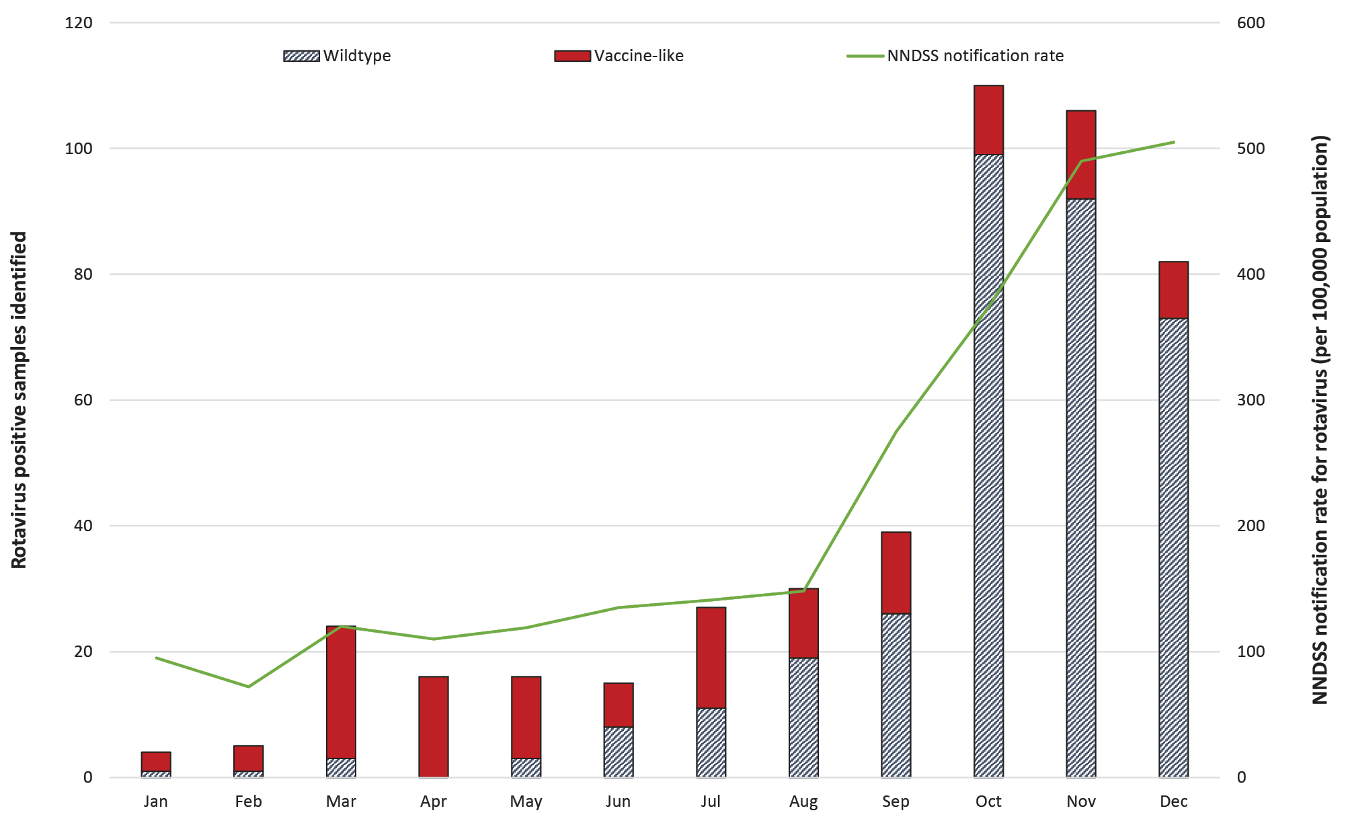
As with 2020, the coronavirus disease 2019 (COVID-19) pandemic has impacted the ability for collaborating laboratories to collect, store and send rotavirus samples to the NRRC.²⁵ The number of samples submitted to NRRC overall was lower than had been observed in the periods prior to 2020. Collaborating laboratories were consulted throughout the year to determine if and when sample collection would resume; however, at the end of 2021, most reported that sample collection and storage had not recommenced or that laboratories were still experiencing reduced capacity. No samples were collected or submitted to the NRRC from laboratories in Tasmania or South Australia in 2021.

Wildtype rotavirus specimens

Age distribution for wildtype rotavirus infections
From 1 January to 31 December 2021, just over half of wildtype rotavirus positive samples (n = 170/336; 50.6%) were obtained from children < 5 years of age (Table 1). The majority of positive samples from children < 5 years of age were obtained from the 25–36, 13–24 and < 6 month age groups, accounting for 25.9% (n = 44/170), 24.1% (n = 41/170) and 21.2% (36/170) of such samples respectively (Table 1).

Wildtype rotavirus genotype distribution
Genotype analysis was performed on all 336 confirmed wildtype rotavirus positive samples from children and adults (Table 2). G8P[8] was the most common genotype identified nationally, representing 87.5% of all wildtype specimens analysed (n = 294/336). The incidence of G8P[8] was similar between the < 5 and ≥ 5 years of age groups, representing 86.5% (n = 147/170) and 88.6% (n = 147/166) of samples respectively. G8P[8] samples were mostly obtained from Western Australia (n = 160/294), Queensland (n = 84/294), and the Northern Territory (n = 47/294), although this reflects the regional distribution of total samples submitted to the NRRC during 2021. High levels of G8P[8] samples were identified between October and December (n = 91/294, 87/294, and 70/294 respectively) which correlated with the timing of the outbreak reported in Western Australia and the Northern Territory at this time.
G3 was the next most common G-type identified, including wildtype human G3P[8] (n = 12/336), and unusual G3 strains such as feline-like G3P[9] (n = 4), feline-like G3P[NT] (n = 6), and feline-like G3P[8] (n = 1) (Tables 2, 3). Other unusual, potentially zoonotic genotypes were identified this year, including bovine-like G8P[14] (n = 2), porcine-like G4P[6] (n = 1), G6P[1] (n = 1), and G6P[9] (n = 1) (Tables 2, 3).

Table 2: Rotavirus G and P genotype distribution in infants, children and adults, 1 January to 31 December 2021
Jurisdictionª | Age | Total | G1P[8] |  | G2P[4] |  | G3P[8] |  | G3P[9] ^{b} |  | G8P[8] |  | G8P[14] |  | G9P[4] |  | G9P[8] |  | Non-typeable ^{c} |  | Other ^{d}
 | (years) | n | n | % | n | % | n | % | n | % | n | % | n | % | n | % | n | % | n | % | n | %
NSW | < 5 | 2 | 1 | 50.0 |  |  | 1 | 50.0
 | ≥ 5 | 2 |  |  |  |  | 1 | 50.0 |  |  | 1 | 50.0
NT | < 5 | 48 |  |  |  |  | 1 | 2.1 | 3 | 6.3 | 39 | 81.3 |  |  |  |  |  |  | 4 | 8.3 | 1 | 2.1
 | ≥ 5 | 11 |  |  |  |  |  |  | 1 | 9.1 | 8 | 72.7 |  |  |  |  |  |  | 2 | 18.2
Qld | < 5 | 50 |  |  | 1 | 2.0 |  |  |  |  | 47 | 94.0 |  |  |  |  | 1 | 2.0 | 1 | 2.0
 | ≥ 5 | 44 | 1 | 2.3 |  |  | 1 | 2.3 |  |  | 37 | 84.1 | 1 | 2.3 |  |  |  |  |  |  | 4 | 9.1
SA^{e} | < 5 | 3 |  |  |  |  |  |  |  |  | 2 | 66.7 |  |  |  |  |  |  | 1 | 33.3
 | ≥ 5 | 0
Vic. | < 5 | 6 |  |  | 1 | 16.7 |  |  |  |  |  |  |  |  | 2 | 33.3 |  |  | 2 | 33.3 | 1 | 16.7
 | ≥ 5 | 5 |  |  |  |  | 4 | 80.0 |  |  |  |  |  |  |  |  |  |  | 1 | 20.0
WA | < 5 | 61 |  |  |  |  | 2 | 3.3 |  |  | 59 | 96.7
 | ≥ 5 | 104 |  |  |  |  | 2 | 1.9 |  |  | 101 | 97.1 | 1 | 1.0
Subtotal | < 5 | 170 | 1 | 0.6 | 2 | 1.2 | 4 | 2.4 | 3 | 1.8 | 147 | 86.5 |  |  | 2 | 1.2 | 1 | 0.6 | 8 | 4.7 | 2 | 1.2
 | ≥ 5 | 166 | 1 | 0.6 |  |  | 8 | 4.8 | 1 | 0.6 | 147 | 88.6 | 2 | 1.2 |  |  |  |  | 3 | 1.8 | 4 | 2.4
Total |  | 336 | 2 | 0.6 | 2 | 0.6 | 12 | 3.6 | 4 | 1.2 | 294 | 87.5 | 2 | 0.6 | 2 | 0.6 | 1 | 0.3 | 11 | 3.3 | 6 | 1.8
a No results shown for the Australian Capital Territory (samples were not wildtype positive) or for Tasmania (no samples submitted).
b Equine-like G3P[8].
c Specimen where G or P genotype was not determined.
d Canine-like G3P[3].
e These samples from South Australian residents were received from NSW and NT.

Table 3: Unusual and non-typeable genotype combinations identified in infants, children and adults, 1 January to 31 December 2021
Genotypeª | Total
(Feline-like) G3P[8] | 1
(Feline-like) G3P[NT] | 6
(Porcine-like) G4P[6] | 1
G6P[1] | 1
G6P[9] | 1
G8P[NT] | 1
GNTP[8] | 2
GNTP[9] | 1
GNTP[NT] | 1
Mixed G1/G3P[8] | 1
Mixed G8/G9P[8] | 1
Total | 17
a NT: non-typeable.

Vaccine-like rotavirus specimens

Age distribution for rotavirus vaccine-like samples
All G1P[8] samples (n = 141) were analysed by VP7 sequencing to identify vaccine-like strains. All samples were successfully sequenced, of which 138 were Rotarix vaccine-like and three were wildtype (one of which was a mixed infection G1/G3P[8]). Of the vaccine-like samples, 135/138 were from the 0–6 months of age group, with most identified in patients 1 month of age (44.9%; n = 62/138), followed by 2 months of age (29.0%; n = 40/138), and 3 months of age (13.0%; n = 18/138). The remaining samples were from patients aged 4 to 6 months (10.9%; n = 15/138); 7 to 12 months (1.4%; n = 2/138); and one adult (Appendix A, Figure A.1).

Discussion
In this Australian Rotavirus Surveillance Program Report for 2021, we describe the distribution of rotavirus genotypes identified in Australia for the period 1 January to 31 December 2021, marking the fourth year of exclusive use of Rotarix in the National Immunisation Program.^{6,7} For the first time, G8P[8] was identified as the predominant genotype causing rotavirus diarrhoea in Australia, identified in five out of six jurisdictions that had representative samples sent for the year; this genotype constituted 87.5% of all wildtype samples genotyped in 2021. G8P[8] was identified in 79.7% of all samples from the Northern Territory (n = 47/59), and in 97.0% of all samples from Western Australia (n = 160/165), where two rotavirus outbreaks were reported by OzfoodNet and the Northern Territory Centre for Disease Control. These outbreaks commenced in September 2021 and continued through to December 2021, and were primarily associated with children < 10 years of age.^{23,26}
Prior to the 2017 G8P[8] outbreak in New South Wales, a limited number of G8 strains with varying P-types had only been identified between 1995 and 2015 in Australia.^{14,27} The 2017 New South Wales outbreak was the first time G8 was identified as a major genotype during twenty years of rotavirus surveillance in Australia.¹⁴ The emergence of unusual intergenogroup reassortant rotaviruses with bovine-like G8 (DS-1-like G8P[8]) have been reported in several Asian countries, including Japan, Thailand, and Vietnam.^{11,28,29} Indeed, G8P[8] was identified as the prominent cause of multiple outbreaks in Japan in 2014, and also in 2017 where sequence and phylogenetic analyses revealed a unique genotype constellation, including genes from both genogroup 1 and 2: G8-P[8]-I2-R2-C2-M2-A2-N2-T2-E2-H2.^{11,29} Phylogenetic analysis revealed that the VP1 gene of this strain appeared to have originated from DS-1-like G1P[8] strains from Thailand and Vietnam, whereas the remaining ten genes were closely related to those of previously reported DS-1-like G8P[8] strains.^{11,29} Interestingly, in 2018, Thailand reported an increase in G8P[8] associated gastroenteritis in both children and adults, with the same genotype constellation as the 2017 Japanese G8P[8] strain.^{30,31} G8P[8] has also been observed as an emerging genotype in countries outside Asia including Chile, the Czech Republic, and Gabon.^{32–34} Until recently, the G8 genotype was considered rare in the Americas; however, in 2019, G8P[8] was identified in 48% of rotavirus episodes over an 18-month period of surveillance in Chile.³³ Similarly, the bovine-human reassortant DS-1-like G8P[8], which clustered with G8P[8] strains from Vietnam in 2014/2015, was identified in 9.3% of all rotavirus positive samples over the period of 2016–2019. It was also identified as a cause of an outbreak in the Czech Republic despite previously being classified as rare.³⁴
It has been postulated that, in the context of high vaccine coverage, vaccine-related selective pressure may contribute to the emergence of unusual genotypes, such as G8.^{14,27} A systematic review of Rotarix (and RotaTeq) revealed similar effectiveness against homotypic and heterotypic rotavirus strains, although these comparisons were reported in 2014 and may not reflect trends observed more than a decade after rotavirus vaccine introduction.³⁵ Currently, there is limited data on the genetic similarity of vaccine strains and their relationship with emerging wildtype strains. For example, a study in Gabonese children reported that the G8P[8] strain observed in 18% of all rotavirus diarrhoea samples had high antigenic variability when compared to the vaccine strains.³² There is concern that the genetic variability observed in these contemporary strains may evade immune responses induced by prior infection or vaccination.³² Genotype-specific vaccine-effectiveness analysis was not performed for the New South Wales 2017 G8P[8] outbreak. However, high one- and two-dose rotavirus vaccine effectiveness has been observed in Australian infants, suggesting good protection by Rotarix against contemporary strains.²⁷ The 2014 G8P[8] outbreak in Japan also reported no difference in clinical characteristics for patients infected with G8P[8] compared to those infected with non-G8P[8] rotaviruses, suggesting that the severity of gastroenteritis caused by G8P[8] could possibly be attenuated by the existence of VP7/VP4 genotype cross-reactive (heterotypic) protective responses, by protective immunity associated with other genes (for example, VP6 and NSP4), or by a combination of both factors.¹¹
In this study, G8 was also found in combination with P[14] (n = 2); other zoonotic genotypes such as the feline G3, porcine G4, G6, P[1], P[6], and P[9] also featured more frequently than expected for the relatively small sample size compared to previous reporting periods in Australia. With the exception of P[1], the listed unusual and rare genotypes have also been reported with increased frequency around the world, including G8P[6] in Korean neonates,³⁶ G3P[3] in Japan,³⁷ and G8P[14] in Japan and Morocco.^{37,38} The results of these studies, in conjunction with the increased detection of zoonotic strains in Australia, highlight the importance of interspecies transmission and multiple reassortment events for generating genetic diversity in humans, which could affect the success of current and future vaccination programs.
The overall increase in detection of rotavirus vaccine-like virus in samples observed over recent years through the ARSP is most likely due to the shift in diagnostic techniques to multiplex PCR panels that do not distinguish between wildtype and vaccine rotavirus strains.^{39–43} Consequently, it is important to interpret a rotavirus positive result in children aged less than 8 months of age with caution, as this result could be due to the receipt of a recent dose of rotavirus vaccine.
As with the 2020 reporting period, the COVID-19 pandemic had a major impact on the collection and storage of stool samples in participating laboratories and on the transporting of samples to the NRRC. The lack of samples submitted to the ARSP from Tasmania and South Australia means that is only possible to infer genotype patterns based on the data from the other states and territories.
In conclusion, in this 2021 Annual Rotavirus Surveillance Report, we describe the incidence of both wildtype and vaccine-like rotavirus strains detected in Australia for the period of 1 January – 31 December 2021. During this period, the previously rare genotype G8P[8] emerged as the predominant strain associated with diarrhoea disease due to wildtype rotavirus in Australia. An increase in zoonotic-like and unusual genotypes was also observed. As previously noted, almost three-quarters of samples from infants 0 to 6 months of age contained vaccine-like rotavirus, highlighting the importance of interpreting diagnostic data together with clinical symptoms and recent vaccination history to ensure accurate interpretation of rotavirus disease burden. The Australian Rotavirus Surveillance Program also provides a platform where diagnostic laboratories are provided with additional information regarding rotavirus positive samples whereas genotyping data can assist gastroenteritis outbreak investigations by state and territory public health units.

Acknowledgements
The Australian Rotavirus Surveillance Program is supported by grants from the Australian Government Department of Health and Aged Care and from GlaxoSmithKline Biologicals SA [Study#209328]. The Murdoch Children’s Research Institute (MCRI) is supported by the Victorian Government’s Operational Infrastructure Support program. GlaxoSmithKline Biologicals SA was provided the opportunity to review a preliminary version of this manuscript for factual accuracy, but the authors are solely responsible for final content and interpretation. The authors received no financial support or other form of compensation related to the development of the manuscript.
Rotavirus positive specimens were collected from numerous centres throughout Australia. We acknowledge and appreciate the significant time and effort involved in the collection, storage, packaging, compiling data and forwarding of specimens, especially given their outstanding commitment to SARS-CoV-2 testing.

Author Details
Mrs Susie Roczo-Farkas, Research Assistant¹
Mrs Sarah Thomas, Research Assistant¹
Mrs Nada Bogdanovic-Sakran, Research Assistant¹
Dr Celeste M Donato, Senior Research Officer^{1,} ^{2, 3}
Dr Eleanor A Lyons, Research Officer¹
Prof. Julie E Bines, Group Leader^{1, 2, 4}
and the Australian Rotavirus Surveillance Group
- Enteric Diseases, Murdoch Childrens Research Institute, Parkville, Victoria
- Department of Paediatrics, University of Melbourne, Parkville, Victoria
- Department of Microbiology, Biomedicine Discovery Institute, Monash University, Clayton, Victoria
- Department of Gastroenterology and Clinical Nutrition, Royal Children’s Hospital, Parkville, Victoria

The National Rotavirus Surveillance Group includes:

Australian Rotavirus Surveillance Program Central Laboratory
Mrs Susie Roczo-Farkas; Coordinator Australian Rotavirus Surveillance Program, Research Assistant, Enteric Diseases, MCRI
Mrs Sarah Thomas, Research Assistant, Enteric Diseases, MCRI
Dr Celeste M Donato, Senior Research Officer, Enteric Diseases, MCRI; Department of Paediatrics, University of Melbourne; Department of Microbiology, Biomedicine Discovery Institute, Monash University
Mrs Nada Bogdanovic-Sakran, Research Assistant, Enteric Diseases, MCRI
Dr Eleanor A Lyons, Research Officer, Enteric Diseases, MCRI
Prof. Julie E Bines, Director, Australian Rotavirus Surveillance Program; Leader, Enteric Diseases, MCRI; Department of Paediatrics, University of Melbourne; Department of Gastroenterology and Clinical Nutrition, Royal Children’s Hospital

Australian Capital Territory
Ms. S Bradbury, Mr J Choo and members of the Microbiology Department, Canberra Hospital

New South Wales
Prof. W Rawlinson, Prof. M Lahra, Ms J Hanrahan, Mr P Huntington, and members of the Microbiology Department, SEALS, Prince of Wales Hospital
Dr V Sintchenko, T Olma, and members of the Centre for Infectious Disease and Microbiology, Westmead
Dr A Kesson, Ms I Tam, and members of the Virology Department, The Children’s Hospital, Westmead
Dr R Givney, S Pearce, K Delves, K Ross, and members of the Microbiology Department, John Hunter Hospital, Newcastle
Dr D deWit, Ms C Wright, and members of the Microbiology Department, Central Coast, Gosford
Dr M Wehrhahn, and members of Douglass Hanly Moir Pathology, New South Wales

Northern Territory
Mr K Freeman, Mr F Dakh and members of Territory Pathology, Royal Darwin Hospital, Tiwi, NT

Queensland
Dr G Nimmo, Dr C Bletchly, and department members, Pathology Queensland Central

South Australia
Mr M Turra, Dr J Arthur, and members of the Microbiology and Infectious diseases laboratory SA Pathology, Adelaide

Tasmania
Dr J Williamson and members of Molecular Medicine, Pathology Services, Royal Hobart Hospital, Hobart, Tasmania

Victoria
Dr T Korman, Mrs D Kotsanas, and members of the Department of Microbiology, Monash Medical Centre, Clayton
Ms K Rautenbacher, Ms P Adamopoulos, Laboratory Services, Royal Children’s Hospital, Parkville
E Hrysoudis, F Gray, R Quach, and members of the Molecular Infectious Department, Australian Clinical Labs, Clayton

Western Australia
Mr D Bradford, E Lee, and members of QEII Microbiology Department, PathWest Laboratory Medicine WA, Perth

Corresponding author
Professor Julie Bines
Enteric Diseases, Murdoch Children’s Research Institute, 50 Flemington Road, Parkville, Victoria, 3052.
Ph: 03 8341 6383
Email: jebines@unimelb.edu.au

References
- Troeger C, Khalil IA, Rao PC, Cao S, Blacker BF, Ahmed T et al. Rotavirus vaccination and the global burden of rotavirus diarrhea among children younger than 5 years. JAMA Pediatr. 2018;172(10):958–65. doi: https://doi.org/10.1001/jamapediatrics.2018.1960.
- Immunization, Vaccines and Biologicals (IVB), World Health Organization (WHO). Vaccine in National Immunization Programme Update. [PowerPoint presentation.] Geneva: WHO; 27 October 2020. Available from: https://cdn.who.int/media/docs/default-source/immunization/hpv/vaccineintrostatus.pdf.
- Buttery JP, Lambert SB, Grimwood K, Nissen MD, Field EJ, Macartney KK et al. Reduction in rotavirus-associated acute gastroenteritis following introduction of rotavirus vaccine into Australia’s National Childhood vaccine schedule. Pediatr Infect Dis J. 2011;30(1 Suppl):S25–9. doi: https://doi.org/10.1097/INF.0b013e3181fefdee.
- Macartney KK, Porwal M, Dalton D, Cripps T, Maldigri T, Isaacs D et al. Decline in rotavirus hospitalisations following introduction of Australia’s national rotavirus immunisation programme. J Paediatr Child Health. 2011;47(5):266–70. doi: https://doi.org/10.1111/j.1440-1754.2010.01953.x.
- Reyes JF, Wood JG, Beutels P, Macartney K, McIntyre P, Menzies R et al. Beyond expectations: post-implementation data shows rotavirus vaccination is likely cost-saving in Australia. Vaccine. 2017;35(2):345–52. doi: https://doi.org/10.1016/j.vaccine.2016.11.056.
- Roczo-Farkas S, Cowley D, Bines JE, the Australian Rotavirus Surveillance Group. Australian Rotavirus Surveillance Program: Annual Report, 2017. Commun Dis Intell (2018). 2019;43. doi: https://doi.org/10.33321/cdi.2019.43.28.
- Australian Government Department of Health and Aged Care. Clinical update: ATAGI advice on Rotarix® to replace RotaTeq®. [Internet.] Canberra: Australian Government Department of Health and Aged Care; 20 December 2017. Available from: https://beta.health.gov.au/news-and-events/news/clinical-update-atagi-advice-on-rotarixr-to-replace-rotateqr.
- Desselberger U. Rotaviruses. Virus Res. 2014;190:75–96. doi: https://doi.org/10.1016/j.virusres.2014.06.016.
- Bányai K, László B, Duque J, Steele AD, Nelson EA, Gentsch JR et al. Systematic review of regional and temporal trends in global rotavirus strain diversity in the pre rotavirus vaccine era: insights for understanding the impact of rotavirus vaccination programs. Vaccine. 2012;30(Suppl 1):A122–30. doi: https://doi.org/10.1016/j.vaccine.2011.09.111.
- Dóró R, László B, Martella V, Leshem E, Gentsch J, Parashar U et al. Review of global rotavirus strain prevalence data from six years post vaccine licensure surveillance: is there evidence of strain selection from vaccine pressure? Infect Genet Evol. 2014;28:446–61. doi: https://doi.org/10.1016/j.meegid.2014.08.017.
- Kondo K, Tsugawa T, Ono M, Ohara T, Fujibayashi S, Tahara Y et al. Clinical and molecular characteristics of human rotavirus G8P[8] outbreak strain, Japan, 2014. Emerg Infect Dis. 2017;23(6):968–72. doi: https://doi.org/10.3201/eid2306.160038.
- Matthijnssens J, Ciarlet M, Rahman M, Attoui H, Bányai K, Estes MK et al. Recommendations for the classification of group A rotaviruses using all 11 genomic RNA segments. Arch Virol. 2008;153(8):1621–9. doi: https://doi.org/10.1007/s00705-008-0155-1.
- Matthijnssens J, Ciarlet M, McDonald SM, Attoui H, Bányai K, Brister JR et al. Uniformity of rotavirus strain nomenclature proposed by the Rotavirus Classification Working Group (RCWG). Arch Virol. 2011;156(8):1397–413. doi: https://doi.org/10.1007/s00705-011-1006-z.
- Roczo-Farkas S, Kirkwood CD, Cowley D, Barnes GL, Bishop RF, Bogdanovic-Sakran N et al. The impact of rotavirus vaccines on genotype diversity: a comprehensive analysis of 2 decades of Australian surveillance data. J Infect Dis. 2018;218(4):546–54. doi: https://doi.org/10.1093/infdis/jiy197.
- Gómara MI, Cubitt D, Desselberger U, Gray J. Amino acid substitution within the VP7 protein of G2 rotavirus strains associated with failure to serotype. J Clin Microbiol. 2001;39(10):3796–8. doi: https://doi.org/10.1128/JCM.39.10.3796-3798.2001.
- Simmonds MK, Armah G, Asmah R, Banerjee I, Damanka S, Esona M et al. New oligonucleotide primers for P-typing of rotavirus strains: strategies for typing previously untypeable strains. J Clin Virol. 2008;42(4):368–73. doi: https://doi.org/10.1016/j.jcv.2008.02.011.
- Gentsch JR, Glass RI, Woods P, Gouvea V, Gorziglia M, Flores J et al. Identification of group A rotavirus gene 4 types by polymerase chain reaction. J Clin Microbiol. 1992;30(6):1365–73. doi: https://doi.org/10.1128/jcm.30.6.1365-1373.1992.
- Gouvea V, Glass RI, Woods P, Taniguchi K, Clark HF, Forrester B et al. Polymerase chain reaction amplification and typing of rotavirus nucleic acid from stool specimens. J Clin Microbiol. 1990;28(2):276–82. doi: https://doi.org/10.1128/jcm.28.2.276-282.1990.
- Donato CM, Ch’ng LS, Boniface KF, Crawford NW, Buttery JP, Lyon M et al. Identification of strains of RotaTeq rotavirus vaccine in infants with gastroenteritis following routine vaccination. J Infect Dis. 2012;206(3):377–83. doi: https://doi.org/10.1093/infdis/jis361.
- Elschner M, Prudlo J, Hotzel H, Otto P, Sachse K. Nested reverse transcriptase-polymerase chain reaction for the detection of group A rotaviruses. J Vet Med B Infect Dis Vet Public Health. 2002;49(2):77–81. doi: https://doi.org/10.1046/j.1439-0450.2002.00510.x.
- Cowley D, Donato CM, Roczo-Farkas S, Kirkwood CD. Emergence of a novel equine-like G3P[8] inter-genogroup reassortant rotavirus strain associated with gastroenteritis in Australian children. J Gen Virol. 2016;97(2):403–10. doi: https://doi.org/10.1099/jgv.0.000352.
- Australian Government Department of Health and Aged Care. Notification Rate for Rotavirus, Australia, in the period of 1991 to 2021 and year-to-date notifications for 2021. [Tabulation, updated 1 March 2022.] Canberra; Australian Government Department of Health and Aged Care. Available from: http://www9.health.gov.au/cda/source/rpt_3.cfm.
- Government of Western Australia Department of Health. Rotavirus Notifications. Notifiable Infectious Diseases Reports, WA Department of Health. [Internet.] Perth: Government of Western Australia Department of Health, Communicable Disease Control Directorate; 28 February 2022. Available from: https://ww2.health.wa.gov.au/Articles/N_R/Notifiable-infectious-disease-report?report=rotavirus.
- Government of South Australia Department of Health (SA Health). Notification of rotavirus in South Australia, by age-group (years): 1 Jan 2017 to 26 Feb 2022. Adelaide: SA Health, Communicable Disease Control Branch; February 2022. Available from: https://www.sahealth.sa.gov.au/wps/wcm/connect/281a3d8042fb3067bb9abb9d0fd82883/Item+9_Rotavirus.pdf.
- Roczo-Farkas S, Thomas S, Donato CM, Bogdanovic-Sakran N, Bines JE. Australian Rotavirus Surveillance Program: Annual Report, 2020. Commun Dis Intell (2018). 2021;45. doi: https://doi.org/10.33321/cdi.2021.45.64.
- Lucas F. ECEC services warned about increase in rotavirus in Northern Territory. [Internet.] Southport: Sector Publishing, The Sector; 4 November 2021. Available from: https://thesector.com.au/2021/11/04/ecec-services-warned-about-increase-in-rotavirus-in-northern-territory/.
- Maguire JE, Glasgow K, Glass K, Roczo-Farkas S, Bines JE, Sheppeard V et al. Rotavirus epidemiology and monovalent rotavirus vaccine effectiveness in Australia: 2010–2017. Pediatrics. 2019;144(4):e20191024. doi: https://doi.org/10.1542/peds.2019-1024.
- Tacharoenmuang R, Komoto S, Guntapong R, Ide T, Sinchai P, Upachai S et al. Full genome characterization of novel DS-1-like G8P[8] rotavirus strains that have emerged in Thailand: reassortment of bovine and human rotavirus gene segments in emerging DS-1-like intergenogroup reassortant strains. PLoS One. 2016;11(11):e0165826. doi: https://doi.org/10.1371/journal.pone.0165826.
- Kamiya H, Tacharoenmuang R, Ide T, Negoro M, Tanaka T, Asada K et al. Characterization of an unusual DS-1-like G8P[8] rotavirus strain from Japan in 2017: evolution of emerging DS-1-like G8P[8] strains through reassortment. Jpn J Infect Dis. 2019;72(4):256–60. doi: https://doi.org/10.7883/yoken.JJID.2018.484.
- Satayarak J, Strauss ST, Duangdee C, Charunwatthana P, Jiamsomboon K, Kosoltanapiwat N et al. Prevalence and diversity of human rotavirus among Thai adults. J Med Virol. 2020;92(11):2582–92. doi: https://doi.org/10.1002/jmv.26076.
- Yodmeeklin A, Khamrin P, Kumthip K, Malasao R, Ukarapol N, Ushijima H et al. Increasing predominance of G8P[8] species A rotaviruses in children admitted to hospital with acute gastroenteritis in Thailand, 2010–2013. Arch Virol. 2018;163(8):2165–78. doi: https://doi.org/10.1007/s00705-018-3848-0.
- Manouana GP, Niendorf S, Tomazatos A, Mbong Ngwese M, Nzamba Maloum M, Nguema Moure PA et al. Molecular surveillance and genetic divergence of rotavirus A antigenic epitopes in Gabonese children with acute gastroenteritis. EBioMedicine. 2021;73:103648. doi: https://doi.org/10.1016/j.ebiom.2021.103648.
- Lucero Y, O’Ryan M, Liparoti G, Huerta N, Mamani N, Ramani S et al. Predominance of rotavirus G8P[8] in a city in Chile, a country without rotavirus vaccination. J Pediatr. 2019;204:298–300.e1. doi: https://doi.org/10.1016/j.jpeds.2018.08.037.
- Moutelíková R, Sauer P, Dvořáková Heroldová M, Holá V, Prodělalová J. Emergence of rare bovine-human reassortant DS-1-like rotavirus A strains with G8P[8] genotype in human patients in the Czech Republic. Viruses. 2019;11(11):1015. doi: https://doi.org/10.3390/v11111015.
- Leshem E, Lopman B, Glass R, Gentsch J, Bányai K, Parashar U et al. Distribution of rotavirus strains and strain-specific effectiveness of the rotavirus vaccine after its introduction: a systematic review and meta-analysis. Lancet Infect Dis. 2014;14(9):847–56. doi: https://doi.org/10.1016/S1473-3099(14)70832-1.
- Lee SK, Choi S, Shin SH, Lee EJ, Hyun J, Kim JS et al. Emergence of G8P[6] rotavirus strains in Korean neonates. Gut Pathog. 2018;10:27. doi: https://doi.org/10.1186/s13099-018-0255-8.
- Okitsu S, Hikita T, Thongprachum A, Khamrin P, Takanashi S, Hayakawa S et al. Detection and molecular characterization of two rare G8P[14] and G3P[3] rotavirus strains collected from children with acute gastroenteritis in Japan. Infect Genet Evol. 2018;62:95–108. doi: https://doi.org/10.1016/j.meegid.2018.04.011.
- Alaoui Amine S, Melloul M, El Alaoui MA, Touil N, El Fahime E. Full-length genome analysis of the first human G8P[14] rotavirus strain from Morocco suggests evidence of zoonotic transmission. Virus Genes. 2019;55(4):465–78. doi: https://doi.org/10.1007/s11262-019-01677-9.
- May FJ, Stafford RJ, Carroll H, Robson JM, Vohra R, Nimmo GR et al. The effects of culture independent diagnostic testing on the diagnosis and reporting of enteric bacterial pathogens in Queensland, 2010 to 2014. Commun Dis Intell Q Rep. 2017;41(3):E223–30.
- Tate JE, Mijatovic-Rustempasic S, Tam KI, Lyde FC, Payne DC, Szilagyi P et al. Comparison of 2 assays for diagnosing rotavirus and evaluating vaccine effectiveness in children with gastroenteritis. Emerg Infect Dis. 2013;19(8):1245–52. doi: https://doi.org/10.3201/eid1908.130461.
- Whiley DM, Ye S, Tozer S, Clark JE, Bletchly C, Lambert SB et al. Over-diagnosis of rotavirus infection in infants due to detection of vaccine virus. Clin Infect Dis. 2020;71(5):1324–6. doi: https://doi.org/10.1093/cid/ciz1196.
- Ye S, Whiley DM, Ware RS, Kirkwood CD, Lambert SB, Grimwood K. Multivalent rotavirus vaccine and wild-type rotavirus strain shedding in Australian infants: a birth cohort study. Clin Infect Dis. 2018;66(9):1411–8. doi: https://doi.org/10.1093/cid/cix1022.
- Ye S, Whiley DM, Ware RS, Sloots TP, Kirkwood CD, Grimwood K et al. Detection of viruses in weekly stool specimens collected during the first 2 years of life: a pilot study of five healthy Australian infants in the rotavirus vaccine era. J Med Virol. 2017;89(5):917–21. doi: https://doi.org/10.1002/jmv.24716.

Appendix A: Supplementary data
Table A.1: Age distribution of rotavirus samples received by the ARSP in comparison to NNDSSª reported cases
Age (months) | Age (years) | Number of samples received | NNDSS reported | % of total^{b}
0–6 |  | 36 | 1,018 | 3.5
7–12 | ≤ 1 | 14 | 111 | 12.6
13–24 | 1 – ≤ 2 | 41 | 185 | 22.2
25–36 | 2 – ≤ 3 | 44 | 169 | 26.0
37–48 | 3 – ≤ 4 | 22 | 105 | 21.0
49–60 | 4 – < 5 | 13 | 72 | 18.1
Subtotal |  | 170 | 1,660 | 10.2
61–120 | 5 – ≤ 10 | 28 | 131 | 21.4
121–240 | 10 – ≤ 20 | 14 | 75 | 18.7
241–960 | 20 – ≤ 80 | 100 | 620 | 16.1
961+ | > 80 | 24 | 97 | 24.7
Subtotal |  | 166 | 923 | 18.0
Unknown age |  | — | 1 | —
Total |  | 336 | 2,584 | 13.0
a NNDSS: National Notifiable Diseases Surveillance System.
b Number of ARSP samples / number of NNDSS reported cases.
Table A.2: Age distribution of vaccine-like rotavirus samples received by the ARSP, 1 January to 31 December 2021
Age (months) | Age (years) | n | % of total
0–6 |  | 135 | 97.8
7–12 | ≤ 1 | 2 | 1.4
13–24 | 1 – ≤ 2 | 0 | 0.0
25–36 | 2 – ≤ 3 | 0 | 0.0
37–48 | 3 – ≤ 4 | 0 | 0.0
49–60 | 4 – < 5 | 0 | 0.0
Subtotal |  | 137 | 99.3
61–120 | 5 – ≤ 10 | 0 | 0.0
121–240 | 10 – ≤ 20 | 0 | 0.0
241–960 | 20 – ≤ 80 | 1 | 0.7
961+ | > 80 | 0 | 0.0
Subtotal |  | 1 | 0.7
Unknown age |  | —
Total |  | 138 | 100.0

Figure A.1: Number of rotavirus positive samples by genotype in children ≤ 1 year, Australia, 2008 to 2020
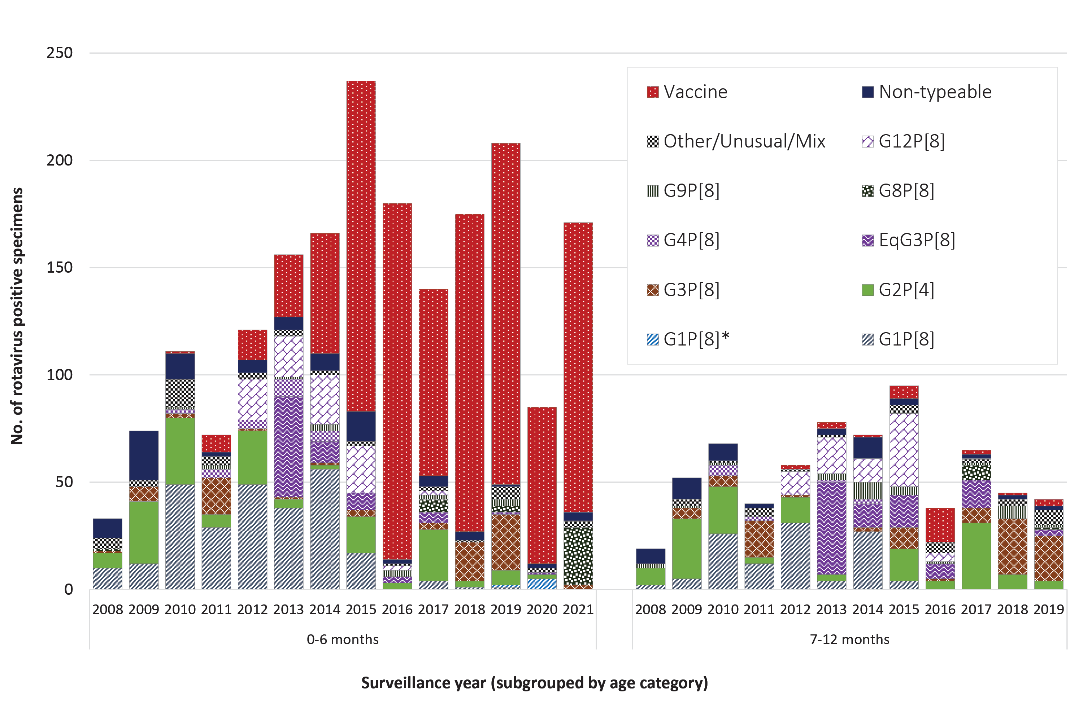

Communicable Diseases Intelligence
ISSN: 2209-6051 Online

Communicable Diseases Intelligence (CDI) is a peer-reviewed scientific journal published by the Office of Health Protection and Response, Department of Health and Aged Care. The journal aims to disseminate information on the epidemiology, surveillance, prevention and control of communicable diseases of relevance to Australia.

Editor: Noel Lally
Deputy Editor: Simon Petrie
Design and Production: Kasra Yousefi
Editorial Advisory Board: David Durrheim, Mark Ferson, John Kaldor, Martyn Kirk and Linda Selvey

Website: http://www.health.gov.au/cdi

Contacts
CDI is produced by the Office of Health Protection and Response, Australian Government Department of Health and Aged Care, GPO Box 9848, (MDP 6) CANBERRA ACT 2601

Email: cdi.editor@health.gov.au

Submit an Article
You are invited to submit your next communicable disease related article to the Communicable Diseases Intelligence (CDI) for consideration. More information regarding CDI can be found at: http://health.gov.au/cdi.
Further enquiries should be directed to: cdi.editor@health.gov.au.

This journal is indexed by Index Medicus and Medline.

Creative Commons Licence - Attribution-NonCommercial-NoDerivatives CC BY-NC-ND
© 2022 Commonwealth of Australia as represented by the Department of Health and Aged Care
This publication is licensed under a Creative Commons Attribution-NonCommercial-NoDerivatives 4.0 International Licence from https://creativecommons.org/licenses/by-nc-nd/4.0/legalcode (Licence). You must read and understand the Licence before using any material from this publication.

Restrictions
The Licence does not cover, and there is no permission given for, use of any of the following material found in this publication (if any):
- the Commonwealth Coat of Arms (by way of information, the terms under which the Coat of Arms may be used can be found at www.itsanhonour.gov.au);
- any logos (including the Department of Health and Aged Care’s logo) and trademarks;
- any photographs and images;
- any signatures; and
- any material belonging to third parties.

Disclaimer
Opinions expressed in Communicable Diseases Intelligence are those of the authors and not necessarily those of the Australian Government Department of Health and Aged Care or the Communicable Diseases Network Australia. Data may be subject to revision.

Enquiries
Enquiries regarding any other use of this publication should be addressed to the Communication Branch, Department of Health and Aged Care, GPO Box 9848, Canberra ACT 2601, or via e-mail to: copyright@health.gov.au

Communicable Diseases Network Australia
Communicable Diseases Intelligence contributes to the work of the Communicable Diseases Network Australia.
http://www.health.gov.au/cdna

http://blast.ncbi.nlm.nih.gov/Blast.cgi.

