Australian Paediatric Surveillance Unit (APSU) Annual Surveillance Report 2021
Suzy M Teutsch, Carlos A Nunez, Anne Morris, Guy D Eslick, Angela Berkhout, Daniel Novakovic, Julia ML Brotherton, Skye McGregor, Laila Khawar, Gulam Khandaker, Robert Booy, Cheryl A Jones, William Rawlinson, Bruce R Thorley, Elizabeth J Elliott

Abstract
The Australian Paediatric Surveillance Unit (APSU) has been conducting surveillance of rare communicable and non-communicable conditions in children since its inception in 1993. In this report, the results are described of surveillance of ten communicable diseases (and complications) for 2021, including the numbers of cases and incidence estimates; demographics; clinical features; and management and short-term outcomes. The included diseases are: acute flaccid paralysis (AFP); congenital cytomegalovirus (CMV); neonatal herpes simplex virus (HSV) infection; paediatric human immunodeficiency virus (HIV) infection; perinatal exposure to HIV; severe complications from influenza; juvenile-onset respiratory papillomatosis (JoRRP); congenital rubella syndrome; congenital varicella syndrome; and neonatal varicella infection. In 2021, cases of JoRRP were reported to the APSU for the first time since 2017, indicating potential gaps in HPV vaccination. AFP surveillance by APSU again contributed to Australia achieving a minimum target incidence of one AFP case per 100,000 children aged < 15 years. There were no cases of children with severe complications of influenza. No cases of varicella or congenital rubella were reported; however, at-risk populations, especially young migrant and refugee women from countries without universal vaccination programs, need to be screened and prioritised for vaccination prior to pregnancy. Cases of perinatal exposure to HIV continue to increase; however, the rate of mother-to-child-transmission remains at low levels due to the use of effective intervention strategies. Case numbers of congenital CMV and neonatal HSV remain steady in the absence of vaccines, prompting the need for greater awareness and education, with recent calls for target screening of at-risk infants for congenital CMV.
Keywords: Australia; child; communicable disease; emerging infectious diseases; public health surveillance; rare disease

Introduction
The Australian Paediatric Surveillance Unit (APSU) has proven to be a valuable resource in the 29 years since it was established, with prospective national surveillance conducted for over 70 rare childhood conditions to date, often collecting the first incidence estimates as well as detailed epidemiological and clinical data. Conditions that have so far been studied have included rare communicable diseases and complications of communicable diseases; genetic disorders; other rare diseases; uncommon injuries; and severe adverse reactions to medication and other therapies.
In 2021, the APSU conducted surveillance for ten communicable diseases and complications, as follows: acute flaccid paralysis (AFP); congenital CMV (cCMV); neonatal herpes simplex virus infection (HSV); paediatric human immunodeficiency virus (HIV) infection; perinatal exposure to HIV; severe complications from influenza; juvenile-onset respiratory papillomatosis (JoRRP); congenital rubella syndrome (CRS); congenital varicella syndrome (CVS); and neonatal varicella infection. This report presents the results of this surveillance.

Surveillance method
Monthly surveillance was conducted from 1 January to 31 December 2021 using previously- described methods.¹ A report card (Figure 1), either in electronic (95.4%) or in paper format (4.6%), was distributed each month to an average of 1,424 paediatricians and other clinicians engaged in child health, who were registered with the APSU and in active clinical practice (‘APSU contributors’). The report card listed 15 conditions under surveillance which included communicable diseases, rare injuries and uncommon adverse drug effects. APSU contributors were asked to complete a detailed case report form (CRF) if they had seen any child with one or more of the conditions listed on the card, either online using the secure Research Electronic Data capture (REDCap) platform^{2,3} hosted by the University of Sydney, or in paper format (which was manually entered into REDCap by APSU staff). The CRF captured data on demographics, risk factors, diagnosis, hospitalisation, clinical features, management, vaccination status (where a vaccine was available) and disease outcomes. If APSU contributors had not seen a case, they were still asked to return the monthly report card, indicating ‘nothing to report’ in order to calculate the overall response rate as a measure of clinician reporting. The resulting data were downloaded from REDCap into SPSS statistical software (Chicago, IL, USA) and analysed. Incidence estimates and 95% confidence intervals (95% CI) were calculated using known formulas, with population denominators obtained from the Australian Bureau of Statistics (ABS)⁴ for children aged < 16 years [paediatric HIV] and < 15 years [AFP, influenza, JoRRP], and from the Australian Institute of Health and Welfare (AIHW)⁵ for neonates and infants (live births) [cCMV, neonatal HSV, perinatal exposure to HIV, CRS, CVS, neonatal varicella]. Ethics approval for APSU surveillance studies was obtained from the Sydney Children’s Hospitals Network and from the University of New South Wales Human Research Ethics Committees.

Figure 1: Example of the APSU monthly report card in 2021
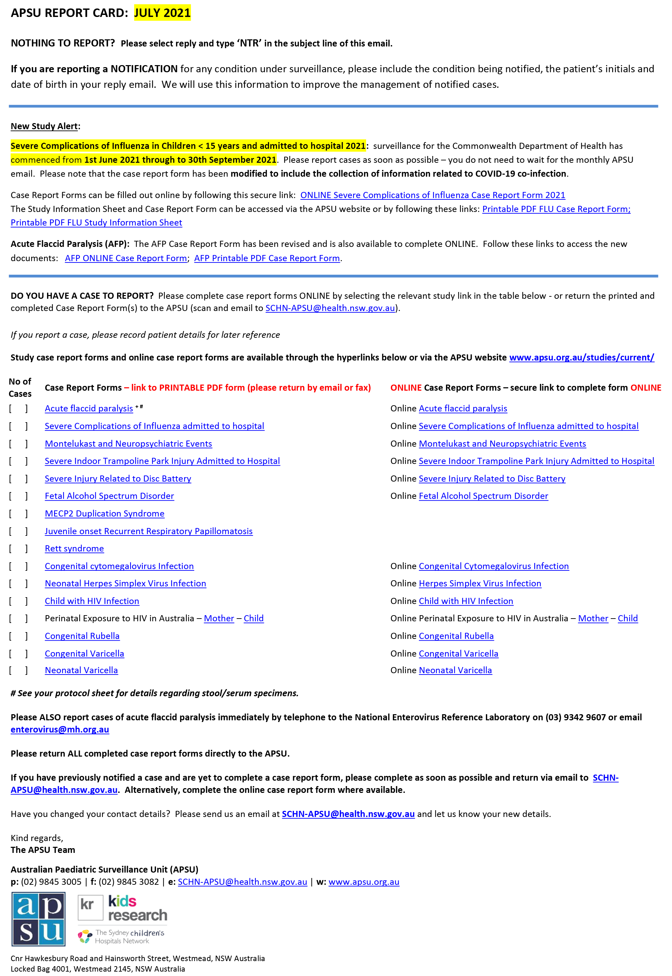

Results

Representativeness of reporting and response rates
In 2021, an average of 1,424 APSU contributors received the monthly APSU report card. Paediatricians (n = 1,321) accounted for the majority of contributors (93%), with clinicians from other specialities (n = 103) accounting for the remainder (Table 1). Contributors were distributed across every Australian state and territory (Figure 2), with the proportion of contributors in each state and territory approximately matching the proportion of children residing in those locations (Table 1).
APSU contributors were located in metropolitan, rural, and remote areas; they worked in both hospitals and in private practice in a range of specialities (Table 1 and Figure 3).
The overall response rate to the monthly APSU report card in 2021 was 81%, which included case notifications and ‘nothing to report’ responses. Prior to 2021, the response rate had consistently remained ≥ 90% for the previous 28 years.¹
Figure 2: Map of Australia showing distribution and numbers at each location of 1,424 paediatricians and other clinicians who were reporting to the APSU in 2021
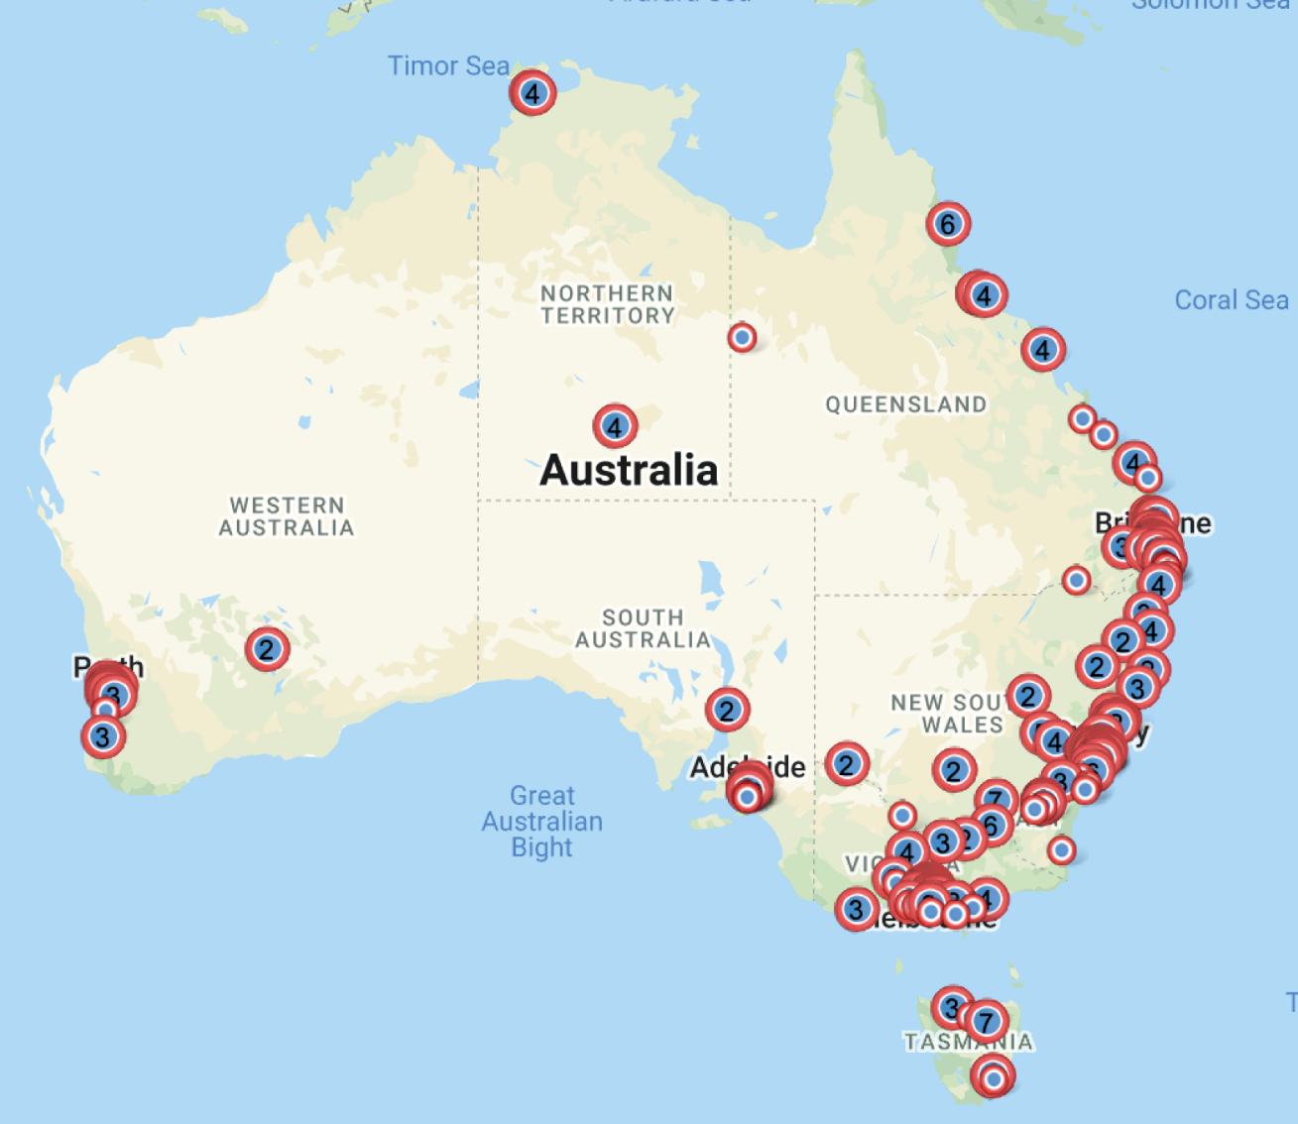

Table 1: Number and proportion of APSU contributors (n = 1,424) and child population (aged 0–14 years) by Australian state and territory, in 2021
Jurisdiction | APSU contributors  N = 1424 |  | Total child population  0–14 years  in 2021^{b} | Percentage  of child population  0–14 years  in 2021
 | Paediatricians | Other specialitiesª
Australian Capital Territory | 19 (1.3%) | 6 (0.4%) | 82,617 | 1.7
New South Wales | 473 (33.2%) | 50 (3.5%) | 1,507,622 | 31.6
Northern Territory | 19 (1.3%) | 3 (0.2%) | 52,552 | 1.1
Queensland | 231 (16.2%) | 8 (0.6%) | 998,190 | 20.9
South Australia | 85 (6.0%) | 7 (0.5%) | 309,805 | 6.5
Tasmania | 28 (2.0%) | 1 (0.1%) | 94,036 | 2.0
Victoria | 326 (22.8%) | 20 (1.4%) | 1,212,729 | 25.4
Western Australia | 140 (9.8%) | 8 (0.6%) | 517,627 | 10.8
Australia | 1,321 (92.8%) | 103 (7.2%) | 4,772,652 | 100
a Other specialities include: public health medicine; surgery; psychiatry; anaesthetics; general practice; nuclear medicine; obstetrics; sexual health medicine.
b Taken from reference 4.
Figure 3: Distribution of paediatricians (n = 1,321) contributing to the APSU in 2021 by speciality
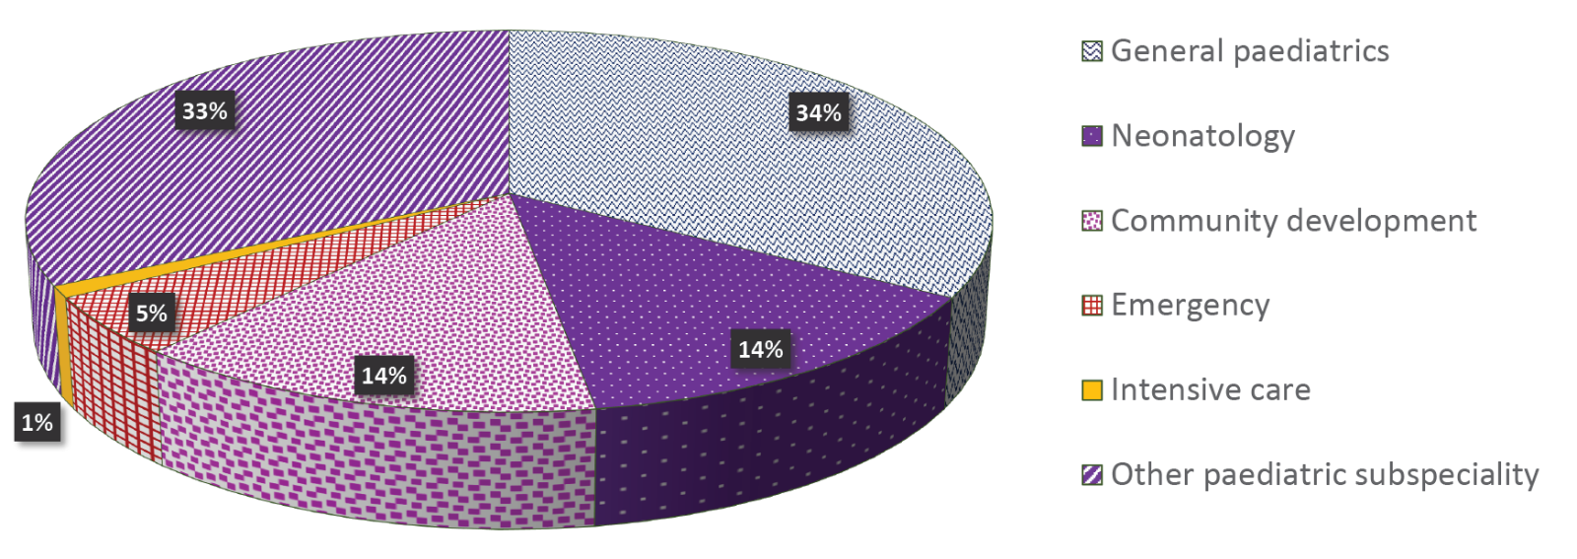

Total notifications, confirmed cases and incidence estimates of conditions under surveillance
A total of 207 notifications were received for the ten communicable diseases under APSU surveillance in 2021, with 160 notifications confirmed as cases and 33 classified as duplicates. Nine notifications were classified as reporting errors or had missing or insufficient data to confirm (Table 2).
Table 2: Notifications received in 2021 of communicable diseases and complications of communicable diseases under surveillance by the APSU, and their categorisation
Disease or complication under surveillance | Total notifications | Confirmed cases | Duplicates | Errorsª | Other^{b}
Acute flaccid paralysis^{c} | 86 | 63 | 19 | 4 | 0
Congenital cytomegalovirus | 60 | 45 | 8 | 5 | 2
Neonatal herpes simplex virus infection | 14 | 14 | 0 | 0 | 0
Perinatal exposure to HIV | 43 | 35 | 5 | 0 | 3
Paediatric HIV infection (non-perinatal exposure) | 0 | 0 | 0 | 0 | 0
Severe complications of influenza | 0 | 0 | 0 | 0 | 0
Juvenile-onset recurrent respiratory papillomatosis | 4 | 3 | 1 | 0 | 0
Congenital rubella syndrome | 0 | 0 | 0 | 0 | 0
Congenital varicella syndrome | 0 | 0 | 0 | 0 | 0
Neonatal varicella infection | 0 | 0 | 0 | 0 | 0
Total | 207 | 160 | 33 | 9 | 5
a Includes administrative errors, cases outside of study definition, missing case report forms or insufficient data provided to confirm.
b Historical (prevalent) cases not previously reported.
c Includes all cases of acute flaccid paralysis (AFP) reported via the APSU/National Enterovirus Reference Laboratory (NERL) and PAEDS surveillance systems. All confirmed cases have been classified by the Polio Expert Panel (PEP) as ‘non-polio AFP’ according to World Health Organization criteria. 31 cases were reported via APSU/NERL, with 22 of these cases confirmed and 14 cases duplicated by PAEDS.
Table 3 summarises the numbers of confirmed cases for each of the ten communicable diseases or complications of communicable diseases under APSU surveillance in 2021, and total numbers of confirmed cases for the study period to date. Incidence estimates (and 95% CIs) are also presented for 2021 and for the whole study period to date.

Table 3: Confirmed cases identified by the APSU during the period 1 January – 31 December 2021 and for the total study period, and estimated incidence per 105 children of the relevant population/age per annum, by condition
Communicable disease  or complication of communicable disease | Surveillance study date of commencement | Confirmed cases for Jan–Dec 2021 | Incidence estimate per 100,000 per annum  and 95% CI for 2021 | Confirmed cases for the whole study period to Dec 2021 | Incidence estimate per 100,000 per annum for the whole study period to Dec 2021
Acute flaccid paralysis | March 1995 | 63ª | 1.31 [1.03–1.69]^{b} | 1,246 | 1.14 [1.08–1.20]^{b}
Congenital cytomegalovirus | Jan 1999 | 45 | 14.71 [10.99–19.71]^{c} | 444 | 6.43 [5.86–7.06]^{c}
Neonatal herpes simplex virus | Jan 1997 | 14 | 4.58 [2.71–7.73]^{c} | 229 | 3.22 [2.83–3.67]^{c}
Perinatal exposure to HIV | May 1993 | 35 | 11.44 [8.22–15.94]^{c} | 963 | 11.85 [11.12–12.62]^{c}
Paediatric HIV infection (non-perinatal exposure) | May 1993 | 0 | 0 | 98 | 0.08 [0.06–0.09]^{d}
Severe complications of influenza^{e} | 2008 (flu season only) | 0 | 0 | 695 | 1.11 [1.03–1.20]^{b}
Juvenile-onset recurrent respiratory papillomatosis^{f} | Sep 2011 | 3 | 0.06 [0.02–0.19]^{b} | 20 | 0.04 [0.03–0.06^{b}
Congenital rubella infection/syndrome | May 1993 | 0 | 0 | 54 | 0.66 [0.51–0.87]^{c}
Congenital varicella syndrome | May 2006 | 0 | 0 | 4 | 0.08 [0.03–0.22]^{c}
Neonatal varicella | May 2006 | 0 | 0 | 31 | 0.64 [0.45–0.91]^{c}
a Includes all cases of AFP reported via the APSU, NERL and PAEDS. All cases have been classified by the PEP as ‘non-polio AFP’ according to WHO criteria.
b Based on population of children aged < 15 years.³
c Based on number of live births.⁴
d Based on population of children aged < 16 years.³
e Influenza surveillance was conducted each year during the influenza season, from July to September (inclusive) for 2008 and 2010–2015; June to October (inclusive) in the 2009 H1N1 influenza pandemic year; June to September (inclusive) 2016–2019; and May to September (inclusive) in the 2020-2021 SARS-CoV-2 coronavirus pandemic years.
f Includes both confirmed cases (visualisation on endoscopy, histological confirmation) and probable cases (visualisation on endoscopy, no histology report)

Results for each condition under surveillance

Acute flaccid paralysis
Syndromic surveillance for acute flaccid paralysis (AFP), the differential diagnosis for poliomyelitis, is critical for the Australian Government’s commitment to the global eradication of wild poliovirus and to monitor Australia’s polio-free certification by the World Health Organization (WHO) in the Western Pacific Region.^{6,7} The APSU was requested by the Australian Government Department of Health in 1995 to conduct AFP surveillance, which was later expanded in 2007 to include surveillance by the Paediatric Active Enhanced Disease Surveillance (PAEDS) network.⁸ The WHO international surveillance standards for a polio-free country are an annual incidence of at least one non-polio AFP case per 100,000 children aged < 15 years and two stool samples collected at least 24 hours apart and within 14 days of onset of paralysis (known as ‘adequate stools’) in ≥ 80% of cases.⁹ AFP cases identified using APSU surveillance are either notified to the APSU or directly to the National Enterovirus Reference Laboratory (NERL) using a standardised case report form (either electronic or paper-based) for all sources of reporting. AFP cases identified via PAEDS surveillance in the eight paediatric tertiary hospitals where PAEDS operates are notified to NERL by designated PAEDS nurses working within those hospitals, who collect case data using a case report form similar to that used by APSU. All AFP data are collated by NERL and cases are reviewed and classified by the Polio Expert Panel (PEP) and reported to WHO.¹⁰
In 2021, a total of 86 AFP notifications were contributed by both APSU/NERL and PAEDS surveillance systems, with 31 contributed by APSU/NERL. Sixty-three were confirmed as non-polio AFP and 19 were duplicates. An additional four cases were classified as errors (outside the age range or subsequent diagnosis not AFP). The incidence estimate was 1.31 (95% CI: 1.03–1.69) non-polio AFP cases per 100,000 children less than 15 years of age, which met the WHO annual surveillance target for Australia’s polio-free status. Adequate stool samples were collected from 39/63 (62%) of the confirmed non-polio AFP cases.
In 2021, there were 22 confirmed non-polio AFP cases notified via the APSU/NERL surveillance system, with 14 duplicated by PAEDS surveillance. Duplicates are important for validating the effectiveness of both surveillance systems. Five cases were identified outside of the eight hospitals where PAEDS operates and would therefore have been missed if PAEDS surveillance alone had been used.
Of the 63 confirmed cases, 28 were in New South Wales, 13 in Victoria, 10 in Queensland, seven in Western Australia, two each in South Australia and the Northern Territory and one case in Tasmania,. No cases were reported in the Australian Capital Territory.
Ethnicity was recorded for 58 cases and three were Aboriginal/Torres Strait Islander.
The most common diagnoses assigned by the PEP for the non-polio AFP cases were Guillain-Barré Syndrome (19), transverse myelitis (8), acute disseminated encephalomyelitis (ADEM)(4) and botulism (4). Two cases were diagnosed with acute flaccid myelitis (AFM).
In the 27 years since AFP surveillance commenced, a total of 1,246 confirmed non-polio AFP cases have been reported via the APSU/NERL and PAEDS surveillance systems. The WHO international AFP surveillance target has consistently been met for the last 14 years.¹¹
The APSU/NERL and PAEDS AFP surveillance systems allowed retrospective analysis of AFP case data over almost 20 years to identify and estimate the incidence of the rare condition of AFM,¹² having first been described in 2012 in the United States of America (USA).¹³ The analysis showed that AFM occurred sporadically in Australia up to 2010, and has occurred regularly since then. This study supports the current mechanism of AFP surveillance as being well positioned to identify future trends of AFM in Australia.¹²
AFP data were also published in the Australian National Enterovirus Reference Laboratory 2020 annual report¹¹ and in the Paediatric Active Enhanced Disease Surveillance (PAEDS) 2019 report to Communicable Diseases Intelligence.¹⁴
Australian AFP data were published fortnightly by the WHO Regional Office for the Western Pacific in the Polio Bulletin 2021⁶ and contributed to the WHO’s annual progress report on sustaining polio-free status in the Western Pacific Region.¹⁰

Congenital cytomegalovirus
The APSU has conducted surveillance of congenital cytomegalovirus (cCMV) since 1999. Although CMV infection in the community is common and is often mild or asymptomatic, infection of unborn children via maternal transmission during pregnancy is rare but may lead to a high level of mortality in newborn infants, including stillbirth, or severe morbidity, resulting in a range of clinical deficits that can include prematurity, low birth weight, sensorineural deafness, encephalitis, cerebral palsy, microcephaly, chorioretinitis, cataracts, hepatitis and pneumonitis.^{15–17}
A total of 60 cases of cCMV were notified to the APSU in 2021, with 45 cases confirmed. There were eight duplicate reports, five errors (missing data) and two historical cases diagnosed prior to 2021.
Thirty-eight infants were classified as having definite cCMV infection, and seven were classified with probable cCMV infection. Cases were aggregated to calculate an overall minimum incidence estimate of 14.71 per 100,000 births in 2021.
Of the 45 infants with confirmed cCMV, 18 were reported in New South Wales, 14 in Queensland, six in Western Australia, four in Victoria, two in South Australia and one in the Australian Capital Territory. No cases were reported in Tasmania or the Northern Territory.
Ethnicity was reported for 40 infants and one was Aboriginal/Torres Strait Islander.
Of the 45 infants, 18 were symptomatic (38%), with the most common clinical characteristics being: jaundice (19); thrombocytopaenia (15); hearing impairment (14, of which 11 were sensorineural); hepatitis (13); and intrauterine growth restriction (11). Brain imaging was conducted in 38 infants, with 13 having brain abnormalities detected, including periventricular or intraventricular cysts, subcortical white matter abnormalities, intraventricular haemorrhages and ventriculomegaly.
Antiviral treatment with valganciclovir or ganciclovir is currently recommended only for neonates with moderate to severe cCMV symptoms, including neurological symptoms and presentation of multiple symptoms, and only for a maximum of six months, due to the association of these antivirals with severe side effects.^{18–20} Of the 13/18 symptomatic infants who were eligible, all received antiviral treatment.
A symptomatic illness suggestive of maternal CMV infection was reported during pregnancy in eight of 45 mothers (18%) for whom these data were available. A positive immunoglobulin G (IgG) and/or IgM for CMV infection was reported in 19 mothers.
During 23 years of surveillance, a total of 444 confirmed cases of cCMV have been reported to the APSU, with annual case numbers remaining consistent over time. The highest number of cases was reported in 2021 (45 cases) and the lowest in 2003 (7 cases). We believe that the high number of cases reported in 2021 was the result of greater engagement between the APSU/cCMV study investigators and relevant reporting clinicians, which has increased over the last two years.
In 2021, a congenital CMV national registry was initiated in four Australian states (New South Wales, Victoria, Queensland and Western Australia) in order to study long-term outcomes of cCMV infection and the effects of antiviral treatment. APSU is collaborating with the Registry to improve case notification and minimise duplication of effort by reporting paediatricians.
Surveillance of congenital CMV by APSU is now the longest running CMV study in the world. APSU data have shown that cCMV incidence has remained steady over time; however, the disease remains under-recognised and under-diagnosed,²¹ despite being a major cause of developmental disability (including cerebral palsy) in infants and sensorineural hearing loss. ^{15,20} Analysis of APSU data has also led to recommendations of newborn CMV screening to better identify infants with cCMV,^{21,22} in the absence of a vaccine, which has again been recently proposed for use in Australia.²⁰
In 2021, a summary of APSU cCMV surveillance and findings were included in the Cerebral Palsy Alliance/CMV Australia cCMV Network Bulletin (https://www.cerebralpalsy.org.au). APSU findings from congenital CMV surveillance also supported to the development of eLearning course for midwives about CMV, which was shown to greatly improve their knowledge about the infection and prevention strategies in order to help educate expectant mothers.²³

Neonatal herpes simplex virus infection
The APSU has conducted surveillance of neonatal herpes simplex virus (HSV) in infants since January 1997. Currently, APSU contributors report infants aged ≤ 3 months with laboratory- confirmed HSV infection and evidence of either clinical HSV disease or asymptomatic HSV infection.
In 2021, there were 14 notifications of HSV infection in infants reported to the APSU, all of whom were neonates (aged ≤ 28 days) and all were confirmed as meeting case criteria. Six cases were reported in Victoria, five cases in New South Wales, two cases in Queensland and one case in the Australian Capital Territory. There were no cases reported in South Australia, Western Australia, Tasmania or the Northern Territory. All neonates were Australian- born and ethnicity was reported for 12 neonates. Two neonates were Aboriginal/Torres Strait Islander.
The most common serotype was HSV-1, seen in 11 of 14 cases (79%). Six neonates (43%) presented with central nervous system (CNS) disease; four (29%) with skin, eye, mouth (SEM) disease; two (15%) with disseminated disease; and two (15%) with asymptomatic HSV infection (screened due to known maternal HSV infection). One neonate with SEM disease also had keratitis. Two neonates with CNS disease also presented with SEM involvement and the two neonates with disseminated HSV disease also had SEM involvement, with one of these neonates also having CNS involvement. All neonates received antiviral management with Aciclovir.
Two neonates with disseminated HSV disease died. Of the 12 surviving neonates, neurological sequelae was reported at discharge for one neonate with CNS disease with generalised weakness. Extensive CNS involvement on neuroimaging was reported for this case, with bilateral restricted diffusion reported throughout the thalami, frontal, parietal and occipital lobes. One neonate with CNS disease had punctate white matter changes in both parietal lobes on neuroimaging; no neurological sequelae at discharge were reported for this neonate. The remaining four neonates with HSV CNS disease had normal neuroimaging and no focal neurology reported at discharge. The APSU is routinely conducting 12-month follow-up of survivors with neonatal HSV by sending a brief report form to the reporting paediatrician, requesting information on survival, neurological symptoms, neurodevelopment, sequelae and recurrences of HSV infection, so follow-up of these neonates should clarify whether there is any longer-term effects of HSV infection.
Since commencement of HSV surveillance, a total of 229 confirmed cases have been reported over the 25-year period, with incidence estimates remaining steady.²⁴ The highest number of cases was reported in 2015 (16 cases) and the lowest number in 2017 (4 cases).
Despite the reduction previously shown by us in mortality associated with high dose Aciclovir (60 mg/kg/day) in neonates with HSV disease,²⁴ significant neurological morbidity occurs in survivors, especially in those with CNS disease. A further analysis of neonatal HSV CNS disease in Australia over 24 years (1997–2020) compared with other forms of neonatal HSV is currently underway to investigate why this is the case and to also ascertain whether there are specific differences between CNS restricted and disseminated disease (with CNS involvement) that may influence disease outcomes.
In addition, a study was initiated by the APSU in 2021 to cross-match HSV cases ascertained by APSU in two Australian states with laboratory and medical record data collected on neonatal HSV cases in those states. This has been undertaken to obtain a more comprehensive understanding of the extent of neonatal HSV disease, as it is currently not notifiable in Australia.
In 2021 a Principal Investigator on the APSU HSV study, Dr Angela Berkhout, delivered oral presentations entitled: “Paediatric cohort study of Herpes Simplex Meningo-encephalitis in Queensland” at the Australasian Society Infectious Diseases Annual Scientific Meeting, and at the Centre for Children’s Health Research (CCHR), Brisbane.

Perinatal exposure to HIV and paediatric HIV infection
Since 1993, the APSU has been conducting surveillance for perinatal exposure to human immunodefiociency virus (HIV) and paediatric HIV. While HIV among infants and children is rare in Australia, there remains a risk of infection, most often from perinatal exposure from a mother living with HIV, especially if born in a country where there is high HIV prevalence.

Perinatal exposure to HIV
In 2021, there were 43 infants with perinatal exposure reported to the APSU, of whom five were duplicates and three were historical cases born in 2008, 2017 and 2020, and not previously reported. All of the 35 confirmed cases were infants born in 2021 in Australia. Based on 35 cases, the incidence estimate of perinatal exposure in 2021 was 11.44 per 100,000 births (Table 3).
Of the 35 confirmed cases, 15 infants were reported in Western Australia, ten in Victoria, five in New South Wales, four in Queensland and one in the Australian Capital Territory. No cases were reported in South Australia, Tasmania or the Northern Territory. One infant was Aboriginal/Torres Strait Islander.
As reporting clinicians were asked to complete separate case report forms for both the infant and the mother, completion of only one form often occurred, resulting in incomplete datasets.
HIV test results for perinatally exposed infants were only available when infant CRFs were completed and only 24/35 were returned. Of the 24 infants, 19 tested negative at their most recent test and five had an unknown result at the time of reporting. Nineteen infants were reported to have been treated with prophylactic antiviral treatment after birth. The APSU is now conducting an 18-month follow-up to determine the children’s HIV status based on clinical guidelines.
Data were available for 16 mothers. Thirteen (81%) were born outside of Australia and no mothers who were born in Australia were Aboriginal/Torres Strait Islander. All mothers received antiretroviral therapy during pregnancy. The most common mode of delivery was vaginal birth (10), followed by caesarean section (6) with one being an elective procedure. One infant was breastfed for five days. The risk of mother-to-child transmission (MTCT) of HIV may be substantially reduced through the mother’s use of antiretroviral therapy during pregnancy and through antiretroviral and prophylactic treatment of the child, elective caesarean section delivery if appropriate, and avoidance of breastfeeding.²⁵
For two of the cases with perinatal exposure, who were born in 2017 and 2020, the place of birth was Australia and their HIV test results were negative. However, the case born in 2008 with perinatal exposure tested positive to HIV and was born outside Australia in a country with a high prevalence of HIV. HIV-1 was the identified sub-type and the child was reported to have AIDS defining illness at the time of HIV testing in 2021.

Paediatric HIV
At the time of reporting, there were no children with paediatric HIV (non-perinatal exposure) diagnosed in 2021. No cases have been reported to the APSU since 2014.²⁶

Summary
In 29 years of surveillance, a total of 963 confirmed cases of perinatal exposure to HIV and 98 confirmed cases of paediatric HIV infection have been reported to the APSU (Table 2).
Data on perinatal HIV exposure and perinatal HIV transmission in Australian born infants and paediatric HIV infections are routinely reported in the Australian Annual Surveillance Report on HIV, viral hepatitis and sexually transmissible infections.²⁷
We conducted an analysis of APSU perinatal exposure to HIV surveillance data over the whole study period 1993–2021, which showed that 47 cases had acquired HIV infection due to MTCT.²⁸ Furthermore, the MTCT rate significantly declined during this period from 27.6% in 1993–1996 to 1.5% in 2017–2021 (Figure 4).²⁸
Figure 4: Rate of mother-to-child-transmission (MTCT) of HIV in Australian-born children potentially exposed to HIV, 1993–2021
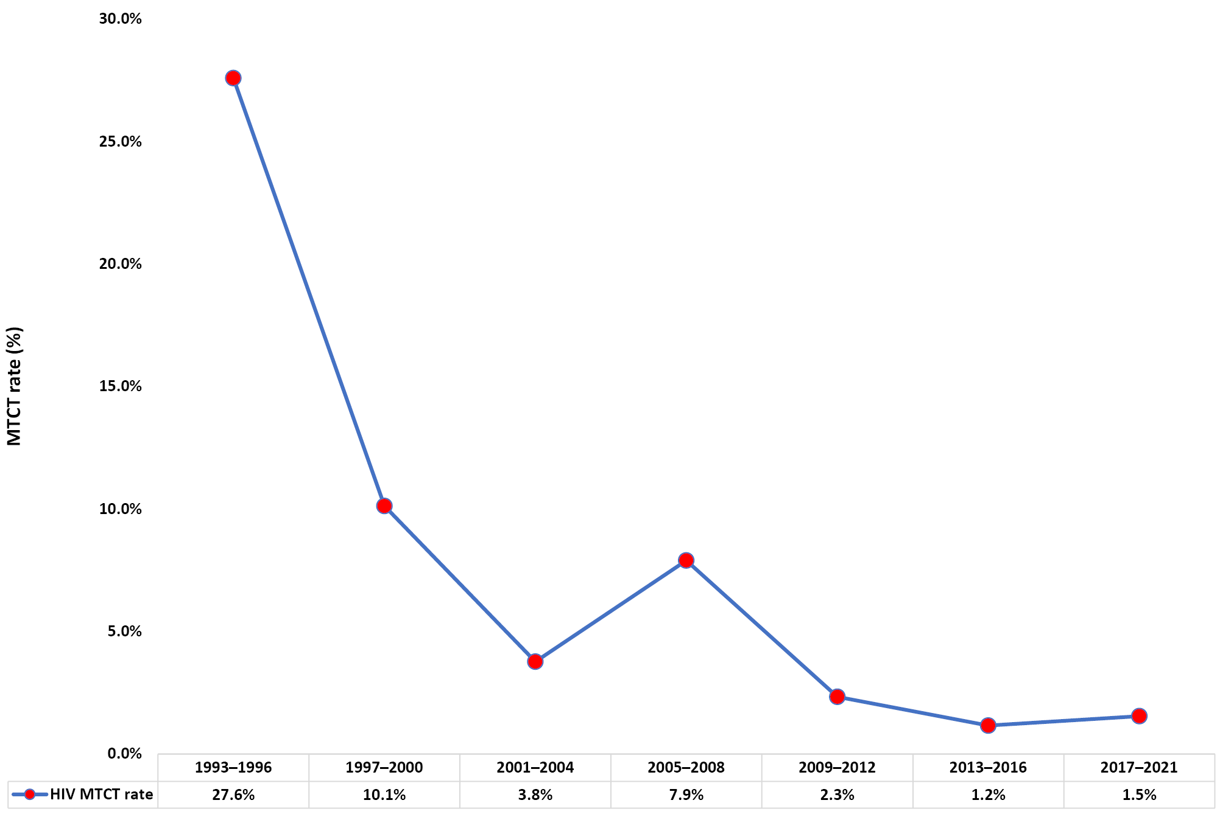
These data were also presented as a plenary talk at the Joint Australasian HIV /AIDS and Sexual Health Conferences: Paediatric HIV and Hepatitis Special Theme Day in September 2021. (Abstract: Khawar L, King J, Donovan B, Bartlett A, Miranda CN, Morris A, Palasanthiran P, Teutsch S, Elliot E, Costello J, Kaldor J, Guy R, McGregor S. “Evaluating progress towards elimination of mother-to-child transmission (EMTCT) of HIV on Australia”.)

Severe complications of influenza
Since 2008, APSU has conducted annual seasonal surveillance of severe complications of influenza in hospitalised children aged < 15 years with laboratory-confirmed influenza infection. Severe complications of influenza in children can lead to significant morbidity and mortality, with a range of organ systems affected, including the lungs, heart, kidneys, and central nervous system.^{29,30} We recently analysed 11 years of APSU surveillance of severe influenza (2008–2018), and showed that over a quarter of all children, (165/633; 26%) had neurological complications associated with influenza, and that almost half of all deaths (15/32; 47%) were associated with these neurological complications. For the 2020 winter season, the APSU added questions about co-infection with COVID-19 to the case report form,¹ and these questions were again included in the 2021 CRF. A recent large study of hospitalised adults in the United Kingdom showed that co-infection of COVID-19 with influenza significantly increased the likelihood of requiring mechanical ventilation as well as the likelihood of death.³¹
Between 1 May and 30 September 2021, there were no notifications of children with severe complications of influenza reported to the APSU in any Australian state or territory. This is the second consecutive year of no cases being reported. In contrast, 62 confirmed cases were reported in 2019 and a total of 695 cases were reported during the first 12 years (2008–2019) of surveillance.³⁰
The absence, of children reported with severe complications of influenza reported to the APSU in 2021, is consistent with the marked reduction of notifications reported to other surveillance systems.³² As in 2020, this was most likely due to strict physical distancing measures and, to a lesser extent, to the use of influenza vaccination in children.^{33,34} In particular, the continued use of government-mandated public health measures to reduce circulating cases of COVID-19 during the ongoing SARS-Cov-2 pandemic, including closure of international and interstate borders, stay-at-home restrictions, physical distancing, mask wearing, and hand hygiene have likely attributed to lower case numbers of influenza infection observed in children.^{35–37} However, as restrictions for reducing COVID-19 transmission have started to ease across all Australian states in early 2022, following the introduction and high uptake of COVID-19 vaccination in 2021, influenza infections could substantially increase again in the community. Ongoing surveillance of severe influenza in children, in the 2022 winter season, will continue. Moreover, influenza vaccination in children aged ≥ 6 months to < 5 years was reduced in 2021, with a 40% reduction in vaccinations³⁸ despite the expansion in 2020 of free influenza vaccination for children in this age group under the National Immunisation Program (NIP).³⁹

Juvenile-onset recurrent respiratory papillomatosis
The APSU has been conducting surveillance of juvenile-onset recurrent respiratory papillomatosis (JoRRP) in children aged < 15 years since October 2011, following the implementation of a universal human papillomavirus vaccination program in Australia in 2007, initially for adolescent females and from 2013 for adolescent males.⁴⁰
In 2021, there were four notifications of JoRRP reported to the APSU. Three cases were confirmed and there was one duplicate report. All cases were reported in New South Wales. Ethnicity was recorded for all children and one was Aboriginal/Torres Strait Islander. Clinical symptoms included hoarseness and acute respiratory distress. HPV genotyping was available for one child, with genotype 6 present, which is causative of JoRRP ⁴¹ and targeted by the HPV vaccine.⁴² HPV vaccination status was recorded for one overseas- born mother, who had not been vaccinated (too old for routine school program vaccination in her country of birth). One other mother was born outside Australia in a country that does not have a universal vaccination program for HPV. No details about the third mother were available.
These are the first cases of JoRRP that have been reported to the APSU since 2017.⁴³ A total of 20 cases of JoRRP have been reported to the APSU during nine years of surveillance, with cases reported in each year until 2017, declining from a maximum of seven cases in 2012.⁴⁴ The appearance of new cases in 2021 suggests that gaps may remain in HPV vaccination coverage amongst adult women now bearing children in Australia.

Congenital rubella infection/syndrome
The APSU has been conducting surveillance for definite and suspected congenital rubella infection, either with or without defects, since 1993.
There were no notifications of congenital rubella infection/syndrome reported to the APSU in 2021, for the sixth consecutive year. This was consistent with the absence of congenital rubella notifications reported to the National Notifiable Diseases Surveillance System (NNDSS) during the same time period. The last reported congenital rubella case was in 2015.⁴⁵ Since APSU surveillance commenced, a total of 54 cases of definite or suspected congenital rubella infection/syndrome have been reported.
Over the 29 years of congenital rubella surveillance, cases numbers were at their highest in 1993–1996 with a total of 24 cases reported during those years, declining significantly in subsequent years.⁴⁶⁻⁴⁸

Congenital varicella syndrome and neonatal varicella infection
The APSU has twice conducted surveillance for both congenital varicella syndrome (CVS) and neonatal varicella infection: firstly in 1995–1997,⁴⁹ prior to the introduction of universal vaccination for children aged 18 months in 2005;⁵⁰ and secondly, since 2006, in the post-vaccination era.^{51,52}
There were no cases of either congenital or neonatal varicella reported to the APSU in 2021. One case of CVS was previously reported to the APSU in 2020.¹ Three cases of neonatal varicella were previously reported to the APSU in 2019.⁵³
A total of four cases of CVS and 31 cases of neonatal varicella have been reported to the APSU in the last 16 years.
An analysis of APSU congenital and neonatal varicella data collected between 2006 and 2020 has showed a significant and sustained decrease in the incidence of these diseases in the 15 years since universal varicella vaccination was introduced; however, persistent congenital and neonatal varicella infection is still occurring in the infants of at-risk migrant and refugee women from countries without similar vaccination programs.

Discussion and conclusions
Since 1993, the APSU has contributed critical national data on rare communicable diseases and complications of rare diseases using active monthly paediatrician reporting. The surveillance mechanism is valued by paediatricians for its simplicity, minimal workload and ability to guide clinical practice, research and public policy. ^{54,55} In 2021, the process for reporting case data improved for APSU contributors, with online reporting extended for all surveillance studies.
The response rate to the monthly report card from APSU contributors was lower in 2021 at only 81%, compared with the previous 28 years of ≥ 90%. Although the 81% result still represents good engagement by clinicians reporting to the APSU, we speculate that the unexpected decline in response rate may have been due to ongoing disruptions, increased workloads and fatigue experienced by contributors during the second year of the COVID-19 pandemic, especially with the prolonged lockdowns in Australia’s eastern states.
In 2021, surveillance of ten communicable diseases and complications of communicable diseases resulted in the following:
- The reporting of JoRRP cases to the APSU for the first time in four years warrants continued surveillance of this disease, to better identify gaps in HPV vaccination. Global coverage of HPV vaccination fell for the first time in 2020 (in relation to COVID-19 pandemic disruptions) to just 13% for two doses (from 20% in 2019), despite its introduction in 111 countries, including low and middle-income countries.⁵⁶ Global coverage is well short of the scale-up vaccination goal of 90% two-dose coverage for 15-year old girls by 2030, which has been set by the WHO in order to achieve the eventual elimination of cervical cancer as a public health problem (incidence < 4 per 100,000).⁵⁷
- The minimum surveillance target of ≥ 1 non-polio AFP case per 100,000 children aged < 15 years was again achieved in 2021, contributing to the retention of Australia’s polio-free status. However, maintaining a sensitive AFP surveillance system is required since, until the global eradication of polio is certified, Australia remains at risk of importing wild-type or vaccine-derived poliovirus.
- The report of no cases of severe influenza, for the second consecutive year, is a likely result of continued mandatory restrictions and public health measures implemented during the COVID-19 pandemic, which may change following the easing of such restrictions in the 2022 influenza season. The impact of changes in influenza vaccine coverage in children aged six months to less than five years during this period, due e.g. to full funding under the NIP,⁵⁸ should also be monitored for its impact on the numbers of severe cases going forward.
- Reductions in the incidence of other vaccine-preventable diseases in infants, including congenital rubella, CVS, and neonatal varicella continue, although targeted vaccination of young migrant and refugee women from countries without universal vaccination programs and continued surveillance of these diseases is still required to further reduce incidence. Vaccine coverage of measles-mumps-rubella-varicella under the NIP in children by age 60 months continues to increase across Australia, with 96.8% coverage in 2020.⁵⁸
- The incidence of congenital CMV and neonatal HSV have not declined significantly during long-running APSU surveillance of these infections, indicating the importance of education and other strategies to reduce case numbers in the absence of suitable vaccines. Analysis of APSU data has previously recommended targeted screening of cCMV in newborns who fail routine hearing tests ²² and universal CMV screening of newborns ²¹ and there has recently been a renewed call to introduce targeted cCMV screening in Australia, with the implementation of a clinical trial in the state of Western Australia,²⁰ which was also reiterated by one of us (WR).⁵⁹ Also, one of us (WR) has recently shown inhibition of CMV in human placental cells by a microRNA molecule produced naturally by the placenta, suggesting a potential antiviral treatment that could be safely used to prevent congenital CMV in pregnancy.⁶⁰ Ongoing APSU surveillance of congenital CMV will therefore be required to assess the effects of new therapeutics and vaccine targets on disease incidence and severity.
- Although case numbers for perinatal exposure to HIV have increased over time, reflecting a larger population of women of childbearing age living with HIV, and greater reproductive choices, MTCT transmission has significantly decreased due to implementation of prevention strategies. Paediatric HIV cases caused by non-perinatal exposures continue to decline and are mostly imported from countries where HIV infection is prevalent. It is important that Australia continues to monitor perinatal exposure to HIV, and paediatric HIV, to both assess progress with WHO targets of elimination of MTCT of HIV,⁶¹ and to ensure a comprehensive understanding of children living with HIV in Australia.
- As the APSU has been previously shown the capacity to rapidly respond to new and emerging infections of concern, e.g. severe influenza,⁶² in 2021 the APSU developed study protocols and case report forms for the surveillance of dengue and Q fever, for implementation in early 2022. The epidemiology of these communicable diseases, caused by dengue virus and the Coxiella burnetii bacterium respectively, has not been well studied in children, as well as the extent of their distribution in Australia. The development of vaccines for both of these infections in children are currently underway. Data from these studies will therefore be able to provide new insights into the characteristics and outcomes of these infections prior to vaccination.

Acknowledgements
We thank all Australian paediatricians for their ongoing, voluntary contribution to APSU surveillance and for providing data to inform clinical care, policy and prevention. We also acknowledge the contribution and expertise of all researchers, clinicians and research groups who use the APSU mechanism.
We thank current APSU Scientific Review Panel members (David Burgner, Fiona Mackie, Mavis Duncanson, David Lester-Smith, Tasneem Karim, Ravisha Srinivasjois) and previous members (Carol Bower, Bin Jalaludin, Nigel Dickson, Yvonne Zurynski, Jane Bell) for providing expertise that has greatly assisted in study development.
APSU acknowledges the contribution of study coordinators Linda Hobday and Arnau Garcia-Clapes (AFP); Ece Egilmezer and Susanne Booth (cCMV); and Ela Naruka (HIV).
Special thanks go to APSU Administration Officer Dannielle Handel for the management of the APSU database and for providing the clinician data for this report.
APSU activities are supported by the Australian Government Department of Health and Aged Care; The University of Sydney, Faculty of Medicine and Health, Discipline of Child and Adolescent Health; The Children’s Hospital at Westmead and the Royal Australasian College of Physicians. Elizabeth Elliott is supported by an NHMRC MRFF Practitioner Fellowship (#1135959).

Author details
Dr Suzy M Teutsch, Research Fellow, The Australian Paediatric Surveillance Unit; The University of Sydney, Faculty of Medicine and Health, Discipline of Child and Adolescent Health; and The Sydney Children’s Hospitals Network, Westmead, Sydney, New South Wales, AUSTRALIA.
Dr Carlos A Nunez, Research Associate, The Australian Paediatric Surveillance Unit and The University of Sydney, Faculty of Medicine and Health, Discipline of Child and Adolescent Health; and The Sydney Children’s Hospitals Network, Westmead, Sydney, New South Wales, AUSTRALIA.
Dr Anne Morris, Senior Research Fellow, Paediatrician and Senior Lecturer, The Australian Paediatric Surveillance Unit; The University of Sydney, Faculty of Medicine and Health, Discipline of Child and Adolescent Health; and The Sydney Children’s Hospitals Network, Westmead, Sydney, New South Wales, AUSTRALIA.
A /Prof. Guy D Eslick, Director of Research, The Australian Paediatric Surveillance Unit; The University of Sydney, Faculty of Medicine and Health, Discipline of Child and Adolescent Health; and The Sydney Children’s Hospitals Network, Westmead, Sydney, New South Wales, AUSTRALIA.
Dr Angela Berkhout, Paediatric Infectious Diseases Physician, Infection Management & Prevention Service, The Queensland Children’s Hospital; and
The University of Queensland, Faculty of Medicine, Brisbane, Queensland, AUSTRALIA.
A/Prof. Daniel Novakovic, ENT, Head and Neck Surgeon, Laryngologist, and Director, Dr Liang Voice Program, The University of Sydney, Faculty of Medicine and Health, Central Clinical School, Sydney, New South Wales, AUSTRALIA.
Prof. Julia ML Brotherton, Medical Director, Population Health, Australian Centre for the Prevention of Cervical Cancer; and Professor of Cancer Prevention Policy and Implementation, Melbourne School of Population and Global Health, University of Melbourne, Victoria, AUSTRALIA.
Dr Skye McGregor, Epidemiologist, The Kirby Institute, The University of New South Wales, Sydney, New South Wales, AUSTRALIA.
Dr Laila Khawar, Senior Research Officer, The Kirby Institute, The University of New South Wales, Sydney, New South Wales, AUSTRALIA.
Prof. Gulam Khandaker, Director of Public Health/Public Health Physician and Director of Medical Research, Central Queensland Hospital and Health Service, Rockhampton, Queensland, AUSTRALIA.
Prof. Robert Booy, Senior Professorial Fellow, The University of Sydney, Faculty of Medicine and Health; and the National Centre for Immunisation Research and Surveillance, Sydney, New South Wales, AUSTRALIA.
Prof. Cheryl A Jones, Dean and Head of Sydney Medical School, The University of Sydney, Faculty of Medicine and Health, Sydney, New South Wales, AUSTRALIA.
Prof. William Rawlinson, Senior Medical Virologist, Director of Serology, Virology and OTDS Laboratories, NSW Health Pathology Randwick and UNSW Sydney, New South Wales, AUSTRALIA.
A/Prof. Bruce R Thorley, Head, National Enterovirus Reference Laboratory and WHO Polio Regional Reference Laboratory, Victorian Infectious Disease Reference Laboratory, The Peter Doherty Institute for Infection and Immunity, Melbourne, Victoria, AUSTRALIA.
Prof. Elizabeth J Elliott, Professor of Paediatrics and Child Health and Director of the Australian Paediatric Surveillance Unit; The University of Sydney, Faculty of Medicine and Health, Discipline of Child and Adolescent Health; and The Sydney Children’s Hospitals Network, Westmead, Sydney, New South Wales, AUSTRALIA.

Corresponding author
Dr Suzy M. Teutsch, Research Fellow,
The Australian Paediatric Surveillance Unit, Kids Research Sydney Children’s Hospitals Network, Westmead, Locked Bag 4001, Westmead NSW, AUSTRALIA, 2145.
Telephone: +61 2 9845 3025
Email: suzy.teutsch@health.nsw.gov.au

References
- Teutsch SM, Nunez CA, Morris A, Eslick GD, Khandaker G, Berkhout A et al. Australian Paediatric Surveillance Unit (APSU) Annual Surveillance Report 2020. Commun Dis Intell (2018). 2021;45. doi: https://doi.org/10.33321/cdi.2021.45.59.
- Harris PA, Taylor R, Thielke R, Payne J, Gonzalez N, Conde JG. Research electronic data capture (REDCap)—a metadata-driven methodology and workflow process for providing translational research informatics support. J Biomed Inform. 2009;42(2):377–81. doi: https//doi.org/10.1016/j.jbi.2008.08.010.
- Harris PA, Taylor R, Minor BL, Elliott V, Fernandez M, O’Neal L et al. The REDCap consortium: building an international community of software platform partners. J Biomed Inform. 2019;95:103208. doi: https://doi.org/10.1016/j.jbi.2019.103208.
- Australian Bureau of Statistics. 31010do002_202106. National, state and territory population, June 2021. [Webpage.] [Accessed on 18 February 2022.] https//:www.abs.gov.au.
- Australian Institute of Health and Welfare (AIHW). Australia’s children. (Cat. no. CWS 69). Canberra: AIHW; 18 March 2020. Available from: https://www.aihw.gov.au/reports/children-youth/australias-children.
- World Health Organization (WHO) Regional Office for the Western Pacific (WPRO). Polio Bulletin 2021. [Webpage.] Manila: WPRO; 2021. Available from: https://apps.who.int/iris/handle/10665/338522.
- WHO. Major milestone reached in global polio eradication: Western Pacific Region is certified polio-free. Commun Dis Intell. 2000;24(10):304.
- Zurynski Y, Davey E, Elliott EJ. Australian Paediatric Surveillance Unit annual report, 2008 and 2009. Commun Dis Intell Q Rep. 2010;34(3):285–90.
- WHO. Poliomyelitis. [Webpage.] Geneva: WHO; 5 September 2018. [Accessed on 25 March 2022.] Available from: https://www.who.int/immunization/ monitoring_surveillance/burden/vpd/ WHO_SurveillanceVaccinePreventable_18_ Polio_R2.pdf.
- WHO. Twenty-seventh Meeting of the Regional Commission for the Certification of Poliomyelitis Eradication in the Western Pacific, Virtual meeting, 9–11 November 2021: meeting report. Geneva: WHO; 2021. Available from: https://apps.who.int/iris/handle/10665/352186.
- Kaye M, Garcia-Clapes A, Hobday L, Ibrahim A, Chanthalavanh P, Bruggink L et al. Australian National Enterovirus Reference Laboratory annual report, 2020. Commun Dis Intell (2018). 2021;45. doi: https://doi/org/10.33321/cdi.2021.45.56.
- Walker LJ, Thorley BR, Morris A, Elliott EJ, Saul N, Britton PN. Using the acute flaccid paralysis surveillance system to identify cases of acute flaccid myelitis, Australia, 2000‒2018. Emerg infect Dis. 2022;28(1):20–8. doi: https://doi.org/10.3201/eid2801.211690.
- Kidd S, Lopez A, Nix WA, Anyalechi G, Itoh M, Yee E et al. Vital Signs: clinical characteristics of patients with confirmed acute flaccid myelitis, United States, 2018. MMWR Morb Mortal Wkly Rep. 2020;69(31):1031–8. https://doi.org/10.15585/mmwr.mm6931e3.
- Dinsmore N, McRae JE, Quinn HE, Glover C, Dougherty S, McMinn A et al. Paediatric Active Enhanced Disease Surveillance (PAEDS) 2019: prospective hospital-based surveillance for serious paediatric conditions. Commun Dis Intell (2018). 2021;45. doi: https://doi.org/10.33321/cdi.2021.45.53.
- Munro SC, Trincado D, Hall B, Rawlinson WD. Symptomatic infant characteristics of congenital cytomegalovirus disease in Australia. J Paediatr Child Health. 2005;41(8):449–52. doi: https://doi.org/10.1111/j.1440-1754.2005.00665.x.
- Lombardi G, Garofoli F, Stronati M. Congenital cytomegalovirus infection: treatment, sequelae and follow-up. J Matern Fetal Neonatal Med. 2010;23(Suppl 3):45–8. doi: https://doi.org/10.3109/14767058.2010.506753.
- Ssentongo P, Hehnly C, Birungi P, Roach MA, Spady J, Fronterre C et al. Congenital cytomegalovirus infection burden and epidemiologic risk factors in countries with universal screening: a systematic review and meta-analysis. JAMA Netw Open. 2021;4(8):e2120736. doi: https://doi.org/10.1001/jamanetworkopen.2021.20736.
- Rawlinson WD, Boppana SB, Fowler KB, Kimberlin DW, Lazzarotto T, Alain S et al. Congenital cytomegalovirus infection in pregnancy and the neonate: consensus recommendations for prevention, diagnosis, and therapy. Lancet Infect Dis. 2017;17(6):e177–88. doi: https://doi.org/10.1016/S1473-3099(17)30143-3.
- Poole CL, Kimberlin DW. Antiviral drugs in newborn and children. Pediatr Clin North Am. 2017;64(6):1403–15. doi: https://doi.org/10.1016/j.pcl.2017.08.014.
- Reid A, Bowen AC, Brennan-Jones CG, Kuthubutheen JB. Congenital cytomegalovirus: the case for targeted infant screening in Australia. Med J Aust. 2022;216(4):167–71. doi: https://doi.org/10.5694/mja2.51406.
- Bartlett AW, Hall BM, Palasanthiran P, McMullan B, Shand AW, Rawlinson WD. Recognition, treatment and sequelae of congenital cytomegalovirus in Australia: an observational study. J Clin Virol. 2018;108:121–5. doi: https://doi.org/10.1016/j.jcv.2018.09.017.
- McMullan, BJ, Palasanthiran, P, Jones CA, Hall BM, Robertson PW, Howard J et al. Congenital cytomegalovirus--time to diagnosis, management and clinical sequelae in Australia: opportunities for earlier identification. Med J Aust. 2011;194(12):625–9. doi: https://doi.org/10.5694/j.1326-5377.2011.tb03144.x.
- Smithers-Sheedy H, Swinburn K, Waight E, King R, Hui L, Jones CA et al. eLearning significantly improves maternity professionals’ knowledge of the congenital cytomegalovirus prevention guidelines. Aust N Z J Obstet Gynaecol. 2022. doi: https://doi.org/10.1111/ajo.13500.
- Jones CA, Greenow-Raynes C, Isaacs D, Neonatal HSV Study Investigators and Contributors to the APSU. Population-based surveillance of neonatal herpes simplex virus infection in Australia, 1997–2011. Clin Infect Dis. 2014;59(4):525–31. doi: https://doi.org/10.1093/cid/ciu381.
- Townsend CL, Cortina-Borja M, Peckham CS, de Ruiter A, Lyall H, Tookey PA. Low rates of mother-to-child transmission of HIV following effective pregnancy interventions in the United Kingdom and Ireland, 2000–2006. AIDS. 2008;22(8):973–81. doi: https://doi.org/10.1097/QAD.0b013e3282f9b67a.
- Deverell M, Phu A, Zurynski YA, Elliott EJ, all chief investigators of APSU surveillance studies. Australian Paediatric Surveillance Unit annual report, 2014. Commun Dis Intell Q Rep. 2016;40(2):E216–20.
- King J, McManus H, Gray R, McGregor S. HIV, viral hepatitis and sexually transmissible infections in Australia Annual surveillance report 2021: HIV. Sydney: University of New South Wales (UNSW), Kirby Institute; 2021. Available from: https://kirby.unsw.edu.au/sites/default/files/kirby/report/Annual-Suveillance-Report-2021_HIV.pdf.
- Khawar L. Evaluating progress towards elimination of mother-to-child transmission of HIV in Australia. In New methods to track progress toward elimination of sexually transmissible infections and blood-borne viruses in Australia. 2021, Doctoral dissertation, the Kirby Institute, UNSW Sydney.
- Khandaker G, Zurynski Y, Buttery J, Marshall H, Richmond PC Dale RC et al. Neurologic complications of influenza A (H1N1) pdm09: surveillance in 6 pediatric hospitals. Neurology. 2012;79(14):1474–81. doi: https://doi.org/10.1212/WNL.0b013e31826d5ea7.
- Teutsch SM, Zurynski YA, Nunez C, Lester-Smith D, Festa M, Booy R et al. Ten years of national seasonal surveillance for severe complications of influenza in Australian children. Pediatr Infect Dis J. 2021;40(3):191–8. doi: https://doi.org/10.1097/INF.0000000000002961.
- Swets MC, Russell CD, Harrison EM, Docherty AB, Lone N, Girvan M et al. SARS-CoV-2 co-infection with influenza viruses, respiratory syncytial virus, or adenoviruses. Lancet. 2022;399(10334):1463–4. doi: https://doi.org/10.1016/S0140-6736(22)00383-X.
- Australian Government Department of Health. Australian Influenza Surveillance Report. No. 11, 2021. Reporting fortnight: 16 to 29 August 2021. Canberra: Australian Government Department of Health; 2021. Available from: https://www1.health.gov.au/internet/main/publishing.nsf/Content/136525040161BBB0CA258744007DCFB6/$File/flu-11-2021.pdf.
- Beard F, Hendry A, Macartney K. Influenza vaccination uptake in Australia in 2020: impact of the COVID-19 pandemic? Commun Dis Intell (2018). 2021;45. doi: https://doi.org/10.33321/cdi.2021.45.10.
- Carlson SJ, Blyth CC, Beard FH, Hendry AJ, Cheng AC, Quinn HE et al. Influenza disease and vaccination in children in Australia. Med J Aust. 2021;215(2):64–7.e1. doi: https://doi.org/10.5694/mja2.51100.
- Abo YN, Clifford V, Lee LY, Costa AM, Crawford N, Wurzel D, Daley AJ. COVID-19 public health measures and respiratory viruses in children in Melbourne. J Paediatr Child Health. 2021;57(12):1886–92. doi: https://doi.org/10.1111/jpc.15601.
- Yeoh DK, Foley DA, Minney-Smith CA, Martin AC, Mace AO, Sikazwe CT et al. Impact of coronavirus disease 2019 public health measures on detections of influenza and respiratory syncytial virus in children during the 2020 Australian winter. Clin Infect Dis. 2021;72(12):2199–202. doi: https://doi.org/10.1093/cid/ciaa1475.
- George CRR, Booy R, Nissen M, Lahra MM. The decline of invasive meningococcal disease and influenza in the time of COVID‐19: the silver linings of the pandemic playbook. Med J Aust. 2022. doi: https://doi.org/10.5694/mja2.51463.
- Australian Technical Advisory Group on Immunisation (ATAGI). Statement on the administration of seasonal influenza vaccines in 2021 – updated December 2021. Canberra: Australian Government Department of Health, ATAGI; December 2021. [Accessed on 23 March 2022.] Available from: https://www.health.gov.au/sites/default/files/documents/2021/12/atagi-advice-on-seasonal-influenza-vaccines-in-2021-december-2021-update.pdf.
- National Centre for Immunisation Research and Surveillance (NCIRS). Significant events in influenza vaccination practice in Australia. Sydney: NCIRS; 2019. Available from: https://ncirs.org.au/sites/default/files/2019-07/Influenza-history-July%202019.pdf.
- Cancer Council Victoria. HPV Vaccine. [Webpage.] Melbourne: Cancer Council Victoria; 2022. Available from: https://www.hpvvaccine.org.au.
- Somers GR, Tabrizi SN, Borg AJ, Garland SM, Chow CW. Juvenile laryngeal papillomatosis in a pediatric population: a clinicopathologic study. Pediatr Pathol Lab Med. 1997;17(1):53–64.
- Villa LL, Costa RLR, Petta CA, Andrade RP, Ault KA, Giuliano AR et al. Prophylactic quadrivalent human papillomavirus (types 6, 11, 16, and 18) L1 virus-like particle vaccine in young women: a randomised double-blind placebo-controlled multicentre phase II efficacy trial. Lancet Oncol. 2005;6(5):271–8. doi: https://doi.org/10.1016/S1470-2045(05)70101-7.
- Teutsch S, Zurynski Y, Elliott E, chief investigators of APSU surveillance studies. Australian Paediatric Surveillance Unit annual report, 2017. Commun Dis Intell (2018). 2018;42. pii: S2209-6051(18)00006-4.
- Novakovic D, Cheng ATL, Zurynski Y, Booy R, Walker PJ, Berkowitz R et al. A prospective study of the incidence of juvenile-onset recurrent respiratory papillomatosis after implementation of a national HPV vaccination program. J Infect Dis. 2018;217(2):208–12. doi: https://doi.org/10.1093/infdis/jix498.
- Deverell M, Phu A, Zurynski YA, Elliott EJ, all chief investigators of APSU surveillance studies. Australian Paediatric Surveillance Unit annual report, 2015. Commun Dis Intell Q Rep. 2017;41(2):E181–5.
- Sullivan EM, Burgess MA, Forrest JM. The epidemiology of rubella and congenital rubella in Australia, 1992 to 1997. Commun Dis Intell. 1999 Aug 5;23(8):209–14.
- Forrest JM, Burgess M, Donavan T. A resurgence of congenital rubella in Australia? Commun Dis Intell Q Rep. 2003;27(4):533–6.
- Khandaker G, Zurynski Y, Jones C. Surveillance for congenital rubella in Australia since 1993: cases reported between 2004 and 2013. Vaccine. 2014;32(50):6746–51. doi: https://doi.org/10.1016/j.vaccine.2014.10.021.
- Forrest J, Mego S, Burgess M. Congenital and neonatal varicella in Australia. J Paediatr Child Health. 2000;36(2):108–13. doi: https://doi.org/10.1046/j.1440-1754.2000.00474.x.
- NCIRS. Significant events in varicella vaccination practice in Australia. Sydney: NCIRS; 2018. Available from: https://www.ncirs.org.au/sites/default/files/2018-11/Varicella-history-July-2018.pdf.
- Peadon E, Burgner D, Nissen M, Buttery J, Zurynski Y, Elliott E et al. Case for varicella surveillance in Australia. J Paediatr Child Health. 2006;42(11):663–4. doi: https://doi.org/10.1111/j.1440-1754.2006.00949.x.
- Khandaker G, Marshall H, Peadon E, Zurynski Y, Burgner D, Buttery J et al. Congenital and neonatal varicella: impact of the national varicella vaccination programme in Australia. Arch Dis Child. 2011;96(5):453–6. doi: https://doi.org/10.1136/adc.2010.206037.
- Teutsch SM, Nunez CA, Morris A, McGregor S, King J, Brotherton JML et al. Australian Paediatric Surveillance Unit (APSU) annual surveillance report 2019. Commun Dis Intell (2018). 2020;44. doi: https://doi.org/10.33321/cdi.2020.44.60.
- He S, Zurynski YA, Elliott EJ. Evaluation of a national resource to identify and study rare diseases: the Australian Paediatric Surveillance Unit. J Paediatr Child Health. 2009;45(9):498–504. doi: https://doi.org/10.1111/j.1440-1754.2009.01549.x.
- He S, Zurynski Y, Elliott EJ. What do paediatricians think of the Australian Paediatric Surveillance Unit? J Paediatr Child Health. 2010;46(7–8):412–8. doi: https://doi.org/10.1111/j.1440-1754.2010.01755.x.
- WHO, United Nations Children’s Fund (UNICEF). Progress and challenges with sustaining and advancing immunization coverage during the COVD-19 pandemic. 2020 WHO/UNICEF estimates of national immunization coverage (WUENIC 2020). Geneva: WHO/New York City/UNICEF; 15 July 2021. Available from: https://data.unicef.org/resources/dataset/immunization/.
- WHO. Global strategy to accelerate the elimination of cervical cancer as a public health problem. Geneva: WHO; 17 November 2020. [Accessed on 28 March 2022.] Available from: https://www.who.int/publications/i/item/9789240014107.
- Hull B, Hendry A, Dey A, Brotherton J, Macartney K, Beard F. Annual Immunisation Coverage Report 2020. Sydney: National Centre for Immunisation Research and Surveillance; 29 November 2021. Available from: https://www.ncirs.org.au/sites/default/files/2021-11/NCIRS%20Annual%20Immunisation%20Coverage%20report%202020.pdf.
- Colyer S. Targeted screening for cytomegalovirus warranted. [Internet.] Sydney: Medical Journal of Australia, InSight+: 7 March 2022. Available from: https://insightplus.mja.com.au/2022/8/targeted-screening-for-cytomegalovirus-warranted/.
- Hamilton ST, Hahn F, Sonntag E, Marschall M, Rawlinson WD. A placental specific miRNA miR-517a-3p exerts anti-human cytomegalovirus activity. Placenta. 2021;112:62–5. doi: https://doi.org/10.1016/j.placenta.2021.06.013.
- WHO. Triple elimination initiative: elimination of mother-to-child transmission of HIV, syphilis and hepatitis B virus. [Internet.] Geneva: WHO; 2021. [Accessed on 30 March 2022.] Available from: https://www.who.int/initiatives/triple-elimination-initiative-of-mother-to-child-transmission-of-hiv-syphilis-and-hepatitis-b.
- Zurynski YA, Lester-Smith D, Festa MS, Kesson AM, Booy R, Elliott EJ. Enhanced surveillance for serious complications of influenza in children: role of the Australian Paediatric Surveillance Unit. Commun Dis Intell Q Rep. 2008;32(1):71–6.

Appendix A. APSU conditions under surveillance
APSU conditions under surveillance
Surveillance study – Case definition
Acute flaccid paralysis (AFP)
- Any child less than 15 years of age with acute flaccid paralysis in one or more limbs or acute onset of bulbar paralysis.
- All cases reported through APSU, NERL and PAEDS are reviewed by the PEP and classified as: confirmed poliomyelitis; non-polio AFP; polio-compatible; or non-AFP. The NERL determines whether there is an infectious cause of AFP including enteroviruses.
- The PEP secretariat reports all Australian cases to the WHO.
Congenital cytomegalovirus (CMV) infection
- Congenital CMV: Any child from whom CMV is isolated in the first three (3) weeks of life, from urine, blood, saliva, or any tissue taken at biopsy.
- Suspected congenital CMV: any child up to 12 months of age, in whom CMV is isolated from urine, blood, saliva or any tissue taken at biopsy and/or a positive serum IgM is found and in whom clinical features exist that may be due to intrauterine CMV infection.
- Clinical features associated with congenital CMV infection include: prematurity, low birth weight, sensorineural deafness, other neurological abnormalities (encephalitis, microcephaly, developmental delay), seizures, microphthalmia, chorioretinitis, cataracts), hepatitis, hepatosplenomegaly, thrombocytopaenia, pneumonitis or myocarditis.
Neonatal and young infant herpes simplex virus (HSV) infection
- Any neonate or infant aged less than 3 months of age (regardless of gestation) seen in the last month with laboratory confirmation of HSV infection and with either clinical evidence of HSV infection or laboratory confirmation of maternal perinatal HSV infection in an asymptomatic infant.
- Laboratory confirmation is by detection of HSV by PCR in a surface swab, respiratory specimen and/or sterile site (CSF or blood) (or by virus isolation), or by immunofluorescence.
- Clinical evidence of neonatal HSV infection is one or more of: typical herpetic lesions of the skin, eye or mouth; evidence of disseminated infection (bleeding, bruising or coagulopathy, jaundice or elevated serum bilirubin, hepatosplenomegaly or elevated liver transaminases), pneumonitis (respiratory distress or chest radiograph) or encephalitis (lethargy, seizures, apnoea or abnormalities on neuroimaging or EEG).
- Laboratory evidence of maternal perinatal HSV infection is provided by detection of HSV in maternal genital swab and /or mother seroconverted to HSV or IgM positive in pregnancy or early postnatal period.
Paediatric human immunodeficiency virus (HIV) infection and perinatal exposure to HIV in Australia
- Any child aged less than 16 years at diagnosis of HIV infection in Australia or any child born to a woman with diagnosed HIV infection. Children born to women with HIV infection and who are known to have been exposed to HIV perinatally, by in utero exposure or through breastfeeding, should be notified, even if they are subsequently confirmed as HIV antibody negative.
Juvenile onset recurrent respiratory papillomatosis (JoRRP)
- Any infant or child under the age of 15 years diagnosed with juvenile onset recurrent respiratory papillomatosis (JoRRP) confirmed by endoscopy of the larynx and by histology.
Severe complications of influenza in children < 15 years (May – September 2020)
Any child aged less than 15 years with laboratory confirmed influenza admitted to hospital with at least one of the following complications:
- Pneumonia (confirmed radiologically and/or microbiology)
- Acute respiratory distress syndrome (ARDS)
- Laboratory proven viral co-infection including COVID-19
- Laboratory proven bacterial co-infection; bacteraemia; septicaemia
- Encephalitis / encephalopathy
- Seizures (including simple febrile seizure, prolonged or focal seizure or status epilepticus)
- Transverse myelitis
- Polyneuritis / mononeuritis
- Guillain-Barré syndrome
- Reye syndrome
- Myocarditis; Pericarditis; Cardiomyopathy
- Rhabdomyolysis
- Purpura fulminans
- Disseminated intravascular coagulopathy
- Shock (requiring > 40 ml/kg fluid resuscitation)
- Acute renal failure
- Death, including death at presentation to hospital
- Requirement for supplementary oxygen, non-invasive ventilation, invasive ventilation or extracorporeal membrane oxygenation (ECMO)
Congenital rubella syndrome (CRS)
Any child or adolescent up to 16 years of age who in the opinion of the notifying paediatrician has definite or suspected congenital rubella, with or without defects, based on history, clinical and laboratory findings.
Neonatal varicella infection
Any infant who has neonatal varicella based on history, clinical and/or laboratory findings in the first month of life without features of congenital varicella syndrome.
Features of neonatal varicella infection include pox-like rash which may be papulovesicular, vesiculopustular or haemorrhagic, and fever. Other systemic symptoms may be present. Complications of neonatal varicella include bacterial superinfection, neurological and haematological problems and general visceral involvement.
The diagnosis of neonatal varicella can be made when an infant in the first month of life presents with clinical features of varicella infection. There may be a history of maternal varicella infection in the last 1–4 weeks of pregnancy or contact with a varicella infected person after birth.
The diagnosis can be confirmed by laboratory tests to detect:
- Viral antigen/viral isolate from scrapings of the skin lesions or viral DNA from lesion fluid.
- Varicella specific IgM in a serum sample from the infant (or from the contact).
Congenital varicella
Any stillbirth, newborn infant, or child up to the age of 2 years who, has definite or suspected congenital varicella infection, with or without defects and meets at least one of the following criteria:
- Cicatricial skin lesions in a dermatomal distribution and/or pox-like skin scars and/ or limb hypoplasia.
- Development of herpes zoster in the first year of life.
- Spontaneous abortion, termination, stillbirth or early death following varicella infection during pregnancy.
Confirm varicella infection by one or more of the following:
- Detection of varicella-specific IgM antibodies in cord blood or in serum specimen taken in the first 3 months of life (only 25% of cases are positive).
- Persistence of varicella specific IgG antibody in a child aged beyond 6 months of age.
- Identification of varicella virus in skin lesions or autopsy tissue.
- History of maternal varicella during pregnancy or maternal contact with varicella in pregnancy in the mother of an infant with congenital abnormalities.
The following clinical signs may also be present in cases of congenital varicella syndrome:
- Microcephaly, hydrocephalus, cerebellar hypoplasia, motor or sensory deficits, sphincter dysfunction and peripheral nervous system defects.
- Microphthalmia, cataracts, Horner’s syndrome, chorioretinitis, nystagmus, retinal scars, optic atrophy.
- Gastrointestinal abnormalities including colonic atresia, hepatitis, liver failure.
- Genito-urinary abnormalities.
- Cardiovascular abnormalities.
- Intrauterine growth retardation.

Communicable Diseases Intelligence
ISSN: 2209-6051 Online

Communicable Diseases Intelligence (CDI) is a peer-reviewed scientific journal published by the Office of Health Protection and Response, Department of Health and Aged Care. The journal aims to disseminate information on the epidemiology, surveillance, prevention and control of communicable diseases of relevance to Australia.

Editor: Noel Lally
Deputy Editor: Simon Petrie
Design and Production: Kasra Yousefi
Editorial Advisory Board: David Durrheim, Mark Ferson, John Kaldor, Martyn Kirk and Linda Selvey

Website: http://www.health.gov.au/cdi

Contacts
CDI is produced by the Office of Health Protection and Response, Australian Government Department of Health and Aged Care, GPO Box 9848, (MDP 6) CANBERRA ACT 2601

Email: cdi.editor@health.gov.au

Submit an Article
You are invited to submit your next communicable disease related article to the Communicable Diseases Intelligence (CDI) for consideration. More information regarding CDI can be found at: http://health.gov.au/cdi.
Further enquiries should be directed to: cdi.editor@health.gov.au.

This journal is indexed by Index Medicus and Medline.

Creative Commons Licence - Attribution-NonCommercial-NoDerivatives CC BY-NC-ND
© 2022 Commonwealth of Australia as represented by the Department of Health and Aged Care
This publication is licensed under a Creative Commons Attribution-NonCommercial-NoDerivatives 4.0 International Licence from https://creativecommons.org/licenses/by-nc-nd/4.0/legalcode (Licence). You must read and understand the Licence before using any material from this publication.

Restrictions
The Licence does not cover, and there is no permission given for, use of any of the following material found in this publication (if any):
- the Commonwealth Coat of Arms (by way of information, the terms under which the Coat of Arms may be used can be found at www.itsanhonour.gov.au);
- any logos (including the Department of Health and Aged Care’s logo) and trademarks;
- any photographs and images;
- any signatures; and
- any material belonging to third parties.

Disclaimer
Opinions expressed in Communicable Diseases Intelligence are those of the authors and not necessarily those of the Australian Government Department of Health and Aged Care or the Communicable Diseases Network Australia. Data may be subject to revision.

Enquiries
Enquiries regarding any other use of this publication should be addressed to the Communication Branch, Department of Health and Aged Care, GPO Box 9848, Canberra ACT 2601, or via e-mail to: copyright@health.gov.au

Communicable Diseases Network Australia
Communicable Diseases Intelligence contributes to the work of the Communicable Diseases Network Australia.
http://www.health.gov.au/cdna

https://apsu.org.au.
Donnelley et al, in press.

